

Ask Cardiff 2022
Report
March 2023

Ask Cardiff 2022

Contents
Methodology 3
Response 4
City Life & Public Services 6
Your Neighbourhood 15
Cost of Living 51
Housing 62
Jobs & The Economy 66
Health & Well-being 74
Community Safety 97
Environment 108
Budget Priorities 115
Family Services & Social Care 118
Any Other Comments 128
About You 132
Appendix A – What services and amenities are required in your local neighbourhood to meet your needs? 140
Appendix B – Which of the following services and amenities are available within 15 minutes' walk or cycle from where you live? By Demographic 146
Appendix C – Are any of the following available to enable you to access your local neighbourhood services or amenities? By Demographic 161
Appendix D – Any other barriers to accessing services or amenities in your local neighbourhood? 171
Appendix E – Are there any barriers to you accessing services or amenities in your local neighbourhood? By Demographic 173
Appendix F – Which of the following best describes where you work? 187
Appendix G – Is there anything that is not available to you in your local Hub/Library that you think would be beneficial to you and your community? 188
Appendix H – Volunteering 190
Appendix I - In the last 6 months, have you or anyone else in your household done any of the following because you couldn't AFFORD food by Demographic 191
Appendix J – Impact of Increase in Energy Costs by Demographic 198
Appendix K – How Do You Plan to Cope With The Increase in Energy Costs by Demographic 206
Appendix L – Reasons for declining invitations for screening 208
Appendix M - Reasons for declining invitations for vaccinations 209
Appendix N - Community Safety: Trends 211
Appendix O – Community Safety: Reasons for Feeling Unsafe 213
Appendix P – Community Safety: What could be done to make you feel safer? 228
Appendix Q – Breakdown of Budget Priorities 238
Appendix R – What support have you accessed for your child? 241
Appendix S – Something else to make Cardiff a more Age-Friendly City 242
Appendix T – Any Other Comments 249
Appendix U – Promotion of the survey 256
Appendix V – Map of the Southern Arc of Cardiff 259

Methodology

Ask Cardiff is Cardiff Council’s annual resident’s survey. The 2022 survey ran from 14th October to 22nd November 2022.
The survey was available in hard copy in English and Welsh, and online in English, Welsh and Arabic.
Hard copies of the survey were made available in Hubs, Libraries and community buildings across the city, and were provided to local councillors to distribute within their communities. Posters and flyers with a QR code linking directly to the online survey were also used to promote the survey in community buildings including shops and mosques.
Respondents to the survey were invited to enter a prize draw to win one of ten £50 FOR Cardiff vouchers, or a family ticket to skate at the Winter Wonderland over the Christmas period.
The Cardiff Research Centre worked closely with partnership organisations to ensure as representative a response as possible. In a bid to ensure the survey was promoted as widely as possible, the survey was promoted via:
a) Email

- Organisations known to work with less frequently heard groups (see Appendix U)
Cardiff’s Citizen’s Panel

b) Internet/intranet
The survey was hosted on the Council website, and promoted to Council employees via DigiGov, Intranet and Staff Information.

c) Social media

The survey was promoted via Facebook and Twitter throughout the consultation period. Social media ‘boosts’ were made to selected demographics with a focus on younger people and those in the south of the city.

Response
After data cleansing and validation, there were 3,856 responses to Ask Cardiff 2022, broadly reflecting that of previous surveys.

 | Ask Cardiff 2018 | Ask Cardiff 2019 | Ask Cardiff 2020 | Ask Cardiff 2021 | Ask Cardiff 2022
Total responses | 4,587 | 3,834 | 4,715 | 2,704 | 3,856

Three in five (60.5%, or 2,331) respondents shared their postcode information. The map below shows population representation at ward level for Cardiff residents.
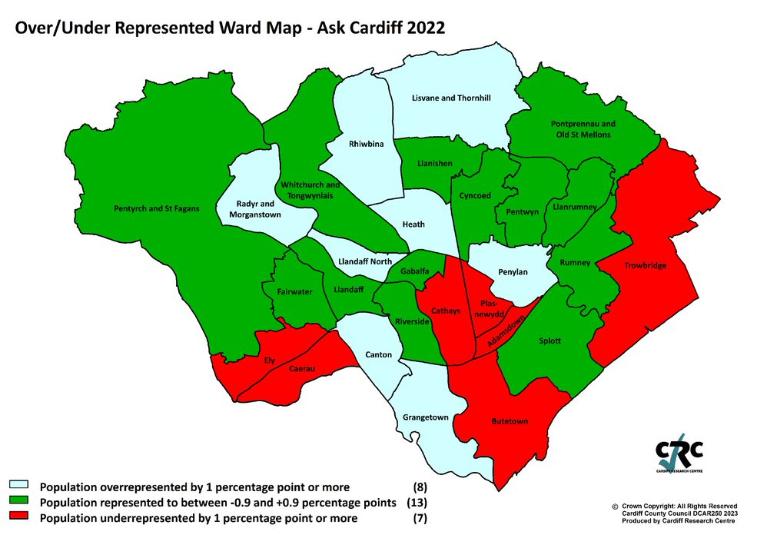
Those that did not provide a postcode are included in overall figures but are excluded from spatial analysis. Similarly, those that did not provide demographic information are included in the overall figures but excluded from subgroup analysis.
The response has been broken down by age, gender, ethnic background, Welsh Speakers, those with a disability, those identifying as LGBTQ, and those living in the least or most deprived areas of the city.
In addition, the analysis includes the response from those living in the ‘Southern Arc’ of Cardiff which comprises the following electoral divisions: Adamsdown, Butetown, Caerau, Canton, Ely, Grangetown, Llanrumney, Riverside, Rumney, Splott, Trowbridge. (see map at Appendix V)

Welsh Index of Multiple Deprivation

To help gain a better understanding of the experiences and views of Cardiff residents an additional level of analysis has been introduced that looks at responses by deprivation fifth.
The Welsh Index of Multiple Deprivation (WIMD) is the official measure of small area deprivation in Wales and is designed to identify those small areas where there are the highest concentrations of several types of deprivation. Each Lower Super Output Area (LSOA) in Wales is ranked in terms of overall deprivation as well as for several separate domains, with a rank of 1 assigned to the most deprived area.
The 218 LSOAs in Cardiff are ranked from highest to lowest by their overall deprivation rank and then split into five equal bands, ranging from least deprived (i.e. least deprived 20% of LSOAs in Cardiff) to most deprived fifth (i.e. most deprived 20%). Respondents are then assigned to a deprivation fifth according to their postcode. As such, respondents from outside Cardiff or those with a missing/incomplete/incorrect postcode will be excluded from this analysis.

Weighted Data

Weighted Data refers to when the data collected from survey respondents are adjusted to represent the population from which the sample was drawn. The overall data for Ask Cardiff survey 2022 was weighted for some of the questions to ensure it was representative in terms of age and gender.
The weighting of the data was found to have no significant impact on the results, with the difference typically no more than one or two percentage points – something that could be explained by standard deviation and should not be cause for concern.
The strong similarity between the observed and the weighted data indicated a high level of robustness in the data collection. As a result we have chosen to report on the ‘observed’ data i.e. the actual response received.

Section 1:

City Life & Public Services

- Overall, how satisfied or dissatisfied are you with Cardiff as a place to live?
Around seven out of ten respondents (72.0%) described themselves as satisfied with Cardiff as a place to live, on a par with results from 2021 (71.9%), but remaining below levels seen during and before the pandemic.

At least seven in ten respondents within each demographic and geographic group analysed were satisfied with Cardiff as a place to live.
Satisfaction was highest amongst under 35s (81.8%) and respondents from a minority ethnicity (81.1%) and it was lowest amongst respondents who identify as disabled (70.0%).
Base sizes shown in brackets; excludes ‘Don’t Know’ responses
There was no correlation with level of deprivation: Base sizes shown in brackets; excludes ‘Don’t Know’ responses
2. Overall, how satisfied are you with the following?
Satisfaction with the quality of public services in Cardiff fell slightly in 2022, dropping 1. 8 percentage points to 52.1% of respondents describing themselves as ‘very’ or ‘fairly’ satisfied (20 percentage points down on the figure recorded in 2020).
Satisfaction with Council services increased slightly from 47.3% to 47.8%, however, this was around 20 percentage points lower than the 2020 figure.
Base sizes shown in brackets; excludes ‘Don’t Know’ responses

Satisfaction with public services was broadly consistent across all demographic groups analysed (ranging from 59.0% amongst respondents from a minority ethnicity to 52.4% amongst LGBTQ), with the exception of those identifying as disabled, who saw satisfaction fall from 52.4% in 2021 to 44.1% in 2022; a similar proportion of this group (40.9%) described themselves as ‘fairly’ or ‘very’ dissatisfied with public services.
Base sizes shown in brackets; excludes ‘Don’t Know’ responses

Satisfaction with council services was highest amongst respondents from a minority ethnicity (58.6%, up from 50.4% in 2021) and under 35s (58.1%, up from 52.9% in 2021); it was lowest amongst those identifying as disabled at 40.0% (down from 46.4% in 2021) – almost half of this group described themselves as dissatisfied with council services (46.5%), with 21.2% ‘very dissatisfied’.
Base sizes shown in brackets; excludes ‘Don’t Know’ responses

There was no correlation with level of deprivation and satisfaction with services.

3. How much do you agree that the Council gives residents good value for money?
Just over a third of respondents (34.9%) agreed that the Council gives residents good value for money, reflecting the findings of 2021 (34.1%) but 17.2 percentage points lower than the 2020 survey (52.1%).

These results fall between the findings of the most recent LGA survey, which saw agreement rise from 43% in October 2021 to 46% in October 2022, and the Glasgow Household survey, which the proportion agreeing fall from 33% in 2021 to 27% in 2022.

Respondents identifying as LGBTQ (45.8%), Welsh speakers (45.4%), under 35s (45.4%) and those from a minority ethnicity (45.2%) were most likely to agree that the Council gives residents good value for money, contrasting with those identifying as disabled (33.9%, up from 28.3%), of whom more than half disagreed with this statement (52.3%).
Base sizes shown in brackets; excludes ‘Don’t Know’ responses

There was no correlation with level of deprivation:

Section 2:

Your Neighbourhood

4. How satisfied or dissatisfied are you with your local community as a place to live?
Seven in ten respondents (68.9%) were satisfied with their local community as a place to live, down slightly from 70.7% in the 2021 Ask Cardiff survey.

Respondents living in the least deprived areas of the city were notably more satisfied with their local community as a place to live than those in the most deprived areas - with the former more than three times more likely to describe themselves as ‘very satisfied’ than the latter (38.2% compared with 11.9% respectively).
Base sizes shown in brackets; excludes ‘Don’t Know’ responses
The proportion satisfied dropped in both the most and least deprived areas:
Satisfaction with local community | Most deprived | Least deprived | Difference
2022 | 50.0% | 85.2% | 35.2
2021 | 56.5% | 89.3% | 32.8
2020 | 50.7% | 90.5% | 39.8
2019 | 56.5% | 89.3% | 32.8
Satisfaction with the local community as a place to live was highest amongst older respondents (76.4%) and Welsh speakers (75.1%); it was lowest amongst respondents living in the Southern Arc (60.9%), those identifying as disabled (61.6%) and under 35s (62.0%).
Base sizes shown in brackets; excludes ‘Don’t Know’ responses

5. To what extent do you agree or disagree with this statement: My neighbourhood is a place where people get on well together and help each other?
Around half (49.8%) of those surveyed agreed that their “neighbourhood is a place where people get on well together and help each other”, lower than in previous surveys.

% Agree
2022 | 49.8
2021 | 61.4
2020 | 67.2
2019 | 61.2

Older respondents were most likely to agree with this statement (55.2%), those aged under 35 were least likely to agree (39.3%).
Base sizes shown in brackets; excludes ‘Don’t Know’ responses

There was a correlation with this statement and the level of deprivation, ranging from 33.1% amongst those living in the most deprived areas to 69.1% amongst those in the least deprived areas.
The gap between the two has widened to 36.0 percentage points, three times bigger than was seen in 2020, and the biggest gap in the last five years, primarily driven by the low level of agreement amongst those residing in the most deprived areas.
Base sizes shown in brackets; excludes ‘Don’t Know’ responses

6. To what extent do you agree that you are able to have a say on local issues or how Council services are run in your community?
Almost a quarter of respondents (22.6%) agreed that they are able to have their say on local issues or how Council services are run in their community, reflecting the findings of the 2021 (24.4%) survey.

These results were broadly consistent across the different demographic and geographic groups analysed.

7. Does your local neighbourhood have the necessary services and amenities to meet your needs?
Half of those responding to this question (50.4%) felt their neighbourhood had the necessary services and amenities to meet their needs, 37.7% felt it did not.

Respondents under the age of 35 were most likely to answer ‘Yes’ to this question (59.0%). Almost half of those identifying as disabled (49.4%) said ‘No’.
Base sizes shown in brackets

There was no correlation with level of deprivation.
Respondents answering ‘No’ or ‘Not sure’ were invited to provide details on what services or amenities are required in their local neighbourhood to meet their needs; 1,359 comments were received, and grouped into themes. The top three themes are shown below, with a full list available in Appendix A.
Theme | No. | % | Example comments
Improve bus service | 237 | 17.4 | - Regular bus service - there is 1 bus every 30 min, which will stop in Jan 2023  - Bus service poor  - Better bus services. Need to consider needs if elderly and disabled  - The buses do not take me where I need to go.  - The bus service is absolutely atrocious - 1 x bus an hour! Apart from a very limited service on Sunday, Cardiff Bus is not available at all!  - Bus service is awful.  - Better bus service. One an hour is rubbish.
Litter / Bins / Street cleansing / Fly tipping | 197 | 14.5 | - Better street cleaning.  - Street cleaning, graffiti removal  - You never ever see street cleaners  - Lack of bins (bins overflowing all the time, need more regular collection of dog poo bins).  - As I live near CCFC stadium and big schools, there is a lack of street bins. This is one of the major causes of littering as people just throw anything. This really effects the tidiness and causes issues people with pet with broken glass and ripped cans.  - Litter picks after bin day especially after these stupid recycling sacks
Commercial space / Bank / Shops / Post office / Pub | 168 | 12.4 | - The largest supermarket Tesco, changed from metro to express to charge higher prices  - Post office  - Better local food shop, closer pubs  - local public house, a bank would be very useful  - Better quality shops instead of countless barbers and fast food outlets

8a. Which of the following services and amenities are available within 15 minutes' walk or cycle from where you live?
More than nine in ten respondents (91.0%) reported ‘Essential Food Shops/Groceries’ were available within a 15 minute walk or cycle from their home, followed by ‘Pharmacy or Chemist’ (88.7%), ‘Parks & Play Areas’ (85.5%) and ‘Schools’ (84.4%).
Just 1.6% of respondents stated none of the facilities listed were available within 15 minutes’ walk or cycle.
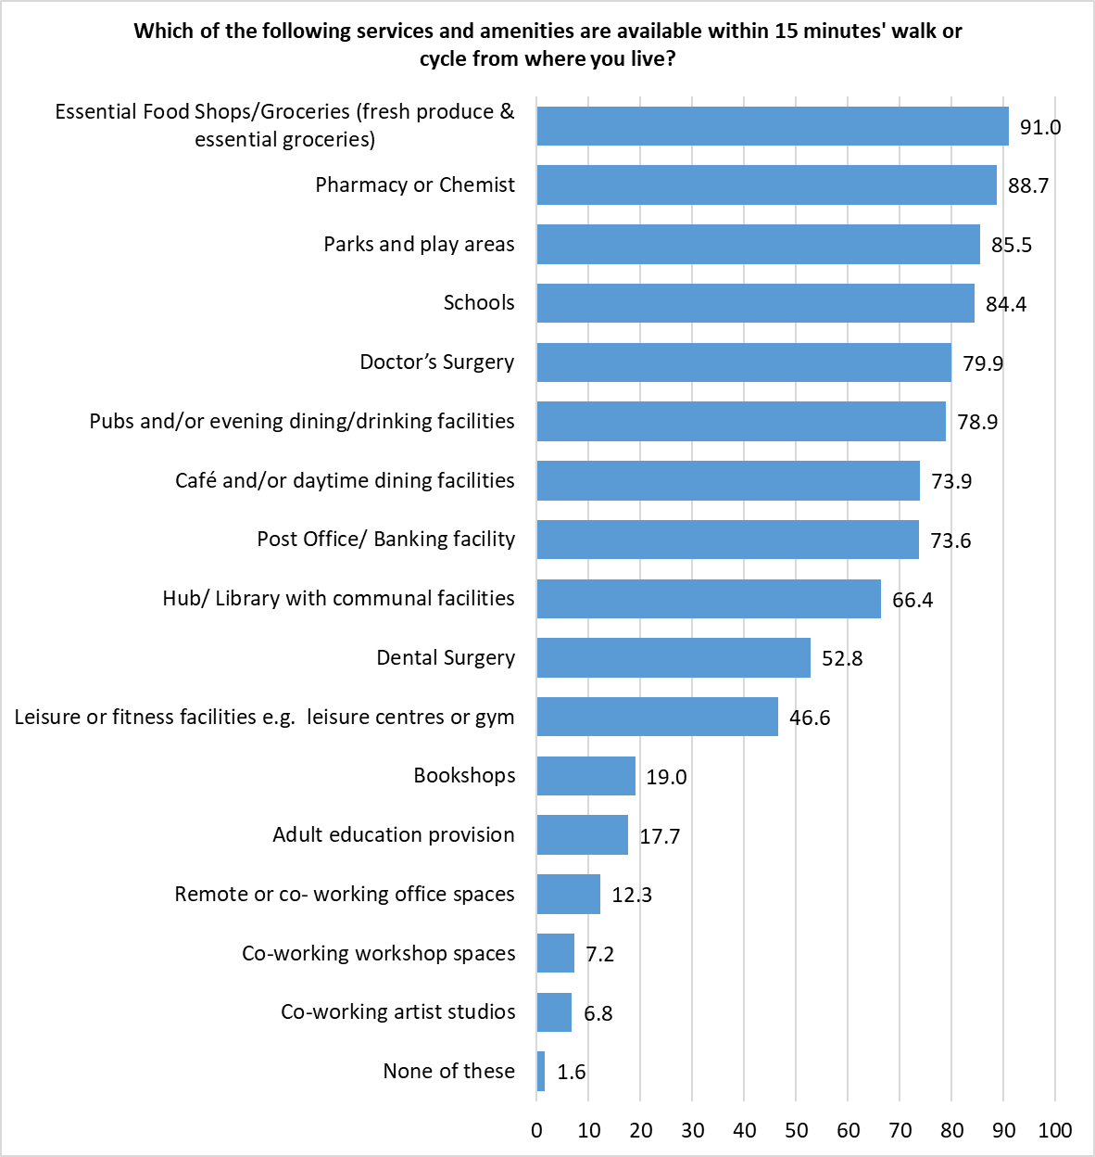Respondents were able to give multiple responses so the total may exceed 100%
Respondents identifying as disabled were more than twice as likely than average to state that none of the facilities listed were available within 15 minutes from their home.
Those living in the least deprived areas were more than twice as likely as those in the most deprived areas to say none of the facilities listed were within a 15 minute walk or cycle from where they live.
A full breakdown of services and amenities by the demographic and geographic groups analysed is available in Appendix B.

8b. Are any of the following available to enable you to access your local neighbourhood services or amenities?
More than half of those responding to this question stated they had access to ‘Frequent and reliable to public transport provision’ (59.7%) or to ‘Car and/or other motorised vehicle parking spaces’ (50.4%)
Around one in six (15.6%) reported there were parking spaces for non-motorised vehicles.
Respondents were able to give multiple responses so the total may exceed 100%
Those identifying as disabled were most likely to state they had no access to any of the facilities listed (14.4%); respondents under the age of 35 (7.6%) and those living in the Southern Arc (7.8%) were least likely to say this.
A full breakdown of results by demographic are available in Appendix C.

Respondents living in the most deprived areas of the city were most likely to cite access to ‘frequent and reliable public transport provision’ (68.3%), however, they were least likely to report availability of disabled parking bays (22.8%), safe walking routes (35.9%), ‘Ovo Bikes’ (36.3%) and parking spaces for cars or other motorised vehicles (46.3%). Around one in eight (12.0%) reported they had no access to any of the facilities listed.
Those living in the least deprived areas were least likely to cite access to ‘frequent and reliable public transport provision’ (54.3%) and safe cycling lanes and/or routes (19.7%).
 | Most Deprived | Next Most Deprived | Middle | Next Least Deprived | Least Deprived | All Respondents
Base | 259 | 392 | 378 | 594 | 608 | 3401
Frequent and reliable public transport provision (Bus and/or train services) | 68.3 | 62.2 | 60.3 | 61.8 | 54.3 | 59.7
Car and/or other motorised vehicle parking spaces | 46.3 | 49.7 | 54.2 | 57.7 | 54.4 | 50.4
Safe walking routes | 35.9 | 46.9 | 53.4 | 55.2 | 52.3 | 48.3
Cardiff ‘Ovo Bike’ use | 36.3 | 51.0 | 53.7 | 45.8 | 45.1 | 45.7
Safe cycling lanes and/ or routes | 27.0 | 27.3 | 36.2 | 27.9 | 19.7 | 26.1
Disabled parking bays | 22.8 | 24.5 | 28.3 | 26.6 | 23.8 | 24.2
Parking space for non-motorised vehicle e.g. bicycles, e-scooter | 15.4 | 14.8 | 20.4 | 16.0 | 15.3 | 15.6
None of these | 12.0 | 9.9 | 6.6 | 8.2 | 11.7 | 11.0

8c. Are there any barriers to you accessing services or amenities in your local neighbourhood?
Respondents were asked if there were any barriers preventing them accessing services or amenities in their local neighbourhood.
The most common response was that there were no barriers (30.3%). Of the barriers identified, the most common issue raised was ‘poor parking facilities’ (23.7%), followed by ‘some services are not available in my local neighbourhood’ (22.9%).
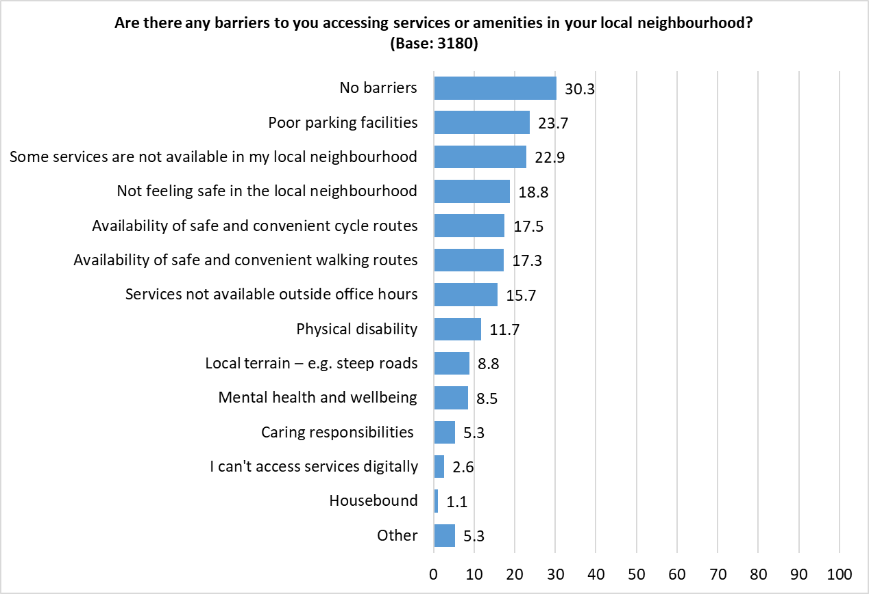 Respondents were able to give multiple responses so the total may exceed 100%

Those answering ‘Other’ were asked to give further details of the barriers they faced in accessing services or amenities; 158 responses were received, and grouped into themes, with the top three shown below. A full breakdown is available in Appendix D.
Theme | No. | % | Example comments
Poor public transport | 59 | 37.3 | - Poor public transport network  - Buses infrequent, often cancelled, have to go into centre and come back out - hours longer journey by public transport rather than car.  - The bus stops in City Centre are too far from the shopping centre.  - No late night bus services  - Buses are unreliable and constantly changing.
Infrastructure - poor pavements / roads / cycle route | 30 | 19.0 | - Poor condition of pavements and roads  - Frequent disruption to the roads because of construction works: going on for 4 years, with several more years of disruption to come. Also, our local playground has been closed for nearly 3 years because necessary flood prevention work has not been carried out.  - Lack of buses, dangerous empty cycle lanes, dangerous pavements covered in wet leaves and branches, continuous roadworks.  - Road crossing with no lights means I cannot reach the hub
Availability | 27 | 17.1 | - We do not have basic services in our local neighbourhood.  - Constantly unable to get to a doctor’s appointment  - No Post Office  - Dentist is rarely available. I've waited 2 years to see an NHS dentist at my dental surgery because the last one left. A&E is also a disgrace.

Looking at responses by demographic, males and those aged 55 or over were most likely to state there were no barriers to accessing services and amenities (34.5% and 33.5% respectively). Those identifying as disabled were notably less likely than all other groups to report there were ‘No barriers’.

Respondents identifying as disabled were more likely than the average respondent to cite a physical disability (52.4%), ‘some services are not available in my local neighbourhood’ (29.6%), poor parking facilities (29.4%), mental health and wellbeing (27.5%), local terrain (18.3%), not able to access services digitally (6.6%) or being housebound (4.8%) as barrier to accessing services or amenities.
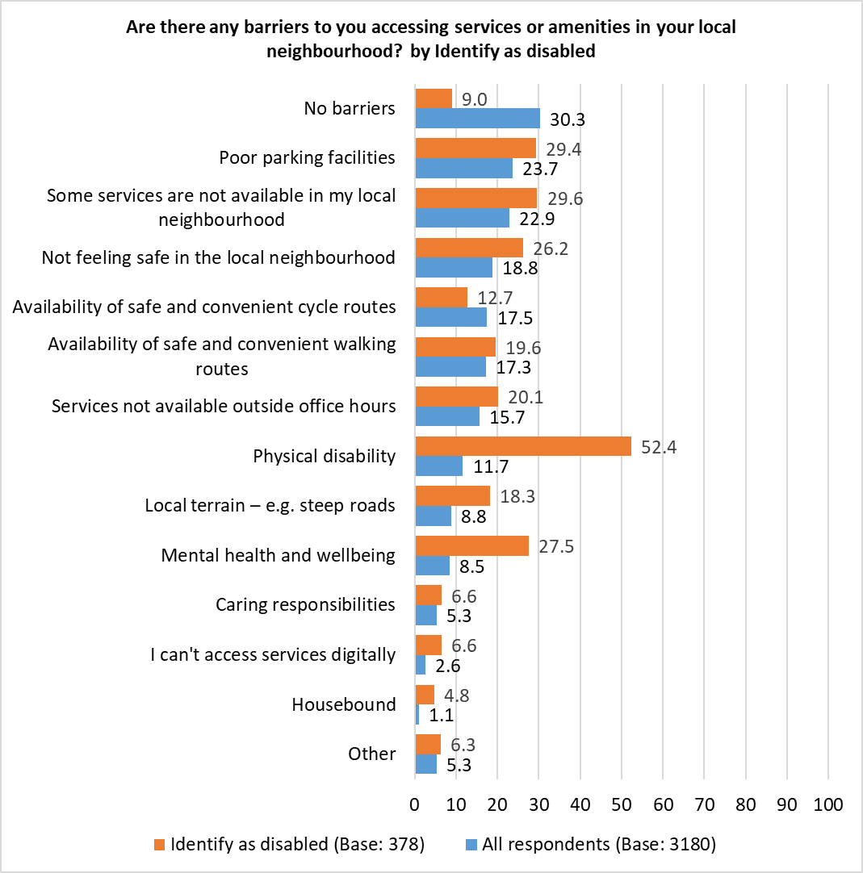 Respondents were able to give multiple responses so the total may exceed 100%
Those living in the most deprived areas were less likely to cite ‘No barriers’ than those in the least deprived areas:

Of the barriers listed, the strongest correlation with level of deprivation was ‘Not feeling safe in the local neighbourhood’, with two in five respondents in the most deprived areas (40.9%) citing this as a barrier, compared with just 6.6% in the least deprived areas.

A full breakdown of responses by the demographic and geographic groups analysed is available in Appendix E.

9a. Following the Covid pandemic, more workers have taken up working remotely or working from home on-line. Which of the following best describes where you work?
The employment status question within the ‘About You’ section of the survey identified 757 respondents who were ‘wholly retired from work’; these have been excluded from this analysis, giving a base of 1,986 respondents.
More than two-fifths of respondents (43.4%) stated that they work remotely from home, either full- or part-time, with a further 2.9% working remotely from another setting. Almost three in ten (28.1%) work in a fixed setting, with no option to work remotely, whilst around one in seven (13.1%) stated they were not currently in work.
Excludes respondents describing themselves as ‘wholly retired from work’ (Base: 1,986)

Those answering ‘Other’ were asked to give further details of where they work; 583 responses were received, and grouped into themes, with the top three shown below. A full breakdown is available in Appendix F.
Theme | No. | % | Example Comments
Retired | 331 | 56.8 | - Retired  - Pensioner  - Very old and very retired
Hybrid Working - Flexible / Mix | 129 | 22.1 | - work both from office and remotely  - I work equally from home and at a fixed setting in person  - Flexible, both at home and the office.
Not applicable e.g. Taxi, outdoor work | 50 | 8.6 | - Field work from home for company in company provided vehicle (i.e. site visits)  - Work in film locations  - Taxi driver

Excluding respondents describing themselves as ‘wholly retired from work’, respondents identifying as disabled or those over 55 were least likely to state they worked remotely from home, either full- or part-time (33.0% and 33.5% respectively).
Welsh speakers (31.9%), those living in the Southern Arc (30.2%) and those from a minority ethnicity (30.1%) were most likely to work in a fixed setting.
Respondents identifying as disabled were most likely to state they were not currently in work (34.5%).
 | Base | I work in a fixed setting (e.g. an office, shop or factory) with no option to work remotely | I work remotely from home (part- or full-time) | I work remotely from another setting (part- or full-time) | I am not currently in work | Other
All respondents | 1986 | 28.1 | 43.4 | 2.9 | 13.1 | 12.5
Under 35 | 329 | 28.9 | 48.9 | 3.0 | 9.7 | 9.4
55+ | 645 | 27.0 | 33.5 | 3.1 | 20.3 | 16.1
Female | 1178 | 28.9 | 43.5 | 2.6 | 12.8 | 12.2
Male | 697 | 27.3 | 43.2 | 3.3 | 12.8 | 13.5
Minority ethnicity | 246 | 30.1 | 43.9 | 1.6 | 12.2 | 12.2
Identify as disabled | 267 | 19.5 | 33.0 | 1.5 | 34.5 | 11.6
Welsh speaker | 216 | 31.9 | 48.6 | 3.2 | 6.0 | 10.2
Southern Arc | 648 | 30.2 | 39.0 | 3.2 | 15.1 | 12.3
Children in household | 679 | 29.7 | 45.8 | 2.9 | 10.0 | 11.5
LGBTQ+ | 224 | 27.7 | 50.4 | 0.9 | 14.3 | 6.7

There was a correlation with level of deprivation and those working remotely from home, with those in the least deprived areas most likely to report this working pattern.
 | Base | I work in a fixed setting (e.g. an office, shop or factory) with no option to work remotely | I work remotely from home (part- or full-time) | I work remotely from another setting (part- or full-time) | I am not currently in work | Other
Most Deprived | 221 | 29.0 | 33.5 | 1.8 | 20.8 | 14.9
Next Most Deprived | 330 | 31.5 | 38.2 | 3.9 | 13.9 | 12.4
Middle | 293 | 23.9 | 45.4 | 3.8 | 13.7 | 13.3
Next Least Deprived | 427 | 25.8 | 49.4 | 2.3 | 11.2 | 11.2
Least Deprived | 359 | 24.2 | 53.8 | 1.4 | 7.5 | 13.1
All Respondents | 1986 | 28.1 | 43.4 | 2.9 | 13.1 | 12.5

9b. Are any of the following shared working spaces and facilities needed within 15 minutes’ walk or cycle in your local neighbourhood?
Respondents indicating they worked remotely, either from home or another setting, were asked to indicate if any of the working spaces listed were needed within 15 minutes’ walk or cycle from their home.
Two fifths of respondents either felt none of the spaces listed were not needed (40.9%) or they didn’t know if they were needed (40.9%).
One in six respondents (16.1%) felt flexible co-working office spaces were needed, with just 4.4% identifying a need for co-working workshop spaces, and 3.7% for co-working artist studios.
Respondents could select multiple options so the total will exceed 100%

Respondents living in the Southern Arc were most likely to express the need for flexible co-working office space (28.5%), and were least likely to answer ‘None of these’ (27.0%).
 | Base | Flexible co-working office spaces | Co-working artist studios | Co working workshops space | None of these | Don't know
All respondents | 1127 | 16.1 | 3.7 | 4.4 | 40.8 | 40.9
Under 35 | 171 | 18.1 | 4.7 | 4.7 | 42.1 | 39.2
55+ | 240 | 15.0 | 2.9 | 3.3 | 32.9 | 49.2
Female | 543 | 19.0 | 4.1 | 5.0 | 37.0 | 42.0
Male | 326 | 14.7 | 3.7 | 3.7 | 40.8 | 41.7
Minority ethnicity | 108 | 22.2 | 7.4 | 3.7 | 43.5 | 34.3
Identify as disabled | 92 | 22.8 | 5.4 | 8.7 | 31.5 | 41.3
Welsh speaker | 112 | 23.2 | 8.0 | 9.8 | 40.2 | 31.3
Children in household | 328 | 17.7 | 3.7 | 4.0 | 42.7 | 37.5
LGBTQ+ | 113 | 17.7 | 6.2 | 8.8 | 43.4 | 35.4
Southern Arc | 274 | 28.5 | 8.0 | 6.9 | 27.0 | 42.7
Respondents could select multiple options so the total will exceed 100%
Supporting this, respondents living in the more deprived areas of the city were more likely to highlight the need for flexible co-working office spaces; those in the least deprived areas were most likely to answer ‘None of these’ (51.0%).
 | Base | Flexible co-working office spaces | Co-working artist studios | Co working workshops space | None of these | Don't know
Most Deprived | 79 | 22.8 | 8.9 | 8.9 | 39.2 | 38.0
Next Most Deprived | 138 | 24.6 | 6.5 | 5.1 | 26.1 | 48.6
Middle | 144 | 22.2 | 4.2 | 6.9 | 36.8 | 37.5
Next Least Deprived | 221 | 13.6 | 3.2 | 2.7 | 33.5 | 50.2
Least Deprived | 200 | 10.0 | 0.5 | 2.0 | 51.0 | 38.5
All Respondents | 1127 | 16.1 | 3.7 | 4.4 | 40.8 | 40.9

10a. Do you have access to affordable broadband?
The proportion of respondents with access to affordable broadband at home fell slightly from 96.3% in 2021 to 91.1%, whilst those answering ‘No’ increased from 2.7% to 7.1%.

Respondents could select multiple options so the total will exceed 100%
One in seven respondents who identify as disabled said they did not have access to affordable broadband at home (14.2%).
 | Base | Yes, at home | Yes, elsewhere | No
All respondents | 3437 | 91.1 | 5.4 | 7.1
Under 35 | 332 | 91.0 | 4.5 | 8.7
55+ | 1386 | 92.9 | 4.5 | 5.6
Female | 1527 | 91.7 | 5.7 | 6.5
Male | 1106 | 92.4 | 5.0 | 6.2
Minority ethnicity | 287 | 87.8 | 6.6 | 10.1
Identify as disabled | 393 | 84.0 | 3.1 | 14.2
Welsh speaker | 286 | 95.1 | 4.9 | 3.8
Children in household | 698 | 90.0 | 5.7 | 7.9
LGBTQ+ | 275 | 89.8 | 6.2 | 8.7
Southern Arc | 817 | 89.2 | 5.4 | 8.8

The proportion of respondents living in the most deprived areas of the city stating they did not have access to affordable broadband rose from 3.1% in 2021 to 13.6% in 2022.
 | Base | Yes, at home | Yes, elsewhere | No
Most Deprived | 264 | 84.5 | 5.3 | 13.6
Next Most Deprived | 399 | 91.0 | 4.8 | 8.0
Middle | 389 | 91.0 | 5.9 | 6.4
Next Least Deprived | 601 | 93.3 | 6.7 | 4.8
Least Deprived | 612 | 96.1 | 3.9 | 3.4
All respondents | 3437 | 91.1 | 5.4 | 7.1
10b. How satisfied are you with the level of connectivity that your current broadband service provides?
Four out of five respondents (80.0%) described themselves as ‘very’ or ‘fairly’ satisfied with their current broadband provision.

These findings were consistent across the demographic and geographic groups analysed.

10c. Has your broadband connectivity affected your ability to work on-line effectively and efficiently, from home or remotely from other areas in your neighbourhood?
Respondents who indicated they worked remotely at Q9 were asked if their broadband connectivity affected their ability to work from home, or another venue in their local neighbourhood.
Just over a third (37.2%) stated they were not impacted at all, with a similar proportion (35.9%) felt they were affected ‘a little’ by their broadband connectivity, with 18.0% affected ‘Somewhat’ and almost one in ten (8.9%) affected ‘to a great extent’.

Respondents identifying as disabled were least likely to say they were not affected ‘at all’ by broadband connectivity when working remotely, with 74.0% reporting being affected at least ‘a little’.

There was no correlation with level of deprivation.

11a. Did you visit a library or Hub in the last 12 months?
More than half of those surveyed (52.6%) had visited a library or Hub in the last 12 months, the first increase since the start of the pandemic in 2020, but well below the pre-pandemic level.
Base sizes shown in brackets

Respondents from a minority ethnicity and those with children in their household were most likely to have visited a library or Hub (66.9% and 63.4% respectively), men were least likely (52.1%).
Base sizes shown in brackets; excludes ‘Don’t Know’ responses
There was no correlation with likelihood to have visited a library or Hub with level of deprivation.

11b. What services delivered within your local Hub/Library do you find most helpful to you?
Respondents were given a list of services delivered within their local Hub/library, and asked to indicate which they found most helpful.
Two-fifths (42.3%) of respondents found none of the services to be helpful, reflecting the proportion stating they had not visited a Hub or library over the previous year. This mirrors the findings of the 2021 survey.
Of the services listed, the most helpful was ‘Book loan’, selected by 37.5% of respondents. This was followed by ‘community events’ (10.6%), and ‘children’s activities, including story and rhyme time’ (10.2%).
Respondents could select multiple options so the total will exceed 100%
There were some differences by demographic and level of deprivation:
Respondents with children in their household were most likely to cite book loans (45.6%) and children’s activities (25.8%).
Those identifying as disabled were most likely to find housing and benefit advice (18.7%).
Respondents under the age of 35 were most likely to state that they volunteer opportunities (8.5%) helpful.
Respondents from minority ethnicities were most likely to find community events (16.6%), PC use & digital assistance (11.9%), Into Work Services (11.1%) Adult Learning and Friends & Neighbours groups (each 10.3%) helpful.

The proportion of respondents reporting they found the following services to be helpful were correlated with level of deprivation, with those living in the most deprived areas finding them to be more helpful:
 | Most Deprived (Base: 236) | Least Deprived (Base: 508)
Housing & Benefit Advice | 18.6 | 2.4
PC use & digital assistance | 11.0 | 5.5
Money Advice | 9.3 | 1.8
Adult Learning | 7.6 | 4.9
Into Work Services | 6.4 | 1.4
Job clubs | 6.4 | 0.4
Coffee mornings | 5.1 | 3.5

Is there anything that is not available to you in your local Hub/Library that you think would be beneficial to you and your community?
Respondents were invited to make suggestions on additional services or facilities not currently available in their local Hub/Library; 590 responses were received, and grouped into themes, with the top three shown below. A full breakdown is available in Appendix G.

Theme | No. | % | Example Comments
More activities / courses for all age groups / abilities | 117 | 19.8 | - Spaces for YOUTHS to meet in safety and social inclusion in ALL areas, Youths are marginalised  - Adult learning for professionals. It's all for kids, unemployed and retired people.  - The Reading Group at the Main Library stopped at the lockdown and has not started again.  - Activities for disabled children  - Friendship groups.
No hub near me | 65 | 11.0 | - We don’t have one!!!!! We need one please!!!  - The closest Hub is an hour’s walk away.  - There is not a hub / library in my area
Citizen’s advice / general advice/ Info | 43 | 7.3 | - Personal Finance Education  - CAB local services  - Ways of helping engaging people in consultations who due to certain barriers find it hard to engage.

12. How satisfied or dissatisfied are you with the following in your neighbourhood?
Respondents were given a list of services and asked their level of satisfaction with each.
Reflecting previous surveys, satisfaction was highest for parks and open spaces (74.0%), street lighting (66.2%) and Libraries/Hubs (64.4%). Dissatisfaction was highest for pavement maintenance (59.8%), road maintenance (54.2%) and frequency of vandalism and graffiti (53.3%).
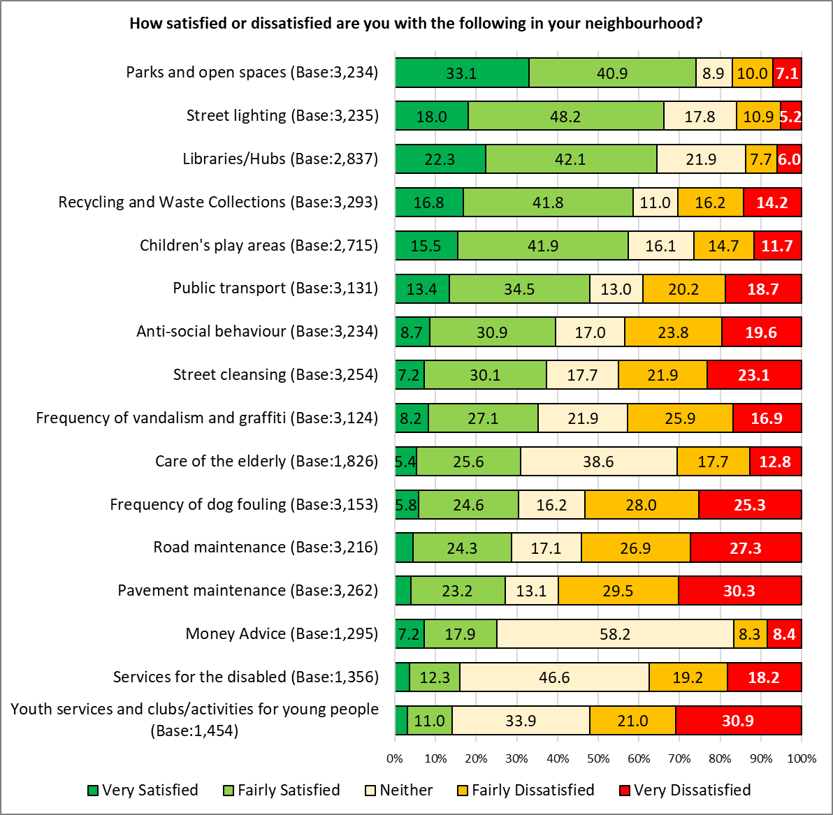Base sizes shown in brackets; excludes ‘Don’t Know’ responses
Where trend data is available, both the top and bottom three services were unchanged from the previous year. Following a drop in satisfaction with all services in 2021 with 2020, satisfaction levels increased for children’s play areas, public transport, anti-social behaviour, pavement maintenance and road maintenance, but continued to fall for street cleansing, frequency of dog fouling and services for the disabled:
 | 2022 | 2021 | 2020 | 2019
Parks and open spaces | 74.0 | 74.0 | 79.1 | 78.5
Street lighting | 66.2 | 66.8 | 74.6 | 72.9
Libraries/Hubs | 64.4 | 64.1 | 71.1 | 75.9
Children's play areas | 57.5 | 52.9 | 54.0 | 53.5
Public transport | 48.0 | 43.6 | 57.7 | 51.8
Street cleansing | 37.3 | 39.3 | 52.3 | 43.3
Frequency of vandalism and graffiti | 35.3 | 35.8 | 44.0 | 43.6
Frequency of dog fouling | 30.4 | 35.0 | 36.5 | 37.9
Anti-social behaviour | 39.5 | 34.3 | 38.5 | 41.1
Care of the elderly | 30.9 | 32.4 | 39.8 | 36.1
Pavement maintenance | 27.1 | 26.4 | 34.2 | 32.5
Road maintenance | 28.8 | 23.2 | 28.8 | 24.3
Services for the disabled | 16.0 | 22.0 | 27.5 | 27.3
Youth services and clubs/activities for young people | 14.1 | 14.3 | 14.9 | 19.9
Red indicates a drop in the % describing themselves as satisfied compared with the previous year, green indicates an increase in satisfaction

The biggest increase in satisfaction was seen for:
- Road maintenance, rising 5.6 percentage points from 23.2% to 28.8%
- Antisocial behaviour, rising 5.2 percentage points from 34.3% to 39.5%
The biggest drop in satisfaction was seen for:
- Services for the disabled, falling 6.0 percentage points from 22.0% to 16.0%
- Frequency of dog fouling, falling 4.6 percentage points from 35.0% to 30.4%

Amongst respondents identifying as disabled, satisfaction with services for the disabled was 12.4% (down from 19.5% in 2021, and half the figure seen in 2020, 24.3%), with two-thirds (63.5%) describing themselves as dissatisfied. This group also showed the lowest level of satisfaction with parks and open spaces (66.1%), libraries and Hubs (56.4%), recycling and waste collections (51.8%, children’s play areas (47.8%), street cleansing (29.8%) and pavement maintenance (22.4%).
Respondents living in the Southern Arc showed the highest level of satisfaction with public transport (51.6%).
Respondents with children in their household showed the highest level of satisfaction with libraries/Hubs (71.5%); they were less satisfied than average with children’s play areas (54.3%).

Four of the services listed showed a correlation between satisfaction and level of deprivation:
% Satisfied | Most Deprived | Least Deprived | Difference
Anti-social behaviour | 17.4 | 61.0 | 43.6
Frequency of vandalism and graffiti | 16.3 | 52.6 | 36.3
Frequency of dog fouling | 16.0 | 40.2 | 24.2
Street cleansing | 28.5 | 45.9 | 17.5

13. Do you currently volunteer?
Overall, around a quarter (27.5%) of respondents said they currently volunteer, on a par with the 2021 findings – this rose to 35.9% of Welsh speaking respondents, and fell to 21.2% of under 35s.
Base sizes shown in brackets
Respondents living in the least deprived areas were more likely to volunteer than those in the most deprived areas (32.5% compared with 23.0% respectively).
Base sizes shown in brackets
13b. Listed below are a number of ways that you could contribute to the wellbeing of your community. Please tell us if you are, or would like to be, involved in each of the following:
Respondents were most likely to already be involved ‘learning more about how to reduce your carbon footprint’ (19.7%) and Community Volunteering (17.5%).
Of the volunteering opportunities listed, those generating the most interest for future volunteering opportunities were:
- Learning more about how to reduce your carbon footprint (19.3%)
- Improving community safety as part of Neighbourhood Watch (19.2%)
- Community Volunteering (18.8%)
- Become a member of a group delivering a project or activity in my community (15.6%)

A total of 1,393 respondents expressed an interest in getting involved in contributing to the wellbeing of their community, of whom 898 provided contact details for further information to be sent to them. This has been passed to the relevant teams to take further action.
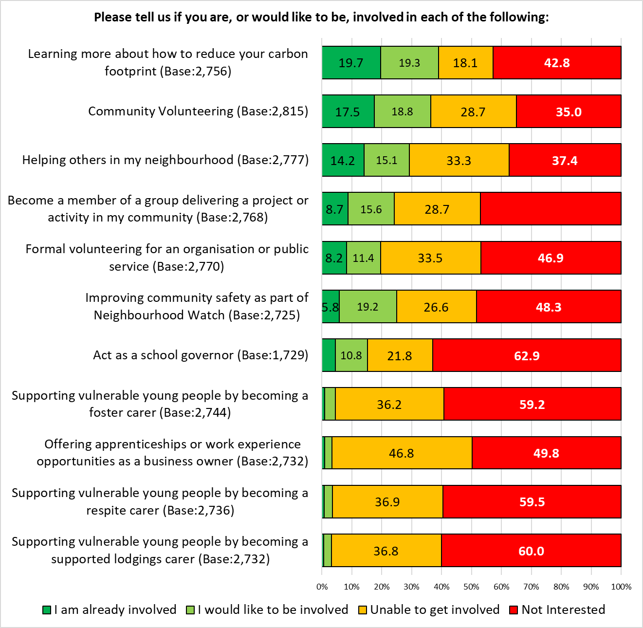
Base sizes shown in brackets; excludes ‘Don’t Know’ responses

Respondents were invited to give details of other volunteering opportunities they would be interested in getting involved with – 166 comments were received, and grouped into themes. The top three themes are shown below, with a full breakdown in Appendix H.

Theme | No. | % | Example Comments
Support | 22 | 13.3 | - I would like to help adults with basic learning - reading and writing in English  - Tenancy and Homelessness Advice  - Digital mentor/buddy  - amenities for disabled
Green / green space / nature | 21 | 12.7 | - Something to help nature  - Tree planting and helping wildlife.  - I would happily help with green issues - making community areas - gardens more salubrious and productive not dumping grounds for rubbish
Foodbanks / food related | 16 | 9.6 | - Food banks  - Drop off food share for leftovers like unopened bread, so others in need can have access  - Community cafe if there are any

Section 3:

Cost of Living

14. Are you aware that the Council offers help with benefits and income, help with debts, Into Work and housing advice?
Overall, 58.1% of respondents were aware that the Council offers help with benefits and income, help with debts, Into Work and housing advice, down slightly from 2021 (63.0%).
Awareness of support in Hubs/libraries was highest (54.0%), followed by the Cardiff Money Advice website (18.1%), and Adviceline (10.1%), reflecting the pattern seen in 2021.
Respondents could select multiple options so the total will exceed 100%

Those answering ‘Other’ were asked to give further details – 41 comments were received:
- Do not need the service (6 comments)
- Not eligible / refused service (5 comments)
- Difficulty contacting the service (4 comments)
- Advice did not help (4 comments)
- Did not receive a response to request (2 comments)
- Job Centre (2 comments)
- Independent Living Services (2 comments)
- Cost of Living workshop (2 comments)
- Community Centre (2 comments)
- Miscellaneous comments (12 comments)

Awareness of this service was highest amongst females (64.0%) and those identifying as disabled (61.0%); it was lowest amongst males (51.8%).
 | Base | Yes, in Hubs / Libraries | Yes, at the website | Yes, the Adviceline | Welfare Liaison Team | Help with debts | Other | No
Female | 1445 | 59.7 | 20.7 | 11.1 | 3.9 | 6.3 | 1.8 | 36.0
Identify as disabled | 374 | 56.7 | 16.0 | 10.7 | 3.7 | 6.1 | 2.7 | 38.5
Southern Arc | 774 | 57.0 | 21.4 | 11.1 | 4.1 | 6.3 | 1.9 | 39.0
Children in Household | 662 | 54.8 | 20.1 | 10.4 | 3.2 | 6.2 | 2.4 | 39.3
Under 35 | 125 | 50.6 | 22.8 | 11.2 | 3.5 | 2.6 | 4.8 | 40.1
Minority ethnicity | 273 | 55.3 | 23.1 | 9.2 | 3.3 | 6.2 | 0.7 | 40.3
55+ | 1308 | 57.3 | 16.0 | 8.6 | 2.7 | 5.9 | 1.3 | 40.4
All respondents | 3122 | 54.0 | 18.1 | 10.1 | 3.1 | 6.1 | 1.9 | 41.9
LGBTQ+ | 261 | 49.4 | 22.2 | 13.0 | 3.4 | 5.0 | 1.9 | 43.3
Welsh speaker | 270 | 48.1 | 18.1 | 10.4 | 3.0 | 4.8 | 1.1 | 47.4
Male | 1054 | 48.3 | 15.4 | 8.7 | 2.6 | 5.6 | 2.0 | 48.2

Awareness of the advice service was higher amongst those living in the more deprived areas of the city:
 | Base | Yes, in Hubs / Libraries | Yes, at the website | Yes, the Adviceline | Welfare Liaison Team | Help with debts | Other | No
Most deprived | 254 | 61.0 | 24.8 | 14.2 | 5.9 | 10.6 | 2.0 | 33.5
Next most deprived | 374 | 59.1 | 25.7 | 11.2 | 4.5 | 5.3 | 2.7 | 37.7
Middle | 363 | 53.4 | 14.6 | 9.1 | 3.6 | 4.4 | 1.1 | 43.5
Next least deprived | 568 | 47.0 | 14.6 | 7.4 | 1.8 | 5.3 | 1.9 | 48.9
Least deprived | 583 | 54.7 | 15.8 | 7.7 | 1.7 | 5.1 | 1.7 | 42.5
All respondents | 3122 | 54.0 | 18.1 | 10.1 | 3.1 | 6.1 | 1.9 | 41.9

15. In the last 6 months, have you missed paying rent or mortgage payments?
Overall, 3.1% of respondents reported missing rent or mortgage payments over the past 6 months, with those living in the most deprived areas around ten times more likely to answer ‘Yes’ than those in the least deprived areas (5.3% compared with 0.5% respectively).
 | Base | Yes | No
Most deprived | 207 | 5.3 | 94.7
Next most deprived | 319 | 3.4 | 96.6
Middle | 285 | 3.2 | 96.8
Next least deprived | 439 | 2.3 | 97.7
Least deprived | 417 | 0.5 | 99.5
All respondents | 2419 | 3.1 | 96.9

Respondents identifying as disabled were most likely to report missing rent or mortgage payments (6.9%), followed by those with children in their household (5.6%). Those aged 55 or over and Welsh speakers were least likely to answer ‘Yes’ (2.4% and 2.7% respectively).

16. Which of the following statements regarding advice on money management, debt, benefits, Into Work or housing advice applies to you?
More than one in seven respondents (15.7%) reported they had sought advice on these services in the past, up from 11.7% in 2021; 18.6% felt they may need advice in the future, up from 16.3% reported in 2021.
These findings reflect those seen in the pandemic in 2020.
Base sizes shown in brackets; excludes ‘Don’t Know’ responses

Respondents identifying as disabled were most likely to have sought advice in the past (almost tripling from 10.6% in 2021 to 30.7%), and were most likely to expect to do so in the future (34.0%).
All demographic groups analysed, and where trend data is available, indicated they would be more likely to seek advice in the future than they had done in the past.
 | Have sought advice in the past |  | May seek advice in the future
 | 2022 | 2021 | 2022 | 2021
Identify as disabled | 30.7 | 10.6 | 34.0 | 20.0
Children in Household | 22.0 | 13.1 | 25.1 | 17.9
Minority ethnicity | 20.8 | 12.1 | 25.8 | 17.7
Southern Arc | 20.0 | 13.4 | 24.7 | 17.3
Under 35 | 19.9 | 15.1 | 28.1 | 21.4
LGBTQ+ | 18.8 | - | 23.5 | -
Female | 17.5 | 12.1 | 19.7 | 15.3
All respondents | 15.7 | 11.7 | 18.6 | 16.3
Welsh speaker | 14.9 | 12.7 | 15.4 | 15.6
Male | 12.8 | 11.1 | 16.4 | 16.6
55+ | 12.1 | 10.2 | 14.6 | 14.7
Respondents living in the most deprived areas were four times more likely than those in the least deprived areas to have sought advice on money management, debt, benefits, Into Work or housing advice, and were 11 percentage points more likely to report having done so than in 2021; they were also more likely to indicate they may seek advice in the future.
Again, figures reflect those seen in 2020 during the Covid-19 pandemic.
 | Have sought advice in the past |  |  | May seek advice in the future
 | 2022 | 2021 | 2020 | 2022 | 2021 | 2020
Most deprived | 27.6 | 16.6 | 27.9 | 27.8 | 19.8 | 28.9
Least deprived | 6.8 | 11.8 | 8.8 | 8.6 | 13.4 | 9.9

17. In the last six months, have you or anyone else in your household done any of the following because you couldn't AFFORD food:
There was a notable increase in the proportion of respondents stating they had eaten smaller meals, or skipped meals completely because they couldn’t afford food in the last 6 months, increasing from 9.6% in the 2021 Ask Cardiff survey to 15.6% in 2022.
One in twenty (5.9%) reported missing meals to be able to afford to pay their bills during the cost of living ‘crisis’.
A similar proportion (5.8%) had been hungry but not eaten – on a par with previous survey results.
The proportion reporting they had not eaten for a whole day during the last six months rose to 3.5% from 2.5% in 2021.
The proportion receiving food from a food bank or charity increased slightly, from 1.8% to 2.6%.
% | 2022 | 2021 | 2020
Had smaller meals than usual, or skipped meals | 15.6 | 9.6 | 8.0
Missed meals to afford to pay your bills | 5.9 | - | -
Been hungry but not eaten | 5.8 | 5.2 | 5.2
Not eaten for a whole day | 3.5 | 2.5 | 3.4
Received food from a food bank or charity | 2.6 | 1.8 | 1.6

Respondents under the age of 35 were most likely to report they had not been able to afford food in the last six months, reporting at least one of the options listed (24.8%, up from 17.1% in 2021, compared with 12.8% of those aged 55 or over, up from 8.1% in 2021).
 | Under 35 | 55+
Base | 327 | 1358
Had smaller meals than usual, or skipped meals | 21.4 | 11.0
Been hungry but not eaten | 9.8 | 2.9
Not eaten for a whole day | 4.9 | 2.2
Missed meals to afford to pay your bills | 7.0 | 3.5
Received food from a food bank or charity | 2.1 | 1.7
None of these | 75.2 | 87.2

There was a correlation with those unable to afford food and the level of deprivation:
 | Most Deprived | Next Most Deprived | Middle | Next Least Deprived | Least Deprived | All Respondents
At least one of the actions listed | 36.7 | 23.8 | 16.4 | 14.5 | 7.0 | 18.5

Respondents living in the most deprived areas of the city were notably more likely to report having been impacted by not being able to afford food, with 28.4% eating smaller meals, or skipping meals completely; one in eight (15.5%) missed meals to be able to pay bills; one in seven (14.0%) had been hungry but not eaten, whilst one in ten (10.2%) had not eaten for a whole day. One in thirteen (7.2%) had received food from a food bank or charity.
 | 2022 |  | 2021
 | Most deprived | Least deprived | Most deprived | Least deprived
Had smaller meals than usual, or skipped meals | 28.4 | 6.5 | 17.1 | 5.7
Missed meals to afford to pay your bills | 15.5 | 1.0 | - | -
Been hungry but not eaten | 14.0 | 1.3 | 8.0 | 3.7
Not eaten for a whole day | 10.2 | 0.2 | 4.3 | 2.0
Received food from a food bank or charity | 7.2 | 0.3 | 4.3 | 0.7

A full breakdown of these questions broken down by demographics is available in Appendix I.

18a. In the last 6 months, have you or anyone in your household…?
Almost half of those responding to this question (48.8%) reported they had not taken any steps to deal with increasing energy costs. However, a similar proportion (48.3%) had ‘purposely not put the heating on because of the cost’, and more than one in ten respondents (11.4%) had ‘struggled to pay’ gas and/or electric bills.
 | No. | %
Purposely not put the heating on because of the cost | 1,552 | 48.3
Struggled to pay gas/electric bills | 367 | 11.4
Applied for support to pay for gas/electric | 145 | 4.5
Been cut off from the electricity/gas supply | 33 | 1.0
Received fuel vouchers from a charity | 21 | 0.7
None of these | 1,568 | 48.8
Total Respondents | 3,214 | -

Older respondents were twice as likely than those under 35 to report they had not taken any of the actions listed with regard to coping with rising energy prices (59.4% compared with 29.6% respectively).

These results are correlated with level of deprivation, with those living in the most deprived areas half as likely as those living in the least deprived areas to state they had done none of the options listed.

One in ten of those living in the most deprived areas of the city (10.0%) had applied for support to pay their energy bill, compared with just 0.7% of those living in the least deprived areas.
A full breakdown of these questions broken down by demographics is available in Appendix J.

18b. How will you/your household cope with the expected increase in energy costs this winter?
Respondents were given a list of options, and asked how they planned to cope with the expected increase in energy costs.
More than three in five (62.5%) said they would ‘significantly cut down on heating’; a fifth (19.2%) planned not to use their heating at all. One in eight (12.3%) would ‘cut out other essentials such as food’.
 | No. | %
Significantly cut down on heating | 2,008 | 62.5
I can afford the increase in energy cost | 918 | 28.6
Not use the heating | 616 | 19.2
Cut out other essentials such as food | 394 | 12.3
Borrow money/pay on credit card | 221 | 6.9
Other | 240 | 7.5
Total Respondents | 3,213 | -
Those answering ‘Other’ were asked to say how they planned to cope with the increase in energy costs; 192 responses were received and grouped into themes. The top three themes are shown below, with a full breakdown in Appendix K.
Theme | No. | % | Example Comments
Cut back on other things | 38 | 19.8 | - By cutting down on expenditure elsewhere  - Stop going out for food or drinks, cut down on doing things that cost money.  - Buy only at Aldi and Asda. No new clothes. Reduce window cleaner. Stop Amazon Prime.  - No heating 'til 1st Nov. I stopped dance lessons to pay for them. Bought cheaper ready meals. Stretched out a ready meal for one over two meals. Been often to shops to buy special offers. Not eating out!
Reduce hours / thermostat for heating | 30 | 15.6 | - Only use when bathing kids and a little before bedtime otherwise it's impossible to afford.  - Not switch the heating on  - Reduce the thermostat and time the heating is on.
Cut energy use | 27 | 14.1 | - Careful with energy usage.  - Cut down on energy usage - be smarter  - I had already reduced my energy use due to climate change which has helped with reducing my bills

More than half of every group analysed stated they would ‘significantly cut down on heating’.
Respondents identifying as disabled were most likely to report they would ‘not use the heating’ (29.7%) or that they would ‘cut out other essentials such as food’ (20.3%), and were least likely to feel they ‘can afford the increase in energy cost’ (17.7%).
Respondents aged 55 or over were almost twice as likely as those under the age of 35 to say they can afford the increase in energy cost (34.6% compared with 22.0% respectively); younger respondents were notably more likely to borrow money or use a credit card to pay their energy bills (13.4% compared with 2.2%).
 | Base | Not use the heating | Significantly cut down on heating | Cut out other essentials such as food | Borrow money / pay on credit card | I can afford the increase in energy cost
Identify as disabled | 384 | 29.7 | 65.9 | 20.3 | 10.2 | 17.7
LGBTQ+ | 269 | 26.4 | 68.8 | 19.0 | 8.6 | 20.4
Under 35 | 328 | 26.2 | 64.3 | 16.2 | 13.4 | 22.0
Children in household | 692 | 22.4 | 67.6 | 18.1 | 11.8 | 22.4
Female | 1515 | 20.0 | 66.1 | 12.6 | 7.4 | 23.8
Southern Arc | 807 | 22.8 | 65.3 | 15.0 | 8.7 | 24.7
Minority ethnicity | 282 | 19.1 | 64.2 | 17.0 | 8.5 | 26.2
All respondents | 3213 | 19.2 | 62.5 | 12.3 | 6.9 | 28.6
Welsh speaker | 282 | 18.1 | 64.2 | 12.1 | 6.0 | 32.6
55+ | 1360 | 12.6 | 58.3 | 7.4 | 2.2 | 34.6
Male | 1083 | 14.3 | 56.5 | 10.2 | 5.0 | 38.4

There were correlations between respondents stating they would take action to cope with the expected increase in energy costs and level of deprivation, with those living in the most deprived areas of the city most likely to not use the heating, cut out other essentials or borrow money to pay the bill; they were least likely to feel they could afford the increase:
 | Base | Not use the heating | Significantly cut down on heating | Cut out other essentials such as food | Borrow money / pay on credit card | I can afford the increase in energy cost
All Respondents | 3213 | 19.2 | 62.5 | 12.3 | 6.9 | 28.6
Least Deprived | 602 | 9.1 | 57.3 | 5.0 | 2.7 | 39.2
Next Least Deprived | 595 | 17.5 | 60.8 | 10.3 | 6.2 | 33.4
Middle | 381 | 18.9 | 64.0 | 13.6 | 7.1 | 26.2
Next Most Deprived | 393 | 22.6 | 67.2 | 16.3 | 9.4 | 22.6
Most Deprived | 263 | 30.0 | 63.9 | 20.5 | 11.4 | 19.8

Section 4:

Housing

19. To what extent do you agree that you have access to good quality housing?
Almost three-quarters of respondents (73.7%) agreed they had access to good quality housing, returning to the level of the 2020 survey following a slight drop in 2021.
Also reflecting previous findings, those aged 55 or over (82.5%) were most likely to agree.
Under 35s were most likely to disagree, with a fifth (22.2%) stating they ‘disagreed’ or ‘strongly disagreed’, again reflecting previous findings.
Base sizes shown in brackets; excludes ‘Don’t Know’ responses

Agreement with this statement was correlated with level of deprivation, with those living in the most deprived areas least likely to agree.
More than one in ten (11.4%) of those living in the most deprived areas ‘strongly disagreed’, more than four times that of those in the least deprived areas (2.6%).
Base sizes shown in brackets; excludes ‘Don’t Know’ responses

Over the last 12 months, has your housing situation:
The majority of respondents (86.8%) stated there had not been a change in their housing situation over the past year.
Respondents under the age of 35 were most likely to report a change in their circumstance, with a fifth (20.5%) stating it had improved, and one in ten (10.4%) that it had declined.
Base sizes shown in brackets; excludes ‘Don’t Know’ responses

There was no correlation with level of deprivation, however around one in six (15.8%) of those living in the most deprived areas of the city reported a decline in their housing situation, compared with 3.3% of those in the least deprived areas.

Section 5:

Jobs & The Economy

20. To what extent do you agree or disagree with this statement: Cardiff has a thriving and prosperous economy?
The proportion of respondents agreeing that Cardiff has a thriving and prosperous economy continued a steady decline, with 35.9% of respondents agreeing, down by 7.2 percentage points over the last year, and by 28.7 points over the last five years.
Excludes ‘Don’t Know’ responses

Respondents under the age of 35 were most likely to agree with this statement (48.6%), more than 13 percentage points higher than for those aged 55 or older (35.4%).
Respondents identifying as disabled were least likely to agree with this statement (30.5%).
Base sizes shown in brackets; excludes ‘Don’t Know’ responses

There was no clear correlation with level of deprivation.

21. Over the last 12 months would you say your employment situation has:
Despite the negative view of Cardiff’s economy, slightly fewer respondents reported a decline in their employment situation than in the 2021 survey (11.0% compared with 12.6%), with the lowest proportion reporting a decline since before the pandemic.
Base sizes shown in brackets; excludes ‘Don’t Know’ responses

There was no correlation by level of deprivation, however, those living in the most deprived areas were most likely to report a decline in their employment situation over the last year (18.1% compared with 7.8% of those living in the least deprived areas):
Base sizes shown in brackets; excludes ‘Don’t Know’ responses
A quarter of respondents aged under 35 (26.9%) reported their employment situation had improved over the past year (up from 18.3% in 2021).
Almost a fifth (18.8%) of respondents who identify as disabled reported a decline in their employment situation.
Base sizes shown in brackets; excludes ‘Don’t Know’ responses

How confident are you about your future job/career prospects in Cardiff?
Overall, 60.2% of respondents felt confident about future job or career prospects in Cardiff, unchanged from the 2021 survey.
Base sizes shown in brackets; excludes ‘Don’t Know’ and ‘Not applicable’ responses
Confidence in future job/career prospects was highest amongst under 35s (66.8%, broadly unchanged from 2021); it was lowest amongst those identifying as disabled (44.9%), with more than a quarter of this group (26.7%) feeling ‘very unconfident’ about future prospects.Base sizes shown in brackets; excludes ‘Don’t Know’ and ‘Not applicable’ responses

Whilst there was no correlation with level of deprivation, those living in the most deprived areas were twice as likely as those in the least deprived areas to feel ‘very unconfident’ about future job/career prospects (21.4% compared with 10.2% respectively).
Base sizes shown in brackets; excludes ‘Don’t Know’ and ‘Not applicable’ responses
22. Over the last 12 months would you say your personal financial situation has:
There was a notable decline in respondents’ personal financial situation, with over two in five (44.1%) reporting a decline.
Base sizes shown in brackets; excludes ‘Don’t Know’ responses

All groups analysed were more likely to report a decline in their personal financial situation than an improvement, and all groups reported a bigger decline than for the 2021 survey.
More than half of those identifying as disabled (52.0%) reported a decline in their financial situation.
Base sizes shown in brackets; excludes ‘Don’t Know’ responses
At least two-fifths of respondents in each of the quintiles reported a decline in their personal financial situation over the last 12 months, with those in the most deprived areas reporting the biggest decline.
Base sizes shown in brackets; excludes ‘Don’t Know’ responses

Section 6:

Health & Well-being

23. How would you describe your...?
Fewer than seven in ten respondents (69.4%) described their physical health as ‘good’ or ‘very good’, with this downward trend continuing for the fourth year in a row.
Base sizes shown in brackets; excludes ‘Don’t Know’ responses

Analysis of the different demographic groups showed a broad consistency of those describing themselves as being in good physical health, with the exception of those identifying as disabled – just 27.4% of this group described their physical health as ‘good’ or ‘very good’ (down from 63.6% in 2021, and 31.5% in 2020); one in seven (15.5%) described their physical health as ‘very poor’, an increase of more than ten percentage points from the 2021 survey.

Base sizes shown in brackets; excludes ‘Don’t Know’ responses

Respondents living in the least deprived areas were more likely to describe their physical health as ‘good’ or ‘very good’.
Base sizes shown in brackets; excludes ‘Don’t Know’ responses

There was also a drop in the proportion of respondents describing their mental health as ‘good’ or ‘very good’, dropping from 70.3% in 2021 to 65.0%, and 11.5 percentage points lower than pre-pandemic levels in 2019.
Base sizes shown in brackets; excludes ‘Don’t Know’ responses

Respondents identifying as disabled reported the lowest levels of mental health, repeating the findings of previous surveys, with fewer than half (43.7%) describing their mental health as ‘good’ or ‘very good’. One in ten (10.3%) of this group described their mental health as ‘very poor’.
Older respondents were notably more likely than their younger counterparts to describe their mental health as good (71.3% compared with 53.0% respectively). Base sizes shown in brackets; excludes ‘Don’t Know’ responses

There was a correlation between mental health and level of deprivation, with those living in the most deprived areas of the city reporting the lowest proportion of ‘good’ mental health (54.0%, compared with 75.3% amongst those living in the least deprived areas).
Base sizes shown in brackets; excludes ‘Don’t Know’ responses

The difference in the proportion of respondents from the most and least deprived areas of the city with good mental health was 21.2 percentage points, double that seen in 2021, but reflecting the findings of earlier surveys.
 | Most Deprived | Least Deprived | Difference
2022 | 54.0 | 75.3 | 21.2
2021 | 64.2 | 74.5 | 10.3
2020 | 53.4 | 79.3 | 26.0
2019 | 62.0 | 84.0 | 21.9

Thinking about your health since the start of the pandemic, which of the following applies?
Despite the decline in physical health reported above, there was little change in respondents’ perception of their health compared with that of a year ago, with almost half (46.9%) reporting there had been no change. The proportion reporting a change in their health (positive or negative) year-on-year has been consistent over the past three years.
Base sizes shown in brackets; excludes ‘Don’t Know’ responses

Around a third of respondents under the age of 35 (35.9%) and those from a minority ethnicity (35.4%) felt their physical health was better than a year ago.
Men (50.8%) and those aged 55 or older (50.5%) were most likely to report no change in their physical health.
Almost three in five of those identifying as disabled reported a decline in their physical health compared with a year before (58.4%).
Base sizes shown in brackets; excludes ‘Don’t Know’ responses

There was no correlation with level of deprivation.

Most respondents (54.8%) reported there had been ‘no change’ in their mental health compared to a year ago.
There was a year-on year reduction in the proportion of respondents reporting their mental health had worsened, dropping from 53.3% during the pandemic in 2020 to 26.8% in 2022.
Base sizes shown in brackets; excludes ‘Don’t Know’ responses

Under 35s were most likely to report a change in their mental health, with 38.7% saying their mental health was better, contrasting with 31.4% who reported a decline.
More than a third of respondents identifying as disabled (37.5%) reported their mental health was worse than it had been a year ago.
Base sizes shown in brackets; excludes ‘Don’t Know’ responses

There was a correlation with those reporting their mental health was ‘much worse’ and level of deprivation, with those in the most deprived areas almost five times as likely to state this as those in the least deprived areas (9.7% compared with 2.0%).

24. How many portions of fruit and vegetables do you typically eat each day?
Just over a quarter of respondents (26.2%) reported they typically ate at least five portions of fruit and vegetables each day; just under one in twenty (4.4%) said they didn’t eat any fruit or vegetables in a typical day.
The average respondent ate 3.1 portions of fruit and vegetables each day.

Welsh speakers and those aged 55 or over reported the highest consumption of fruit and vegetables, with an average of 3.5 and 3.3 portions per day respectively.
Respondents identifying as disabled and those under 35 ate the fewest, with an average of 2.6 and 2.7 portions per day.
 | Base | 0 | 1 | 2 | 3 | 4 | 5 + | Average
Welsh speaker | 282 | 1.8 | 6.7 | 15.6 | 28.0 | 16.3 | 31.6 | 3.5
55+ | 1378 | 3.1 | 9.4 | 19.2 | 22.7 | 14.7 | 30.9 | 3.3
Female | 1517 | 4.0 | 11.1 | 18.4 | 24.5 | 14.2 | 27.8 | 3.2
All respondents | 3201 | 4.4 | 11.5 | 20.2 | 24.0 | 13.8 | 26.2 | 3.1
Male | 1099 | 4.3 | 11.9 | 21.5 | 24.0 | 14.0 | 24.3 | 3.0
LGBTQ+ | 273 | 5.1 | 9.2 | 24.2 | 23.1 | 15.0 | 23.4 | 3.0
Minority ethnicity | 285 | 4.6 | 15.4 | 18.9 | 22.1 | 15.4 | 23.5 | 3.0
Southern Arc | 807 | 5.5 | 13.6 | 21.1 | 24.8 | 12.3 | 22.8 | 2.9
Children in household | 692 | 5.6 | 14.3 | 20.5 | 26.6 | 11.0 | 22.0 | 2.9
Under 35 | 327 | 6.1 | 13.8 | 23.2 | 27.2 | 15.9 | 13.8 | 2.7
Identify as disabled | 388 | 9.8 | 14.7 | 25.3 | 21.4 | 11.3 | 17.5 | 2.6

There was a correlation between the amount of fruit and vegetables eaten each day and the level of deprivation, with those in the least deprived areas typically eating an extra portion per day than those in the most deprived areas.
 | Base | 0 | 1 | 2 | 3 | 4 | 5 + | Average
Most Deprived | 258 | 10.1 | 18.6 | 23.6 | 19.0 | 12.8 | 15.9 | 2.5
Next Most Deprived | 396 | 5.8 | 14.9 | 20.5 | 25.3 | 13.6 | 19.9 | 2.9
Middle | 383 | 3.7 | 12.8 | 19.8 | 25.8 | 12.8 | 25.1 | 3.1
Next Least Deprived | 599 | 3.3 | 9.5 | 21.0 | 21.5 | 14.7 | 29.9 | 3.2
Least Deprived | 611 | 1.5 | 7.2 | 17.0 | 25.0 | 17.3 | 31.9 | 3.5
All Respondents | 3201 | 4.4 | 11.5 | 20.2 | 24.0 | 13.8 | 26.2 | 3.1

And in a typical week, for how many​ minutes do you exercise or do physical activity (such as walking or gardening)?
A third of those (33.9%) surveyed reported undertaking at least 150 minutes of exercise or physical activity in a typical week. Just 3.4% said they didn’t do any exercise or physical activity.
The average respondent did a minimum of 88.3 minutes of exercise per week.

Welsh speakers and men reported the highest levels of physical activity, with a minimum of 97.4 and 96.0 minutes per week respectively. Those identifying as disabled had the lowest levels of activity, with an average of 64.4 minutes per week.
 | Base | 0 | 1-29 | 30-59 | 60-89 | 90-119 | 120-149 | 150 + | Average
Welsh speaker | 281 | 1.1 | 7.1 | 13.9 | 12.8 | 13.5 | 13.5 | 38.1 | 97.4
Male | 1100 | 3.2 | 8.4 | 13.3 | 11.5 | 11.0 | 13.2 | 39.5 | 96.0
55+ | 1378 | 4.1 | 9.8 | 13.0 | 13.4 | 9.7 | 13.2 | 36.8 | 91.8
All respondents | 3203 | 3.4 | 11.6 | 13.5 | 14.0 | 12.1 | 11.6 | 33.9 | 88.3
Southern Arc | 811 | 4.1 | 12.5 | 13.4 | 14.2 | 12.3 | 10.2 | 33.3 | 86.0
Minority ethnicity | 286 | 2.8 | 11.9 | 14.7 | 16.1 | 10.8 | 11.9 | 31.8 | 85.9
Female | 1515 | 3.6 | 12.2 | 13.3 | 15.6 | 12.7 | 11.1 | 31.6 | 85.5
Under 35 | 329 | 2.4 | 10.9 | 15.8 | 17.9 | 12.2 | 9.4 | 31.3 | 84.8
Children in household | 693 | 3.2 | 12.8 | 14.7 | 14.1 | 12.8 | 12.3 | 30.0 | 84.3
LGBTQ+ | 273 | 4.0 | 10.3 | 14.7 | 16.5 | 13.6 | 12.8 | 28.2 | 84.3
Identify as disabled | 389 | 12.6 | 18.8 | 15.9 | 12.6 | 9.0 | 9.8 | 21.3 | 64.4
Again, there was a correlation with level of deprivation, with those living in the most deprived areas doing less exercise per week than those in the least deprived areas (a minimum of 75.1 minutes compared with a minimum of 98.1 minutes, on average).
 | Base | 0 | 1-29 | 30-59 | 60-89 | 90-119 | 120-149 | 150 + | Average
Most Deprived | 264 | 7.6 | 14.4 | 17.0 | 14.8 | 9.5 | 8.7 | 28.0 | 75.1
Next Most Deprived | 395 | 3.3 | 14.4 | 12.4 | 15.2 | 14.4 | 8.6 | 31.6 | 83.8
Middle | 381 | 2.6 | 9.2 | 15.2 | 16.0 | 13.1 | 12.1 | 31.8 | 88.2
Next Least Deprived | 597 | 2.3 | 9.0 | 12.1 | 12.7 | 13.7 | 13.9 | 36.2 | 94.7
Least Deprived | 611 | 2.1 | 8.2 | 11.6 | 13.1 | 11.6 | 12.8 | 40.6 | 98.1
All Respondents | 3203 | 3.4 | 11.6 | 13.5 | 14.0 | 12.1 | 11.6 | 33.9 | 88.3

The NHS invites people for screening to identify those at higher risk of some diseases, such as bowel, breast or cervical cancers, and for vaccinations to protect against infectious diseases such as measles, flu, Covid-19 and meningitis.
25a. Have you taken up invitations for screening?
Overall, 53.7% of those responding to this question had taken up invitations for screening.
Older respondents (70.7%) and women (63.8%) were most likely to take up their invitations.
Those under the age of 35 (56.4%) and men (50.9%) were most likely to report they had not been invited for screening.
Those from a minority ethnicity and those identifying as LGBTQ+ were most likely to report they had declined invitations for screening (9.5% and 9.2% respectively).
Base sizes shown in brackets; excludes ‘Don’t Know’ responses

Respondents living in the least deprived areas of the city were most likely to take up their invitations for screening, with just 4.5% reporting they had declined any such invitations.
Those living in the most deprived areas were more likely to report they had not been invited for screening (49.4%).
Base sizes shown in brackets; excludes ‘Don’t Know’ responses

Please tell us what stopped you taking up the invitation for screening.
Those stating they had not taken up the invitation for screening were asked what had stopped them from doing so. A total of 88 responses were received and grouped into themes; the top three themes are shown below with a full list in Appendix L.
Theme | No. | % | Example Comments
Don’t trust NHS/ bad experiences/ GP/access | 21 | 23.9 | - No longer trust the NHS  - My trust in the NHS died with the pandemic.  - The inability to make an appt at GP for a suitable time
Lack of time | 16 | 18.2 | - Too busy  - No time  - I am a 24/7/365 housebound carer - DUH!
Worry/anxiety/Fear | 15 | 17.0 | - I find the pap smears traumatic  - Needle phobia. Visits are rushed and not accommodating for people like myself.  - just the name of smear test has me screaming

25b. And have you taken up invitations for vaccinations?
Overall, 88.4% of respondents reported taking up their invitation for vaccination, with around one in twenty (5.4%) declining this offer, and 6.2% not receiving an invitation.
Almost all of those aged 55 or over accepted this invitation (95.3%), with just 3.2% of this group declining to do so.
Respondents under the age of 35 (7.9%) and those identifying as disabled (7.5%) were most likely to decline the invitation for vaccination.
Base sizes shown in brackets; excludes ‘Don’t Know’ responses

Take up of invitations for vaccination were correlated with level of deprivation, with those living in the least deprived areas most likely to accept.
Base sizes shown in brackets; excludes ‘Don’t Know’ responses

Please tell us what stopped you taking up the invitation for vaccination.
Those stating they had not taken up the invitation for vaccination were asked what had stopped them from doing so. A total of 114 responses were received and grouped into themes; the top three themes are shown below with a full list in Appendix M.
Theme | No. | % | Example Comments
Dangerous / unsafe / insufficient info | 27 | 23.7 | - Unsure of side effects of new vaccines for COVID. All other vaccines up to date.  - Not safe not tested  - I don’t wish to be injected with poison  - Blood clots ... heart attacks ... full list on yellow card scheme
Not relevant to me / I rely on my immune system | 19 | 16.7 | - Flu and covid-19 vaccinations are not necessary for persons who are healthy and aged under 50.  - I have an excellent immune system  - Declined flu vaccine, don’t feel I need it.
Bad response to previous one | 13 | 11.4 | - Allergic reaction to last vaccine - I have been waiting to see the allergy clinic ever since and am putting off vaccines until I can  - Adverse reaction  - It made me Unwell and I cannot be poorly I am needed

26. Are your day-to-day activities limited because of a health problem or disability which has lasted, or is expected to last, at least 12 months? (This includes problems related to old age).
Overall, 10.2% of respondents reported their day-to-day activities were limited a lot because of a health problem or disability, with a further 23.9% saying their activities were limited a little.
Perhaps unsurprisingly, those identifying as disabled were most likely to report a limit to their activities (89.6%).
Base sizes shown in brackets; excludes ‘Don’t Know’ responses

There was no correlation with level of deprivation.

27. How Do You Feel About Yourself?
Respondents were given four statements, and asked to indicate how they felt in relation to each, using a 0 to 10 scale:
- Overall, how satisfied are you with your life nowadays?
- Overall, how happy did you feel yesterday?
- Overall, how anxious did you feel yesterday?
- Overall, to what extent do you feel like the things you do in your life are worthwhile?
Mean scores were calculated for each of the questions posed.
The table below shows the scores, both overall, and for the different demographic groups analysed. Where scores are better than the overall mean by 0.2 (higher for satisfaction, happiness and feeling worthwhile, and lower for anxiety), cells are highlighted in green; those worse by 0.2 are highlighted in red. Those within +/- 0.2 of the overall mean are highlighted in amber.
Respondents identifying as disabled reported the lowest scores for satisfaction with their life, happiness and feeling the things they do are worthwhile
Respondents under the age of 35 were typically less satisfied, less happy, more anxious, and less likely to feel the things they do in their life are worthwhile, contrasting with those aged 55 or over.
Those identifying as LGBTQ+ were also less satisfied with their life, happy, feel the things they do are worthwhile and feel more anxious than the average respondent.
Whilst there was not a clear correlation with level of deprivation, respondents living in the most deprived areas of the city were amongst the least satisfied, least happy, most anxious, and to feel the things they do in life are worthwhile. Those living in the least deprived areas recorded the highest scores for satisfaction, happiness and feeling the things they do are worthwhile, and were less anxious than average.

Group | Satisfied | Happy | Anxious | Worthwhile
All respondents | 6.6 | 6.5 | 4.1 | 6.6
Under 35 | 6.4 | 6.1 | 4.8 | 6.2
55+ | 6.9 | 6.9 | 3.6 | 6.9
Female | 6.6 | 6.5 | 4.3 | 6.7
Male | 6.8 | 6.7 | 3.7 | 6.7
Minority Ethnicity | 6.7 | 6.5 | 4.6 | 6.8
Southern Arc | 6.4 | 6.3 | 4.3 | 6.4
Identify as Disabled | 5.4 | 5.4 | 4.4 | 5.5
Welsh Speaker | 6.9 | 6.8 | 4.1 | 7.1
LGBTQ+ | 6.1 | 5.9 | 4.7 | 6.1
Children in household | 6.5 | 6.4 | 4.4 | 6.8
Most Deprived | 5.8 | 5.8 | 4.5 | 5.8
Next Most Deprived | 6.4 | 6.2 | 4.3 | 6.5
Middle | 6.7 | 6.6 | 3.9 | 6.7
Next Least Deprived | 6.7 | 6.6 | 4.1 | 6.7
Least Deprived | 7.2 | 7.0 | 3.7 | 7.2
If an apparent difference of +/- 0.2 is not highlighted, this is due to figures being rounded up/down

Overall, figures against each of the measures showed a slightly lower sense of wellbeing than in previous years, particularly when compared to pre-pandemic levels.
 | Satisfied | Happy | Anxious | Worthwhile
All respondents 2022 | 6.6 | 6.5 | 4.1 | 6.6
All respondents 2021 | 6.7 | 6.6 | 4.0 | 6.7
All respondents 2020 | 6.7 | 6.5 | 4.2 | 6.8
All respondents 2019 | 7.1 | 7.0 | 3.8 | 7.0
All respondents 2018 | 7.1 | 7.0 | 3.6 | 7.0

28. Over the specified period, would you describe your sense of well-being as having:
Levels of wellbeing looking back over the past seven days were consistent with those seen in 2021.
Base sizes shown in brackets; excludes ‘Don’t Know’ responses
Respondents’ sense of well-being over the past seven days was broadly consistent across the demographic and geographic groups analysed.

Respondents’ sense of well-being over the last 12 months showed a slight improvement compared to the 2021 Ask Cardiff survey findings, with 16.0% reporting an improvement.
Base sizes shown in brackets; excludes ‘Don’t Know’ responses

Half of those identifying as disabled (50.0%) reported a decline in their sense of well-being over the past 12 months.
Younger respondents were around three times more likely than those aged 55 or over to report an improved sense of wellbeing over this period of time (32.5% compared with 11.3%).
Base sizes shown in brackets; excludes ‘Don’t Know’ responses

There was no correlation with level of deprivation.

29. In the last 12 months, have you been to any of the following in Cardiff?
As seen in previous surveys, respondents were most likely to have been to the cinema, with 53.9% having been at least once in the previous year:
Base sizes shown in brackets; excludes ‘Don’t Know’ responses
The proportion of respondents attending at least one cultural activity over the last 12 months rose to 81.9%, but this was still below pre-pandemic levels.
The proportion of respondents attending an ‘Other cultural activity’, live music or concert or the theatre rose by around 100% on the previous year.
 | 2022 | 2021 | 2020 | 2019
At least one activity | 81.9 | 64.4 | 68.8 | 92.1
Cinema | 53.9 | 37.7 | 59.7 | 74.0
Other cultural activity | 50.3 | 28.1 | 47.3 | 66.0
Live music or concert | 46.2 | 24.2 | 43.1 | 60.1
Theatre | 43.7 | 21.0 | 43.3 | 57.1
Museum | 42.6 | 25.0 | 50.9 | 64.0
Art Gallery | 22.7 | 12.0 | 25.9 | 36.3

Respondents who identified as disabled and those living in the most deprived areas of the city were less likely to attend an event than the average respondent.

Section 7:

Community Safety

30. To what extent would you agree or disagree that the police and other local public services are successfully dealing with anti-social behaviour and crime in your local area?
Just a fifth (22.0%) of respondents agreed that enough was being done to tackle anti-social behaviour and crime in their local area; more than half (52.1%) disagreed, 24.5% disagreeing strongly.
Excludes ‘Don’t Know’ responses

The proportion agreeing with this statement reflects the findings of the 2021 survey, but is down around ten percentage points compared with older survey results:

Respondents from a minority ethnicity were most likely to agree with this statement (32.5%); more than half of all other groups analysed disagreed with this statement, with the highest disagreement amongst respondents living in the Southern Arc (63.3%).
Base sizes shown in brackets; excludes ‘Don’t Know’ responses

There was a clear correlation between disagreement with this statement and level of deprivation, with those in the most deprived areas most likely to disagree.
Base sizes shown in brackets; excludes ‘Don’t Know’ responses

The gap in agreement between the most and least deprived areas more than doubled since the 2021 survey:
% Disagree | Most Deprived | Least Deprived | Difference
2022 | 67.9 | 39.8 | 28.1
2021 | 61.6 | 49.7 | 11.9

33. How safe or unsafe do you feel in the following situations?
Overall, Cardiff residents felt most safe when:
- At home in the daylight (96.3%)
- Walking in their neighbourhood in the daylight (92.8%)
- Travelling by bus in daylight (94.3%)
They felt least safe when:
- Cycling in Cardiff after dark (24.5%)
- Walking in the city centre after dark (30.3%)
- Walking in your neighbourhood after dark (53.1%)
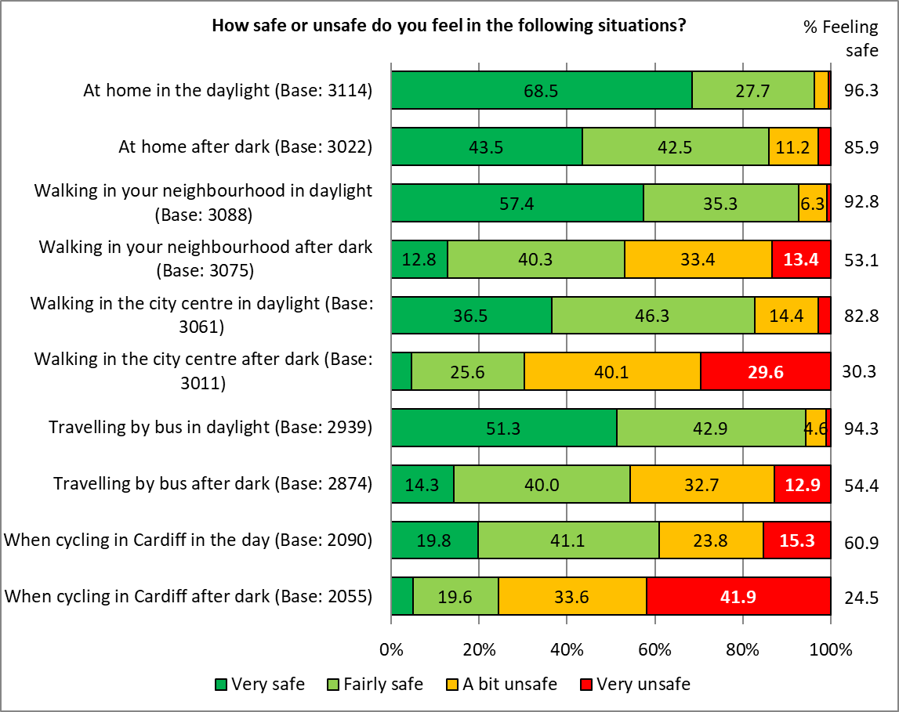Base sizes shown in brackets; excludes ‘Don’t Know’ responses
Respondents felt a little safer when travelling by bus, both in the daylight and after dark, and when cycling in Cardiff after dark compared with the findings of the 2021 Ask Cardiff survey. They felt less safe when walking in the city centre in daylight and when cycling in the city during the day.
% Feeling Safe | 2022 | 2021 | Difference
At home in the daylight | 96.3 | 96.1 | 0.2
At home after dark | 85.9 | 85.6 | 0.3
Walking in your neighbourhood in daylight | 92.8 | 92.8 | 0.0
Walking in your neighbourhood after dark | 53.1 | 53.7 | -0.6
Walking in the city centre in daylight | 82.8 | 84.0 | -1.2
Walking in the city centre after dark | 30.3 | 29.7 | 0.6
Travelling by bus in daylight | 94.3 | 91.7 | 2.6
Travelling by bus after dark | 54.4 | 52.0 | 2.4
When cycling in Cardiff in the day | 60.9 | 61.9 | -1.0
When cycling in Cardiff after dark | 24.5 | 23.3 | 1.2

As seen in previous surveys, women felt less safe than men in all situations, with the difference widening after dark.
Younger respondents felt less safe than their older counterparts, particularly after dark, when at home, or when walking in their local neighbourhood; they felt safer when cycling regardless of the time.
% Feeling Safe | At home |  |  | Walking in your neighbourhood |  |  | Walking in the city centre |  |  | Travelling by bus |  |  | When cycling in Cardiff
 | Daylight | After Dark | Daylight |  | After Dark | Daylight |  | After Dark | Daylight |  | After Dark | Daylight |  | After Dark
Overall | 96.3 | 85.9 | 92.8 |  | 53.1 | 82.8 |  | 30.3 | 94.3 |  | 54.4 | 60.9 |  | 24.5
Under 35 | 96.3 | 81.8 | 89.3 |  | 44.8 | 84.0 |  | 31.0 | 93.0 |  | 55.1 | 67.8 |  | 27.0
55+ | 96.7 | 89.8 | 94.7 |  | 59.9 | 85.0 |  | 32.3 | 95.9 |  | 58.0 | 60.0 |  | 24.0
Female | 96.4 | 85.1 | 92.7 |  | 45.0 | 83.3 |  | 24.4 | 94.6 |  | 47.9 | 60.4 |  | 18.3
Male | 96.6 | 89.8 | 94.4 |  | 69.0 | 83.9 |  | 42.1 | 94.9 |  | 68.2 | 67.1 |  | 34.0
ME | 97.9 | 86.1 | 91.0 |  | 56.2 | 91.6 |  | 31.3 | 97.8 |  | 67.7 | 72.8 |  | 32.4
Southern Arc | 95.3 | 82.4 | 89.8 |  | 41.3 | 84.6 |  | 32.2 | 92.8 |  | 55.7 | 63.9 |  | 27.9
Disability | 90.4 | 76.2 | 86.6 |  | 40.7 | 73.4 |  | 46.8 | 90.1 |  | 41.4 | 49.8 |  | 20.9
Welsh speaker | 96.9 | 86.0 | 95.4 |  | 57.5 | 84.5 |  | 31.8 | 94.5 |  | 58.2 | 59.5 |  | 25.5
Children in household | 96.5 | 85.0 | 92.2 |  | 50.2 | 81.1 |  | 35.3 | 93.3 |  | 53.6 | 64.8 |  | 24.0
LGBT | 96.3 | 83.4 | 88.4 |  | 50.4 | 83.6 |  | 31.1 | 92.9 |  | 57.6 | 59.8 |  | 28.7

Those living in the more deprived areas of the city felt less safe than those in the least deprived areas when:
- at home, both during the day and particularly after dark
- walking in their neighbourhood, both during the day and particularly after dark (the proportion of respondents feeling safe walking in their neighbourhood after dark fell from 73.3% amongst those living in the least deprived areas to 28.7% in the most deprived areas)
% Feeling Safe | At home |  | Walking in your neighbourhood |  |  | Walking in the city centre |  |  | Travelling by bus |  | When cycling in Cardiff
 | Daylight | After Dark | Daylight | After Dark | Daylight |  | After Dark | Daylight |  | After Dark | Daylight | After Dark
Most Deprived | 91.6 | 67.7 | 83.9 | 28.7 | 80.0 |  | 39.1 | 92.9 |  | 54.0 | 59.9 | 19.8
Next Most Deprived | 95.7 | 84.5 | 90.1 | 40.9 | 85.3 |  | 30.7 | 94.1 |  | 57.9 | 60.9 | 28.4
Middle | 95.8 | 86.6 | 93.2 | 51.2 | 82.4 |  | 35.0 | 94.2 |  | 53.4 | 69.8 | 27.2
Next Least Deprived | 97.5 | 90.9 | 95.9 | 61.1 | 82.2 |  | 32.6 | 94.5 |  | 58.6 | 61.7 | 27.1
Least Deprived | 98.4 | 94.4 | 97.4 | 73.3 | 87.0 |  | 30.0 | 95.3 |  | 58.6 | 59.7 | 22.4
Overall | 96.3 | 85.9 | 92.8 | 53.1 | 82.8 |  | 30.3 | 94.3 |  | 54.4 | 60.9 | 24.5

Trend data shows levels of safety in these situations are largely unchanged since 2019. Trend data by situation is available in Appendix N.
Respondents who felt unsafe in these situations were asked to explain why they felt this way; responses for each situation were grouped into themes, with the top three reasons shown below, with full lists of themes provided in Appendix O.
Walking in your neighbourhood |  |  |  | Walking in the city centre
Anti-social behaviour | 19.3% |  |  | Homeless / Beggars | 36.4%
Disruptive / Intimidating Youths | 18.3% |  |  | Drunk / Disorderly | 34.8%
Drug use / Dealing | 17.1% |  |  | Drug use / Dealing | 23.5%
Travelling by bus |  |  |  | Cycling
Anti-social behaviour | 36.1% |  |  | Too many cars / Dangerous driving | 50.1%
Poor lighting / Travelling in the dark | 15.6% |  |  | Poor Cycling Infrastructure | 35.7%
Members of the public | 12.4% |  |  | Safety concerns | 23.2%
Respondents who reported feeling unsafe in any of the above situations were also asked what would make them feel safer. Again, responses were grouped into themes, with the top three for each scenario shown below, and a full breakdown for each available in Appendix P.
When at Home
Theme | No. | % | Example Comments
More / better resourced police | 166 | 48.1 | - Better police presence  - More police on beat  - double or even triple the police and get bobbies on the beat  - More proactive and very visible policing  - Police Presence. Greater support to the local community
Take action against offenders | 52 | 15.1 | - More to be done to combat antisocial behaviour and drug use. Many consider it useless to complain to the police as the likelihood of them taking action is so small  - Police to do regular patrols and actually take action  - More police/ actions taken when reported
Security e.g. gated lanes, CCTV, Neighbourhood watch, alarms, cold calling restrictions | 51 | 14.8 | - Have cctv  - Free security checks and subsidised security things i.e. window locks door cams etc.  - Take the principle of ring doorbell cameras and put them on bus stops. They're happy to put tracker cameras in the advertisements on bus stops to see their popularity but won't do it for safety. Arrests from damages would increase and public costs decrease overall. Plus I'd feel safer with my family being near them. Probably a lot more assaults would be caught too.

When Walking in my Neighbourhood
Theme | No. | % | Example Comments
More / better resourced police | 604 | 52.2 | - Police on the beat and responding to calls  - More police presence in the streets, police actually coming out when they take cares of anti-social behaviours.  - Police Presence. Greater support to the local community  - Police need to be visible. Only seen ONE PC "walking" in the area in last 2 years or so.  - Have a police service. Regular beats, have a presence and don't hide in the few stations we have now the other side of the City.  - More police presence and more action from police when there are incidents
Better street lighting | 252 | 21.8 | - Better Street lighting  - Brighter streetlights  - Lighting when it's dark especially near entrances to parks  - Better lighting, these energy saving/environmentally friendly bulbs are not very bright  - Fix street lights.
Take action against offenders | 158 | 13.7 | - Proper sentencing in the courts.  - Random knife searches, workshops for youths on knife crime, police patrols  - Arrest men who harass women  - Tackling anti-social behaviour  - More police, lock up the dealers and offenders.

When Walking in the City Centre
Theme | No. | % | Example Comments
More Police / PCSO / Community Wardens Presence | 887 | 60.0 | - More police presence  - Police presence, other enforcement. Tackle social issues at root cause more widely.  - Enforce the law. Have police out and about with zero tolerance. Don't sit in police vehicles and watch illegal activities.  - Please have police or PCSOs on St Mary Street - it is horrible at all times of the day. I see people taking drugs in broad daylight and last week a man was running up to people threatening them. Is this what you want visitors to Cardiff to see as they get off the train?  - Basically more police!
Greater Support for Homeless People / Outreach Services for Rough Sleepers | 363 | 24.5 | - Better provision for vulnerable people  - More support for the homeless which will mean fewer homeless people  - Many of these people appear to be homeless. So more support for them  - The removal of the homeless & beggars in the streets including their tents.  - I feel very sorry for homeless people, but they shouldn't be allowed to reside on the streets. Accommodation should be provided for them.
Stop Cyclists / Scooters | 102 | 6.9 | - Stop the cyclists and scooters  - stop cyclists in pedestrian zones  - Sort out all the delivery people on bikes out. They race around on pavements I've been nearly knocked over twice. The bike lanes are a hazard they don't stop at red lights I have seen an elderly person getting knocked over its a disgrace I could go on and on.  - Stopping all wheeled transport including cycling and electric scooters in pedestrian areas including delivery cyclists

When Travelling by Bus
Theme | No. | % | Example Comments
Security Measures - Police Patrols / CCTV / Improved Lighting | 188 | 23.4 | - More cctv  - More police  - I feel sorry for the bus drivers. More cameras?  - Emergency buttons on bus stops to trigger a camera and assistance if someone feels unsafe  - Enforce the laws in place to keep people safe.
Improved Bus Service - Reliability / Frequency / Bus Shelters / Routes | 106 | 13.2 | - Better, reliable service and a proper bus station would help  - Sufficient buses available that are also reliable. I hate standing at a bus stop whether in the dark or daylight, being informed by the screen that my bus is due - and then it doesn't arrive with no explanation, and I have an additional wait.  - Give me a regular, 20 min service  - Bus Stops too far from my house  - provide much improved bus services in local area
More Staff / Bus Conductor | 94 | 11.7 | - Bring back conductors!  - Bus bouncer.  - have extra staff on the bus at night  - More staff on the buses, more police presence.

When Cycling
Theme | No. | % | Example comments
Improved Cycling Infrastructure - Cycle Lanes / Paths / Tracks / Routes / Barriers / Lighting / Storage | 625 | 57.2 | - More separate cycle lanes  - Offer secure bike parking around the city.  - More cycle lanes that link together  - Cycle lanes that are respected by motorists or barriers on lanes  - Separate well-lit cycle paths segregated between those who cycle at high speeds and those who amble.  - Full dedicated cycle lanes across the city. NOT just in the city centre!!!
Enforcement / Policing | 176 | 16.1 | - Enforce parking restrictions and get the police to do their job  - Enforce highway code.  - More cycle lanes and enforce the recent Highway Code changes.  - more enforcement against antisocial parking and speeding vehicles  - Stricter controls on electric bikes and scooters
Driver Education / Guidance | 67 | 6.1 | - Better driver education  - Educate car drivers  - Significant improvement in driver behaviour.  - Educating car / bus Drivers  - more respectful drivers

Section 6:

Environment

32. To what extent do you agree with the following statements?
Two-fifths of respondents rated air quality in Cardiff as good (39.6%), a slight increase from 2021 but lower than in 2020 (when lockdowns during the pandemic restricted the use of vehicles).
Base sizes shown in brackets; excludes ‘Don’t Know’ responses

Welsh speakers were least likely to rate air quality in Cardiff as good (34.3%).
Base sizes shown in brackets; excludes ‘Don’t Know’ responses
There was no clear correlation between rating of air quality in the city and the level of deprivation.

Just over a quarter of respondents (28.7%) agreed that Cardiff has a clean environment, reflecting the findings of the 2021 survey. The proportion disagreeing fell slightly to 45.8%.
Base sizes shown in brackets; excludes ‘Don’t Know’ responses

Younger respondents and those from a minority ethnicity were most likely to agree that ‘Cardiff has a clean environment’ (38.2% and 38.1% respectively). Those living in the Southern Arc were least likely to agree (25.5%).
Base sizes shown in brackets; excludes ‘Don’t Know’ responses. Caution should be taken with small base sizes

Respondents living in the least deprived areas were most likely to agree with the statement (37.1%).
Base sizes shown in brackets; excludes ‘Don’t Know’ responses.

33. Over the last 12 months, would you say the cleanliness in your local area has:
Two fifths of respondents (39.8%) reported the cleanliness in their local area had declined over the last year, compared with just 3.4% who felt it had improved, reflecting the findings of the 2021 survey.
Base sizes shown in brackets; excludes ‘Don’t Know’ responses

The proportion of those stating cleanliness in their local area had declined ranged from 29.3% of those aged under 35 to 45.2% of respondents living in the Southern Arc.
Base sizes shown in brackets; excludes ‘Don’t Know’ responses
There was a clear correlation between level of deprivation and the proportion of respondents reporting a decline in the cleanliness, with more than half of those in the most deprived areas reporting a decline in cleanliness compared with 30.4% of those in the least deprived areas.
Base sizes shown in brackets; excludes ‘Don’t Know’ responses
33. How concerned are you about Climate Emergency?
The majority of respondents (84.1%) expressed concern about Climate Emergency, reflecting the findings of previous surveys.
Levels of concern ranged from 90.3% amongst females to 76.8% amongst men.
Base sizes shown in brackets; excludes ‘Don’t Know’ responses

There was no correlation with level of deprivation.

34. Do you feel the Council is doing enough to respond to the challenge of Climate Emergency?
Looking at all responses, around two in five (42.6%) were unsure if the Council was doing enough to respond to the challenges of Climate Emergency. When excluding those answering, ‘Don’t know’, around two-thirds (67.8%) felt the Council was not doing enough to respond to the Climate Emergency.
Base sizes shown in brackets
Perhaps reflecting the pattern of concern about the Climate Emergency, women were least likely to feel the Council was doing enough, contrasting with men (27.3% compared with 38.3% respectively).
Base sizes shown in brackets; excludes ‘Don’t Know’ responses
There was no correlation with level of deprivation.

Section 9:

Budget Priorities

35. The Council is facing a budget gap of £21.3 million next year and £80.9 million over the medium term. Each year the Council must set a balanced budget that reflects the priorities of residents and ensures statutory services can continue to be provided within the limited resources available.
Respondents were given a list of services provided by the Council, and asked to prioritise the Council’s available resources both for the next financial year, and in the longer term.
Scores were generated based on the number of votes for first place, second place and so on, giving each service a total score out of 12 – the higher the score, the more important the service.

Priorities for 2023/24
Schools and Education, including Youth Services, was seen as the most important service, with a score of 9.5 out of 12. Over a third of respondents (34.8%) ranked this as their most important priority, with three-fifths (61.4%) putting this in their top three priorities.
This was followed by supporting vulnerable children and families (scoring 9.2, with 18.5% placing this as their most important priority) and supporting vulnerable adults and older people (scoring 8.7, with 8.9% of first place votes).
These findings reflect the priorities highlighted in the 2021 Ask Cardiff survey.
‘Culture, Venues and Events’ was seen as the lowest priority, gaining a score of 3.8, with 1.3% of first place votes.
Priorities for the Longer Term
The pattern of priorities for the longer term broadly matched those for the next financial year; ‘Delivery of the One Planet Cardiff Strategy’ and ‘Major projects including infrastructure to support businesses, local economy, city centre and local community centres’ were given a higher priority in the longer term, with a fifth of respondents ranking each in their top three priorities.

Priorities were broadly consistent across the different demographic and geographic groups analysed. A full breakdown is available in Appendix Q.

Section 10:

Family Services & Social Care

36. Have you used Cardiff Council Parenting Services in your area?
Respondents were asked if they had used Cardiff Council Parenting Services in their area; 2.2% of all respondents had done so; amongst respondents with children in their household, this rose to 6.8%
Base sizes shown in brackets

How satisfied or dissatisfied are you with Cardiff Council Parenting Services in your area?
Almost three-quarters (72.6%) of those who had used the Council’s Parenting Services described themselves as satisfied, up from 69.8% in 2021.
Caution should be taken with low base sizes

How would you prefer to access Cardiff Parenting Services?
Half (50.8%) of those using Cardiff Parenting Services would prefer to do so within their local community, with a quarter (25.4%) preferring to access the services in their own home or virtually (23.7%).
Caution should be taken with low base sizes

37. Are you aware of Cardiff Family Advice and Support Service?
Around a fifth of respondents (22.1%) were aware of the Cardiff Family Advice and Support Service.

Have you used Cardiff Family Advice and Support Service within the last 12 months?
Amongst those who were aware of the service, around one in eleven (8.9%) had used the service in the past year.

How satisfied or dissatisfied are you with Cardiff Family Advice and Support Service?
Three-quarters (75.0%) of those who had used Cardiff Family Advice & Support Service in the last 12 months were satisfied with this service compared with 19.2% who were dissatisfied.
Caution should be taken with low base sizes

38. Are you a parent of a child under 25 with additional needs?
Of those responding to this question, 6.7%, or 188 individuals, were identified as a parent of a child aged under 25 with additional needs.

Those answering ‘Yes’ were then asked the following questions:

Have you accessed support for your child?
More than half (56.0%) had accessed support.

Those accessing support were asked to give further details of the kind of support they had accessed; 79 responses were received, and categorised into themes. The top three themes are shown below, with a full breakdown available in Appendix R:
Theme | No. | % | Example Comments
School services / SEN | 24 | 30.4 | - School services  - additional school support - SEN dept  - Through school
Statemented | 15 | 19.0 | - Statement of educational needs.  - Statement for school  - Statement & SLT
Neurodivergent support | 10 | 12.7 | - Autism support  - Autism Protect animation in chapter. In the past - medical diagnosis at St David’s hospital  - ADHD assessment
Respondents could select multiple options so the total will exceed 100%

How satisfied or dissatisfied are you with the services you received?
Almost two-thirds (63.4%) of those accessing support were satisfied with the services they had received, with three in ten (29.7%) stating they were dissatisfied.
Caution should be taken with low base sizes

Please tell us why you have not accessed support
Those who had not accessed support for their child were asked why; 57 responses were received, and grouped into the following themes:
Theme | No. | % | Example Comments
Unaware of support available | 17 | 29.8 | - Not sure what is available  - Not heard about it  - Didn't know there was any
Previous request denied / awaiting add support | 12 | 21.1 | - No, none never seems available or we do not qualify  - Because the school is taking months and months to help me gain support.
Support I need not available | 11 | 19.3 | - No provision for able children who have additional needs such as Tourettes and mental health issues.  - my son will not get any help unless he has a 'label' put on him
Support not needed | 9 | 15.8 | - Not required  - Received everything we needed
Misc. | 11 | 19.3 | - He does not want to engage in CAMHS  - Been told nothing wrong by doctor  - Under assessment for support at moment

Are you aware of the Disability Index?
Respondents with a child aged under 25 with additional needs were asked if they were aware of the Disability Index – three in ten (29.6%) said they were.

39. Has anyone in your household accessed social care from the Council?
Amongst those responding to this question, 7.3% reported that someone in their household had accessed social care from the Council; 5.5% of these had accessed care for an adult, and 1.8% for a child, reflecting the results of previous Ask Cardiff surveys.

Respondents could select multiple options so the total will exceed 100%

How satisfied were they with the service they received?
Just over half of the adults who had accessed social care were satisfied with this service (51.7%, down from 71.2% in 2021); 49.0% of those accessing this service for a child were satisfied, up from 42.9% in 2021.
Base sizes shown in brackets; excludes ‘Don’t Know’ responses. Caution should be taken with low base sizes

Cardiff is committed to becoming more age-friendly, and joined the World Health Organisation’s Global Network for Age Friendly Cities and Communities in March 2022. This aims to make the city a better place for older people to live and thrive in.

40. Please rank the following to tell us what to prioritise to make Cardiff a more Age-Friendly City
Respondents were given a list of services and asked to prioritise them in order of importance. Points were awarded according to the ranking to give an overall score out of ten.
‘Support for older people to live independently in their own home’ was rated as most important amongst those aged 55 or over with a score of 8.5. ‘Access to health care’ was also awarded a score of 8.5 by older respondents, slightly higher than the score of 8.4 from all respondents, who ranked this as the most important service.
‘Work/volunteer opportunities beyond retirement age’ was ranked least important by all respondents and those aged 55 or older.
 | All respondents | 55+
Base | 2361 | 1195
Support for older people to live independently in their own home | 8.2 | 8.5
Access to health care | 8.4 | 8.5
Access to suitable housing | 7.5 | 7.5
Access to transport | 6.7 | 6.9
Community-based services, close to home | 5.6 | 5.6
Access to culture, events and social groups | 5.1 | 5.0
Improved access to information | 4.6 | 4.5
Opportunities to have your say on how public services should be run | 4.3 | 4.5
Work/volunteer opportunities beyond retirement age | 3.7 | 3.6
Something else | 1.8 | 1.9

Respondents were invited to suggest other things that would help to make Cardiff an Age-Friendly City; 851 comments were received and grouped into themes. The top three are shown below, with a full list available in Appendix S.
Theme | No. | % | Example Comments
Public transport | 147 | 17.3 | - Better public transport, Cardiff Bus isn't working and needs a serious amount of investment to increase services at difficult times.  - Better bus information about changes stops  - Better public transport.  - getting public transport sorted, it's a mess, specially the city centre  - Improved local sustainable transport  - Bus services that ran more than once every 90 minutes
Social care | 64 | 7.5 | - Better social care provision  - Home visits to be sure they are safe, warm well and fed.  - Better social care provision- it was much better when carers employed by the council rather than agencies  - More carers for private homes  - Care homes  - Integration of health and social care.
Maintain pavements | 61 | 7.2 | - Better pavements  - Make pavements more wheelchair friendly. Get the people who plan such things out pushing someone in a wheelchair to see how easy or not pavement use is.  - Pavements easy to walk on, not broken  - Need to consider impact of poor pavement and road repair causing trip and falls hazards. In addition the leaves on public highway huge risk. Last year they weren’t ever cleaned up  - Safer pavements, I’m afraid I’ll fall on them again

Section 12:

Any Other Comments

41. Do you have any other feedback for us? This could include comments about your experiences of Council services, what the Council does well, what we could do better, or what you’d like to see in the future.
Respondents were asked for any other comments they wished the Council to be made aware of; 1,266 comments were received, which have been grouped into themes. The top three themes are shown below, with a full breakdown in Appendix T.
Theme | No. | % | Example Comments
Recycling & Waste / Street Cleaning / Refuse Issues / Increase Bin Collections | 292 | 23.1 | - Every area of Cardiff is covered in litter and I do volunteer for litter picks...perhaps schools could adopt a strategy for educating young people about the hazards it causes to our wildlife and the blight to our landscape.  - More regular green bins over the winter  - Improved advice about recycling e.g. tetrapaks, aluminium foil  - Cardiff is looking a mess, rubbish etc more bins might help  - Cardiff is a dirty city the new collection for waste is a joke doesn't work
Highways / Roads /Cycle lanes/ Pavements / Walkways | 254 | 20.1 | - Please sort out the highways, they are seriously ridiculous  - The ridiculous amount of money wasted on cycle tracks that cyclists don't use  - Glad to see more cycle lanes.  - You have declared a climate emergency now we want to see action! Stop caving in to the developers and car owners and start doing what needs to be done to make Cardiff a better place to live. More cycle lanes. Better public transport.  - Yes ABOLISH. The RIDICULOUS !!!!!!!!!!! 20mph rule!😡😡😡😡😡😡😡😡 stupid, stupid stupid !!! It does NOT reduce pollution! Yes outside of schools but some roads that have been nominated are totally ridiculous and sooo random
Protection of Green Open Spaces / Leisure facilities/ Tackle Climate Change | 178 | 14.1 | - Stop destroying green spaces by putting buildings on them. Public Park and green spaces are being lost at a rapid rate. The council ignores local people and the planning process just allows the council and companies to build whatever they want. Where is the green city? All the new developments in the city centre are concrete high rise blocks. Cardiff is becoming an ugly city.  - More maintenance on all the trees planted!  - Provision of allotments for people in the current climate would be of benefit to many.  - Please stop selling off our green spaces. We need our parks for mental wellness.

Some face-to-face engagement was undertaken by officers distributing and promoting the survey in Riverside, Butetown, Adamsdown, Canton, Cardiff Bay and the City Centre. Whilst most members of the public took (or declined) hard copies of the survey, or flyers, a small number took the time to comment on issues that were important to them:
Cardiff Bay, White British Male, late 20s:
The Council are installing a cycle lane along his road in Cathays, and that means there’s nowhere to park. “I don’t know how other people are doing it, where they’re finding to park. Sometimes I have to park on the other side of the cemetery, and sometimes there isn’t anywhere to park. I’ve had fines already. I like my bike, I cycle myself, but… you can’t expect people to get rid of their cars just like that. They’re not going to. So there needs to be more provision for parking. And if you’re going to take away parking, there needs to be something to make up for that”.
Tudor Street, Riverside
A shop owner, an Asian male in his 50s, was very clear about how frustrating the neighbourhood regeneration work had been. He said his “takings have been down 40%! There’s no parking, it’s now been made one way, the work has been going on for about 18months already, and clearly won’t be finished for ages”. He said he tells the men working on the road that they have become ‘like family’, they’ve been there such a lot, and for so long. He is joking, to make a point, but he’s fed up. And he and other shop owners spoken to in the road feel that they are not listened to. At all. They’ve “had the Head of the Council come down and nothing has happened since then”. They don’t know what the vision is, for the works, and they feel very angry that they’re being asked to pay Tax when there is still no opportunity for them to make their normal takings.
A Middle Eastern female, in her 40s, working in a shop on Tudor Street highlighted issues with anti-social behaviour in the area - the amount of drug dealing, alcohol and drug use and related behaviour that they have to deal with on a daily basis is substantial, and horrible. “You have to pretend you are deaf, and you have to build thick skin, with the things you hear. People are shooting up, in broad daylight, right out there (gesturing the pavement directly outside the shop). People steal from the town centre, sell things, and then come into the shop, and boast about how much money they’ve got from begging, or selling something they’ve stolen, and how much money they’ve spent on crack: ‘I spent £200 on crack two days ago, and its all gone!’. And then they ask for a lower price (…), or for things for free, because they haven’t got any money!”
Cowbridge Road East, Riverside
Staff and customers in a charity shop, all retired, wanted to see the local Councillor, or someone from the Council, come out to the area, on a regular basis, so they could hear and see the problems for themselves, “that would be much appreciated”. They said that the Council are just too difficult to get hold of – “It’s so big! Who do you talk to?! If you go to the Hub, that’s just for help filling in forms, it’s not to raise your concerns about [anti-social] behaviour.”

A gentleman in his 60s felt there was little point in completing the survey or spending time chatting: “it’s not worth telling the Council because the problems have already been raised many many times”.

Section 13:

About You

What is your home postcode?
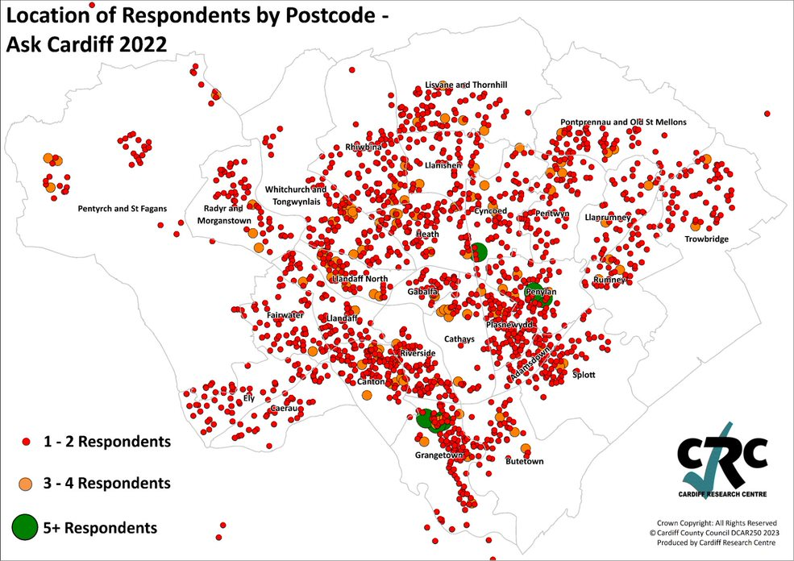
What was your age on your last birthday?
 | No. | % |  | % | Ask Cardiff 2022 | 2021 Mid-Year Estimate
Under 16 | 7 | 0.3 |  | 16-34 | 15.8 | 38.6
16-24 | 43 | 1.6 |  | 35-54 | 34.5 | 30.2
25-34 | 283 | 10.2 |  | 55+ | 49.7 | 31.2
35-44 | 464 | 16.8
45-54 | 501 | 18.1
55-64 | 620 | 22.4
65-74 | 544 | 19.6
75+ | 237 | 8.6
Prefer not to say | 71 | 2.6
 | 2770 | 100.0

Note: Figures comparing against the Mid-Year estimates excludes ‘Prefer not to say’ and under 16s
Are you…?
 | No. | % | 2021 Mid-Year Estimate
Female | 1534 | 55.5 | 51.6
Male | 1116 | 40.4 | 48.4
Non-binary | 9 | 0.3 | -
Other | 6 | 0.2 | -
Prefer not to say | 100 | 3.6 | -
 | 2765 | 100.0 | 100.0

Do you identify as Trans?
 | No. | %
Yes | 30 | 1.1
No | 2533 | 93.8
Prefer to self-describe | 11 | 0.4
Prefer not to say | 126 | 4.7
 | 2700 | 100.0

Do any children live in your household?
 | No. | %
No children | 2021 | 74.3
Yes, under 5 years old (pre-school) | 202 | 7.4
Yes, aged 5 - 11 (primary school) | 306 | 11.3
Yes, aged 11 - 16 (secondary school) | 260 | 9.6
Yes, aged 16 - 18 in full-time education, or working | 144 | 5.3
Yes, aged 16 - 18 but not in full time education or working | 21 | 0.8
 | 2720 | -
Respondents could select multiple options so the total will exceed 100%

Are you pregnant, or have you given birth within the last 26 weeks?
 | No. | %
Yes, I’m pregnant | 26 | 1.0
Yes, I’ve given birth | 17 | 0.6
No | 2591 | 96.2
Prefer not to say | 59 | 2.2
Not specified | 26 | 1.0
 | 2693 | 100.0

Do you care unpaid, for a friend or family member who due to illness, disability, a mental health problem or an addiction cannot cope without your support?
 | No. | %
Yes | 532 | 19.6
No | 2069 | 76.3
Prefer not to say | 112 | 4.1
Total | 2713 | 100.0

Which of the following best describes what you are doing at present?
 | No. | %
Working full-time (30+ hours per week) | 1219 | 44.2
Working part-time (less than 30 hours per week) | 352 | 12.8
On a government training scheme | 1 | 0.0
In full time education | 38 | 1.4
Unemployed - Registered Job Seeker | 22 | 0.8
On a zero-hour contract | 17 | 0.6
Permanently sick or disabled person | 92 | 3.3
Wholly retired from work | 766 | 27.8
Looking after home | 20 | 0.7
Caring for a child or adult | 79 | 2.9
Unemployed - Unregistered but seeking work | 31 | 1.1
Other | 120 | 4.4
 | 2757 | 100.0

Which of the following best describes your housing tenure?
 | No. | %
Owned outright | 1267 | 46.1
Owned with a mortgage | 945 | 34.4
Rented from Local Authority | 81 | 2.9
Rented from a Housing Association | 102 | 3.7
Private rented | 269 | 9.8
Other | 82 | 3.0
 | 2746 | 100.0

Are you or a member of your household:
 | You |  | A member of your household
 | No. | % | No. | %
Currently serving | 15 | 0.6 | 23 | 0.9
An armed forces service leaver (Veteran) | 75 | 2.8 | 52 | 1.9

Do you identify as a disabled person?
 | No. | %
Yes | 395 | 14.5
No | 2184 | 80.2
Prefer not to say | 143 | 5.3
Not specified | 395 | 14.5
 | 2722 | 100.0

Please tick any of the following that apply to you:
 | No. | %
Deaf/Deafened/Hard of Hearing | 249 | 9.1
Learning impairment/difficulties | 59 | 2.2
Wheelchair user | 30 | 1.1
Long-standing illness or health condition (e.g. cancer, HIV, diabetes or asthma) | 562 | 20.6
Mental health difficulties | 366 | 13.4
Visual impairment | 102 | 3.7
Mobility impairment | 334 | 12.3
Prefer not to say | 201 | 7.4
Other | 77 | 2.8
 | 2722 | -

Do you regard yourself as belonging to any particular religion?
 | No. | %
No, no religion | 1331 | 48.8
Christian (Including Church in Wales, Catholic, Protestant and all other Christian denominations) | 1109 | 40.7
Muslim | 20 | 0.7
Buddhist | 13 | 0.5
Hindu | 8 | 0.3
Jewish | 40 | 1.5
Sikh | 1 | 0.0
Other | 147 | 5.4
Prefer not to answer | 59 | 2.2
 | 2728 | 100

How would you describe your sexual orientation?
 | No. | %
Bisexual | 111 | 4.1
Gay Woman/Lesbian | 34 | 1.3
Gay Man | 84 | 3.1
Heterosexual/Straight | 2155 | 79.7
Other | 42 | 1.6
Prefer not to answer | 277 | 10.2
 | 2703 | 100.0

Are you:
 | No. | %
Single | 536 | 19.9
In a same-sex Civil Partnership | 13 | 0.5
Married | 1449 | 53.9
Living together / Cohabiting | 377 | 14.0
Separated/divorced or legally separated if formerly in a same-sex Civil Partnership | 125 | 4.7
Widowed | 113 | 4.2
Other | 74 | 2.8
 | 2687 | 100.0

How would you describe your Welsh language skills?
 | No. | %
None | 1414 | 52.1
Learner | 455 | 16.8
Basic | 559 | 20.6
Moderate | 138 | 5.1
Fluent | 149 | 5.5
 | 2715 | 100.0

Do you consider yourself to be Welsh?
 | No. | %
Yes | 1838 | 67.6
No | 880 | 32.4
 | 2718 | 100.0

What is your ethnic group?
 | No. | % | 2021 Census
White - Welsh/English/Scottish/Northern Irish/British | 2328 | 85.6 | 73.6
White - Irish | 38 | 1.4 | 0.6
White - Any other white background | 104 | 3.8 | 5.0
Asian/Asian Welsh/British - Bangladeshi | 3 | 0.1 | 2.4
Asian/Asian Welsh/British - Chinese | 8 | 0.3 | 2.4
Asian/Asian Welsh/British - Indian | 19 | 0.7 | 1.9
Asian/Asian Welsh/British – Pakistani | 10 | 0.4 | 1.4
Asian/Asian Welsh/British - Any other | 10 | 0.4 | 1.6
Black/African/Caribbean/Black Welsh/British | 24 | 0.9 | 3.8
Mixed/Multiple Ethnic Groups - White & Asian | 10 | 0.4 | 1.2
Mixed/Multiple Ethnic Groups - White and Black African | 6 | 0.2 | 0.7
Mixed/Multiple Ethnic Groups - White and Black Caribbean | 9 | 0.3 | 1.0
Mixed/Multiple Ethnic Groups - Any other | 20 | 0.7 | 1.1
Arab | 12 | 0.4 | 1.8
Any other ethnic group | 17 | 0.6 | 1.5
Prefer not to say | 101 | 3.7 | -
 | 2719 | 100.0 | 100.0

Appendix A – What services and amenities are required in your local neighbourhood to meet your needs?

Theme | No. | % | Example comments
Improve bus service | 237 | 17.4 | - Regular bus service - there is 1 bus every 30 min, which will stop in Jan 2023  - Bus service poor  - Better bus services. Need to consider needs if elderly and disabled  - The buses do not take me where I need to go.  - The bus service is absolutely atrocious - 1 x bus an hour! Apart from a very limited service on Sunday, Cardiff Bus is not available at all!  - Bus service is awful.  - Better bus service. One an hour is rubbish.
Litter / Bins / Street cleansing / Fly tipping | 197 | 14.5 | - Better street cleaning.  - Street cleaning, graffiti removal  - You never ever see street cleaners  - Lack of bins (bins overflowing all the time, need more regular collection of dog poo bins).  - As I live near CCFC stadium and big schools, there is a lack of street bins. This is one of the major causes of littering as people just throw anything. This really effects the tidiness and causes issues people with pet with broken glass and ripped cans.  - Litter picks after bin day especially after these stupid recycling sacks
Commercial space / Bank / Shops / Post office / Pub | 168 | 12.4 | - The largest supermarket Tesco, changed from metro to express to charge higher prices  - Post office  - Better local food shop, closer pubs  - local public house, a bank would be very useful  - Better quality shops instead of countless barbers and fast food outlets
Access to health services - doctors, dentists, pharmacies | 139 | 10.2 | - no appointments available with GPs for many months  - Dental surgery taking on new patients  - a local pharmacy  - Better access to doctor and NHS services  - Can never get a doctor appointment
Green Space | 138 | 10.2 | - More green space  - Far, far more trees and nature friendly greenery.  - we are losing green spaces  - More green spaces and access to nature  - Consultation for planning - proper consultation and not the presentation of a sewage pump that the council knew would happen and takes a significant chunk of another green area the council seem willing to carve up
Community facilities | 130 | 9.6 | - Library, non-denomination community centre.  - We need adequate play area a community hall, we need a good library (not the tiny thing at the hub).  - Community centre for all  - There is no Hub style building in the local neighbourhood  - no hub or pub
Sporting facilities | 123 | 9.1 | - Local leisure centre and swimming pool - remains closed  - skate park  - Youth club sports pitches for all to use not just football  - Leisure facilities  - Leisure centres are not what they were, less classes
Police/crime reduction | 118 | 8.7 | - More Police needed to tackle anti-social behaviour  - Local Police.  - Dealing with anti-social behaviour and drug issues  - Less drug dealers and asbo  - Police on the beat
Childrens amenities | 107 | 7.9 | - My children have been without a local park for 5 years! Yet Redrow can build hugely expensive homes up the road. You as a council are happy to let developers build over huge areas of green space but can’t sort out a local park - shameful you are  - Safer environments for kids to play  - More play areas for children  - There isn't a well maintained park for my children to play in.  - Something for the kids to do
Waste and recycling collections | 102 | 7.5 | - Waste collections, specifically garden waste needs to be collected throughout the winter  - Waste collection and bin size.  - You are going to do a three week bin pick we pay for it to be emptied every week  - waste should be collected on time  - A decent refuse collection where the collectors actually empty the containers and don't just throw them in the general area of where they were picked up from
Public transport | 95 | 7.0 | - Better public transport  - No public transport  - More frequent and accessible public transport  - Better public transport not just for getting into the city centre  - There is a lack of public transport from where I live to various other parts of Cardiff.
Parking concerns | 92 | 6.8 | - BAN on parking on pavements, parking wardens  - parking control  - Better parking  - The amount of pavement parking also makes it very difficult to get around on foot. I'd love to see permit parking to reduce the number of parked cars everywhere.  - Urgent review of management of street traffic - parking, obstruction etc.
Road maintenance | 81 | 6.0 | - Any maintenance on the roads would be an improvement, they are in a diabolical and pothole ridden, speed bump damaging third world state.  - Roads need repaired  - Streets are too bumpy in north Grangetown. A forgotten place.  - Good roads without potholes  - Potholes in road are growing and not maintained regularly
HWRCs | 72 | 5.3 | - The reopening of the Waungron Road recycling centre would make a huge difference to residents living in the west of the city.  - no recycling / waste disposal centres  - Recycling centre we can access on foot  - More local recycling would be a great help. Bottle banks, cardboard bins, fabric recycling, tetrapaks etc. It's a waste of fuel to travel to the centres for every little thing
Pavement maintenance | 59 | 4.3 | - Better pavements.  - pavement repairs  - repairs to footpaths require priority. not the slap dash pot hole repairs
Accessibility considerations | 56 | 4.1 | - Services for Disabled people  - No Night buses - lack of concern for people who are disabled and need to get home after 8pm  - Pavements that can be negotiated by a wheelchair for starters then I might be able to access my community.
Better transport / traffic options | 56 | 4.1 | - A decent transport system  - Adequate traffic management on "restricted "streets.  - solutions to traffic delays.
No bus service | 53 | 3.9 | - Bus service nowhere near home and I can’t walk far  - Better bus service, our bus was withdrawn  - No buses.
Youth | 48 | 3.5 | - More things for youths. Unsocial behaviour is rife  - A community centre that holds classes etc for teenagers  - Places for teenagers to go, things for them to do that don’t cost a fortune
Blocked drains / fallen leaves | 47 | 3.5 | - better pavement sweeping when the leaves come down.  - Autumn street cleaning to remove leaves from pavements & gutters to avoid risk of falls and flooding - with cleaning timed when residents are at work, so streets are clear of vehicles and gutter areas exposed.  - cleaning out the drain hole covers to stop flooding when it rains
Traffic Calming / enforcement measures | 46 | 3.4 | - Traffic management through my village – Pentyrch  - 20mph speed limit and parking constraints enforced  - you put a blanket 20mph without asking us
Educational establishment | 42 | 3.1 | - More school places and choices. Lack of high schools  - Schools are full.  - School catchment
Trains | 40 | 2.9 | - A local train station  - A train service  - A small commuter trains station
Planning / infrastructure | 39 | 2.9 | - Transport, health and schools infrastructure to cope with 7000 new houses  - We have no community facilities, no pharmacy, lack of shops. And we don't want any more building of houses.  - State of all roads in the city, particularly the centre, with traffic restrictions lasting for months - if not years. It gives the impression that the city planners - particularly the highways dept. haven't clue as to what they are supposed to be doing!!!
Cycle lanes / infrastructure | 38 | 2.8 | - Safe Cycle routes  - More and better cycle infrastructure  - Bicycle storage, bicycle racks, cycle lanes
Overgrowth | 32 | 2.4 | - Cut down overhanging trees  - Pavement weeding  - Verge and green area maintenance
Everything / Got worse | 29 | 2.1 | - East of the City nothing  - more services over the years is all gone  - I feel all the services have cut back again and again
Support for elderly / vulnerable | 27 | 2.0 | - I need access to support as an elderly person in very poor health living alone, but the council is unable to provide any support.  - Things for pensioners to do  - More sociable things for elderly people
Street lighting | 22 | 1.6 | - Better street lights  - More lighting around the park  - to feel more safe when walking at night with dogs.
Contact with council / councillors | 19 | 1.4 | - more opportunity for a say in local decisions.  - Opening hours of Council Services  - More community contact, support and interaction from elected councillors! They are a waste of public money.
Active travel / Pedestrians | 17 | 1.3 | - A pedestrian crossing is vital on Cardiff Road and fairwater road. It is dangerous.  - Foot paths - there are so few walking is dangerous.
Dog fouling | 14 | 1.0 | - Too much dogs mess, dirty messy streets  - Dog bins
Public toilets | 13 | 1.0 | - More public toilet availability  - No proper facilities at Heath Park and empty playground and no toilets or cafe facilities. Children have to wee in the bushes if caught short. Not pleasant for anyone
Social care / services | 7 | 0.5 | - May need social services in the future
Noise | 6 | 0.4 | - The noise problem after 10pm
Food banks | 3 | 0.2 | - More food banks
Misc. | 65 | 4.8 | - There are services - they are just badly run  - More money spent per pupil on Welsh-medium education.  - Allotment sites.  - street scene - prettier e.g. flower boxes planted.  - Too simplistic a question  - you increase com tax every year then waste the money, i could go on but hell what's the hell I doubted if anyone ever read this.
 | 1359
Respondents could select multiple options so the total will exceed 100%

Appendix B – Which of the following services and amenities are available within 15 minutes' walk or cycle from where you live? By Demographic

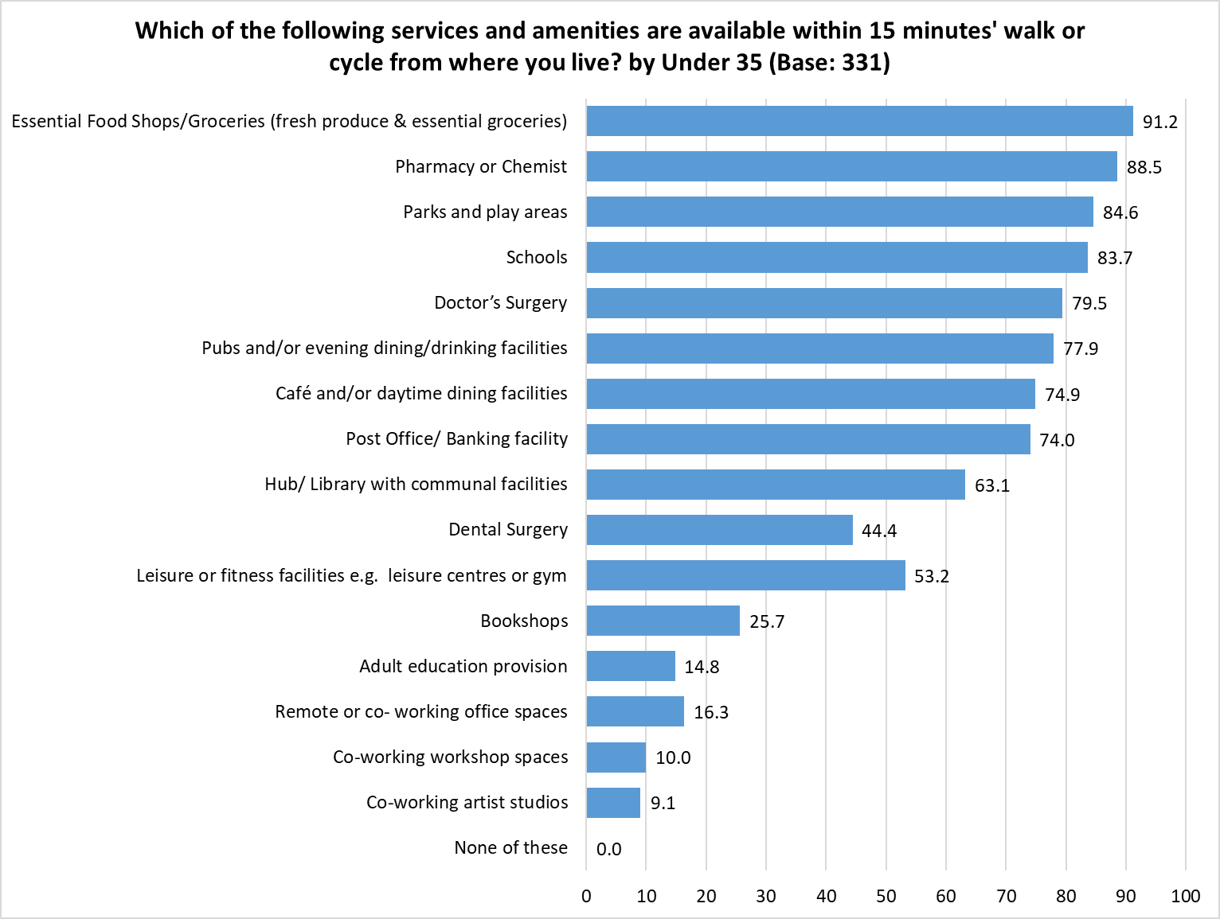 Respondents could select multiple options so the total will exceed 100%

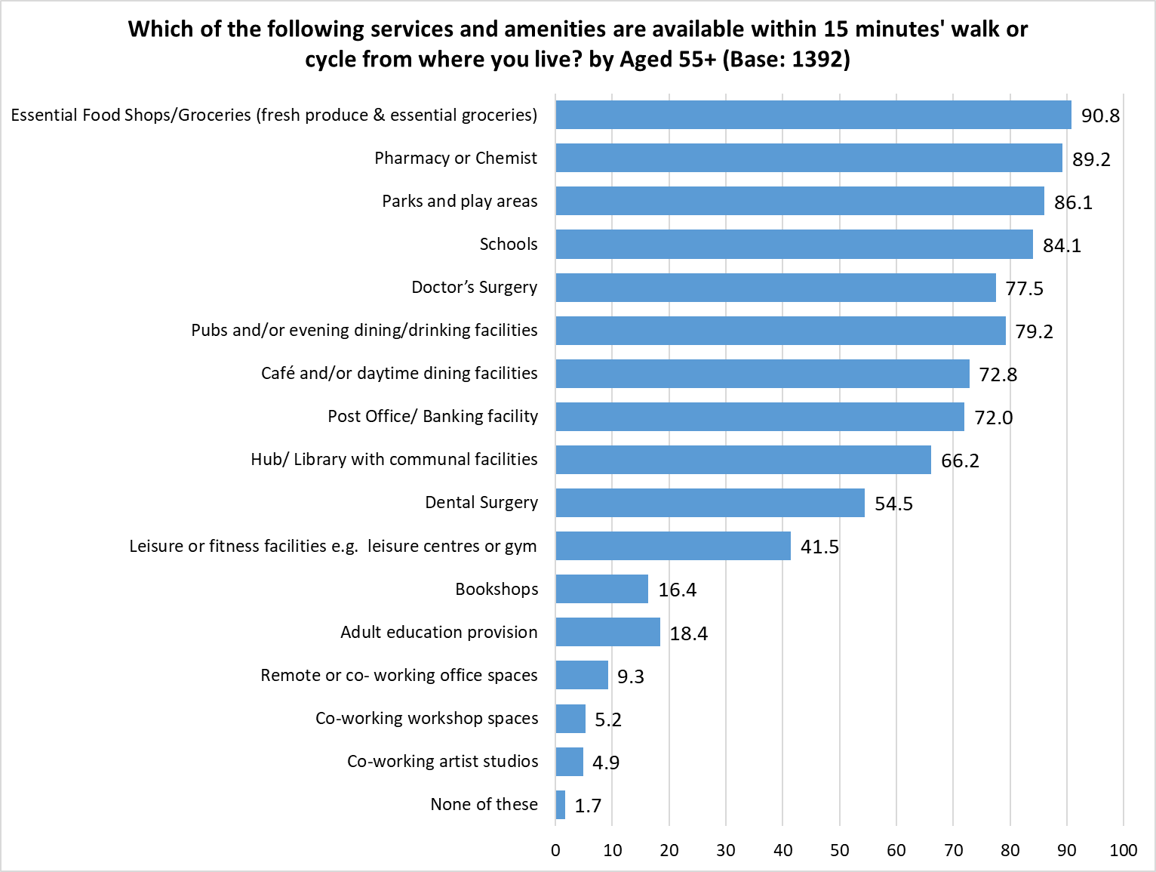 Respondents could select multiple options so the total will exceed 100%

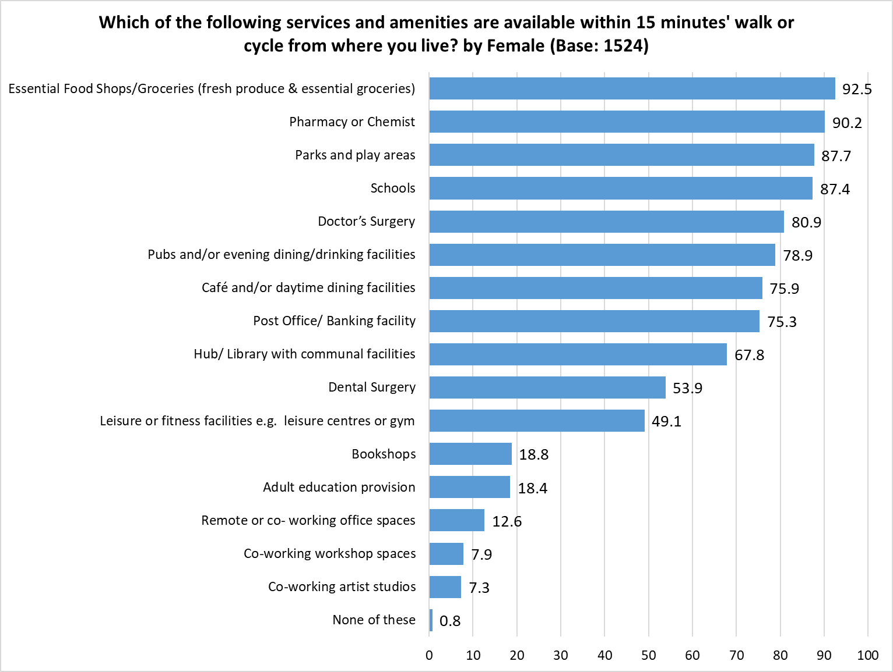 Respondents could select multiple options so the total will exceed 100%

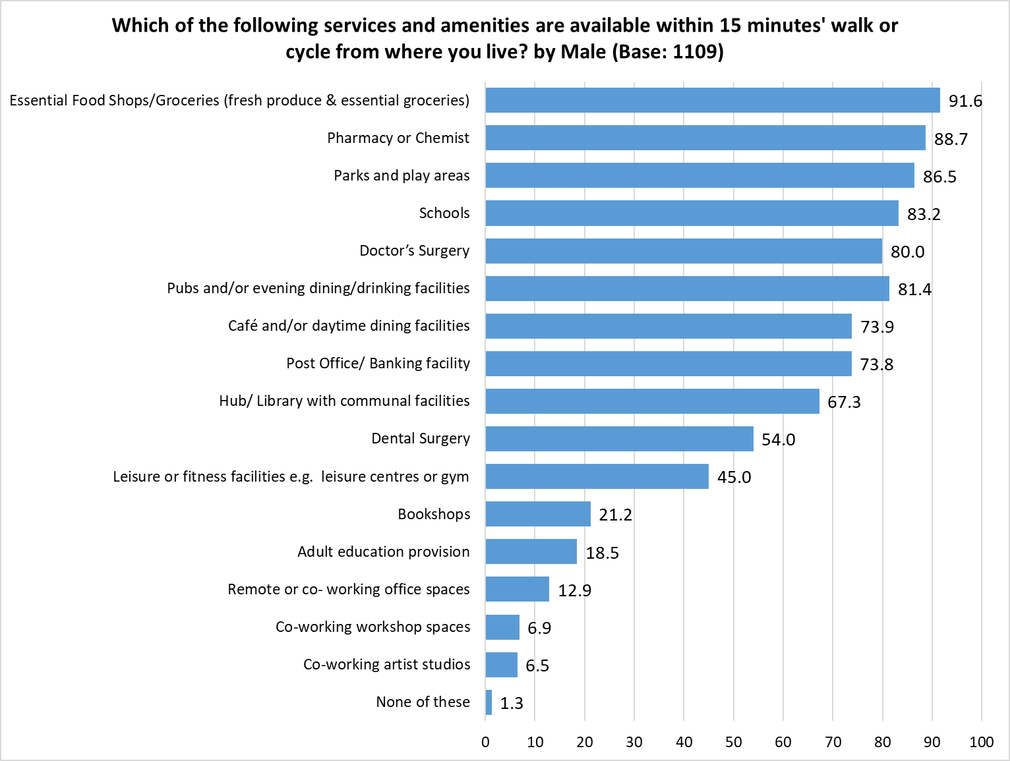 Respondents could select multiple options so the total will exceed 100%

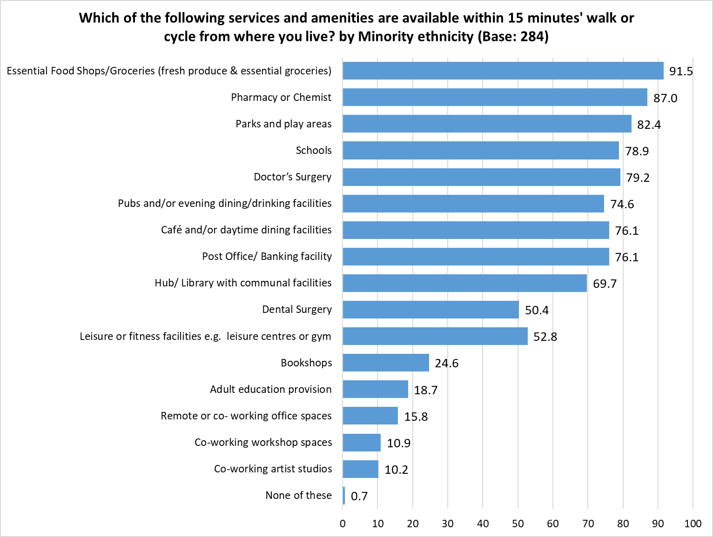 Respondents could select multiple options so the total will exceed 100%

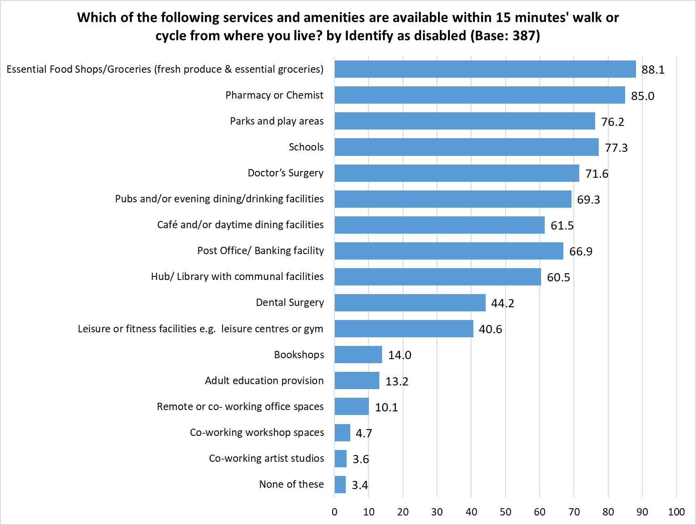 Respondents could select multiple options so the total will exceed 100%

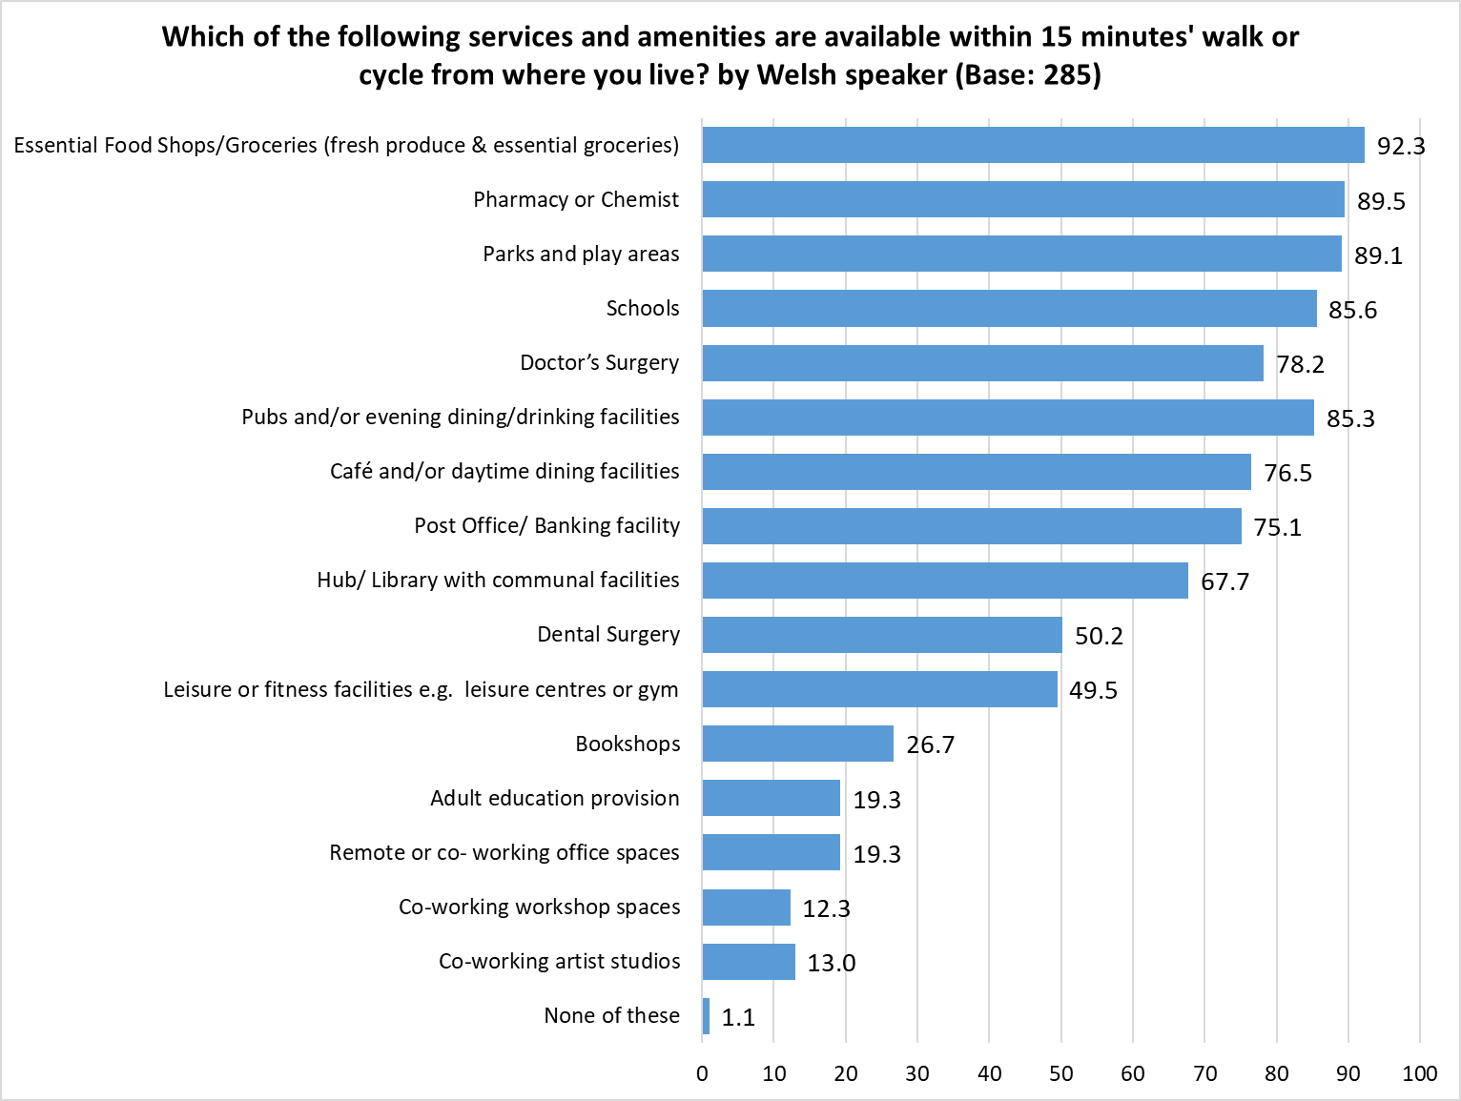 Respondents could select multiple options so the total will exceed 100%

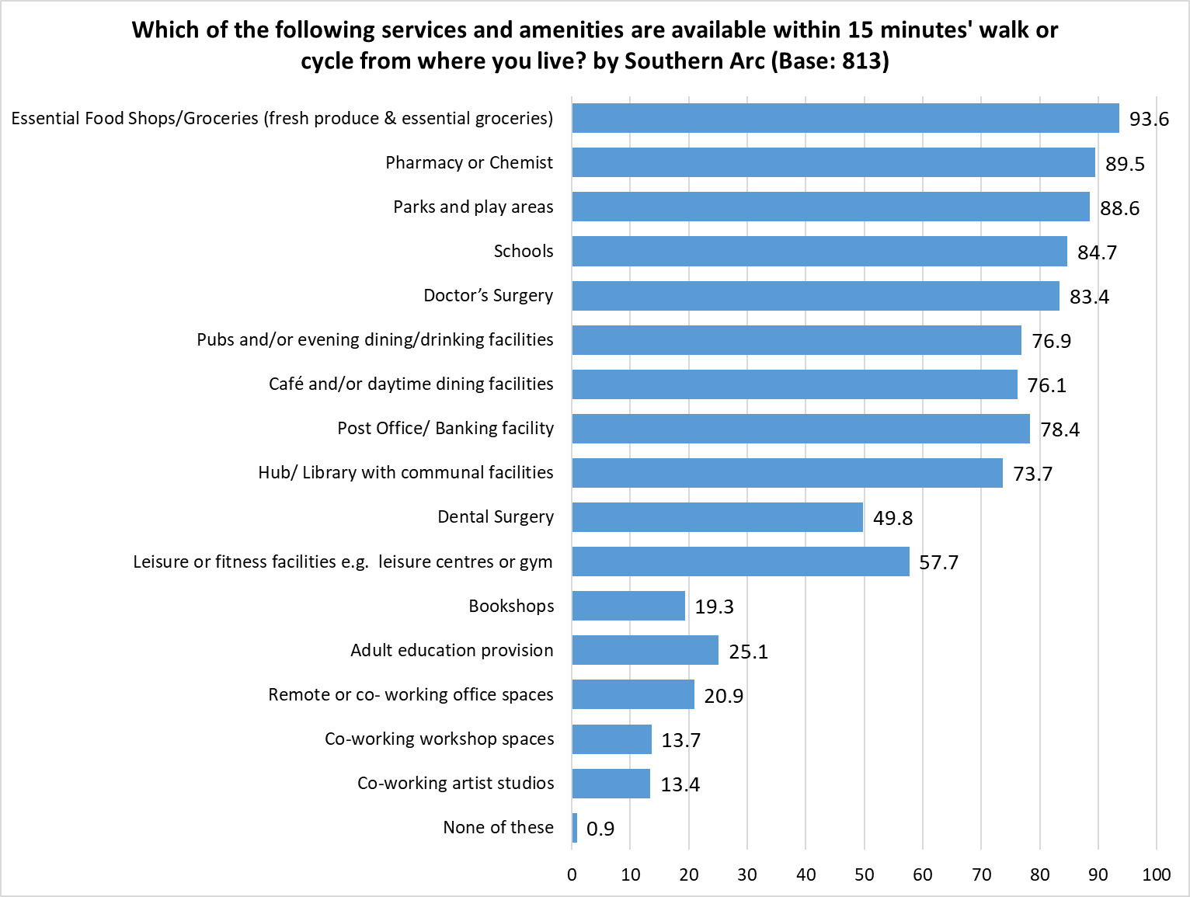 Respondents could select multiple options so the total will exceed 100%

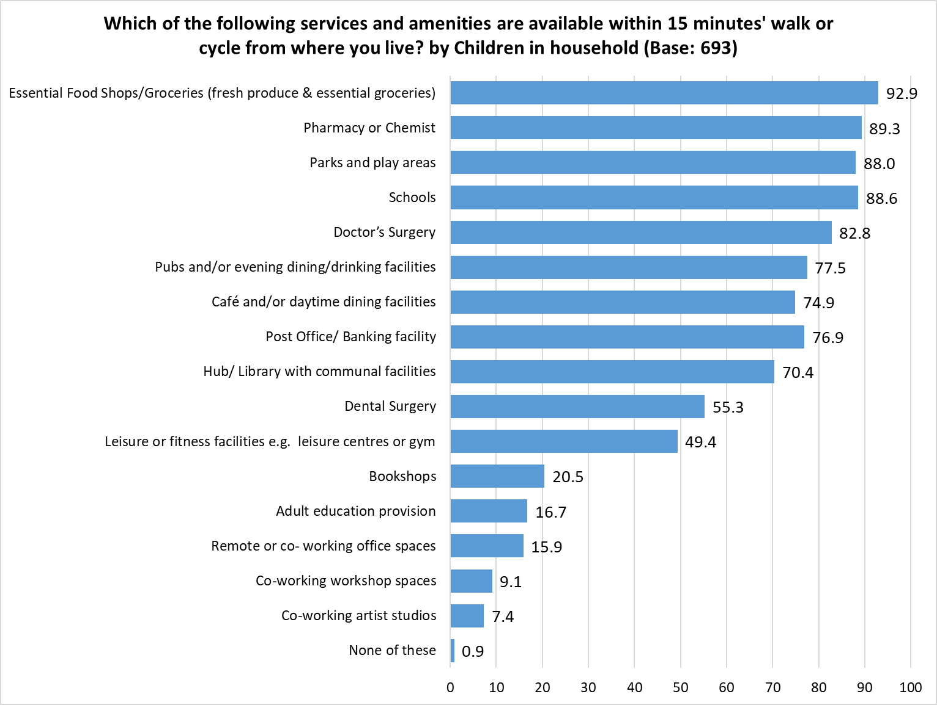 Respondents could select multiple options so the total will exceed 100%

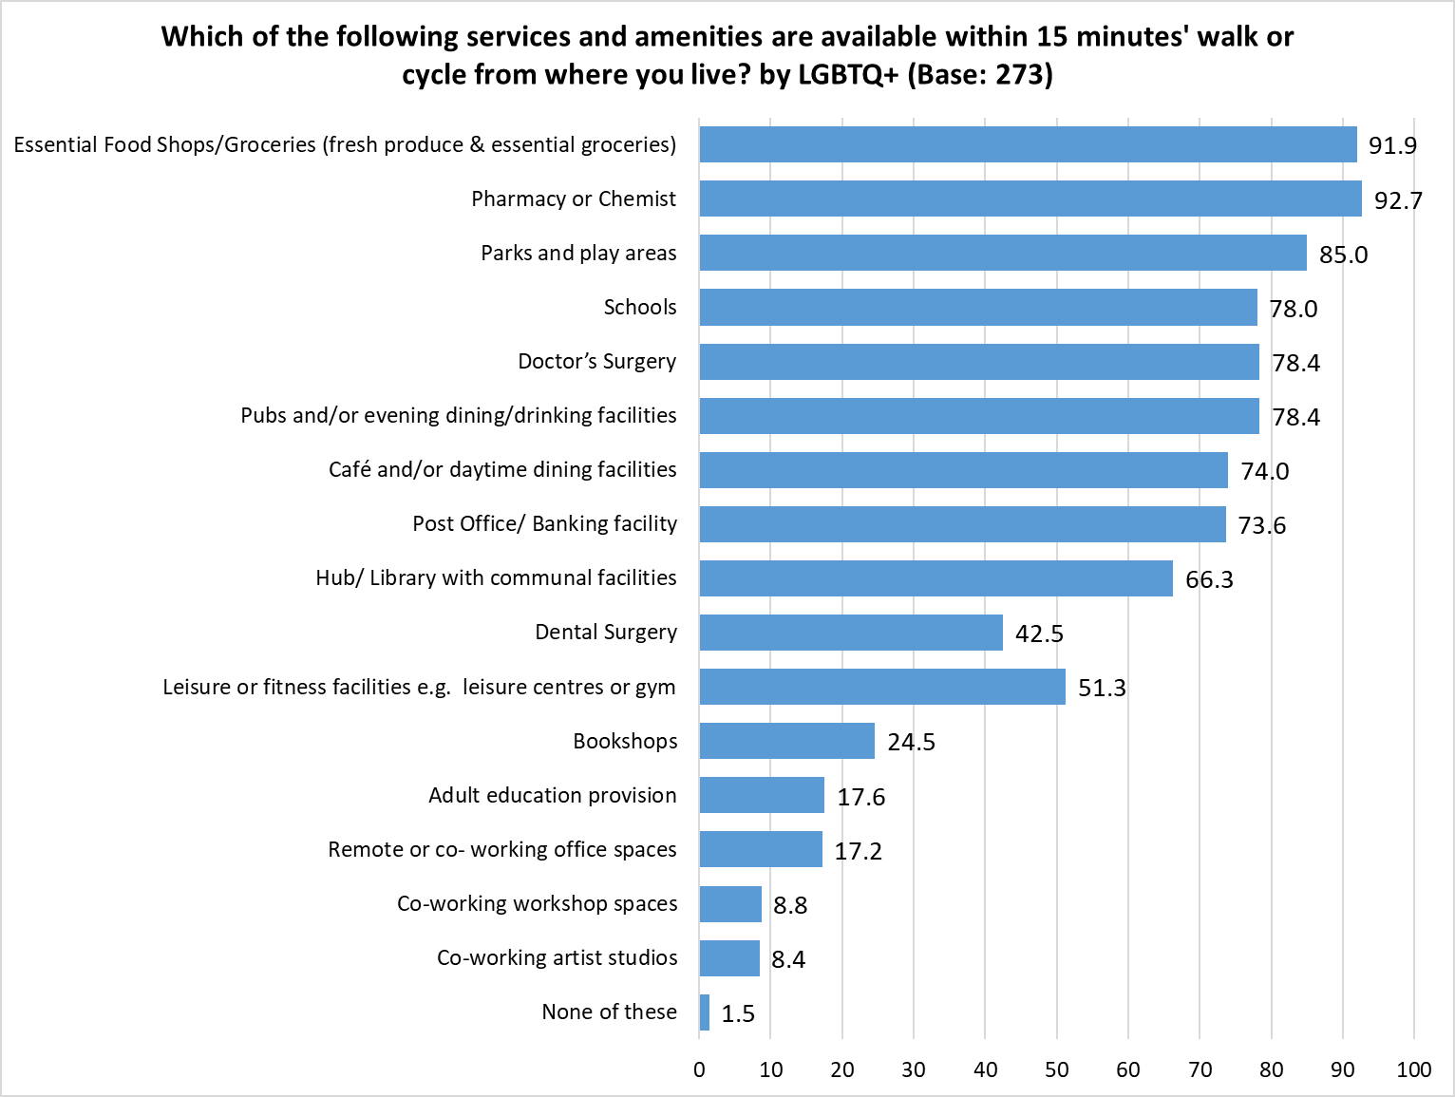 Respondents could select multiple options so the total will exceed 100%

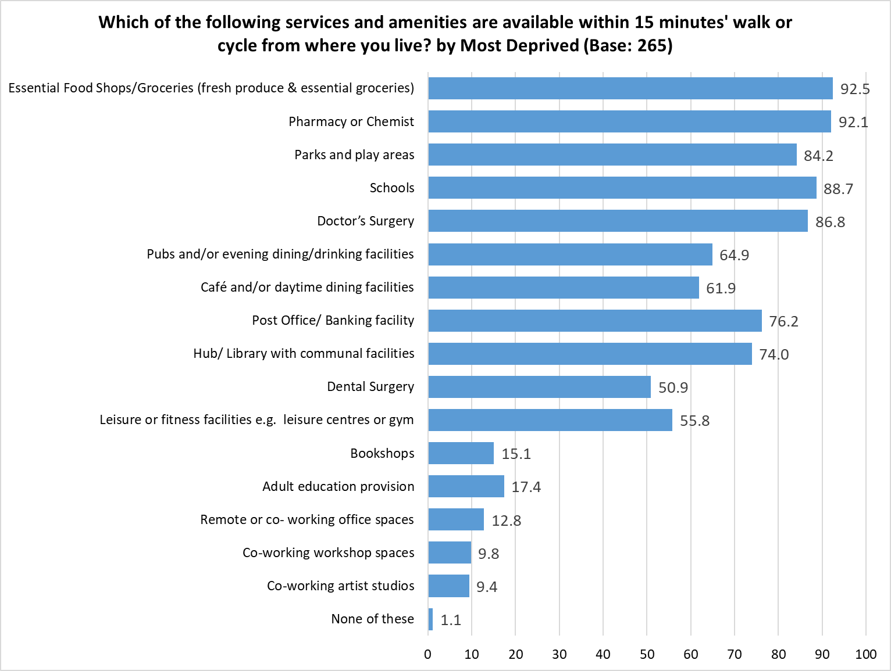 Respondents could select multiple options so the total will exceed 100%

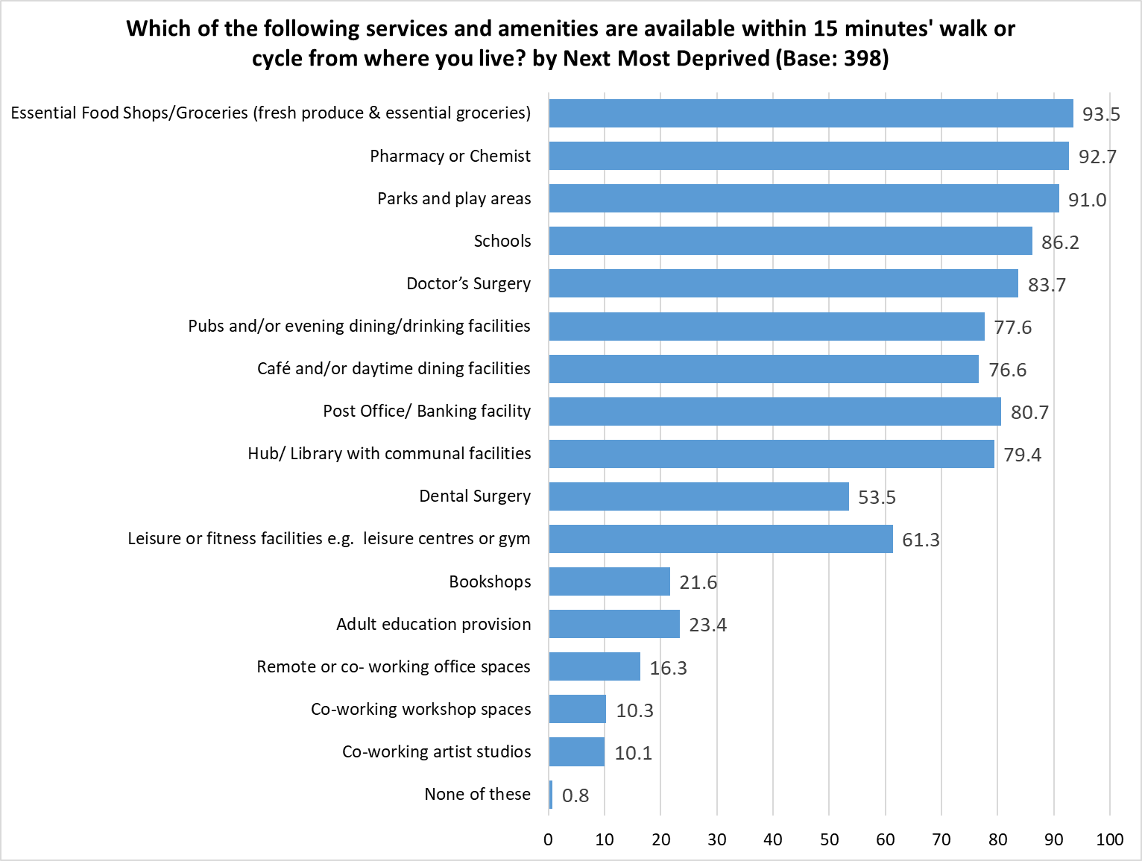 Respondents could select multiple options so the total will exceed 100%

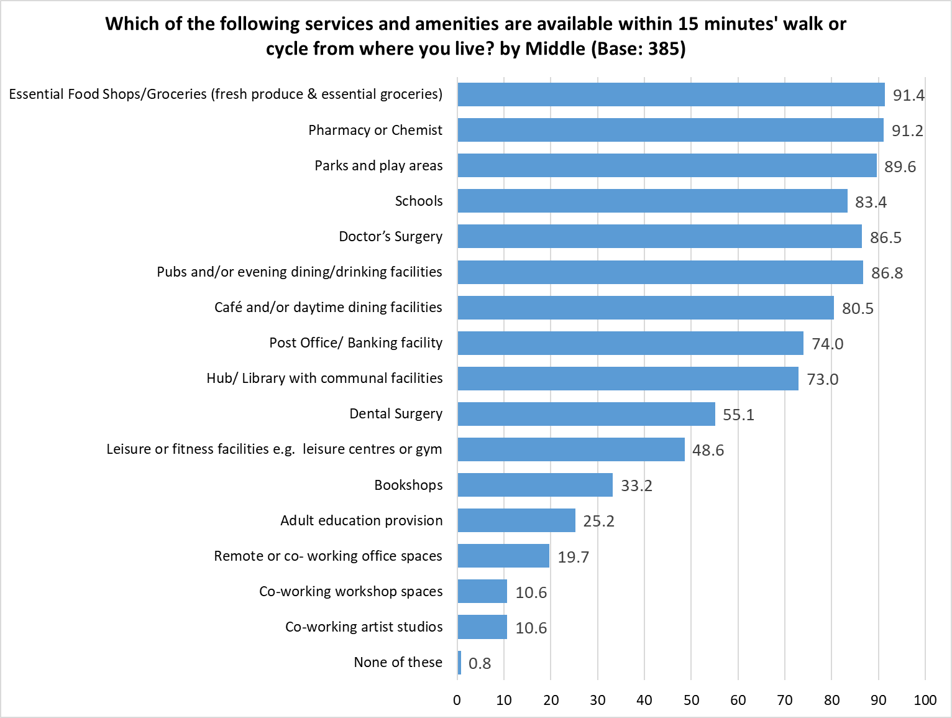 Respondents could select multiple options so the total will exceed 100%

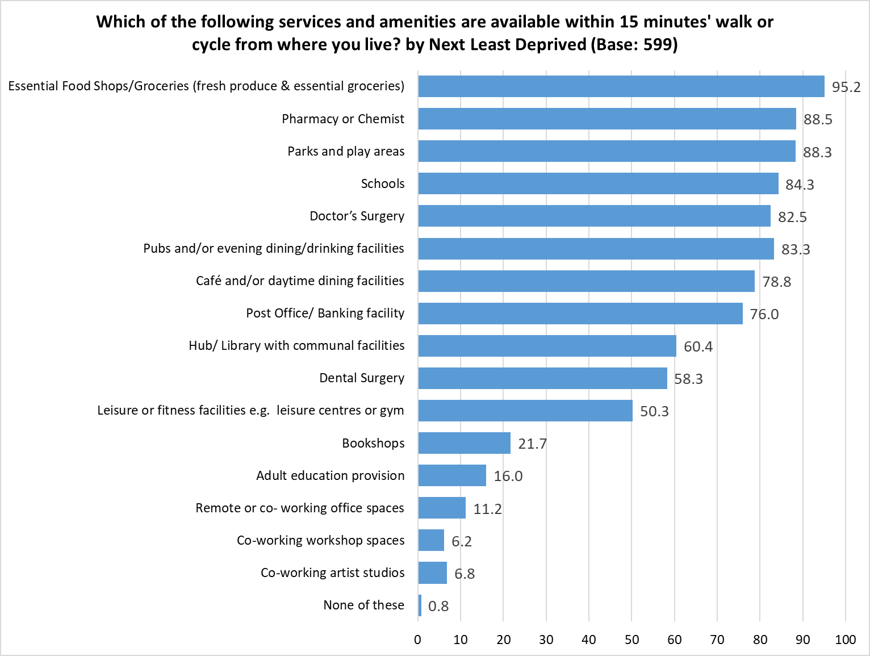 Respondents could select multiple options so the total will exceed 100%

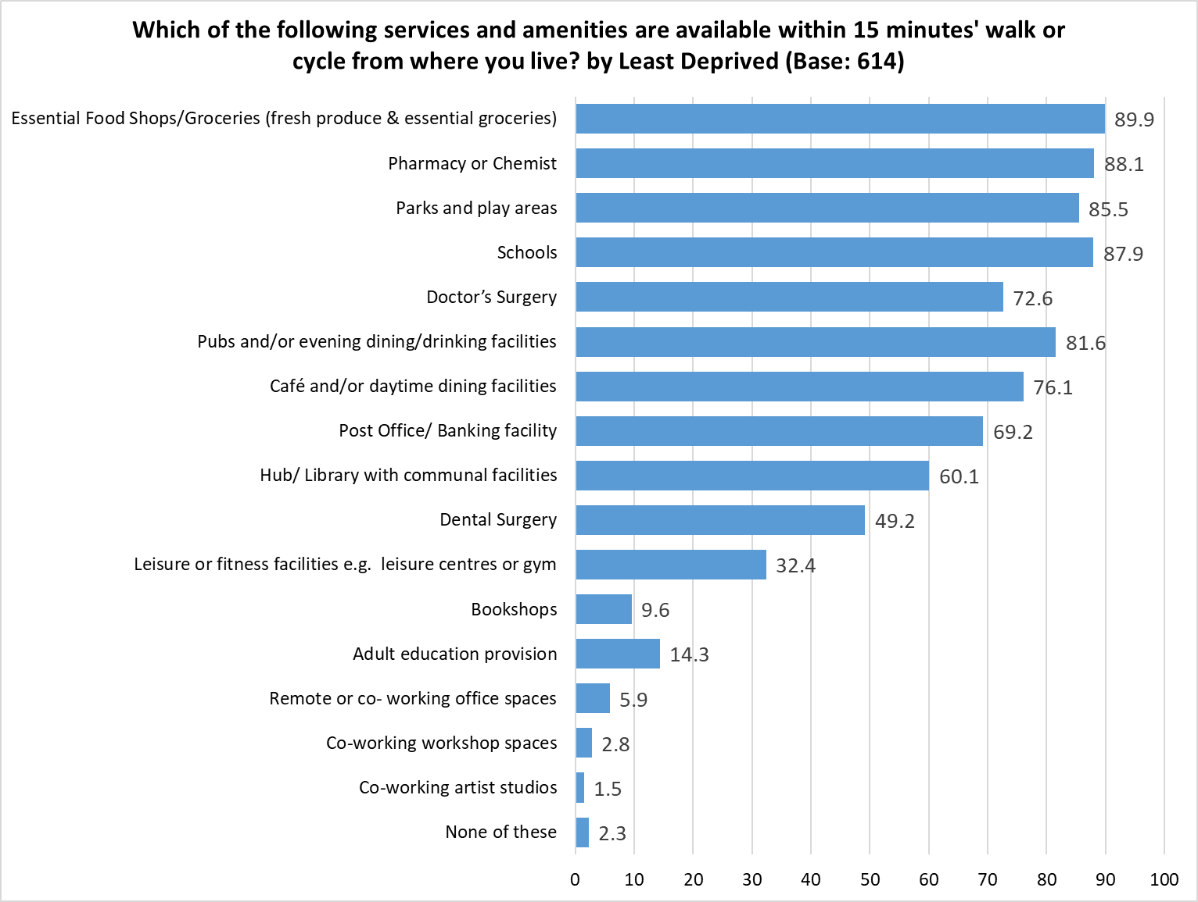 Respondents could select multiple options so the total will exceed 100%

Appendix C – Are any of the following available to enable you to access your local neighbourhood services or amenities? By Demographic

Respondents could select multiple options so the total will exceed 100%

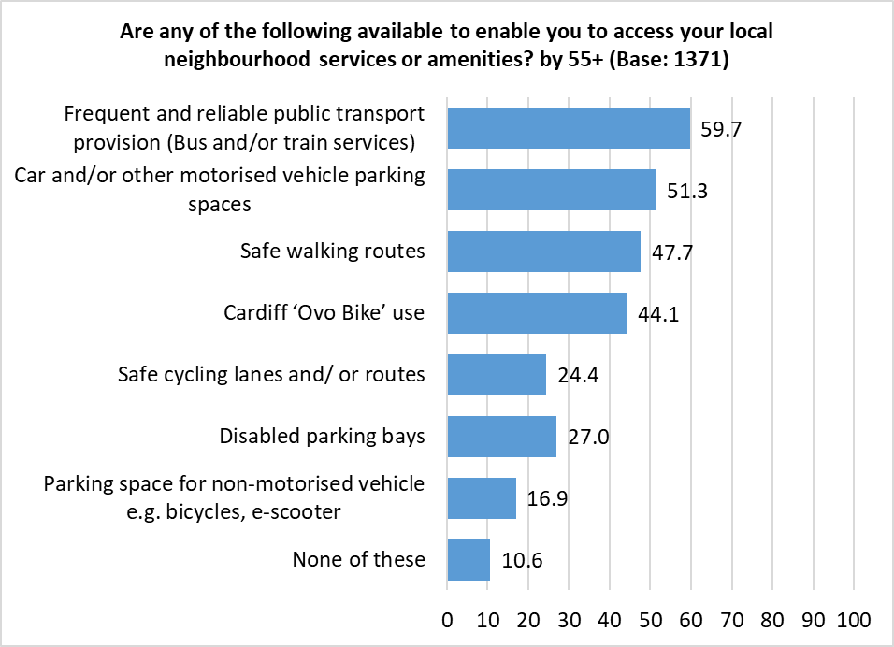 Respondents could select multiple options so the total will exceed 100%

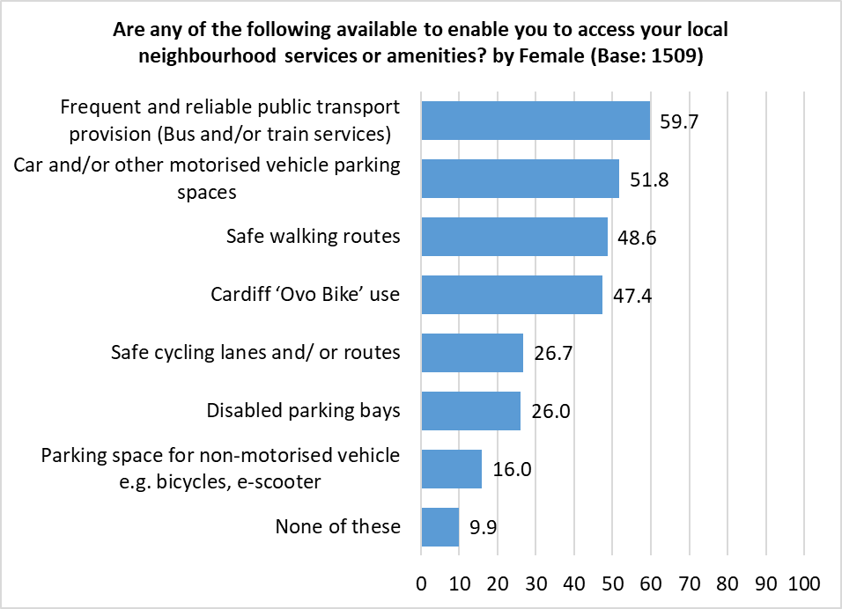 Respondents could select multiple options so the total will exceed 100%

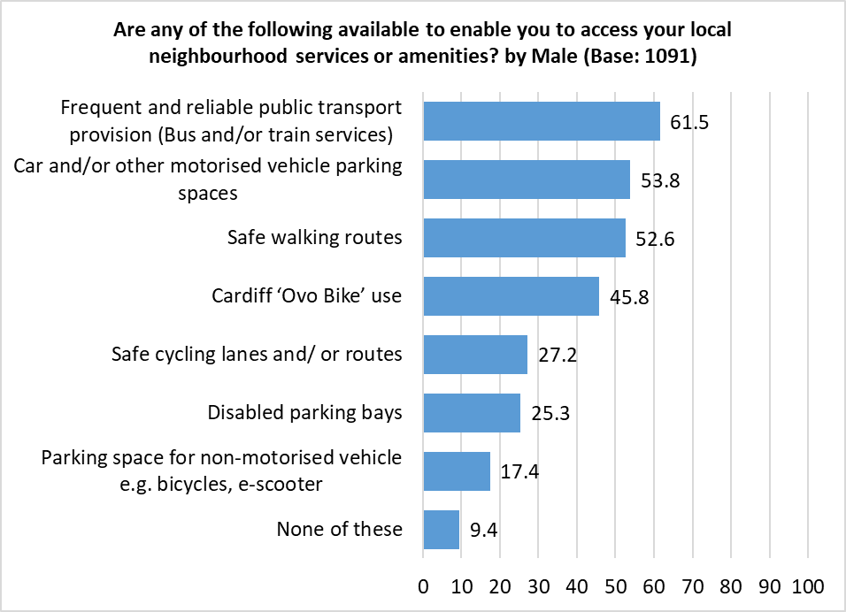 Respondents could select multiple options so the total will exceed 100%

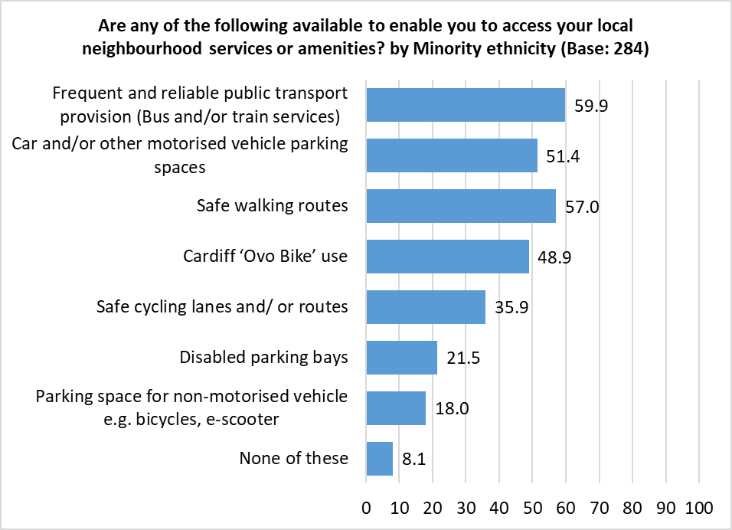 Respondents could select multiple options so the total will exceed 100%

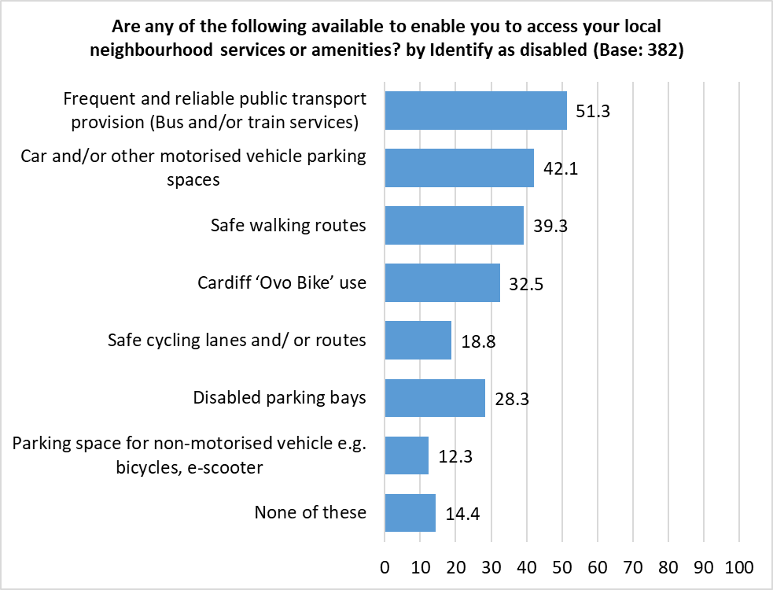 Respondents could select multiple options so the total will exceed 100%

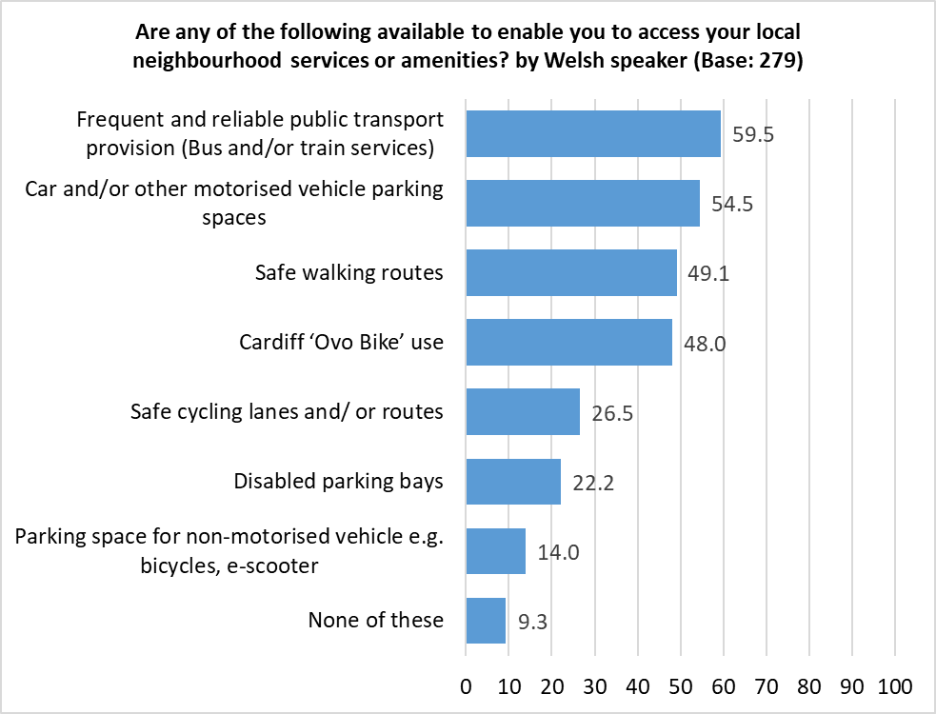 Respondents could select multiple options so the total will exceed 100%

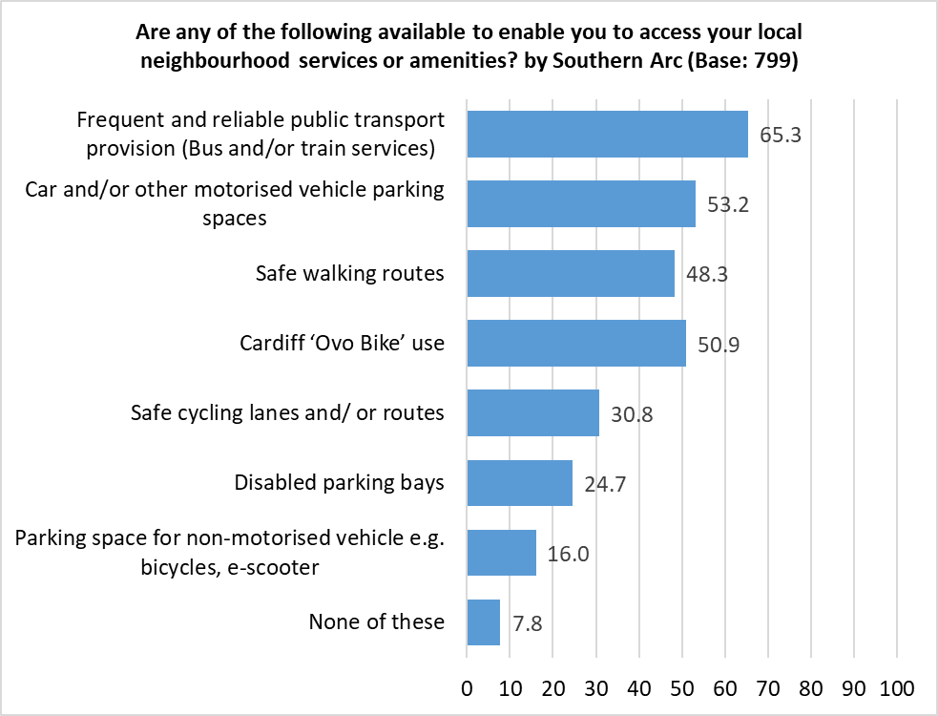 Respondents could select multiple options so the total will exceed 100%

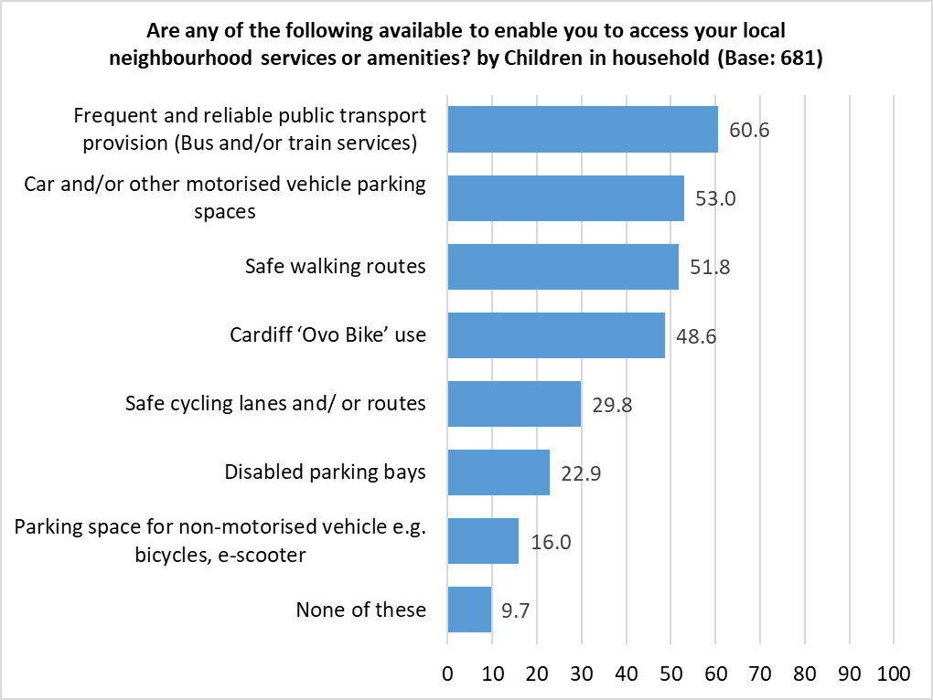 Respondents could select multiple options so the total will exceed 100%

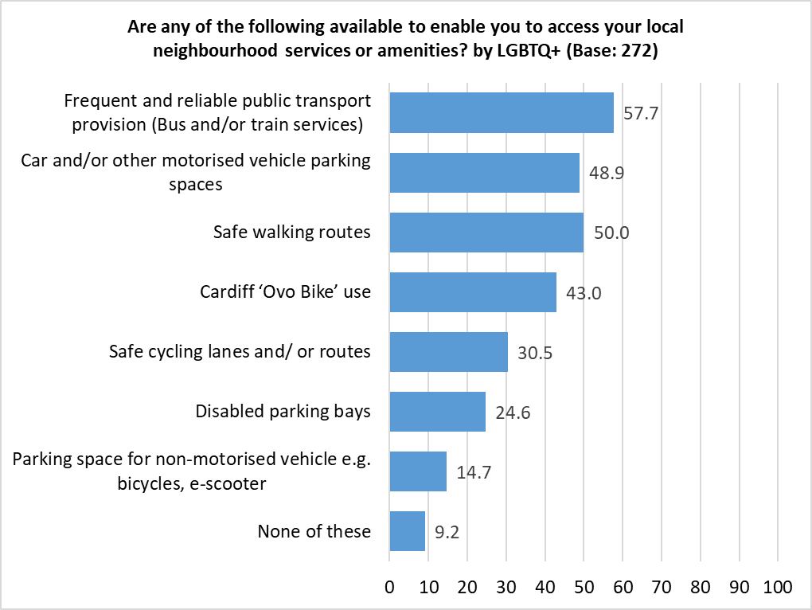 Respondents could select multiple options so the total will exceed 100%

Appendix D – Any other barriers to accessing services or amenities in your local neighbourhood?

Theme | No. | % | Example comments
Poor public transport | 59 | 37.3 | - Poor public transport network  - Buses infrequent, often cancelled, have to go into centre and come back out - hours longer journey by public transport rather than car.  - The bus stops in City Centre are too far from the shopping centre.  - No late night bus services  - Buses are unreliable and constantly changing.
Infrastructure - poor pavements / roads / cycle route | 30 | 19.0 | - Poor condition of pavements and roads  - Frequent disruption to the roads because of construction works going on for 4 years, with several more years of disruption to come. Also, our local playground has been closed for nearly 3 years because necessary flood prevention work has not been carried out.  - Lack of buses, dangerous empty cycle lanes, dangerous pavements covered in wet leaves and branches, continuous roadworks.  - Road crossing with no lights means I cannot reach the hub
Availability | 27 | 17.1 | - We do not have basic services in our local neighbourhood.  - Constantly unable to get to a doctor’s appointment  - No Post Office  - Dentist is rarely available. I've waited 2 years to see an NHS dentist at my dental surgery because the last one left. A&E is also a disgrace.
Safety concerns | 21 | 13.3 | - Gabalfa interchange unsafe to walk many near misses with cyclists in pedestrians lane and going too fast and too close forcing one off the lane into brambles  - The streets are not unsafe / feel unsafe for a young woman  - Safe walking routes are limited.
Health / Disability | 16 | 10.1 | - Disabled parking  - Child's physical disability  - Council erected barriers preventing access to UHW on my disability scooter.
Parking - Bikes | 13 | 8.2 | - No secure parking for bikes. Businesses should offer secure bike parking for customers, and residential buildings should also cater for cyclists and have secure bike parking. Cars are still prioritised over bikes. Safety measures need to be in place.  - secure bicycle parking
Transportation | 9 | 5.7 | - No trains on Sundays.  - Our household does not own a car and this restricts us. An example is we cannot access a Recycling Centre.
Accessibility | 9 | 5.7 | - Poor access to services for wheelchair users, due to poor pavements and dropped curbs, especially around CRI  - Pavements are broken and as a disabled person I struggle to get out as I have to use my wheelchair on the road and this is not safe
Money / Cost | 7 | 4.4 | - Cost of bus fare  - Remote or co-working office spaces, workshop spaces and artist studios are available but prohibitively expensive.
Work | 5 | 3.2 | - Working core hours 9-5  - Nothing is available in walking distance to me when i am free. Everything is in the day or weekend when i happen to work.
Age | 2 | 1.3 | - Age walking a mile to a doctors is not possible for many older people
Misc. | 21.5 | 34 | - speeding in 20mph areas  - Anti-social behaviour is rife. Insufficient police resources. Increased crime rate.  - no pub retreat gone. no way to speak to anyone. Cllrs / AM's / MP's only turn up if there's an election.  - Knowledge of who to contact
 | 158 | -
Respondents could select multiple options so the total will exceed 100%

Appendix E – Are there any barriers to you accessing services or amenities in your local neighbourhood? By Demographic

Appendix F – Which of the following best describes where you work?

Theme | No. | % | Example Comments
Retired | 331 | 56.8 | - Retired  - Pensioner  - Very old and very retired
Hybrid Working - Flexible / Mix | 129 | 22.1 | - work both from office and remotely  - I work equally from home and at a fixed setting in person  - Flexible, both at home and the office.
Not applicable e.g. Taxi, outdoor work | 50 | 8.6 | - Field work from home for company in company provided vehicle (i.e. site visits)  - Work in film locations  - Taxi driver
Self-employed | 16 | 2.7 | - I’m self employed  - Freelance self-employed. Work in many locations.  - Self-employed driver.
Carer | 15 | 2.6 | - Full carer for my husband  - Carer for disabled parent  - Caring for my disabled child (hidden disability)
Retired / Volunteer | 9 | 1.5 | - Retired but doing voluntary work.  - Retired doing volunteer work for a charity
Disabled / Long term health condition | 9 | 1.5 | - Don’t work due to illness  - Disabled long health condition
Retired / ill heath | 7 | 1.2 | - Medically retired  - Retirement due to significant health reasons.
Misc. | 36 | 6.2 | - I work at home, not remotely though  - covid wrecked my business and there was no public support - felt abandoned whilst others thrived on hand-outs  - Student
Total | 583 | -
Respondents could select multiple options so the total will exceed 100%

Appendix G – Is there anything that is not available to you in your local Hub/Library that you think would be beneficial to you and your community?

Theme | No. | % | Example Comments
More activities / courses for all age groups / abilities | 117 | 19.8 | - Spaces for YOUTHS to meet in safety and social inclusion in ALL areas, Youths are marginalised  - Adult learning for professionals. It's all for kids, unemployed and retired people.  - The Reading Group at the Main Library stopped at the lockdown and has not started again.  - Activities for disabled children  - Friendship groups.
No hub near me | 65 | 11.0 | - We don’t have one!!!!! We need one please!!!  - The closest Hub is an hour’s walk away.  - There is not a hub / library in my area
Citizen’s advice / general advice/ Info | 43 | 7.3 | - Personal Finance Education  - CAB local services  - Ways of helping engaging people in consultations who due to certain barriers find it hard to engage.
Books / Library materials | 42 | 7.1 | - More books.  - e reader loan -??  - Newspapers, magazines
Better recycling options / services | 41 | 6.9 | - Waste drop offs  - More access to refuse bags  - Recycling facilities for Tetrapack milk cartons and other small items - hard to access without a car
Increased opening times | 37 | 6.3 | - Available after 5pm?  - Longer hours. Community centre feeling
Do not use local hub / library | 31 | 5.3 | - I don’t visit my local hub anymore as there is always groups of kids hanging around there.  - Since Covid i have not managed to get back into a routine of going to the library
Café facilities | 30 | 5.1 | - Would love a cafe like the one Ely Hub has. Ely Hub seems to have a lot more going on  - Coffee shop with cheap price
In process of development | 20 | 3.4 | - Local Hub is in the process of being redeveloped. I would like to see many of the above available.  - The library is closed for refurbishment. Looking forward for it to reopen as it’s a massive benefit
Workspace / Hire option | 20 | 3.4 | - Working spaces  - Hire of their rooms
IT | 18 | 3.1 | - more IT advice. digital learning is hit and miss.  - Affordable printing service
Accessibility | 18 | 3.1 | - Can’t access my hub because I am a wheelchair user, and I can’t use the pavements.  - There is. It's just not really open for people who work.
Parking / bike storage | 11 | 1.9 | - Better Car Parking Facilities  - Secure bicycle storage.
Privacy | 7 | 1.2 | - A quiet room. Libraries seem to be noisy places nowadays.
Toilets | 5 | 0.8 | - Public lavatories. There are none in my area
Councillors Surgery | 5 | 0.8 | - Access to my local council representatives! They no longer appear at my local library
Repair service / Borrow tools, etc | 4 | 0.7 | - repair cafes- places where you can bring items to be repaired by volunteers
Police | 4 | 0.7 | - Somewhere to easily report crime
Medical | 4 | 0.7 | - Walk in medical advice
Volunteer information | 3 | 0.5 | - Volunteer opportunities
Banking | 3 | 0.5 | - Banking facilities
Don't know | 32 | 5.6 | - Don't know  - I’m new in neighbourhood and haven’t come across these facilities yet.  - I’ve no idea because it closes so early it’s never open when I need it
Misc. | 70 | 11.9 | - From the above list at least half of the items are not available  - Staff who are trained to offer the increased range of services libraries are providing.  - Had no idea the Hub provided all these services!
Total | 590 | -
Respondents could select multiple options so the total will exceed 100%

Appendix H – Volunteering

Theme | No. | % | Example Comments
Support | 22 | 13.3 | - I would like to help adults with basic learning - reading and writing in English  - Tenancy and Homelessness Advice  - Digital mentor/buddy  - amenities for disabled
Green / green space / nature | 21 | 12.7 | - Something to help nature  - Tree planting and helping wildlife.  - I would happily help with green issues - making community areas - gardens more salubrious and productive not dumping grounds for rubbish
Foodbanks / food related | 16 | 9.6 | - Food banks  - Drop off food share for leftovers like unopened bread, so others in need can have access  - Community cafe if there are any
Youth | 10 | 6.0 | - happy to mentor under privileged kids  - Helping with homework clubs for kids  - Street play
Litter | 7 | 4.2 | - litter picking  - I sometimes litter pick around my local area, but could do with ability to dispose of the rubbish without taking up any of my household limited capacity
Other | 66 | 39.8 | - Cadet force  - Volunteering to be a Magistrate  - Crime prevention  - Local Church community work  - Supporting animal welfare, helping people with pets  - Engaging young people in voting
Shouldn't need volunteers | 18 | 10.8 | - No too busy to do free work that is council responsibility  - You are asking for volunteers yet the majority of these services should be covered by social and council services paid for by the excessive council tax!  - I pay you I’m not part of your team
 | 166 | -
Respondents could select multiple options so the total will exceed 100%

Appendix I - In the last 6 months, have you or anyone else in your household done any of the following because you couldn't AFFORD food by Demographic

Appendix J – Impact of Increase in Energy Costs by Demographic

Appendix K – How Do You Plan to Cope With The Increase in Energy Costs by Demographic

Theme | No. | % | Example Comments
Cut back on other things | 38 | 19.8 | - By cutting down on expenditure elsewhere  - Stop going out for food or drinks, cut down on doing things that cost money.  - Buy only at Aldi and Asda. No new clothes. Reduce window cleaner. Stop Amazon Prime.  - No heating 'til 1st Nov. I stopped dance lessons to pay for them. Bought cheaper ready meals. Stretched out a ready meal for one over two meals. Been often to shops to buy special offers. Not eating out!
Reduce hours / thermostat for heating | 30 | 15.6 | - Only use when bathing kids and a little before bedtime otherwise it's impossible to afford.  - Not switch the heating on  - Reduce the thermostat and time the heating is on.
Cut energy use | 27 | 14.1 | - Careful with energy usage.  - Cut down on energy usage - be smarter  - I had already reduced my energy use due to climate change which has helped with reducing my bills
Fixed contract for energy | 25 | 13.0 | - I am on a fixed rate contract with price set before the rise in energy costs  - fixed price deal does not run out till May 23.  - I have a fixed contract from September 2020 until September 2023 so it won’t rise.
Warm clothing / blankets | 24 | 12.5 | - The good old, put another jumper on  - Use more blankets and hot water bottles to try to avoid putting the heating on  - Layer up clothing
Use more efficient appliances / Renewable energy | 14 | 7.3 | - I have installed a heat pump which is more efficient and uses less energy than the gas boiler.  - recently installed a more efficient boiler  - cook using microwave, when using cooker I will fill it and make food to freeze
Think I should be OK | 14 | 7.3 | - I THINK I can afford the increase.  - I can afford the increase in costs due to a fixed tariff and government support but i will still reduce my heating usage for additional savings  - Extra money given to our energy supplier off our bills - i.e. I can afford the increase in energy cost with help from government
Don't know | 13 | 6.8 | - Haven’t a clue! Cut down no help for average income earners at all!  - With my crystal ball!! How do we know until it happens.  - No idea.
Overtime / Extra jobs | 11 | 5.7 | - take on more work  - Found a second job  - work overtime
Wood burner / coal fire | 9 | 4.7 | - Use the coal fire more.  - Use the central heating less and use our wood burner more  - Burn scrap wood
Insulation | 9 | 4.7 | - Insulation of property and people  - Reduce heating use. Try to continue to improve insulation etc.  - Thermal curtains, draught excluders and other energy saving measures.
Use savings | 6 | 3.1 | - I am fortunate to have enough savings to afford the increase in energy cost.  - Use my savings
Not applicable | 5 | 2.6 | - I am in residential care  - At present, electrical bills are included in my rent.
Will not cope / can't afford it | 5 | 2.6 | - Will not cope.  - Soon will struggle to pay gas/electric bills. Will cancel gas supply and rely on electric halogen heater and microwave.
Grants / borrow money | 5 | 2.6 | - Ask charities and council to help  - Overdraft
Use warm spaces | 5 | 2.6 | - Go out more to other heated areas  - work at office rather than remotely
Misc. | 8 | 4.2 | - Minimise the usage of fracking  - Check bills to see if I can afford as I haven't been receiving paper bills  - using terracotta pots with candles underneath to try and add warmth
 | 192 | -
Respondents could select multiple options so the total will exceed 100%

Appendix L – Reasons for declining invitations for screening

Theme | No. | % | Example Comments
Don’t trust NHS/ bad experiences/ GP/access | 21 | 23.9 | - No longer trust the NHS  - My trust in the NHS died with the pandemic.  - The inability to make an appt at GP for a suitable time
Lack of time | 16 | 18.2 | - Too busy  - No time  - I am a 24/7/365 housebound carer - DUH!
Worry/anxiety/Fear | 15 | 17.0 | - I find the pap smears traumatic  - Needle phobia. Visits are rushed and not accommodating for people like myself.  - just the name of smear test has me screaming
not interested/I'm low risk | 9 | 10.2 | - Don’t want them.  - I'm 75 and reasonably fit for my age. The NHS has higher priorities.  - Not identified as higher risk
Forgot/missed | 7 | 8.0 | - Keep forgetting  - Forgot my cervical screen but can't get an appointment with GP anyway  - I forgot- will try and book it in
Worried about or dislike of procedure | 5 | 5.7 | - Procedure just too yuk!  - Procedure too invasive
Couldn't take up any treatment | 4 | 4.5 | - Regarding breast screening, the possibility of receiving unnecessary treatment.  - I'm a carer with no one else to rely on so I couldn't go, nor could I go for any treatment in any case
Misc. | 27 | 30.7 | - Less to worry about and we’re all going to die of something. We are too focussed on living to a ripe old age!  - i go through private medical care for that so as not to use up NHS resources  - I'm a man - no invitations  - Inertia
 | 88 | -
Respondents could select multiple options so the total will exceed 100%

Appendix M - Reasons for declining invitations for vaccinations

Theme | No. | % | Example Comments
Dangerous / unsafe / insufficient info | 27 | 23.7 | - Unsure of side effects of new vaccines for COVID. All other vaccines up to date.  - Not safe not tested  - I don’t wish to be injected with poison  - Blood clots ... heart attacks ... full list on yellow card scheme
Not relevant to me / I rely on my immune system | 19 | 16.7 | - Flu and covid-19 vaccinations are not necessary for persons who are healthy and aged under 50.  - I have an excellent immune system  - Declined flu vaccine, don’t feel I need it.
Bad response to previous one | 13 | 11.4 | - Allergic reaction to last vaccine - I have been waiting to see the allergy clinic ever since and am putting off vaccines until I can  - Adverse reaction  - It made me Unwell and I cannot be poorly I am needed
Not needed / pointless - people who have had it still get covid/flu | 12 | 10.5 | - Don't feel it is needed anymore.  - Not enough real world research or info on it. Also almost everyone I know who has been "vaccinated" have all had covid at least twice.  - I don't want or need it.
Don’t trust vaccine / NHS / govt | 8 | 7.0 | - Don’t trust untested vaccines or the government to tell the truth  - Don’t trust vaccines
Personal choice | 8 | 7.0 | - that's personal.  - My choice. I did not need it.
Don’t want it | 8 | 7.0 | - I don’t want it  - Not interested
Vaccine doesn't work / no perceived benefit | 7 | 6.1 | - Don't see benefit of vaccination  - Vaccine does not stop transmission. Nobody will assure me that if it is safe.
Had at least one, don't want more | 6 | 5.3 | - Had enough vaccinations  - I do not want another Covid 19 vaccination
Anxiety/ mental health | 4 | 3.5 | - Too nervous worried and anxious
Appointment issues | 4 | 3.5 | - Not suitable appointment, can’t get through to change it
Contra-indicators | 3 | 2.6 | - I have disabling illnesses that make me very susceptible to bad reactions from vaccinations and medication
No invitation | 3 | 2.6 | - I have not been invited. It is my choice.
Had covid, don't need vaccine | 2 | 1.8 | - Already had covid, don’t need further injections
Misc. | 24 | 21.1 | - the head of Pfizer confirms that the CV19 jabs do not prevent infection or transmission. The likelihood of dying of CV19 is very small and the risk is no greater than catching flu. The MRNA platform has not been tested through RCTs as it should have been. Total scandal, Lockdown a crime against humanity driven by greedy profiteering of Big pharma.  - For covid? Don’t be silly! Stupid question  - 500 characters is not enough space to even start  - hahahahahahahahahahahahahahahahahahahahaha
 | 114 | -
Respondents could select multiple options so the total will exceed 100%

Appendix N - Community Safety: Trends

Appendix O – Community Safety: Reasons for Feeling Unsafe

When at Home
Theme | No. | % | Example Comments
Crime / Burglary | 126 | 35.0 | - Too many burglaries locally  - There has been a lot of reported crime in my area on the Police website.  - I have had items stolen from my gardens / locked sheds broken into. No one looks out for a neighbour in my community.  - I live in a high crime area and nobody really gives a damn.  - Increase in opportunistic burglaries
Anti-Social Behaviour | 78 | 21.7 | - Full of undesirable people near my home causing trouble  - Criminal and anti-social behaviour in the area  - Anti-social behaviour and being a target  - Neighbours fighting in the street
Drug Use & Dealing | 50 | 13.9 | - The area is stinking with drugs  - Drug deals happen constantly at the end of the street and around the area.  - Drug paraphernalia in lanes, cannabis factory found on our street recently!  - U see drugs handed out in street
Security / privacy issues | 49 | 13.6 | - people in and out all hours and ringing my bell all hours to get in  - People trying doors  - My bedroom is on the ground floor on the main road and I hear unsocial behaviour and people hanging around outside my window regularly. The fact they are only a1-2 metres away and only glass between us makes me anxious.
Lack of police resource, presence or response | 29 | 8.1 | - Police never respond to calls so no point calling them better off barricading yourself in your house and hoping for the best.  - Because if something was to happen I have no faith in the police  - Police do not do their job
Disruptive Youths | 28 | 7.8 | - A lot of gangs of boys hanging around and can smell weed a lot  - Neighbourhood has gangs of youths  - Young boys hanging around the streets lighting fireworks. Selling drugs
Living alone / Vulnerable Household | 25 | 6.9 | - Live alone and feel unsafe  - Single person in an area where break ins are becoming more common  - I am a disabled person
Issues with neighbours | 22 | 6.1 | - My neighbours are violent and use drugs. The area in general also has many similar people.  - I have issues with my neighbours and the male next door repeatedly tries to intimidate me.  - My neighbours make me feel unsafe due to their actions
Unsafe area | 17 | 4.7 | - Live in a rough neighbourhood  - It is a horrible neighbourhood with a lot of anti-social behaviour
Alcohol abuse | 14 | 3.9 | - Drunk people around smash car windows  - lots of drunk people
Gangs | 10 | 2.8 | - Because off all the gangs around my area  - Groups of men hanging around
Unsolicited calls | 10 | 2.8 | - Too many cold callers and random people checking out houses.  - Unscheduled callers - such as charity workers
Health / Age -related issues | 10 | 2.8 | - Because I've fallen a few times and I don't have any help  - I live alone and am of an age when poor health is starting to reduce my-self confidence
Poor Street Lighting | 7 | 1.9 | - It’s very dark around my house, I’m an end terrace which huge trees covering lighting from the street lights.  - I live in a cul de sac that only has one street light.
Speeding/reckless driving | 7 | 1.9 | - There are quad bikes and motor cross bikes frequently terrorising the area (Splott) and police helicopters overhead sometimes - my road is a rat run for cars going too fast - not sure motorists pay much attention to 20 mph limit in residential areas - not safe to cycle on roads as cycle routes run out - and priority still given to motorised vehicles  - Anti-social behaviour - quad bikes, scramblers, yobs, boy racers
Feel unsafe as female | 6 | 1.7 | - My husband works away so don’t feel so safe  - woman who is visibly Muslim
Pests / Animal control | 3 | 0.8 | - There is a new block of flats next to us with a lot of people in who are either on drugs or drinking a lot all hours of the day, there are a lot with big dogs and really don't care about the mess they make in the last 12 months my area has gone from a nice area to a scarlet one
Misc. | 26 | 7.2 | - Constant police helicopter circling  - Transient population  - My landlords only care about money, hence the many and varied financial short cuts taken  - Its cardiff
Total | 360
Respondents could select multiple options so the total will exceed 100%

When Walking in my Neighbourhood
Theme | No. | % | Example Comments
Anti-Social Behaviour | 233 | 19.3 | - Antisocial behaviour  - Some strange people about sometimes, shouting in the street, generally seeming out of control of themselves  - Too many idiots  - Previous incident of fireworks being set off down a street at night whilst I was walking has increased anxiety. If alone, concerned about other people about  - lots of antisocial behaviour - drunk people hurling abuse in broad day light.  - Sometimes there are thugs around and you never know how they are going to behave
Disruptive / Intimidating Youths | 221 | 18.3 | - Sometimes groups of teenagers make me feel nervous.  - A lor of youngsters wearing hoodie riding around looking at vehicles  - Children (teenagers) have nothing to do so they hang around streets and cause mischief.  - Generally groups of teenagers/young people who seem a bit loud and rowdy. Feel mostly uncomfortable when have my little boy with me  - Quite a few gangs of youths congregating especially by shops  - Too many kids in hoodies and balaclavas
Drug Use & Dealing | 207 | 17.1 | - People involved with substance mis-use  - I see a lot of drug addicted people walking around.  - Drug dealing  - I see drug activity  - A lot of young adults dealing drugs and not looking very approachable  - Drug users everywhere
Poor Street Lighting | 187 | 15.5 | - At night, lighting is limited, as is council operated CCTV so as a female, the risk of being attacked is too high.  - Lighting is not as bright as it used to be  - Street lighting is poor so it's very dark and isolated  - Not very well lit. The estate was not designed very well so there are a lot of blind spots.  - Not enough lights  - Very dark in some places
Feels unsafe in area after dark | 127 | 10.5 | - Only feel unsafe in the dark. Usual reasons.  - At night. Is anywhere safe at night?  - I don't like being out alone after dark  - Bus routes mean a long dark walk to my home. Very unsafe in the dark.  - at night time everything feels more unsafe
Crime / Theft | 97 | 8.0 | - reading about stabbings gun use who the hell feels safe  - Seemingly increased crime in my area (or maybe just reported more in local community social media groups)  - Due to the crime in the area  - Lots of crime such as bike thefts and cars being broken into even during the day.  - Mugging
Drunk & Disorderly | 95 | 7.9 | - Too many drunk people hanging around  - Drunk people around  - There are often drunk people walking home after the pubs close  - There are people drinking and shouting in the streets.  - Too often people walking home after having too much to drink
Gangs | 83 | 6.9 | - Sometimes gangs about  - Gangs of undesirables around.  - A lot of youths in gangs around  - Groups of men congregating outside shops so I have to walk on the road out of their paths  - Groups of youngsters with nowhere to go, thrill seeking
More vulnerable as a female | 80 | 6.6 | - I’m a woman, I think lots of women feel unsafe walking late  - As a female I Would feel unsafe walking anywhere at night  - Simply being a woman walking alone at night. I would feel safe with my husband.  - I'm female and walking after dark round quiet streets will always feel unsafe.  - because I’ve experienced street harassment as a woman
Scooters / Motor bikes on pavements | 74 | 6.1 | - people riding bikes on payments and not road scooter travelling fast  - Motorised scooters whizzing on pavement, youngsters give verbal abuse if you ask them not to go on pavement.  - always wary of gangs of youth in area scooters on pavements and roads bombing down pavements etc. don’t hear them till they’re close  - Electric scooters and electric bikes ridden by ‘yobs’  - Scooters and cycles being used irresponsibly, feel like you’re going to get knocked off your feet.
Lack of police resource & presence | 64 | 5.3 | - No police in the area  - No police presence, no CCTV  - Hardly see a police officer  - Police are not resourced enough to respond should crime happen  - No police ever seen in area
Poorly Maintained / Unsteady Pavements | 62 | 5.1 | - bad and uneven pavements, tree roots in the pavement, dog excrement, fruit from the trees making the pavements slippery  - Pavements aren’t good.  - Slippery, uneven pavements and paths. Overhanging bushes and trees which block pavements and force you into the road where cars drive too fast.  - Poor quality paving and don’t want to trip or fall over. Not comfortable as a woman walking on my own.  - I wouldn’t walk on my own in the dark in my neighbourhood as lighting is poor, pavements are uneven and there are a lot of people hanging about
Driving recklessly | 46 | 3.8 | - The mobile drug dealers, cars/vans etc treating the roads as speed tracks  - mainly from traffic, as cars park on pavements, speed through our 20mph area  - Too many cars. Parking on pavement. Speeding. Driving dangerously.  - Cars breaking the 20mph limit.
Homeless / Beggars | 38 | 3.1 | - There are quite a few people hanging around possibly making dodgy deals, beggars waiting outside shops and near cash machines  - Drug use/anti-social behaviour/aggressive begging  - So many homeless people begging outside the shops
Unsafe area | 31 | 2.6 | - Some rough areas  - Local thugs very unsafe  - I do not feel safe in my area - it has an undertone of tension on my local shopping street - security is necessary on the door of the local supermarket - that is a barometer of how safe businesses feel! In the local park i used to go running - now I think I might get bitten by a dangerous dog
Due to age / disability | 31 | 2.6 | - I’m old  - Mobility issues  - I am elderly, breathless and can't walk very fast.
Violence, Attacks | 30 | 2.5 | - Risk of attack  - Knife crime and muggings increasing  - Perceived and actual risk of knife crime and violence
Sexual Harassment / Assault | 24 | 2.0 | - Women are still subjected to unwanted harassment which is infrequently taken seriously by law enforcement. We have to adapt our behaviour to avoid this, because men don’t change their behaviour.  - Sometimes I get catcalled  - I'm female and have been raped and hassled on the street by men before
Other vulnerability | 19 | 1.6 | - I don't trust people, bad experiences in the past  - It's just me as I get nervous
Cycling on footways | 18 | 1.5 | - Cyclists riding on the pavements. Can't hear them coming up behind me. They don't ring the bicycle bell.  - Crazy cyclists who do not follow the rules
Litter/ graffiti | 17 | 1.4 | - unkempt streets  - There are a number of lanes which connect the different areas, and they are overgrown and full of rubbish
Parking on footway | 16 | 1.3 | - It's often not that well-lit, pavements are usually blocked with parked cars, so you can't tell if someone's waiting for you. You also sometimes need to step into the road to avoid parked cars, which can be dangerous.  - Cars driving on pavements
Misc. | 64 | 5.3 | - Lack of crossings  - Unknown factors  - Transphobia  - My street can be very unpredictable
Total | 1210
Respondents could select multiple options so the total will exceed 100%

When Walking in the City Centre
Theme | No. | % | Example Comments
Homeless / Beggars | 641 | 36.4 | - Too many itinerants.  - Lots of people begging, some get quite nasty when I say sorry I have nothing to give  - People begging makes me feel uncomfortable  - There are so many people begging and so much homelessness that I just don't feel safe.  - I’m frequently approached by people asking for money  - Too many down and outs  - Drunks and anti-social behaviour, homeless beggars. No policing at all.
Drunk & Disorderly | 614 | 34.8 | - Mainly if there's lots of groups of very drunk noisy people  - Too many drunks, loud, rowdy, generally unpleasant  - Cardiff City Centre lacks the alfresco vibe of European cities. People get very drunk. Cardiff Bay is equally as rowdy.  - Fine in daylight but I find the atmosphere in town, particularly at weekends, very intimidating because of the amount of drunken revellers.  - Drunk people  - Drunks gathering on public seats and drug sellers openly selling drugs
Drug Use & Dealing | 414 | 23.5 | - Lots of people high on drugs shouting when I walk to work worried that even walking past could make them attack me  - A lot of people on drugs hanging round  - Queen street is a disgrace with the druggies and their tents, St Mary’s even worse  - too many drug addicts who are not getting the treatment needed to get better means that they attract dealers who openly push to them during the day.  - young people acting like zombies on drugs  - There are too many drug induced people about.
Anti-Social Behaviour | 255 | 14.5 | - unsocial behaviours  - I live in the city centre and witness anti-social behaviour every single day.  - I work on Queen Street. The anti-social behaviour is awful. You know that you do nothing  - I feel it is too rowdy  - I feel there is some anti-social behaviours that worry me
Cyclist / E-scooters | 156 | 8.9 | - Have to very aware of what is around me especially bikes and scooters, which unnerve me.  - Cyclists and scooters  - A lot of cycling traffic weaving in and out.  - People cycling and riding scooters in pedestrian areas  - Too many cyclists on the pavements and escooters too (which are illegal anyway)
Feels unsafe at night-time | 138 | 7.8 | - Cardiff at night-time is quite disturbing  - There are some very drunk and antisocial individuals in the city centre at night  - Mostly at night when more people are drunk and behaving in an intimidating manner. Day time - I love the city centre.  - usually just later in the evenings when large groups who have been drinking are around  - In the dark yes. Lack of police & community protection people
Gangs / Large Crowds | 116 | 6.6 | - Crowds mess chaos  - So many people around, cannot keep an eye on them as so many.  - Gangs of threatening men  - Far too many people around.  - sometimes groups of people hanging around the shopping centres they can look threatening
Lack of police resource & presence | 115 | 6.5 | - No police presence  - Shortage of police presence  - Better policing - zero tolerance of antisocial behaviour  - No visible police presence  - Never any police
Crime | 109 | 6.2 | - because of the crime rate in the centre  - Unsafe - Get beaten up and jumped have your stuff nicked  - I’m transgender and worry of any queerphobic behaviour and violence that could potentially happen to me  - Drugs drunk knife crime  - Pickpockets and general higher rates of crime
Other people | 66 | 3.7 | - uncertainty about other people  - Too many unsavoury characters hanging around  - The homelessness and various unsavoury people  - Just wary of people  - Not sure of who I am sharing pavement with...
More vulnerable as a female | 54 | 3.1 | - As a single female there is always the worry that something might happen.  - Women are vulnerable at night and I don't feel this has improved.  - Because I'm a woman  - I'm a lone female and there are a lot of people that make you feel uncomfortable  - As a female I worry about the number of assaults reported especially for my daughter
Disruptive / Intimidating Youths | 54 | 3.1 | - Too many youths in groups, atmosphere is sometimes tense and unwelcoming  - Kids and increased knife crime  - Because of groups of youths  - Many youths wandering around  - the youth of today
Violence, Attacking, Fights | 48 | 2.7 | - risk of attack  - Lots of people fighting shouting and walking with bloodied face or body.  - Inebriated males, fighting  - I was held up at knife point once  - An atmosphere. Have witnessed fights. Drinking culture.
Unsafe area | 42 | 2.4 | - The city is becoming a no go area  - Just gives a feeling of unease.  - I'm always aware of safety in busy public locations  - Rough as hell  - Doesn't feel a nice environment
Age / Health Reasons | 30 | 1.7 | - Due to mobility issues I struggle to move quickly and often fall. The condition of the paving, size of the city centre and unsocial behaviour means it is not somewhere I can cope with.  - I'm old and would be easy to be picked upon as I am a short old woman.  - There are often drunk people or people on drugs and I’m a vulnerable person so it really doesn’t help my anxiety  - I am unable to walk very far so stopping all the time makes you vulnerable  - Unsure why! Never experienced any trouble, but aware of my own age-related limitations in reacting to difficulties.
Area is run-down | 28 | 1.6 | - Town appears scruffy and unsafe  - It's grubby, empty shops, shouty, unfamiliar, strange people, some drunk people.  - The environment of the City centre has declined  - Some areas are trashy and smelly and looks like it welcomes certain people. Makes me uncomfortable walking in certain areas. Especially around lots of homeless and groups of men  - City centre reputation
Poor lighting | 23 | 1.3 | - Better street lighting  - the burdens of being a woman. Perhaps I will always feel a bit unsafe at night but ensuring areas are well lit make me feel a bit safer.  - It isn't well lit and there are so many people and it only takes one of them to be bad to make it unsafe.
Doesn't visit city centre | 21 | 1.2 | - I try not to go to the city centre at night. Happy to stay at home  - I wouldn't go into the city centre alone as I would feel uncomfortable being female  - I don’t go into Cardiff at night anymore too many yobs around
Sexual Harassment / Assault | 20 | 1.1 | - Catcalling, drunk men  - Sexual assaults/ harassment  - I'm female and I’ve been regularly sexually harassed and assaulted in the city centre
Poor pavement condition | 16 | 0.9 | - Poor paving conditions  - Pavements are cracked and uneven
Lack of public transport | 12 | 0.7 | - limited busses which end early in the evening, anxiety about missing the bus!  - very few late night public transport options to get home from work. Even in the late afternoon buses can be infrequent and often cancelled
Misc. | 38 | 2.2 | - Historic behaviour  - Police aggression towards people begging etc. they need support not punishment.  - could be racially targeted  - Always watchful when walking on my own
Total | 1762
Respondents could select multiple options so the total will exceed 100%
When Travelling by Bus
Theme | No. | % | Example Comments
Anti-Social Behaviour | 331 | 36.1 | - Too many drunks  - Antisocial and intimidating behaviour  - Buses are not very clean and some people on them behave very badly.  - You are a captive audience for any antisocial behaviour.  - Racism from youth  - Drug dealers
Poor Street Lighting / Travelling in the dark | 143 | 15.6 | - As a woman, you don't feel safe travelling by public transport in the dark.  - At the bus stops either end in the dark  - After dark feels less safe than in daytime.  - Only at night. wouldn’t travel on a bus at night  - At night there’s the concern of drunk/drugged persons getting on the bus
Members of the public - General | 114 | 12.4 | - Sometimes there are dodgy men in there  - Some of the passengers  - No control of crazy people or gangs  - intimidating characters  - Being in close proximity to strangers
Poor Bus Service - Unreliable / Lack of Services / Overcrowding / Dirty | 94 | 10.3 | - Would never get on a bus, dirty and smelly  - Not reliable often left stranded with missed buses  - Waiting for up to 40 mins on bus stops at night is scary  - Lack of reliable bus service and random bus stops with no central station where there would be more people
Security Reasons | 57 | 6.2 | - No security  - Feel vulnerable as there is only a driver.  - I Don't trust the people on the bus. Last week I was on the bus at night. 6-passengers were sat at the back of the bus smoking weed. The driver was too scared to tackle them. People won't address the issue for risk of physical harm to themselves.  - lack of support from other bus users if there's an incident...everyone puts their heads down
Generally feels unsafe | 44 | 4.8 | - Not safe  - Can be intimidating  - Unsafe when waiting at bus stops and walking from the bus stop home  - It’s a risk assessment. Waiting for a long period in dark and dingy area with not enough people around.
More vulnerable as a female | 38 | 4.1 | - As a female will always feel vulnerable travelling at night on public transport. Feel a target.  - I would feel safe with someone else but not on my own as a woman  - Women are vulnerable at night and I don't feel this has improved.
COVID | 29 | 3.2 | - Still concerned about covid  - Not travelled on public transport since the pandemic  - Probably anxiety from pandemic
The Bus Drivers | 29 | 3.2 | - Many of the drivers do not drive safely. I have been thrown from my seat twice on Cardiff buses because of poor driving skills.  - Not all drivers are aware of passengers disabilities.  - Bus drivers don’t always deal with problem passengers
Age / Heath Reasons | 26 | 2.9 | - Due to my autism I do not like being in close proximity to others so tend to avoid traveling by bus unless absolutely necessary  - As a pensioner I feel people disrespect the older passengers  - Too many people, no face masks, no good ventilation, nobody remembers to be kind
Harassment / Sexual Harassment / Assault | 26 | 2.9 | - I have been assaulted on a bus previously  - Pervy men. Drug use.  - have previous experience of being hassled when on the bus, which the driver eventually stopped but not for some time - v unpleasant
Lack of Passengers / Travelling Alone | 12 | 1.3 | - Lack of people on bus  - at night there are less people around and so it's more unnerving
Crime | 6 | 0.7 | - Feel unsafe in the evening due to high crime rate
Misc. | 34 | 3.8 | - Scared of being followed  - Have you been on a bus lately?  - Probably because I do it rarely.
Total | 897
Respondents could select multiple options so the total will exceed 100%

When Cycling
Theme | No. | % | Example comments
Traffic / Too many cars / Dangerous driving or Speeding / passing too close / inconsiderate parking | 541 | 50.1 | - Sharing the road with careless car drivers  - Idiot drivers, and unsafe cycle routes  - Erratic driving  - Cycle routes are patchy and there are too many cars driving too fast  - Cardiff is very car dominated and cycling infrastructure is sporadic, poorly maintained, inconsistent and inadequate, in spite of some recent high-profile but low impact schemes. Drivers are getting more aggressive and dangerous and illegal parking is out of control.  - I cycle 13000kms a year riding in the city is pretty unpleasant car drivers want to kill you a lot of the time! Apart from the recent ones most of Cardiff's old cycle lanes are a joke! cycle lanes get used by all sorts of people and they are rarely cleaned even the new ones such as around the sports centre in Sophia Gardens covered in leaf debris!  - Drivers frustrated by constant road changes take it out on cyclists.
Poor Cycle infrastructure - connection/ Not enough segregated cycle lanes / Bad design | 385 | 35.7 | - the cycle lanes are sometimes laid out too dangerously. They are too small, too short and token.  - Cycle lanes are not consistent. Lots of traffic on roads  - Roads, even the new cycle lanes not fit for purpose  - Inconsistent and incomplete cycle routes  - There's very little safe cycling infrastructure and many people – drivers and pedestrians – don't pay attention to what's going on around them. I generally have at least one near miss on every cycling journey (a close pass, someone opening a car door into my path, a pedestrian stepping off the pavement in front of me, etc.) and the increase in cars parked on roads at all times (because more people are working from home) has made visibility even worse and reduced the space available for cars and cyclists to share the roads.
Safety concerns | 250 | 23.2 | - Mixing cars and bicycles is unsafe at any speed.  - Roads aren't safe enough for cyclists  - Cycling is not a safe mode of transport  - dangerous cycle lanes that cross over road lanes, i felt safer without the cycle lanes.  - cycle lanes just stop or don't go the way I need to travel so you go from safe lane into traffic  - there are no safe Cycle lanes outside of the city centre
Nigh time /Dark / Poor lighting | 160 | 14.8 | - uncomfortable when cycling in dark in non-lit areas e.g. taff trail  - I will not cycle after dark due to street lighting issues.  - When dark it is not safe, large groups, many robberies and muggings  - Lack of street lighting in parks/ cycle lanes  - In the dark not enough lights, not enough cycle paths
Other /cyclists / e-scooters / E-bikes /Road Users / pedestrians / Dogs | 142 | 13.2 | - Too many use the cycle ways as a race track  - lack of pedestrian knowledge of cyclists. Dog walkers with extendable leads across a cycle path that you can’t see, many accidents. need an education programme to ensure that people understand the needs of cyclists  - Cycling is a nightmare in the City or anywhere, the Council have put all these cycle lanes in and the roads look busier than ever, especially when cyclists are riding in the wrong direction (oncoming) to cars driving on the roads. Too many cycling lanes and it makes Cardiff City Centre look so untidy and causes more traffic jams and pollution from cars idling for longer.  - Lots of delivery cyclists who don't obey the rules  - Scooters other cyclists and jaywalking pedestrians
Anti-Social / Aggressive Behaviour | 112 | 10.4 | - people in Cardiff are mean to cyclists  - Road rage  - Large groups of youths  - people hanging around, anti-social behaviour. Have personally had things thrown at me while cycling.  - It’s great that cycle lanes are available but they aren’t available consistently and I have seen cyclists abused by pedestrians and motorists. As a new cyclist this makes me feel unsafe
Potholes / Road Surface/ Debris | 97 | 9.0 | - Poor road conditions  - The state of the roads …. Potholes, puddles, no cycle route to my work  - Road surfaces are very poorly maintained.  - Cardiff roads not suitable for bicycles
Bike theft / Muggings / Crime | 81 | 7.5 | - Not viable to leave bike locked up as high theft rate.  - Bike thefts increasing at an extremely high rate.  - Because of the amount of assaults  - People pinching bikes
Problems exacerbated by reduced speed limits / 20mph | 17 | 1.6 | - there is no enforcement of the 20mph speed limit and buses don't care about getting close to cyclists  - The 20mph speed limit is just leading to road rage. Motorists can't overtake. Stupid Council policy.
Lone Woman concerns | 13 | 1.2 | - Women are getting attacked on the Taff Trail. I would not cycle on it alone any time of day or night  - As a woman I always feel unsafe in Cardiff. Druggies and alcoholics by cycle path near stadium yell abuse and deliberately jump into my way. Cardiff isn’t safe.
Don't know | 4 | 0.4 | - Don't know
Misc. | 54 | 4.5 | - To many people now dislike cyclists due to cycle lanes  - In places where there aren't suitable cycle lanes, it feels dangerous to cycle on the road. There also seems to be a drive to demonise cyclists on social media which makes me uncomfortable  - I'm not a confident cyclist - so would not want to cycle and end up causing any incidents  - It's all a bit confusing in town at the moment!
Total | 1209
Respondents could select multiple options so the total will exceed 100%

Appendix P – Community Safety: What could be done to make you feel safer?

When at Home
Theme | No. | % | Example Comments
More / better resourced police | 166 | 48.1 | - Better police presence  - More police on beat  - double or even triple the police and get bobbies on the beat  - More proactive and very visible policing  - Police Presence. Greater support to the local community
Take action against offenders | 52 | 15.1 | - More to be done to combat antisocial behaviour and drug use. Many consider it useless to complain to the police as the likelihood of them taking action is so small  - Police to do regular patrols and actually take action  - More police/ actions taken when reported
Security e.g. gated lanes, CCTV, Neighbourhood watch, alarms, cold calling restrictions | 51 | 14.8 | - Have cctv  - Free security checks and subsidised security things i.e. window locks door cams etc.  - Take the principle of ring door bell cameras and put them on bus stops. They're happy to put tracker cameras in the advertisements on bus stops to see their popularity but won't do it for safety. Arrests from damages would increase and public costs decrease overall. Plus I'd feel safer with my family being near them. Probably a lot more assaults would be caught too.
Housing changes/ improvements | 33 | 9.6 | - having more stability in community. council buying hmo's off career landlords and housing families instead of students  - I understand people need homes but why put a large number of drug and alcohol users in one area it doesn’t make sense, the flats look lovely and they just do not care about their surroundings and other people in the area  - I'm waiting to move
Better street lighting | 15 | 4.3 | - Better lighting  - Better lit street  - fix street lighting.
More youth services | 9 | 2.6 | - activities to occupy young people  - Improved youth services
Services for homeless, addicts, metal health | 3 | 0.9 | - Improve homeless outreach services.
Education/ culture change | 3 | 0.9 | - For neighbours to be kinder and realise their actions effect others.
Repair paths, fences etc. | 2 | 0.6 | - Attend and repair things in community areas instead of neglecting them.
Clamp down on illegal riding of bikes & scooters | 2 | 0.6 | - Sort out the quad bikes - and electric scooters and push bikes that often travel on the pavements
Don't know | 17 | 4.9 | - Don’t think anything would  - I don't know
Misc. | 38 | 11.0 | - What is the point nobody listens  - give me a gun  - There is no money to do anything. And we are not a priority area.
Total | 345
Respondents could select multiple options so the total will exceed 100%

When Walking in my Neighbourhood
Theme | No. | % | Example Comments
More / better resourced police | 604 | 52.2 | - Police on the beat and responding to calls  - More police presence in the streets, police actually coming out when they take cares of anti-social behaviours.  - Police Presence. Greater support to the local community  - Police need to be visible. Only seen ONE PC "walking" in the area in last 2 years or so.  - Have a police service. Regular beats, have a presence and don't hide in the few stations we have now the other side of the City.  - More police presence and more action from police when there are incidents
Better street lighting | 252 | 21.8 | - Better Street lighting  - Brighter streetlights  - Lighting when it's dark especially near entrances to parks  - Better lighting, these energy saving/environmentally friendly bulbs are not very bright  - Fix street lights.
Take action against offenders | 158 | 13.7 | - Proper sentencing in the courts.  - Random knife searches, workshops for youths on knife crime, police patrols  - Arrest men who harass women  - Tackling anti-social behaviour  - More police, lock up the dealers and offenders.
Security e.g. gated lanes, CCTV, neighbourhood watch | 63 | 5.4 | - More CCTV, Police / PCSO patrols or security  - Knowing there are cameras  - More funding for my area, more police patrols and more street CCTV.  - I don't think flooding the area with more police will be helpful but more CCTV cameras might help in some places. Addressing the economical and social issues at the route doesn't seem like a problem the council can resolve.
More youth services | 54 | 4.7 | - more for kids to do  - More places where teenagers could go to socialise e.g. youth clubs.  - youth services  - Provide young people with a viable alternative to hanging round on the streets
Repair paths, fences etc. | 44 | 3.8 | - Improve the pavements  - Make the pavement more even, whether by tarmacing or other means  - Fix streetlights and improvements to footpaths as these are uneven and untidy  - Pavements are not safe for me with my disability
more pedestrian routes & crossings | 32 | 2.8 | - More zebra crossings  - Clear signage on who can use bridle paths.  - Better walkways
Clear litter, graffiti, undergrowth | 28 | 2.4 | - Improved street lighting and cutting back overhanging hedges to make visibility better  - cleaner streets and less graffiti
Traffic calming | 26 | 2.2 | - Traffic calming measures  - Speed bumps, speed cameras
Education/ culture change | 25 | 2.2 | - A massive societal change where everyone is given the right to feel safe no matter their gender, sexual orientation, or race  - Better education for men about sexual harassment, treating women with respect, and citizenship etc.
Housing changes/ improvements | 25 | 2.2 | - Making owners of derelict buildings accountable to improve or sell  - When placing tenants in social housing they should be vetted, some residents i.e., single mothers and families share hallways with drug dealers etc, not great for safeguarding
Services for homeless, addicts, metal health | 25 | 2.2 | - Less alcohol and drug abuse, services that support people into safe housing and work and hopefully away from that. Some more visibility of community support or watch  - I would feel safer knowing that people who are struggling financially or with their mental health or addictions are supported. My perception is that I am the least safe around those people and so if they are protected and able to access services and be more happy and secure I will feel safer
Nothing | 19 | 1.6 | - Nothing really - nobody can help it being dark or the fact that people will try and do bad things  - Not a lot, really: you can't police everyone all the time.
take action on illegal riding of bikes & scooters | 15 | 1.3 | - Crack down on illegal bikes  - Get rid of the E scooters and drug dealing Youths who fly around the streets
Better public transport | 13 | 1.1 | - Better bus service - my daughter was made to disembark on halloween a mile from home earlier than advertised!  - Reliable buses with understanding bus drivers with regards to children travelling
Close parks at night | 4 | 0.3 | - Close the parks at night  - Park attendants? Close the park at night
Don't know | 48 | 4.1 | - No idea. Kids and people will do what they want. Speak up or confront and it simply gets worse  - Can't think of anything specific
Misc. | 47 | 4.1 | - i would like to move to a bungalow so i can have some peace and a garden to sit in  - Society think it’s ok, police have a very hard job to help  - No anti-social behaviour (won't happen I know)
Total | 1157
Respondents could select multiple options so the total will exceed 100%
When Walking in the City Centre
Theme | No. | % | Example Comments
More Police / PCSO / Community Wardens Presence | 887 | 60.0 | - More police presence  - Police presence, other enforcement. Tackle social issues at root cause more widely.  - Enforce the law. Have police out and about with zero tolerance. Don't sit in police vehicles and watch illegal activities.  - Please have police or PCSOs on St Mary Street - it is horrible at all times of the day. I see people taking drugs in broad daylight and last week a man was running up to people threatening them. Is this what you want visitors to Cardiff to see as they get off the train?  - Basically more police!
Greater Support for Homeless People / Outreach Services for Rough Sleepers | 363 | 24.5 | - Better provision for vulnerable people  - More support for the homeless which will mean fewer homeless people  - Many of these people appear to be homeless. So more support for them  - The removal of the homeless & beggars in the streets including their tents.  - I feel very sorry for homeless people, but they shouldn't be allowed to reside on the streets. Accommodation should be provided for them.
Stop Cyclists / Scooters | 102 | 6.9 | - Stop the cyclists and scooters  - stop cyclists in pedestrian zones  - Sort out all the delivery people on bikes out. They race around on pavements I've been nearly knocked over twice. The bike lanes are a hazard they don't stop at red lights I have seen an elderly person getting knocked over its a disgrace I could go on and on.  - Stopping all wheeled transport including cycling and electric scooters in pedestrian areas including delivery cyclists
Disperse Gangs / Intoxicated People | 78 | 5.3 | - Dispersal of gangs  - Remove the undesirables  - Culture - more families and less gangs drinking  - Move the alcoholics / drug users along and don't allow them to congregate  - Get rid of beggars, drunks and drug addicts with antisocial behaviour making people feel unsafe when walking around town.
Greater Enforcement / Punishment / Better Prosecutions / ASBO's | 70 | 4.7 | - Get rid of the drug users  - Zero tolerance, following the example of Singapore.  - Enforce the law and fine those cycling on pedestrianised streets and arrest drug users.  - No murders or stabbing  - More control over drunken / drug induced behaviour - some of this is a cultural problem but maybe helped by stricter control on licenced premises
Improved Lighting | 68 | 4.6 | - More lighting  - More and better lighting  - Bright lights, shops open, not needing to leave lit areas to reach a bus stop for home  - More lights on the street
Improve Surroundings - Fix Paving / Empty Shops / Clean Streets | 68 | 4.6 | - Create a cleaner smarter city.  - Repair floor slabs  - Better floor conditions and far more disabled parking in order to access different parts of the city centre area.  - encourage shops to re-open to populate the city centre
Healthier Socialising Culture - Limit Alcohol Sales / Less Pubs / Reduce drinking hours | 64 | 4.3 | - It appears that Cardiff centre has more licenced premises per population than any other UK city. There are far too many drunken youths / yobs, out and about on any night. They appear to have no scruples.  - Stop issuing licences to pubs & clubs  - Make it less of a drink/ food monoculture, more cultural venues/ destinations.  - The city centre seems to have been surrendered to those who want to go out and get very drunk, at the expense of those who don't. Clubs and theatres don't mix but the council is only interested in the revenue it gets from such venues.
Improved Public Transport Infrastructure | 26 | 1.8 | - A decent bus station away from bars would be a start as walking for buses you get all sorts coming up to you.  - Bus stops in well-lit busy areas - not in dark places behind big car parks etc leaving women very vulnerable late at night
CCTV | 18 | 1.2 | - More cctv needed  - more noticeable camera systems and publicity of this
Better Education | 12 | 0.8 | - Better education for men about sexual harassment, treating women with respect, and citizenship etc.  - Deal with it at primary school rather than waiting until they’re too old to care
Improved Taxi Service | 7 | 0.5 | - Taxi Marshall’s reintroduced, taxis to be better regulated
Concerns Around Foreign Nationals | 6 | 0.4 | - stop illegal immigrants entering our country and filling our hotels house and army barracks
Misc. | 95 | 6.4 | - It would and will never be safe.  - A place where people can inject safely and needles be disposed of safely and correctly  - People will always drink or take drugs so I guess I should just not go there?  - campaign to show men how they could modify behaviour to male women feel safer  - Nothing would make me feel safe alone at night. Lone women will never be safe at night.
Total | 1479
Respondents could select multiple options so the total will exceed 100%

When Travelling by Bus
Theme | No. | % | Example Comments
Security Measures - Police Patrols / CCTV / Improved Lighting | 188 | 23.4 | - More cctv  - More police  - I feel sorry for the bus drivers. More cameras?  - Emergency buttons on bus stops to trigger a camera and assistance if someone feels unsafe  - Enforce the laws in place to keep people safe.
Improved Bus Service - Reliability / Frequency / Bus Shelters / Routes | 106 | 13.2 | - Better, reliable service and a proper bus station would help  - Sufficient buses available that are also reliable. I hate standing at a bus stop whether in the dark or daylight, being informed by the screen that my bus is due - and then it doesn't arrive with no explanation, and I have an additional wait.  - Give me a regular, 20 min service  - Bus Stops too far from my house  - provide much improved bus services in local area
More Staff / Bus Conductor | 94 | 11.7 | - Bring back conductors!  - Bus bouncer.  - have extra staff on the bus at night  - More staff on the buses, more police presence.
Deal with ASB Issues | 69 | 8.6 | - The buses aren't a problem - the people who use them are!  - Enforce decent behaviour  - Not allowing anyone intoxicated on  - No anti-social behaviour (won't happen I know)
Bus Driver Comments | 38 | 4.7 | - more responsibility from the driver  - More support for drivers when having to deal with anti-social behaviour  - better driver awareness/understanding of lone females
Health & Safety Measures | 35 | 4.4 | - Mandatory masks, hand gel dispensers  - put seatbelts in buses  - Easier to get up the step
Avoid / Don't use Bus | 14 | 1.7 | - Only going on there accompanied during the daytime and don't go on there in the night  - Wouldn't travel by bus, taxis are quicker, and can take me to exactly where I want to go. Bus routes too convoluted.
More People on the Bus | 9 | 1.1 | - Encourage more people to use them  - I try to travel on busier buses.
Don’t Know / Not Sure | 150 | 18.7 | - I don’t know about this one  - Not sure  - Unsure as always been an issue
Nothing | 78 | 9.7 | - Nothing really  - Nothing can be done in this society 😪  - Not a lot as there is only a bus driver as support.
Misc. | 61 | 7.6 | - Better education about gender related violence  - Lots  - Get rid of Cardiff bus  - Its life - you just take a chance
Total | 804
Respondents could select multiple options so the total will exceed 100%

When Cycling
Theme | No. | % | Example comments
Improved Cycling Infrastructure - Cycle Lanes / Paths / Tracks / Routes / Barriers / Lighting / Storage | 625 | 57.2 | - More separate cycle lanes  - Offer secure bike parking around the city.  - More cycle lanes that link together  - Cycle lanes that are respected by motorists or barriers on lanes  - Separate well-lit cycle paths segregated between those who cycle at high speeds and those who amble.  - Full dedicated cycle lanes across the city. NOT just in the city centre!!!
Enforcement / Policing | 176 | 16.1 | - Enforce parking restrictions and get the police to do their job  - Enforce highway code.  - More cycle lanes and enforce the recent Highway Code changes.  - more enforcement against antisocial parking and speeding vehicles  - Stricter controls on electric bikes and scooters
Driver Education / Guidance | 67 | 6.1 | - Better driver education  - Educate car drivers  - Significant improvement in driver behaviour.  - Educating car / bus Drivers  - more respectful drivers
Improved Road Infrastructure - One Way Streets / Layout / Improve Road Surfaces | 54 | 4.9 | - resurface the roads and improved lights  - Improve the condition of the roads to cycle on  - Improving the actual roads- so many potholes  - Redesign road layout and continuous cycle lanes  - Leaf litter removed
Don't Currently Cycle | 47 | 4.3 | - I don’t really cycle any more  - I do not wish to cycle in Cardiff  - I’m not cycling again Cardiff is a horrible place to travel
Less Traffic on Roads | 37 | 3.4 | - Less traffic. I would say further cycle lanes but I don’t want green space to be sacrificed for cycle lanes.  - fewer cars, more cycle lanes that are connected! And shorter waiting times at the lights!  - car free zones
Remove Cycle Lanes / Ban Bikes / Money Should be Spent Elsewhere | 17 | 1.6 | - Reduce the number of cycle lanes and spend the money of improving the normal road surface  - Ban bikes on roads
More Pedestrianised Areas | 12 | 1.1 | - More designated cycling and pedestrian only areas  - Look at complete separation of walkers, cycling and cars
Reduce Crime | 10 | 0.9 | - stop the gangs loitering  - Less crime?
Speed Limits | 6 | 0.5 | - more cyclists and being able to do same speed as cars (20 mph)
Cyclists to Pay Insurance / Road Tax | 4 | 0.4 | - Insurance requirements for all
Not Sure | 64 | 5.9 | - Million dollar question. How do you get people out of cars especially for unnecessary journeys, and onto public transport, pollution congestion rides quality of life  - It's hard to know. But I appreciate the new cycle paths in the city centre. Thank you!  - Not sure, I'd rather drive at night so I can lock myself in
Nothing | 57 | 5.2 | - Nothing  - I honestly don’t think you can  - not a lot
Misc. | 61 | 5.6 | - Get rid of other cyclists  - get me a new hip please  - Stabilisers  - The councils cycling strategy is crap. Look at any other major city for inspiration
Total | 1092
Respondents could select multiple options so the total will exceed 100%

Appendix Q – Breakdown of Budget Priorities

2023/2024 Priorities | All respondents | Under 35 | 55+ | Female | Male | Minority ethnicity
 | 1554 | 294 | 1178 | 1329 | 978 | 247
Schools and Education including Youth Services. | 9.5 | 8.8 | 9.6 | 9.5 | 9.4 | 9.4
Supporting vulnerable children and families. | 9.2 | 9.4 | 9.1 | 9.5 | 8.8 | 9.1
Supporting vulnerable adults and older people. | 8.7 | 8.6 | 9.0 | 9.0 | 8.3 | 8.4
Housing and Homelessness Services. | 7.8 | 8.8 | 7.7 | 8.1 | 7.3 | 7.7
Recycling and Waste Services | 7.6 | 6.7 | 8.0 | 7.3 | 7.9 | 7.4
Neighbourhood Services such as street cleansing. | 6.5 | 5.6 | 6.8 | 6.1 | 6.8 | 6.4
Highways and Transport. | 6.2 | 5.8 | 6.5 | 5.8 | 6.6 | 5.4
Parks and Sport. | 5.5 | 5.1 | 5.3 | 5.3 | 5.6 | 5.3
Libraries and Community Hubs. | 5.4 | 5.3 | 5.4 | 5.4 | 5.3 | 5.5
Major projects | 5.1 | 5.3 | 5.1 | 4.9 | 5.4 | 5.4
Delivery of the One Planet Cardiff Strategy | 4.6 | 5.3 | 4.0 | 4.8 | 4.3 | 5.4
Culture, Venues and Events. | 3.8 | 4.5 | 3.6 | 3.8 | 3.9 | 4.2

2023/2024 Priorities | All respondents | Southern Arc | Identify as disabled | Welsh speaker | Children in household | LGBTQ+
 | 1554 | 706 | 330 | 250 | 638 | 251
Schools and Education including Youth Services. | 9.5 | 9.2 | 9.1 | 9.7 | 10.5 | 8.5
Supporting vulnerable children and families. | 9.2 | 9.3 | 9.4 | 9.3 | 9.8 | 9.2
Supporting vulnerable adults and older people. | 8.7 | 8.7 | 9.2 | 8.6 | 8.7 | 8.8
Recycling and Waste Services | 7.6 | 7.3 | 7.6 | 7.5 | 7.2 | 7.1
Neighbourhood Services such as street cleansing. | 6.5 | 6.6 | 6.8 | 6.2 | 5.9 | 6.0
Housing and Homelessness Services. | 7.8 | 8.0 | 8.1 | 8.0 | 7.8 | 8.7
Libraries and Community Hubs. | 5.4 | 5.4 | 6.1 | 5.6 | 5.4 | 5.5
Highways and Transport. | 6.2 | 5.9 | 6.2 | 6.0 | 5.5 | 5.5
Parks and Sport. | 5.5 | 5.3 | 5.3 | 5.7 | 5.7 | 5.4
Major projects | 5.1 | 4.9 | 4.8 | 4.5 | 4.6 | 5.2
Delivery of the One Planet Cardiff Strategy | 4.6 | 4.7 | 3.9 | 5.1 | 4.8 | 5.3
Culture, Venues and Events. | 3.8 | 4.1 | 3.8 | 4.0 | 3.6 | 4.5

Longer term priorities | All respondents | Under 35 | 55+ | Female | Male | Minority ethnicity
 | 1554 | 853 | 1579 | 1210 | 894 | 230
Schools and Education including Youth Services. | 9.7 | 9.2 | 9.7 | 9.8 | 9.5 | 9.7
Supporting vulnerable children and families. | 9.0 | 9.1 | 9.0 | 9.4 | 8.5 | 9.0
Supporting vulnerable adults and older people. | 8.5 | 8.2 | 8.7 | 8.9 | 8.0 | 8.1
Housing and Homelessness Services. | 7.5 | 8.0 | 7.5 | 7.8 | 7.1 | 7.3
Recycling and Waste Services | 7.5 | 6.7 | 7.8 | 7.3 | 7.6 | 7.4
Highways and Transport. | 6.2 | 6.0 | 6.4 | 5.7 | 6.7 | 5.6
Neighbourhood Services such as street cleansing. | 6.0 | 5.2 | 6.3 | 5.7 | 6.4 | 5.9
Major projects | 5.8 | 6.2 | 5.7 | 5.5 | 6.2 | 6.0
Parks and Sport. | 5.3 | 4.9 | 5.2 | 5.0 | 5.6 | 4.8
Delivery of the One Planet Cardiff Strategy | 5.2 | 6.3 | 4.6 | 5.5 | 4.8 | 5.8
Libraries and Community Hubs. | 5.2 | 5.0 | 5.2 | 5.2 | 5.1 | 5.5
Culture, Venues and Events. | 3.8 | 4.3 | 3.7 | 3.6 | 4.1 | 4.4

Longer term priorities | All respondents | Southern Arc | Identify as disabled | Welsh speaker | Children in household | LGBTQ+
 | 1554 | 631 | 302 | 225 | 574 | 228
Schools and Education including Youth Services. | 9.7 | 9.4 | 9.3 | 9.8 | 10.6 | 9.0
Supporting vulnerable children and families. | 9.0 | 9.1 | 9.4 | 9.0 | 9.5 | 9.1
Supporting vulnerable adults and older people. | 8.5 | 8.5 | 9.3 | 8.4 | 8.5 | 8.7
Housing and Homelessness Services. | 7.5 | 7.8 | 7.9 | 7.5 | 7.4 | 8.3
Recycling and Waste Services | 7.5 | 7.2 | 7.8 | 7.6 | 7.1 | 7.1
Neighbourhood Services such as street cleansing. | 6.0 | 6.1 | 6.5 | 5.6 | 5.4 | 5.6
Highways and Transport. | 6.2 | 5.9 | 6.2 | 6.0 | 5.6 | 5.8
Major projects | 5.8 | 5.8 | 5.1 | 5.2 | 5.3 | 5.6
Parks and Sport. | 5.3 | 5.2 | 5.0 | 5.4 | 5.5 | 5.3
Delivery of the One Planet Cardiff Strategy | 5.2 | 5.4 | 4.7 | 6.1 | 5.3 | 6.0
Libraries and Community Hubs. | 5.2 | 5.2 | 5.6 | 5.2 | 5.2 | 5.3
Culture, Venues and Events. | 3.8 | 4.0 | 3.7 | 4.3 | 3.7 | 4.5

2023/2024 Priorities | All respondents | Most Deprived | Next Most Deprived | Middle | Next Least Deprived | Least Deprived
 | 1554 | 235 | 342 | 336 | 539 | 559
Schools and Education including Youth Services. | 9.5 | 9.1 | 9.2 | 9.1 | 9.5 | 9.8
Supporting vulnerable children and families. | 9.2 | 9.4 | 9.3 | 9.2 | 9.2 | 9.0
Supporting vulnerable adults and older people. | 8.7 | 9.0 | 8.6 | 8.7 | 8.8 | 8.7
Housing and Homelessness Services. | 7.8 | 8.2 | 8.1 | 8.0 | 7.8 | 7.5
Recycling and Waste Services | 7.6 | 7.3 | 7.4 | 7.5 | 7.6 | 8.0
Neighbourhood Services such as street cleansing. | 6.5 | 6.8 | 6.7 | 6.6 | 6.2 | 6.0
Highways and Transport. | 6.2 | 5.6 | 5.8 | 6.2 | 6.2 | 6.4
Parks and Sport. | 5.5 | 5.4 | 5.4 | 5.4 | 5.4 | 5.5
Libraries and Community Hubs. | 5.4 | 5.6 | 5.6 | 5.5 | 5.2 | 5.4
Major projects | 5.1 | 4.6 | 4.8 | 5.1 | 5.4 | 5.1
Delivery of the One Planet Cardiff Strategy | 4.6 | 4.2 | 4.9 | 4.5 | 4.7 | 4.4
Culture, Venues and Events. | 3.8 | 4.0 | 4.4 | 3.8 | 3.6 | 3.5

Longer term priorities | All respondents | Most Deprived | Next Most Deprived | Middle | Next Least Deprived | Least Deprived
 | 1554 | 194 | 261 | 269 | 374 | 423
Schools and Education including Youth Services. | 9.7 | 9.3 | 9.4 | 9.5 | 9.6 | 9.9
Supporting vulnerable children and families. | 9.0 | 9.3 | 9.2 | 8.8 | 9.0 | 8.9
Supporting vulnerable adults and older people. | 8.5 | 8.9 | 8.4 | 8.3 | 8.6 | 8.3
Housing and Homelessness Services. | 7.5 | 8.0 | 7.7 | 7.8 | 7.4 | 7.2
Recycling and Waste Services | 7.5 | 7.2 | 7.2 | 7.5 | 7.5 | 7.7
Highways and Transport. | 6.2 | 5.4 | 5.9 | 6.1 | 6.1 | 6.5
Neighbourhood Services such as street cleansing. | 6.0 | 6.4 | 6.1 | 6.0 | 5.9 | 5.5
Major projects | 5.8 | 5.5 | 5.6 | 5.7 | 6.1 | 5.9
Parks and Sport. | 5.3 | 5.3 | 5.2 | 5.2 | 5.2 | 5.3
Delivery of the One Planet Cardiff Strategy | 5.2 | 4.9 | 5.6 | 5.3 | 5.5 | 5.0
Libraries and Community Hubs. | 5.2 | 5.6 | 5.3 | 5.2 | 4.9 | 5.2
Culture, Venues and Events. | 3.8 | 3.7 | 4.1 | 4.1 | 3.6 | 3.7

Appendix R – What support have you accessed for your child?

Theme | No. | % | Example Comments
School services / SEN | 24 | 30.4 | - School services  - additional school support - SEN dept  - Through school
Statemented | 15 | 19.0 | - Statement of educational needs.  - Statement for school  - Statement & SLT
Neurodivergent support | 10 | 12.7 | - Autism support  - Autism Protect animation in chapter. In the past - medical diagnosis at St David’s hospital  - ADHD assessment
Mental Health / CAMHS | 9 | 11.4 | - CAMHS  - Mental Health team and Eating disorder teams
Financial | 7 | 8.9 | - Direct payments  - College funding & mobility
Social Services | 6 | 7.6 | - social services support  - disability social services team
Sensory support (hearing, vision, etc) | 5 | 6.3 | - Hearing, Vision and Habilitation Specialists attend school  - Specialist teacher of deaf
Speech Therapy | 4 | 5.1 | - Paediatrician, speech therapy, school support
Transportation | 4 | 5.1 | - Free transport.
Respite | 4 | 5.1 | - Looking after them
Family support | 3 | 3.8 | - Family support
Occupational therapy | 3 | 3.8 | - Grwp 1, early years, portage play therapy, home adaptation advice, occupational therapy, physical therapy
Misc. | 20 | 25.3 | - I'm more inclined to support my child's ideas and encourage him to be himself  - I had to go privately. It was glacial in NHS  - Latch children's cancer charity  - None, we were declined
Total | 79
Respondents could select multiple options so the total will exceed 100%

Appendix S – Something else to make Cardiff a more Age-Friendly City
Theme | No. | % | Example Comments
Public transport | 147 | 17.3 | - Better public transport, Cardiff Bus isn't working and needs a serious amount of investment to increase services at difficult times.  - Better bus information about changes stops  - Better public transport.  - getting public transport sorted, it's a mess, specially the city centre  - Improved local sustainable transport  - Bus services that ran more than once every 90 minutes
Social care | 64 | 7.5 | - Better social care provision  - Home visits to be sure they are safe, warm well and fed.  - Better social care provision- it was much better when carers employed by the council rather than agencies  - More carers for private homes  - Care homes  - Integration of health and social care.
Maintain pavements | 61 | 7.2 | - Better pavements  - Make pavements more wheelchair friendly. Get the people who plan such things out pushing someone in a wheelchair to see how easy or not pavement use is.  - Pavements easy to walk on, not broken  - Need to consider impact of poor pavement and road repair causing trip and falls hazards. In addition the leaves on public highway huge risk. Last year they weren’t ever cleaned up  - Safer pavements, I’m afraid I’ll fall on them again
Community facilities | 57 | 6.7 | - More local meeting places  - Thriving suburbs (15-minute neighbourhoods), not lifeless housing estates  - Local access to all types of shops and amenities.  - More support groups based in local communities
Social events / activities | 55 | 6.5 | - Range of activities available  - Some form of network to get people out to & home from 'events', nice having local artist's groups, but walking might be too far & not safe at all gone 9pm in the dark for older females.  - More daytime events for older people
Health care | 55 | 6.5 | - Health is the biggest thing and the NHS being overwhelmed and underfinanced makes it very difficult and very frightening for older people. There's no effective ambulance service anymore and doctor's surgery appointments are difficult to get  - A liaison person to connect all aspects of health care. No co-operation between hospitals, Drs, Care and families  - Option to access health care on phone or person. Not just digitally
Police / Crime / ASB | 54 | 6.3 | - Safety on the streets. I'm afraid to take my dog for walks.  - Crackdown on anti-social behaviour and crime  - More police on the streets
Cars / Driving / transport | 53 | 6.2 | - An end to the relentless war on the car. Not all Older people can walk, cycle or even use public transport, which is appalling in this area  - More accessible transport.  - Better door to door transport. The V.E.S.T service is so limited on what they provide.
Pedestrians | 45 | 5.3 | - More pedestrian friendly. Safe Pavements and roads so people are not at risk every time they go for a walk in their area  - Pedestrians should be a priority - good lighting, good surfaces, ease of traversing, less street furniture. The new traffic light systems do not put pedestrians first.  - Safer road crossings - more zebra crossings with better signage, longer pelican crossing timings, safe walking routes connected to bus routes
Mix the generations | 41 | 4.8 | - Mixing age groups in a social environment  - More schemes were children or young adults and old people are paired together  - Creating intergenerational community and living spaces reducing loneliness in old age
Housing | 41 | 4.8 | - Housing, Housing, Housing.  - More bungalows/maisonette’s/ older community housing so older people have an opportunity to sell their house and be able to afford a smaller property to live in that’s all on one level  - Have more age related housing available instead of building 3/4 bedded housing have age related housing communities built so older people have the option of downsizing to more affordable energy efficiency homes. Resources for older people can be centred around these communities. The housing vacated by older people can then be utilised by younger people. Established older housing already has commuter routes newer housing does not creating more grid lock.
Accessibility | 39 | 4.6 | - More wheelchair access  - Making shops, cafes and other essential services more accessible- particularly physically.  - More ramps, easier way to get on bus
Finances / Cost of living | 34 | 4.0 | - Offering discounts to senior citizens, in pubs and shops, just the same as offered to students.  - Make things affordable for older people, so they can join in events, which would help to make them feel they are still an important part of the community.  - Cheaper social care for the elderly
Education / Employment / Volunteering | 34 | 4.0 | - Don't know about young people, but apart from Mens' Sheds there is very little for retired men other than a few mixed sex exercise classes - which most of us aren't interested in. I would welcome the opportunity to make more use of my life and professional skills to make a positive difference in the community as a mentor/volunteer. Basically, doing what grandfathers do anyway - but with their families.  - Access to good quality affordable adult education across Cardiff (more of what we have already which is excellent).  - opportunities for older people to feel they have a role to play
Alternative to digital | 32 | 3.8 | - Recognise that not all elderly people have access to or understand internet. Provide information to households on how Council services and advice can be obtained through local hubs. Many elderly people still think that council services can be found at City Hall.  - More hands on support for the older generation who are not able to use technology  - Most older people prefer to speak to a human being and not have to use the internet or phone (hearing over the phone is harder as you get older). Perhaps opportunities to meet you in the library? Better advertising of activities.
Better Info / Communication | 31 | 3.6 | - Better information in a format suitable for older people  - More publicity on how to support the elderly  - Cardiff Bus numbers cannot be read at distance by those with aged eyesight. There needs to be a way of letting the community know what social groups exist in their area AND letting people know how these groups can be 'advertised'
Cycle lanes | 29 | 3.4 | - Stop installing cycle lanes that make crossing roads or catching buses difficult for older people especially those who have mobility/sensory impairment  - Remove cycle lanes from near bus stops to prevent elderly passengers getting knocked over when boarding/disembarking from buses  - Stop prioritising cycle paths to the detriment of those who need to use their cars for mobility purposes, do not reduce pavement size either so those who need walking aids have sufficient room
Parking | 27 | 3.2 | - More (FREE short-term) disabled parking  - No cars parked on pavements  - More parking for shops for those who are not disabled but cannot walk far due to health reasons
Family / community support | 24 | 2.8 | - helping neighbours know each other  - Opportunities for families to support each other  - Encouraging a more personal/family/community based approach, as opposed to the Council being responsible for everything
Mitigate loneliness | 23 | 2.7 | - Try and find all the lonely people who are too shy to come forward. Don't know how though.  - Many lonely elderly people there could be more places for them to meet  - Anti-loneliness strategy
Open spaces / Parks / Outdoors | 23 | 2.7 | - Stop getting rid of all the urban green spaces if you want older people to look after their physical & mental health better!  - Activities in local parks  - Providing a cleaner, safer, more pleasant environment to live and walk in. Investing in our parks to ensure they are accessible e.g. more benches, parking
Listen to us / Engagement | 22 | 2.6 | - Engage us in what is going on - when you hit your late 50's you start becoming invisible, your opinions aren't sought, you're not listened to, you are dismissed.  - local councillors visiting homes where people over retirement age live  - Representation in decision making forums
Bikes/scooters on pavements | 21 | 2.5 | - Pavements without cyclists and scooters  - A ban (enforced) on e-scooters  - By getting rid of motorised scooters for the young people, they drive them on the pavements and expect you to get out of their way. The scooter riders have no respect for anyone especially when they pass you on the road, and if they get injured you get fined not them. Make them have tax and insurance and wear helmets.
Benches | 21 | 2.5 | - Things like benches in shopping areas, areas where people can rest if they need to, or sit and chat with others  - More seating - resting places that aren't cafes.  - Benches at bus all bus stops
Respect | 21 | 2.5 | - Teaching respect in schools and delivering a respect agenda across all communities.  - Education for the general public on why it's important to be age-friendly  - More respect for the elderly
Independent living | 20 | 2.4 | - More ability to stay in own home  - Supporting people to remain in their own homes.  - Recommended/ vetted home maintenance services with the aim of helping older people to easily find reliable and trustworthy tradespeople to carry out work in their homes. As a widow now living alone without family nearby, my biggest worry is dealing with workmen. I need tradespeople who turn up reliably, are skilled and competent, don't overcharge and who treat me with respect. I also need the Council to remove bulky items of rubbish that are too heavy for ME to lift in my particular situation.
Public toilets | 19 | 2.2 | - Better public toilets  - More public toilets!  - Public toilets. Current provision is totally inadequate, and discriminates against those with continence issues. Relying on private businesses simply doesn't work
Accessible services | 17 | 2.0 | - Accessibility of services  - increased accessibility to services  - A focus on ensuring all council services remain accessible. Be careful about the move towards digitising your services - you risk excluding the digitally excluded, especially if systems offer a poor user experience (e.g. I had a torrid time trying to navigate your new online process for renewing my parking permits).
Not just the elderly / Other groups | 17 | 2.0 | - More activities for young people and help to work  - More activities for teenagers  - Less students. Less old elderly. Focus on 25 -55 workers
Exercise / Sports / Fitness | 16 | 1.9 | - Free swimming at any time in local swimming pools for the retired  - Leisure Centres promoting classes for the over 50s and not solely promoting the gym.  - Free exercise classes for 50+
Cleaner streets | 14 | 1.6 | - Cardiff centre looking very shabby, uneven pavements, glass on streets and in gutters graffiti in subways near to civic centre, Museum frontage poor  - Providing a cleaner, safer, more pleasant environment to live and walk in.  - keeping the streets clean, people of a certain age remember what it was like before all the litter!
Target services to those in need | 14 | 1.6 | - Separating the over 50s further - someone aged 50 needs different types of support to someone aged 100 and grouping them together means that support is diluted  - About time you are doing this but make sure the funds go where needed, e.g. NOT to the sharp elbowed well of ladies of Llandaff who had masses of money to build a 50+ centre which can only cater for a dozen tai chi people whilst the Canton 50+ has to rely on soup kitchen and handouts from the local co-op for 100 people at a time. Another disgrace.  - To provide more equality for those in disadvantaged areas
Active travel | 10 | 1.2 | - Better footways and cycle tracks.  - Safe cycling. Access to suitable bikes, such as 3 wheelers. More encouragement and opportunities to keep active to reduce the burden on health services.
Street lighting | 9 | 1.1 | - better street lighting  - well-lit bus stops
Services / facilities for all groups | 8 | 0.9 | - If it was people friendly it would be age friendly  - More integrated community - not services for young, separate services for older people - good service for all.
Dementia Friendly | 7 | 0.8 | - Dementia Friend training  - Dementia villages
Maintain roads | 6 | 0.7 | - Decent roads  - Keeping up with street repairs
Infrastructure | 6 | 0.7 | - Cardiff's infrastructure is increasingly designed for the young and able bodied in society. The elderly and disabled find it increasingly difficult to participate/access areas of the City/City Centre. There needs to be better access and parking for people with mobility issues, not everyone can walk or cycle.  - Safer infrastructure so that children and the elderly are able to take themselves places without the need to rely on cars.
Joined-up services | 6 | 0.7 | - More joined up working with other agencies  - Holistic approach needed.
Don't waste money | 5 | 0.6 | - Stop wasting funds on projects that can wait  - It is an absolutely ridiculous strategy wasting valuable Council taxpayers money. Focus on priorities like roads and refuse collection not populist socialist activities
Don't know / No opinion | 47 | 5.5 | - don't know, but stimulate that conversation, in "warm places" this winter!  - Not sure, to be honest
Misc. | 43 | 5.1 | - Stop promoting Cardiff as Europe's youngest capital.  - Stop assuming all residents need your help.  - All the services [listed] are equally important and necessary.
Total | 851
Respondents could select multiple options so the total will exceed 100%

Appendix T – Any Other Comments

Theme | No. | % | Example Comments
Recycling & Waste / Street Cleaning / Refuse Issues / Increase Bin Collections | 292 | 23.1 | - Every area of Cardiff is covered in litter and I do volunteer for litter picks...perhaps schools could adopt a strategy for educating young people about the hazards it causes to our wildlife and the blight to our landscape.  - More regular green bins over the winter  - Improved advice about recycling e.g. tetrapaks, aluminium foil  - Cardiff is looking a mess, rubbish etc more bins might help  - Cardiff is a dirty city the new collection for waste is a joke doesn't work
Highways / Roads /Cycle lanes/ Pavements / Walkways | 254 | 20.1 | - Please sort out the highways, they are seriously ridiculous  - The ridiculous amount of money wasted on cycle tracks that cyclists don't use  - Glad to see more cycle lanes.  - You have declared a climate emergency now we want to see action! Stop caving in to the developers and car owners and start doing what needs to be done to make Cardiff a better place to live. More cycle lanes. Better public transport.  - Yes ABOLISH. The RIDICULOUS !!!!!!!!!!! 20mph rule!😡😡😡😡😡😡😡😡 stupid, stupid stupid !!! It does NOT reduce pollution! Yes outside of schools but some roads that have been nominated are totally ridiculous and sooo random
Protection of Green Open Spaces / Leisure facilities/ Tackle Climate Change | 178 | 14.1 | - Stop destroying green spaces by putting buildings on them. Public park and green spaces are being lost at a rapid rate. The council ignores local people and the planning process just allows the council and companies to build whatever they want. Where is the green city? All the new developments in the city centre are concrete high rise blocks. Cardiff is becoming an ugly city.  - More maintenance on all the trees planted!  - Provision of allotments for people in the current climate would be of benefit to many.  - Please stop selling off our green spaces. We need our parks for mental wellness.
Improve public transport | 163 | 12.9 | - The lack of public transport in my area makes it very difficult for older people, as Cardiff council is making it increasingly difficult to drive and park in the City. It appears that public transport is concentrated in those wards with Labour Councillors, the rest of the city does not matter.  - Buses routinely late or don't show up. Difficult for those with appointments or getting to/from work.  - The bus service in Cardiff is appalling! No buses at certain times of the day and none whatsoever at night.  - Please sort out public transport - buses are rubbish in cardiff and don’t allow for travelling around the city, we also need a bus station…
Negative Council Comments | 130 | 10.3 | - Cardiff Council has destroyed a vibrant capital city over the last two and a half years. I don’t expect that to change.  - Council are far more interested in major projects than providing core services  - Operation on a far more democratic basis and decisions not controlled by political parties. There is little point in pursuing complaints or questions as the Council has a majority position and can, therefore, do whatever it decides.  - The council does absolutely nothing well. Services are continually eroded but the council tax keeps rising well above inflation.
Council/Councillors do not listen/ engage with residents / | 105 | 8.3 | - Do what we ask, not what you think.  - Yes listen to the people who live in Cardiff then maybe we will make Cardiff a City fit for the times we live in.  - More public consultation on issues faced by people in Cardiff.  - Radically rethink the city to what residents require. Listen to and act on residents’ wishes.
Improved Active Travel / Traffic / Infrastructure / Reduce use of Cars / Green Energy / Cycling | 88 | 7.0 | - Concerned about the level of increasing congestion due to new venues being built without consultation as the infrastructure cannot cope. Cardiff is becoming a gridlocked concrete jungle. I want to move as it isn't a nice place anymore  - More restrictions on cars entering city centre, e.g. congestion zone charging to encourage use of Park&Ride / public transport  - The talk of making Cardiff a cycling city has been going on for years with very little meaningful progress. Please focus on making cycling a priority as it will make some of the other issues less of an issue.
Planning Permission / procedures/LDP | 83 | 6.6 | - The planning process is corrupt. I live near Hailey Park and the approval to put a sewage station in a community green space is indefensible. Councillors are corrupt.  - Planning decisions by the Council are destroying the environment, and making the city an increasingly unpleasant place to live. Huge building sites are destroying the city, and surrounding countryside.  - Cardiff Planning is a disgrace. The ability to communicate is non-existent and there is no respect, understanding or support for local communities
Parking | 76 | 6.0 | - There's no mention of problem parking but it is a huge issue where I live. Unauthorised cars frequently park in residents only parking, cars block dropped curbs or park on yellow lines or on junctions. Need better enforcement  - I do worry about street parking and the ability of emergency vehicles being able to get through to any emergency  - Please do something about the cars all over the pavements. You care about the cars in Cathays, but come outside the centre and it’s crazy round here. As if the law doesn’t apply!
Council Tax | 60 | 4.7 | - Lower council tax. Council tax is amongst the highest in the UK. It needs to be lower  - We pay a huge sum of council tax yet the services the council provide are dreadful.  - For me personally, apart from refuse collection and street lamps - I don't get anything from the huge annual Council Tax Bill. I can't think really of anything that the council does well. In regards to roads and traffic the council has definitely made things far worse.
Tackle Homeless & Improve Housing Accommodation / Services | 58 | 4.6 | - If there is more focus that can be put towards housing problem within the city, currently it’s in mess & wait time for people to be in housing list goes beyond 12months  - Council needs to support landlords more as if they don't support them housing is going to be far more difficult for people with mental and health problems.  - Better management of homeless people in the city centre
Positive Council Comments | 57 | 4.5 | - The council listens and is working for the residents of Cardiff  - Thanks for your services  - I think you have an extremely difficult job, and I think you make a decent fist of it.
Antisocial behaviour / crime / Increase Policing | 56 | 4.4 | - Anti-social behaviour needs to be tackled so people feel safe and able to leave their homes and venture out rather than hiding in them  - Cardiff feels like it is getting worse, crime feels like it is increasing - bike theft, attacks, antisocial behaviour.  - Cardiff Council and the police need to work more to remove persistent criminals from the city centre (drug addicts, drug dealers who supply to the addicts, and vandals).
Health & Social Care | 55 | 4.3 | - Better integration with health services where there is much need for improved communication and access to hospital services in particular  - Sort out access to GPs  - My father has Alzheimer's. My mother has no support whatsoever
Invest in internal technology / Improve Customer support & services | 41 | 3.2 | - Better access to information without the need for digital access  - Honestly the website is so outdated it makes me tense trying to use it. It's hard to access information and could be a lot better to run. I have about a thousand suggestions for that as someone who does communications for a non-profit organisation, so please feel free to talk to me.  - Where enquiries are made about an issue, then feedback should be given at a later date on the result.
Increase Public Funding / Stop Wasting Money | 40 | 3.2 | - Very troubled by the amount of money being spent on questionable major projects when a large deficit is being forecast  - Stop wasting money on vanity projects  - Stop wasting money on bike lanes that are rarely used, causing major disruption on other roads
Further support for Education, Schools & younger people | 33 | 2.6 | - Get rid of disability segregation in schools  - Please seriously look at secondary school provision in the short term in East Cardiff. There seems to be a serious misalignment between growth of new housing areas, new primary schools appearing but no enhanced secondary school provision  - Cardiff to become a caring city, return of youth services to let children/ teenagers somewhere to go.
Survey Comments | 32 | 2.5 | - These questionnaires are good way to gather opinions, but unsure how much consultation actually goes into the original premise of the questions being asked?  - The section I haven’t answered is because it is not possible to rank things in the manner you want someone to do it!  - Build trust - it usually looks like you do these surveys and don't take notice of them if they don't agree with your / councillor thoughts.
Hubs & Libraries | 22 | 1.7 | - Council staff use Connect to Cardiff and Hubs to avoid direct contact by phone and face to face with all Council departments. A nightmare trying to get anything done by Cardiff Council.  - Library services have been very good for me  - Libraries are fantastic
Support for the elderly | 21 | 1.7 | - I do think a review of bulky item collections from elderly persons property could be looked into.  - The 029 2087 2087 service used to be brilliant but I don’t know whether it exists anymore. You can't expect the elderly to do things digitally, it's hard to get to banks to carry out your business  - Reliable public transport is not always available & is very important to elderly
Equality & Diversity/Accessibility | 20 | 1.6 | - The environment, and equality and diversity are my top priorities at the moment.  - Cardiff is not a disability friendly city, especially hidden disabilities. Reductions in your waste collections have been a huge strain on households and have led to issues of fly tipping and people hoarding rubbish in their homes with no way to dispose - especially if they don't drive! Reducing services such as bin collections and charging the same council tax has made a lot of people very angry!  - The council needs to create a safe space for LGBT+ people. I used to consider Charles Street that space back in the day, but with only Eagle Bar surviving as an LGBT+ venue, and the complaints they are getting from 'Residents' in new builds where the clubbing community was there before them is not very good. Also a safe space for MSM to meet.
E-Scooters | 11 | 0.9 | - Stop cycle and scooter riders from using pavements and pedestrian areas.  - The question in this survey about parking e-scooters legitimises something that is 100% illegal. They are illegal on the road and on pavements.
Protect small/local businesses | 9 | 0.7 | - Provide parking and support to local businesses e.g. Whitchurch Rd  - many small businesses have been lost from the Victorian arcades recently. It is sad to keep losing the local/independent businesses which make Cardiff special and unique, as large chains increasingly dominate the high street.
Protect Culture, music venues, theatres | 9 | 0.7 | - Invest in its culture rather than sell off to the highest bidder (New Theatre & St David's Hall) be like Bristol and Liverpool and recognise the social and economic return that culture brings to a city.  - A commitment to protecting remaining well-loved areas such as Womanby Street would be reassuring to see. We have already lost venues/areas such as Guildford Crescent, and Porter's is soon to be moving premises. The Tramshed was recently threatened by nearby residential development, and the Corp Market was forced to move from Womanby Street to Canton.
Focus on core services | 8 | 0.6 | - Please stick to core council services such as collecting bins, cleaning streets etc. Stop these vanity projects that waste our money.  - I feel the Council should concentrate more on making Cardiff a pleasant environment for its residents than on high-profile projects which usually result in a loss of amenity.
Misc. | 101 | 8.0 | - I am not answering - it would take too long  - I feel woefully ignorant of what Cardiff Council does and offers - this is because I have never been taught/told about the role of councils in school/by my parents/in life.  - Generally everything.  - Too many services that are irrelevant.  - I've just read in France and part of Spain, they have mandated that all open air carparks are covered in solar panels. This would be something worth looking at, in my opinion
Total | 1266
Respondents could select multiple options so the total will exceed 100%

Appendix U – Promotion of the survey

- Hubs and libraries across the city
- Face-to-face engagement in Central Cardiff, Cardiff Bay, Adamsdown, Butetown, Canton, Riverside, surveys and flyers left in shops, cafes, restaurants, pubs and other local businesses
- FAN groups
- Schools (including Adamsdown Primary, Kitchener Community Outreach, Riverside Primary, Ysgol Hamadryad, Mount Stuart Primary)
- Green squirrel
- Trinity Centre
- Women Connect First
- Moorlands Community Centre
- Dusty Forge
- Caerau Heritage Centre
- Beacon Centre
- Butetown Medical Centre
- Butetown Community Centre
- JOMEC

- Local councillors, particularly those in areas with historically low response
- Community Councils
- C3SC
- Public Health Wales
- Schools via Education & Lifelong Learning
- Youth Council
- PSB Members
- Tenants Website
- Partnership Team (to pass to Faith Groups, PCC, Disability groups including the Cardiff People First, Cardiff Institute for the Blind, Guide Dogs Cymru, RNIB and Diverse Cymru)
- Members
- Cardiff Council website (Home page and pop-ups on other pages receiving high traffic)
- Ask Cardiff Live Consultations Page
- Staff Intranet
- DigiGov
- Email to all staff from Staff Information
Social Media Presence
- Cardiff Council’s corporate accounts on Facebook, Twitter and Instagram
- Caerau (Cardiff) Residents
- Caerau and Ely MATTERS
- Residents of Canton & Riverside, Cardiff
- Victoria Park Matters
- Connect Cathays
- Keep Cathays Tidy
- Creigiau Hub
- Fairwater Community Group
- Gabalfa/Llandaff - Community Page
- Gwaelod y Garth villagers
- Heath & Birchgrove (Cardiff) Community Information Group
- Llandaff North & Whitchurch Daily Life Cardiff
- Llanishen and Thornhill Community Page
- Llanishen Residents' Group
- Llanishen & Rhiwbina Past And Present
- I love Llanishen and north Cardiff
- Llanishen Parks Group
- Llanrumney News
- Pentyrch Community Group
- Friends of Roath Brook. Protecting Penylan's parks
- Pengam Green residents
- Rhiwbina Community News
- Roath Living Streets Group
- Rumney Community
- Rumney and Cardiff East News
- Rumney News
- People of Splott
- Westfield Park Residents, St Fagans Cardiff
- St Mellons News And Info
- Trowbridge, Cardiff News and Events
- MyWhitchurch
- Friends of Whitchurch Library Park
- Tongwynlais Village

- Cardiff Covid-19 Mutual Aid Network
- Riverside Covid-19 Mutual Aid Group
- Canton Covid-19 mutual aid group
- Llanishen Covid -19 Mutual Aid Group
- Llandaff North COVID-19 Assistance
- Grangetown & Leckwith Covid Mutual Aid
- Cyncoed Covid-19 Mutual Aid Group
- Whitchurch COVID-19 Assistance Group
- Roath / Cathays / Gabalfa / Heath Mutual Aid Group
- Splott/Adamsdown Community Noticeboard
- Pontprennau Coronavirus Community Support
- Fairwater & Pentrebane Mutual Aid for Covid-19 Coronavirus
- Ely and Caerau Covid-19 Support
- Thornhill Covid-19 - Mutual Aid
- Covid-19 Support and Positivity Cardiff
- Penylan Covid-19 Community Support
- Rumney Coronavirus Support Group
- Cardiff Coronavirus Support
- Cardiff North Coronavirus Response
- Llanrumney Coronavirus Support Group
- Pentwyn & Llanedeyrn Coronavirus Community Help

- Cardiff Dog Action Group
- Cardiff West Issues Group
- Developing Cardiff
- Gwaelod y Garth Villagers
- Creigiau Hub
- Pentyrch & Creigiau Hub
- Pentyrch Community Group
- Pentyrch Community Council FB Page

Appendix V – Map of the Southern Arc of Cardiff

