

Annual Transport Survey 2024
Table of Contents
Introduction 4
Methodology 4
Results 5
Q1 Language used 5
Q2 Do you live in Cardiff? 5
Q3 How satisfied are you with the following facilities in Cardiff? 6
Q4 How do you travel to or from the following activities? 14
Q5 Are you currently in employment? 23
Q6 If currently in employment, how often do you travel by the following types of transport when commuting to or from your usual place of work? 23
Q7 Have you changed how you travel over the last 12 months? Please indicate whether you have travelled more or less by each of the following modes. 25
Q8 How has your travel changed since the introduction of 20mph speed limits? 28
Q9 How have your shopping habits changed over the past three years? 31
Q10 Approximately how many trips did you make in the last 7 days by each of the following? (There and back counts as 2 trips) 31
Q11 How satisfied or dissatisfied are you with each of the following elements of the local bus services? (Whether you use them or not) 34
Q12 Do you use the bus? 36
Q13 What are your main reasons for using the bus? 36
Looking at the above by demographic group 37
Please specify: 37
Q14 What are your main reasons for not using the bus? 39
Looked at by demographic group 40
Please specify: 41
Q15 Do you use the train? 42
Q16 What are your main reasons for using the train? 42
Looked at by demographic group 43
Please specify: 44
Q17 What are your main reasons for not using the train? 45
Looked at by demographic group 45
Please specify: 46
Q18 How satisfied or dissatisfied are you with each of the following elements of cycling facilities? (Whether you normally use them or not) 47
Q19 How satisfied or dissatisfied are you with the condition of each of the following facilities on the highway? 50
Q20 How safe do you feel... 51
Q20a How safe do you feel...Walking in Cardiff 51
Q20b How safe do you feel...Cycling in Cardiff 52
Q20c How safe do you feel...travelling by bus in Cardiff 54
Q20d How safe do you feel...travelling by train in Cardiff 55
Q21 Thinking about travel and transport in Cardiff, do you think there are... 56
Q 22/23 What improvements would you like to see to transport in Cardiff? 57
Please specify 58
Q24 Do you hold a concessionary bus pass? 59
Q25 Do you hold a blue badge? 60
Q26 In total, how many cars or vans are owned, or available for use, by members of this household? Include any company car(s) or van(s) available for private use. 62
Q27 In total, how many bicycles are owned, or available for use, by members of this household? 62
Q28 If you have any other comments on transport in Cardiff, then please note these below: 62
About You 65
What is your preferred language? 65
What was your age on your last birthday? 65
Are you? 65
Do you identify as Trans? 66
Are you pregnant, or have you given birth within the last 26 weeks? 66
Do any children live in your household? 66
Which of the following best describes what you are doing at present? 66
Which of the following best describes your housing tenure? 67
Do you identify as a disabled person? 67
Please tick any of the following that apply to you: 67
Do you or a member of your household identify as neurodivergent (e.g. Attention Deficit Disorders, Autism, Dyslexia, Dyspraxia, Dyscalculia and Dysgraphia) 68
Do you regard yourself as belonging to any particular religion? 68
How would you describe your sexual orientation? 68
Are you: 69
What is your ethnic group? 69
Appendix A – Q13 Main reason for using the bus by sub-groups. 70
Appendix B – Q13 What are your main reasons for using the bus? Other (please specify) 72
Appendix C – Q14 Main reason for not using the bus by sub-groups. 74
Appendix D – Q14 What are your main reasons for not using the bus? Other (please specify) 77
Appendix E – Q16 Main reason for using the train by sub-groups 78
Appendix F – Q16 What are your main reasons for using the train? Other 80
Appendix G – Q17 Main reasons for not using the train by sub-groups. 82
Appendix H – Q17 What are your main reasons for not using the train? Other 85
Appendix I – Q22/23 Improvements you’d like to see / Priorities for investment. Other 87
Appendix J – Q28 Any other comments on transport in Cardiff. 91

Introduction
Cardiff Council has set out an ambitious programme for the future of transport within its Transport White Paper, One Planet Cardiff Strategy and Local Development Plan.
We do an annual Transport Survey (apart from during the pandemic) to help us understand how people choose to travel and their reasons behind the choices.

Methodology
The 2024 survey is the fifth time that the Transport Survey has been a standalone survey. Prior to this, it formed part of Cardiff Council’s Ask Cardiff Survey, which, in contrast, covers a wide range of topics. In previous years, paper versions of the Ask Cardiff Survey were also sent to a sample of several thousand Cardiff residents. However, this ceased in 2017 with the survey essentially becoming online only. These methodological changes may have resulted in a change to the profile/characteristics of respondents from 2017 onwards compared with previous years.

The internet-based survey was available to complete online from 11th November to 9th December 2024. It was promoted via:
- A bilingual online survey was developed by the Transport Vision Policy & Strategy team in conjunction with the Cardiff Research & Engagement Centre.
- A banner on the homepage of the Cardiff Council website and on the consultation (Have Your Say) page.
- The survey was promoted via the council’s corporate Facebook, Twitter and Instagram accounts throughout the consultation period.
- The Council’s internal computer system Digigov, and through internal staff Comms
- The Citizens Panel (Roughly 7,000 Cardiff residents).

Results
In total, 2,329 valid responses were received. This was down from 2,540 in 2023, but up from 1,191 valid responses in 2019 and 1,910 in 2018. [NB. Results within this report are unweighted and reflect the observed numbers and percentages]

Q1 Language used
Of the 2,329 responses 2,293 (98.5%) were in English. The remaining 36 (1.5%) were in Welsh.

Q2 Do you live in Cardiff?
Cardiff residents made up the main cohort of responses with nearly nine tenths (88.4%) of respondents living in the Local Authority.
 | No. | %
Yes | 2,058 | 88.4
No | 271 | 11.6
Total Respondents | 2,329 | 100.0

The Table below shows a breakdown of the place of residence of respondents by Local Authority. Outside of Cardiff, the Vale of Glamorgan (85 respondents) was the most common location, followed by Rhondda Cynon Taff (37) and Caerphilly (29).
Local Authority | No. | %
Cardiff | 1,848 | 90.1
Vale of Glamorgan | 85 | 4.1
Rhondda Cynon Taff | 37 | 1.8
Caerphilly | 29 | 1.4
Newport | 14 | 0.7
Bridgend | 11 | 0.5
Monmouthshire | 8 | 0.4
Merthyr Tydfil | 4 | 0.2
Torfaen | 4 | 0.2
Neath Port Talbot | 3 | 0.1
Powys | 3 | 0.1
Carmarthenshire | 2 | 0.1
Blaenau Gwent | 1 | 0.0
Ceredigion | 1 | 0.0
Pembrokeshire | 1 | 0.0
Total Respondents | 2,051 | 100
NB. Location has been based on postcode provided.
The map below shows the distribution of Cardiff respondents, using the postcodes provided:

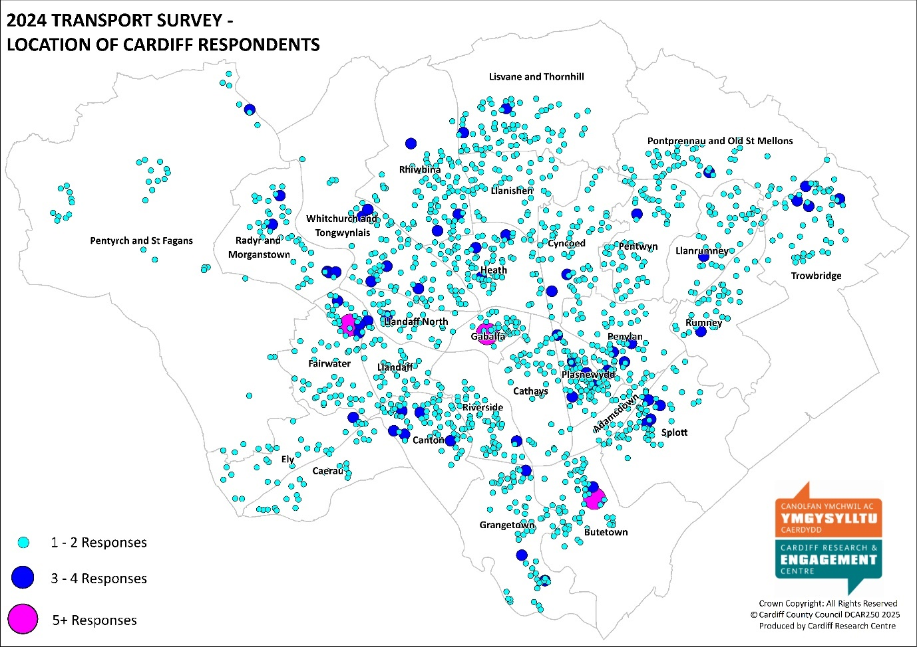
Figure 1: Distribution of Cardiff respondents, using the postcodes provided

Q3 How satisfied are you with the following facilities in Cardiff?
The highest satisfaction was for Walking Facilities in Cardiff, with around six in ten (61.5%) respondents were satisfied. This is followed by Taxi services which were seen as satisfactory by around four in ten respondents (42.9%).
For public transport, 37.4% of respondents were satisfied with the Rail Service, with a similar proportion (35.2%) satisfied with the Bus Service.
In contrast, only one in ten (11.3%) respondents were satisfied with Park & Ride facilities. Nearly four in ten (37.9%) were Very Dissatisfied with those facilities.
Walking, Bus and Rail services elicited higher response numbers compared with other modes.

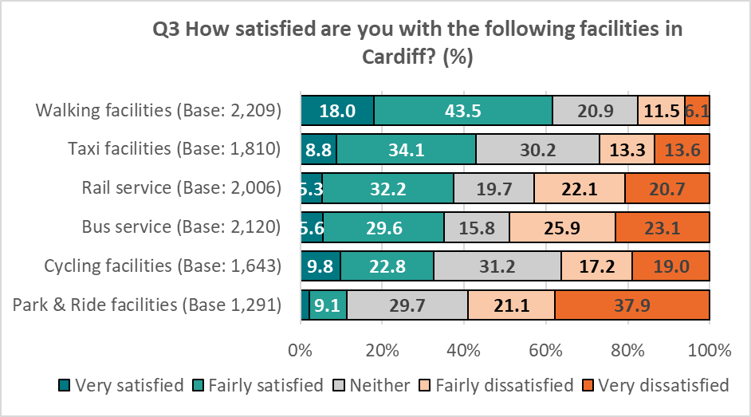

The table and chart below show a year-on-year comparison. Note that the earlier Public Transport option was separated into Bus service and Rail service for 2023 and 2024. In 2024 a new category, Taxi facilities, was added.
In every year except 2016, Walking facilities has had the highest satisfaction ratings: in 2024, 61.5% were satisfied, of which 18.0% were Very Satisfied, and 43.5% Fairly Satisfied.

There has been a marked drop in satisfaction with public transport services since 2016, from two thirds of respondents saying they were satisfied in 2016 (66.9%), to nearer one third of respondents satisfied in 2023 and 2024.
Satisfaction with Park & Ride facilities has also shown a decline since 2016, from 51.7% to 11.3% in 2024.
However, satisfaction with Cycling facilities has improved from a 22.5% low in 2017 to 32.6% in 2024.
 | 2013 | 2014 | 2015 | 2016 | 2017 | 2018 | 2019 | 2023 | 2024
Public transport | 66.1 | 59.3 | 60.1 | 66.9 | 54.8 | 49.8 | 40.2 | N/A | N/A
Bus service | - | - | - | - | - | - | - | 32.7 | 35.2
Rail service | - | - | - | - | - | - | - | 31.0 | 37.4
Walking facilities | 74.8 | 72.7 | 74.3 | 56.0 | 59.5 | 67.2 | 63.5 | 58.4 | 61.5
Cycling facilities | 44.9 | 41.4 | 37.7 | 38.0 | 22.5 | 28.8 | 24.2 | 32.5 | 32.6
Park & Ride facilities | 49.9 | 48.5 | 51.4 | 51.7 | 33.8 | 31.8 | 27.6 | 11.8 | 11.3
Taxi facilities | - | - | - | - | - | - | - | - | 42.9

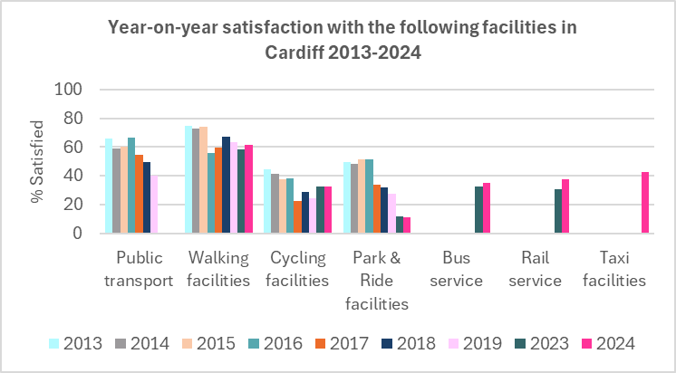
In terms of the respondent sub-groups, in 2024’s survey satisfaction with the ‘Bus Service’ was highest for those aged 55+ (42.4%). However, over two fifths of each demographic group analysed were dissatisfied with the service, most notably respondents that identify as disabled (58.4%), those aged 35-54 (57.1%), households with a child (56.5%) and those from an ethnically diverse background (54.4%).
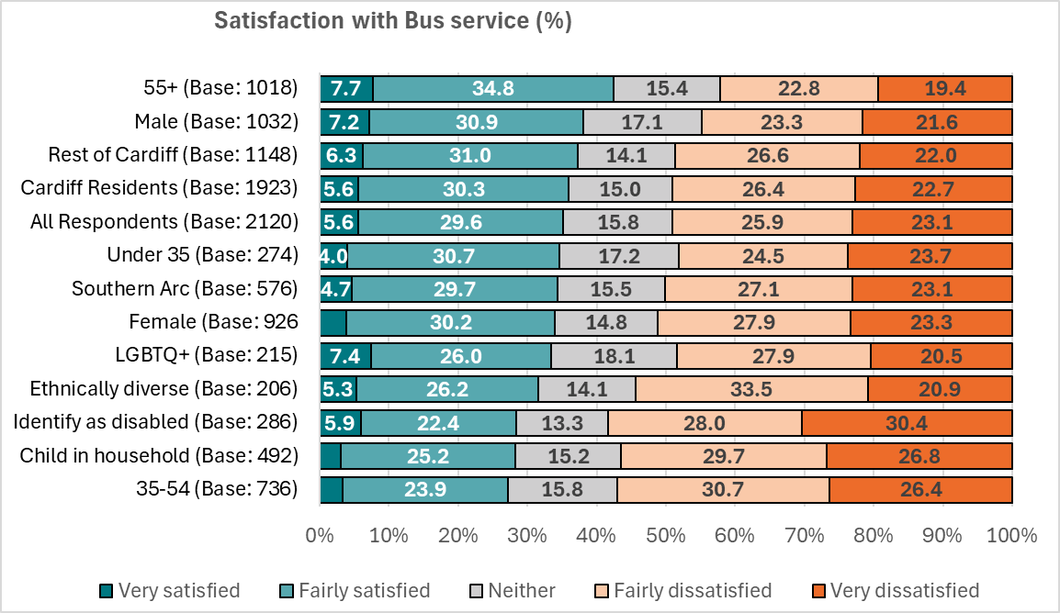
Excludes ‘Don’t Know’ responses
Respondents aged 55+ (42.9%) were the group most satisfied with the Rail Service in Cardiff, with a similar figure for LGBTQ+ respondents (41.5%). Respondents with a child in the household and those aged 35-54 were the two groups that showed the highest dissatisfction with the service (51.6% and 50.7% respectively).
.
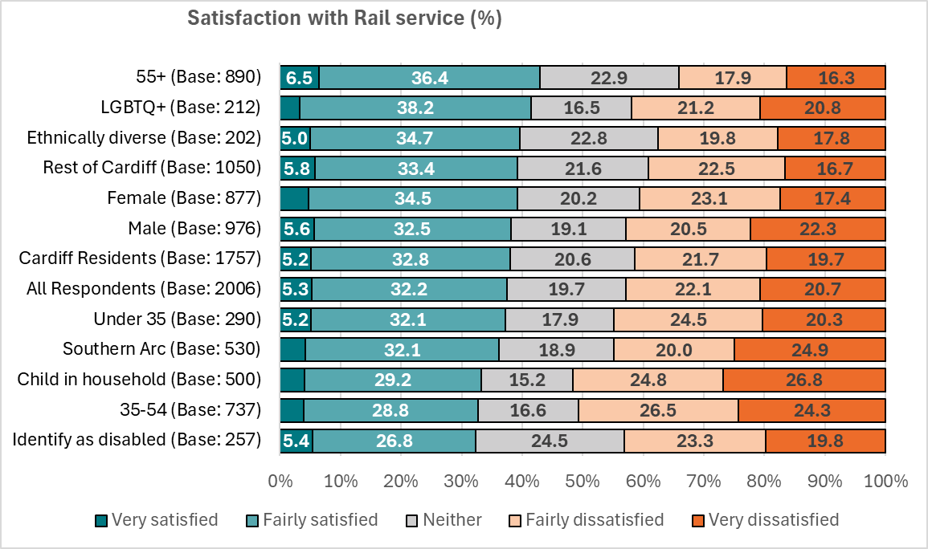
Excludes ‘Don’t Know’ responses
Respondents aged under 35 were most likely to be content with ‘Walking Facilities’ with seven in ten (70.5%) stating they were satisfied. In fact, with the exception of those that identity as disabled, at least circa six in ten (58.9% up to 70.5%) of respondents from each of the sub-groups were satisfied with these facilities. However, around a quarter of respondents that identify as disabled (26.2%) expressed dissatisfaction, as did around a fifth of Southern Arc respondents (21.8%).
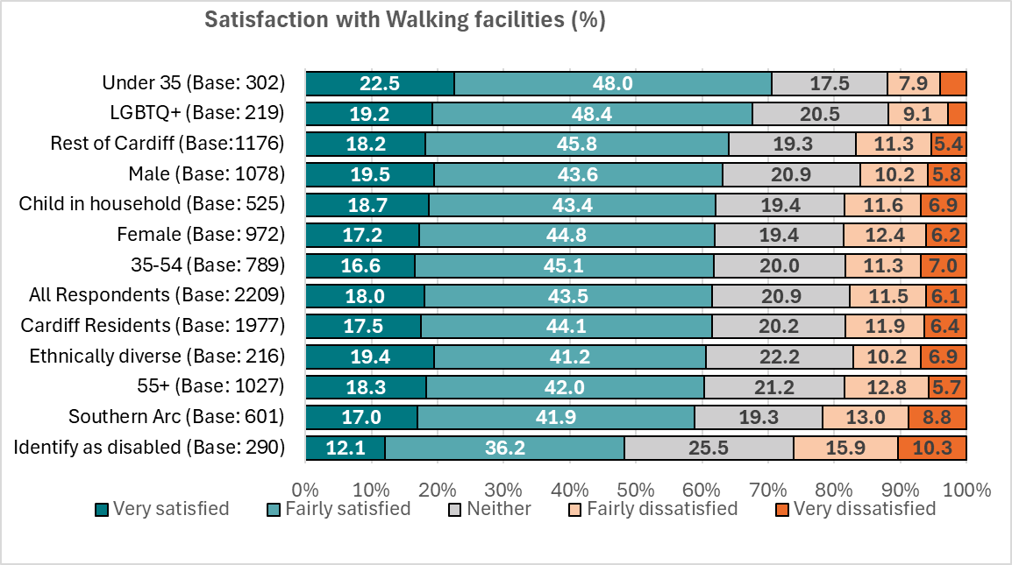
Excludes ‘Don’t Know’ responses.

When broken down by demographics, satisfaction with ‘Cycling Facilities’ was broadly consistent with that of the overall findings with the exception of those who identify as disabled, which had the highest ‘Neither’ score (41.5%). Those from an ethnically diverse background (41.3%) was seen as the group most satisfied with the facilities, closely followed by those under 35 (39.4%), whilst men and those that identify as disabled were least likely to be satisfied (38.7% and 38.5% respectively).
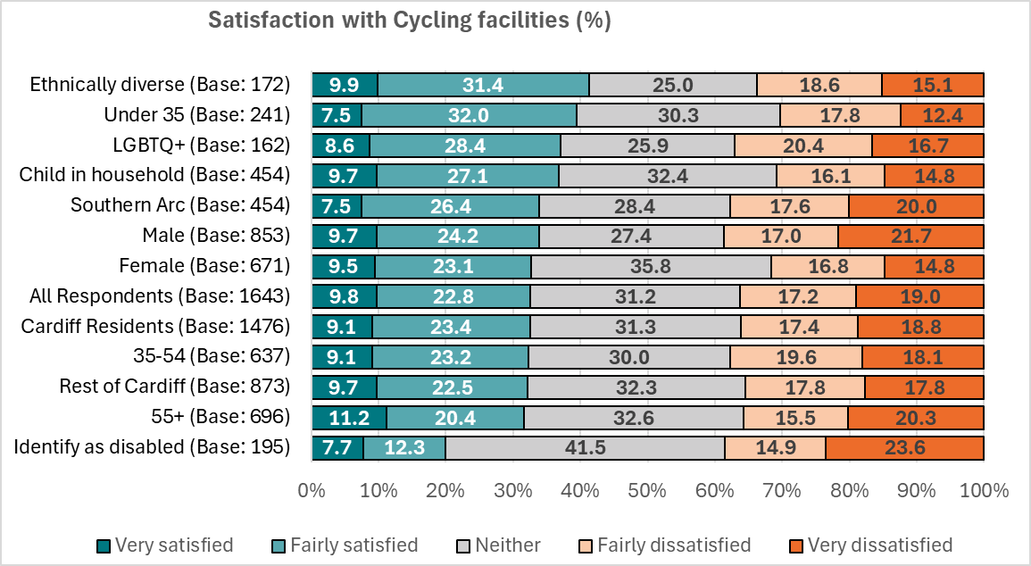
Excludes ‘Don’t Know’ responses.

Opinions of Park and Ride Facilities were low across the board, with satisfaction ranging from 10.2% for Southern Arc respondents to 18.7% from respondents from an ethnically diverse background. At least a half of all sub-groups were dissatisfied with Park and Ride facilities in Cardiff.
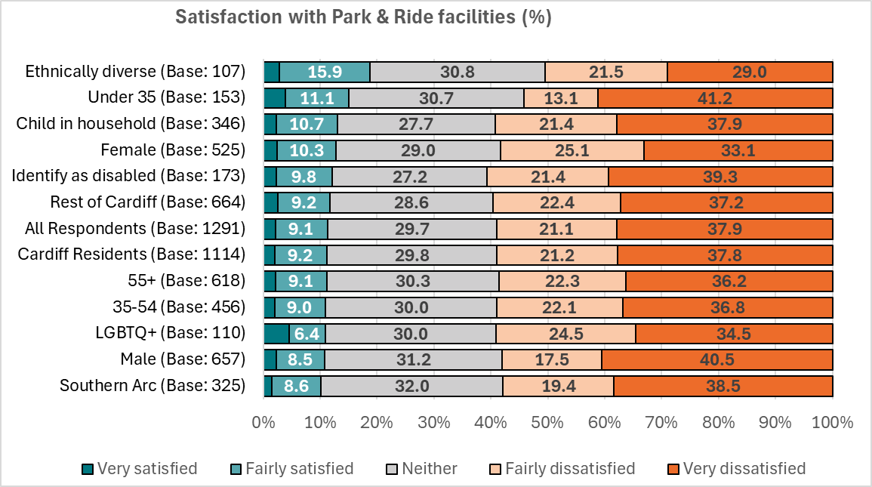
Excludes ‘Don’t Know’ responses.

Satisfaction with Taxi Facilities was fairly consistent across all the groups, ranging from a high of just under five in ten (48.7%) females to just under four in ten (39.8%) males. Dissatisfaction was greatest amongst the LGBTQ+ group (35.1%) and those who identify as disabled (34.7%). In this latter group, around two in ten (21.9%) were Very Dissatisfied.
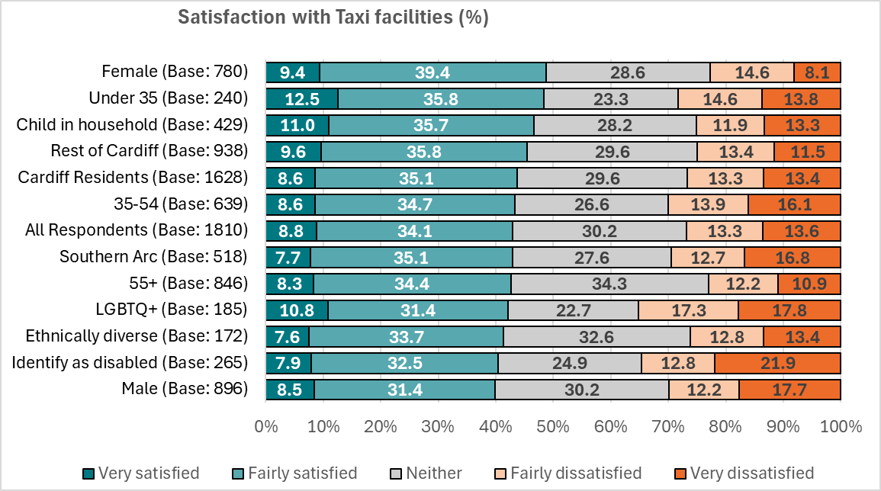
Excludes ‘Don’t Know’ responses.

Q4 How do you travel to or from the following activities?
The data can be looked at two ways: by activity, and by mode of transport.
The table below shows the data by activity. Respondents could select more than one mode for each activity reflecting different travel on different occasions, or combination usage. The main activities were Leisure (2,096 responses), City Centre Shopping (2,093 responses), Other Shopping (1,969) and Other Personal Business (1,556). There were smaller responses for Within your work day (1,404) and Escorting others (947) and the lowest reporting for Education (453). Regardless of activity, figures for Cycle Hire, Park & Ride and ‘Other’ are small, so should be treated with caution.
Looking at the main activities: for Leisure Activities, more than half travel On Foot (53.7%) and as Car or Van Driver alone (53.6%). For City Centre Shopping over half (54.6%) use the bus, and nearly four in ten (38.6%) do so on foot. This may be in combination with bus use / other modes. For Other Shopping, 57.5% travel as Car or Van Driver alone. This rises to six in ten for Other Personal Business and Travel within your Work Day (59.2% and 59.5% respectively).
Mode of transport | City Centre Shopping |  | Other Shopping |  | Education |  | Leisure Activities |  | Other personal business e.g. to bank |  | Escorting others |  | Within your work day as part of your job
Mode of transport | No. | % | No. | % | No. | % | No. | % | No. | % | No. | % | No. | %
On Foot | 808 | 38.6 | 935 | 47.5 | 121 | 26.7 | 1125 | 53.7 | 882 | 56.7 | 275 | 29.0 | 390 | 27.8
Bicycle | 230 | 11.0 | 207 | 10.5 | 50 | 11.0 | 495 | 23.6 | 216 | 13.9 | 55 | 5.8 | 226 | 16.1
Cycle hire | 12 | 0.6 | 8 | 0.4 | 1 | 0.2 | 38 | 1.8 | 8 | 0.5 | 2 | 0.2 | 11 | 0.8
Bus | 1143 | 54.6 | 341 | 17.3 | 74 | 16.3 | 783 | 37.4 | 433 | 27.8 | 91 | 9.6 | 319 | 22.7
Train | 547 | 26.1 | 174 | 8.8 | 51 | 11.3 | 735 | 35.1 | 194 | 12.5 | 51 | 5.4 | 328 | 23.4
Car or Van (Driver Alone) | 635 | 30.3 | 1133 | 57.5 | 184 | 40.6 | 1123 | 53.6 | 921 | 59.2 | 376 | 39.7 | 836 | 59.5
Car or Van (Driver with passengers) | 596 | 28.5 | 831 | 42.2 | 131 | 28.9 | 900 | 42.9 | 516 | 33.2 | 500 | 52.8 | 279 | 19.9
Car or Van (Passenger) | 299 | 14.3 | 452 | 23.0 | 46 | 10.2 | 527 | 25.1 | 290 | 18.6 | 136 | 14.4 | 151 | 10.8
Park & Ride by Bus | 48 | 2.3 | 22 | 1.1 | 4 | 0.9 | 26 | 1.2 | 29 | 1.9 | 4 | 0.4 | 14 | 1.0
Park & Ride by Train | 68 | 3.2 | 22 | 1.1 | 1 | 0.2 | 55 | 2.6 | 18 | 1.2 | 7 | 0.7 | 20 | 1.4
Taxi | 127 | 6.1 | 69 | 3.5 | 11 | 2.4 | 738 | 35.2 | 142 | 9.1 | 37 | 3.9 | 93 | 6.6
Other | 12 | 0.6 | 19 | 1.0 | 21 | 4.6 | 25 | 1.2 | 12 | 0.8 | 15 | 1.6 | 27 | 1.9
Total Respondents | 2,093 | - | 1,969 | - | 453 | - | 2,096 | - | 1,556 | - | 947 | - | 1,404 | -
NB. Percentages do not sum to 100% because respondents could give multiple answers

The data can also be looked at by mode of transport, where the base for the percentage is the number of people who selected that mode for one or more activities. This gives different percentages to those in the table above, and both perspectives provide insights into travel patterns.
Here the modes are grouped into ‘Public Transport’ (train and bus), ‘Active Travel’ (on foot, bicycle, and cycle hire), ‘Car and Van’ (driver alone, driver with passenger(s), passenger), ‘Park & Ride’, ‘Taxi’ and ‘Other.
For Public Transport, City Centre Shopping and Leisure / Social activities are the main activities:
Nearly eight in ten of respondents who selected Bus for one or more activities use it for City Centre Shopping (78.4%), followed by Leisure/Social Activities (53.7%).
Of those who travel by Train, 63.5% use it for Leisure/Social Activities, followed by City Centre shopping (47.2%).
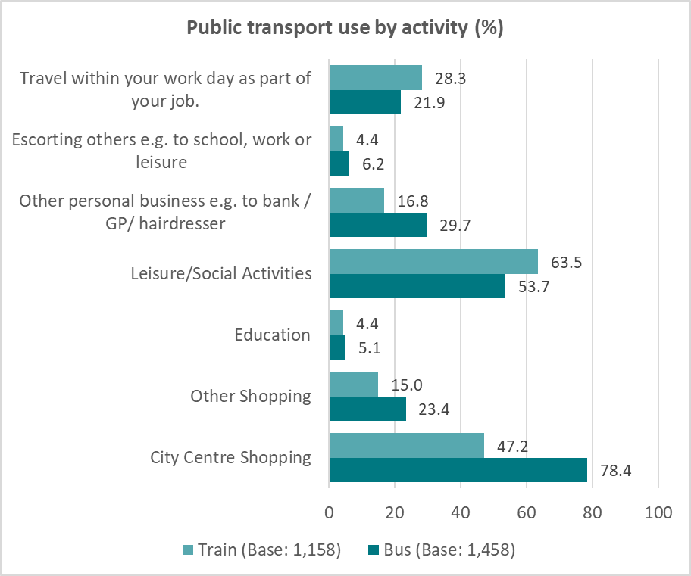
NB. Percentages do not sum to 100% because respondents could give multiple answers.

For Active Travel we asked about travel On Foot, Bicycle, and Cycle Hire. However, as cycle hire figures as very low, only on foot and bicycle travel are discussed here.
For those travelling on foot, the main use is Leisure/Social Activities (63.6%) followed by Other shopping (52.8%) and City Centre shopping (45.6%)
The main use of Bicycles is Leisure/Social Activities (82.4%), followed by City Centre Shopping (38.3%) and Travel within your work day as part of your job (37.6%).

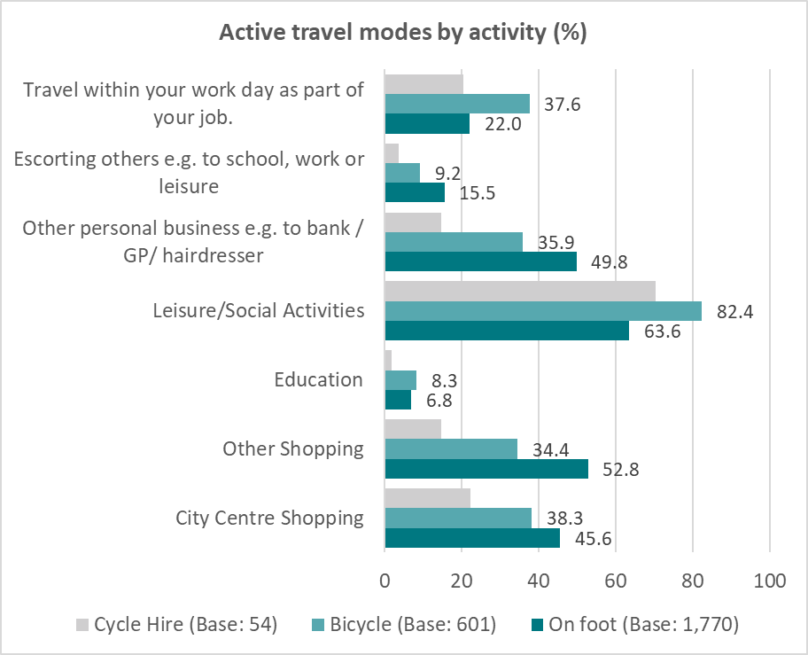
NB. Percentages do not sum to 100% because respondents could give multiple answers.
For Car and Van use, a larger number of respondents travel as a Driver alone (1,617) compared with Driver with passengers (1,241) or Passenger (725).
The pattern of use is similar for each of those, except for Travel within your work day, which was more common for Driver alone (51.7% compared to 22.5% with passenger, and 20.8% as passenger).
The main car and van uses are for Other shopping (70.1% Driver alone, 67.0% with passenger, 62.3% as passenger), and Leisure / Social activities (69.4% Driver alone, 72.5% with passenger,72.7% as passenger).

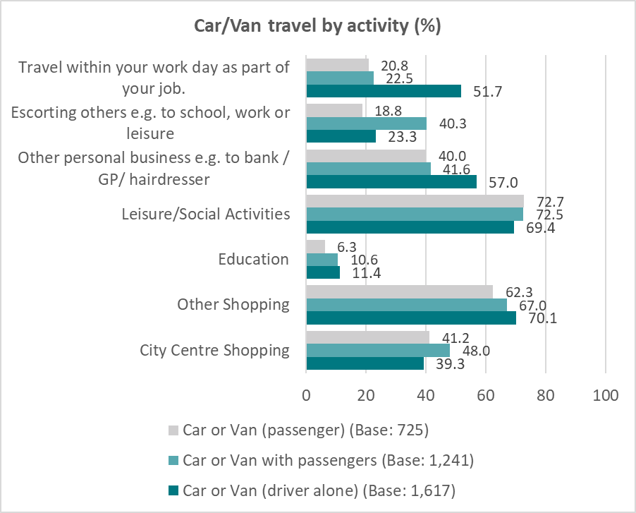
NB. Percentages do not sum to 100.0% because respondents could give multiple answers.

Park & Ride modes
The number reporting using Park & Ride is small, at a little over 100 respondents reporting using either Park & Ride by train or Park & Ride by bus, so percentages should be treated with caution. However, The main use of Park & Ride by bus and train is for City Centre Shopping (45.3% and 60.7% respectively). For Park & Ride by train, the next most common purpose was for Leisure/Social Activities (49.1%). For Park & Ride by bus the next most common was Other personal business (27.4%) with Leisure/Social Activities a close third (24.5%)
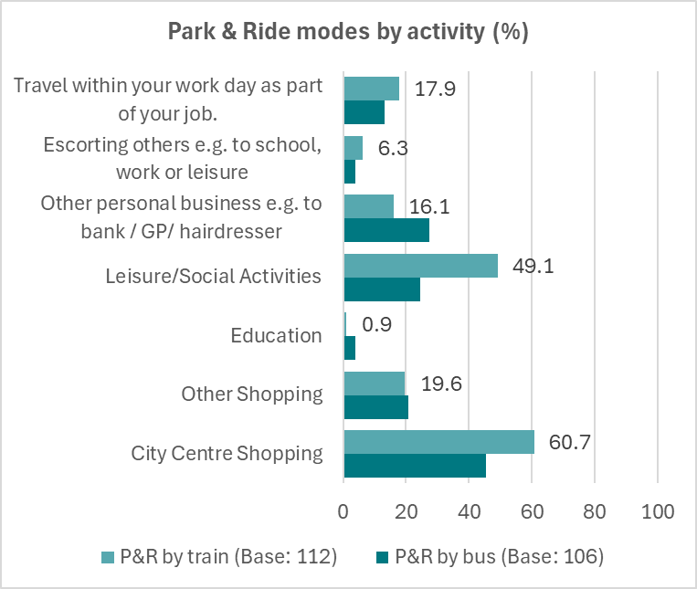
NB. Percentages do not sum to 100.0% because respondents could give multiple answers.

For travel by Taxi most responses were for Leisure/Social activities (82.2%), followed by Other personal business (15.8%).
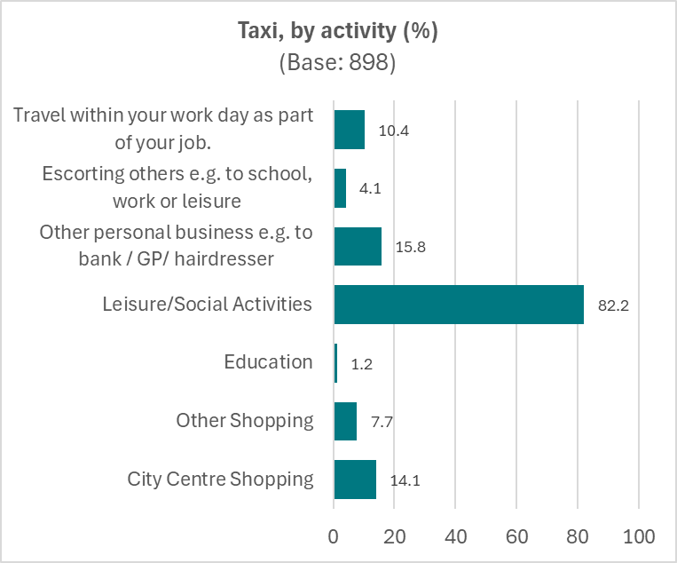
NB. Percentages do not sum to 100.0% because respondents could give multiple answers.

‘Other’
There were 68 instances of ‘Other mode’ being chosen, which is a small sample and should therefore be treated with caution. However, the highest proportions were for ‘Travel with your work day as part of your job’ (39.7%), and Leisure/Social activities (36.8%).
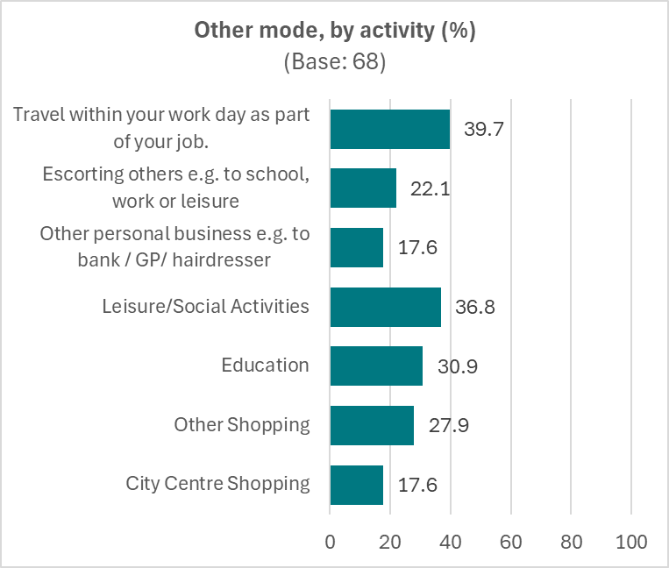
NB. Percentages do not sum to 100.0% because respondents could give multiple answers.

Respondents that selected ‘Other’ were asked to specify: 40 left a comment. Of these, 18 were ‘N/A’. Of the remaining 22, 6 stated they used a motorbike, 4 use an accessibility vehicle e.g. a wheelchair or wheelchair-adapted vehicle, 4 active travel (e.g 3 walk, 1 roller-skates), 4 said ‘online’. There were 9 miscellaneous comments e.g. “When bank holiday services 14 bus that takes me to work on weekdays is not on so I have to pay a taxi to get to uhw . It's making it really hard for me since the service runs only morning and struggle to get home from work in the night as got to change 2 buses.” Comments could cover more than one theme, so the total is greater than the number of respondents.
Summary table showing how respondents use different modes of travel:
Mode of transport | City Centre Shopping |  | Other Shopping |  | Education |  | Leisure Activities |  | Other personal business e.g. to bank / GP/ hairdresser |  | Escorting others e.g. to school, work or leisure |  | Travel within your work day as part of your job. |  | Total for mode
Mode of transport | No. | % | No. | % | No. | % | No. | % | No. | % | No. | % | No. | % | No.
On Foot | 808 | 45.6 | 935 | 52.8 | 121 | 6.8 | 1125 | 63.6 | 882 | 49.8 | 275 | 15.5 | 390 | 22.0 | 1770
Bicycle | 230 | 38.3 | 207 | 34.4 | 50 | 8.3 | 495 | 82.4 | 216 | 35.9 | 55 | 9.2 | 226 | 37.6 | 601
Cycle hire | 12 | 22.2 | 8 | 14.8 | 1 | 1.9 | 38 | 70.4 | 8 | 14.8 | 2 | 3.7 | 11 | 20.4 | 54
Bus | 1143 | 78.4 | 341 | 23.4 | 74 | 5.1 | 783 | 53.7 | 433 | 29.7 | 91 | 6.2 | 319 | 21.9 | 1458
Train | 547 | 47.2 | 174 | 15.0 | 51 | 4.4 | 735 | 63.5 | 194 | 16.8 | 51 | 4.4 | 328 | 28.3 | 1158
Car or Van (Driver Alone) | 635 | 39.3 | 1133 | 70.1 | 184 | 11.4 | 1123 | 69.4 | 921 | 57.0 | 376 | 23.3 | 836 | 51.7 | 1617
Car or Van (Driver with passengers) | 596 | 48.0 | 831 | 67.0 | 131 | 10.6 | 900 | 72.5 | 516 | 41.6 | 500 | 40.3 | 279 | 22.5 | 1241
Car or Van (Passenger) | 299 | 41.2 | 452 | 62.3 | 46 | 6.3 | 527 | 72.7 | 290 | 40.0 | 136 | 18.8 | 151 | 20.8 | 725
Park & Ride by Bus | 48 | 45.3 | 22 | 20.8 | 4 | 3.8 | 26 | 24.5 | 29 | 27.4 | 4 | 3.8 | 14 | 13.2 | 106
Park & Ride by Train | 68 | 60.7 | 22 | 19.6 | 1 | 0.9 | 55 | 49.1 | 18 | 16.1 | 7 | 6.3 | 20 | 17.9 | 112
Taxi | 127 | 14.1 | 69 | 7.7 | 11 | 1.2 | 738 | 82.2 | 142 | 15.8 | 37 | 4.1 | 93 | 10.4 | 898
Other | 12 | 17.6 | 19 | 27.9 | 21 | 30.9 | 25 | 36.8 | 12 | 17.6 | 15 | 22.1 | 27 | 39.7 | 68
NB. Percentages do not sum to 100.0% because respondents could give multiple answers.

Q5 Are you currently in employment?
Nearly seven in ten (67.7%) respondents are currently in employment.
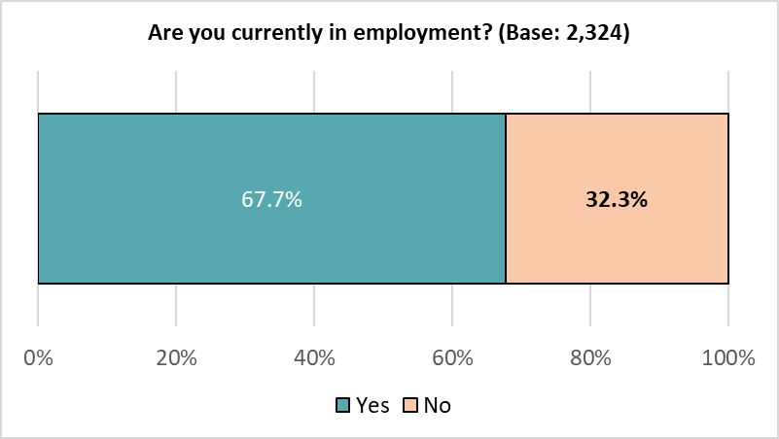

Q6 If currently in employment, how often do you travel by the following types of transport when commuting to or from your usual place of work?
Amongst respondents in employment, a little under seven in ten (67.8%) indicated that they work from home at least one day a week. This included 19.2% that work from home 3 days a week, and 16.1% that work from home 5 days a week.

Three in five (65.1%) indicated that they commute to work at least once a week by car or van (driver alone). This is more than double that of the next highest figure of 30.6% for travelling by foot.

A little under one in four (23.2%) indicated that they commuted to work at least once a week using a bicycle.
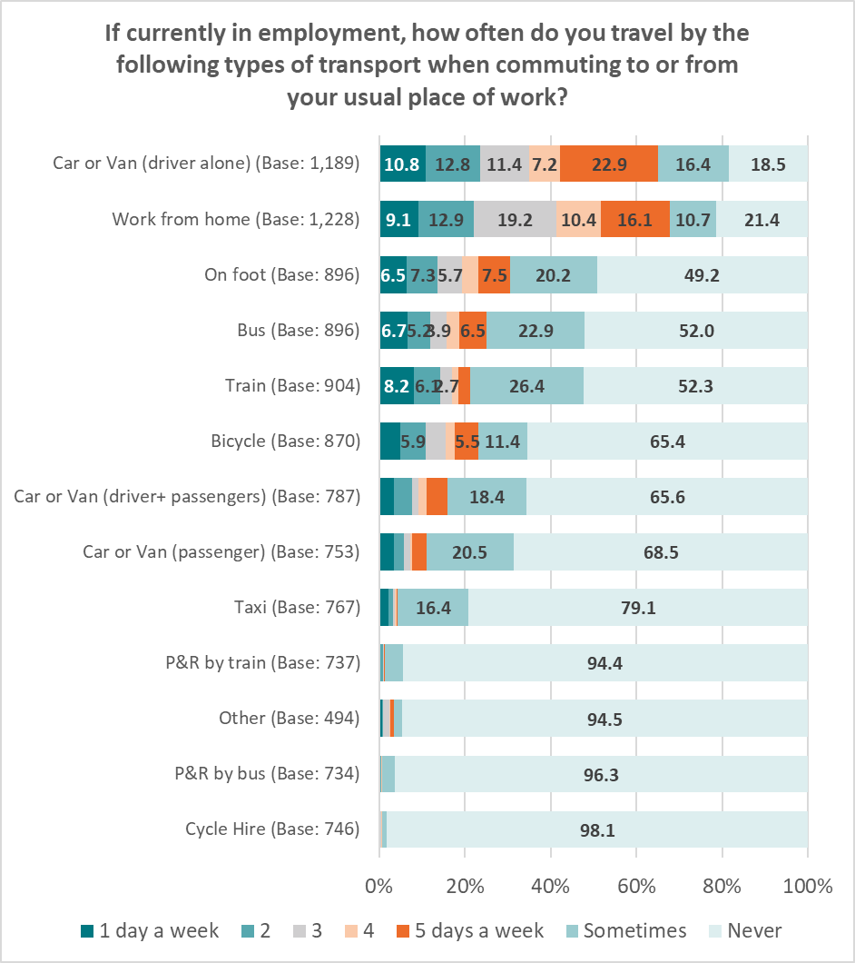

Eighteen respondents left further information about ‘Other’: Of these, 10 use a motorbike, and 8 were miscellaneous, e.g. ‘Coach’, ‘I drive for employment and vehicle is on driveway’.

Q7 Have you changed how you travel over the last 12 months? Please indicate whether you have travelled more or less by each of the following modes.
For each mode of travel, the most likely response was ‘No change’.
Looking at public transport and active travel, a higher proportion (24.9%) indicated that they had used the bus more, compared with 20.7% who had used the bus less. One in five (19.9%) had used the train more, and a similar proportion (21.6%) had used the train less. For walking, a higher proportion (23.8%) said they walk more, compared with 11.0% who had travelled on foot less. In contrast, a lower proportion (10.1%) travel by bicycle more, compared with 18.4% who do so less.
One in five (21.1%) had driven more (Car or Van, driver alone), compared with 13.6% who had driven less. 16.6% had driven with passengers more, compared with 8.8% who had driven with passengers less. 13.5% had been a car or van passenger more, compared with 9.3% who had been a passenger less. For electric car use, one in ten (10.1%) said they used an E-car more, compared with 4.7% who said they used an E-car less.

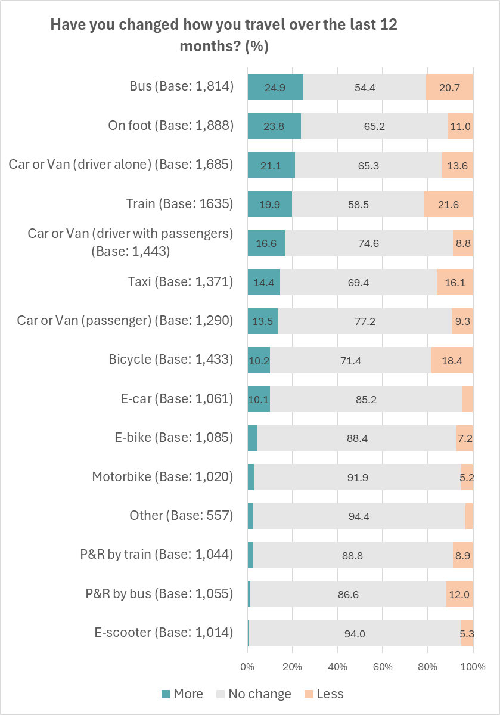
Base sizes are in brackets. Excludes ‘Don’t know’ responses.

Respondents that selected ‘Other’ were asked to specify: 41 participants left a comment.
Theme | No. | % | Example Comments
Public transport / Park & Ride issues | 14 | 34.1 | - Attempted to commute by train and bike from Rhoose several times but service to unreliable, infrequent and limited to support shift work.  - No park and ride available from east;  - Bus not convenient from where I live. Train fairly inconvenient as have to drive to station
Accessibility issues | 8 | 19.5 | - I am partially disabled so need my own car to get around  - 20mph should be more targeted to areas where vulnerable road users are likely to be eg Schools parks etc rather than the blanket cover applied
Motorbike or other wheels | 7 | 17.1 | - Motorcycle
NB. Percentages total more than 100% as responses could include multiple themes.

Q8 How has your travel changed since the introduction of 20mph speed limits?
This was a new question for 2024. It should be noted that the question does not ask ‘How has your travel changed as a result of the introduction’, and therefore a causal relationship should not be inferred.
As for the previous question, the vast majority of respondents reported no change to their travel since the introduction of the 20mph speed limits. For Car and Van, around one in ten reported an increased use (13.9%, 11.3% and 9.8% respectively for driver alone, with passenger, or as a passenger). Similarly, one in ten (10.2%) reported that their on-foot travel had increased.
However, 11.2% of respondents reported that their bus travel had decreased since the introduction of 20mph speed limits.
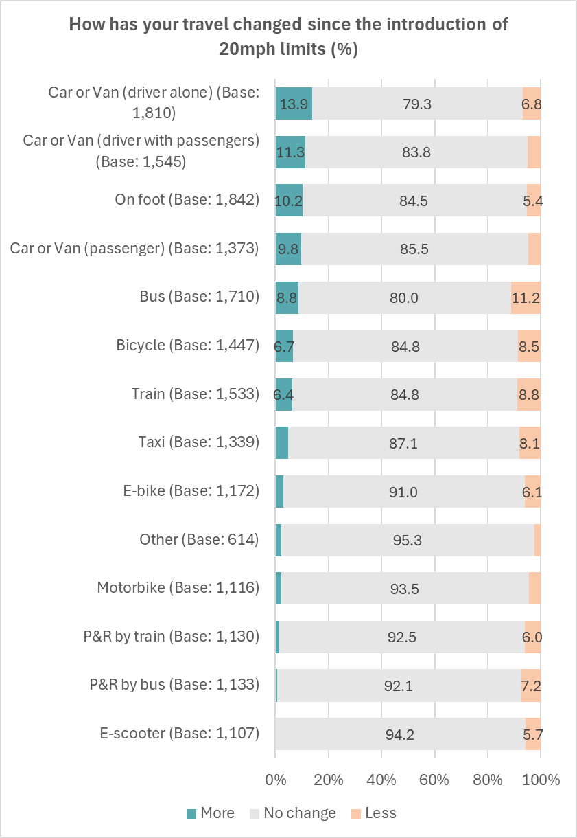

Respondents that selected ‘Other’ were asked to specify: 60 participants left a comment
Theme | No. | % | Example Comments
Increased travel times / congestion | 19 | 31.7% | - Pointlessly sitting in long lines of slow moving traffic or behind cyclists who ignore the over specified cycle lanes  - Travel the same (via car) but it now takes significantly longer due to ridiculous 20mph limits.
(Blanket) 20mph should not have been introduced | 14 | 23.3 | - 20mph should be more targeted to areas where vulnerable road users are likely to be eg Schools parks etc rather than the blanket cover applied
It has not changed anything | 10 | 16.7 | - 20mph has made no difference
NB. Percentages total more than 100% as responses could include multiple themes.

Q9 How have your shopping habits changed over the past three years?
This was a new question for 2024.
Six in ten (59.8%) respondents said they now do more shopping online, with only 4.6% saying they do less.
Nearly six in ten (57.4%) said they do less City Centre shopping.
There was a higher proportion saying ‘No change’ for District Centre Shopping (59.2%), Shopping Outside of Cardiff (53.0%) and Retail Parks (50.5%).
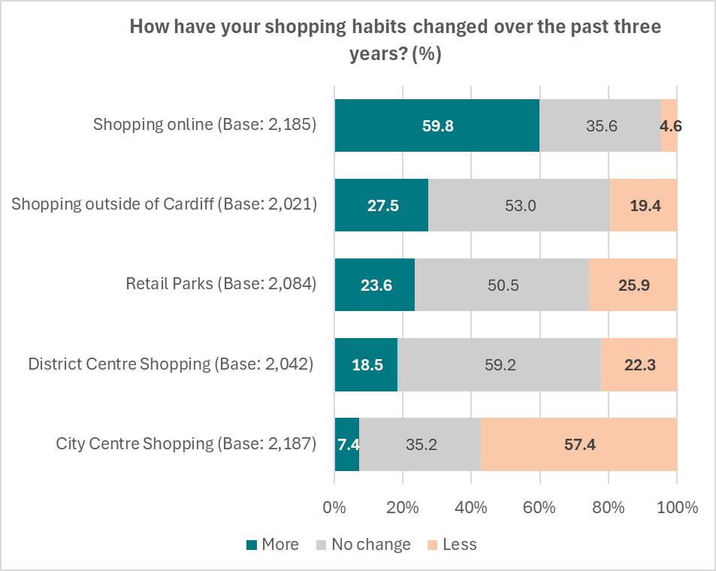

Q10 Approximately how many trips did you make in the last 7 days by each of the following? (There and back counts as 2 trips)
Travelling ‘On foot’ was viewed as the most common trip type with just under four in ten (38.9%) making at least 6 trips in the last 7 days.
Over nine tenths of respondents indicated that they’d taken zero trips in the last 7 days via ‘E-scooter’ (99.6%), ‘Park and Ride by bus’ (98.0%), ‘Park & Ride by Train’ (97.1%), ‘E-bike’ (96.6%) and ‘Other’ (96.0%).
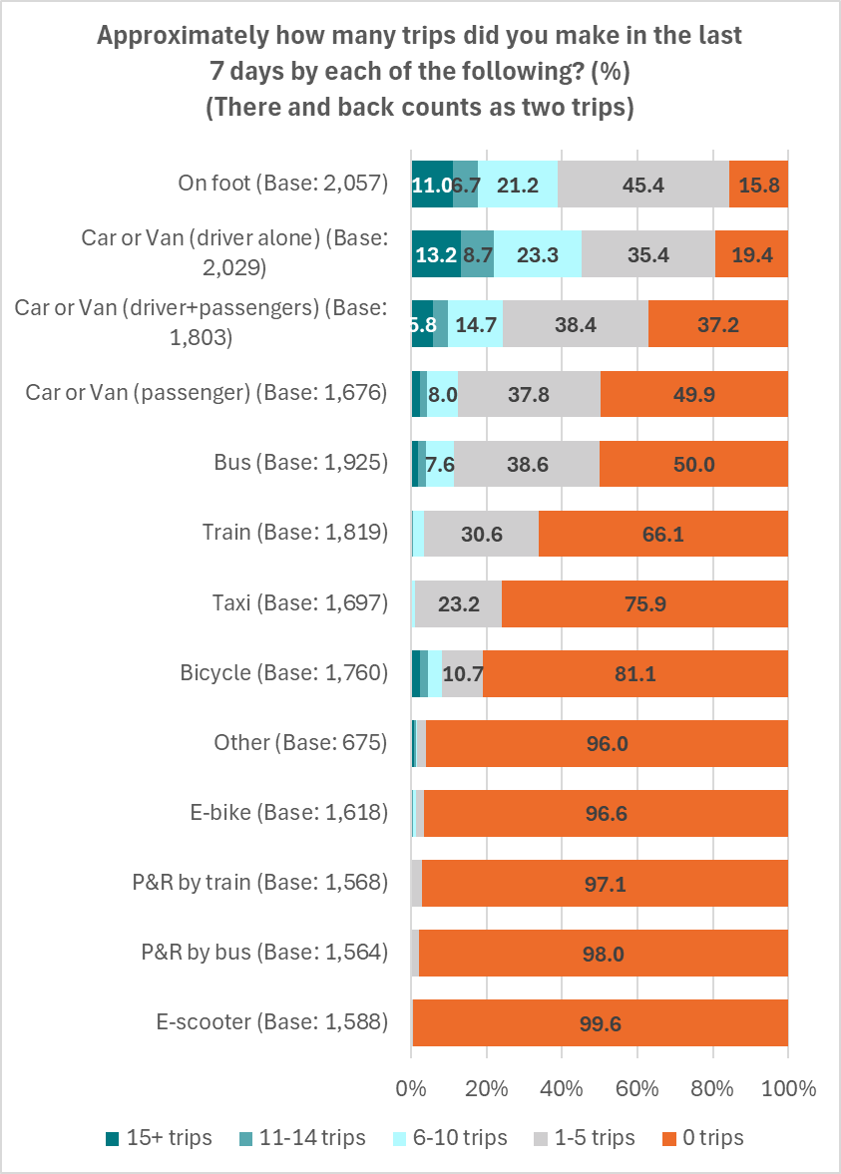

Respondents that selected ‘Other’ were asked to specify, and 33 participants left a comment. The main themes are shown below:
Theme | No. | % | Example Comments
Motorbike | 15 | 45.5% | - Motorcycle  - Motorbike
Other forms of transport | 12 | 36.4 | - Run with Pram  - Pogo
Misc | 6 | 18.2 | - Too cold to ride bikes this time of year!!
NB. Percentages may total more than 100% as responses could include multiple themes.

Q11 How satisfied or dissatisfied are you with each of the following elements of the local bus services? (Whether you use them or not)
After a pattern of decline from 2016, satisfaction with local bus services increased in 2024 for all except one element (Condition of bus stops / bus shelters) when compared with 2023. However, no elements reach the 2016 satisfaction levels.
NB: There have been methodological differences for 2017 onwards compared with previous years. For 2013 to 2016, the Transport Survey was not a standalone survey and instead formed part of Cardiff Council’s Ask Cardiff Survey, which covers a wide range of topics.
In 2024 three elements achieved over 50% satisfaction: Frequency of bus services (60.3%), Reliability of buses (59.9%), and Local bus service overall’ (52.1%).
Two new elements were added for 2024: Cleanliness of the buses, and Driver friendliness/helpfulness.

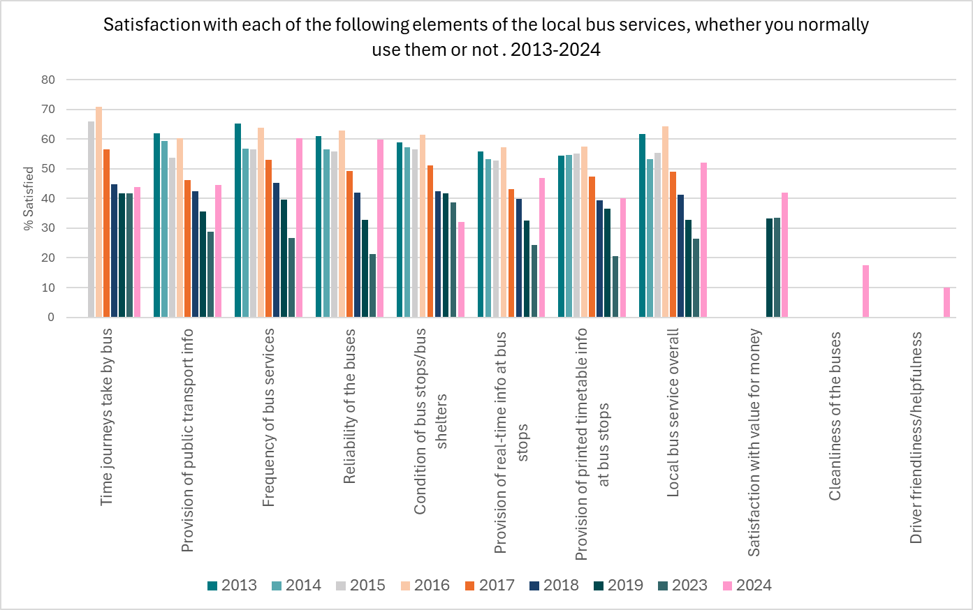
Excludes ‘Don’t Know’ responses.

Q12 Do you use the bus?
Seven in ten (70.5%) respondents indicated that they use the bus.
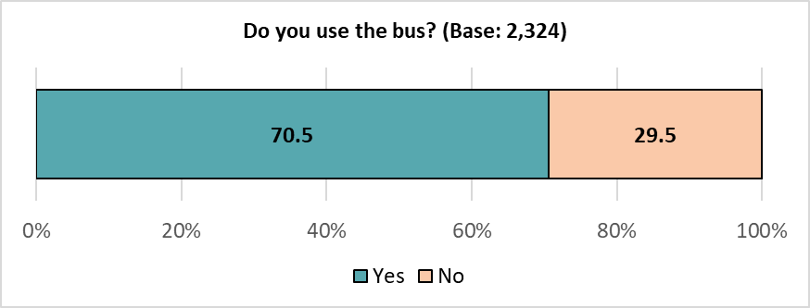

Q13 What are your main reasons for using the bus?
Respondents who use the bus were asked to give the main reasons why they do so.
The main reasons were ‘I have good facilities nearby (bus stops / stations / Park & Ride etc)’ (34.3%), ‘To do my bit to reduce congestion’ (33.4%), and ‘It is cheaper than travelling by other means’ (33.0%). This was followed by ‘To reduce my carbon footprint’ (30.8%) and ‘It is more convenient than travelling by other means’ (27.2%).
Just over one in ten (12.9%) selected ‘It is quicker than travelling by other means’.
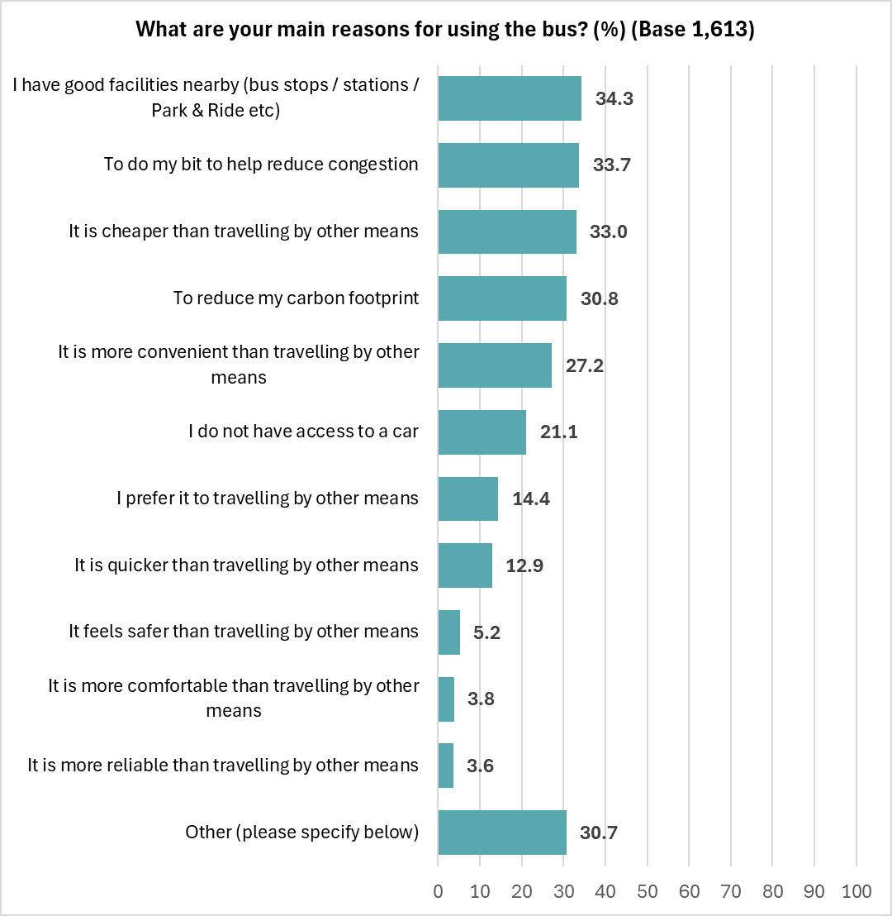
NB. Percentages total more than 100% as respondents could select multiple options.

Looking at the above by demographic group, ‘I have good facilities nearby (bus stops / stations / Park & Ride etc)’ was selected by around three in ten respondents in each demographic group, as was ‘To reduce my carbon footprint’.
‘It is cheaper than travelling by other means’ was less likely to be chosen by those aged 35-54 (15.2%), or with children in the household (15.1%) compared with other groups. As older age groups are more likely to have a bus pass, it is perhaps not surprising that those aged 55+ had the highest proportion (47.3%) who felt that bus is a cheaper option.
There was also variation for ‘To do my bit to help reduce congestion’, which was selected more by LGBTQ+ respondents (42.0%), those aged 55+ (37.2%), and Ethnic Minority (36.9%) groups, compared with those under 35 years old (27.7%).
A full breakdown can be viewed in Appendix A.

Please specify:
Respondents who selected ‘Other’ were asked to specify the reason(s) why they use the bus.
There were 486 respondents left a comment. These comments were then grouped into themes; the top three themes, along with example comments can be viewed below.
A full breakdown of themes can be found in Appendix B.
Theme | No. | % | Example Comments
To avoid drinking and driving / for social occasions | 116 | 23.9 | - To go into town if I am having a night out and want to drink alcohol  - So that I can have a drink  - I don’t drink and drive  - Able to have a beer
To avoid parking costs / hassles | 110 | 22.6 | - If going to town then I would consider taking his as can be cheaper than parking costs.  - Car parking in town too expensive so I have to suffer late buses  - No choice as parking in Cardiff is awful
When there’s no other option | 109 | 22.4 | - As a last resort and if running as the service in Morganstown is terrible.  - I used it as a last resort on days when I don't have access to the car, it's too wet/far/dark to cycle with my kids and there's no train station on my route  - The bus is my last port of call, will only use if there's no other transport, just because it takes too long to get anywhere with traffic, stupid bus lanes which start and finish, no continuous ones which would keep the buses flowing, except they don't and just get caught up in normal traffic jams
NB. Percentages may total more than 100% as responses could include multiple themes.

Q14 What are your main reasons for not using the bus?
Respondents who do not use the bus were asked to give the reasons why they don’t.
‘It is less convenient’ (58.1%) was the most frequently chosen reason why respondents don’t use the bus. This was followed by ‘I prefer to travel by car’ (55.9%) and ‘Journey times are too slow’ (52.1%).
Around 16% stated that they do not use the bus service as ‘It feels unsafe’ (16.7%), ‘It is uncomfortable’ (16.5%) and ‘Toilet facilities are inadequate’ (16.3%).
More than one in ten (12.7%) who do not use the bus said that they ‘prefer to cycle’, and 8.3% said they do not use the bus because ‘Access for disabilities is inadequate’.
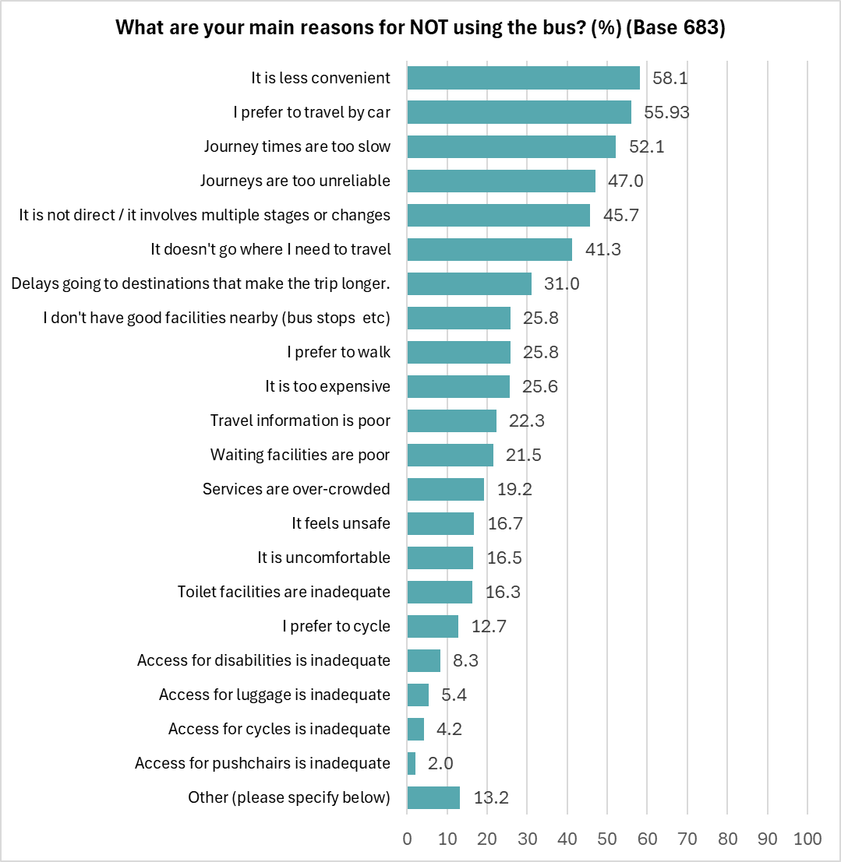
NB. Percentages total more than 100% as respondents could select multiple options.

Looked at by demographic group, ‘It is less convenient’ was more evident for respondents aged under 35 (71.4%), but it was chosen by at least 50% of each group.

‘I prefer to travel by car’ was chosen by between 50% and 60% of each group, apart from Ethnic Minority (43.8%) and LGBTQ+ (42.6%) (NB: there were small numbers for these two groups for this question, so should be treated with caution.)

LGBTQ+, Under 35s and Southern Arc were more likely than other groups to select ‘I prefer to walk’ (44.4%, 36.2% and 36.6% and 34.9% respectively).

Apart from those aged 55+, at least one in five selected ‘It is too expensive’, ranging from 23.2% for Ethnic Minority to 35.4% for those with a child in the house, compared with 18.2% when viewed by respondents aged 55+.
A full breakdown can be viewed in Appendix C.

Please specify:
Respondents who selected ‘Other’ were asked to specify the reason(s) why they don’t use the bus.
There were 86 comments received. These comments were then grouped into themes; the top three themes and example comments can be viewed below.
A full breakdown of themes can be found in Appendix D.
Theme | No. | % | Example Comments
Bus does not run where / when I need it to | 29 | 33.7 | - I don’t have bus service within reasonable walking distance  - The last bus back from town is around 8pm so can't use it for anything in the city centre over an evening  - Timetable times are too late to get to work
Accessibility | 15 | 17.4 | - Not able to use public transport due to mobility and mental health conditions.  - I have a chronic disease and bus travel is too exhausting.
Bus takes too long | 13 | 15.1 | - Do not go to place of work in one trip. Car journey is only 15 minutes. Bus would take 1hr plus  - Awful bus service, takes 50 minutes sat on bus to get to city centre, train 6 minutes. Plus bus service stops mid afternoon. I did try the bus service no 86 btw and have decided never again
NB. Percentages may total more than 100% as responses could include multiple themes.

Q15 Do you use the train?
Just over a half (57.6%) of respondents use the train.
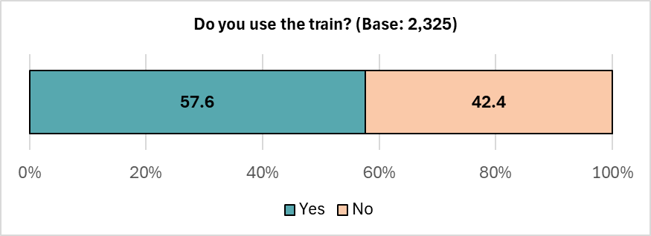

Q16 What are your main reasons for using the train?
Respondents who use the train were asked to give the main reason why they do so.
‘It is quicker than travelling by other means’ (49.4%) was viewed as the main reason why respondents use the train.
This was followed by ‘It is more convenient than travelling by other means’ (37.3%) and ‘To do my bit to help reduce congestion’ (32.5%) and ‘To reduce my carbon footprint’ (32.2%).
Around one in ten (9.7%) cited ‘It is cheaper than travelling by other means’, in contrast to the one in three (33.7%) that selected this option as a reason why they travel by bus.
Both ‘To reduce my carbon footprint’ and ‘To do my bit to help reduce congestion’ were in the top four reasons why respondents use the bus and train.
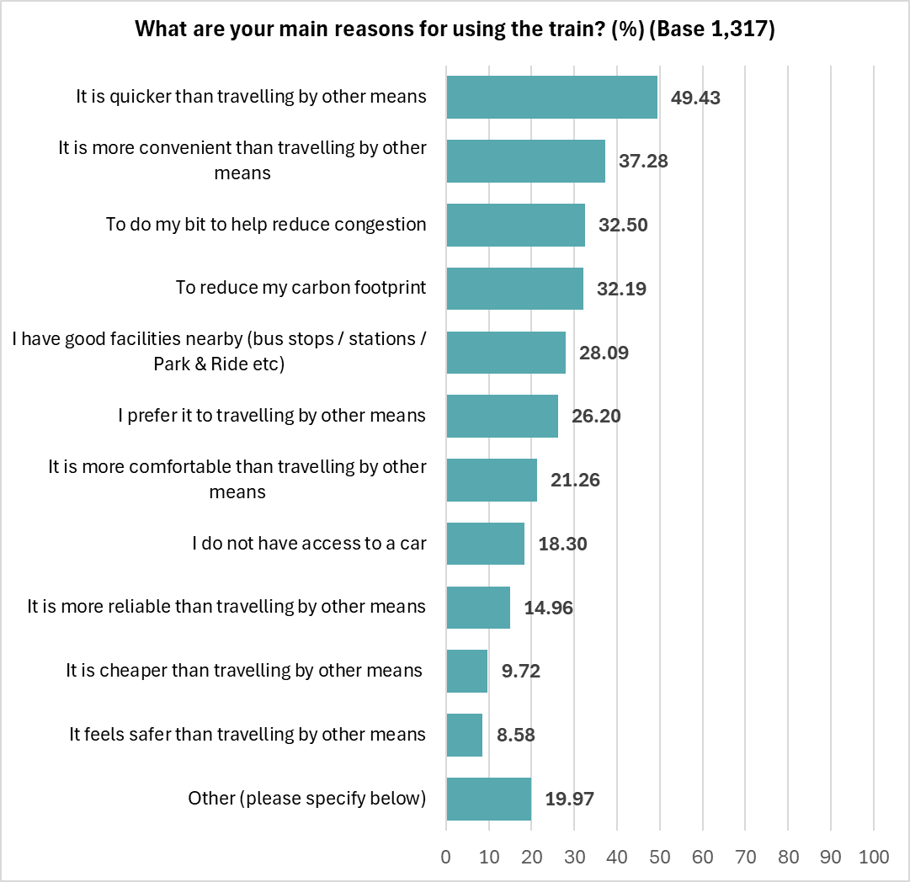
NB. Percentages total more than 100% as respondents could select multiple options.
Looked at by demographic group, when explaining why they travel by train at least two fifths of each sub-group cited ‘It is quicker than travelling by other means’, most notably those aged under 35, where the proportion rose to almost three in five (61.9%).
As with the bus, ‘I do not have access to a car’ saw large discrepancies by age with those aged under 35 more than twice as likely as those aged 55+ to select this option (32.4% and 13.8% respectively). One in three (37.6%) of those who identify as disabled selected this as a reason they use the train.
One in five (20.2%) respondents from the Southern Arc stated that the reason they travel by train was ‘I have good facilities nearby (bus stops / stations / Park & Ride etc)’, compared with one in three (33.9%) respondents in the rest of Cardiff.
A full breakdown can be viewed in Appendix E.

Please specify:
Respondents who selected ‘Other’ were asked to specify the reason(s) why they use the Train.
There were 260 comments received. These comments were then grouped into themes; the top three themes, along with example comments can be viewed below.
A full breakdown of themes can be found in Appendix F.
Theme | No. | % | Example Comments
For longer distances | 77 | 29.6 | - Travel to London regularly by train from Cardiff  - I only use it to travel long distance  - I use it for long distance travel, really expensive though
Negative train comment | 46 | 17.7 | - I use the train to London as it is better than driving, mostly for work. However, the rail fares are way too high and the trains are not reliable enough for business or catching connections.  - I use trains when visiting family. Always a problem, with trains being cancelled, overcrowded, having to stand, nowhere to put luggage. Public transport in the main is unreliable.  - Only when they ain’t cancelled 24/7
To avoid drinking and driving | 41 | 15.8 | - If I want a night out in town  - Only use the train when I know I will be socialising after work..  - When I go to meet people in the city centre and it may involve alcohol.
NB. Percentages may total more than 100% as responses could include multiple themes.

Q17 What are your main reasons for not using the train?
Respondents who do not use the train were asked to give the reasons why they don’t.
‘It is too expensive’ (46.3%) was viewed as the main reason why respondents do not use the train. This was followed by ‘I don't have good facilities nearby (bus stops / stations / Park & Ride etc)’ (37.5%), ‘I prefer to travel by car’ (36.4%) and ‘It is less convenient’ (35.5%).
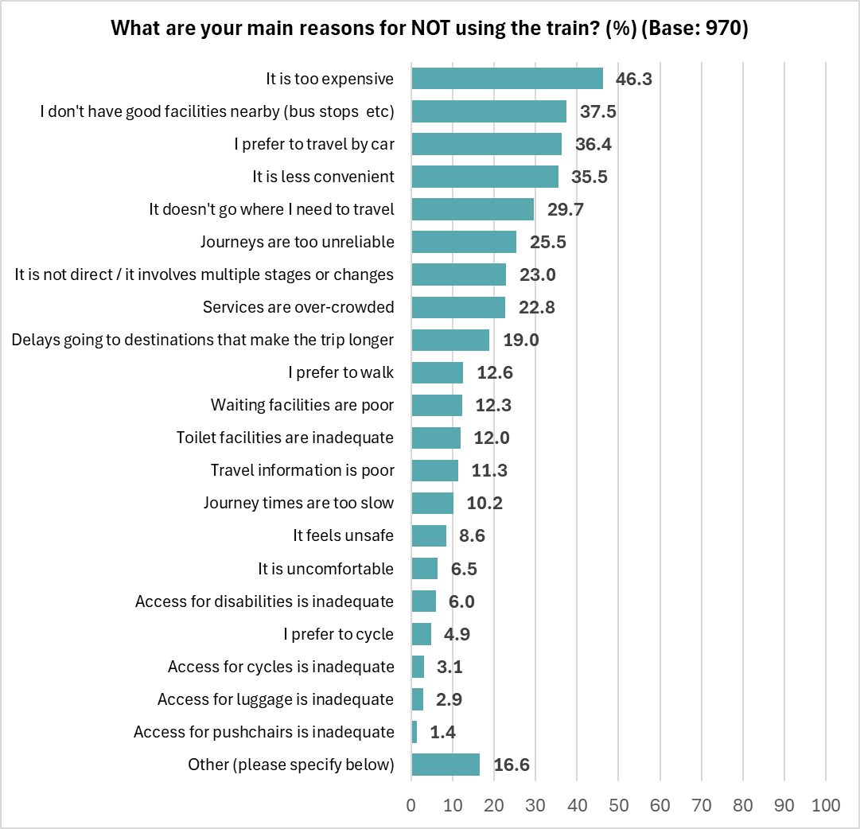NB. Percentages total more than 100% as respondents could select multiple options.
Looked at by demographic group, over two in five respondents from each sub-group cited ‘It is too expensive’ as a reason for not travelling by train - most notably LGBTQ+ (60.6%) and those who identify as disabled (50.3%)
One in five (20.3%) of respondents that identify as disabled selected ‘Toilet facilities are inadequate’, as did LGBTQ+ (19.7%) and those under 35 (19.4%).
Around one in five (22.9%) of respondents that identify as disabled selected ‘Access for disabilities is inadequate’. A full breakdown can be viewed in Appendix G.

Please specify:
Respondents who selected ‘Other’ were asked to specify the reason(s) why they don’t use the train.
There were 157 comments received. These comments were then grouped into themes; the top three themes, along with example comments can be viewed below.
A full breakdown of themes can be found in Appendix H.
Theme | No. | % | Example Comments
No station nearby | 82 | 52.2 | - I live in Old St Mellon's so have no access whatsoever to trains, the buses are unreliable and only every hour, the area I live is massively congested and in need of a rail link  - I literally cannot because I live in Pentwyn where we have 0 facilities for rail travel.  - No station near my home
Unreliable or limited | 18 | 11.5 | - Trains too infrequent to where I live, often don't turn up and finish far too early in an evening. I used to use the train for work, now I drive.  - Infrequent service - Coryton, stopped using when having to get tickets before travel, Cancelled too often, Different tickets to the bus.
Prefer another option | 17 | 10.8 | - It is less convenient than the bus and the bus is free with my pensioner pass. Even if I chose to walk half a mile in the cold with heart disease to my closest station, it is likely the train would be cancelled or over crowded and I'd be put on a rail replacement bus anyway  - Bus stop outside the door train station a walk away
NB. Percentages may total more than 100% as responses could include multiple themes.

Q18 How satisfied or dissatisfied are you with each of the following elements of cycling facilities? (Whether you normally use them or not)
There were changes to the previous question ‘Availability of cycle paths/lanes’, which was split into ‘Availability of shared cycle paths/lanes’ and ‘Availability of segregated cycle paths/lanes. Two questions around cycle hire were not used in 2024, as the cycle hire scheme was not running at the time of the survey.
Looking at changes over time, in 2024 opinions on Cycling Facilities appear to be improving on the 2023 position, with only the satisfaction re ‘Availability of cycle stands’ and ‘Condition of the highway for cycling’ not increasing.
For 2024 the highest level of satisfaction was with ‘Cardiff as a Cycling City’ (34.9%), followed by Width of Cycle paths / Cycle lanes’ (33.9%), ‘Availability of shared cycle paths/lanes’ (33.1%), and ‘Availability of segregated cycle paths/lanes’ (32.3%).

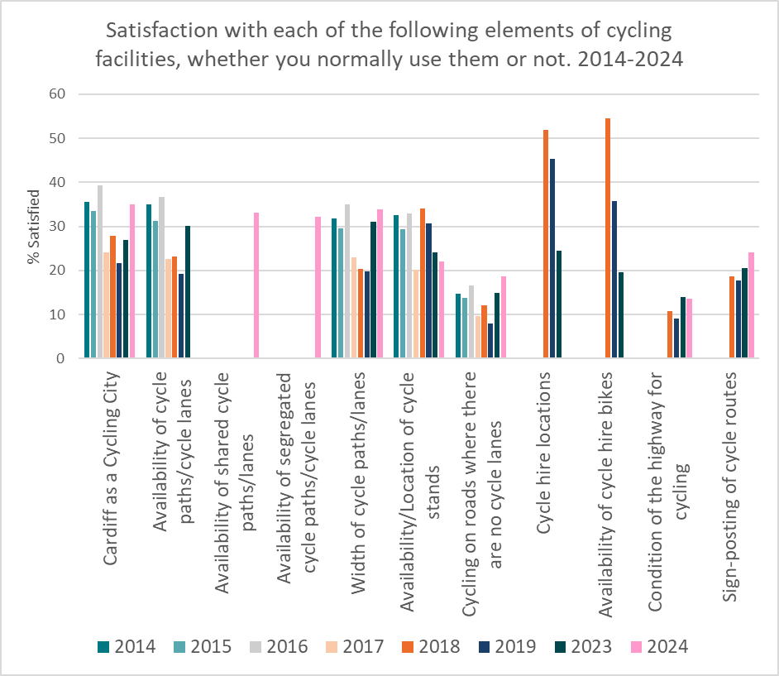

For 2024, Satisfaction was higher than Dissatisfaction for all but two elements: ‘Condition of the Highway for cycling’ (13.4% satisfied compared with 24.7% dissatisfied), and ‘Cycling on roads where there are no cycle lanes’ (20.3% satisfied compared with 18.7% dissatisfied).
Around one in three participants were satisfied with ‘Cardiff as a good place to cycle in’ (34.9%), ‘Width of cycle paths/lanes’ (33.9%), ‘Availability of shared cycle paths/cycle lanes’ (33.1%) and ‘Availability of segregated cycle paths/cycle lanes’ (32.3%).
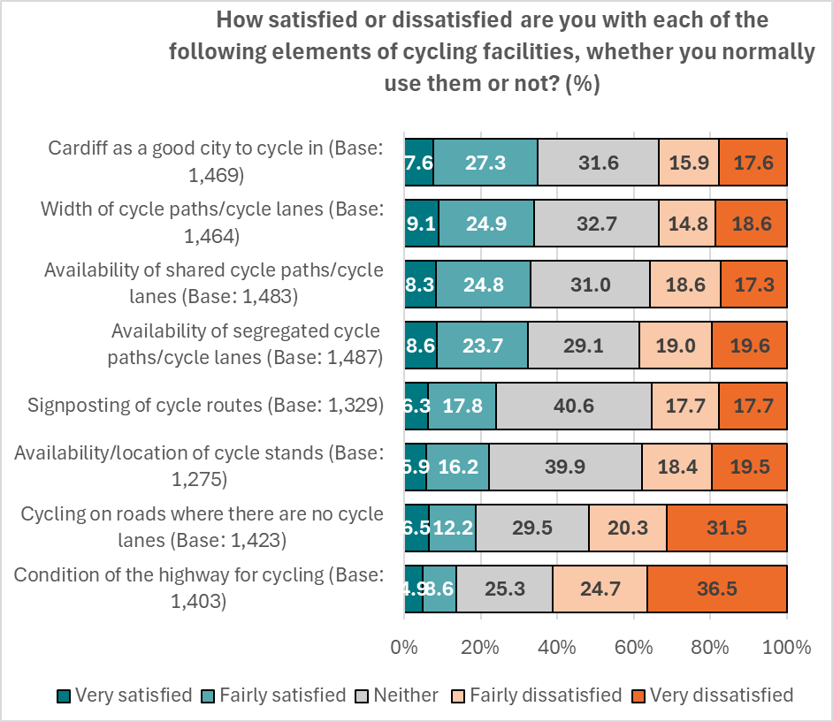
Base sizes shown in brackets. Excludes ‘Don’t Know’ responses.

Q19 How satisfied or dissatisfied are you with the condition of each of the following facilities on the highway?
Over a half of respondents were happy with ‘Street lighting’ and ‘Traffic lights at junctions’ (56.5% and 51.0% respectively).
In contrast, over three in five respondents were dissatisfied with the ‘Road surface’ (78.5%), ‘Road drainage’ (66.9%), and ‘Footway / pavement surface’ (65.2%).
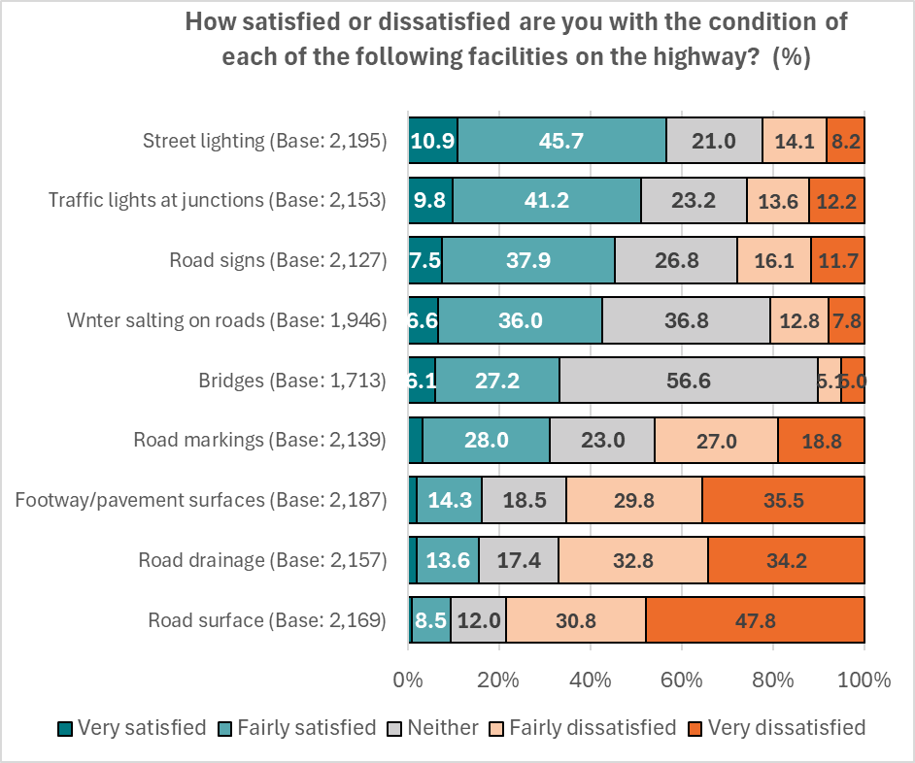
Base sizes shown in brackets. Excludes ‘Don’t Know’ responses.

Q20 How safe do you feel...
Nine in ten respondents said they feel safe or somewhat safe travelling by train or bus in Cardiff (90.7% and 89.0% respectively), and eight in ten (80.0%) said they feel safe or somewhat safe when walking in Cardiff.
However, almost half (46.5%) feel unsafe when cycling in Cardiff.
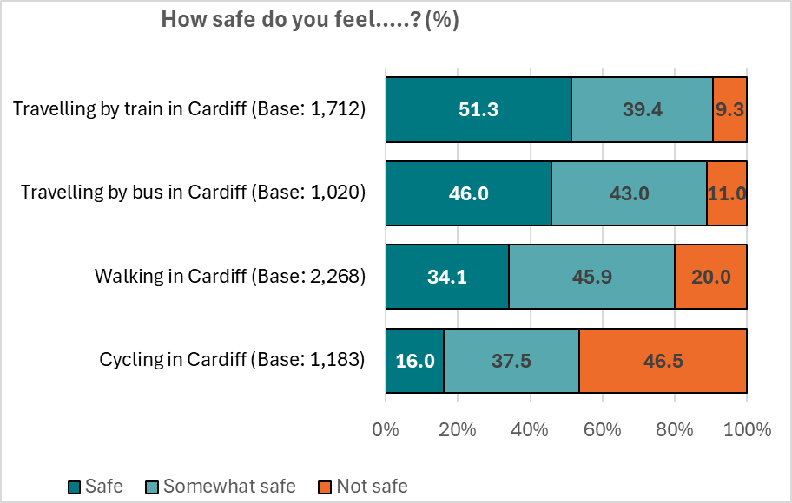
Excludes ‘Don’t Know’ responses.

Q20a How safe do you feel...Walking in Cardiff
Looking at responses from previous years, whilst in 2024 eight in ten (80.0%) of respondents said that they felt safe or somewhat safe when walking in Cardiff, the proportion that state that they do not feel safe when walking in Cardiff is continuing to increase year on year, from 5.8% in 2017 to 20.0% in 2024.
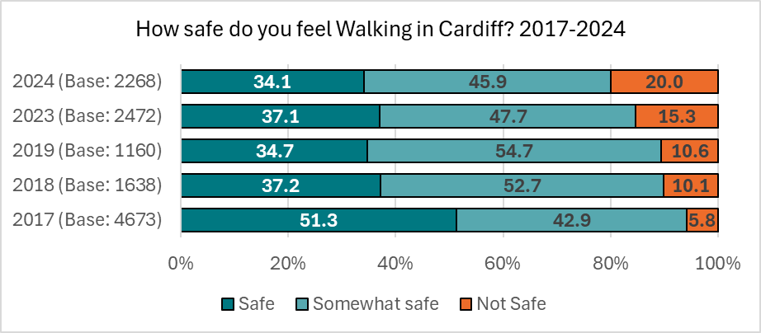
Excludes ‘Don’t Know’ responses.
Looked at by demographics, respondents from each of the sub-groups also predominantly felt safe or somewhat safe when walking in Cardiff. However, although 77.3% of females felt safe or somewhat safe, just 24.1% felt very safe – this is well below the comparative proportion for males (44.6%).
Those that identify as disabled were the least likely to feel safe walking in Cardiff, with nearly three in ten (28.8%) saying they felt unsafe.
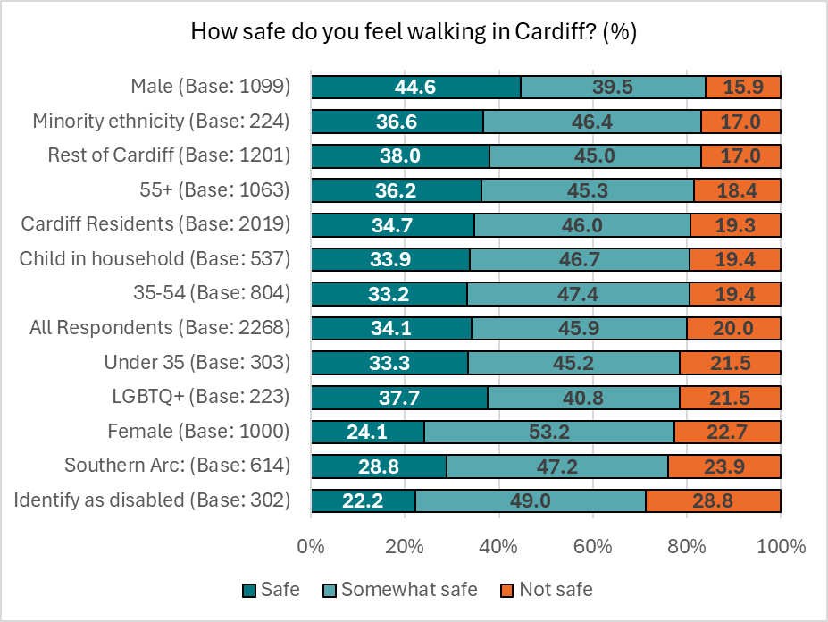
Excludes ‘Don’t Know’ responses.

Q20b How safe do you feel...Cycling in Cardiff
In contrast to walking, almost a half (46.5%) of respondents said they felt unsafe when cycling in Cardiff. However, the proportion of respondents feeling unsafe is at an all-time survey low and is a fall of 13.9 percentage points when compared with the findings from the 2019 survey (60.3%).
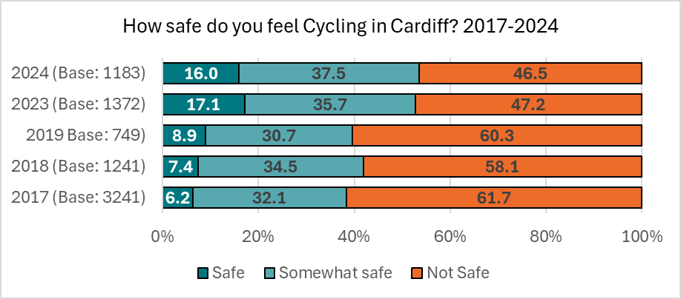
Excludes ‘Don’t Know’ responses.
Looked at by demographic group, at least two in five (38.7%) respondents from all sub-groups felt unsafe whilst cycling in Cardiff, most notably Females (56.4%) and respondents that identify as disabled (53.2%)
Males were most likely to feel ‘Safe’, with one in five (20.0%) male respondents selecting that option compared with one in ten (9.8%) female respondents.
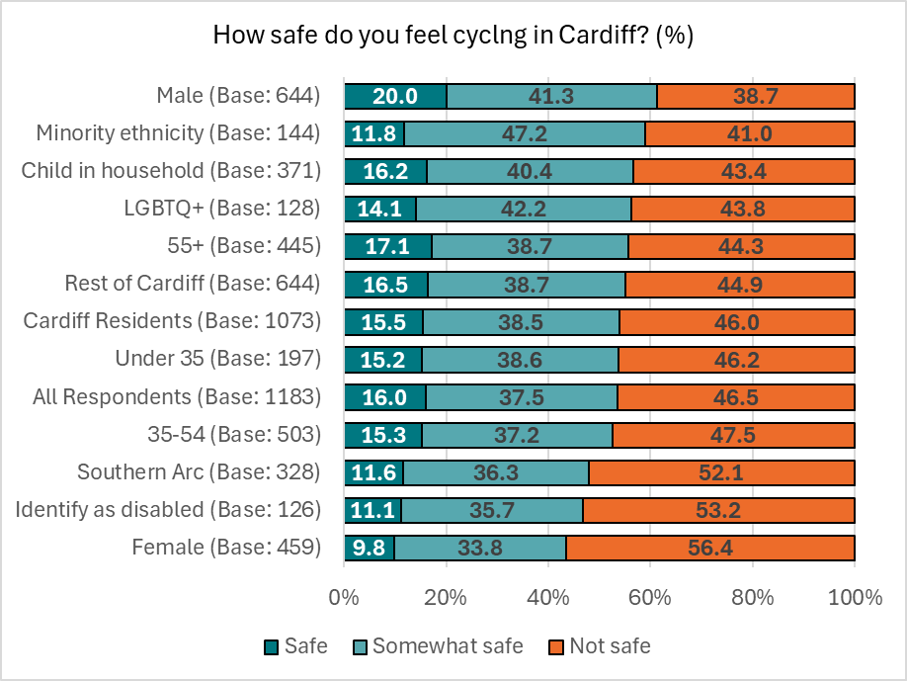
Excludes ‘Don’t Know’ responses.

Q20c How safe do you feel...travelling by bus in Cardiff
Overall, nine in ten (89.0%) respondents feel safe or somewhat safe when travelling by bus in Cardiff.
Looked at by demographic group, at least four fifths of respondents from all sub-groups felt safe or somewhat safe when travelling by bus in Cardiff. Respondents that identify as disabled were the group most likely to not feel safe (16.2%).
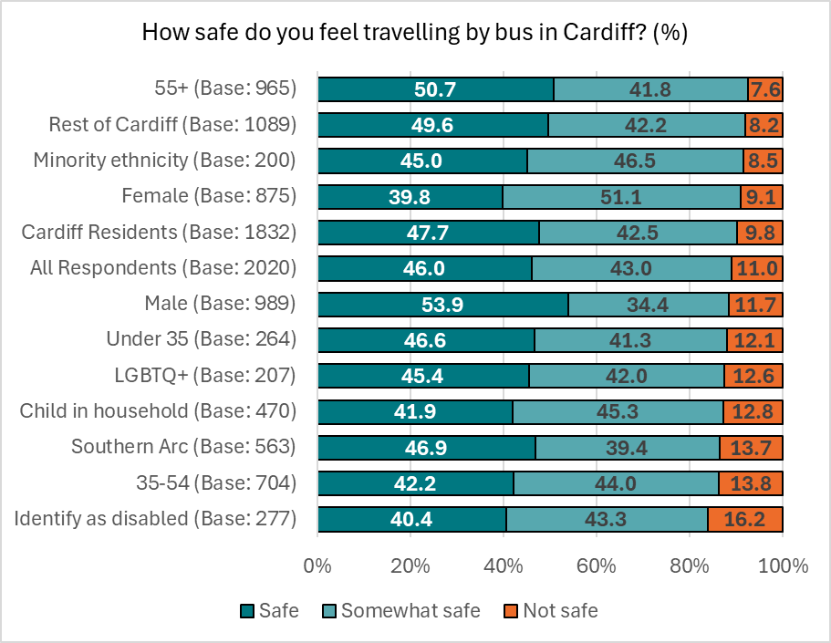
Excludes ‘Don’t Know’ responses.

Q20d How safe do you feel...travelling by train in Cardiff
Following the trend in the previous safety questions, once again those respondents that identify as disabled (14.9%) were the group most likely to not feel safe when travelling by train in Cardiff.
Those from an ethnically diverse background and respondents aged under 35 were the groups most likely to feel safe or somewhat safe (94.1% and 93.7% respectively).
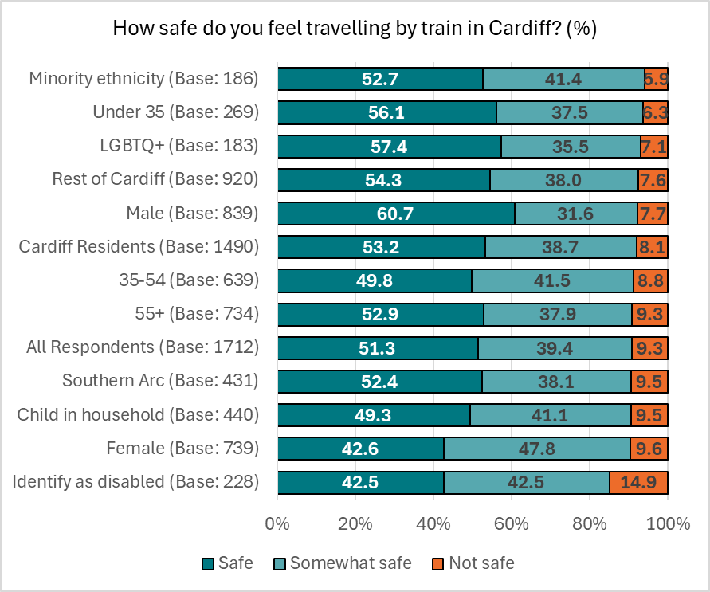
Excludes ‘Don’t Know’ responses.

Q21 Thinking about travel and transport in Cardiff, do you think there are...
Almost all (99.6%) respondents felt there are problems with travel and transport in Cardiff, this included 53.1% who felt there are serious problems.
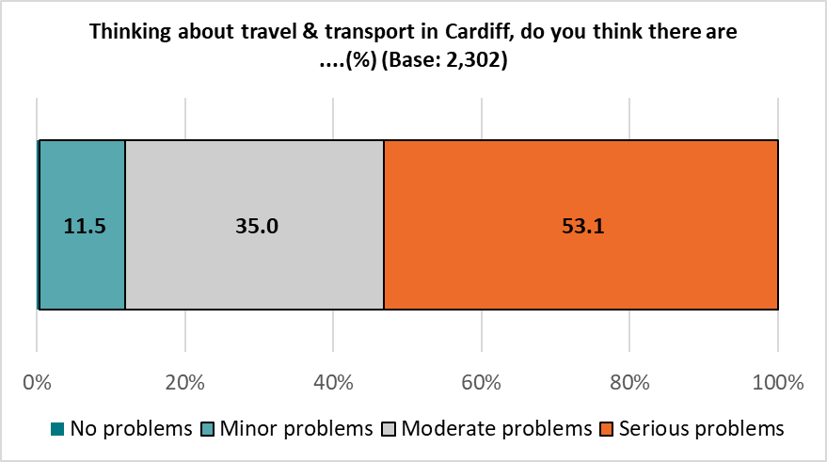
Excludes ‘Don’t Know’ responses.

Q 22/23 What improvements would you like to see to transport in Cardiff?
‘Improved bus service frequency and reliability’ (61.0%) was the transport improvement most respondents would like to see, followed by ‘Improved road carriageway conditions’ (53.1%), ‘Tackling illegal/inconsiderate parking’ (53.1%), ‘More cross-city bus services’ (50.4%). A similar proportion chose ‘Integrated ticketing to enable one ticket for a journey combining bus and/or train services’ (49.7%), and ‘Extended hours of bus operation’ (49.0%).
In terms of future investment, the improvement most selected was ‘Improved bus service frequency and reliability’, highlighted by more than a third (35.7%) of respondents. This was followed by ‘Improved road carriageway conditions’ (27.2%), ‘Improved local train services’ (18.7%) and ‘Reduced congestion’ (18.4%).
 | Would like to see | Priorities for investment
Improved bus service frequency and reliability | 61.0 | 35.7
Improved road carriageway conditions | 53.1 | 27.2
Tackling illegal/inconsiderate parking | 50.7 | 15.1
More cross-city bus services | 50.4 | 14.1
Integrated ticketing to enable one ticket for a journey combining bus and/or train services | 49.7 | 12.4
Extended hours of bus operation | 49.0 | 17.4
Improved local train services | 47.6 | 18.7
Reduced congestion | 47.0 | 18.4
Improved national train services | 40.3 | 6.4
Improved/faster bus connections e.g. bus lanes | 38.6 | 9.6
Improved access to toilet facilities when travelling by public transport | 34.8 | 4.9
Better managed local parking | 34.3 | 7.9
Improved pedestrian crossing facilities and walking routes | 33.3 | 10.8
More direct bus services that stop less often to reduce the time stopped at bus stops (Express Bus services) | 32.8 | 6.6
Better travel information to enable better travel choices to be made by all modes (walk, cycle, bus, rail, road) | 32.3 | 4.7
More Park and Ride sites | 29.2 | 12.3
Improved air quality | 26.8 | 6.2
More convenient and safer access for pedestrians and cyclists in local areas | 25.6 | 4.6
Improved cycle routes | 24.4 | 8.0
Other (please specify) | 22.4 | 16.4
More cycling facilities (e.g. bike parking, access security) | 21.6 | 4.6
Reduced transport-related carbon emissions | 21.0 | 3.9
More cycle lanes | 20.7 | 7.9
Cycle hire schemes | 13.0 | 2.1
More opportunities to car share | 7.8 | 0.7
More car clubs / communal cars for hire | 7.5 | 0.8
Park & Share sites | 6.5 | 0.7
Total Respondents | 2,308 | 2,305
NB. Percentages total more than 100% as respondents could select multiple options.

Please specify
Respondents that selected ‘Other’ were asked to specify what they would like to see / priorities for investment.
Would like to see/priorities for investment
There were 375 comments received. These comments were then grouped into themes; the top three themes, along with example comments can be viewed below / overleaf:
A full breakdown of themes can be found in Appendix I.
Theme | No. | % | Example Comments
Stop ‘war on motorists’ / improve driver experience | 102 | 27.2 | - Stop meddling with the infrastructure to suit your narrative. Purposely causing congestion. You need to widen the roads to ease the flow of traffic  - Focus on making roads easier to use for car users and more car parks. Watch your city centre die if people can’t get in as all it is is shops, restaurants and a stadium. Nothing that other cities don’t offer  - Better and more public car parks. Stop being anti car and accept the vast majority of people wish and prefer to use cars!!  - Cheaper parking, free permit parking for your street. Traffic light sequences changed to match stupid 20mph speed limits.
Bike/bus lane criticism | 95 | 25.3 | - Less bus lanes and cycle lanes which causes congestion  - The bus & cycle lanes are an absolute nightmare everywhere, I’m afraid to drive as it’s impossible not to end up in the wrong lane, with cameras everywhere its fear for my license.  - Get rid of useless cycle lanes. They cost a fortune to install and not all cyclists use them. They end abruptly. Poorly planned out and wasted money which could be spent on improving public transport.  - Fewer cycle lanes and reclaim road for motorists until public transport is improved
Improve public transport | 74 | 19.7 | - Cheap, reliable, frequent public transport. I want a viable alternative to my car.  - .(…) penalising drivers when public transport is still awful isn’t fair.  - Night buses for late night workers and safety of people travelling home as taxis won't always take people if fare isn't enough.  - Bus service needs to be much more reliable. Frequent failure to turn up is damaging and a massive disincentive to use the bus.
NB. Percentages may total more than 100% as responses could include multiple themes.

Q24 Do you hold a concessionary bus pass?
Just over one in three (36.7%) respondents hold a concessionary bus pass. As would be expected, these were most common amongst those aged 55+ (71.9%) and those that identify as disabled (50.5%).

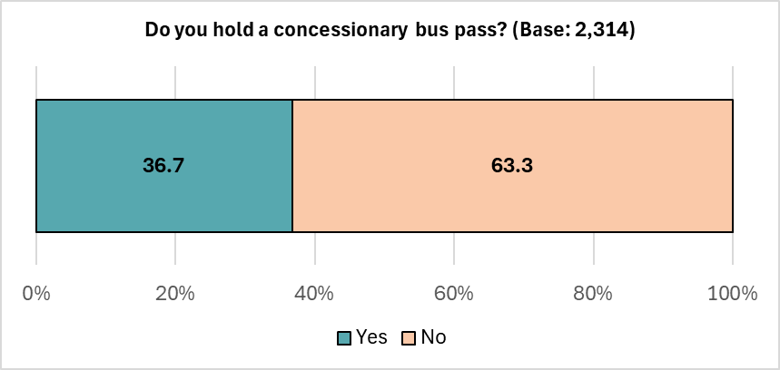
Excludes ‘Don’t Know’ responses.

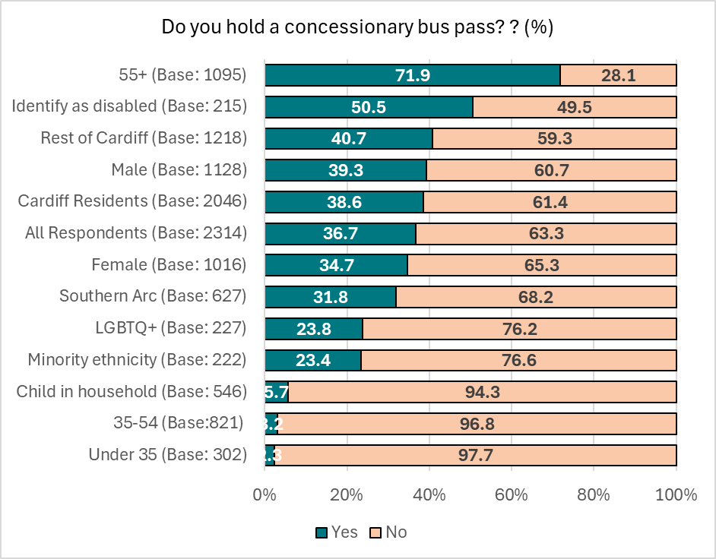
Excludes ‘Don’t Know’ responses.

Q25 Do you hold a blue badge?
Around one in fifteen (7.0%) respondents currently hold a blue badge.
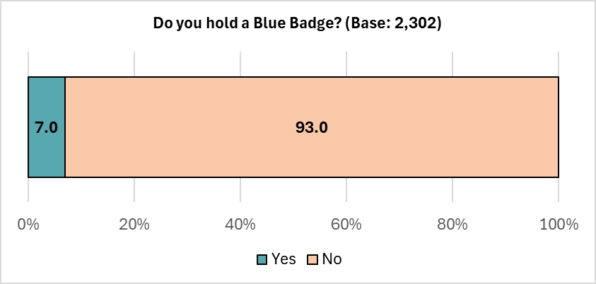
Excludes ‘Don’t Know’ responses.

As expected, this figure was greatest for those that identify as disabled (36.4%) and those aged 55+ (10.2%).
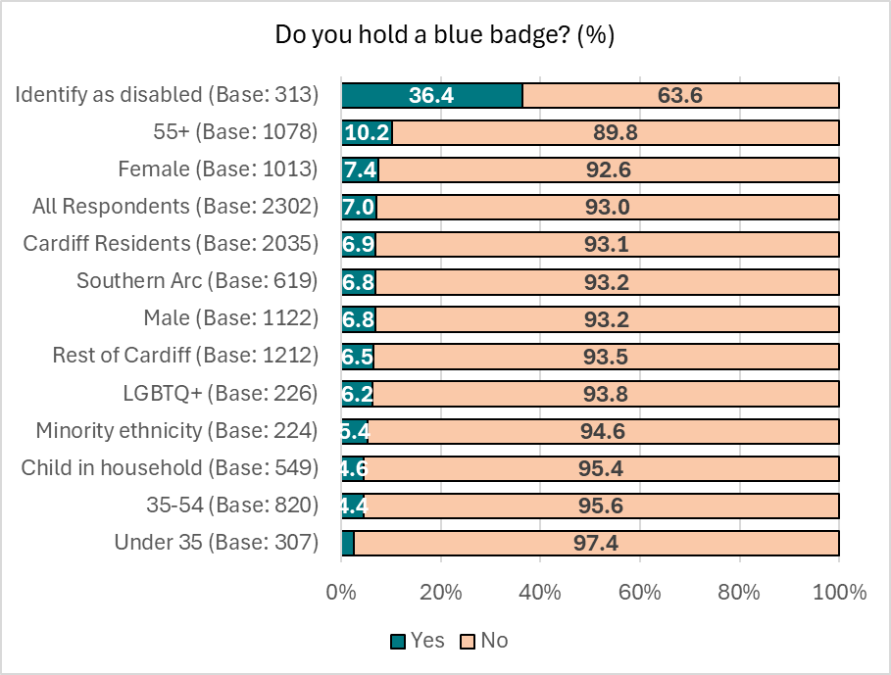
Excludes ‘Don’t Know’ responses.

Q26 In total, how many cars or vans are owned, or available for use, by members of this household? Include any company car(s) or van(s) available for private use.
Nearly nine in ten (88.4%) respondents had at least one car or van available for use by members of their household, this included 10.3% that had three or more.

The 11.6% with no cars/vans was well below the 26.0% of households that stated they did not own a car/van in the 2021 Census.

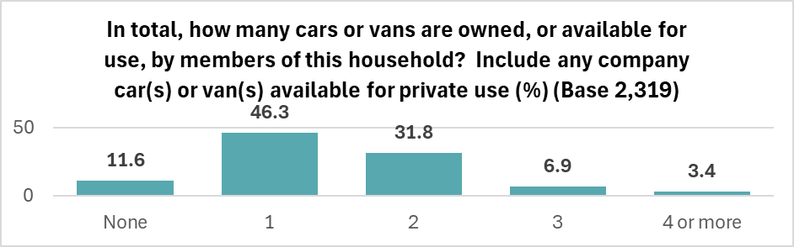

Q27 In total, how many bicycles are owned, or available for use, by members of this household?
Nearly three in five (57.8%) respondents had at least one bicycle available for use by members of their household. This includes one in five (20.3%) that had three or more bicycles.

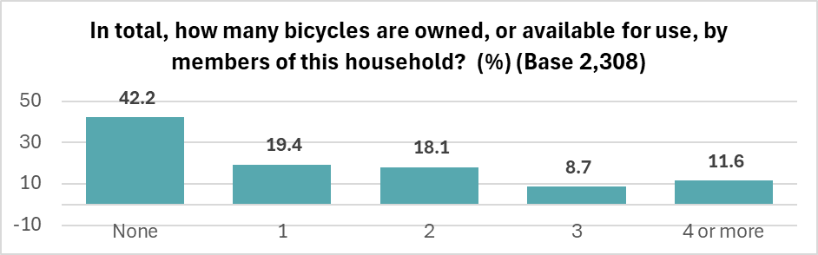

Q28 If you have any other comments on transport in Cardiff, then please note these below:
Respondents were given the opportunity to leave any other comments they had in relation to transport in Cardiff.
There were 1,396 comments received. These comments were then grouped into themes; the top four themes, along with example comments can be viewed below. The main themes were that public transport needs to improve (46.4%); there needs to be improvement in the road surface, traffic flow, signage and road layout (23.1%); critical comments about bike / bus lanes (22.6%); and safety comments (14.7%). Some comments are related to specific locations.
A full breakdown of themes can be found in Appendix J.

Theme | No. | % | Example Comments
Public transport needs to improve | 648 | 46.4 | - Very disappointed with the punctuality of the buses, it can be gone for an hour and then two come at once with a 1 minute gap. It is also absolutely impossible to rely on train timetables.  - Please make public transport better before making it harder to park. Transport options from the East of the city are basically only bus or car as Rumney/Trowbridge/St Mellons don't have the option of a train despite the track running through the areas close to homes. It takes about an hour to get into the city centre from parts of St Mellons by bus. If you make parking too hard it makes parts of the city inaccessible to people from those areas, plus areas like Pontprennau where the train line doesn't run.  - It would be great to see improved bus frequency, currently the nearest bus service to where I live only operates hourly and finishes at 19:30. There is also no service on a Sunday! The price of the bus tickets should be reduced to make it more affordable.  - At rush hour, sometimes the bus goes past full. Particularly since the St Ederns estate was built. We need double deckers or more busses between 7 and 9am.  - It is clear that council are actively discouraging travel by car but there is no other effective means of travel available buses don’t go where you need them to go and transport for Wales is not fit for service  - Buses turn up whenever they like or not at all. Buses stop so early for a capital city, difficult for hospitality workers to find safe transport home. Also Cardiff Bay buses stop super early, absolute joke, especially with all of the shows going on there.
Improve road surface / traffic flow / lights / signage / layout | 323 | 23.1 | - The state of the roads are really bad. Potholes and damage to roads takes ages to fix, and the vast majority of road markings need redoing. A lot of speed bumps have faded paint to the point where it’s difficult to see. Junction markings have faded so it’s not clear that you need to give way on some streets.  - Driving around Cardiff is an absolute nightmare. It’s becoming impossible to work. Spending more time driving due to poor road design and traffic management and ridiculous speed limits..  - Congestion on castle street and the junction at Newport Road down to the prison both ways. It feels to me that the light systems for basically the whole area are causing the congestion.
Critical comment re bike / bus lanes | 315 | 22.6 | - Council is attempting to bully cars off the road, not by proving viable alternatives, but by making it as hard as possible to use a car. Road space and parking being stripped away by unused cycle lanes  - The cycle lanes in the city are always empty and will just randomly stop meaning cyclist still cycle in the road next to them. These lanes have also caused an increase in congestion with the same amount of people using their cars. It seems a waste of time and money.  - Less bus lanes, less traffic lights, more clear access for cars, clear signage, less traffic enforcement cameras. Less pointless cycle lanes/paths.
Safety comment | 205 | 14.7 | - Pavements are terrible - constantly flooded and full of trip hazards. Can we also have better lit routes across parks for coming home at night.  - E-bikes (uber eats et al) are a hazard all over the city. People are travelling at high speed in pedestrian areas and cycle lanes, often in dark clothing and without light. That needs to be address asap given the potential for injury.
NB. Percentages may total more than 100% as responses could include multiple themes.

About You

What is your preferred language?
 | No. | %
English | 2,219 | 96.6
Welsh | 69 | 3.0
Other (please specify) | 8 | 0.3
Total respondents | 2,296 | 100
Six of the eight people who selected ‘Other’ supplied further information: three said ‘Both English and Welsh’, one said English, one said BSL and the last gave a different language.

What was your age on your last birthday?
 | No. | %
Under 16 | 5 | 0.2
16-24 | 51 | 2.2
25-34 | 251 | 10.9
35-44 | 358 | 15.6
45-54 | 465 | 20.2
55-64 | 547 | 23.8
65-74 | 399 | 17.3
75+ | 150 | 6.5
Prefer not to say | 74 | 3.2
Total respondents | 2,300 | 100

Are you?
 | No. | %
Female | 1022 | 44.7
Male | 1133 | 49.5
Non-binary | 15 | 0.7
Other | 0 | 0.0
Prefer not to say | 117 | 5.1
Total respondents | 2,287 | 100

Do you identify as Trans?
 | No. | %
Yes | 13 | 0.6
No | 2,084 | 93.1
Prefer to self-describe | 6 | 0.3
Prefer not to say | 136 | 6.1
Total respondents | 2,226 | 99

Are you pregnant, or have you given birth within the last 26 weeks?
 | No. | %
Yes, I’m pregnant | 12 | 0.5
Yes, I’ve given birth | 9 | 0.4
No | 2093 | 93.5
Prefer not to say | 125 | 5.6
Total respondents | 2,239 | 100

Do any children live in your household?
 | No. | %
No children | 1,695 | 75.5
Under 5 yrs old (pre-school) | 102 | 4.5
5 - 11yrs (primary school) | 210 | 9.4
11 - 16yrs (secondary school) | 243 | 10.8
16 - 18yrs in full-time education, or working | 140 | 6.2
16 - 18yrs but not in full time education or working | 32 | 1.4
Total respondents | 2,245 | -
NB. Percentages total more than 100% as respondents could select more than one option.

Which of the following best describes what you are doing at present?
 | No. | %
Working full time (30+ hours per week) | 1,285 | 56.0
Wholly retired from work | 542 | 23.6
Working part time (less than 30 hours per week) | 232 | 10.1
Permanently sick or disabled person | 52 | 2.3
Caring for a child or adult | 40 | 1.7
In full time education | 27 | 1.2
Looking after home | 21 | 0.9
Unemployed - Unregistered but seeking work | 18 | 0.8
On a zero hour contract | 11 | 0.5
Unemployed - Registered Job Seeker | 9 | 0.4
Other | 59 | 2.6
Total respondents | 2,296 | 100

Which of the following best describes your housing tenure?
 | No. | %
Owned outright | 1,027 | 45.1
Owned with a mortgage | 838 | 36.8
Private rented | 233 | 10.2
Rented from a Housing Association | 70 | 3.1
Rented from the Local Authority | 49 | 2.2
Other | 61 | 2.7
Total respondents | 2,278 | 100

Do you identify as a disabled person?
 | No. | %
Yes | 317 | 14.0
No | 1,822 | 80.3
Prefer not to say | 131 | 5.8
Total respondents | 2,270 | 100

Please tick any of the following that apply to you:
 | No. | %
Long-standing illness or health condition (e.g. cancer, HIV, diabetes, or asthma) | 373 | 42.6
Mobility impairment | 218 | 24.9
Mental health difficulties | 179 | 20.5
Deaf/ Deafened/ Hard of hearing | 177 | 20.2
Visual impairment | 52 | 5.9
Learning impairment/ difficulties | 34 | 3.9
Wheelchair user | 16 | 1.8
Other | 34 | 3.9
Prefer not to say | 168 | 19.2
Total respondents | 875 | -
NB. Percentages total more than 100% as respondents could select more than one option.

Do you or a member of your household identify as neurodivergent (e.g. Attention Deficit Disorders, Autism, Dyslexia, Dyspraxia, Dyscalculia and Dysgraphia)
 | Yes |  | No
 | No. | % | No. | %
You | 228 | 44.6 | 1,650 | 52.9
A member of your household | 283 | 55.4 | 1,471 | 47.1
Total respondents | 511 | 100 | 3,121 | 100

Do you regard yourself as belonging to any particular religion?
 | No. | %
No, no religion | 1,168 | 52.5
Christian (Including Church in Wales, Catholic, Protestant and all other Christian denominations) | 812 | 36.5
Muslim | 20 | 0.9
Buddhist | 13 | 0.6
Jewish | 9 | 0.4
Hindu | 4 | 0.2
Sikh | 1 | 0.0
Other | 27 | 1.2
Prefer not to answer | 172 | 7.7
Total respondents | 2,226 | 100

How would you describe your sexual orientation?
 | No. | %
Bisexual | 85 | 3.8
Gay Man | 86 | 3.9
Gay Woman/ Lesbian | 22 | 1.0
Heterosexual/ Straight | 1,724 | 77.2
Other | 26 | 1.2
Prefer not to say | 289 | 12.9
Total respondents | 2,232 | 100

Are you:
 | No. | %
Married | 1,137 | 51.1
Single | 456 | 20.5
Living together/Co-habiting | 325 | 14.6
Separated/divorced or legally separated if formerly in a Civil Partnership | 112 | 5.0
Widowed | 91 | 4.1
In a Civil Partnership | 38 | 1.7
Other | 66 | 3.0
Total respondents | 2,225 | 100

What is your ethnic group?
Where the term ‘British’ is used, this refers to any of the four home nations of Wales, England, Northern Ireland and Scotland, or any combination of these.
 | No. | %
White - Welsh / English / Scottish / Northern Irish / British | 1920 | 84.8
White - Irish | 28 | 1.2
White - Gypsy or Irish Traveller | 1 | 0.0
White - Any other white background | 88 | 3.9
Mixed / Multiple Ethnic Groups - White & Asian | 17 | 0.8
Mixed / Multiple Ethnic Groups - White and Black Caribbean | 19 | 0.8
Mixed / Multiple Ethnic Groups - White and Black African | 6 | 0.3
Mixed / Multiple Ethnic Groups - Any other | 10 | 0.4
Asian / Asian British - Chinese | 7 | 0.3
Asian / Asian British – Pakistani | 4 | 0.2
Asian / Asian British - Indian | 13 | 0.6
Asian / Asian British - Any other | 4 | 0.2
Black /African / Caribbean / Black British - African | 3 | 0.1
Black / African / Caribbean / Black British – Caribbean | 3 | 0.1
Black /African / Caribbean / Black British - Any other | 1 | 0.0
Arab | 2 | 0.1
Any other ethnic group | 20 | 0.9
Prefer not to say | 119 | 5.3
Total respondents | 2,265 | 100

Appendix A – Q13 Main reason for using the bus by sub-groups.
Main reason for using the bus | Under 35 | 35-54 | 55+ | Female | Male | Ethnic Minority | Overall
Base: | 191 | 534 | 825 | 710 | 782 | 149 | 1613
I do not have access to a car | 43.5 | 22.1 | 15.4 | 24.6 | 18.5 | 32.2 | 21.1
I prefer it to travelling by other means | 17.8 | 12.5 | 15.2 | 13.2 | 15.9 | 12.8 | 14.4
I have good facilities nearby (bus stops / stations / Park & Ride etc) | 29.8 | 29.8 | 39.2 | 33.4 | 36.2 | 37.6 | 34.3
It is cheaper than travelling by other means | 24.6 | 15.2 | 47.3 | 30.6 | 37.3 | 30.2 | 33.0
It is quicker than travelling by other means | 17.3 | 9.2 | 14.7 | 12.5 | 13.6 | 12.1 | 12.9
It is more convenient than travelling by other means | 30.4 | 23.8 | 29.2 | 25.9 | 29.2 | 24.2 | 27.2
It is more reliable than travelling by other means | 4.7 | 4.5 | 2.9 | 3.8 | 3.5 | 4.7 | 3.6
It is more comfortable than travelling by other means | 9.4 | 2.4 | 3.5 | 2.7 | 4.7 | 3.4 | 3.8
It feels safer than travelling by other means | 3.1 | 3.0 | 7.0 | 6.8 | 4.0 | 4.7 | 5.2
To do my bit to help reduce congestion | 27.7 | 33.0 | 37.2 | 33.7 | 35.0 | 36.9 | 33.7
To reduce my carbon footprint | 32.5 | 29.2 | 33.0 | 32.4 | 31.1 | 35.6 | 30.8
Other | 25.7 | 37.1 | 26.7 | 31.4 | 28.5 | 26.8 | 30.7
[Caution should be taken with low base numbers]

Main reason for using the bus (cont) | Identify as Disabled | Southern Arc | Rest of Cardiff | LGBTQ+ | Child in Household | Cardiff Resident | Overall
Base: | 210 | 450 | 904 | 169 | 352 | 1503 | 1613
I do not have access to a car | 39.0 | 30.2 | 17.9 | 33.1 | 15.6 | 21.3 | 21.1
I prefer it to travelling by other means | 18.1 | 14.2 | 15.5 | 14.2 | 14.2 | 14.5 | 14.4
I have good facilities nearby (bus stops / stations / Park & Ride etc) | 29.0 | 33.3 | 37.9 | 32.0 | 31.0 | 35.3 | 34.3
It is cheaper than travelling by other means | 30.0 | 31.1 | 35.3 | 33.1 | 15.1 | 33.9 | 33.0
It is quicker than travelling by other means | 10.0 | 11.6 | 14.6 | 11.2 | 11.6 | 13.2 | 12.9
It is more convenient than travelling by other means | 26.2 | 25.8 | 30.2 | 22.5 | 25.9 | 28.0 | 27.2
It is more reliable than travelling by other means | 5.2 | 2.7 | 4.1 | 3.0 | 4.3 | 3.7 | 3.6
It is more comfortable than travelling by other means | 5.7 | 4.2 | 4.2 | 7.1 | 2.8 | 4.1 | 3.8
It feels safer than travelling by other means | 6.7 | 6.0 | 5.3 | 4.7 | 3.4 | 5.5 | 5.2
To do my bit to help reduce congestion | 29.5 | 30.2 | 36.6 | 42.0 | 32.4 | 34.3 | 33.7
To reduce my carbon footprint | 29.0 | 30.2 | 33.4 | 39.1 | 29.3 | 31.5 | 30.8
Other | 33.8 | 30.9 | 28.7 | 30.2 | 35.5 | 29.7 | 30.7
[Caution should be taken with low base numbers]

Appendix B – Q13 What are your main reasons for using the bus? Other (please specify)
Theme | No. | % | Example Comments
To avoid drinking and driving / for social occasions | 116 | 23.9 | - To go into town if I am having a night out and want to drink alcohol  - So that I can have a drink  - I don’t drink and drive  - Able to have a beer
To avoid parking costs / hassles | 110 | 22.6 | - If going to town then I would consider taking his as can be cheaper than parking costs.  - Car parking in town too expensive so I have to suffer late buses  - No choice as parking in Cardiff is awful
When there’s no other option | 109 | 22.4 | - As a last resort and if running as the service in Morganstown is terrible.  - I used it as a last resort on days when I don't have access to the car, it's too wet/far/dark to cycle with my kids and there's no train station on my route  - The bus is my last port of call, will only use if there's no other transport, just because it takes too long to get anywhere with traffic, stupid bus lanes which start and finish, no continuous ones which would keep the buses flowing, except they don't and just get caught up in normal traffic jams
City Centre to avoid traffic | 67 | 13.8 | - I don’t want to drive into the city centre as the roads and speed limits seem to change every week and I don’t want to get prosecuted.
I have a bus pass | 57 | 11.7 | - I am over 60 I use the bus for free travel
As alternative to active travel e.g. if poor weather/ lots to carry | 24 | 4.9 | - If weather not good rather than walk
Other cost consideration (ie exc bus pass/parking) | 18 | 3.7 | - Means I can have a drink on an evening out and it’s cheaper than a taxi
When it's convenient | 18 | 3.7 | - sometimes convenient when i have nowhere to be in a rush
I enjoy it / it is relaxing | 4 | 0.8 | - More relaxing than driving
Other | 34 | 7.0 | - only if i need to get to town and catch a train for forward journey
NB. Percentages may total more than 100% as responses could include multiple themes.

Appendix C – Q14 Main reason for not using the bus by sub-groups.
Main reason for not using the bus | Under 35 | 35-54 | 55+ | Female | Male | Ethnic Minority | Overall
Base: | 112 | 278 | 258 | 306 | 328 | 73 | 683
I prefer to travel by car | 55.4 | 54.0 | 58.5 | 52.6 | 59.8 | 43.8 | 55.9
I prefer to walk | 36.6 | 25.5 | 21.7 | 23.9 | 29.0 | 30.1 | 25.8
I prefer to cycle | 21.4 | 13.7 | 9.3 | 7.2 | 19.2 | 20.5 | 12.7
I don't have good facilities nearby (bus stops / stations / Park & Ride etc) | 26.8 | 23.4 | 26.4 | 25.8 | 25.0 | 23.3 | 25.8
It is too expensive | 28.6 | 31.3 | 18.2 | 23.2 | 25.6 | 23.3 | 25.6
It is less convenient | 71.4 | 59.4 | 51.9 | 57.8 | 57.6 | 54.8 | 58.1
Journey times are too slow | 67.9 | 54.3 | 43.0 | 51.6 | 50.9 | 49.3 | 52.1
Journeys are too unreliable | 54.5 | 50.7 | 37.6 | 46.4 | 44.5 | 49.3 | 47.0
Delays going to destinations that make the trip longer. | 43.8 | 32.4 | 24.4 | 30.1 | 30.2 | 30.1 | 31.0
Services are over crowded | 25.0 | 21.2 | 15.1 | 18.6 | 19.2 | 16.4 | 19.2
Travel information is poor | 28.6 | 21.6 | 19.8 | 24.5 | 16.8 | 24.7 | 22.3
Waiting facilities are poor | 20.5 | 23.4 | 19.4 | 21.9 | 19.2 | 20.5 | 21.5
Toilet facilities are inadequate | 11.6 | 14.7 | 19.0 | 13.7 | 16.2 | 17.8 | 16.3
Access for pushchairs is inadequate | 2.7 | 1.8 | 1.9 | 1.6 | 2.1 | 2.7 | 2.0
Access for disabilities is inadequate | 2.7 | 8.6 | 10.9 | 10.8 | 5.2 | 9.6 | 8.3
Access for cycles is inadequate | 3.6 | 5.4 | 3.9 | 3.6 | 4.9 | 9.6 | 4.2
Access for luggage is inadequate | 4.5 | 4.0 | 7.4 | 4.6 | 5.5 | 6.8 | 5.4
It doesn't go where I need to travel | 35.7 | 40.6 | 43.0 | 41.5 | 39.0 | 42.5 | 41.3
It is uncomfortable | 16.1 | 17.6 | 15.5 | 13.4 | 18.6 | 11.0 | 16.5
It feels unsafe | 18.8 | 16.2 | 14.3 | 14.1 | 16.8 | 15.1 | 16.7
It is not direct / it involves multiple stages or changes | 50.0 | 43.2 | 44.6 | 47.7 | 40.2 | 38.4 | 45.7
Other (please specify below) | 3.6 | 13.7 | 15.1 | 12.4 | 12.5 | 20.5 | 13.2
[Caution should be taken with low base numbers]

Main reason for not using the bus (cont) | Identify as Disabled | Southern Arc | Rest of Cardiff | LGBTQ+ | Child in Household | Cardiff Resident | Overall
Base: | 105 | 166 | 307 | 54 | 192 | 528 | 683
I prefer to travel by car | 53.3 | 49.4 | 58.0 | 42.6 | 51.0 | 54.7 | 55.9
I prefer to walk | 15.2 | 34.9 | 27.7 | 44.4 | 22.4 | 29.5 | 25.8
I prefer to cycle | 3.8 | 17.5 | 13.4 | 14.8 | 14.1 | 14.8 | 12.7
I don't have good facilities nearby (bus stops / stations / Park & Ride etc) | 20.0 | 19.9 | 24.1 | 18.5 | 22.4 | 22.0 | 25.8
It is too expensive | 31.4 | 28.3 | 25.1 | 25.9 | 35.4 | 25.2 | 25.6
It is less convenient | 51.4 | 56.0 | 58.6 | 53.7 | 62.5 | 57.8 | 58.1
Journey times are too slow | 51.4 | 53.6 | 48.5 | 55.6 | 54.7 | 48.3 | 52.1
Journeys are too unreliable | 53.3 | 47.6 | 45.9 | 48.1 | 53.6 | 45.5 | 47.0
Delays going to destinations that make the trip longer. | 28.6 | 33.1 | 29.3 | 24.1 | 34.9 | 29.9 | 31.0
Services are over crowded | 29.5 | 28.3 | 15.0 | 29.6 | 20.8 | 18.9 | 19.2
Travel information is poor | 21.9 | 24.7 | 20.8 | 31.5 | 23.4 | 22.0 | 22.3
Waiting facilities are poor | 31.4 | 24.7 | 19.5 | 24.1 | 26.0 | 20.6 | 21.5
Toilet facilities are inadequate | 30.5 | 17.5 | 13.0 | 18.5 | 15.6 | 13.6 | 16.3
Access for pushchairs is inadequate | 2.9 | 2.4 | 1.6 | 5.6 | 3.6 | 1.9 | 2.0
Access for disabilities is inadequate | 29.5 | 14.5 | 5.9 | 13.0 | 9.9 | 8.5 | 8.3
Access for cycles is inadequate | 4.8 | 8.4 | 3.6 | 5.6 | 5.2 | 5.1 | 4.2
Access for luggage is inadequate | 8.6 | 6.6 | 5.9 | 7.4 | 5.2 | 5.9 | 5.4
It doesn't go where I need to travel | 50.5 | 39.8 | 40.4 | 37.0 | 37.5 | 39.8 | 41.3
It is uncomfortable | 27.6 | 19.9 | 13.0 | 29.6 | 12.0 | 14.6 | 16.5
It feels unsafe | 26.7 | 23.5 | 12.4 | 33.3 | 13.5 | 15.9 | 16.7
It is not direct / it involves multiple stages or changes | 49.5 | 38.0 | 43.3 | 46.3 | 40.6 | 41.9 | 45.7
Other (please specify below) | 17.1 | 12.7 | 15.0 | 24.1 | 9.9 | 13.6 | 13.2
[Caution should be taken with low base numbers]

Appendix D – Q14 What are your main reasons for not using the bus? Other (please specify)
Theme | No. | % | Example Comments
Bus does not run where / when I need it to | 29 | 33.7 | - I don’t have bus service within reasonable walking distance  - The last bus back from town is around 8pm so can't use it for anything in the city centre over an evening  - Timetable times are too late to get to work
Accessibility | 15 | 17.4 | - Not able to use public transport due to mobility and mental health conditions.  - I have a chronic disease and bus travel is too exhausting.
Bus takes too long | 13 | 15.1 | - Do not go to place of work in one trip. Car journey is only 15 minutes. Bus would take 1hr plus  - Awful bus service, takes 50 minutes sat on bus to get to city centre, train 6 minutes. Plus bus service stops mid afternoon. I did try the bus service no 86 btw and have decided never again
Other bus problem | 13 | 15.1 | - Don’t like crowds and dirtyness
Train is better | 11 | 12.8 | - Train is a better option
Bus service is poor | 8 | 9.3 | - Unreliable punctuality
Too much to carry | 5 | 5.8 | - I carry tools and kit so for work bus is no good.
Safety concern | 4 | 4.7 | - It's too risky from a Covid perspective. Despite people not talking about it anymore, Covid is very much still rampant.
Other | 11 | 12.8 | - I just want to emphasize “access for cycles”. I once tried to take a bus after getting a flat tyre to get my bike home; even though no one else was on the bus I was told I couldn’t and had to walk.
NB. Percentages may total more than 100% as responses could include multiple themes.

Appendix E – Q16 Main reason for using the train by sub-groups

Main reason for using the train | Under 35 | 35-54 | 55+ | Female | Male | Ethnic Minority | Overall
Base: | 210 | 489 | 567 | 566 | 652 | 137 | 1317
I do not have access to a car | 32.4 | 17.8 | 13.8 | 19.8 | 17.6 | 22.6 | 18.3
I prefer it to travelling by other means | 34.3 | 26.4 | 24.2 | 22.1 | 31.0 | 29.9 | 26.2
I have good facilities nearby (bus stops / stations / Park & Ride etc) | 31.0 | 29.0 | 27.9 | 25.8 | 31.9 | 32.8 | 28.1
It is cheaper than travelling by other means | 15.7 | 8.4 | 8.5 | 8.7 | 10.9 | 10.2 | 9.7
It is quicker than travelling by other means | 61.9 | 47.9 | 47.4 | 51.6 | 49.8 | 41.6 | 49.4
It is more convenient than travelling by other means | 44.8 | 37.0 | 35.8 | 36.4 | 39.3 | 42.3 | 37.3
It is more reliable than travelling by other means | 21.0 | 12.5 | 15.3 | 15.5 | 15.0 | 17.5 | 15.0
It is more comfortable than travelling by other means | 26.7 | 20.0 | 20.8 | 19.6 | 23.2 | 29.2 | 21.3
It feels safer than travelling by other means | 13.8 | 6.7 | 8.6 | 8.3 | 9.2 | 12.4 | 8.6
To do my bit to help reduce congestion | 30.5 | 33.5 | 33.9 | 33.7 | 32.5 | 32.1 | 32.5
To reduce my carbon footprint | 38.1 | 33.3 | 30.9 | 34.1 | 32.1 | 37.2 | 32.2
Other (please specify below) | 14.8 | 19.2 | 21.3 | 17.0 | 20.1 | 22.6 | 20.0
[Caution should be taken with low base numbers]

Main reason for using the train (cont) | Identify as Disabled | Southern Arc | Rest of Cardiff | LGBTQ+ | Child in Household | Cardiff Resident | Overall
Base: | 157 | 332 | 716 | 153 | 313 | 1150 | 1317
I do not have access to a car | 37.6 | 29.8 | 14.8 | 33.3 | 14.4 | 19.2 | 18.3
I prefer it to travelling by other means | 26.8 | 35.2 | 24.0 | 34.0 | 23.3 | 27.1 | 26.2
I have good facilities nearby (bus stops / stations / Park & Ride etc) | 22.9 | 20.2 | 33.9 | 23.5 | 32.9 | 28.5 | 28.1
It is cheaper than travelling by other means | 12.7 | 8.1 | 10.5 | 12.4 | 9.9 | 9.4 | 9.7
It is quicker than travelling by other means | 45.2 | 44.9 | 53.9 | 60.8 | 52.4 | 50.4 | 49.4
It is more convenient than travelling by other means | 30.6 | 38.9 | 38.8 | 39.2 | 39.0 | 38.0 | 37.3
It is more reliable than travelling by other means | 16.6 | 13.6 | 17.7 | 22.2 | 14.7 | 16.2 | 15.0
It is more comfortable than travelling by other means | 20.4 | 27.7 | 21.1 | 27.5 | 17.3 | 22.4 | 21.3
It feels safer than travelling by other means | 10.8 | 13.3 | 7.5 | 16.3 | 6.4 | 9.0 | 8.6
To do my bit to help reduce congestion | 28.7 | 27.7 | 36.5 | 40.5 | 31.9 | 33.0 | 32.5
To reduce my carbon footprint | 28.0 | 30.4 | 35.9 | 42.5 | 32.9 | 33.2 | 32.2
Other (please specify below) | 22.3 | 18.7 | 17.0 | 19.0 | 17.6 | 18.2 | 20.0
[Caution should be taken with low base numbers]

Appendix F – Q16 What are your main reasons for using the train? Other
Theme | No. | % | Example Comments
For longer distances | 77 | 29.6 | - Travel to London regularly by train from Cardiff  - I only use it to travel long distance  - I use it for long distance travel, really expensive though
Negative train comment | 46 | 17.7 | - I use the train to London as it is better than driving, mostly for work. However, the rail fares are way to high and the trains are not reliable enough for business or catching connections.  - I use trains when visiting family. Always a problem, with trains being cancelled, overcrowded, having to stand, nowhere to put luggage. Public transport in the main is unreliable.  - Only when they ain’t cancelled 24/7
To avoid drinking and driving | 41 | 15.8 | - If I want a night out in town  - Only use the train when I know I will be socialising after work..  - When I go to meet people in the city centre and it may involve alcohol.
To avoid parking issues / costs | 36 | 13.8 | - Used for travelling to city centre. Less hassle than parking.  - When parking is restricted and 20 mph causes congestion and delays.  - When going to a specific event where parking in cardiff will be a problem.
If normal option not available / no other option | 35 | 13.5 | - When my car is out of action  - When I have no choice  - Trains run after the busses have stopped.
Work-related | 34 | 13.1 | - I can work at the same time as travel  - To get to and from meetings and conferences outside Cardiff  - For work
To go to town centre | 31 | 11.9 | - Only use when going into town  - I only use the train to go to the city centre  - I use the train when I am travelling to the city centre as I do not like driving to the city centre
Convenient / reliable / other positive | 28 | 10.8 | - I like trains  - Handy near home and work
To avoid traffic issues | 12 | 4.6 | - Cardiff is a nightmare to drive in.
For leisure | 10 | 3.8 | - Occasional leisure trips
Cost benefits | 8 | 3.1 | - Railway staff = free travel
Safety | 4 | 1.5 | - Only use intercity trains for trips away from Cardiff. I only get a taxi to the station as I don’t feel safe walking the streets of Cardiff or using Cardiff Bus.
Other | 19 | 7.3 | - Very infrequently - once every two years if that.  - Can fit my mobility scooter on
NB. Percentages may total more than 100% as responses could include multiple themes.

Appendix G – Q17 Main reasons for not using the train by sub-groups.
Main reason for not using the train | Under 35 | 35-54 | 55+ | Female | Male | Ethnic Minority | Overall
Base: | 93 | 325 | 508 | 437 | 462 | 84 | 970
I prefer to travel by car | 38.7 | 34.2 | 37.2 | 31.4 | 42.2 | 27.4 | 36.4
I prefer to walk | 19.4 | 13.8 | 11.2 | 10.3 | 16.0 | 14.3 | 12.6
I prefer to cycle | 5.4 | 7.1 | 3.9 | 1.8 | 8.2 | 7.1 | 4.9
I don't have good facilities nearby (bus stops / stations / Park & Ride etc) | 50.5 | 44.3 | 30.7 | 37.8 | 37.4 | 45.2 | 37.5
It is too expensive | 47.3 | 49.8 | 43.3 | 42.3 | 48.9 | 47.6 | 46.3
It is less convenient | 35.5 | 34.2 | 36.2 | 33.9 | 37.2 | 27.4 | 35.5
Journey times are too slow | 11.8 | 11.7 | 7.7 | 6.2 | 12.8 | 10.7 | 10.2
Journeys are too unreliable | 32.3 | 25.8 | 22.0 | 24.5 | 25.1 | 27.4 | 25.5
Delays going to destinations that make the trip longer | 26.9 | 19.1 | 16.7 | 15.3 | 21.0 | 25.0 | 19.0
Services are over crowded | 30.1 | 26.2 | 19.1 | 23.1 | 21.2 | 25.0 | 22.8
Travel information is poor | 9.7 | 12.9 | 10.4 | 10.3 | 11.3 | 11.9 | 11.3
Waiting facilities are poor | 15.1 | 12.6 | 11.0 | 10.1 | 13.6 | 15.5 | 12.3
Toilet facilities are inadequate | 19.4 | 8.3 | 12.6 | 11.0 | 11.9 | 14.3 | 12.0
Access for pushchairs is inadequate | 2.2 | 2.2 | 0.8 | 0.9 | 1.5 | 2.4 | 1.4
Access for disabilities is inadequate | 3.2 | 5.8 | 6.9 | 5.9 | 5.8 | 3.6 | 6.0
Access for cycles is inadequate | 2.2 | 3.7 | 3.0 | 2.3 | 3.7 | 7.1 | 3.1
Access for luggage is inadequate | 4.3 | 3.4 | 2.6 | 2.7 | 2.8 | 4.8 | 2.9
It doesn't go where I need to travel | 26.9 | 33.2 | 28.1 | 28.8 | 29.4 | 34.5 | 29.7
It is uncomfortable | 9.7 | 8.3 | 4.7 | 4.8 | 7.1 | 7.1 | 6.5
It feels unsafe | 8.6 | 8.9 | 7.7 | 7.3 | 7.8 | 9.5 | 8.6
It is not direct / it involves multiple stages or changes | 26.9 | 25.8 | 19.9 | 21.1 | 23.4 | 29.8 | 23.0
Other (please specify below) | 7.5 | 15.4 | 18.5 | 16.7 | 15.2 | 17.9 | 16.6
[Caution should be taken with low base numbers]

Main reason for not using the train (cont) | Identify as Disabled | Southern Arc | Rest of Cardiff | LGBTQ+ | Child in Household | Cardiff Resident | Overall
Base: | 153 | 281 | 492 | 71 | 227 | 870 | 970
I prefer to travel by car | 37.9 | 29.5 | 36.0 | 45.1 | 33.9 | 33.6 | 36.4
I prefer to walk | 12.4 | 12.1 | 14.6 | 25.4 | 11.5 | 13.0 | 12.6
I prefer to cycle | 2.6 | 3.9 | 5.3 | 4.2 | 7.5 | 5.2 | 4.9
I don't have good facilities nearby (bus stops / stations / Park & Ride etc) | 33.3 | 44.1 | 35.2 | 42.3 | 47.6 | 38.3 | 37.5
It is too expensive | 50.3 | 44.1 | 46.7 | 60.6 | 48.9 | 45.1 | 46.3
It is less convenient | 35.9 | 26.3 | 38.4 | 38.0 | 38.8 | 33.6 | 35.5
Journey times are too slow | 11.1 | 8.2 | 8.9 | 23.9 | 10.1 | 8.5 | 10.2
Journeys are too unreliable | 30.1 | 19.2 | 25.0 | 39.4 | 29.1 | 22.6 | 25.5
Journeys are too unreliable | 19.6 | 14.9 | 18.7 | 25.4 | 23.3 | 17.2 | 19.0
Services are over crowded | 26.8 | 18.9 | 22.4 | 36.6 | 26.0 | 20.7 | 22.8
Travel information is poor | 15.0 | 10.0 | 11.0 | 15.5 | 12.8 | 10.7 | 11.3
Waiting facilities are poor | 19.0 | 8.9 | 14.4 | 18.3 | 11.9 | 11.7 | 12.3
Toilet facilities are inadequate | 20.3 | 8.2 | 13.0 | 19.7 | 9.3 | 11.1 | 12.0
Access for pushchairs is inadequate | 3.3 | 0.7 | 1.6 | 5.6 | 3.1 | 1.3 | 1.4
Access for disabilities is inadequate | 22.9 | 4.3 | 6.9 | 18.3 | 3.5 | 5.6 | 6.0
Access for cycles is inadequate | 3.9 | 3.9 | 2.6 | 7.0 | 3.1 | 3.2 | 3.1
Access for luggage is inadequate | 3.9 | 2.1 | 2.8 | 7.0 | 1.8 | 2.5 | 2.9
It doesn't go where I need to travel | 30.7 | 33.1 | 29.5 | 35.2 | 32.2 | 29.9 | 29.7
It is uncomfortable | 9.8 | 5.0 | 6.3 | 12.7 | 5.7 | 5.4 | 6.5
It feels unsafe | 12.4 | 6.8 | 7.9 | 12.7 | 6.6 | 7.0 | 8.6
It is not direct / it involves multiple stages or changes | 24.2 | 22.1 | 20.1 | 32.4 | 24.2 | 21.5 | 23.0
Other (please specify below) | 13.7 | 16.4 | 16.9 | 0.0 | 13.2 | 16.6 | 16.6
[Caution should be taken with low base numbers]

Appendix H – Q17 What are your main reasons for not using the train? Other
Theme | No. | % | Example Comments
No station nearby | 82 | 52.2 | - I live in Old St Mellon's so have no access whatsoever to trains, the buses are unreliable and only every hour, the area I live is massively congested and in need of a rail link  - I literally cannot because I live in Pentwyn where we have 0 facilities for rail travel.  - No station near my home
Unreliable or limited | 18 | 11.5 | - Trains too infrequent to where I live, often don't turn up and finish far too early in an evening. I used to use the train for work, now I drive.  - Infrequent service - Coryton, stopped using when having to get tickets before travel, Cancelled too often, Different tickets to the bus.
Prefer another option | 17 | 10.8 | - It is less convenient than the bus and the bus is free with my pensioner pass. Even if I chose to walk half a mile in the cold with heart disease to my closest station, it is likely the train would be cancelled or over crowded and I'd be put on a rail replacement bus anyway  - Bus stop outside the door train station a walk away
No need | 13 | 8.3 | - No need to use the train.
Cost | 11 | 7.0 | - cost of journey
Accessibility | 10 | 6.4 | - Disabled with reduced walking ability
Difficulties buying a ticket | 8 | 5.1 | - Buying the tickets is too complicated
Poor connectivity with other modes | 6 | 3.8 | - Unable to walk to nearby stations and parking is,difficult
Comfort issues | 6 | 3.8 | - trains are over crowded
Trains don’t run early / late enough | 5 | 3.2 | - Services don’t run early / late enough to make it a viable form of transport for attending shift / non 9-5 style employment
Need to transport things / people | 4 | 2.5 | - Great Dane comes with me
Other | 15 | 9.6 | - staff are not customer focused
NB. Percentages may total more than 100% as responses could include multiple themes.

Appendix I – Q22/23 Improvements you’d like to see / Priorities for investment. Other
Theme | No. | % | Example Comments
Stop ‘war on motorists’ / improve driver experience | 102 | 27.2 | - Stop meddling with the infrastructure to suit your narrative. Purposely causing congestion. You need to widen the roads to ease the flow of traffic  - Focus on making roads easier to use for car users and more car parks. Watch your city centre die if people can’t get in as all it is is shops, restaurants and a stadium. Nothing that other cities don’t offer  - Better and more public car parks. Stop being anti car and accept the vast majority of people wish and prefer to use cars!!  - Cheaper parking, free permit parking for your street. Traffic light sequences changed to match stupid 20mph speed limits.
Bike/bus lane criticism | 95 | 25.3 | - The cycle lanes have caused MORE not less congestion - so there is definitely no need for more - they are empty! . The cycle lanes are also far too wide. Traffic Lights also need to re re-configured to ease congestion  - Remove cycle lanes and return more road space for cars  - Get rid of useless cycle lanes. They cost a fortune to install and not all cyclists use them. They end abruptly. Poorly planned out and wasted money which could be spent on improving public transport. We don't have the weather in Cardiff to support all year round cycling everywhere.  - Fewer cycle lanes and reclaim road for motorists until public transport is improved
Improve public transport | 74 | 19.7 | - Cheap, reliable, frequent public transport. I want a viable alternative to my car.  - .(…) penalising drivers when public transport is still awful isn’t fair.  - NIght buses for late night workers and safety of people travelling home as taxis won't always take people if fare isn't enough.  - Bus service needs to be much more reliable. Frequent failure to turn up is damaging and a massive disincentive to use the bus.  - Train station/service from St Mellons.
Get rid of all / some 20mph | 60 | 16.0 | - Stop narrowing road and preventing people from driving around the city. You congestion/emissions project on 20mph have done nothing but cause more issues  - bring the speed limit back up to 30mph in places where it's safe to do so, like away from schools and hospitals  - Get rid of 20mph on most roads and reduce the number of cycle lanes so cars can get moving again  - Removal of the 20mph speed limit
Improve parking, (inc Park & Ride) | 50 | 13.3 | - More cheaper parking in the city.  - More parking at sensible rates.  - Make it easier to drive into and park in the city centre.  - Focus on making roads easier to use for car users and more car parks. Watch your city centre die if people can’t get in as all it is is shops, restaurants and a stadium. Nothing that other cities don’t offer
Improve cyclists’ behaviour / increase enforcement | 43 | 11.5 | - more control over cyclists who ride on pavements as is dangerous for elderly and disabled persons. This is the main reason I drive around Cardiff as unsafe to walk as cyclists use pathways at high speed and swap from road to pathway and go through red lights and zebra crossings. Have been hit by cyclists several times and they do not stop.  - Need to tackle inconsiderate cyclists and stop them using the pavements. Cyclists are the cause of many problems on and off the roads. Often do not use their bells or have any lights and weave in and out of pedestrians and traffic rarely using the cycle lanes provided for them. They have become a right pain particularly after recent highway code changes.  - Stop cyclists using pedestrian areas and make them slow down
Improve road surface / signage / traffic lights | 39 | 10.4 | - Sort out the traffic light system so they are sensor aware - instead of ridiculous system where a couple of cars from one direction are allowed through at peak times when there are loads in queue, and the other direction hardly any cars.  - Resurface the roads and road markings as its dangerous to all road users.
Cheaper public transport | 33 | 8.8 | - Lower fees for buses and trains - make them affordable and cheaper than driving by car  - reducing travel costs e.g bus fares, train fares
Improve cycle infrastructure | 21 | 5.6 | - Although I do not cycle, my son does and there are areas where the cycle paths are not well thought out and rather confusing to both cyclists and drivers, making them in fact more dangerous. I think a fresh pair of eyes needs to review the safety of the cycle lanes to Truely make Cardiff a cycle friendly city. However I feel these should be alterations and not big expensive plans at a time when the council doesn’t have much money to spend.  - invest in making cycle parking more secure, particularly in city centre
Improve pedestrian experience | 21 | 5.6 | - Better lighting on walking routes e.g Llanrumney to Pentwyn. Pontprennau to Llanrumney. Through the Eastern Leisure Centre  - Fix the pavements so that walking for the elderly is safer.
Improve accessibility | 20 | 5.3 | - There are not enough buses going to llandough or the Heath hospitals. I live The Sanctuary Culverhouse Cross. There is only one bus a 96 that stops by me and that only runs 1 per hour. I am not able to walk far and it is really frustrating to see the number 17 and18 running every 10 minutes. I cannot walk down that far. We need bus services to the hospitals that cover ALL OF CARDIFF  - More car parking. Current policies ignore car needs of older and disabled
Safety comment | 15 | 4.0 | - the Council have dipped the street lighting so much that you cannot see the road markings, because they are fading away, cannot see pedestrians or cyclists (especially Deliveroo, not lights on their bikes at all), cannot see when you need to turn off and lighting is so dim and also street light is switched off too early in the mornings when it is still dark.
E-scooters/bikes | 14 | 3.7 | - All e-scooters should be banned completely - they are dangerous and illegal/ Queen Street is an absolute nightmare to walk along with all the food delivery cyclists cutting in and out. Again, why is nothing done about this on a daily basis.
Increase policing of road users other than bikes | 13 | 3.5 | - Do something about bike theft and about dangerous/angry motorists
Stop wasting money / anti-council or anti-government | 13 | 3.5 | - Stop wasting public money
Other | 28 | 7.5 | - Stop only focussing on city centre, outskirts and villages considered Cardiff have no pavements, cycle paths, poor bus service and only option is car  - Ticked congestion but only for to mention vehicles should be allowed to use the bus lane on off peak times, especially around holidays(Xmas)
NB. Percentages may total more than 100% as responses could include multiple themes.

Appendix J – Q28 Any other comments on transport in Cardiff.
Theme | No. | % | Example Comments
Public transport needs to improve | 648 | 46.4 | - Very disappointed with the punctuality of the buses, it can be gone for an hour and then two come at once with a 1 minute gap. It is also absolutely impossible to rely on train timetables.  - Please make public transport better before making it harder to park. Transport options from the East of the city are basically only bus or car as Rumney/Trowbridge/St Mellons don't have the option of a train despite the track running through the areas close to homes. It takes about an hour to get into the city centre from parts of St Mellons by bus. If you make parking too hard it makes parts of the city inaccessible to people from those areas, plus areas like Pontprennau where the train line doesn't run.  - It would be great to see improved bus frequency, currently the nearest bus service to where I live only operates hourly and finishes at 19:30. There is also no service on a Sunday! The price of the bus tickets should be reduced to make it more affordable.  - At rush hour, sometimes the bus goes past full. Particularly since the St Ederns estate was built. We need double deckers or more busses between 7 and 9am.  - It is clear that council are actively discouraging travel by car but there is no other effective means of travel available buses don’t go where you need them to go and transport for Wales is not fit for service  - Buses turn up whenever they like or not at all. Buses stop so early for a capital city, difficult for hospitality workers to find safe transport home. Also Cardiff bay buses stop super early, absolute joke, especially with all of the shows going on there.
Improve road surface / traffic flow / lights / signage / layout | 323 | 23.1 | - The state of the roads are really bad. Potholes and damage to roads takes ages to fix, and the vast majority of road markings need redoing. A lot of speed bumps have faded paint to the point where it’s difficult to see. Junction markings have faded so it’s not clear that you need to give way on some streets.  - Driving around Cardiff is an absolute nightmare. It’s becoming impossible to work. Spending more time driving due to poor road design and traffic management and ridiculous speed limits..  - Congestion on castle street and the junction at Newport Road down to the prison both ways. It feels to me that the light systems for basically the whole area are causing the congestion.
Critical comment re bike / bus lanes | 315 | 22.6 | - Council is attempting to bully cars off the road, not by proving viable alternatives, but by making it as hard as possible to use a car. Road space and parking being stripped away by unused cycle lanes  - The cycle lanes in the city are always empty and will just randomly stop meaning cyclist still cycle in the road next to them. These lanes have also caused an increase in congestion with the same amount of people using their cars. It seems a waste of time and money.  - Less bus lanes, less traffic lights, more clear access for cars, clear signage, less traffic enforcement cameras. Less pointless cycle lanes/paths.
Safety comment | 205 | 14.7 | - Pavements are terrible - constantly flooded and full of trip hazards. Can we also have better lit routes across parks for coming home at night.  - E-bikes (uber eats et al) are a hazard all over the city. People are travelling at high speed in pedestrian areas and cycle lanes, often in dark clothing and without light. That needs to be address asap given the potential for injury.  - cycle lanes that don’t continue meaning cyclists have to return to the road which can be very hazardous to drivers and cyclists.
Stop being anti-car / cars should be higher priority | 167 | 12.0 | - There is no need to continually penalise car users - simply improve public transport frequency at affordable rates  - For a capital city, it is embarrassing. Full of cycle lanes for the minority. The infrastructure around Cardiff City centre, is purposefully designed to catch out motorists.  - improve public transport before you continue with your anti car actions - alternatives need to be in place and be more attractive
Parking | 161 | 11.5 | - Traffic around school areas also terrible, we walk to school but it’s really unsafe due to inconsiderate parking and dangerous driving  - Sort out illegal parking!  - Congestion so high because buses are so expensive and parking facilities in city centre are poor. Need bigger car parks, especially for around Christmas time when everyone’s out shopping. Makes the experience an absolute chore.
Improve cycling facilities | 156 | 11.2 | - I would cycle into town except there is no way I would leave my bike there, as it is likely to be stolen. I would be willing to pay for bike storage.  - Safe bike parking is needed - too much risk of theft. Integrated cycle lanes that link up Safe cycling provision for children/teenagers  - I think there have been good improvements in cycle routes but there is a long way to go. Look at cities like Cambridge, Bristol or Amsterdam. Make sure all suburbs have signed routes to the centre, and radially to each other.
Improve law enforcement & education | 154 | 11.0 | - You desperately need to sort the illegal cycling on pavements and through city centre it’s absolutely chaos and has become the norm I see street wardens doing nothing about it  - Bike security is an issue in encouraging more cycling. My family all enjoy cycling, but are put off using this more to travel around the city due to the lack of secure places to lock bikes and being targeted by thieves (we have had 2 bikes stolen from the City Centre while locked to bicycle stands, and my teenage son was robbed of his e-bike at our local park).  - please , CCC provide more traffic wardens around city road area. Its outrageous how people are parking , double parking , speeding up and down city road. Its seems like no one cares about the rules and regulations of parking and driving on this road.
Environmental comment e.g. pollution, ULEZ, electric vehicles | 148 | 10.6 | - The 20mph has made a substantial increase in carbon emissions, this should be reviewed. The 20mph should only be invoked when it is required for safety needs. It not required 24 hrs a day in most situations.  - Please do not introduce more pedestrian, cycling or low emission zones. We will end up like London. Civilised life is untenable there.  - Public transport needs huge investment before tacking congestion/air quality/carbon emissions can be tackled.
Changes to 20mph / speed restrictions | 138 | 9.9 | - Stop the 20mph law , and stop spending masses amounts of money on cycle lanes  - Scrap 20mph as it’s caused more congestion- keep traffic flowing at proper speed  - The 20mph scheme is in need of an urgent review. It has been implemented on too many roads which is slowing down the movement of traffic and is resulting in very aggressive driving.
Public transport needs to be cheaper | 117 | 8.4 | - Reduce the cost of travel and extend the times of the last train/bus if you want us to leave the car at home. The cheaper and access public transport the more people will use it.  - We need to be proactively encouraging people to use public transport but at the moment there's no incentive when it's always cheaper and more convenient to drive.
Improve walking facilities | 115 | 8.2 | - Surely it's time the pavement was returned to the pedestrian unless it is a shared facility with obvious lane markings.  - Mae cyflwr y llwybrau cerdded yn ofnadwy ac yn ei gwneud yn anoddach a mwy peryglus i bobl hŷn gerdded. Dail llithrig heb eu clirio Pyllau dŵr Tyllau Cerrig anwastad Sbwriel a gwylanod /The condition of the sidewalks is terrible and makes it harder and more dangerous for elderly people to walk. Slippery leaves, uncleared water puddles, uneven stone holes, litter, and seagulls.
Critical comment re cyclists | 105 | 7.5 | - Cyclist need to know Highway Code! Stop them wearing headphones and mobile phones wear reflective clothes and lights on bikes. Stop cycling in and out of cars.  - Cyclists should be encouraged to actually use cycle paths - many avoid them and use the roads still????? Is this not similar to cars using bus lanes. Causes congestion.
Accessibility | 91 | 6.5 | - Travel in Cardiff as a disabled person is diabolical, the buses go nowhere near the paved area and do not in anyway encourage travel into the city centre to shop.  - We also have a lot of on-pavement parking which is difficult for those of us who have mobility issues.
Improve infrastructure / integration | 70 | 5.0 | - Please have a whole city plan, the thinking seems so disjointed and no clear thinking. There also needs to be consideration of transport, when approving building planning, city centre is being flooded with huge (not to mention ugly) apartment or student buildings and there seems to be no thinking of how this will impact travel in the city.  - Integration of the transport network is essential. Better bus/train services would reduce car journeys because they are more convenient.
Not everyone can cycle / cycling is restricted | 64 | 4.6 | - I am a senior citizen with limited mobility, I can't ride a bike and can no longer walk far.  - People will not cycle in the Wales. It is too wet and cold for most of the year.
Park & Ride | 63 | 4.5 | - Park and ride facilities on the east of cardiff need to be improved/provided.
Impact on shopping / business | 54 | 3.9 | - The city center shopping facilities is an asset that it promoted by Cardiff Council. But the shopping experience is being impacted by the drive to make it more difficult to use a car to get there. I dont want to be carrying all shopping on busses and trains.
Taxi | 41 | 2.9 | - Buses rarely run past 7/8pm from my area (north Canton) and I have to result in taking a taxi which are expensive
You don’t listen | 37 | 2.7 | - the list is endless but I doubt you are interested and will do what you want any, despite common sense
Planning | 31 | 2.2 | - Integration of planning seems non existent - new housing with no access to mass transit transport and poor bus routes pushes more onto roads.
Events | 27 | 1.9 | - For a capital city trying to get home after a night out or event is ridiculous
Critical comment re Council / Senedd | 26 | 1.9 | - The people in charge have no idea what the every day citizen lives like. Nothing functions! And transport is soooo expensive.
Pro 20mph | 12 | 0.9 | - Please enforce 20mph!!
Other | 56 | 4.0 | - Sort it out babes <3  - The council-run recycling centres are apparently not available unless you're a car owner.
NB. Percentages may total more than 100% as responses could include multiple themes.

