
Ask Cardiff 2024
Residents Survey

REPORT
April 2025
Ask Cardiff 2024

Contents
Background 1
Response 2
City Life & Public Services 4
Your Neighbourhood 15
Access to Services 31
Hubs & Libraries 40
Cost of Living 49
Housing 66
Jobs & The Economy 69
Health & Well-being 76
Community Safety 103
Environment 114
Budget Priorities 121
Family Services & Social Care 124
Any Other Comments 131
About You 134
Appendix 1 Volunteering 142
Appendix 2 How Would You Prefer to Access Information About Services, Events etc.? Breakdown by Demographic and Geography 144
Appendix 3 Why Do You Disagree That Contacting the Council is Simple? 147
Appendix 4 What Other Services Delivered in your Local Hub/Library Do You Find Most Helpful? 150
Appendix 5 What Services Delivered in your Local Hub/Library Do You Find Most Helpful? Breakdown by Demographic and Geography 153
Appendix 6 What Other Activities or Events Would You Like To See in Your Local Hub? 156
Appendix 7 What Activities or Events Would You Like To See in Your Local Hub? Breakdown by Demographic and Geography 158
Appendix 8 How Else Would You Like To Know About Events In Your Local Hub/Library? 161
Appendix 9 In the last six months, have you or anyone else in your household done any of the following because you couldn't AFFORD food? Breakdown by Demographic and Geography 162
Appendix 10 In the last six months, have you or anyone else in your household had issues paying energy bills? Breakdown by Demographic and Geography 164
Appendix 11 Please tell us how you plan to cope with the increase in energy costs 166
Appendix 12 To what extent do you agree or disagree with this statement: Cardiff has a thriving and prosperous economy? Breakdown by Demographic and Geography 167
Appendix 13 Over the last 12 months, would you say your employment situation has…? Breakdown by Demographic and Geography 168
Appendix 14 Please Tell Us What Else Stopped You Taking Up The Invitation For Screening 169
Appendix 15 Please Tell Us What Else Stopped You Taking Up The Invitation For Vaccination 171
Appendix 16 How much time do you spend in nature / green spaces? Breakdown by Demographic Geography 172
Appendix 17 How Close is This Space To Your Home? Breakdown by Demographic Geography 173
Appendix 18 How important do you think it is to have green spaces in your local area? Breakdown by Demographic Geography 174
Appendix 19 How Safe or Unsafe Do You Feel In The Following Situations? Trend Data 175
Appendix 20 Why Do You Feel Unsafe in These Situations? 177
Appendix 21 What Could Be Done To Make You Feel Safer? 188
Appendix 22 Budget Priorities by Demographic and Geography 196
Appendix 23 What Other Support Have You Accessed for Your Child? 211
Appendix 24 Why Have You Not Accessed Support for Your Child? 212
Appendix 25 Do you have any other feedback for us? 213
Appendix 26 Organisations Approached to Support Promotion of the survey 221
Appendix 27 Map of the Southern Arc 224

Background
Ask Cardiff is Cardiff Council’s annual resident’s survey. The 2024 survey ran from 1st October to 8th December 2024; it was extended by a week from its planned closing date to boost the response rate, particularly amongst under-represented groups.
The survey was available in hard copy and online in English, Welsh, Arabic, Bengali and Somali, reflecting the more commonly-spoken languages in the city, plus targeted engagement with under-represented groups.
Hard copies of the survey were made available in Hubs, Libraries and community buildings across the city, and were provided to local councillors to distribute within their communities. Posters with a QR code linking directly to the online survey were also used to promote the survey in community buildings including shops and faith spaces, e.g. churches and mosques.
Respondents to the survey were invited to enter a prize draw to win one of ten £50 FOR Cardiff vouchers, a £50 voucher for Cardiff International White Water or a family ticket to skate at the Winter Wonderland over the Christmas period.
The Cardiff Research Centre worked closely with partnership organisations to ensure as representative a response as possible. In a bid to ensure the survey was promoted as widely as possible, the survey was promoted via:
a) Email

- Organisations known to work with less frequently heard groups (see Appendix 26)
- Cardiff’s Citizen’s Panel

b) Internet/intranet
The survey was hosted on the Council website, and promoted to Council employees via DigiGov, Intranet and Staff Information.

c) Social media

The survey was promoted via Facebook and Twitter throughout the consultation period. Social media ‘boosts’ were made to selected demographics with a focus on younger people and those in the south of the city.

Response
After data cleansing and validation, there were 2,620 responses to Ask Cardiff 2024. This figure was lower than usual, in part because the general election earlier in the year paused other consultation and engagement work, meaning Ask Cardiff could not be run without overlap of other major surveys (including the Council’s annual Transport survey, which received 2,329 validated responses, and a Parking Strategy consultation, which received 6,381 validated responses).

 | Ask Cardiff 2020 | Ask Cardiff 2021 | Ask Cardiff 2022 | Ask Cardiff 2023 | Ask Cardiff 2024
Total responses | 4,715 | 2,704 | 3,856 | 3,187 | 2,620

Almost two thirds (63.6%, or 1,667) of respondents shared their postcode information. The map below shows population representation at ward level for Cardiff residents.
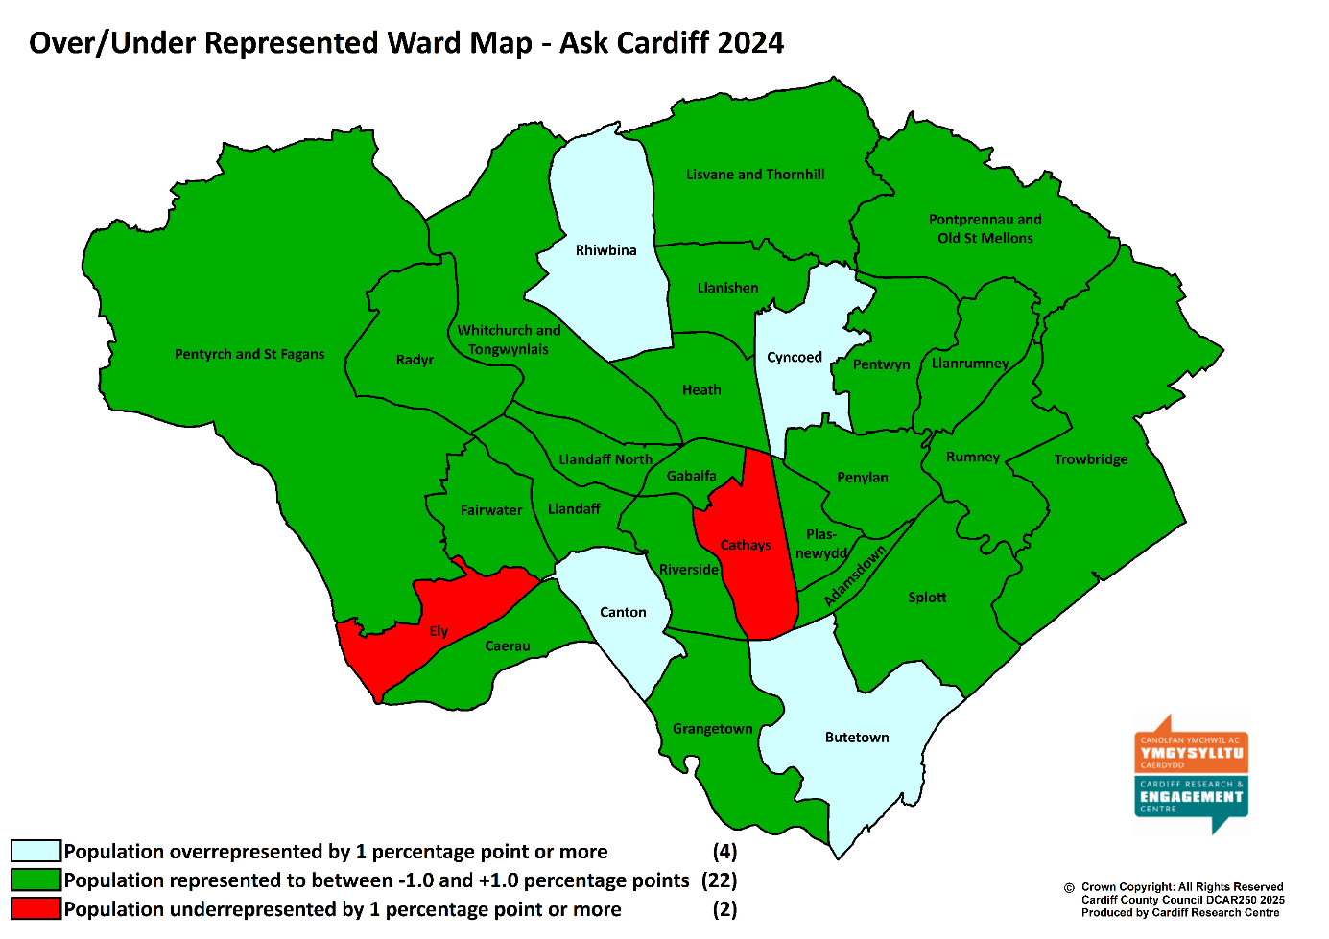
Those that did not provide a postcode are included in overall figures but are excluded from spatial analysis. Similarly, those that did not provide demographic information are included in the overall figures but excluded from subgroup analysis.
The response has been broken down by age, gender, ethnic background, Welsh Speakers, those with a disability, those identifying as LGBTQ+, and those living in the least or most deprived areas of the city.
In addition, the analysis includes the response from those living in the ‘Southern Arc’ of Cardiff which comprises the following electoral wards: Adamsdown, Butetown, Caerau, Canton, Ely, Grangetown, Llanrumney, Riverside, Rumney, Splott, Trowbridge (see map at Appendix 27).
Open-response comments included in the report are verbatim; any errors in grammar or spelling have been ignored.

Welsh Index of Multiple Deprivation

To help gain a better understanding of the experiences and views of Cardiff residents an additional level of analysis has been introduced that looks at responses by deprivation fifth.
The Welsh Index of Multiple Deprivation (WIMD) is the official measure of small area deprivation in Wales and is designed to identify those small areas where there are the highest concentrations of several types of deprivation. Each Lower Super Output Area (LSOA) in Wales is ranked in terms of overall deprivation as well as for several separate domains, with a rank of 1 assigned to the most deprived area.
The 218 LSOAs in Cardiff are ranked from highest to lowest by their overall deprivation rank and then split into five equal bands, ranging from least deprived (i.e. least deprived 20% of LSOAs in Cardiff) to most deprived fifth (i.e. most deprived 20%). Respondents are then assigned to a deprivation fifth according to their postcode. As such, respondents from outside Cardiff or those with a missing/incomplete/incorrect postcode will be excluded from this analysis.

Weighted Data

Weighted Data refers to when the data collected from survey respondents are adjusted to represent the population from which the sample was drawn. The overall data for Ask Cardiff survey 2024 was weighted for some of the questions to ensure it was representative in terms of age and gender.
The weighting of the data was found to have no significant impact on the results, with the difference typically no more than one or two percentage points – something that could be explained by standard deviation and should not be cause for concern.
The strong similarity between the observed and the weighted data indicated a high level of robustness in the data collection. As a result we have chosen to report on the ‘observed’ data i.e. the actual response received.

Section 1:

City Life & Public Services

- Overall, how satisfied or dissatisfied are you with Cardiff as a place to live?
Around seven out of ten respondents (70.8%) described themselves as satisfied with Cardiff as a place to live, on a par with results from the previous three years, but remaining below levels seen during and before the pandemic.

Satisfaction was highest amongst respondents from ethnically diverse backgrounds (78.9%) and under 35s (76.4%); it was lowest amongst respondents who identify as disabled (67.1%) and those living in the Southern Arc (69.3%), reflecting the findings of last year’s survey.
Base sizes shown in brackets; excludes ‘Don’t Know’ responses.

There was no correlation with level of deprivation:
Base sizes shown in brackets; excludes ‘Don’t Know’ responses.

2. Overall, how satisfied are you with the following?
Satisfaction with the quality of public services in Cardiff was on a par with the 2023 findings, with around half of those answering this question rating themselves as ‘satisfied’ with public services (49.8%).
When asked specifically about the services the Council provides, satisfaction rose slightly, to 42.7% of respondents declaring themselves to be satisfied, (up from 39.2% in 2023).
Base sizes shown in brackets; excludes ‘Don’t Know’ responses.

There was a variation in levels of satisfaction across the different demographic groups analysed – respondents from ethnically diverse backgrounds were most satisfied with the quality of public services in Cardiff (58.4%), around 14 percentage points higher than those who identified as disabled (44.8%). The low levels of satisfaction amongst the latter group reflects findings of previous surveys.Base sizes shown in brackets; excludes ‘Don’t Know’ responses.

Respondents from ethnically diverse backgrounds also showed the highest levels of satisfaction with the services the council provides (52.1%, up from 46.2% in 2023), again contrasting with those identifying as disabled (36.7%, on a par with the 2023 findings) – a fifth of this group (20.1%) described themselves as ‘very dissatisfied’, the lowest proportion over the last three years
Base sizes shown in brackets; excludes ‘Don’t Know’ responses

There was no correlation with level of deprivation and satisfaction with services.

3. How much do you agree that the Council gives residents good value for money?
Almost one in three respondents (32.6%) agreed that the Council gives residents good value for money, up slightly from the 2023 figure (30.2%), but broadly on a par with post-pandemic results.

As in 2023, younger respondents were most likely to agree that the council gives residents good value for money (41.6%, down slightly from 45.7%), whilst those identifying as disabled were most likely to disagree (54.0%, broadly consistent with previous findings).
Base sizes shown in brackets; excludes ‘Don’t Know’ responses.

There was no correlation with level of deprivation.

4. Overall, how well informed do you think Cardiff council keeps residents about the services and benefits it provides?
Two in five (43.3%) felt the Council keeps residents informed about the services and benefits it provides ‘very’ or ‘fairly’ well, whilst 56.7% felt this was not done well.

Respondents from ethnically diverse backgrounds and those identifying as LGBTQ+ were most likely to feel well informed by the Council (52.0% and 51.2% respectively), contrasting with those identifying as disabled (40.7%) and respondents aged 55 or over (41.1%).

There was no correlation between how well-informed people felt and level of deprivation.
5. To what extent do you agree with the statement: Cardiff city centre feels welcoming and inclusive
Almost half of all respondents (45.1%) agreed that ‘Cardiff city centre feels welcoming and inclusive’, compared with 36.0% who disagreed. Just 2.7% reported that they did not visit the city centre.
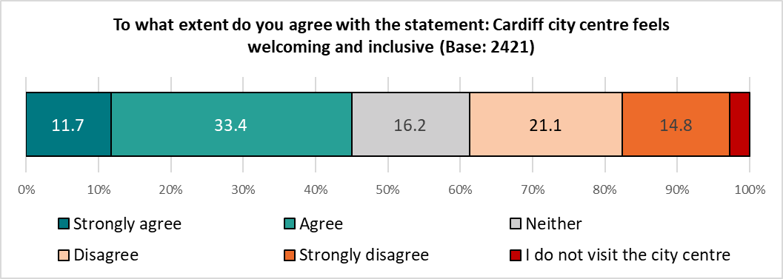

There was a clear divide by age, with younger people most likely to agree (64.8%), and older respondents least likely to agree (36.9%).
Respondents identifying as disabled and those aged 55 or older were most likely to report that they did not visit the city centre (6.6% and 4.0% respectively).
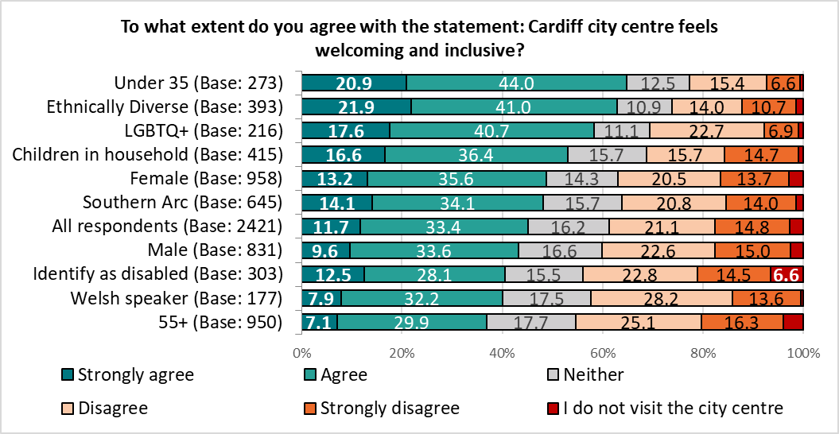

Whilst there was no direct correlation with level of deprivation, respondents living in the less deprived areas of the city were a little less likely to agree than those in more deprived areas.
Respondents living in the least deprived areas were most likely to state that they did not visit the city centre (4.8%, compared with 1.7% of those from the most deprived areas).

Section 2:

Your Neighbourhood

6. How satisfied or dissatisfied are you with your local community as a place to live?
Almost seven in ten respondents (68.8%) were satisfied with their local community as a place to live, reflecting the findings of previous Ask Cardiff surveys.

There was a clear correlation between level of deprivation and satisfaction with their local community as a place to live - respondents living in the least deprived areas of the city were notably more satisfied with their local community as a place to live than those in the most deprived areas, with the former almost twice as likely to describe themselves as ‘satisfied’ than the latter (84.6% compared with 47.6% respectively), reflecting the results of previous surveys. Less than one in ten respondents from the least deprived areas described themselves as ‘dissatisfied’ with their local community, four times less likely than those in the most deprived areas (9.2% compared with 40.7%)

Base sizes shown in brackets; excludes ‘Don’t Know’ responses.
Fewer than half of those living in the most deprived areas reported feeling satisfied with their local community as a place to live, up slightly from 2023, but still below previous findings:
Satisfaction with local community | Most deprived | Least deprived | Difference
2024 | 47.6% | 84.6% | 37.0
2023 | 45.8% | 85.4% | 39.6
2022 | 50.0% | 85.2% | 35.2
2021 | 56.5% | 89.3% | 32.8
2020 | 50.7% | 90.5% | 39.8

Satisfaction with the local community as a place to live was notably lower amongst respondents living in the Southern Arc (57.3%, eight percentage points lower than any of the other sub-groups analysed). This reflects the findings of previous surveys.
Base sizes shown in brackets; excludes ‘Don’t Know’ responses

7. To what extent do you agree or disagree with this statement: My neighbourhood is a place where people get on well together and help each other?
Three in five (59.7%) of those surveyed agreed that their “neighbourhood is a place where people get on well together and help each other”, broadly reflecting the findings of previous surveys.

Welsh speakers (69.9%) were most likely to agree with this statement, those living in the Southern Arc of the city were least likely to agree (52.6%), reflecting previous surveys.
Base sizes shown in brackets; excludes ‘Don’t Know’ responses.

There was a correlation with this statement and the level of deprivation, ranging from 43.2% amongst those living in the most deprived areas to 73.2% amongst those in the least deprived areas. The gap between the most and least deprived areas remains consistent post-pandemic.
Base sizes shown in brackets; excludes ‘Don’t Know’ responses.

8. To what extent do you agree that you are able to have a say on local issues or how Council services are run in your community?
Around a quarter of respondents (24.8%) agreed that they are able to have their say on local issues or how Council services are run in their community, reflecting the findings of previous surveys.

Respondents from ethnically diverse backgrounds were most likely to agree with this statement (38.8%).
More than half of respondents who identified as disabled (53.8%), or those aged 55 or older (52.5%) disagreed.

There was no correlation with level of deprivation.

9. How satisfied or dissatisfied are you with the following in your neighbourhood?
Respondents were given a list of services and asked their level of satisfaction with each.
Satisfaction was highest for Libraries/Hubs (72.1%), parks and open spaces (70.5%) and street lighting (66.0%). Dissatisfaction was highest for road maintenance (60.5%, down from 65.7% in 2023), pavement maintenance (57.9%, down from 62.5% in 2023), and Youth services and clubs / activities for young people (48.3%).

Base sizes shown in brackets; excludes ‘Don’t Know’ responses.

Where trend data is available, the top three services were unchanged from the previous year, although satisfaction with Libraries and Hubs was highest for the first time, just overtaking parks and open spaces.
Compared with the previous year, there was an increase in satisfaction across all of the services listed, with the exception of parks and open spaces, street lighting and dealing with anti-social behaviour, each of which were broadly unchanged.
 | 2024 | 2023 | 2022 | 2021
Libraries/Hubs | 72.1 | 69.2 | 64.4 | 64.1
Parks and open spaces | 70.5 | 72.5 | 74.0 | 74.0
Street lighting | 66.0 | 67.9 | 66.2 | 66.8
Schools | 58.6 | 54.8 | - | -
Children's play areas | 56.0 | 52.7 | 57.5 | 52.9
Recycling and Waste Collections | 52.2 | 31.8 | 58.6 | -
Anti-social behaviour | 44.8 | 44.2 | 39.5 | 34.3
Frequency of vandalism and graffiti | 42.7 | 40.2 | 35.3 | 35.8
Public transport | 42.6 | 32.0 | 48.0 | 43.6
Care of the elderly | 41.9 | 37.4 | 30.9 | 32.4
Frequency of dog fouling | 39.3 | 35.5 | 30.4 | 35.0
Money Advice | 38.6 | 32.4 | - | -
Street cleansing | 36.8 | 33.9 | 37.3 | 39.3
Services for the disabled | 32.6 | 24.4 | 16.0 | 22.0
Pavement maintenance | 26.6 | 24.9 | 27.1 | 26.4
Road maintenance | 24.9 | 20.6 | 28.8 | 23.2
Youth services and clubs/activities for young people | 22.0 | 16.3 | 14.1 | 14.3
Orange indicates a drop of ±2% describing themselves as satisfied compared with the previous year, teal indicates an increase in satisfaction of ±2%.

The biggest increase in satisfaction was seen for:
- Recycling and Waste collections, rising 20.4 percentage points from 31.8% in 2023 (during a time of industrial action) to 52.2%.
- Public transport, rising 10.6 percentage points from 32.0% to 42.6%.

Amongst respondents identifying as disabled, satisfaction with services for the disabled continued to rise from 12.4% in 2022 and 19.5% in 2023, to 30.0% in 2024; the level of dissatisfaction fell slightly from 54.7% in 2023 to 51.8%. This group also showed the lowest level of satisfaction with libraries and Hubs (67.8%), street lighting (61.6%), children’s play areas (46.0%), recycling and waste collections (45.4%), public transport (35.5%) and street cleansing (33.4%).
Respondents living in the Southern Arc showed the lowest levels of satisfaction with frequency of dog fouling (33.9%), anti-social behaviour (32.5%) and frequency of vandalism & graffiti (31.7%).
Respondents under 35 showed the highest level of satisfaction with schools (68.8%) and anti-social behaviour (53.0%).
Two of the services listed showed a correlation between satisfaction and level of deprivation, repeating the findings of the 2022 and 2023 surveys. There were notable gaps in satisfaction with levels of anti-social behaviour and frequency of vandalism and graffiti between the most and least deprived areas:
% Satisfied | Most Deprived | Least Deprived | Difference
Anti-social behaviour | 23.4 | 66.2 | 42.8
Frequency of vandalism and graffiti | 24.6 | 60.9 | 36.4

10. Do you currently volunteer?
Overall, around a quarter (26.6%) of respondents said they currently volunteer, on a par with previous findings – this rose to 42.3% amongst Welsh speakers, and fell to 19.4% of under 35s.
Base sizes shown in brackets.

Whilst there was no direct correlation, respondents living in the least deprived areas were more likely to volunteer than those in the most deprived areas (31.8% compared with 21.4% respectively), again reflecting previous findings.
Base sizes shown in brackets.
Listed below are a number of ways that you could contribute to the wellbeing of your community. Please tell us if you are, or would like to be, involved in each of the following:
Respondents were most likely to already be involved ‘learning more about how to reduce your carbon footprint’ (22.6%) and Community Volunteering (16.2%), repeating the findings of the 2023 survey.
Of the volunteering opportunities listed, those generating the most interest for future volunteering opportunities were:
- Improving community safety as part of Neighbourhood Watch (21.5%)
- Learning more about how to reduce your carbon footprint (18.0%)
- Community Volunteering (17.4%)

A total of 1,078 respondents expressed an interest in getting involved in contributing to the wellbeing of their community, of whom 720 provided contact details for further information to be sent to them. This has been passed to the relevant teams to take further action.
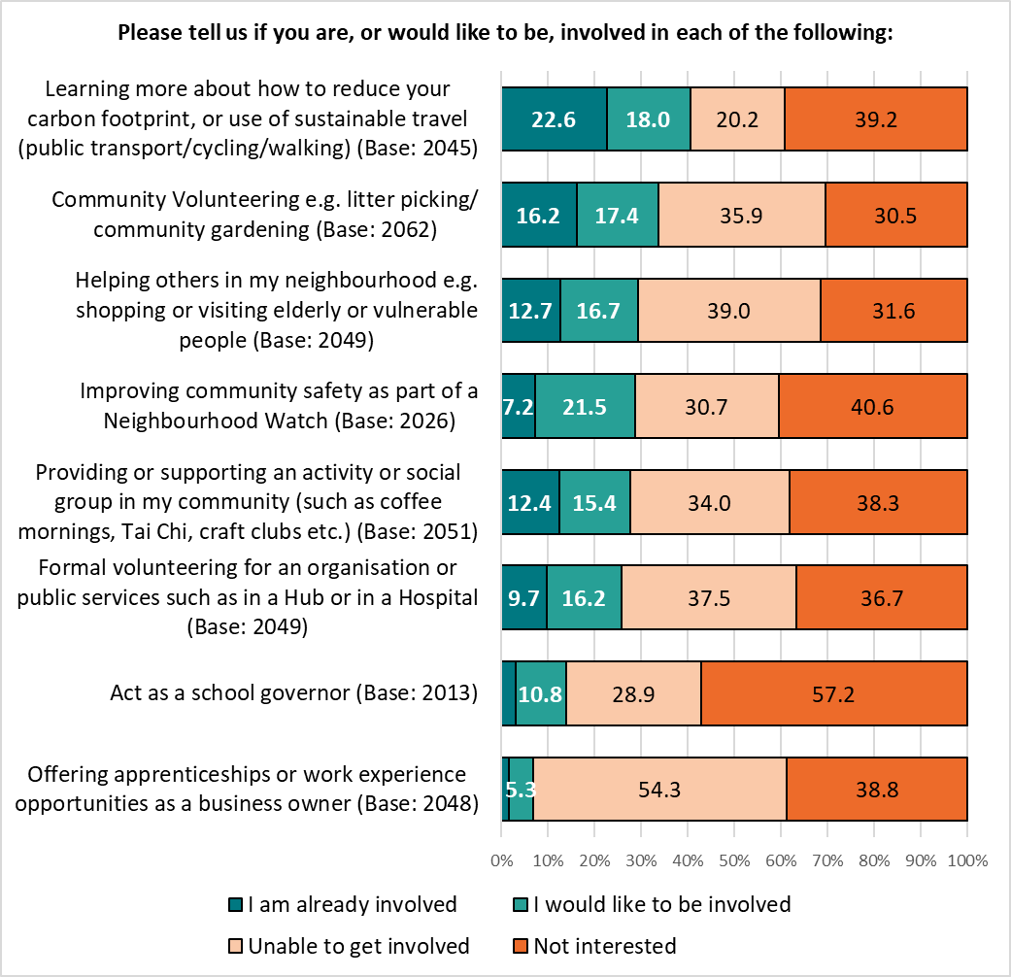 Base sizes shown in brackets; excludes ‘Don’t Know’ responses.

Respondents were invited to give details of other volunteering opportunities they would be interested in getting involved with – 170 comments were received, and grouped into themes. The top three themes are shown below, with a full breakdown in Appendix 1.
Theme | No. | % | Example Comments
Too busy / old / poorly to volunteer | 19 | 11.1 | - I am over 80 and deaf!! There's not a lot I can do  - I work enough hours  - I have a disability not able to be involved.
Already Involved | 15 | 8.8 | - I volunteer with Cardiff Foodbank  - I volunteer in the third sector  - I am already involved in litter picking, volunteer teaching for asylum seekers at Oasis. A facilitator and trustee of FAN and a school governor. I don't think I have time or energy to do more.
Gardening / Green Spaces / Nature | 14 | 8.2 | - Community gardening  - woodland conservation / maintenance. planting  - Environmental volunteering

Section 3:

Access to Services

11. How do you prefer to access information about services, events, etc?
Respondents were presented with a range of methods, both digital and non-digital, of accessing information about services, events and so on, and asked which they preferred to use.
The top three preferred means of accessing information – websites (70.4%), email (58.0%) and social media (47.4%) – were (as in 2023) all digital, with just 3.6% of respondents indicating they ‘don’t want to / can’t access information digitally’. [Note: most respondents completed the survey digitally.]
Just over a third (38.6%) of those answering this question indicated a preference for ‘posters/flyers/leaflets in community buildings’ (down from 49.8% in 2023).
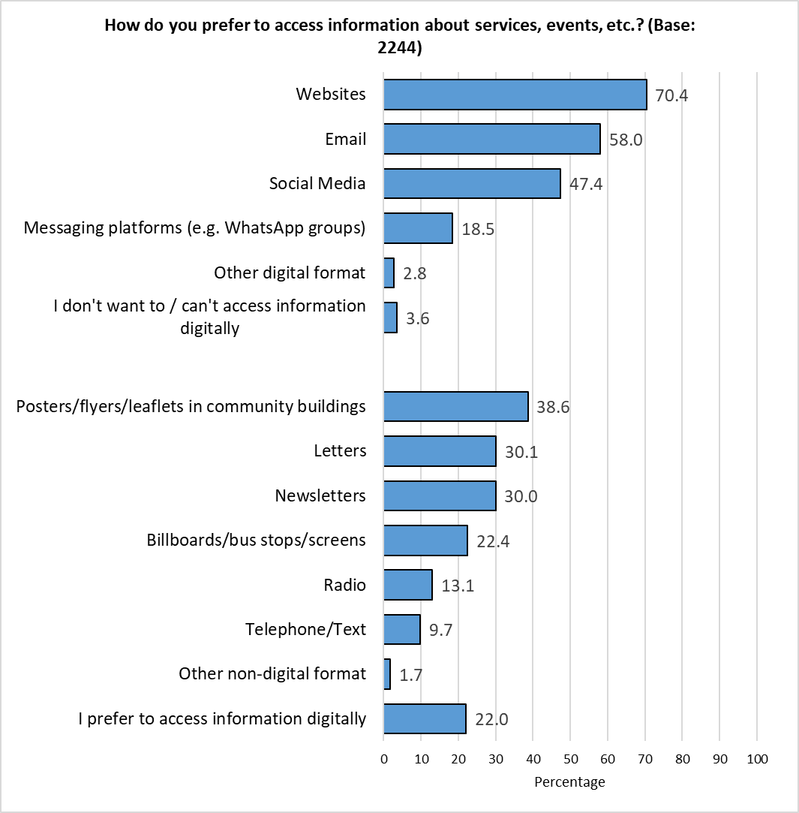 Respondents could select multiple options so the total will exceed 100%.
Digital
Non-Digital
Those answering ‘Other digital format’ were asked to specify how else they would like to access information; 22 responses were received, and grouped into themes:
- Council App (7 responses)
- Social media (5 responses)
- Non-digital formats (2 responses)
- Email (2 responses)
- Local news (2 responses)
- WhatsApp (2 responses)
- Text to phone (1 response)
- Teams (1 response)
- All (1 response)

Those answering ‘Other non-digital format’ were also asked to specify how else they would like to access information; 10 responses were received, and grouped into themes:
- In person (5 responses)
- Local media (3 responses)
- Post (1 response)
- Council Newspaper (1 response)
Results were generally consistent across the demographic groups analysed, although there were some notable differences:
- Welsh speakers were most likely to report using websites (78.0%), contrasting with respondents from ethnically diverse backgrounds (63.7%)
- Respondents with children in the household were most likely to use social media (58.0%), older respondents, aged 55 or over, were least likely to do so (41.6%)
- Older respondents were most likely to use email (64.1%) or newsletters (35.4%), contrasting with those under the age of 35 (52.2% and 22.7% respectively)

There was no correlation between preferred means of accessing information and level of deprivation.

A full breakdown of results by demographic and level of deprivation is available in Appendix 2.

12. Do you have access to affordable broadband?
Nine out of ten respondents (88.6%) reported having they had access to affordable broadband at home, with 10.2% accessing it elsewhere. Almost one in ten (8.7%) reported having no access to affordable broadband, up from 5.4% in 2023.
Respondents could select multiple options so the total will exceed 100%.

This pattern was consistent across the demographic groups analysed.
Looking at results by level of deprivation showed just 5.0% of respondents living in the most affluent areas of the city had no access to affordable broadband, around a third of the level seen in the most deprived areas (14.7%).
 | All Respondents | Least Deprived | Next Least Deprived | Middle | Next Most Deprived | Most Deprived
Base | 2,211 | 378 | 331 | 289 | 307 | 232
Yes, at home | 88.6 | 93.7 | 88.5 | 89.6 | 85.0 | 80.6
Yes, elsewhere | 10.2 | 8.7 | 10.6 | 12.5 | 12.1 | 9.1
No | 8.7 | 5.0 | 8.8 | 6.9 | 11.7 | 14.7

13. How do you currently access Council Services?
Most respondents (83.5%) currently accessed council services online. Just over a quarter (27.4%) accessed services by phone, and almost one in five (18.3%) in person.
Respondents could select multiple options so the total will exceed 100%.

The 51 respondents answering ‘Other’ were asked to give further details – 35 responses were received, and grouped into the following themes:
Theme | No. | % | Example Comments
I don’t | 17 | 48.6 | - I don’t  - I don't. It's not for taxpayers, only for unemployed and those who refuse to contribute to society.  - I try not to as there is never any outcome.  - I don't. I have very little action taken on anything from CCC. I'm not interested in people pretending to care about my issues then doing nothing anyway.
Word of mouth | 5 | 14.3 | - Wife let's me know  - If I need information I ask a family member it looks it up on their broadband  - Word of mouth
Through Services | 3 | 8.6 | - Weekly rubbish collection  - Support workers
In writing | 2 | 5.7 | - Write a letter
What Services? | 2 | 5.7 | - What service? You just waste money
Misc. | 4 | 11.4 | - App  - Any way as long as you keep giving us handouts
Total Responses | 35 | -
Respondents could comment on multiple themes so the total may exceed 100%.
This pattern of response was broadly similar across the demographic and geographic groups analysed, with some notable variations. All groups were most likely to access services online, but:
- Respondents under the age of 35 were least likely to access services by phone (21.3%), but most likely to do so in person (30.9%).
- Those identifying as disabled were most likely to access services by phone (36.1%), followed by respondents aged 55 or over (31.7%) and those living in the Southern Arc of the city (30.8%).
- Older respondents were least likely to access services in person (15.5%).
% | Base | Online | By phone | In person | Other
All respondents | 2224 | 83.5 | 27.4 | 18.3 | 3.1
Under 35 | 249 | 78.7 | 21.3 | 30.9 | 4.0
55+ | 922 | 83.9 | 31.7 | 15.5 | 2.0
Female | 958 | 84.3 | 28.8 | 18.7 | 2.5
Male | 827 | 82.5 | 26.8 | 20.1 | 2.8
Ethnically Diverse | 384 | 71.6 | 26.8 | 27.9 | 6.3
Identify as disabled | 305 | 82.3 | 36.1 | 19.7 | 1.6
Welsh speaker | 181 | 88.4 | 26.5 | 16.0 | 2.2
Southern Arc | 643 | 77.8 | 30.8 | 23.6 | 3.1
Children in household | 418 | 80.9 | 24.6 | 18.9 | 4.1
LGBTQ+ | 217 | 86.2 | 24.9 | 19.8 | 2.8
Respondents could select multiple options so the total will exceed 100%.

There was no correlation between means of accessing services and level of deprivation.

14. Please indicate the extent to which you agree or disagree with the below statements:
Three in five respondents (59.2%) agreed that “Council staff are approachable and friendly”; two in five agreed that “Contacting the Council is simple” and “Accessing up to date information about Council services is easy” (43.9% for each).

Those who disagreed that ‘Contacting the Council is simple’ were asked to explain why they had said this; 435 comments were received, and grouped into themes. The top three are shown below, with a full list in Appendix 3.
Theme | No. | % | Example Comments
Issues with C2C / when phoning the Council | 182 | 41.8 | - Recent example - had to wait on telephone for 45 minutes to speak to someone in person about council tax  - nobody never answers the phone . emails are ignored and excuses are given that its not my department. there appears to be a complete lack of accountability  - Your C2C service is pretty hopeless  - Sometimes you can't find the correct place online so you have to phone, then they always tell you there's a high volume of calls and to go online. NOT acceptable. BObbi the chat bot is useless
Poor digital channels | 75 | 17.2 | - C2C has long wait times. I suspect due to budget cuts. Why can’t I contact the council via What’s App. Digital channels haven’t developed fast enough. Planning doesn’t have a phone line and their digital services are poor and challenging to navigate.  - The website it complicated and poorly designed. You can only find information on set certain things. Anything else is very difficult to do  - No one there when I want them. Responses to emails takes too long. Website is hopeless
Time taken to answer / respond - Method not specified | 51 | 11.7 | - Well. I complained to the council and councillor XXX. And what must be 3 months I have had no response. You keep taking my money but 100% avoid dealing with actual issues people face  - No one ever replies.  - Difficult to get a response. Not approachable. Rude. Elitist

Respondents identifying as disabled were least likely to agree that ‘contacting the Council is simple’ (39.0%), followed by those aged 55 or over (42.6%).

Respondents identifying as disabled and those aged 55 or over were also least likely to agree that ‘Accessing up to date information about Council services is easy’ (37.5% and 40.3% respectively).

There was consistency of opinion as to ‘Council staff are approachable and friendly” across the demographic groups analysed.

There was no correlation between agreement with any of the three statements and level of deprivation.

Section 4:

Hubs & Libraries

15. What services delivered within your local Hub/Library do you find most helpful to you?
Respondents were given a list of services delivered within their local Hub/library, and asked to indicate which they found most helpful.
Of the services listed, the two most helpful were unchanged from the previous year - ‘Book loan’, selected by 43.0% of respondents (up from 32.1% in 2023), followed by ‘community events’ (15.2%, up from 10.8%). ‘Adult learning’ was placed third, with 14.8%, double the proportion seen in 2023 (7.1%).
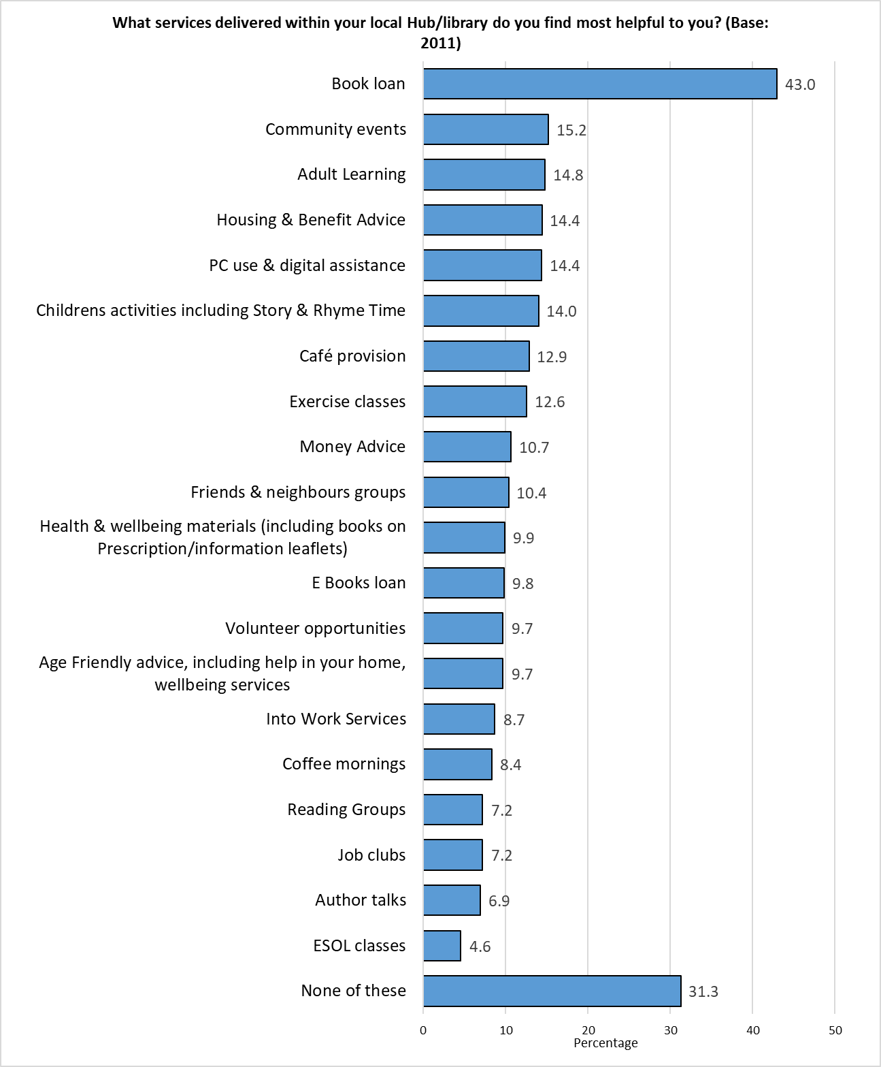Respondents could select multiple options so the total will exceed 100%.

Respondents were invited to put forward for other services at their local Hubs/libraries they found to be helpful; 306 comments were received, and grouped into themes. The top three are shown below, with a full list in Appendix 4.
Theme | No. | % | Example Comments
There is no local Hub/Library / Access Issues | 41 | 13.4 | - We do not have a local library or hub within 5 miles  - We don't have a local library at all  - No hub here
Don't know / use | 38 | 12.4 | - I rarely use the hub and when I do it's to collect waste sacks  - I don't currently use the libraries hubs but I do support them  - Never knew they existed
Age specific activities | 25 | 8.2 | - There is nothing at my local hub for old age pensioners  - More child or youth activities after school time

There were some differences by demographic and level of deprivation:
With the exception of book loans, respondents under the age of 35 were more likely to find library services helpful than their older counterparts – the table below highlights the highest scores amongst the demographic groups analysed in teal, and the lowest score in orange:
% | All respondents | Under 35 | 55+
Base | 2011 | 249 | 891
Book loan | 43.0 | 39.8 | 43.9
Childrens activities including Story & Rhyme Time | 14.0 | 20.9 | 7.1
Coffee mornings | 8.4 | 13.3 | 6.8
E Books loan | 9.8 | 16.9 | 6.6
ESOL classes | 4.6 | 10.8 | 2.2
Exercise classes | 12.6 | 18.1 | 10.8
Health & wellbeing materials (including books on Prescription / information leaflets) | 9.9 | 17.7 | 9.1
Housing & Benefit Advice | 14.4 | 23.3 | 10.2
Into Work Services | 8.7 | 19.3 | 3.7
Job clubs | 7.2 | 17.7 | 2.9
Money Advice | 10.7 | 18.5 | 6.2
PC use & digital assistance | 14.4 | 21.7 | 12.5
Volunteer opportunities | 9.7 | 20.5 | 6.8

Welsh speakers were most likely to find book loans (57.1%), community events (22.0%), author talks (16.1%) and reading groups (13.1%) helpful.
Respondents with children in their household were most likely to cite children’s activities (33.7%).
Those identifying as disabled were most likely to find housing and benefit advice (24.5%, up from 16.3% in 2023), age friendly advice (15.1%) and Friends & Neighbours groups (15.1%) helpful.
Respondents from an ethnically diverse background were most likely to find adult learning (27.7%, up from 14.9%), money advice (18.9%) and ESOL classes (13.0%) helpful. They were least likely to state that ‘none’ of the services listed were helpful.
Males were most likely to state they found ‘none’ of the services listed helpful (37.6%).

The following services correlated with level of deprivation, with those living in the most deprived areas finding them to be more helpful:
 | Most Deprived (Base: 219) | Least Deprived (Base: 364)
Housing & Benefit Advice | 28.8 | 6.6
Adult learning | 20.5 | 10.7
Money Advice | 17.8 | 6.0
Into Work Services | 15.5 | 3.6
Job clubs | 13.2 | 2.7
ESOL classes | 8.2 | 1.9

A full breakdown is available in Appendix 5.

16. What activities and events would you like to see in your Hub/library?
Respondents were given a new list of services, and asked to indicate which they would like to see in their local Hub or Library.
At least one in six respondents expressed an interest in each of the services listed.
The most popular were fitness activities (e.g. walking groups) (31.7%) and exercise classes for over 50s (e.g. Tai Chi) (28.3%)
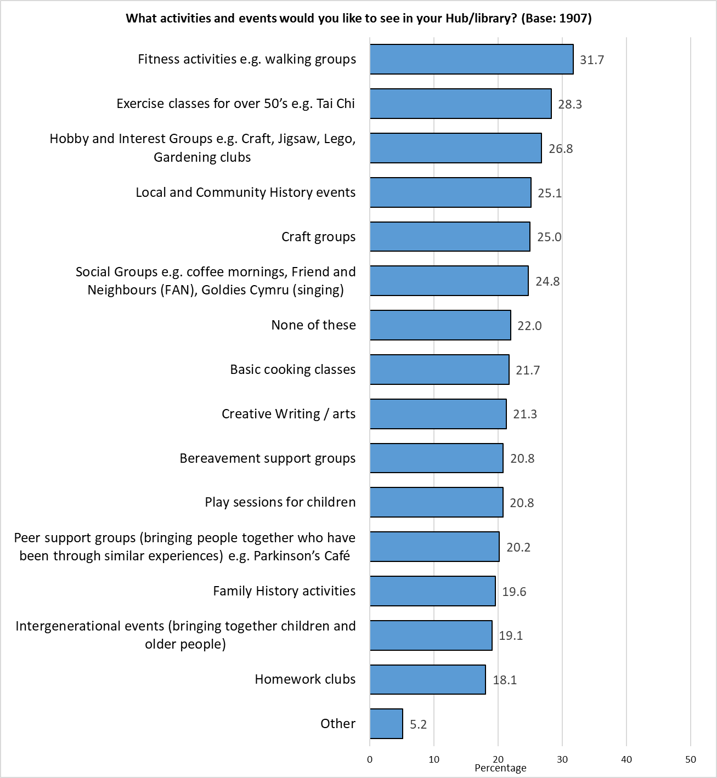 Respondents could select multiple options so the total will exceed 100%

Respondents were invited to put forward suggestions for other activities or events they would like to see in Hubs/libraries; 77 comments were received, and grouped into themes. The top three are shown below, with a full list in Appendix 6.
Theme | No. | % | Example Comments
Languages | 7 | 9.1 | - Having activities that encourage learning or building on languages, especially Welsh.  - Language exchanges but outside normal working hours
Health support | 6 | 7.8 | - Help with mental health and wellbeing  - Dementia cafe, volunteering fairs, food cooperatives, health talks eg ADHD, parenting, dementia, mobility aids support, mobility aids loan.
Arts / Crafts / Games | 6 | 7.8 | - Art for adults  - Knitting and crocheting  - Card Playing Group

There were some differences across the demographic and geographic groups analysed:
Respondents under the age of 35 showed the highest levels of interest in craft groups (38.1%), social groups such as coffee mornings (33.9%), creative writing / arts (33.5%), peer support groups (28.0%) and intergenerational events (25.8%).
Those with children in the household were most interested in play sessions for children (43.2%), hobby and interest groups (38.2%), basic cooking classes (35.8%) and homework clubs (35.3%).
Welsh speakers were most likely to express interest in local and community history events (32.5%) and family history activities (25.6%).
Men (29.7%) and respondents aged 55 or over (26.3%) were most likely to indicate they were not interested in any of the services listed

Two of the services listed were correlated with levels of deprivation, with respondents living in the most deprived areas showing the highest levels of interest:
% | Most Deprived | Least Deprived | Difference
Homework clubs | 27.9 | 14.9 | 13.0
Bereavement support groups | 26.5 | 17.1 | 9.4

A full breakdown of results by demographic and level of deprivation can be found in Appendix 7.
17. How would you like us to tell you about events that are happening in your Hub/ library? (e.g. technology events, book events)
Respondents were given a list of options, and asked how they would like to be told about events in their local Hub/library.
Two-thirds (66.3%) of respondents chose email, almost double the second most popular option, Facebook (37.5%), with a third (33.3%) wanting information via posters in Hubs/libraries.
Around one in twelve respondents (8.6%) indicated that they didn’t want information from any of the sources listed.

Those answering ‘Other’ were asked how they would like to be told about events; 109 comments were received and grouped into themes. The top three are shown below, with a full list available in Appendix 8.
Theme | No. | % | Example Comments
Community Flyers / Leaflets / Posters / Newsletters | 31 | 28.4 | - Local flyers / posters outside of the hub/library  - Posters on lampposts, bus stops and along frequently used paths  - Posters around the city and boroughs  - Posters outside hub library - shop windows etc.
Letter / Through the post | 29 | 26.6 | - posters and pamphlets through the post  - Regular newsletters by post  - Leaflets in post with calendar of events
Council / Hub Website | 22 | 20.2 | - Through council website  - The hub website  - Just update website information  - Council website app, push notifications for activities in your area

Section 5:

Cost of Living

18. In the last 6 months, have you missed paying rent or mortgage payments?
Overall, 5.7% of respondents reported missing rent or mortgage payments over the past 6 months, slightly higher than the 3.7% recorded in the previous year.

As in previous years, those living in the most deprived areas were almost ten times more likely to answer ‘Yes’ than those in the least deprived areas. The proportion of those in the most deprived areas who had missed payments increased slightly, to 10.8%.
Missed Payments | 2024 | 2023 | 2022
Most deprived | 10.8 | 9.3 | 5.3
Next most deprived | 6.4 | 4.3 | 3.4
Middle | 4.6 | 2.9 | 3.2
Next least deprived | 4.1 | 3.0 | 2.3
Least deprived | 0.7 | 1.1 | 0.5
All respondents | 5.7 | 3.7 | 3.1

Of the demographic groups analysed, respondents under the age of 35 were most likely to report missing a payment (10.0%), followed by respondents from an ethnically diverse background (9.9%), those identifying as disabled (8.6%) and households with children (8.1%).
Respondents aged 55 or over were least likely to answer ‘Yes’ (2.9%).

19. In the last six months, have you or anyone else in your household done any of the following because you couldn't AFFORD food:
Results were broadly similar to the findings of the 2023 survey, with around one in 6 (15.9%) eating smaller meals than usual, or skipping meals because they couldn’t afford food; one in twelve (8.6%) missed meals to afford to pay bills.
The proportion of respondents receiving food from a food bank or charity increased from 2.5% in 2023 to 4.4%.
% | 2024 | 2023 | 2022 | 2021 | 2020
Had smaller meals than usual, or skipped meals | 15.9 | 16.2 | 15.6 | 9.6 | 8.0
Missed meals to afford to pay your bills | 8.6 | 7.5 | 5.9 | - | -
Been hungry but not eaten | 7.1 | 6.2 | 5.8 | 5.2 | 5.2
Not eaten for a whole day | 4.2 | 3.4 | 3.5 | 2.5 | 3.4
Received food from a food bank or charity | 4.4 | 2.5 | 2.6 | 1.8 | 1.6

Respondents under the age of 35 were most likely to have undertaken at least one of the options listed (38.5%), followed by those identifying as disabled (31.0%), and residents of the Southern Arc (30.3%). Respondents over the age of 55 were most likely to report they had done ‘none’ of the options listed (86.6%).
Around one in fourteen of those identifying as disabled (7.7%) reported that they had ‘not eaten for a whole day’ – the highest proportion of all demographic groups analysed, reflecting the findings of the previous year.
 | Identify as disabled | Under 35 | Southern Arc
Base | 300 | 260 | 624
Had smaller meals than usual, or skipped meals | 30.8 | 25.3 | 22.3
Been hungry but not eaten | 15.0 | 13.3 | 9.1
Not eaten for a whole day | 7.3 | 7.7 | 5.8
Missed meals to afford to pay your bills | 15.0 | 15.3 | 14.1
Received food from a food bank or charity | 6.9 | 9.7 | 7.1
None of these | 61.5 | 69.0 | 69.7

There was a broad correlation with those unable to afford food and the level of deprivation:
At least one of the actions listed | Most Deprived | Next Most Deprived | Middle | Next Least Deprived | Least Deprived | All Respondents
2024 | 41.3 | 29.1 | 17.8 | 18.2 | 8.7 | 21.1
2023 | 36.8 | 21.8 | 18.1 | 15.3 | 9.0 | 20.1

As in previous years, respondents living in the most deprived areas of the city were notably more likely to report having been impacted by not being able to afford food, with 29.3% ‘eating smaller meals, or skipping meals’ completely; a fifth (20.0%) ‘missed meals to be able to pay bills’; almost one in seven (12.9%) had ‘been hungry but not eaten’.
The proportion of those in the most deprived areas reporting they had not ‘eaten for a whole day’ (9.8%) or ‘received food from a food bank or charity’ (12.0%) increased from 6.3% and 4.5% respectively in 2023.
 | 2024 |  | 2023
 | Most deprived | Least deprived | Most deprived | Least deprived
Had smaller meals than usual, or skipped meals | 29.3 | 6.6 | 29.7 | 8.1
Missed meals to afford to pay your bills | 20.0 | 2.6 | 17.5 | 2.0
Been hungry but not eaten | 12.9 | 2.9 | 14.5 | 2.7
Not eaten for a whole day | 9.8 | 0.3 | 6.3 | 0.7
Received food from a food bank or charity | 12.0 | 1.1 | 4.5 | 0.5

A full breakdown of these questions broken down by demographics is available in Appendix 9.

In the last 6 months, have you or anyone in your household…?
More than half of those responding to this question (58.6%, up slightly from 52.9% in 2023) reported they had not taken any steps to deal with increasing energy costs. More than a third (37.3%) had ‘purposely not put the heating on because of the cost’, and one in seven respondents (14.3%) had ‘struggled to pay gas and/or electric bills’.
 | No. | %
Purposely not put the heating on because of the cost | 774 | 37.3
Struggled to pay gas/electric bills | 297 | 14.3
Applied for support to pay for gas/electric | 71 | 3.4
Been cut off from the electricity/gas supply | 29 | 1.4
Received fuel vouchers from a charity | 19 | 0.9
None of these | 1215 | 58.6
Total Respondents | 2,075 | -
Respondents could select multiple options so the total will exceed 100%.

As in previous years, older respondents and men were most likely to report they had not taken any of the actions listed with regard to coping with rising energy prices; more than half of respondents identifying as disabled and younger respondents stated they had done at least one of the options listed in response to rising energy costs.

There was a clear correlation with level of deprivation, those living in the most deprived areas were least likely to state they had done none of the options listed, with those in the least deprived areas most likely to do so.

Almost one in ten (9.2%) respondents living in the most deprived areas of the city had applied for support to pay their energy bill halved, returning to the level seen in 2022 (10.0%) after dropping to 4.8% in 2023.
A full breakdown of these questions broken down by demographics is available in Appendix 10.

How will you/your household cope with the expected increase in energy costs this winter?
Respondents were given a list of options, and asked how they planned to cope with the expected increase in energy costs.
Just over a third of respondents (38.0%) reported they ‘can afford the increase in energy cost’, reflecting the findings of the previous year.
The proportion of respondents stating they would ‘significantly cut down on heating’ continued to fall, from 62.5% in 2022 to 54.5% in 2023, down to 46.6% in 2024.
 | No. | %
Significantly cut down on heating | 954 | 46.6
I can afford the increase in energy cost | 779 | 38.0
Not use the heating | 338 | 16.5
Cut out other essentials such as food | 231 | 11.3
Borrow money/pay on credit card | 124 | 6.1
Other | 146 | 7.1
Total Respondents | 2,048 | -
Respondents could select multiple options so the total will exceed 100%.

Those answering ‘Other’ were asked to say how they planned to cope with the increase in energy costs; 92 responses were received and grouped into themes. The top three themes are shown below, with a full breakdown in Appendix 11.
Theme | No. | % | Example Comments
Make Savings - use less energy / reduce outgoings | 40 | 43.5 | - Stick to one room as much as possible. Wear more layers of clothing.  - Wear more jumpers, suffer the cold, have fewer showers  - Use less heating, but not 'significantly' so. It will be on much less than desired though.  - Other expenses will have to go - not putting the heating on leads to damp homes and ill health.
Wear more layers / blankets | 11 | 12.0 | - Wear extra jumpers and blankets to not get cold.  - I will reduce my heating a little, will wear warm cloths, miss my heating allowance.
Doesn't affect me | 6 | 6.5 | - We have 3 KW PV panels facing due south, a 5kWh battery and 90%+ smoke free triple combustion wood burning stove so our energy bills are very low.  - pay the bill - we earn enough to manage
Respondents identifying as disabled were most likely to report they would ‘significantly cut down on heating’ (59.7%), and were least likely to feel they ‘can afford the increase in energy cost’ (22.7%).
Respondents aged 55 or over were notably more likely than those under the age of 35 to say they can ‘afford the increase in energy cost’ (45.6% compared with 29.0% respectively); the older group were less likely than their younger counterparts to ‘not use the heating (11.5% compared with 24.5% respectively), or ‘borrow money or pay on a credit card’ (1.9% compared with 13.5% respectively).
Respondents under the age of 35 and those with children in their household were most likely to ‘borrow money or use a credit card’ to pay their energy bills (13.5% and 12.1% respectively).
 | Base | Not use the heating | Significantly cut down on heating | Cut out other essentials such as food | Borrow money / pay on credit card | I can afford the increase in energy cost
Identify as disabled | 245 | 23.7 | 59.7 | 13.3 | 10.7 | 22.7
Ethnically Diverse | 344 | 18.9 | 47.4 | 17.7 | 9.6 | 27.9
Under 35 | 245 | 24.5 | 44.1 | 15.5 | 13.5 | 29.0
Children in household | 398 | 18.8 | 51.3 | 17.1 | 12.1 | 31.4
Southern Arc | 607 | 21.3 | 48.9 | 16.5 | 9.6 | 32.1
Female | 918 | 15.3 | 52.7 | 10.8 | 7.1 | 33.9
LGBTQ+ | 221 | 18.1 | 43.0 | 13.6 | 11.8 | 37.6
All respondents | 2048 | 16.5 | 46.6 | 11.3 | 6.1 | 38.0
Male | 796 | 15.5 | 39.2 | 11.3 | 5.0 | 45.2
55+ | 932 | 11.5 | 43.6 | 7.4 | 1.9 | 45.6
Welsh speaker | 179 | 14.5 | 41.9 | 8.9 | 4.5 | 45.8

There were correlations between respondents stating they would take action to cope with the expected increase in energy costs and level of deprivation, with those living in the most deprived areas of the city most likely to not use or cut down use of the heating, cut out other essentials or borrow money to pay the bill; they were least likely to feel they could afford the increase:
 | Base | Not use the heating | Significantly cut down on heating | Cut out other essentials such as food | Borrow money / pay on credit card | I can afford the increase in energy cost
All Respondents | 2048 | 16.5 | 46.6 | 11.3 | 6.1 | 38.0
Least Deprived | 376 | 8.8 | 41.8 | 3.7 | 2.1 | 48.4
Next Least Deprived | 352 | 15.4 | 42.8 | 11.1 | 5.8 | 44.0
Middle | 291 | 14.4 | 47.1 | 10.3 | 5.2 | 43.6
Next Most Deprived | 291 | 19.6 | 49.5 | 15.1 | 7.2 | 33.0
Most Deprived | 217 | 28.1 | 55.3 | 23.5 | 12.9 | 20.3

20. Are you aware that the Council offers help with benefits and income, help with debts, Into Work and housing advice?
Awareness of this service was broadly similar to that seen in 2023, with 61.3% of respondents aware of at least one of the options listed.
Awareness of support in Hubs/libraries was highest (54.4%), followed by the Cardiff Money Advice website (20.2%), and Adviceline (11.6%), reflecting the pattern seen in previous years.
Respondents could select multiple options so the total will exceed 100%.

Those answering ‘Other’ were asked to give further details – 37comments were received:
- Not eligible (7 comments)
- Aware advice is available but unsure how to access it (2 comments)
- Do not need / use this help (5 comments)
- Advice did not help (4 comments)
- Benefits are for the lazy (4 comments)
- Splott community volunteers (1 comment)
- gov.uk budgeting loans (1 comment)
- Age concern (1 comment)
- Age Connect (1 comment)
- Independent Living Services Visiting Team and Floating Support (1 comment)
- Adult learning, food bank access (1 comment)
- Also other organisations/ charities (1 comment)
- I am aware of most of the services as I work in the council (1 comment)
- Friends who worked for Cardiff Council (1 comment)
- From these surveys :-) (1 comment)

Awareness of this Advice Service was broadly consistent across the demographic groups analysed.
 | Base | Yes, in Hubs / Libraries | Yes, at the website | Yes, the Adviceline | Welfare Liaison Team | Help with debts | Other | No
Female | 910 | 59.3 | 20.9 | 12.4 | 5.6 | 7.7 | 2.9 | 33.6
Identify as disabled | 300 | 59.3 | 22.0 | 9.7 | 5.0 | 6.7 | 2.7 | 36.3
Southern Arc | 606 | 58.6 | 20.5 | 11.7 | 5.9 | 6.9 | 3.8 | 34.0
Children in Household | 402 | 53.5 | 22.4 | 13.2 | 5.0 | 9.2 | 3.5 | 38.1
Under 35 | 253 | 52.6 | 24.9 | 15.8 | 5.9 | 8.3 | 2.4 | 37.5
Ethnically Diverse | 351 | 52.1 | 15.7 | 11.7 | 3.7 | 8.3 | 5.1 | 38.7
55+ | 914 | 55.7 | 17.7 | 8.9 | 4.3 | 5.6 | 2.5 | 39.3
All respondents | 2036 | 54.4 | 20.2 | 11.6 | 4.8 | 6.5 | 3.1 | 38.7
LGBTQ+ | 221 | 55.7 | 22.6 | 12.7 | 7.7 | 9.0 | 4.5 | 34.8
Welsh speaker | 172 | 51.2 | 20.9 | 11.0 | 7.6 | 9.3 | 1.7 | 40.7
Male | 795 | 52.6 | 21.5 | 11.4 | 4.4 | 6.2 | 2.9 | 41.8

Awareness of the advice service was higher amongst those living in deprived areas of the city:
 | Base | Yes, in Hubs / Libraries | Yes, at the website | Yes, the Adviceline | Welfare Liaison Team | Help with debts | Other | No
Most deprived | 215 | 57.8 | 22.5 | 13.3 | 7.3 | 10.1 | 6.0 | 32.1
Next most deprived | 296 | 61.8 | 19.6 | 12.2 | 4.7 | 6.4 | 4.1 | 31.1
Middle | 286 | 54.9 | 22.7 | 12.2 | 6.3 | 7.3 | 1.4 | 40.2
Next least deprived | 316 | 55.4 | 24.1 | 11.1 | 4.4 | 6.6 | 1.9 | 39.2
Least deprived | 370 | 48.4 | 15.7 | 9.7 | 3.5 | 5.1 | 1.6 | 46.2
All respondents | 2036 | 54.4 | 20.2 | 11.6 | 4.8 | 6.5 | 3.1 | 38.7

21. Which of the following statements regarding advice on money management, debt, benefits, Into Work or housing advice applies to you?
The proportion of respondents stating they have accessed advice in the past continued its upward trend, rising from 15.7% in 2022 and 17.0% in 2023 to 23.5% in 2024. More than a third (36.7%) felt they may need advice in the future, up from almost a fifth (18.1%) in last year’s survey.
Base sizes shown in brackets.

Respondents identifying as disabled and those from an ethnically diverse background were most likely to seek advice, either having done so in the past (38.7% and 35.6% respectively), or expect to do so in the future (59.7% and 57.1% respectively):
 | Have sought advice in the past |  | May seek advice in the future
 | 2024 | 2023 | 2024 | 2023
Identify as disabled | 38.7 | 31.5 | 59.7 | 30.1
Ethnically Diverse | 35.6 | 24.9 | 57.1 | 33.5
Southern Arc | 31.8 | 21.4 | 48.9 | 22.4
LGBTQ+ | 31.5 | 26.8 | 43.8 | 28.4
Under 35 | 29.4 | 22.7 | 54.3 | 28.0
Children in Household | 28.9 | 18.8 | 44.9 | 23.9
Female | 26.3 | 19.4 | 39.2 | 19.7
All respondents | 23.5 | 17.0 | 36.7 | 18.1
Welsh speaker | 22.0 | 14.9 | 31.0 | 12.8
Male | 20.8 | 11.8 | 32.1 | 14.8
55+ | 18.6 | 14.7 | 27.6 | 14.0

Respondents living in the most deprived areas were almost four times more likely than those in the least deprived areas to have sought advice on money management, debt, benefits, Into Work or housing advice (39.8% compared with 10.9% respectively), and more than twice as likely to expect to seek advice in the future (59.1% compared with 23.5% respectively), with the gap between these areas continuing to widen
` | Have sought advice in the past |  |  | May seek advice in the future
 | 2024 | 2023 | 2022 | 2024 | 2023 | 2022
Most deprived | 39.8 | 32.5 | 27.6 | 59.1 | 31.3 | 27.8
Least deprived | 10.9 | 8.9 | 6.8 | 23.5 | 10.6 | 8.6
Difference | 28.9 | 23.6 | 20.8 | 35.6 | 20.7 | 19.2

22. If you are State Pension age and over, do you currently claim Pension Credit?
Excluding responses from those indicating they were not of State Pension age, one in fourteen (7.4%) stated they currently claimed Pension Credit.

Amongst respondents of State Pension age, those identifying as disabled were most likely to claim Pension Credit (13.3%), followed by those resident in the Southern Arc (12.5%).
Caution should be taken with small base sizes

Whilst there was not a direct correlation with level of deprivation, residents in the most deprived areas of the city were around three times more likely to claim Pension credit than those in the most affluent areas (19.4% compared with 5.9% respectively).
Caution should be taken with small base sizes

22. Why don't you claim Pension Credit?
Those who did not currently claim Pension Credit were asked why they did not claim, selecting options from a provided list, or giving their own reasons.
Three in five (60.7%) did not think they were eligible, a fifth (20.9%) felt they didn’t need the extra financial help, and around one in six (12.5%) applied, but were not eligible.

Those answering ‘Other’ were asked to explain why, 30 responses were received:
- I know I’m not eligible (23 responses)
- I don't know what it is (1 comment)
- My husband was not eligible so am unsure if I can claim it on my own right (1 comment)
- my mental health makes it difficult (1 comment)
- Only benefit for lazy people. Not worth trying as they don't listen. (1 comment)
- Our community (Hindu) don't like to claim benefits. We work hard to have our savings. But then it is not fair that we are constantly asked to pay for others on benefits. We can't get help with boiler, roof, heating.... (1 comment)
- That's private info (1 comment)
- This is for people who couldn't be bothered to work when younger and couldn't be bothered to save either. (1 comment)

Selected demographic groups were analysed (those with small base sizes were excluded), with results broadly consistent across these groups:
% | All respondents | 55+ | Female | Male | Identify as disabled | Southern Arc
Base | 512 | 492 | 210 | 278 | 91 | 126
I applied and was not eligible | 12.5 | 12.4 | 13.3 | 11.9 | 17.6 | 17.5
I don’t think I’m eligible | 60.7 | 61.0 | 58.6 | 61.9 | 58.2 | 54.8
I don’t need the extra financial help | 20.9 | 21.5 | 23.3 | 20.5 | 15.4 | 18.3
I don’t want to claim Pension Credit | 1.8 | 1.8 | 1.9 | 1.8 | 1.1 | 3.2
I don’t know how to apply | 1.2 | 1.0 | 0.0 | 1.8 | 3.3 | 0.8
I have not got around to it | 0.4 | 0.4 | 0.5 | 0.4 | 1.1 | 0.8
I do not know what Pension Credit is | 1.8 | 1.4 | 0.5 | 2.2 | 4.4 | 1.6
Other | 6.4 | 5.9 | 7.6 | 5.0 | 8.8 | 6.3

The proportion of respondents who had applied for Pension Credit but were not eligible to receive it correlated with level of deprivation, with those living in the more deprived areas more likely to give this answer than those in more affluent areas.
Those living in the two most affluent quintiles of the city were more likely to state that think didn’t think they were eligible, or that they didn’t need the extra financial help
% | All Respondents | Least Deprived | Next Least Deprived | Middle | Next Most Deprived | Most Deprived
Base | 512 | 164 | 100 | 72 | 57 | 28
I applied and was not eligible | 12.5 | 7.3 | 11.0 | 15.3 | 15.8 | 25.0
I don’t think I’m eligible | 60.7 | 62.8 | 65.0 | 55.6 | 57.9 | 42.9
I don’t need the extra financial help | 20.9 | 21.3 | 28.0 | 22.2 | 12.3 | 10.7
I don’t want to claim Pension Credit | 1.8 | 1.2 | 2.0 | 2.8 | 1.8 | 3.6
I don’t know how to apply | 1.2 | 0.6 | 2.0 | 1.4 | 0.0 | 0.0
I have not got around to it | 0.4 | 0.6 | 0.0 | 1.4 | 0.0 | 0.0
I do not know what Pension Credit is | 1.8 | 3.0 | 1.0 | 2.8 | 1.8 | 0.0
Other | 6.4 | 8.5 | 5.0 | 2.8 | 10.5 | 3.6
Caution should be taken with small base sizes

Pension Credit tops up weekly income to help with living costs, for people over State Pension age and on a low income. The average Pension Credit award is worth over £3,900 per year and opens doors to other support, including the Winter Fuel Payment, help with housings, council tax and heating bills.

Do you, or does anyone in your household, need support to claim Pension Credit?

Overall, one in 16 respondents (6.8%) stated they, or someone in their household, needed support to claim Pension Credit.
Those from an ethnically diverse background (19.7%) were most likely to need support, followed by those identifying as disabled (10.7%).

Whilst not directly correlated with level of deprivation, those living in the most deprived areas of the city were most likely to need support to claim Pension Credit (13.6%, compared with 5.0% of those in the least deprived areas.

Section 6:

Housing

23. To what extent do you agree that you have access to good quality housing?
Seven in ten respondents (70.7%) agreed they had access to good quality housing, broadly similar to findings of previous years.
Welsh speakers, and those aged 55 or over were most likely to agree (77.1% and 76.9% respectively).
Respondents from ethnically diverse backgrounds were least likely to agree (55.1%).
Base sizes shown in brackets; excludes ‘Don’t Know’ responses.

As in previous years, agreement with this statement was correlated with level of deprivation, with those living in the most deprived areas least likely to agree.
One in seven (16.7%) of those living in the most deprived areas ‘strongly disagreed’, more than five times the proportion of those in the least deprived areas (3.0%).

Base sizes shown in brackets; excludes ‘Don’t Know’ responses.
Over the last 12 months, has your housing situation:
The majority of respondents (84.7%) stated there had not been a change in their housing situation over the past year, reflecting previous surveys.
As in the previous survey, respondents under the age of 35 were most likely to report a change in their circumstance, with one in six (16.6%) stating it had improved (up slightly from 13.4% in 2023), but almost one in five (18.2%) that it had declined (up from 11.1%). Those aged 55 or over were least likely to report a change in their housing situation (91.6%).
Respondents from an ethnically diverse background were most likely to report a decline in their housing situation (19.3%).
Base sizes shown in brackets; excludes ‘Don’t Know’ responses.

There was a correlation between level of deprivation and the proportion of respondents reporting a decline in their housing situation, from 2.9% of those living in the least deprived areas of the city, to 18.6% in the most deprived areas (up from 12.8% in 2023).

Section 7:

Jobs & The Economy

24. To what extent do you agree or disagree with this statement: Cardiff has a thriving and prosperous economy?
The proportion of respondents agreeing that Cardiff has a thriving and prosperous economy remained stable after a decline post-pandemic. Just over a third of respondents (35.3%) agreed with this statement, slightly less than the proportion who disagreed (37.3%).
Excludes ‘Don’t Know’ responses.

Responses were broadly consistent across the demographic and geographic groups analysed. A full breakdown of results is available in Appendix 12
25. Over the last 12 months would you say your employment situation has:
Respondents’ employment situation was broadly unchanged since 2021, following higher levels of decline reported during the pandemic, with around three-quarters reporting their circumstances had remained the same over the last 12 months.
There was, however, a continuing trend showing an increasing proportion of respondents reporting that their employment situation had declined over the last 12 months (up from 11.0% in 2022 and 12.8% in 2023, to 16.6% in 2024).
Base sizes shown in brackets; excludes ‘Don’t Know’ responses.

As seen in previous surveys, respondents aged under 35 were most likely to report their employment situation had improved over the past year (21.3%). Those aged 55 or older were more likely to report their employment situation was unchanged (78.4%).
Respondents from ethnically diverse backgrounds were most likely to report a decline in their employment situation (24.7%).

Base sizes shown in brackets; excludes ‘Don’t Know’ responses.
There was no correlation between level of deprivation and a change in employment situation.
A full breakdown of results can be found in Appendix 13.

How confident are you about your future job/career prospects in Cardiff?
The proportion of respondents stating they felt confident about future job/career prospects in Cardiff dropped ten percentage points, from 58.8% in 2023, to 48.6%. This was the lowest level of confidence recorded over the previous six years, including the pandemic.
Base sizes shown in brackets; excludes ‘Don’t Know’ and ‘Not applicable’ responses

Four of the demographic groups analysed felt more confident than unconfident about their future job/career prospects – females (52.2%), those with children in their household (52.0%), those identifying as LGBTQ+ (51.9%) and Welsh speakers (51.7%).
As in previous years, confidence in future job/career prospects was lowest amongst those identifying as disabled (38.8%, although this proportion dropped from 45.9% seen in 2023). Base sizes shown in brackets; excludes ‘Don’t Know’ and ‘Not applicable’ responses

Whilst there was no correlation with level of deprivation, those living in the most deprived areas were twice as likely as those in the most affluent areas to feel ‘very unconfident’ about future job/career prospects (29.4% compared with 15.1%).
Base sizes shown in brackets; excludes ‘Don’t Know’ and ‘Not applicable’ responses.
26. Over the last 12 months would you say your personal financial situation has:
A third of respondents (33.3%) reported a decline in their personal financial situation, almost three times the proportion of those stating their situation had improved. Over half (54.5%) saw no change.
For the third year running (post-pandemic), the proportion seeing an improvement increased, albeit incrementally.
Base sizes shown in brackets; excludes ‘Don’t Know’ responses

All groups analysed were more likely to report a decline in their personal financial situation than an improvement.
Respondents identifying as disabled were again most likely to report a decline in their financial situation (45.8%, reflecting the findings of the 2023 survey).
Respondents aged 55 or over were least likely to report an improvement (8.3%).
Base sizes shown in brackets; excludes ‘Don’t Know’ responses.
Change in personal financial situation correlated with level of deprivation, with those living in the most deprived areas most likely to report a decline (38.6% in the most deprived areas compared with 26.3% in the least deprived areas).
Base sizes shown in brackets; excludes ‘Don’t Know’ responses.

Section 8:

Health & Well-being

27. How would you describe your...?
Two-thirds of respondents (66.4%) described their physical health as ‘good’ or ‘very good’, stabilising a downward trend over the previous five years.
Base sizes shown in brackets; excludes ‘Don’t Know’ responses.

Analysis of the different demographic groups showed a broad consistency of those describing themselves as being in good physical health, with the exception of those identifying as disabled – just 26.8% of this group described their physical health as ‘good’ or ‘very good’; one in ten (11.3%) described their physical health as ‘very poor’.
Base sizes shown in brackets; excludes ‘Don’t Know’ responses.
As in 2023, respondents living in the most deprived areas were least likely to describe their physical health as ‘good’ or ‘very good’.
Base sizes shown in brackets; excludes ‘Don’t Know’ responses.

The proportion of respondents describing their mental health as ‘good’ or ‘very good’, remained broadly unchanged from the previous year, at 66.4%.
Base sizes shown in brackets; excludes ‘Don’t Know’ responses.

Respondents identifying as disabled reported the lowest levels of mental health, repeating the findings of previous surveys, with around two in five (39.8%) describing their mental health as ‘good’ or ‘very good’.
Older respondents were notably more likely than their younger counterparts to describe their mental health as good (68.8% compared with 52.8% respectively).
Base sizes shown in brackets; excludes ‘Don’t Know’ responses.

Whilst there was not a correlation between mental health and level of deprivation, respondents living in the most deprived areas of the city reporting the lowest proportion of ‘good’ mental health (46.3%, compared with 72.6% amongst those living in the least deprived areas). More than one in ten of this group (11.1%) felt their mental health was ‘very poor’, up from 8.7% in 2023.
Base sizes shown in brackets; excludes ‘Don’t Know’ responses.
The difference in the proportion of respondents from the most and least deprived areas of the city with good mental health was 26.3 percentage points, maintaining the difference seen in the 2023.
 | Most Deprived | Least Deprived | Difference
2024 | 46.3 | 72.6 | 26.3
2023 | 50.8 | 77.5 | 26.8
2022 | 54.0 | 75.3 | 21.2
2021 | 64.2 | 74.5 | 10.3
2020 | 53.4 | 79.3 | 26.0
2019 | 62.0 | 84.0 | 21.9

Thinking about your health compared to a year ago, which of the following applies?
There was little change in respondents’ perception of their health compared with that of a year ago, with almost half (44.4%) reporting there had been no change. The proportion reporting a change in their health (positive or negative) year-on-year has been consistent over the past four years.
Base sizes shown in brackets; excludes ‘Don’t Know’ responses.

Respondents under the age of 35 (41.4%) were most likely to report an improvement in physical health over the past year.
Over three in five of those identifying as disabled reported a decline in their physical health compared with a year before (61.0%, reflecting previous findings); just one in eight (12.5%) reported an improvement in their health over that time.
Base sizes shown in brackets; excludes ‘Don’t Know’ responses.

Whilst results did not directly correlate with level of deprivation, respondents living in the most deprived areas of the city were most likely to report a change in their physical health over the last year, with almost three in ten (28.8%) reporting their physical health was better, but two in five (36.7%) stating it was worse.
Those living in the least deprived areas were least likely to report a change in physical health, with half (50.8%) stating there had been ‘no change’.

Base sizes shown in brackets; excludes ‘Don’t Know’ responses.

Most respondents (54.2%) reported there had been ‘no change’ in their mental health compared to a year ago, continuing a year-on-year trend.
Base sizes shown in brackets; excludes ‘Don’t Know’ responses.

Under 35s were most likely to report a change in their mental health, with 37.4% saying their mental health was better, contrasting with 31.9% who reported a decline. Seven in ten respondents aged 55 or older (68.4%) felt there had been no change in their mental health over the past year. These reflect the pattern of responses in previous years.
Base sizes shown in brackets; excludes ‘Don’t Know’ responses.

Whilst not a direct correlation, those living in the most deprived areas were most likely to report a change in their mental health, with twice as many stating it had got worse compared to those feeling it had got better (40.2% compared with 20.1%).
Those in the least deprived areas were most likely (68.5%) to report no change in their mental health over the past year; they were half as likely as those in the most deprived areas to state their mental health had got worse over the last year (19.2% compared with 40.2% respectively).
Base sizes shown in brackets; excludes ‘Don’t Know’ responses.

28. How many portions of fruit and vegetables do you typically eat each day?
Just under a quarter of respondents (22.6%) reported they typically ate at least five portions of fruit and vegetables each day; just under one in twenty (4.7%) said they didn’t eat any fruit or vegetables in a typical day. Both of these findings reflect the results of previous surveys.
The average respondent ate 3.0 portions of fruit and vegetables each day.

Welsh speakers (3.5 portions a day), females and those aged 55 or over (each averaging 3.2 portions) reported the highest consumption of fruit and vegetables.
Respondents identifying as disabled and those from ethnically diverse backgrounds ate the fewest, with respective averages of 2.5 and 2.6 portions per day.
 | Base | 0 | 1 | 2 | 3 | 4 | 5 + | Average
Identify as disabled | 306 | 10.8 | 19.9 | 19.6 | 22.2 | 11.8 | 15.7 | 2.5
Ethnically Diverse | 384 | 6.0 | 22.1 | 22.9 | 19.0 | 10.2 | 19.8 | 2.6
Under 35 | 274 | 5.5 | 16.4 | 23.4 | 23.0 | 16.8 | 15.0 | 2.7
Southern Arc | 636 | 5.0 | 17.3 | 22.8 | 21.2 | 13.2 | 20.4 | 2.8
Children in household | 414 | 5.1 | 16.9 | 23.7 | 20.5 | 11.8 | 22.0 | 2.8
Male | 828 | 6.0 | 15.1 | 24.9 | 21.1 | 14.4 | 18.5 | 2.8
LGBTQ+ | 222 | 3.6 | 14.4 | 21.6 | 24.8 | 15.3 | 20.3 | 2.9
All respondents | 2101 | 4.7 | 14.7 | 21.5 | 21.7 | 14.9 | 22.6 | 3.0
55+ | 963 | 3.1 | 11.8 | 20.7 | 21.0 | 17.9 | 25.5 | 3.2
Female | 964 | 3.1 | 13.5 | 18.3 | 22.1 | 16.1 | 27.0 | 3.2
Welsh speaker | 182 | 1.6 | 6.6 | 12.6 | 26.4 | 22.0 | 30.8 | 3.5

There was a correlation between the amount of fruit and vegetables eaten each day and the level of deprivation, with those in the least deprived areas typically eating an extra 0.7 portion per day than those in the most deprived areas.
Residents in the most deprived areas were almost three times as likely as those in the most affluent areas to state they didn’t eat any fruit or vegetables (8.7% compared with 3.1% respectively, a difference of 5.6 percentage points). The gap between the two groups has narrowed compared with the 2023 survey results (11.percentage points different, 12.5% and 1.1% respectively).
 | Base | 0 | 1 | 2 | 3 | 4 | 5 + | Average
Most Deprived | 229 | 8.7 | 21.8 | 22.7 | 18.8 | 11.4 | 16.6 | 2.5
Next Most Deprived | 305 | 3.0 | 16.7 | 25.9 | 22.0 | 10.5 | 21.0 | 2.8
Middle | 292 | 5.1 | 11.6 | 20.2 | 23.6 | 15.8 | 23.6 | 3.0
Next Least Deprived | 332 | 2.7 | 14.8 | 21.1 | 20.2 | 26.9 | 22.7 | 3.1
Least Deprived | 383 | 3.1 | 8.1 | 19.8 | 23.8 | 21.7 | 23.5 | 3.2
All Respondents | 2101 | 4.7 | 14.7 | 21.5 | 21.7 | 14.9 | 22.6 | 3.0

And in a typical week, for how many​ minutes do you exercise or do physical activity (such as walking or gardening)?
A third of those (32.6%) surveyed reported undertaking at least 150 minutes of exercise or physical activity in a typical week. Just 4.1% said they didn’t do any exercise or physical activity, reflecting the findings of the 2023 Ask Cardiff survey.
The average respondent did a minimum of 86.6 minutes of exercise per week.

Welsh speakers and those aged 55 or older reported the highest levels of physical activity, with a minimum of 93.7 and 92.1 minutes per week respectively. Those identifying as disabled had the lowest levels of activity, with an average of a minimum 64.1 minutes per week.
 | Base | 0 | 1-29 | 30-59 | 60-89 | 90-119 | 120-149 | 150 + | Average
Welsh speaker | 180 | 1.1 | 7.8 | 14.4 | 15.0 | 12.2 | 16.1 | 33.3 | 93.7
55+ | 957 | 4.2 | 8.7 | 12.0 | 14.2 | 12.6 | 13.2 | 35.1 | 92.1
Male | 825 | 3.6 | 10.4 | 14.8 | 13.8 | 13.1 | 10.2 | 34.1 | 87.9
LGBTQ+ | 222 | 3.2 | 9.5 | 16.7 | 11.3 | 17.1 | 12.6 | 29.7 | 87.0
All respondents | 2088 | 4.1 | 10.9 | 15.0 | 13.7 | 12.0 | 11.8 | 32.6 | 86.6
Female | 952 | 4.3 | 10.9 | 15.4 | 13.9 | 11.7 | 12.8 | 31.0 | 85.4
Under 35 | 267 | 3.7 | .9 | 20.2 | 12.7 | 12.7 | 10.5 | 29.2 | 85.4
Southern Arc | 629 | 5.1 | 12.6 | 17.2 | 12.4 | 11.1 | 10.2 | 31.5 | 82.2
Children in household | 408 | 3.9 | 16.9 | 18.6 | 12.5 | 12.5 | 7.8 | 27.7 | 75.5
Ethnically Diverse | 376 | 5.9 | 16.2 | 19.7 | 10.6 | 13.6 | 9.8 | 24.2 | 72.8
Identify as disabled | 308 | 10.7 | 16.2 | 19.2 | 15.3 | 10.4 | 9.1 | 19.2 | 64.1

Again, there was a correlation with level of deprivation, with those living in the most deprived areas doing around 20 minutes less exercise per week than those in the least deprived areas (a minimum of 73.3 minutes compared with a minimum of 93.0 minutes, on average).
 | Base | 0 | 1-29 | 30-59 | 60-89 | 90-119 | 120-149 | 150 + | Average
Most Deprived | 227 | 6.2 | 17.2 | 21.6 | 8.4 | 9.3 | 9.7 | 27.8 | 73.3
Next Most Deprived | 300 | 3.7 | 11.0 | 16.7 | 16.0 | 11.3 | 10.0 | 31.3 | 83.9
Middle | 292 | 4.8 | 10.3 | 12.0 | 11.3 | 17.8 | 11.3 | 32.5 | 88.9
Next Least Deprived | 332 | 3.0 | 9.3 | 14.2 | 15.7 | 10.8 | 10.2 | 36.7 | 90.9
Least Deprived | 382 | 3.7 | 8.6 | 13.4 | 11.8 | 14.3 | 11.8 | 36.6 | 93.0
All Respondents | 2088 | 4.1 | 10.9 | 15.0 | 13.7 | 12.0 | 11.8 | 32.6 | 86.6

The NHS invites people for screening to identify those at higher risk of some diseases, such as bowel, breast or cervical cancers, and for vaccinations to protect against infectious diseases such as measles, flu, Covid-19 and meningitis.
29. Have you taken up invitations for screening?
Overall, 55.1% of those responding to this question had taken up invitations for screening, on a par with previous surveys.

Older respondents (72.5%) and women (62.2%) were most likely to take up their invitations.
Respondents under the age of 35 (62.4%) and those with children in their household (50.2%) were most likely to report they had not been invited for screening.
Almost one in five of those from an ethnically diverse background were most likely to report they had declined invitations for screening (18.9%).
Base sizes shown in brackets.
There was an increase in the proportion of respondents living in the most deprived areas of the city reporting they had taken up their invitations for screening, rising from 47.8% in 2023 to 62.3% in 2024. This was, however, still less than the 71.6% amongst residents in the most affluent areas.
Base sizes shown in brackets.

Please tell us what stopped you taking up the invitation for screening.
Those stating they had not taken up the invitation for screening were asked what had stopped them from doing so. A total of 81 responses were received and grouped into themes; the top three themes are shown below with a full list in Appendix 14.
Theme | No. | % | Example Comments
Haven't been invited | 13 | 16.0 | - Not Invited  - Never got asked  - I have not been called.
No Time | 8 | 9.9 | - I haven't had time  - Inconvenience of timing
Work Commitments | 7 | 8.6 | - Busy working  - I am a 24/7 carer with no breaks and no free time alone

And have you taken up invitations for vaccinations?
Overall, 62.8% of respondents reported taking up their invitation for vaccination (down from 73.7% in 2023, and 88.4% in 2022), with 11.0% declining this offer, and more than a quarter (26.2%) stating they had not received an invitation.

Eight in ten of those aged 55 or over accepted this invitation (80.1% down from 87.9% in 2023, and 95.3% in 2022), with 9.3% of this group declining to do so.
More than half of those under the age of 35 (52.9%) had not been invited for vaccination.
Base sizes shown in brackets.

Take up of invitations for vaccination were not correlated with level of deprivation, although the highest level was seen amongst those living in the most affluent areas of the city:
Base sizes shown in brackets; excludes ‘Not Been Invited’ responses.

Please tell us what stopped you taking up the invitation for vaccination.
Those stating they had not taken up the invitation for vaccination were asked what had stopped them from doing so. A total of 117 responses were received and grouped into themes; the top three themes are shown below with a full list in Appendix 15.
Theme | No. | % | Example Comments
Not needed / Don't want it / My choice | 42 | 35.9 | - Don't want them  - Decided not to have any future vaccinations.  - Physical health is okay. Weary of vaccine mixed-messaging
Previous negative experience / Heard Negative Stories / Don't trust the vaccine | 37 | 31.6 | - Reaction to previous boosters  - Serious concerns over MRNA vaccines, and reluctance to publish raw data on this by governments and pharma companies  - Don't trust the vaccine anymore
Health Reasons | 8 | 6.8 | - auto immune deficient  - Been ill so much lately I didn't want to get ill from flu vaccine

30. How Do You Feel About Yourself?
Respondents were given four statements, and asked to indicate how they felt in relation to each, using a 0 to 10 scale:
- Overall, how satisfied are you with your life nowadays?
- Overall, how happy did you feel yesterday?
- Overall, how anxious did you feel yesterday?
- Overall, to what extent do you feel like the things you do in your life are worthwhile?
Mean scores were calculated for each of the questions posed.
The table below shows the scores, both overall, and for the different demographic groups analysed. Where scores are better than the overall mean by 0.2 (higher for satisfaction, happiness and feeling worthwhile, and lower for anxiety), cells are highlighted in teal; those worse by 0.2 are highlighted in orange. Those within +/- 0.2 of the overall mean are not highlighted.
Three of the demographic groups analysed were notably below average for all four of the measures:
- Those identifying as disabled (As in previous years, this group reported the lowest scores for satisfaction with their life, happiness and feeling the things they do are worthwhile.)
- Respondents living in the Southern Arc
- Those under the age of 35.
There was a correlation with level of deprivation and levels of satisfaction, happiness and feeling the things done in life are worthwhile, with those in the least deprived areas of the city showing the highest levels for these attributes.
Whilst there was no clear correlation, those living in the most deprived areas of the city were the most anxious, scoring over a full point higher than those in the least deprived areas.

Group | Satisfied | Happy | Anxious | Worthwhile
All respondents | 6.3 | 6.2 | 4.0 | 6.5
Under 35 | 6.0 | 5.8 | 4.7 | 6.1
55+ | 6.6 | 6.6 | 3.6 | 6.7
Female | 6.4 | 6.3 | 4.2 | 6.7
Male | 6.3 | 6.3 | 3.8 | 6.3
Ethnically Diverse | 5.8 | 5.8 | 4.5 | 6.3
Identify as disabled | 5.4 | 5.3 | 4.6 | 5.6
Welsh speaker | 6.9 | 6.7 | 4.0 | 6.9
Southern Arc | 6.0 | 5.8 | 4.3 | 6.2
Children in household | 6.3 | 6.0 | 4.5 | 6.6
LGBTQ+ | 6.1 | 5.9 | 4.5 | 6.3
Most Deprived | 5.6 | 5.4 | 4.7 | 5.9
Next Most Deprived | 6.0 | 5.9 | 4.2 | 6.4
Middle | 6.6 | 6.5 | 3.9 | 6.6
Next Least Deprived | 6.6 | 6.5 | 4.0 | 6.7
Least Deprived | 6.8 | 6.7 | 3.6 | 6.9
If an apparent difference of +/- 0.2 is not highlighted, this is due to figures being rounded up/down.

Overall, figures against each of the measures showed a similar sense of wellbeing than in previous years, lower than that of pre-pandemic levels.
 | Satisfied | Happy | Anxious | Worthwhile
All respondents 2024 | 6.3 | 6.2 | 4.0 | 6.5
All respondents 2023 | 6.4 | 6.3 | 4.0 | 6.6
All respondents 2022 | 6.6 | 6.5 | 4.1 | 6.6
All respondents 2021 | 6.7 | 6.6 | 4.0 | 6.7
All respondents 2020 | 6.7 | 6.5 | 4.2 | 6.8

31. Are your day-to-day activities limited because of a health problem or disability which has lasted, or is expected to last, at least 12 months? (This includes problems related to old age).
Overall, 12.9% of respondents reported their day-to-day activities were limited a lot because of a health problem or disability, with a further 30.3% saying their activities were limited a little, reflecting the proportions seen in previous surveys.
Perhaps unsurprisingly, those identifying as disabled were most likely to report a limit to their activities (92.4%).
Base sizes shown in brackets; excludes ‘Don’t Know’ responses.

There was no correlation with level of deprivation.

32. Over the specified period, would you describe your sense of well-being as having:
Levels of wellbeing looking back over the past seven days were broadly consistent with those seen in previous years, with around four in five respondents stating it had remained the same for each of the last three years.
Base sizes shown in brackets; excludes ‘Don’t Know’ responses.

Respondents’ sense of well-being over the past seven days was broadly consistent across the demographic and geographic groups analysed, although more than a quarter of respondents identifying as disabled reported a decline in their wellbeing over the last seven days (27.3%).
Base sizes shown in brackets; excludes ‘Don’t Know’ responses.
There was no correlation with level of deprivation.
Respondents were twice as likely to report a decline in their well-being over a 12-month period compared with over the last seven days, with 33.4% reporting a decline over this time, compared with 14.3% over the last week.
The sense of well-being was broadly unchanged compared with the findings of previous surveys.
Base sizes shown in brackets; excludes ‘Don’t Know’ responses.

Almost three in five of those identifying as disabled (57.3%) reported a decline in their sense of well-being over the past 12 months.
Younger respondents were almost three times as likely as those aged 55 or over to report an improved sense of wellbeing over this period of time (28.4% compared with 10.2%).
Base sizes shown in brackets; excludes ‘Don’t Know’ responses.
A decline in well-being over the last 12 months did not directly correlate with level of deprivation, but respondents living in the most deprived areas were at least ten percentage points more likely to report a decline than each of the other quintiles.
Base sizes shown in brackets; excludes ‘Don’t Know’ responses.

33. Do you regularly spend time in nature / green space?
Seven in ten respondents (69.9%) reported that they regularly spend time in nature / green space.

Results were broadly consistent across the demographic groups analysed, with the exception of those identifying as disabled, for which this proportion dropped to 51.6%.
Base sizes shown in brackets; excludes ‘Don’t Know’ responses.

There was a correlation with level of deprivation, with those living in the most deprived areas of the city almost twice as likely as those in the most affluent areas to state they did not regularly spend time in nature / green space (22.4% compared with 41.8% respectively).
Base sizes shown in brackets; excludes ‘Don’t Know’ responses.

If yes, approximately how many hours per week?
Respondents who said they regularly spend time in nature / green space were asked to indicate how many hours per week they spend doing so.
Most (60.3%) spent up to five hours per week, with a quarter (25.5%) spending between six and ten hours.

This pattern was consistent across each of the demographic and geographic groups analysed. A full breakdown of responses is available in Appendix 16.

If yes, how close is this space to your home?
More than half (53.7%) of those spending time in nature / green space typically did so within a 5-minute walk of their home, with a third (33.7%) accessing spaces within a 15-minute walk. More than one in eight (13.2%) travelled to green spaces outside of Cardiff.

This pattern was consistent across each of the demographic and geographic groups analysed. A full breakdown of responses is available in Appendix 17.
How important do you think it is to have green spaces in your local area?
Almost all of those surveyed (96.7%) felt it was important to have green spaces in their local area; just 0.9% felt this wasn’t important.

This pattern was consistent across each of the demographic and geographic groups analysed. A full breakdown of responses is available in Appendix 18.

34. In the last 12 months, have you been to any of the following in Cardiff?
As seen in previous surveys, respondents were most likely to have been to the cinema, with 56.9% having been at least once in the previous year:
Base sizes shown in brackets; excludes ‘Don’t Know’ responses.

The proportion of respondents attending at least one cultural activity over the last 12 months remained stable (82.9%), below pre-pandemic levels.
 | 2024 | 2023 | 2022 | 2021 | 2020 | 2019
At least one activity | 82.9 | 84.7 | 81.9 | 64.4 | 68.8 | 92.1
Cinema | 56.9 | 57.6 | 53.9 | 37.7 | 59.7 | 74.0
Other cultural activity | 51.4 | 51.3 | 50.3 | 28.1 | 47.3 | 66.0
Live music or concert | 48.0 | 49.7 | 46.2 | 24.2 | 43.1 | 60.1
Theatre | 48.6 | 49.4 | 43.7 | 21.0 | 43.3 | 57.1
Museum | 48.8 | 50.0 | 42.6 | 25.0 | 50.9 | 64.0
Art Gallery | 28.5 | 25.5 | 22.7 | 12.0 | 25.9 | 36.3

As seen in previous surveys, respondents who identified as disabled and those living in the most deprived areas of the city were less likely to attend an event than the average respondent. The proportion of residents from the most deprived areas of the city dropped by more than 10 percentage points, from 78.6% in 2023 to 66.5%.
Base sizes shown in brackets.

Base sizes shown in brackets.

Section 9:

Community Safety

35. To what extent would you agree or disagree that the police and other local public services are successfully dealing with anti-social behaviour and crime in your local area?
Three in ten (30.0%) respondents agreed that enough was being done to tackle anti-social behaviour and crime in their local area; half (47.7%) disagreed, 24.3% disagreeing strongly.
Excludes ‘Don’t Know’ responses.

The proportion agreeing with this statement shows a year-on-year increase since 2021:

Respondents from ethnically diverse backgrounds were most likely to agree with this statement (40.9%); those identifying as disabled or residing in the Southern Arc of the city were most likely to disagree (55.7% and 55.1% respectively).
Base sizes shown in brackets; excludes ‘Don’t Know’ responses.

As in previous years, there was a broad correlation between disagreement with this statement and level of deprivation, with those in the most deprived areas almost twice as likely to disagree compared with those in the least deprived areas (60.8% and 31.8% respectively).
Base sizes shown in brackets; excludes ‘Don’t Know’ responses.
The gap in disagreement between the most and least deprived areas has remained broadly consistent over the past three years, around three times that seen in 2021:
% Disagree | Most Deprived | Least Deprived | Difference
2024 | 60.8 | 31.8 | 29.0
2023 | 66.5 | 39.8 | 26.7
2022 | 67.9 | 39.8 | 28.1
2021 | 61.6 | 49.7 | 11.9

36. How safe or unsafe do you feel in the following situations?
Overall, Cardiff residents felt most safe when:
- At home in the daylight (97.1%)
- Travelling by bus in daylight (93.0%)
- Walking in their neighbourhood in the daylight (92.8%)
They felt least safe when:
- Cycling in Cardiff after dark (30.8%)
- Walking in the city centre after dark (33.2%)
- Walking in their neighbourhood after dark or travelling by bus after dark (each 58.0%)
Base sizes shown in brackets; excludes ‘Don’t Know’ responses.

Compared with the previous year, respondents felt a little safer when at cycling (both after dark and during the day), when travelling by bus after dark and when walking in their neighbourhood after dark.
They felt less safe when walking in the city centre in the daylight, and at home after dark.
% Feeling Safe | 2024 | 2023 | Difference
At home in the daylight | 97.1 | 96.7 | 0.3
At home after dark | 86.9 | 87.5 | -0.6
Walking in your neighbourhood in daylight | 92.8 | 92.9 | -0.1
Walking in your neighbourhood after dark | 58.0 | 56.6 | 1.4
Walking in the city centre in daylight | 81.9 | 83.9 | -2.0
Walking in the city centre after dark | 33.2 | 31.4 | 1.8
Travelling by bus in daylight | 93.0 | 93.4 | -0.4
Travelling by bus after dark | 58.0 | 54.8 | 3.3
When cycling in Cardiff in the day | 65.8 | 61.0 | 4.8
When cycling in Cardiff after dark | 30.8 | 25.1 | 5.6

As seen in previous surveys, women felt less safe than men in all situations after dark, levels were broadly similar for each situation during daylight.
Younger respondents felt less safe than their older counterparts when walking in their local neighbourhood after dark; they felt safer when walking in the city centre after dark, and when cycling both during the day and after dark.
% Feeling Safe | At home |  |  | Walking in your neighbourhood |  |  | Walking in the city centre |  |  | Travelling by bus |  |  | When cycling in Cardiff
 | Daylight | After Dark | Daylight |  | After Dark | Daylight |  | After Dark | Daylight |  | After Dark | Daylight |  | After Dark
Overall | 97.1 | 86.9 | 92.8 |  | 58.0 | 81.9 |  | 33.2 | 93.0 |  | 58.0 | 65.8 |  | 30.8
Under 35 | 98.4 | 88.3 | 93.0 |  | 55.6 | 86.2 |  | 39.5 | 90.2 |  | 62.5 | 76.9 |  | 41.0
55+ | 97.4 | 89.7 | 93.8 |  | 61.9 | 84.1 |  | 32.4 | 94.9 |  | 60.4 | 59.9 |  | 26.9
Female | 97.4 | 85.6 | 92.4 |  | 53.1 | 84.0 |  | 29.0 | 94.0 |  | 53.3 | 65.1 |  | 27.0
Male | 96.8 | 90.2 | 93.4 |  | 66.7 | 81.3 |  | 40.2 | 93.1 |  | 67.5 | 67.5 |  | 35.6
Ethnically Diverse | 98.0 | 86.5 | 93.6 |  | 56.5 | 87.5 |  | 43.4 | 93.3 |  | 63.1 | 77.8 |  | 41.5
Southern Arc | 96.3 | 82.3 | 89.3 |  | 45.1 | 80.4 |  | 36.9 | 91.6 |  | 56.9 | 67.1 |  | 34.7
Disability | 93.4 | 77.4 | 85.9 |  | 44.5 | 74.2 |  | 21.1 | 86.4 |  | 45.5 | 56.2 |  | 25.1
Welsh speaker | 98.9 | 87.2 | 97.2 |  | 63.3 | 82.8 |  | 40.1 | 96.0 |  | 65.1 | 65.7 |  | 33.8
Children in household | 96.8 | 84.5 | 92.2 |  | 58.3 | 79.4 |  | 34.2 | 92.2 |  | 57.6 | 69.7 |  | 31.7
LGBTQ+ | 97.2 | 85.8 | 92.1 |  | 56.5 | 87.0 |  | 37.4 | 90.7 |  | 61.8 | 73.1 |  | 39.9
Those living in the more deprived areas of the city felt less safe than those in the least deprived areas when:
- at home after dark
- walking in their neighbourhood, both during the day and particularly after dark (respondents living in the least deprived areas felt twice as safe when walking in their neighbourhood after dark as those living in the most deprived areas)
% Feeling Safe | At home |  | Walking in your neighbourhood |  | Walking in the city centre |  | Travelling by bus |  | When cycling in Cardiff
 | Daylight | After Dark | Daylight | After  Dark | Daylight | After Dark | Daylight | After Dark | Daylight | After Dark
Most Deprived | 95.1 | 74.2 | 85.1 | 36.0 | 79.7 | 32.9 | 89.4 | 53.5 | 68.0 | 33.9
Next Most Deprived | 96.2 | 84.7 | 90.8 | 43.3 | 78.6 | 32.6 | 92.4 | 55.4 | 64.5 | 31.0
Middle | 95.9 | 87.5 | 92.8 | 60.0 | 85.0 | 37.5 | 93.3 | 63.8 | 68.4 | 32.6
Next Least Deprived | 99.1 | 92.6 | 94.5 | 62.4 | 83.3 | 31.9 | 94.6 | 59.7 | 64.4 | 26.4
Least Deprived | 98.7 | 95.1 | 97.9 | 76.8 | 85.4 | 34.9 | 95.8 | 61.6 | 64.5 | 29.8
Overall | 97.1 | 86.9 | 92.8 | 58.0 | 81.9 | 33.2 | 93.0 | 58.0 | 65.8 | 30.8

As seen in previous years, there was a correlation between levels of deprivation and feeling safe, with residents in the least deprived areas feeling safer when:
- At home after dark
- When walking in their neighbourhood, both during the day and after dark
- When travelling by bus in the daylight
Trend data shows levels of safety in these situations are largely unchanged since 2020, although levels of feeling safe whilst cycling increased to the highest recorded since 2016.
Trend data by situation is available in Appendix 19.
Respondents who felt unsafe in these situations were asked to explain why they felt this way; responses for each situation were grouped into themes, with the top three reasons shown below, with full lists of themes provided in Appendix 20.
Walking in your neighbourhood |  |  | Walking in the city centre
Crime / Anti-social behaviour | 42.7% |  |  | Crime / Anti-social behaviour | 50.9%
Gangs / Intimidating Youths | 20.7% |  |  | Homelessness / Beggars | 35.4%
Security Issues | 16.3% |  |  | Cyclists / E-scooters | 15.4%
Travelling by bus |  |  | Cycling
Anti-social behaviour | 31.1% |  |  | Too many cars / Dangerous driving | 33.6%
Intoxicated People Drunk / On Drugs | 18.6% |  |  | Safety concerns | 21.6%
Unsavoury characters / People | 17.6% |  |  | Poor Cycling Infrastructure | 21.3%

Respondents who reported feeling unsafe in any of the above situations were also asked what would make them feel safer. Again, responses were grouped into themes, with the top three for each scenario shown below, and a full breakdown for each available in Appendix 21.
When at Home
Theme | No. | % | Example Comments
Improved / More policing | 94 | 49.7 | - More police walking the beat. More police in the area  - Knowing that if robbed police would investigate  - Get the police to do their job  - Get rid of PCSOs and only employ fully trained, professional police officers. Reintroduce PACT meetings. South Wales Listens is absolute rubbish.
Tackle Crime / Better Enforcement / More prosecutions | 31 | 16.4 | - Tackle organised crime in the area. And, put a process in place so that vulnerable council residents / homeless people aren't exploited or given incentive to join crime.  - Evict the problem tenants  - Sort the neighbours, confiscate 'e bikes' crack down on drug use, a more visible police presence.
Improve security - Lighting / CCTV | 27 | 14.3 | - I don't feel my door is secure enough and I feel anyone can just break in  - Better street lighting there is no street light on our side of the road  - Security cameras

When Walking in my Neighbourhood
Theme | No. | % | Example Comments
Improve security - Lighting / CCTV / Greater police presence | 390 | 63.9 | - more police patrols  - Better street lighting and CCTV  - More effective, night sky friendly lighting.  - A police presence, but I realise that is too expensive and they have more important things to cincentrate on.  - Patrols to disperse / question groups hanging around.
Tackle Crime & Anti-Social Behaviour | 85 | 13.9 | - Get rid of dealers in the area.  - Police actively tackling problem not driving past them as if they don’t exsist  - Less people on drugs, better lighting and some police presence  - sort out crime.
Better deterrents / enforcement repercussions | 38 | 6.2 | - Actually enforce the law, cut down on drug dealing and shop lifting  - More visible police and actual punishment to the parents of the children causing intimidation constantly walking the streets  - Enforce more and add more police to that area, make statement by charging for minor offfences so it becomes a deterant and crime doesnt pay

When Walking in the City Centre
Theme | No. | % | Example Comments
Improved security | 497 | 51.4 | - improved paving, lighting and presence of police and stewards.  - Police them better  - Get the police to do their job  - Better lighting. Fewer pubs  - Increase monitoring of high streets.
Greater Support for Homeless / Vulnerable / Youth | 180 | 18.6 | - Provide shelter and a robust reintegration program for addicts and homeless individuals in the area.  - More support for homeless people, police on queen street on weekends  - Find appropriate accommodation and support for people who feel the need to live on the streets drinking and doing drugs.  - Better housing opportunities for people. Drug rehabilitation and support. Visible policing. Curfew for men / something to address the violence against women and girls.  - Sort out the homelessness situation, particularly at the end of Queen Street nearest Queen Street station
Tackle issues around ASB | 118 | 12.2 | - manage vagrancy a little more firmly  - Crack down on open drug dealing and drunkenness and help homeless people off the streets.  - Take an actual stance against transphobia. Stop letting us die. Stop letting people get away with treating us like ****  - Effective enforcement of no cycling zones especially electric bikes and electric motorbikes. Ban on bike couriers covering faces to avoid recognition and prosecution.

When Travelling by Bus
Theme | No. | % | Example Comments
Security Measures | 103 | 23.8 | - It's a difficult one, the bus companies may need security people on the buses?  - Having police activity like on the trains.  - More security  - Visible CCTV recording on all buses, announcements around behaviour  - Camera in bus, system connect to police
Deal with ASB Issues / restrict passengers | 81 | 18.8 | - Bring back conductors  - have inspectors and police on buses  - I think leaving the driver to deal with anti-social behaviour is unfair on them, perhaps wardens are the answer.  - Have an additional member of staff on the bus apart from the driver.
Don’t Know / Not Sure | 81 | 18.8 | - I honestly don’t know.  - Not sure what anyone could do  - Don't know; people will be people  - It’s difficult to say as public transport is just that it’s for every member of the public so o am unsure how threatening behaviour by one or more passengers can be addressed to make the majority feel safer, I appreciate this is a difficult matter to address
When Cycling
Theme | No. | % | Example comments
Improved Cycling Infrastructure | 272 | 46.5 | - Segregated cycle lanes, cycle first traffic lights  - Better route design and investment  - Separate path for bikes from walkers and dog walkers needed.  - Better lighting  - An indoor bike storage facility in the city centre to keep my bike safe from theft.
Policing / Enforcement | 144 | 24.6 | - act on unsafe drivers, electric bikes which ignore road signs and traffic lights. enforce ban on scooters on the roads  - Enforcement of all the illegal delivery riders who use electric bikes and ride so dangerously  - Make sure everyone adheres to highway code.  - Undercover professional cyclists/officers
Improved Road Infrastructure | 63 | 10.8 | - Improve the road surfaces across the city - not every community has cycle lanes  - Put a lane each side of the road, so you travel WITH other traffic, remove floating bus stops, where people often walk into your path.  - Be more proactive about maintaining the road surface and keeping drains in working order so that there is less water on the road surface.

Section 10:

Environment

37. To what extent do you agree with the following statements?
Half of respondents rated air quality in Cardiff as good (50.4%), the highest proportion in the last five years (including in 2020 when lockdowns during the pandemic restricted the use of vehicles). One in ten (10.8%) ‘strongly agreed’ that the air quality in the city is good.
Base sizes shown in brackets; excludes ‘Don’t Know’ responses.

More than three in five respondents from an ethnically diverse background (63.0%) rated air quality as good, contrasting with those identifying as disabled and women (47.1% from each).
Base sizes shown in brackets; excludes ‘Don’t Know’ responses.
There was no clear correlation between rating of air quality in the city and the level of deprivation.
Three in ten respondents (31.4%) agreed that Cardiff has a clean environment, a slight increase from recent surveys, but below levels seen during and before the pandemic.
Base sizes shown in brackets; excludes ‘Don’t Know’ responses.

Respondents from an ethnically diverse background were most likely to agree that ‘Cardiff has a clean environment’ (47.4%). Those identifying as disabled were least likely to agree (29.5%).
Base sizes shown in brackets; excludes ‘Don’t Know’ responses.

There was not a clear correlation with level of deprivation.
38. Over the last 12 months, would you say the cleanliness in your local area has:
Most of those responding (55.1%) felt levels of cleanliness in their area had not changed over the previous year. Two in five (40.1%) felt cleanliness had declined, compared with one in twenty (4.8%) who felt it had improved.
Base sizes shown in brackets; excludes ‘Don’t Know’ responses.
Note: Waste operatives were involved in industrial action whilst the 2023 survey was live, potentially impacting these results.

The proportion of those stating cleanliness in their local area had declined ranged from 26.7% of those aged under 35 to 44.7% of respondents living in the Southern Arc, reflecting the findings of previous surveys.
Base sizes shown in brackets; excludes ‘Don’t Know’ responses.
Respondents living in the most deprived areas were less likely than in the 2023 survey to report a decline in cleanliness compared, falling from 64.1% to 47.3%; one in six (12.4%) reported an improvement in the level of cleanliness in their local area.
Those living in the most affluent areas were least likely to report a decline in cleanliness in their local area (33.9%).
Base sizes shown in brackets; excludes ‘Don’t Know’ responses.

 | 2023 |  | 2024
 | Most deprived | Least deprived | Most deprived | Least deprived
Improved | 4.4 | 1.3 | 12.4 | 1.3
Remained the same | 31.5 | 61.8 | 40.3 | 64.8
Declined | 64.1 | 36.9 | 47.3 | 33.9

39. How concerned are you about Climate Emergency?
Three quarters of respondents (75.6%) expressed concern about Climate Emergency, reflecting the findings of previous surveys.
Levels of concern ranged from 84.1% amongst Welsh speakers to 68.5% amongst men.
Base sizes shown in brackets; excludes ‘Don’t Know’ responses.

There was no correlation with level of deprivation.

Do you feel that the Council should continue to take action to respond to the challenge of Climate Emergency?
Looking at all responses, two-thirds (65.1%) felt the Council should continue to take action to respond to the challenge of the climate emergency, with a fifth (20.9%) feeling action is not needed; around one in seven (14.0%) were unsure.
When excluding those answering, ‘Don’t know’, three-quarters (75.7%) supported continued action, compared with 24.3% who did not.
Base sizes shown in brackets.

At least two-thirds of each demographic group analysed felt the Council should continue to take action to respond to the challenge of the climate emergency.
Base sizes shown in brackets; excludes ‘Don’t Know’ responses.
There was no correlation with level of deprivation.

Section 11:

Budget Priorities

40. The Council is currently forecasting a funding gap of £50 million next financial year (2025/26). This is because available funding is not expected to be able to keep up with rising costs and demand. Planning to bridge this gap and deliver a sustainable and affordable budget will require difficult decisions and careful prioritisation of resources.
Respondents were given a list of services provided by the Council, and asked to prioritise the Council’s available resources both for the next financial year, and in the longer term.
Scores were generated based on the number of votes for first place, second place and so on, giving each service a total score out of 12 – the higher the score, the more important the service.

Priorities for 2025/26
Schools and Education, including Youth Services, was seen as the most important service, with a score of 9.3 out of 12. Over a third of respondents (36.7%) ranked this as their most important priority, with three-fifths (61.4%) putting this in their top three priorities.
This was followed by supporting vulnerable children and families (scoring 9.1, with 15.7% placing this as their most important priority) and supporting vulnerable adults and older people (scoring 8.7, with 8.7% of first place votes).
These three services have consistently been identified as being the highest priorities since the 2021 Ask Cardiff survey.
‘Delivery of the One Planet Cardiff strategy’ was seen as the lowest priority overall, gaining a score of 3.8; it received 5.2% of first place votes.

Priorities for the Longer Term
The pattern of priorities for the longer term broadly matched those for the next financial year; ‘Major projects including infrastructure to support businesses, local economy, city centre and local community centres’ (which scored 5.6 out of 12, and was ranked as the top priority by 9.3% of respondents) ‘Delivery of the One Planet Cardiff Strategy’ (4.2 and 9.7%) and ‘Culture, Venues and Events’ (4.1 and 1.2%) were given a higher priority for the longer term.

Priorities were broadly consistent across the different demographic and geographic groups analysed. A full breakdown is available in Appendix 22.

Section 12:

Family Services & Social Care

41. Would you be interested in fostering or would you like to receive more information?
Of the respondents answering this question, 5.3% indicated an interest in fostering, or in receiving more information on this. Interest was highest for ‘becoming a short breaks foster carer’ (3.1%), followed by ‘becoming a long-term foster carer’ (2.3%) and ‘becoming a supported lodging host’ (1.9%).
Details of these respondents have been passed on to the project team.
Respondents could select multiple options so the total will exceed 100%.

42. Are you aware of Cardiff Family Advice and Support Service?
Respondents were asked if they were aware of Cardiff Family Advice & Support Service with a third (34.8%) stating they were (up from 25.5% in 2023).

Have you used Cardiff Family Advice and Support Service within the last 12 months?
Respondents who were aware of the Cardiff Family Advice and Support Service were then asked if they had used this service in the past 12 months, with around one in eight (13.6%) stating that they had (up from 8.6% in 2023).

How satisfied or dissatisfied are you with Cardiff Family Advice and Support Service?
Respondents who had used the service were asked how satisfied or dissatisfied they were with it. Of the 42 respondents answering this question, three in five (59.5%) were satisfied, with one in five (19.0%, down from 28.0% in 2023) stated they were dissatisfied. The proportion who felt ‘very dissatisfied’ fell from 12.0% in 2023 to 2.4% in 2024.
Caution should be taken with low base sizes.

43. Are you a parent of a child under 25 with additional needs?
Of those responding to this question, 6.8%, or 121 individuals, were identified as a parent of a child aged under 25 with additional needs.

Those answering ‘Yes’ were then asked the following questions:

Have you accessed support for your child?
Of those answering this question, two in five (40.8%) had accessed support, down from 52.4% in 2023).

Those accessing support were asked to give further details of the kind of support they had accessed; 35 responses were received, and categorised into themes. The top three themes are shown below, with a full breakdown available in Appendix 23:
Theme | No. | % | Example Comments
School | 8 | 22.9 | - Through the school  - Educational support  - He has a TA as a result of his IDP
Social services | 7 | 20.0 | - Social services  - Social worker
Specific services | 6 | 17.1 | - Respite  - Eating disorder  - Enfys

How satisfied or dissatisfied are you with the services you received?
Just over half (55.8%) of those accessing support were satisfied with the services they had received, with almost two in five (37.2%) stating they were dissatisfied.
Caution should be taken with low base sizes.

Please tell us why you have not accessed support:
Those who did not access support were asked why they did not; 39 comments were received, and grouped into themes. The top three are shown below, with a full breakdown in Appendix 24:
Theme | No. | % | Example Comments
Unaware of what's available | 14 | 35.9 | - Not sure what is available. And not had positive experience from children's support services  - Don't know how. They don't want to go outside home  - Didn’t know about it
Cannot get support I need / Nothing available | 7 | 17.9 | - It's not available  - Nothing available for adhd
Awaiting assessment | 3 | 7.7 | - Child still going through assessment

Are you aware of the Disability Index?
Respondents with a child aged under 25 with additional needs were asked if they were aware of the Disability Index – three in ten (29.3%) said they were.

44. Has anyone in your household accessed social care from the Council?
Amongst those responding to this question, 7.8% reported that someone in their household had accessed social care from the Council; 6.2% of these had accessed care for an adult, and 2.4% for a child, broadly reflecting the results of previous Ask Cardiff surveys.
Respondents could select multiple options so the total will exceed 100%.

How satisfied were they with the service they received?
Three in five (62.5%) of those who had accessed social care for an adult were satisfied with this service (up from 55.8% in 2023); just under half (44.7%) of those accessing this service for a child were satisfied, up from 32.5% in 2023.
Base sizes shown in brackets; excludes ‘Don’t Know’ responses. Caution should be taken with low base sizes.

Section 13:

Any Other Comments

45. Do you have any other feedback for us? This could include comments about your experiences of Council services, what the Council does well, what we could do better, or what you’d like to see in the future.
Respondents were asked for any other comments they wished the Council to be made aware of; 748 comments were received, which have been grouped into themes. The top three themes are shown below, with a full breakdown in Appendix 25.
Theme | No. | % | Example Comments
Recycling & Waste / Street Cleaning / Refuse Issues / Pollution | 197 | 26.3 | - I pay over £4000 council tax a year and I can’t even get a free bin!!!  - Find the design of the new red and blue bags for collection very bad  - Make city cleaner in appearance and inviting. Take more pride in public areas and parks/gardens  - clearing leaves up in the autumn needs to be addressed, leaves have been strewn around the pavements on my est for the last 6 weeks and its dangerous for the elderly  - The overhaul cleanliness of Cardiff has declined rapidly. Just in the last 4 years one area Canton has declined very sadly. It smells of garbage and the pavements are just dirty. It's really disappointing.  - Why are garden waste bins not collected for much of the year?  - Cleaning the streets roads in all areas to stop the roads flooding
Highways / Roads / Pavements / Walkways / Cycle lanes | 169 | 22.6 | - Fix the holes in the roads - until you can demonstrate competence in managing the highways I will trust you to do nothing else in a competent manner  - More attention to roads and repairs  - The general cleaning of roads and pavements throughout the city is awful. They haven't been cleaned for years and detritus formed from leaves and general dirt has solidified. Also, road signs throughout the city and surrounding motorways are covered in algae to such an extent that it's often difficult to read especially at night.  - There needs to be much stricter enforcement of speed limits. Cars regularly travel through my street at crazy speeds, dispite there being lots of families, older people, disabled people and even a school here! I've reported it but nothing ever seems to get done.  - BETTER BIKE LANES PLEASE  - I have rung the council regarding pavments in my street and they have not been resolved
Better Communication / Consultation / Transparency | 146 | 19.5 | - More involvement with residents regarding major decisions made by council  - Actually listen to the people of Cardiff - recent Roath Park enquiry proves failure to listen and arrogance of council views.  - Recent dealings with Cardiff Council have proved to be totally unacceptable. Communication has been appalling. A lot of my time has been needlessly wasted exacerbated by untrained staff working from home and clearly unsupervised.  - start coming door to door in communities/face to face  - Need to know who to contact  - c2c phone line is very frustrating

Section 14:

About You

Please provide your full postcode below (e.g. CF10 4UW). This allows us to more accurately understand respondents’ views and needs by area, and to make sure we've heard from people in all parts of the city:-
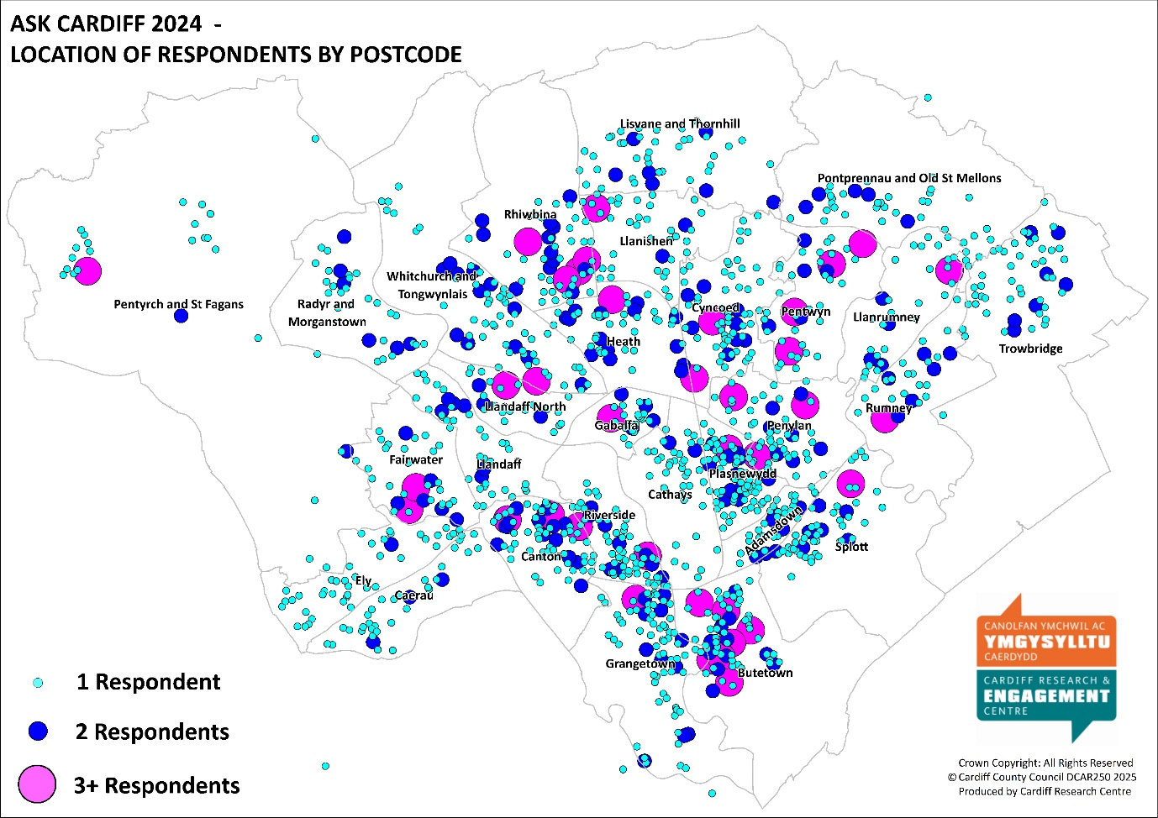

What was your age on your last birthday?
 | No. | %
Under 16 | 10 | 0.5
16-24 | 73 | 3.6
25-34 | 249 | 12.2
35-44 | 316 | 15.5
45-54 | 341 | 16.8
55-64 | 414 | 20.3
65-74 | 404 | 19.9
75+ | 180 | 8.8
Prefer not to say | 48 | 2.4
Total | 2035 | 100.0

Are you…?
 | No. | %
Female | 1036 | 51.0
Male | 908 | 44.7
Non-binary | 21 | 1.0
Other | 1 | 0.0
Prefer not to say | 66 | 3.2
Total | 2032 | 100.0

Do you identify as Trans?
 | No. | %
Yes | 21 | 1.1
No | 1780 | 94.1
Prefer to self-describe | 19 | 1.0
Prefer not to say | 71 | 3.8
Total | 1891 | 100.0

How many children live in your household?
 | No. | %
No children | 1423 | 76.1
Yes, under 5 years old (pre-school) | 109 | 5.8
Yes, aged 5 - 11 (primary school) | 184 | 9.8
Yes, aged 11 - 16 (secondary school) | 195 | 10.4
Yes, aged 16 - 18 in full-time education, or working | 96 | 5.1
Yes, aged 16 - 18 but not in full time education or working | 24 | 1.3
Total | 1869 | -
NB. Percentages do not total 100% as respondent could have children in more than one age group

Are you pregnant, or have you given birth within the last 26 weeks?
 | No. | %
Yes, I’m pregnant | 24 | 1.3
Yes, I’ve given birth | 6 | 0.3
No | 1784 | 96.1
Prefer not to say | 42 | 2.3
Total | 1856 | 100.0

Do you care, unpaid, for a friend or family member due to illness, disability, a mental health problem or an addiction, cannot cope without your support?
 | No. | %
Yes | 347 | 18.7
No | 1408 | 76.1
Prefer not to say | 96 | 5.2
Total | 1851 | 100.0

Which of the following best describes what you are doing at present?
 | No. | %
Working full time (30+ hours per week) | 728 | 38.2
Working part time (less than 30 hours per week) | 247 | 13.0
In full time education | 3 | 0.2
On a government training scheme | 57 | 3.0
Unemployed - Registered Job Seeker | 44 | 2.3
Unemployed - Unregistered but seeking work | 46 | 2.4
On a zero hour contract | 19 | 1.0
Permanently sick or disabled person | 78 | 4.1
Wholly retired from work | 515 | 27.0
Looking after home | 51 | 2.7
Caring for a child or adult | 24 | 1.3
Other | 95 | 5.0
Total | 1907 | 100.0

Which best describes your housing tenure?
 | No. | %
Owned outright | 847 | 45.2
Owned with a mortgage | 513 | 27.4
Rented from the Local Authority | 90 | 4.8
Rented from a Housing Association | 104 | 5.6
Private rented | 232 | 12.4
Other | 86 | 4.6
Total | 1872 | 100.0

Are you or a member of your household…?
 | You |  | A member of your household
 | No. | % | No. | %
Currently serving in the armed forces | 5 | 0.3 | 6 | 0.4
An armed forces service leaver (Veteran) | 39 | 2.4 | 28 | 2.0
Not applicable | 1600 | 97.3 | 1391 | 97.6
Total | 1644 | 100.0 | 1425 | -

Do you identify as a disabled person?
 | No. | %
Yes | 321 | 17.4
No | 1434 | 77.7
Prefer not to say | 91 | 4.9
Total | 1846 | 100.0

Please tick any of the following that apply to you:
 | No. | %
Deaf/ Deafened/ Hard of hearing | 196 | 12.1
Mental health difficulties | 51 | 3.1
Learning impairment/ difficulties | 16 | 1.0
Visual impairment | 411 | 25.3
Wheelchair user | 261 | 16.1
Mobility impairment | 68 | 4.2
Long-standing illness or health condition (e.g. cancer, diabetes, or asthma) | 227 | 14.0
Prefer not to say | 77 | 4.7
Other | 45 | 2.8
None of these | 766 | 47.2
Total Respondents | 1623 | -
NB. Percentages do not total 100% as respondent could answer more than one option

Do you or a member of your family identify as neurodivergent (e.g. Attention Deficit Disorders, Autism, Dyslexia, Dyspraxia, Dyscalculia and Dysgraphia)?
 | No. | %
Yes | 196 | 11.0
No | 1490 | 83.7
Prefer not to say | 95 | 5.3
Total | 1781 | 100.0

Do you regard yourself as belonging to a particular religion?
 | No. | %
No, no religion | 809 | 42.3
Buddhist | 13 | 0.7
Christian (Including Church in Wales, Catholic, Protestant and all other Christian denominations) | 721 | 37.7
Hindu | 41 | 2.1
Jewish | 5 | 0.3
Muslim | 153 | 8.0
Sikh | 8 | 0.4
Other | 51 | 2.7
Prefer not to answer | 111 | 5.8
Total | 1912 | 100.0

How would you describe your sexual orientation?
 | No. | %
Bisexual | 96 | 5.2
Gay Woman/Lesbian | 23 | 1.3
Gay Man | 62 | 3.4
Heterosexual/Straight | 1445 | 78.6
Other | 29 | 1.6
Prefer not to answer | 184 | 10.0
Total | 1839 | 100.0

Are you…?
 | No. | %
Single | 461 | 24.5
In a Civil Partnership | 9 | 0.5
Married | 922 | 49.0
Living together/Co-habiting | 236 | 12.6
Separated/divorced or legally separated if formerly in a Civil Partnership | 117 | 6.2
Widowed | 86 | 4.6
Other | 49 | 2.6
Total | 1880 | 100.0

Do you consider yourself to be Welsh?
 | No. | %
Yes | 1161 | 62.8
No | 689 | 37.2
Total | 1850 | 100.0

How would you describe your Welsh language skills?
 | No. | %
Fluent | 79 | 4.2
Moderate | 104 | 5.6
Basic | 336 | 18.0
Learner | 325 | 17.4
None | 1019 | 54.7
Total | 1863 | 100.0

What is your ethnic group?
 | No. | %
White - Welsh/English/Scottish/Northern Irish/British | 1441 | 72.2
White - Irish | 19 | 1.0
White - Gypsy or Irish Traveller | 3 | 0.2
White - Any other white background | 100 | 5.0
Mixed/Multiple Ethnic Groups - White & Asian Welsh / British / Other | 19 | 1.0
Mixed/Multiple Ethnic Groups - White and Black Caribbean Welsh / British / Other | 11 | 0.6
Mixed/Multiple Ethnic Groups - White and Black African Welsh / British / Other | 19 | 1.0
Mixed/Multiple Ethnic Groups - Any other | 13 | 0.7
Asian/Asian Welsh/British - Bangladeshi | 45 | 2.3
Asian/Asian Welsh/British - Chinese | 24 | 1.2
Asian/Asian Welsh/British - Indian | 56 | 2.8
Asian/Asian Welsh/British – Pakistani | 25 | 1.3
Asian/Asian Welsh/British - Any other | 9 | 0.5
Black/African/Caribbean/Black Welsh/British - African | 44 | 2.2
Black/African/Caribbean/Black Welsh/British – Caribbean | 8 | 0.4
Black/African/Caribbean/Black Welsh/British - Any other | 11 | 0.6
Arab | 51 | 2.6
Any other ethnic group | 23 | 1.2
Prefer not to say | 75 | 3.8
Total | 1996 | 100.0

How did you hear about this survey?
 | No. | %
Cardiff Council social media account (X/Facebook/Instagram) | 364 | 20.0
Other social media account | 130 | 7.2
From a local councillor | 63 | 3.5
I'm a member of the Citizen's Panel | 512 | 28.2
A paper copy in my local library/Hub | 160 | 8.8
Staff email where I work | 142 | 7.8
Other | 344 | 18.9
Don't know | 103 | 5.7
Total | 1818 | 100.0

Volunteering
Click here to return to the main report

Theme | No. | % | Example Comments
Too busy / old / poorly to volunteer | 19 | 11.1 | - I am over 80 and deaf!! There's not a lot I can do  - I work enough hours  - I have a disability not able to be involved.
Already Involved | 15 | 8.8 | - I volunteer with Cardiff Foodbank  - I volunteer in the third sector  - I am already involved in litter picking, volunteer teaching for asylum seekers at Oasis. A facilitator and trustee of FAN and a school governor. I don't think I have time or energy to do more.
Gardening / Green Spaces / Nature | 14 | 8.2 | - Community gardening  - woodland conservation / maintenance . planting  - Environmental volunteering
Education / Training | 12 | 7.0 | - skill exchanges, people teaching each other useful skills they know  - Would love to help Cardiff Council push for skilled apprenticeships. Advise further on post 16 alternative education
Council should do these | 12 | 7.0 | - Is this not what we pay council tax for?  - How about you do more?
Tackling ASB | 10 | 5.8 | - To educated the general public on keeping Cardiff streets litter free and to park appropriately  - Get involved in trying to get more funding for youth services/clubs to tackle crime in our communities
Youth | 8 | 4.7 | - I would love some kind of volunteering in which I can participate with my little kids.  - Working with children with extra support
Previously Volunteered | 7 | 4.1 | - Tried neighbourhood watch: ineffective  - I have been a school governor and I have been a community litter picker
Arts / Culture | 6 | 3.5 | - Music 🎶 activities  - Community arts
Planning | 6 | 3.5 | - Giving feedback to the Planning Dept  - Building restoration – preserving pre-1950s buildings and amenities instead of the horrid new junk that gets built and installed
Health Related | 5 | 2.9 | - Support for neurodivergent people & mental health!  - Disability awareness from myself and my group Cardiff People First to communities around Cardiff
Helping Vulnerable / Homeless / Asylum seekers | 4 | 2.3 | - Visiting vunerable  - Telephone chats with elderly or vulnerable people.
Sport | 3 | 1.8 | - Local sport  - Protecting the legacy of the remaining Cardiff Green spaces (quickly being further eroded) / Also maintaining access to sporting/cultural opportunities for well-being/resilience etc
Science | 2 | 1.2 | - I would like to do volunteer work that I can benefit from in the future, office or scientific work.
Animal related | 2 | 1.2 | - Animal shelters
Misc | 53 | 31.0 | - You should mention the repair cafes that are all over Cardiff now.  - Help for ex forces veterans services  - Getting rid of our useless council with all its vanity projects and self aggrandisment schemes that make life worse for people
Total Respondents | 170 | -
Respondents could comment on multiple themes so the total may exceed 100%.

How Would You Prefer to Access Information About Services, Events etc.? Breakdown by Demographic and Geography
Click here to return to the main report

% | All respondents | Under 35 | 55+ | Female | Male | Ethnically Diverse
Base | 2244 | 278 | 956 | 965 | 835 | 397
Digitally:
Websites | 70.4 | 65.5 | 68.7 | 69.9 | 71.4 | 63.7
Social Media | 47.4 | 51.8 | 41.6 | 51.5 | 43.5 | 48.6
Email | 58.0 | 52.2 | 64.1 | 54.9 | 63.7 | 55.9
Messaging platforms (e.g. WhatsApp groups) | 18.5 | 16.9 | 17.8 | 18.8 | 18.8 | 22.4
Other digital format | 2.8 | 1.8 | 2.7 | 2.5 | 3.4 | 4.5
I don't want to / can't access information digitally | 3.6 | 3.6 | 4.0 | 3.3 | 3.0 | 3.5
Non-Digital:
Posters/flyers/leaflets in community buildings | 38.6 | 43.5 | 36.3 | 43.1 | 34.5 | 39.0
Newsletters | 30.0 | 22.7 | 35.4 | 28.8 | 31.3 | 24.7
Radio | 13.1 | 11.2 | 12.8 | 13.9 | 11.9 | 11.6
Billboards/bus stops/screens | 22.4 | 26.6 | 19.4 | 24.5 | 20.6 | 21.2
Letters | 30.1 | 35.6 | 29.2 | 29.5 | 30.8 | 33.5
Telephone/Text | 9.7 | 12.6 | 7.8 | 9.0 | 11.1 | 12.3
Other non-digital format | 1.7 | 0.7 | 2.0 | 2.3 | 1.2 | 1.5
I prefer to access information digitally | 22.0 | 20.9 | 24.6 | 20.7 | 25.5 | 19.9
Respondents could select multiple options so the total will exceed 100%.

% | All respondents | Identify as disabled | Welsh speaker | Southern Arc | Children in household | LGBTQ+
Base | 2244 | 308 | 182 | 646 | 419 | 219
Digitally:
Websites | 70.4 | 67.5 | 78.0 | 65.3 | 71.1 | 76.3
Social Media | 47.4 | 47.7 | 53.8 | 47.2 | 58.0 | 54.3
Email | 58.0 | 59.7 | 56.6 | 59.6 | 53.9 | 55.3
Messaging platforms (e.g. WhatsApp groups) | 18.5 | 19.2 | 18.1 | 19.2 | 24.8 | 15.5
Other digital format | 2.8 | 2.6 | 6.0 | 3.7 | 3.6 | 5.5
I don't want to / can't access information digitally | 3.6 | 4.2 | 2.2 | 2.9 | 1.9 | 1.8
Non-Digital:
Posters/flyers/leaflets in community buildings | 38.6 | 35.1 | 41.8 | 40.6 | 41.8 | 38.4
Newsletters | 30.0 | 33.1 | 29.1 | 29.3 | 27.2 | 26.9
Radio | 13.1 | 13.0 | 18.7 | 11.5 | 12.6 | 11.9
Billboards/bus stops/screens | 22.4 | 20.5 | 28.0 | 24.1 | 25.5 | 25.1
Letters | 30.1 | 34.1 | 26.9 | 32.0 | 32.9 | 31.1
Telephone/Text | 9.7 | 13.0 | 10.4 | 10.5 | 8.8 | 9.6
Other non-digital format | 1.7 | 2.3 | 1.1 | 1.4 | 1.7 | 2.3
I prefer to access information digitally | 22.0 | 20.5 | 19.8 | 21.2 | 20.8 | 22.8
Respondents could select multiple options so the total will exceed 100%.

% | All Respondents | Least Deprived | Next Least Deprived | Middle | Next Most Deprived | Most Deprived
Base | 2244 | 384 | 332 | 297 | 313 | 234
Digitally:
Websites | 70.4 | 74.0 | 72.9 | 74.4 | 68.1 | 63.2
Social Media | 47.4 | 43.5 | 46.4 | 50.5 | 46.0 | 47.9
Email | 58.0 | 61.5 | 62.3 | 59.9 | 58.1 | 57.7
Messaging platforms (e.g. WhatsApp groups) | 18.5 | 20.8 | 18.4 | 15.5 | 19.8 | 20.1
Other digital format | 2.8 | 3.4 | 2.1 | 3.0 | 1.9 | 3.8
I don't want to / can't access information digitally | 3.6 | 2.9 | 3.0 | 2.0 | 4.8 | 3.4
Non-Digital:
Posters/flyers/leaflets in community buildings | 38.6 | 39.3 | 42.5 | 43.4 | 42.2 | 35.0
Newsletters | 30.0 | 29.9 | 31.3 | 34.0 | 27.2 | 27.4
Radio | 13.1 | 10.9 | 10.5 | 12.5 | 15.3 | 11.1
Billboards/bus stops/screens | 22.4 | 17.4 | 26.5 | 30.3 | 24.9 | 17.1
Letters | 30.1 | 27.9 | 32.8 | 30.0 | 29.1 | 35.9
Telephone/Text | 9.7 | 8.1 | 8.7 | 10.4 | 9.6 | 12.0
Other non-digital format | 1.7 | 2.1 | 1.5 | 0.7 | 1.6 | 2.6
I prefer to access information digitally | 22.0 | 27.3 | 25.9 | 22.2 | 17.3 | 23.5
Respondents could select multiple options so the total will exceed 100%.

Why Do You Disagree That Contacting the Council is Simple?
Click here to return to the main report

Theme | No. | % | Example Comments
Issues with C2C / when phoning the Council | 182 | 41.8 | - Recent example - had to wait on telephone for 45 minutes to speak to someone in person about council tax  - nobody never answers the phone . emails are ignored and excuses are given that its not my department. there appears to be a complete lack of accountability  - Your C2C service is pretty hopeless  - Sometimes you can't find the correct place online so you have to phone, then they always tell you there's a high volume of calls and to go online. NOT acceptable. BObbi the chat bot is useless
Poor digital channels | 75 | 17.2 | - C2C has long wait times. I suspect due to budget cuts. Why can’t I contact the council via What’s App. Digital channels haven’t developed fast enough. Planning doesn’t have a phone line and their digital services are poor and challenging to navigate.  - The website it complicated and poorly designed. You can only find information on set certain things. Anything else is very difficult to do  - No one there when I want them. Responses to emails takes too long. Website is hopeless
Time taken to answer / respond - Method not specified | 51 | 11.7 | - Well. I complained to the council and councillor XXX. And what must be 3 months I have had no response. You keep taking my money but 100% avoid dealing with actual issues people face  - No one ever replies.  - Difficult to get a response. Not approachable. Rude. Elitist
Can't speak to a human being | 47 | 10.8 | - No one to talk too. Just e mails only. Can be very difficult to pass on sensitive information  - Impossible to ring and speak to a person. Web pages do not cover everything.  - You keep trying to push everything online, whereas people often just want to speak to people. It is also important that people communicate properly. The WFH culture in the council is devastating for service delivery.
Unsure who to contact | 33 | 7.6 | - People are unaware of how to contact services and where to get them  - Hard to know who to reach out to  - never clear who does what
Time taken to respond / lack of response - E-mails | 30 | 6.9 | - Previously had difficulty contacting a local councillor, as emails were ignored and only addressed after being raised on social media.  - email take a long time to get a response to and council staff do not include a phone number in their email signature  - It took months to get an email reply from the Council
Passed around departments | 17 | 3.9 | - Sent around in circles  - Long queue to phone, don’t know how to get to right department. Everyone try to shoulder off the job to other departments  - I either get no responses to emails, or I'm told to talk to other people, who tell me to talk to other people, who tell me it's not their responsibility
Issues with specific departments | 11 | 2.5 | - Trying to get hold of council tax department took me a very long time as we given wrong number all the time  - education will not communicate with me despite my child not having a school place for 6 months  - Speaking to relevant people in Planning is very difficult
Suggestions to improve service | 7 | 1.6 | - If your problem fits into one of the designated headings it is fine. You need an 'other' heading on your online platform.  - Finding access to individual departments online could be made simpler, eg Parks dept.
Services not accessible outside working hours | 6 | 1.4 | - There aren't accessible office hours to be able to cater to those who work irregular hours, e.g. if I work in hospitlity and do 12 hour shifts from 5am-5pm or visa versa then I completely miss the office hour window.  - Would prefer easier out of hours contact with a faster response rate. Email is rubbish, you rarely hear back and phone lines are only open during business hours ie when I am at work
Issues if not digitally literate | 5 | 1.1 | - If you can't use online services I think it is difficult  - The move to telecommunication and digital is penalising us disabled and poor
Issues with written correspondence | 4 | 0.9 | - Council has not responded to previous written communications.  - I wrote to the council several months ago I received an acknowledgement but never a response
Misc. | 64 | 14.7 | - You have to be a technoid  - You want to waste money on Welsh names and diversity crap  - No sense of interest in us the people the Council services are supposed to look after.
Total Respondents | 435 | -
Respondents could comment on multiple themes so the total may exceed 100%.

What Other Services Delivered in your Local Hub/Library Do You Find Most Helpful?
Click here to return to the main report

Theme | No. | % | Example Comments
There is no local Hub/Library / Access Issues | 41 | 13.4 | - We do not have a local library or hub within 5 miles  - We don't have a local library at all  - No hub here
Don't know / use | 38 | 12.4 | - I rarely use the hub and when I do it's to collect waste sacks  - I don't currently use the libraries hubs but I do support them  - Never knew they existed
Age specific activities | 25 | 8.2 | - There is nothing at my local hub for old age pensioners  - More child or youth activities after school time
More Books / Printed media | 16 | 5.2 | - More books. The supply is poor now. Also sheet music + scores  - I'd like to borrow books but the choice is very limited  - greater range of e books
Recycling | 14 | 4.6 | - more recycling and compost bags !!!!  - Recycling bins in car park  - More specialist recycling eg blister packs
Better Facilities: Quiet spaces; Toilets; meeting spaces | 12 | 3.9 | - As a neurodivergent person, I really value quiet, calm public spaces.  - Youth Space, Study spaces, AFTER HOURS BOOK DROP  - Our hub is good and we use the library but it is small a separate room for use of groups needed
Arts & Crafts | 12 | 3.9 | - Community visual arts group  - Creative arts classes
Exercise / Fitness Classes | 11 | 3.6 | - Dancing and exercise for older person  - Teen fitness  - Better exercise options
Café | 10 | 3.3 | - Cafe in central library  - Community Cafe
Information / Advice | 10 | 3.3 | - More citizens advice  - Transport information  - Some way of finding out what services etc are available at your local hub
Health & Well being | 9 | 2.9 | - Mental help  - Memory clinics  - Audiology maintenance clinics for hearing aids, instead of having to get to UHW
Increase Opening Times | 9 | 2.9 | - Longer opening hours  - Anything that actually happens after the majority of people finish work. It's all focused on daytime
Welsh Language Classes | 9 | 2.9 | - Conversation classes for Welsh learners  - Dysgu Cymraeg groups
Sports | 8 | 2.6 | - Football and more sport classes  - Badminton pitch
Personal Development | 7 | 2.3 | - Mentoring. Business advice. Personal development  - Life skills for young people.
Hiring / Borrowing equipment | 7 | 2.3 | - Tool/object libraries, lots of people dont have space for tools or bulky items, let them borrow them  - Library of Things (e.g. tablets, power tools, sewing machines, musical instruments etc.)
Negative Comments | 7 | 2.3 | - We were once kicked out of the hub because I had my service dogs with me  - I find the printing to be very expensive, especially when printing government forms
Author Talks / Book Clubs | 6 | 2.0 | - Author talks, book clubs  - it would be nice to have more ‘after work’ activities like creative writing, author talks
ICT | 6 | 2.0 | - Computer access  - Internet computer access
Don't Know What is available | 5 | 1.6 | - I was unaware these services were available. Perhaps CCC should let people know  - No idea what is actually available except for obvious things like cafes and a library
Research / Archives / History | 5 | 1.6 | - Research and archives  - More local history - it's all been moved out of the city centre
Qualified / More Staff | 5 | 1.6 | - Qualified library staff  - More staff!
Food Related | 4 | 1.3 | - Food Bank services + cookery classes.  - Some collective buying/storing of food through services like oddbox to make it accessible to more
Positive Comments | 4 | 1.3 | - Library staff are professional, helpful and friendly  - I feel the hub does an amazing job of serving the community but times staff misjudge our intention.
Better Advertising of what's available | 3 | 1.0 | - Better advertising. I often don't know what is happening until it's over
Councillor Surgeries | 3 | 1.0 | - “Meet your councillors” - like MP surgeries
All / Many of those listed | 3 | 1.0 | - all of above are adequate
Cultural / Music Related | 2 | 0.7 | - Cultural and musical events
Finance / Legal | 2 | 0.7 | - I think High Street banks could look to make use of these spaces for customers in the community
Misc. | 48 | 15.7 | - Repair Café  - Ours appears hardly used. A waste of tax payers money IMHO  - No Deaf friendly services for Deaf BSL signers  - Only use to complain to council
Total Respondents | 306 | -
Respondents could comment on multiple themes so the total may exceed 100%.

What Services Delivered in your Local Hub/Library Do You Find Most Helpful? Breakdown by Demographic and Geography
Click here to return to the main report

% | All respondents | Under 35 | 55+ | Female | Male | Ethnically Diverse
Base | 2011 | 249 | 891 | 893 | 766 | 354
Adult Learning | 14.8 | 22.9 | 11.3 | 19.0 | 10.8 | 27.7
Age Friendly advice, including help in your home, wellbeing services | 9.7 | 12.9 | 9.3 | 11.9 | 7.7 | 13.8
Author talks | 6.9 | 7.2 | 6.6 | 9.0 | 5.5 | 7.6
Book loan | 43.0 | 39.8 | 43.9 | 48.0 | 40.5 | 43.8
Café provision | 12.9 | 18.5 | 10.9 | 15.7 | 10.2 | 13.3
Childrens activities including Story & Rhyme Time | 14.0 | 20.9 | 7.1 | 18.1 | 8.9 | 18.6
Coffee mornings | 8.4 | 13.3 | 6.8 | 11.0 | 5.6 | 12.4
Community events | 15.2 | 17.3 | 15.2 | 20.3 | 10.6 | 20.1
E Books loan | 9.8 | 16.9 | 6.6 | 12.3 | 6.8 | 13.8
ESOL classes | 4.6 | 10.8 | 2.2 | 6.6 | 2.6 | 13.0
Exercise classes | 12.6 | 18.1 | 10.8 | 16.7 | 7.2 | 17.8
Friends & neighbours groups | 10.4 | 14.9 | 8.9 | 13.1 | 7.7 | 14.7
Health & wellbeing materials (including books on Prescription/ information leaflets) | 9.9 | 17.7 | 9.1 | 12.4 | 7.7 | 14.4
Housing & Benefit Advice | 14.4 | 23.3 | 10.2 | 16.0 | 13.1 | 24.0
Into Work Services | 8.7 | 19.3 | 3.7 | 9.9 | 8.1 | 19.2
Job clubs | 7.2 | 17.7 | 2.9 | 7.8 | 7.3 | 16.7
Money Advice | 10.7 | 18.5 | 6.2 | 12.1 | 9.0 | 18.9
PC use & digital assistance | 14.4 | 21.7 | 12.5 | 15.2 | 14.9 | 17.5
Reading Groups | 7.2 | 12.9 | 5.4 | 10.1 | 4.6 | 10.5
Volunteer opportunities | 9.7 | 20.5 | 6.8 | 11.4 | 8.4 | 17.2
None of these | 31.3 | 22.9 | 35.2 | 23.9 | 37.6 | 16.7
Respondents could select multiple options so the total will exceed 100%.

% | All respondents | Identify as disabled | Welsh speaker | Southern Arc | Children in household | LGBTQ+
Base | 2011 | 298 | 168 | 594 | 389 | 212
Adult Learning | 14.8 | 18.5 | 20.8 | 18.4 | 16.7 | 18.9
Age Friendly advice, including help in your home, wellbeing services | 9.7 | 15.1 | 10.1 | 10.8 | 9.3 | 11.3
Author talks | 6.9 | 11.7 | 16.1 | 5.9 | 6.7 | 11.3
Book loan | 43.0 | 40.6 | 57.1 | 41.6 | 46.5 | 48.1
Café provision | 12.9 | 18.1 | 14.9 | 13.1 | 15.4 | 18.9
Childrens activities including Story & Rhyme Time | 14.0 | 12.4 | 15.5 | 15.0 | 33.7 | 10.8
Coffee mornings | 8.4 | 11.7 | 8.9 | 10.1 | 9.0 | 11.3
Community events | 15.2 | 19.1 | 22.0 | 16.3 | 16.2 | 16.5
E Books loan | 9.8 | 10.4 | 16.7 | 11.4 | 10.8 | 17.0
ESOL classes | 4.6 | 3.4 | 5.4 | 7.9 | 7.7 | 5.7
Exercise classes | 12.6 | 14.4 | 12.5 | 13.6 | 16.7 | 13.7
Friends & neighbours groups | 10.4 | 15.1 | 13.7 | 10.4 | 11.1 | 12.7
Health & wellbeing materials (including books on Prescription/ information leaflets) | 9.9 | 16.1 | 11.9 | 11.8 | 10.3 | 12.7
Housing & Benefit Advice | 14.4 | 24.5 | 11.9 | 20.9 | 18.8 | 15.6
Into Work Services | 8.7 | 10.7 | 8.9 | 13.3 | 11.1 | 12.3
Job clubs | 7.2 | 8.7 | 6.0 | 10.8 | 9.3 | 8.5
Money Advice | 10.7 | 17.1 | 12.5 | 14.0 | 13.6 | 15.6
PC use & digital assistance | 14.4 | 16.1 | 16.1 | 19.4 | 12.6 | 17.5
Reading Groups | 7.2 | 9.4 | 13.1 | 7.9 | 8.2 | 10.4
Volunteer opportunities | 9.7 | 11.1 | 11.3 | 11.6 | 9.0 | 16.0
None of these | 31.3 | 31.5 | 23.8 | 27.4 | 21.3 | 29.7
Respondents could select multiple options so the total will exceed 100%.

% | All Respondents | Least Deprived | Next Least Deprived | Middle | Next Most Deprived | Most Deprived
Base | 2011 | 364 | 308 | 271 | 286 | 219
Adult Learning | 14.8 | 10.7 | 12.7 | 14.4 | 18.9 | 20.5
Age Friendly advice, including help in your home, wellbeing services | 9.7 | 9.1 | 9.7 | 8.9 | 10.5 | 15.1
Author talks | 6.9 | 9.9 | 6.8 | 7.7 | 8.0 | 4.6
Book loan | 43.0 | 51.1 | 43.5 | 46.5 | 44.4 | 36.5
Café provision | 12.9 | 11.5 | 10.1 | 13.3 | 16.1 | 14.6
Childrens activities including Story & Rhyme Time | 14.0 | 12.4 | 13.3 | 11.8 | 15.0 | 18.3
Coffee mornings | 8.4 | 8.5 | 6.2 | 7.7 | 11.2 | 10.0
Community events | 15.2 | 16.5 | 14.6 | 14.0 | 20.6 | 16.0
E Books loan | 9.8 | 10.7 | 9.1 | 14.8 | 11.5 | 8.7
ESOL classes | 4.6 | 1.9 | 3.2 | 5.2 | 8.0 | 8.2
Exercise classes | 12.6 | 10.2 | 9.4 | 10.3 | 17.8 | 15.1
Friends & neighbours groups | 10.4 | 13.2 | 7.8 | 9.2 | 12.2 | 11.4
Health & wellbeing materials (including books on Prescription/ information leaflets) | 9.9 | 8.5 | 9.4 | 7.0 | 13.3 | 14.2
Housing & Benefit Advice | 14.4 | 6.6 | 10.1 | 13.3 | 22.0 | 28.8
Into Work Services | 8.7 | 3.6 | 4.9 | 9.2 | 14.7 | 15.5
Job clubs | 7.2 | 2.7 | 4.2 | 7.0 | 12.6 | 13.2
Money Advice | 10.7 | 6.0 | 9.1 | 8.5 | 14.3 | 17.8
PC use & digital assistance | 14.4 | 11.5 | 10.7 | 16.6 | 20.3 | 25.1
Reading Groups | 7.2 | 7.4 | 4.9 | 8.5 | 9.4 | 6.8
Volunteer opportunities | 9.7 | 8.0 | 6.2 | 10.0 | 13.3 | 14.2
None of these | 31.3 | 31.9 | 39.6 | 27.7 | 26.2 | 24.7
Respondents could select multiple options so the total will exceed 100%.

What Other Activities or Events Would You Like To See in Your Local Hub?
Click here to return to the main report

Theme | No. | % | Example Comments
Languages | 7 | 9.1 | - Having activities that encourage learning or building on languages, especially Welsh.  - Language exchanges but outside normal working hours
Health support | 6 | 7.8 | - Help with mental health and wellbeing  - Dementia cafe, volunteering fairs, food cooperatives, health talks eg ADHD, parenting, dementia, mobility aids support, mobility aids loan.
Arts / Crafts / Games | 6 | 7.8 | - Art for adults  - Knitting and crocheting  - Card Playing Group
Youth Focussed | 5 | 6.5 | - More social opportunities for youths  - Something for Teenagers - Reading Challenges stop @ Primary School level  - Youth club for children
Life skills - Finance / Cleaning / DIY | 4 | 5.2 | - 'DIY for the terrified' type classes  - life skills (finance, cleaning, household maintenance, mending, how to cope with emergencies) for young people
Exercise Classes | 4 | 5.2 | - Exercise for under 50s  - Exercise classes for over 70s NOT over 50s - 20 years makes a big difference.
Music related | 3 | 3.9 | - It would be nice if there were a piano so I don't need to go all the way to central (I recognize that this is probably not a pragmatic use of money)  - Singing
Additional Learning Needs Group | 3 | 3.9 | - ALN sessions  - Social groups for additional needs children
Business / Career advice | 2 | 2.6 | - Business / Career Advise
Book Club | 2 | 2.6 | - book club
Use of a room | 2 | 2.6 | - Use of a room that good organisations for local people can use free!!!!
History | 2 | 2.6 | - Local history talks
Gardening | 2 | 2.6 | - Community gardening
Misc. | 32 | 41.6 | - Combat sports  - All above are amazing ideas concern would be how its all funded.  - People at hand to keep us informed about buses when events s are on  - An actual library would be good.
Total Respondents | 77 | -
Respondents could comment on multiple themes so the total may exceed 100%.

What Activities or Events Would You Like To See in Your Local Hub? Breakdown by Demographic and Geography
Click here to return to the main report

 | All respondents | Under 35 | 55+ | Female | Male | Ethnically Diverse
Base | 1907 | 236 | 837 | 857 | 718 | 338
Basic cooking classes | 21.7 | 35.2 | 13.0 | 25.1 | 17.5 | 34.9
Bereavement support groups | 20.8 | 26.3 | 17.1 | 25.2 | 16.4 | 21.6
Craft groups | 25.0 | 38.1 | 19.8 | 34.3 | 15.2 | 33.7
Creative Writing / arts | 21.3 | 33.5 | 14.9 | 26.6 | 16.4 | 32.2
Exercise classes for over 50’s e.g. Tai Chi | 28.3 | 19.9 | 34.2 | 36.5 | 20.1 | 32.0
Family History activities | 19.6 | 18.2 | 20.4 | 22.2 | 18.2 | 15.7
Fitness activities e.g. walking groups | 31.7 | 36.9 | 29.6 | 35.9 | 28.4 | 37.9
Hobby and Interest Groups e.g. Craft, Jigsaw, Lego, Gardening clubs | 26.8 | 34.7 | 19.6 | 34.4 | 20.5 | 34.6
Homework clubs | 18.1 | 25.4 | 10.8 | 21.4 | 14.1 | 26.3
Intergenerational events (bringing together children and older people) | 19.1 | 25.8 | 15.8 | 24.6 | 13.0 | 24.0
Local and Community History events | 25.1 | 26.7 | 26.2 | 26.8 | 25.1 | 25.4
Peer support groups (bringing people together who have been through similar experiences) e.g. Parkinson’s Café | 20.2 | 28.0 | 15.9 | 25.9 | 14.8 | 24.0
Play sessions for children | 20.8 | 28.8 | 12.3 | 24.4 | 17.0 | 28.7
Social Groups e.g. coffee mornings, Friend and Neighbours (FAN), Goldies Cymru (singing) | 24.8 | 33.9 | 20.8 | 28.5 | 21.9 | 30.8
Other | 5.2 | 7.2 | 4.5 | 6.4 | 3.5 | 7.4
None of these | 22.0 | 16.1 | 26.3 | 14.9 | 29.7 | 13.0
Respondents could select multiple options so the total will exceed 100%.

 | All respondents | Identify as disabled | Welsh speaker | Southern Arc | Children in household | LGBTQ+
Base | 1907 | 280 | 160 | 567 | 380 | 206
Basic cooking classes | 21.7 | 25.0 | 20.6 | 28.4 | 35.8 | 24.8
Bereavement support groups | 20.8 | 26.8 | 21.3 | 22.2 | 24.7 | 23.8
Craft groups | 25.0 | 29.6 | 27.5 | 27.0 | 30.8 | 28.6
Creative Writing / arts | 21.3 | 22.1 | 25.0 | 26.5 | 23.9 | 28.6
Exercise classes for over 50’s e.g. Tai Chi | 28.3 | 31.1 | 26.3 | 27.3 | 30.0 | 22.3
Family History activities | 19.6 | 24.6 | 25.6 | 21.5 | 20.5 | 16.0
Fitness activities e.g. walking groups | 31.7 | 25.4 | 31.3 | 33.3 | 33.9 | 31.1
Hobby and Interest Groups e.g. Craft, Jigsaw, Lego, Gardening clubs | 26.8 | 29.6 | 24.4 | 28.7 | 38.2 | 32.5
Homework clubs | 18.1 | 16.1 | 18.8 | 23.6 | 35.3 | 18.0
Intergenerational events (bringing together children and older people) | 19.1 | 23.2 | 21.9 | 21.9 | 25.3 | 22.8
Local and Community History events | 25.1 | 28.2 | 32.5 | 27.3 | 21.8 | 31.6
Peer support groups (bringing people together who have been through similar experiences) e.g. Parkinson’s Café | 20.2 | 26.1 | 24.4 | 23.1 | 23.4 | 26.2
Play sessions for children | 20.8 | 20.7 | 22.5 | 25.9 | 43.2 | 17.5
Social Groups e.g. coffee mornings, Friend and Neighbours (FAN), Goldies Cymru (singing) | 24.8 | 29.6 | 25.6 | 27.7 | 26.8 | 32.5
Other | 5.2 | 6.8 | 6.3 | 6.5 | 6.3 | 6.3
None of these | 22.0 | 18.6 | 21.9 | 17.8 | 13.9 | 24.8
Respondents could select multiple options so the total will exceed 100%.

% | All Respondents | Least Deprived | Next Least Deprived | Middle | Next Most Deprived | Most Deprived
Base | 1907 | 350 | 289 | 266 | 275 | 215
Basic cooking classes | 21.7 | 15.4 | 19.0 | 21.8 | 21.5 | 35.3
Bereavement support groups | 20.8 | 17.1 | 20.1 | 21.8 | 22.2 | 26.5
Craft groups | 25.0 | 21.1 | 27.0 | 28.2 | 30.2 | 26.0
Creative Writing / arts | 21.3 | 16.0 | 19.0 | 26.7 | 30.2 | 24.7
Exercise classes for over 50’s e.g. Tai Chi | 28.3 | 31.1 | 31.5 | 24.1 | 22.2 | 29.3
Family History activities | 19.6 | 19.4 | 17.3 | 19.2 | 22.2 | 23.7
Fitness activities e.g. walking groups | 31.7 | 28.9 | 35.3 | 27.4 | 34.2 | 37.2
Hobby and Interest Groups e.g. Craft, Jigsaw, Lego, Gardening clubs | 26.8 | 25.1 | 30.8 | 26.3 | 27.6 | 32.1
Homework clubs | 18.1 | 14.9 | 15.6 | 17.3 | 22.2 | 27.9
Intergenerational events (bringing together children and older people) | 19.1 | 18.6 | 16.6 | 23.7 | 21.1 | 20.9
Local and Community History events | 25.1 | 25.7 | 27.0 | 31.2 | 25.8 | 22.3
Peer support groups (bringing people together who have been through similar experiences) e.g. Parkinson’s Café | 20.2 | 18.9 | 19.0 | 21.8 | 24.7 | 22.3
Play sessions for children | 20.8 | 18.0 | 15.9 | 20.3 | 24.0 | 32.1
Social Groups e.g. coffee mornings, Friend and Neighbours (FAN), Goldies Cymru (singing) | 24.8 | 25.4 | 22.5 | 26.7 | 24.7 | 28.4
Other | 5.2 | 3.7 | 3.5 | 6.8 | 5.8 | 6.5
None of these | 22.0 | 26.0 | 24.2 | 19.5 | 16.4 | 18.6
Respondents could select multiple options so the total will exceed 100%.

How Else Would You Like To Know About Events In Your Local Hub/Library?
Click here to return to the main report

Theme | No. | % | Example Comments
Community Flyers / Leaflets / Posters / Newsletters | 31 | 28.4 | - Local flyers / posters outside of the hub/library  - Posters on lampposts, bus stops and along frequently used paths  - Posters around the city and boroughs  - Posters outside hub library - shop windows etc.
Letter / Through the post | 29 | 26.6 | - posters and pamphlets through the post  - Regular newsletters by post  - Leaflets in post with calendar of events
Council / Hub Website | 22 | 20.2 | - Through council website  - The hub website  - Just update website information  - Council website app, push notifications for activities in your area
Social Media | 10 | 9.2 | - threads not twitter  - Bluesky  - Reddit
Council App | 8 | 7.3 | - Cardiff Council app  - the Council app could be expanded and used to notify users about events and services
Local Press / Radio | 8 | 7.3 | - Local press  - Local TV & radio stations
Text Message | 2 | 1.8 | - Text
Other | 7 | 6.4 | - Eventbrite  - Bus stops  - Making sure someone volunteers and is approachable to talk as ask about the events and happenings in future.
Total Respondents | 109 | -
Respondents could comment on multiple themes so the total may exceed 100%.

In the last six months, have you or anyone else in your household done any of the following because you couldn't AFFORD food? Breakdown by Demographic and Geography
Click here to return to the main report

% | All respondents | Under 35 | 55+ | Female | Male | Ethnically Diverse
Base | 2091 | 260 | 938 | 933 | 814 | 376
Had smaller meals than usual, or skipped meals | 15.9 | 30.8 | 10.3 | 15.9 | 14.9 | 18.6
Been hungry but not eaten | 7.1 | 15.0 | 3.4 | 6.9 | 7.0 | 6.4
Not eaten for a whole day | 4.2 | 7.3 | 1.9 | 4.5 | 4.3 | 5.3
Missed meals to afford to pay your bills | 8.6 | 15.0 | 4.6 | 8.6 | 7.4 | 11.4
Received food from a food bank or charity | 4.4 | 6.9 | 2.3 | 5.3 | 4.1 | 8.0
None of these | 78.9 | 61.5 | 86.6 | 78.6 | 80.7 | 72.6
Respondents could select multiple options so the total will exceed 100%.

% | All respondents | Identify as disabled | Welsh speaker | Southern Arc | Children in household | LGBTQ+
Base | 2091 | 300 | 176 | 624 | 409 | 218
Had smaller meals than usual, or skipped meals | 15.9 | 25.3 | 16.5 | 22.3 | 21.3 | 21.1
Been hungry but not eaten | 7.1 | 13.3 | 6.3 | 9.1 | 9.8 | 13.3
Not eaten for a whole day | 4.2 | 7.7 | 6.3 | 5.8 | 6.6 | 6.9
Missed meals to afford to pay your bills | 8.6 | 15.3 | 8.0 | 14.1 | 13.2 | 12.8
Received food from a food bank or charity | 4.4 | 9.7 | 1.7 | 7.1 | 7.8 | 6.0
None of these | 78.9 | 69.0 | 81.8 | 69.7 | 72.1 | 71.1
Respondents could select multiple options so the total will exceed 100%.

% | All Respondents | Least Deprived | Next Least Deprived | Middle | Next Most Deprived | Most Deprived
Base | 2091 | 379 | 325 | 292 | 302 | 225
Had smaller meals than usual, or skipped meals | 15.9 | 6.6 | 15.1 | 13.4 | 21.9 | 29.3
Been hungry but not eaten | 7.1 | 2.9 | 7.7 | 5.1 | 9.3 | 12.9
Not eaten for a whole day | 4.2 | 0.3 | 4.6 | 3.4 | 4.0 | 9.8
Missed meals to afford to pay your bills | 8.6 | 2.6 | 6.8 | 7.9 | 11.3 | 20.0
Received food from a food bank or charity | 4.4 | 1.1 | 2.8 | 2.7 | 7.0 | 12.0
None of these | 78.9 | 91.3 | 81.8 | 82.2 | 70.9 | 58.7
Respondents could select multiple options so the total will exceed 100%.

In the last six months, have you or anyone else in your household had issues paying energy bills? Breakdown by Demographic and Geography
Click here to return to the main report

 | All respondents | Under 35 | 55+ | Female | Male | Ethnically Diverse
Base | 2075 | 255 | 934 | 923 | 803 | 361
Struggled to pay gas/electric bills | 14.3 | 23.9 | 8.1 | 14.4 | 13.6 | 19.9
Purposely not put the heating on because of the cost | 37.3 | 43.1 | 32.3 | 40.5 | 32.6 | 35.5
Been cut off from the electricity/gas supply | 1.4 | 3.9 | 0.4 | 1.8 | 1.0 | 3.3
Received fuel vouchers from a charity | 0.9 | 1.2 | 0.5 | 1.1 | 0.9 | 1.4
Applied for support to pay for gas/electric | 3.4 | 7.5 | 1.6 | 3.8 | 3.2 | 5.5
None of these | 58.6 | 49.4 | 65.2 | 55.6 | 63.0 | 56.0
Respondents could select multiple options so the total will exceed 100%.

 | All respondents | Identify as disabled | Welsh speaker | Southern Arc | Children in household | LGBTQ+
Base | 2075 | 600 | 176 | 613 | 399 | 217
Struggled to pay gas/electric bills | 14.3 | 21.7 | 13.6 | 21.7 | 22.6 | 19.4
Purposely not put the heating on because of the cost | 37.3 | 54.7 | 35.2 | 43.2 | 41.6 | 40.6
Been cut off from the electricity/gas supply | 1.4 | 2.7 | 1.7 | 2.4 | 2.5 | 3.7
Received fuel vouchers from a charity | 0.9 | 1.7 | 1.1 | 2.1 | 1.0 | 3.2
Applied for support to pay for gas/electric | 3.4 | 4.3 | 2.3 | 4.9 | 5.8 | 6.0
None of these | 58.6 | 41.0 | 61.4 | 51.2 | 52.4 | 51.6
Respondents could select multiple options so the total will exceed 100%.

% | All Respondents | Least Deprived | Next Least Deprived | Middle | Next Most Deprived | Most Deprived
Base | 2075 | 377 | 325 | 289 | 297 | 217
Struggled to pay gas/electric bills | 14.3 | 6.4 | 11.1 | 14.9 | 21.2 | 29.0
Purposely not put the heating on because of the cost | 37.3 | 30.2 | 34.8 | 35.3 | 47.1 | 53.5
Been cut off from the electricity/gas supply | 1.4 | 0.0 | 0.6 | 0.7 | 1.7 | 5.5
Received fuel vouchers from a charity | 0.9 | 0.3 | 0.3 | 0.7 | 1.3 | 3.2
Applied for support to pay for gas/electric | 3.4 | 0.8 | 2.2 | 2.8 | 3.7 | 9.2
None of these | 58.6 | 68.4 | 63.1 | 59.2 | 48.5 | 40.1
Respondents could select multiple options so the total will exceed 100%.

Please tell us how you plan to cope with the increase in energy costs
Click here to return to the main report

Theme | No. | % | Example Comments
Make Savings - use less energy - reduce outgoings | 40 | 43.5 | - Stick to one room as much as possible. Wear more layers of clothing.  - Wear more jumpers, suffer the cold, have fewer showers  - Use less heating, but not 'significantly' so. It will be on much less than desired though.  - Other expenses will have to go - not putting the heating on leads to damp homes and ill health.
Wear more layers / blankets | 11 | 12.0 | - Wear extra jumpers and blankets to not get cold.  - I will reduce my heating a little, will wear warm cloths, miss my heating allowance.
Doesn't affect me | 6 | 6.5 | - We have 3 KW PV panels facing due south, a 5kWh battery and 90%+ smoke free triple combustion wood burning stove so our energy bills are very low.  - pay the bill - we earn enough to manage
Made changes to Energy Tariff | 6 | 6.5 | - Fixed energy plan for next 12 months  - On fixed tariff, but will review when it ends
I cannot afford increase | 5 | 5.4 | - Struggling in paying our bills  - Extremely struggling to pay the bills
Use Fire / Wood-Burner | 4 | 4.3 | - Increase the usage of the wood burner  - Use a wood burner to heat house
Misc. | 25 | 27.2 | - Stay with friends or family some weeks in winter  - I am homeless, so I'll probably be dead by the end of winter  - Mind your own business!
Total Respondents | 92 | -
Respondents could comment on multiple themes so the total may exceed 100%.

To what extent do you agree or disagree with this statement: Cardiff has a thriving and prosperous economy? Breakdown by Demographic and Geography
Click here to return to the main report

Base sizes shown in brackets; excludes ‘Don’t Know’ responses.

Base sizes shown in brackets; excludes ‘Don’t Know’ responses.

Over the last 12 months, would you say your employment situation has…? Breakdown by Demographic and Geography
Click here to return to the main report

Base sizes shown in brackets; excludes ‘Don’t Know’ responses.

Base sizes shown in brackets; excludes ‘Don’t Know’ responses.

Please Tell Us What Else Stopped You Taking Up The Invitation For Screening
Click here to return to the main report

Theme | No. | % | Example Comments
Haven't been invited | 13 | 16.0 | - Not Invited  - Never got asked  - I have not been called.
No Time | 8 | 9.9 | - I haven't had time  - Inconvenience of timing
Work Commitments | 7 | 8.6 | - Busy working  - I am a 24/7 carer with no breaks and no free time alone
Not Interested | 6 | 7.4 | - I’m not interested. We all have to die eventually and it really doesn’t matter when.  - Apathy
Forgot / Haven't got around to it | 5 | 6.2 | - just not got round to it  - I keep forgetting about it
Personal Circumstances | 4 | 4.9 | - If I were to receive a positive result of screening and subsequently receive treatment, I have no-one to help care for me whilst recuperating. I cannot be a burden to the NHS and bed-block because I am alone with no available support in my home.  - Was homeless and stressed.
Health Reasons | 4 | 4.9 | - Health anxiety  - Covid
Trust issues | 4 | 4.9 | - After the Covid vaccine problems I no longer trust the medical professionals for non-biased information  - No faith in the NHS
Anxiety / Fear | 3 | 3.7 | - fear!
Lack of Transport | 3 | 3.7 | - Could not get to screening centre
Wasn't aware of it | 3 | 3.7 | - I wasn't aware of it.
Difficulty accessing GP | 2 | 2.5 | - Appointments at doctors difficult
Misc | 24 | 29.6 | - not comfortable experience  - Is it free?  - I am very well person  - I think nature should take its course
Total Respondents | 81
Respondents could comment on multiple themes so the total may exceed 100%.

Please Tell Us What Else Stopped You Taking Up The Invitation For Vaccination
Click here to return to the main report

Theme | No. | % | Example Comments
Not needed / Don't want it / My choice | 42 | 35.9 | - Don't want them  - Decided not to have any future vaccinations.  - Physical health is okay. Weary of vaccine mixed-messaging
Previous negative experience / Heard Negative Stories / Don't trust the vaccine | 37 | 31.6 | - Reaction to previous boosters  - Serious concerns over MRNA vaccines, and reluctance to publish raw data on this by governments and pharma companies  - Don't trust the vaccine anymore
Health Reasons | 8 | 6.8 | - auto immune deficient  - Been ill so much lately I didn't want to get ill from flu vaccine
Anxiety / Fear | 4 | 3.4 | - Concerned about the vaccines  - Scared of needles
Work Commitments | 3 | 2.6 | - No time due to work
Haven't received invitation | 3 | 2.6 | - Nobody invites me
Forgot / Haven't got around to it | 3 | 2.6 | - Haven't got round to it yet. l need to.
No Time | 2 | 1.7 | - Time
Misc | 15 | 12.8 | - Big pharma.  - Vaccination for what??  - My position: I support all childhood vaccinations; I support vaccinations for influenza on an individual cost-benefit decision dependent principally upon age and fitness; I do not support the state roll out of pharmaceuticals that are in fact not vaccines at all by all previous definitions (COVID).
Total Respondents | 117 | -
Respondents could comment on multiple themes so the total may exceed 100%.

How much time do you spend in nature / green spaces? Breakdown by Demographic Geography
Click here to return to the main report

% | All respondents | Under 35 | 55+ | Female | Male | Ethnically Diverse
Base | 1,210 | 135 | 582 | 560 | 486 | 160
Less than 1 | 0.3 | 1.5 | 0.0 | 0.2 | 0.4 | 0.6
Up to 5 | 60.3 | 71.1 | 54.8 | 62.9 | 59.5 | 72.5
6-10 | 25.5 | 18.5 | 27.5 | 24.1 | 25.3 | 19.4
11-15 | 6.1 | 2.2 | 8.6 | 5.4 | 7.2 | 2.5
16-20 | 3.2 | 2.2 | 3.8 | 3.4 | 2.5 | 1.9
21-30 | 2.9 | 1.5 | 3.8 | 2.3 | 3.3 | 0.6
31-60 | 0.7 | 0.7 | 0.5 | 0.7 | 0.8 | 1.9
More than 60 | 0.9 | 2.2 | 1.0 | 1.1 | 1.0 | 0.6

% | All respondents | Identify as disabled | Welsh speaker | Southern Arc | Children in household | LGBTQ+
Base | 1,210 | 138 | 125 | 313 | 237 | 132
Less than 1 | 0.3 | 0.7 | 0.0 | 0.3 | 0.4 | 1.5
Up to 5 | 60.3 | 63.0 | 62.4 | 63.6 | 74.3 | 62.9
6-10 | 25.5 | 18.1 | 25.6 | 22.0 | 16.0 | 27.3
11-15 | 6.1 | 6.5 | 3.2 | 5.4 | 4.6 | 2.3
16-20 | 3.2 | 2.9 | 5.6 | 4.2 | 3.4 | 1.5
21-30 | 2.9 | 3.6 | 1.6 | 2.6 | 0.8 | 3.0
31-60 | 0.7 | 2.2 | 1.6 | 1.0 | 0.4 | 0.0
More than 60 | 0.9 | 2.9 | 0.0 | 1.0 | 0.0 | 1.5

% | All Respondents | Least Deprived | Next Least Deprived | Middle | Next Most Deprived | Most Deprived
Base | 1,210 | 274 | 215 | 176 | 154 | 98
Less than 1 | 0.3 | 0.0 | 0.0 | 0.0 | 0.0 | 1.0
Up to 5 | 60.3 | 61.3 | 61.9 | 64.8 | 62.3 | 63.3
6-10 | 25.5 | 28.5 | 24.7 | 19.9 | 22.1 | 24.5
11-15 | 6.1 | 5.1 | 7.9 | 6.8 | 5.2 | 3.1
16-20 | 3.2 | 1.8 | 1.9 | 1.7 | 4.5 | 4.1
21-30 | 2.9 | 1.8 | 3.3 | 4.5 | 2.6 | 2.0
31-60 | 0.7 | 0.7 | 0.5 | 0.6 | 1.9 | 1.0
More than 60 | 0.9 | 0.7 | 0.0 | 1.7 | 1.3 | 1.0

How Close is This Space To Your Home? Breakdown by Demographic Geography
Click here to return to the main report

% | All respondents | Under 35 | 55+ | Female | Male | Ethnically Diverse
Base | 1,394 | 161 | 665 | 650 | 55 | 211
Within a 5-minute walk | 53.7 | 45.3 | 55.3 | 56.0 | 52.9 | 49.3
Within a 15-minute walk | 33.7 | 44.1 | 31.6 | 31.7 | 33.3 | 34.6
Further than 15 minutes’ walk, but within Cardiff | 22.8 | 23.6 | 24.1 | 24.8 | 21.9 | 21.8
Outside of Cardiff | 13.2 | 10.6 | 13.2 | 14.0 | 11.5 | 10.0

% | All respondents | Identify as disabled | Welsh speaker | Southern Arc | Children in household | LGBTQ+
Base | 1,394 | 156 | 138 | 383 | 269 | 151
Within a 5-minute walk | 53.7 | 42.9 | 58.0 | 53.3 | 53.9 | 47.7
Within a 15-minute walk | 33.7 | 40.4 | 31.9 | 30.8 | 33.8 | 34.4
Further than 15 minutes’ walk, but within Cardiff | 22.8 | 25.0 | 13.8 | 25.6 | 22.3 | 28.5
Outside of Cardiff | 13.2 | 10.9 | 12.3 | 11.0 | 10.4 | 9.9

% | All Respondents | Least Deprived | Next Least Deprived | Middle | Next Most Deprived | Most Deprived
Base | 1,394 | 296 | 236 | 204 | 189 | 124
Within a 5-minute walk | 53.7 | 62.2 | 53.0 | 59.8 | 42.9 | 50.8
Within a 15-minute walk | 33.7 | 28.4 | 37.3 | 33.3 | 42.9 | 20.2
Further than 15 minutes’ walk, but within Cardiff | 22.8 | 16.6 | 24.2 | 19.1 | 28.6 | 33.9
Outside of Cardiff | 13.2 | 7.8 | 12.3 | 15.7 | 17.5 | 11.3

How important do you think it is to have green spaces in your local area? Breakdown by Demographic Geography
Click here to return to the main report

Base sizes shown in brackets; excludes ‘Don’t Know’ responses.

Base sizes shown in brackets; excludes ‘Don’t Know’ responses.

How Safe or Unsafe Do You Feel In The Following Situations? Trend Data
Click here to return to the main report

Why Do You Feel Unsafe in These Situations?
Click here to return to the main report

At Home
Theme | No. | % | Example Comments
Levels of criminal activity / Anti-Social Behaviour in the area | 109 | 57.4 | - Groups of young boys hanging around trying to get into houses or gardens  - There's a lot of antisocial behaviour around. You see a lot of people up to no good in the park. People taking drugs and under influence. I don't feel safe at home because I feel expose where I live.  - I feel a little unsafe at night now that I am widowed because I had a burglary a couple of years ago and I am anxious in case it happens again  - There has been antisocial behaviour, theft and vandalism. Aggressive and drunk youths shouting in the street. Why would you feel safe?
Security Concerns - Street Lighting / Lack of Police presence and response | 18 | 9.5 | - No police presence at all  - Street lighting are not available everywhere  - We get a lot of anti-social behaviour and have reported it but nothing gets done
Anxious / Live in fear of potential crime | 9 | 4.7 | - Just the fear of someone breaking in, lighting is poor and there are a lot of young people dealing drugs locally and use my road as a cut through.  - Not sure really just anxious about crime.  - Just a feeling there is more crime and chance of being mugged
Specific Wards mentioned | 8 | 4.2 | - I live in St Mellon's need I say more  - I live in Butetown, I'm surrounded by drug dealers and users  - Canton has changed
Issues with Neighbours | 8 | 4.2 | - Unsociable neighbours  - Because I live in an unsafe area and torn down apartment block where my neighbours threaten me every single day and I’m so afraid to leave because of them, and also because I was a social system child who’s had a hard life and had just been living in terrible unsafe places and now waiting on the housing list for s suitable safer home
Cold Callers | 7 | 3.7 | - Unexpected callers can be intimidating & harassing.  - Uninvited people knocking door canvasing etc
Different kinds of/unsavoury people / groups | 5 | 2.6 | - Sometimes someone knock at door ask us to pay and clean the driveway which they said they were from government, and one midnight a guy knocked at everyone’s door asking people to give him some money for taxi  - Because of the people who hang around on my estate
After Dark | 5 | 2.6 | - Wouldn't open the door after dark.  - a lot of crime in Ely after dark
Disability / Health Condition | 4 | 2.1 | - I am a disabled old person
Living alone | 4 | 2.1 | - Live alone.
Past experiences | 3 | 1.6 | - Have been a victim of crime
My age | 2 | 1.1 | - Age
Misc | 29 | 15.3 | - I am in a HMO, in an area with alot of HMOs. I don't know my neighbours  - Because of where I live and the people that live here and my sexuality  - The council is housing early realised prisoners in a hotel across the road from us
Total Respondents | 190
Respondents could comment on multiple themes so the total may exceed 100%.

Walking in your Neighbourhood
Theme | No. | % | Example Comments
Levels of criminal activity / Anti-Social Behaviour in the area | 278 | 42.7 | - Full of drunks, homeless, people handing around. Groups of Deliveroo type people hanging about. Speeding vehicles  - There is a lot of crime including recent sexual assault  - Mugging and attaks are not uncomon in this area and I have witnessed them myself, both in daylight actually.  - As the area has convicted drug dealers and rapists  - There is a fair bit of anti-social behaviour in the area which makes me feel unsafe in the area
Gangs / Groups of youths / unsavoury people | 135 | 20.7 | - Gangs of youths with aggressive dogs  - Gangs of teenagers  - Morons who live close  - The people around at the time  - More and more undesirables and out of control young people
Security Issues - Poor Lighting / No CCTV / lack of Police | 106 | 16.3 | - Asbo city around here. The kids are feral and the only time you see police is if they are driving to KFC.  - Poor lighting and no pavement  - Current lighting gives very dark shadows, you simply can’t see safely  - Police letting off criminals  - Gangs, no cctv under subways
Inconsiderate Bikes / E-scooters | 97 | 14.9 | - Yobs on electric bikes and motorbikes  - Drug runners on e-bikes  - I have been hit from behind more than once by these kids on bikes  - Too many youths on electric bikes on the pavement and everywhere
After dark | 52 | 8.0 | - don't like going out in the dark  - I feel unsafe as a woman walking at night  - I would feel unsafe walking anywhere after dark, it's not specific to my area  - It’s at night that the crime and the trouble starts
Due to age / disability / Gender / Ethnicity | 52 | 8.0 | - I am a disabled old person  - I am a lone woman, violence against women has increased and women aren’t safe  - I'm transgender & I'm my 60's intolerance has increased in the last 12 months  - I’m a women of colour and over 60
Issues with Homelessness / Begging | 36 | 5.5 | - There is a homeless centre 5 minutes away and occupants are often shouting outside or in a state of collapse.  - Lots of homeless, drunken/drug takers in the local area and lots of shoplifting and aggression  - Knifes, homeless - not homeless, drugs!
Poor Maintenance - Unsteady Pavements / Hedges Overgrown | 34 | 5.2 | - State of pavements making it easy to fall- too many cyclists on pavements  - Very dark with overgrown footpaths.  - Improve the pavement, I have tripped over uneven pavement several times. This is my greatest fear and main reason why I don't go at night.
Fear of Abuse / Sexual Harassment / Assault / Racism | 22 | 3.4 | - I'm new in Llanrumney. The younger people here is wild. They use harsh words whenever see us outside. Too racist and hateful  - Worried about bumping into creepy men  - Imagining what could happen
Past Experiences | 16 | 2.5 | - Single woman. Makes me vulnerable. Looked at and approached. Easy target  - I have been assaulted in the past in this neighbourhood
Lonely / Isolated | 12 | 1.8 | - I feel nervous when walking alone  - I only feel this after dark I'm a women we always feel unsafe after dark on our own  - It’s wooded and very isolated when on own
Specific Wards mentioned | 11 | 1.7 | - Strange men in Cathays  - I live in Llanedeyrn, e-bikes and e-scooters drug runners everywhere  - The Roath area has deteriorated.
Parking concerns / inconsiderate drivers | 4 | 0.6 | - Cars parked on the pavement meaning you have to walk on the road
Misc. | 33 | 5.1 | - A state of lawlessness.  - Just do  - Not safe anywhere these days,
Total Respondents | 651 | -
Respondents could comment on multiple themes so the total may exceed 100%.

Walking in the City Centre
Theme | No. | % | Example Comments
Levels of criminal activity / Anti-Social Behaviour in the area | 533 | 50.9 | - Lot of drunk people that show antisocial behaviours  - Homelessness and antisocial behaviour  - Lots of drug addicts begging.  - Sometimes there is anti-social behavior. There have been incidents of crime in the past. I think this would be the same anywhere though.  - High numbers of incidents of visible anti-social behaviour
Homeless / Beggers | 371 | 35.4 | - Lots of beggars in Queen Street and The Hayes asking for money or causing a ruckus, some of them are agressive.  - too may beggers and rough sleepers  - There is aggressive begging, open drug dealing and regular fight involving drunk down and outs.  - So many homeless.  - Homeless people and drug users make me nervous and set the wrong tone
Cyclist / E-scooters | 161 | 15.4 | - Cyclists riding through city centre, especially delivery cyclists  - Bicycles on pavements  - Cyclists, particularly motoirised/electric  - Too many cyclists using the pedestrian areas and at high speed.
Feels unsafe at nighttime | 90 | 8.6 | - At night because of the unsavoury behaviour of certain people  - Only late at night. There are a lot of people with substance misuse issues in the centre and while I don't judge them I do fear that their behaviour can be unpredictable. Lack of adaquate support services is the real issue.  - Intimidating at night
Gangs / Large Crowds | 79 | 7.5 | - The people hanging around on the corners and by the shops can sometimes make you feel nervous and uneasy  - Because there are large groups hanging around, some are quite rowdy. I hate to say begging is rife as I feel sorry for them, but it can be intimidating, especially when they have had drugs or alcohol.  - Crowds jostling
Lack of police resource & presence | 77 | 7.4 | - No visible police presence  - Drug users paradise no police presence and hobby bobbies who can't do anything  - Can be rowdy at times, never see any police on the beat
General Public | 37 | 3.5 | - Just the amount of people and the possibility that they have medical or substance abuse issues  - too many unsavoury charecters watching and hanging about. police have limited power to move on
Area has deteriorated / feels rundown | 37 | 3.5 | - city centre is dirty and has homeless beggars  - Just a horrible place to walk through... empty shops... homeless (not their fault)...random aggresive people and incidents …
More vulnerable as a female | 22 | 2.1 | - Because I am a woman walking on my own  - Only in the dark, because I am a woman.
Poor Lighting | 22 | 2.1 | - Not well lit, doesn’t feel safe for a woman alone, dodgy people hanging around  - There are very dark places with little lighting.
Disruptive / Intimidating Youths | 21 | 2.0 | - Overly boisterous and/or intoxicated young people  - Cardiff is full of youths up to no good after dark and its not well lit
Past experiences | 20 | 1.9 | - I've been approached by drunken people  - Aggressive behaviour in some areas - I've been verbally abused and witnessed other abuse
Age / Heath Reasons | 18 | 1.7 | - I am old and have poor mobility  - it's an age thing
Poorly Maintained / Unsteady Pavements | 16 | 1.5 | - The pavements are very bad, and I am afraid of falling.  - Poor condition of surfaces
Fear of Racial Abuse / Sexual Harassment / Assault | 13 | 1.2 | - Racial discrimination  - Sexual harassment  - Potential homophobia and misogyny
Generally not a safe place | 10 | 1.0 | - It's rough.  - It’s terrifying
Foreign Nationals | 7 | 0.7 | - Too many foreign people  - All the illegal immigrants
Issues with Public Transport | 7 | 0.7 | - The lack of public transport at night.  - The bus service to St Mellons in the evening is awful, I would feel safer if the buses actually used the new bus station you have taken ages and spent a lot of money to build.
Don't visit city centre | 4 | 0.4 | - I do not visit the city centre after dark  - Don't go into town that often so not used to being there
Misc | 48 | 4.6 | - large city  - Culture change  - Too many unknown variables
Total Respondents | 1,047 | -
Respondents could comment on multiple themes so the total may exceed 100%.

When Travelling by Bus
Theme | No. | % | Example Comments
Anti-Social Behaviour | 152 | 31.1 | - Anti social behaviour.  - behaviour of other passengers  - poor behaviour  - I am vulnerable and many people are rude and aggressive.  - Men approaching your sitting too near you when other seats are available. A man with a dead squirrel attached to him on a chain boarded a bus I was on, and tried to touch me with a bundle of bones he was carrying.
Intoxicated passengers / Drink / Drugs | 91 | 18.6 | - Drunk people tend to use the buses at night  - Presence of addicts  - My bus stop (no.9) is surrounded by bars!  - Drunks getting on the bus even in broad daylight, also cannabis users smelling the whole bus out.
Unsavoury characters / People | 86 | 17.6 | - You don’t know who may get on the bus  - Creepy men  - A small number of deviant characters that use it.  - People are weird, men think they can chat to women unsolicited
At night | 86 | 17.6 | - don't like travelling in the night  - walking from bus stop to home is dark.  - Long wating times on dimly lit streets  - Just as woman after dark not safe
Safety / Security Reasons | 74 | 15.2 | - I’ve never felt safe on busses  - Can be worrying when a passenger is anti-social and you’re unable to walk away  - No police or security on board when people cause problems  - Cardiff Bus has a non-intervention policy about bus passengers.
Poor Bus Service | 50 | 10.2 | - The bus service in Cardiff is dreadful. I feel sorry for the drivers as organisations is very poor which leads to angry passengers.  - Because buses get over crowded  - Bus services only run to selected areas  - Dirty and unreliable
Concerns waiting at / travelling to bus stops | 45 | 9.2 | - Buses are unreliable and that can mean being left alone on bus stops for ages.  - It’s the standing and waiting in the dark. I think the bus station is an improvement but you are a sitting target when you have bags and shopping  - I don't like waiting at the bus stops in quiet area.  - Ok on bus but uncomfortable getting to or waiting at stop
Youth concerns | 33 | 6.8 | - Only if there are groups of youths on bus  - Unruly youths  - Rude teenagers , stand in aisle and using whole of seat
Avoid / Don't travel by bus | 25 | 5.1 | - It is not to bad in the day but I certainly feel uncomfortable if I am on the bus of an evening so try to avoid it.  - I rarely travel on the bus, bit on the occasions I do there is always some looney on the bus behaving badly
More vulnerable as a female | 25 | 5.1 | - Because I am a woman on my own and men have made me feel unsafe on buses in the past  - Just seen too many arguments, scuffles, swearing - it's not much fun sitting with your daughter while a group of lads sit behind you talking about wanting to rape some girl. The abuse if you try to say something just makes it worse.
The Bus Drivers | 21 | 4.3 | - Drivers aren't friendly - you don't feel that they would step in  - Drivers are disinterested and accelerate and brake hard
Age / Heath Reasons | 15 | 3.1 | - Anxious since covid  - As Asian elderly I don’t feel confident
Lack of Passengers / Travelling Alone | 14 | 2.9 | - Feel vulnerable if I am alone and advertised busses to not turn up.  - Sometimes I’m the only one on the bus
Harassment / Sexual Harassment / Assault | 14 | 2.9 | - Sexual assault, inappropriate comments  - I've been harassed on the bus
Crime | 6 | 1.2 | - so much violent crime these days  - Witnessed a knife attack on one a few months back
Feel isolated | 5 | 1.0 | - Isolated  - On the bus is usually fine but bus stops in town are not well lit and some are in isolated feeling spots
Misc. | 55 | 11.3 | - As a bus driver I also often feel unsafe working at night.  - difficulty when travelling with small children  - Being in a confined space with a bunch of strangers. Did covid teach us nothing?
Total Respondents | 488
Respondents could comment on multiple themes so the total may exceed 100%.

When Cycling
Theme | No. | % | Example Comments
Too many cars / Dangerous driving or Speeding | 218 | 33.6 | - Too many cars  - Thoughtless drivers  - Awful drivers, I use the cycling lanes a lot.  - Drivers are dangerous around bikes  - Largely because of the general ‘war’ between cyclists and other road users. The ‘car is king’ mentality. People not understanding how vulnerable bike users are.
Safety concerns / Space | 140 | 21.6 | - Vulnerability to buses and many lonely corners through the houses where accidents or assaults could occur.  - Roads are too narrow for traffic to pass  - Cycling is a on roads is unsafe every where  - I am very vulnerable compered to a car.
Not enough / Poor segregated cycle lanes | 138 | 21.3 | - Cycle routes are dangerous. Who has designed them?!  - when cycle lanes come to an end feels unsafe  - Poor cycle lane or no cycle lanes  - Too few cycle paths
I don't / can't cycle | 93 | 14.3 | - I don’t cycle as feel unsafe anyway with cars so fast and narrow roads  - I don’t cycle due to business of roads  - I’m too old to cycle
Dark / Poor lighting / visibility | 89 | 13.7 | - It's dark and scary  - Not sure cyclists are seen in the dark. A colleague was killed  - Lighting is an issue
Traffic / other road users | 68 | 10.5 | - Unsafe behaviour of other road users  - Other users  - Other cyclists. Bad drivers - have you seen how many people go over on the red in some areas? It's ridiculous.
Potholes / Road Surface | 65 | 10.0 | - The roads are not really safe for bikes.  - Potholes and terrible roads  - State of the roads for cyclists is dreadful. There are pot holes everywhere which can lead to you swerving in front of vehicles
Other cyclist / scooter users / e-bikes / delivery bikes | 63 | 9.7 | - The increase of e-bikes and e-scooters. The increase of food deliveries being done by bike riders who have little interest in other cyclists.  - too many kids on scooters driving dangerously  - E-bikes and e-scooters with little regard for safety
Bike theft / Muggings / Crime | 54 | 8.3 | - It's more leaving your bikes around at risk of them being stolen even with safety measures in place  - Too many horror stories of being pushed and your bike nicked  - Was mugged for my bike while riding it once
Anti-Social Behaviour | 53 | 8.2 | - Antisocial behaviour on e-bikes  - Antisocial behaviours - potential robbery  - The last time I cycled (2022) someone threw a drink at me. Haven't cycled since.
Pedestrians | 18 | 2.8 | - Too many dog unresponsible dog owners. Let off their leads etc.  - Drunkards and high people congregate on paths or in parks especially in evenings
Previous accident / incident | 18 | 2.8 | - I have been knocked off three times. Some, and just some, drivers are idiots. I've almost been run down by a driver while in an off road cycle lane. They were taking a short cut.  - Was almost killed while cycling - not been on a bike since
Inconsiderate parking | 14 | 2.2 | - drivers parking illegally and driving dangerously  - When cycling after dark I can’t take the same routes through parks etc so have to go on the road. Parked cars, pot holes and aggressive drivers are the main reason why I feel unsafe
20 MPH limit | 7 | 1.1 | - Speeding motorists. 20 mph hasn't affected some!  - To many drivers ignore the 20mph speed limit
Harassment as a woman | 5 | 0.8 | - Vulnerable woman alone. Have been approached  - I’m female! If walking down a residential road on a Sunday afternoon isn’t free from horrible creepy men making inappropriate comments why would cycling be any safer?!
Misc. | 22 | 3.4 | - My age...I'm not swift in my reactions anymore.  - Stories you hear  - I hate cyclists
Total Respondents | 649
Respondents could comment on multiple themes so the total may exceed 100%.

What Could Be Done To Make You Feel Safer?
Click here to return to the main report

At Home
Theme | No. | % | Example Comments
Improved / More policing | 94 | 49.7 | - More police walking the beat. More police in the area  - Knowing that if robbed police would investigate  - Get the police to do their job  - Get rid of PCSOs and only employ fully trained, professional police officers. Reintroduce PACT meetings. South Wales Listens is absolute rubbish.
Tackle Crime / Better Enforcement / More prosecutions | 31 | 16.4 | - Tackle organised crime in the area. And, put a process in place so that vulnerable council residents / homeless people aren't exploited or given incentive to join crime.  - Evict the problem tenants  - Sort the neighbours, confiscate 'e bikes' crack down on drug use, a more visible police presence.
Improve security - Lighting / CCTV | 27 | 14.3 | - I don't feel my door is secure enough and I feel anyone can just break in  - Better street lighting there is no street light on our side of the road  - Security cameras
Don't know | 6 | 3.2 | - I do not know  - Not sure, I already make sure everything is locked.
A home / To be moved | 5 | 2.6 | - A home  - Move me out
Better opportunities for youth | 3 | 1.6 | - More things for the young people to do. There are no places for them to safely go when their parents don't want them at home. They then cause trouble
Misc | 39 | 20.6 | - Telling them to stay away from the flats  - A video doorbell  - Offer people with less money security or neighbourhood watch  - Probably nothing
Total Respondents | 189 | -
Respondents could comment on multiple themes so the total may exceed 100%.

Walking in your Neighbourhood
Theme | No. | % | Example Comments
Improve security - Lighting / CCTV / Greater police presence | 390 | 63.9 | - more police patrols  - Better street lighting and CCTV  - More effective, night sky friendly lighting.  - A police presence, but I realise that is too expensive and they have more important things to cincentrate on.  - Patrols to disperse / question groups hanging around.
Tackle Crime & Anti-Social Behaviour | 85 | 13.9 | - Get rid of dealers in the area.  - Police actively tackling problem not driving past them as if they don’t exsist  - Less people on drugs, better lighting and some police presence  - sort out crime.
Better deterrents / enforcement repercussions | 38 | 6.2 | - Actually enforce the law, cut down on drug dealing and shop lifting  - More visible police and actual punishment to the parents of the children causing intimidation constantly walking the streets  - Enforce more and add more police to that area, make statement by charging for minor offfences so it becomes a deterant and crime doesnt pay
Better Maintenance - Pavements / Verges / Hedges / Litter | 33 | 5.4 | - Sweep the streets and repair pavements  - Lower the hedges and maintain them!  - Better pavements
Control E bikes / scooters | 33 | 5.4 | - Restrict electric bikes and scooters especially when they ride on pavements  - Target electric bikes with no lights on pavement  - The whole electric bike situation which is a major issue all over the city needs to be dealt with
Better support / education / opportunities for youth / vulnerable | 29 | 4.8 | - Find an alternative option for the youths rather than them hanging around, sometimes rowdy and acting like pillocks.  - More youth clubs, activities and support for the youth to keep them off the streets causing trouble and more support for all youth  - Better education on how to act like human beings.
Don't know | 29 | 4.8 | - Don't know  - No idea  - Now there's a question, no idea. Not enough police for them to walk around so not a clue.
Sort out issues with Homelessness / Beggars | 10 | 1.6 | - If there were adequate support services for the homeless and drug users, above all mental health support, there would be fewer of them around.  - tackling antisocial behaviour, begging and cleaning up the area
Nothing | 9 | 1.5 | - Nothing!  - It’s too late.
Community Cohesion | 6 | 1.0 | - More community involvement  - More inclusive neighbourhood
Sorting parking issues | 4 | 0.7 | - Ban pavement parking  - Fine drivers that park on the pavement. If I can't get passed walking how is someone in a wheelchair or pushing a pram expected to pass?
Misc | 45 | 7.4 | - maybe make activities that helps people in neighberhood to know each others and do communication with social  - Put more pressure on takeaways, convenience stores and betting shops to upkeep the area and increase taxes for clean up and ASB within 200 yards of their premises  - More support (financial and emotional) for the people troubled in the area
Total Respondents | 610 | -
Respondents could comment on multiple themes so the total may exceed 100%.

Walking in the City Centre
Theme | No. | % | Example Comments
Improved security - Lighting / CCTV / More Police / PCSO / Community Wardens | 497 | 51.4 | - improved paving, lighting and presence of police and stewards.  - Police them better  - Get the police to do their job  - Better lighting. Fewer pubs  - Increase monitoring of high streets.
Greater Support for Homeless / Vulnerable / Youth | 180 | 18.6 | - Provide shelter and a robust reintegration program for addicts and homeless individuals in the area.  - More support for homeless people, police on queen street on weekends  - Find appropriate accommodation and support for people who feel the need to live on the streets drinking and doing drugs.  - Better housing opportunities for people. Drug rehabilitation and support. Visible policing. Curfew for men / something to address the violence against women and girls.  - Sort out the homelessness situation, particularly at the end of Queen Street nearest Queen Street station
Tackle issues around ASB | 118 | 12.2 | - manage vagrancy a little more firmly  - Crack down on open drug dealing and drunkenness and help homeless people off the streets.  - Take an actual stance against transphobia. Stop letting us die. Stop letting people get away with treating us like ****  - Effective enforcement of no cycling zones especially electric bikes and electric motorbikes. Ban on bike couriers covering faces to avoid recognition and prosecution.
Stop Cyclists / Scooters | 91 | 9.4 | - Ban cyclists and scooters in pedestrian areas  - Stop cyclists from using pedestrian areas as many dealers and thieves use bicycles to effect a fast escape.  - Deal with deliveroo bikers
I don't know / I don't / rarely visit city centre | 54 | 5.6 | - I wish I knew  - I do not know and rarely go to the City Centre now.  - At night? I just don't go!
Improve Surroundings | 48 | 5.0 | - Invest in retail businesses in the centre by reducing/subsidising rent and rates. This will improve the local economy and pay dividends longer term.  - More shops and businesses open. Limit fhe city centre to a manageable size and stop opening new shopping areas and leaving the old ones to fall into disrepair  - Clean it up a bit
Healthier Socialising Culture | 29 | 3.0 | - No alcohol in street  - Address drinking culture - difficult challenge
Nothing | 29 | 3.0 | - Probably little the council can do  - Don't think anything can be done.
Disperse Gangs / Intoxicated People | 14 | 1.4 | - Frankly, getting rid of the drunk and loud vagrants would be a start. There are never any police to keep them in line and since COVID they are ruined the centre of Cardiff.  - Remove them if they are causing a nuisance.
Improved Public Transport Infrastructure | 11 | 1.1 | - Better and more frequent public transport  - Have all busses go via the bus station
Remove Foreign Nationals | 7 | 0.7 | - Get rid of immigrents  - No asylum seekers in city centre hotels
Better Education | 3 | 0.3 | - target behavoiur managmemnet
Improved Taxi Service | 3 | 0.3 | - Taxi ranks with inspectors
Misc | 57 | 5.9 | - men need to change their behaviour - can you help?  - More safe spaces  - Walking faster - I don't know!
Total Respondents | 967 | -
Respondents could comment on multiple themes so the total may exceed 100%.

When Travelling by Bus
Theme | No. | % | Example Comments
Security Measures | 103 | 23.8 | - It's a difficult one, the bus companies may need security people on the buses?  - Having police activity like on the trains.  - More security  - Visible CCTV recording on all buses, announcements around behaviour  - Camera in bus, system connect to police
Deal with ASB Issues / restrict passengers | 81 | 18.8 | - Bring back conductors  - have inspectors and police on buses  - I think leaving the driver to deal with anti-social behaviour is unfair on them, perhaps wardens are the answer.  - Have an additional member of staff on the bus apart from the driver.
Don’t Know / Not Sure | 81 | 18.8 | - I honestly don’t know.  - Not sure what anyone could do  - Don't know; people will be people  - It’s difficult to say as public transport is just that it’s for every member of the public so o am unsure how threatening behaviour by one or more passengers can be addressed to make the majority feel safer, I appreciate this is a difficult matter to address
More Staff / Bus Conductor | 77 | 17.8 | - Discretely report harassment via Cardiff bus app for the bus you are currently on  - it shouldnt be up to the bus driver to manager abusive and agressive behaviour - marshalls on busses after dark?  - Get trouble causers off bus  - ban anyone getting on the bus when obviously unable to control themselves or behave in a respectful manner
Improved Bus Service | 58 | 13.4 | - More regular service so you don’t have to wait so long in the street for a bus  - Make sure that the buses turn up  - A bit more flexibility with timetables.  - Having more buses running (maybe even smaller buses for areas where you can see that not many people are taking the bus). More frequent but smaller bus would be ideal
Nothing | 40 | 9.3 | - Nothing, I won't be on a bus  - Not a lot till you takel crime  - It is the way life is, know your surroundings
Bus Driver Comments | 24 | 5.6 | - Drivers who get paid enough to care  - If drivers drove safer  - The drivers simply having the courage not putup with it
Avoid / Don't use Bus | 20 | 4.6 | - My solution is to not travel by bus. Who wants to be looked into a small confined space with loonies?  - Nothing, I refuse to take one at night time.  - Nothing, I avoid travelling by bus whenever possible
Health & Safety Measures | 8 | 1.9 | - The assurance that your safety is a primary objective  - Extra exits
Misc. | 51 | 11.8 | - Introduce some pride in the job  - Women only areas  - Seat far away the noisy people.  - nicer people, nicer physical environment
Total Respondents | 432 | -
Respondents could comment on multiple themes so the total may exceed 100%.
When Cycling
Theme | No. | % | Example Comments
Improved Cycling Infrastructure | 272 | 46.5 | - Segregated cycle lanes, cycle first traffic lights  - Better route design and investment  - Separate path for bikes from walkers and dog walkers needed.  - Better lighting  - An indoor bike storage facility in the city centre to keep my bike safe from theft.
Policing / Enforcement | 144 | 24.6 | - act on unsafe drivers, electric bikes which ignore road signs and traffic lights. enforce ban on scooters on the roads  - Enforcement of all the illegal delivery riders who use electric bikes and ride so dangerously  - Make sure everyone adheres to highway code.  - Undercover professional cyclists/officers
Improved Road Infrastructure | 63 | 10.8 | - Improve the road surfaces across the city - not every community has cycle lanes  - Put a lane each side of the road, so you travel WITH other traffic, remove floating bus stops, where people often walk into your path.  - Be more proactive about maintaining the road surface and keeping drains in working order so that there is less water on the road surface.
Education / Guidance | 46 | 7.9 | - Educate or monitor cyclists  - better signage, more public awareness, safety campaigns, maybe education in schools. The infrastructure just isn't there and the cycling lanes take away so much from people already struggling
Nothing | 37 | 6.3 | - Nothing; the vulnerability is inherent in this activity.  - Nothing I think. Cycling is not the best form of transport for me anyway
Don't Currently Cycle / at night | 33 | 5.6 | - I have stopped cycling because of the unpleasant experience  - I don't ride at night
Don't know | 30 | 5.1 | - Not sure  - Don't know
Less Traffic on Roads | 25 | 4.3 | - Fewer drivers on the road.  - Ban cars in the city centre!
Speed Limits | 14 | 2.4 | - Slower cars, vans and illegally fast ebikes  - speed limit enforcement
Reduce Crime | 13 | 2.2 | - No one with weapons trying to steal my bike  - Lower crime rates
Remove Cycle Lanes / Ban Bikes / Money Should be Spent Elsewhere | 12 | 2.1 | - Please no more cycling lanes! All our money has gone on cycling lanes  - Stop with the cycle lanes.. the 20 mile speed limits.. you have made roads a much scarier place to be.
Cyclists to Pay Insurance / Road Tax | 2 | 0.3 | - Fine electric bikes which don’t need pedalling. They are not cycles they should be insured and regulated
Misc. | 49 | 8.4 | - Adopt the Copenhagen or Dutch street model  - Stabilisers  - Having bubble rap and full body gear
Total Respondents | 585
Respondents could comment on multiple themes so the total may exceed 100%.

Budget Priorities by Demographic and Geography
Click here to return to the main report
All charts are shown in the order of the overall response, to highlight differences.

Under 35
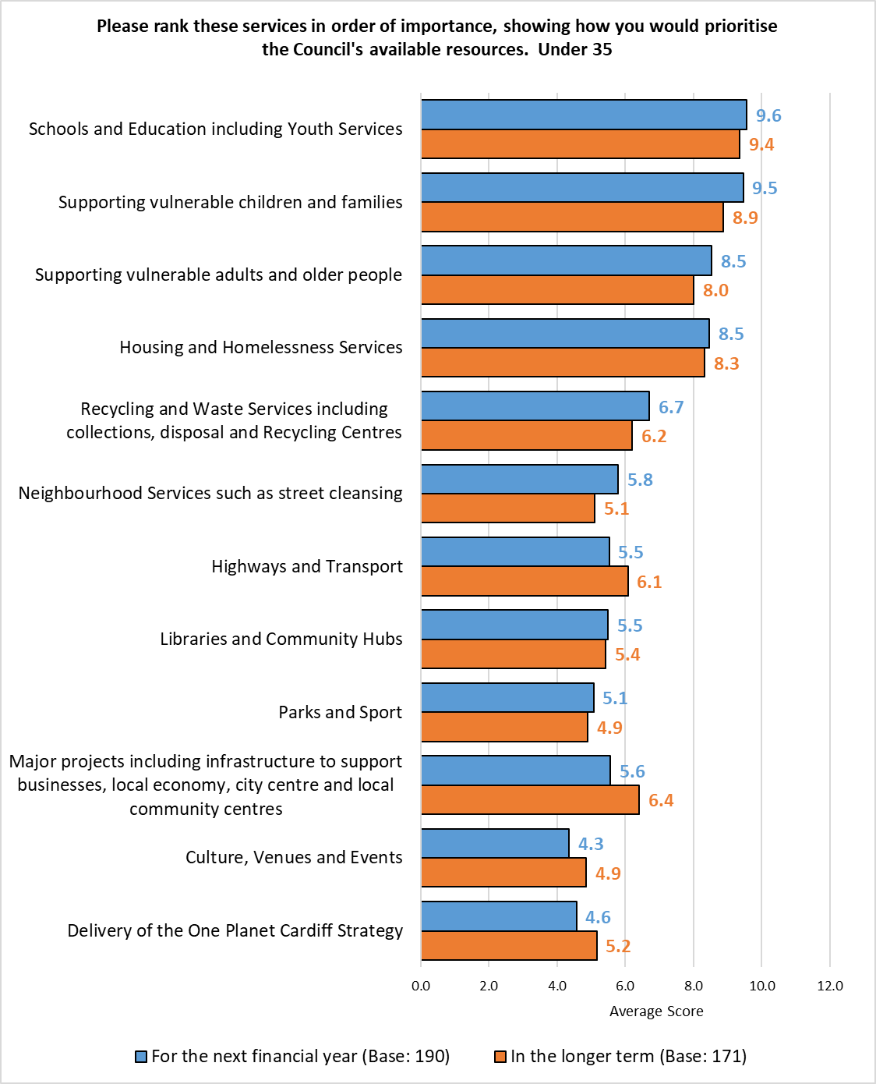
55+
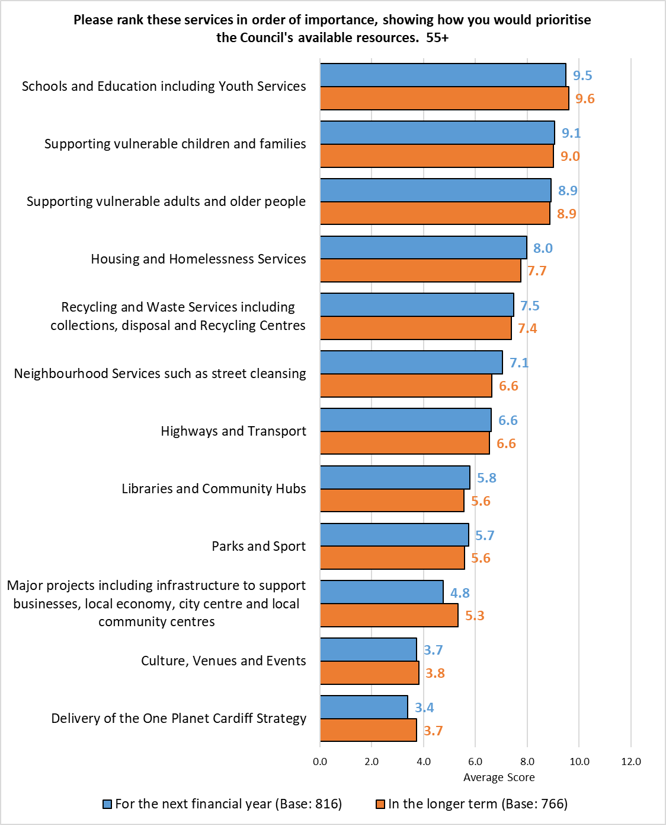

Female
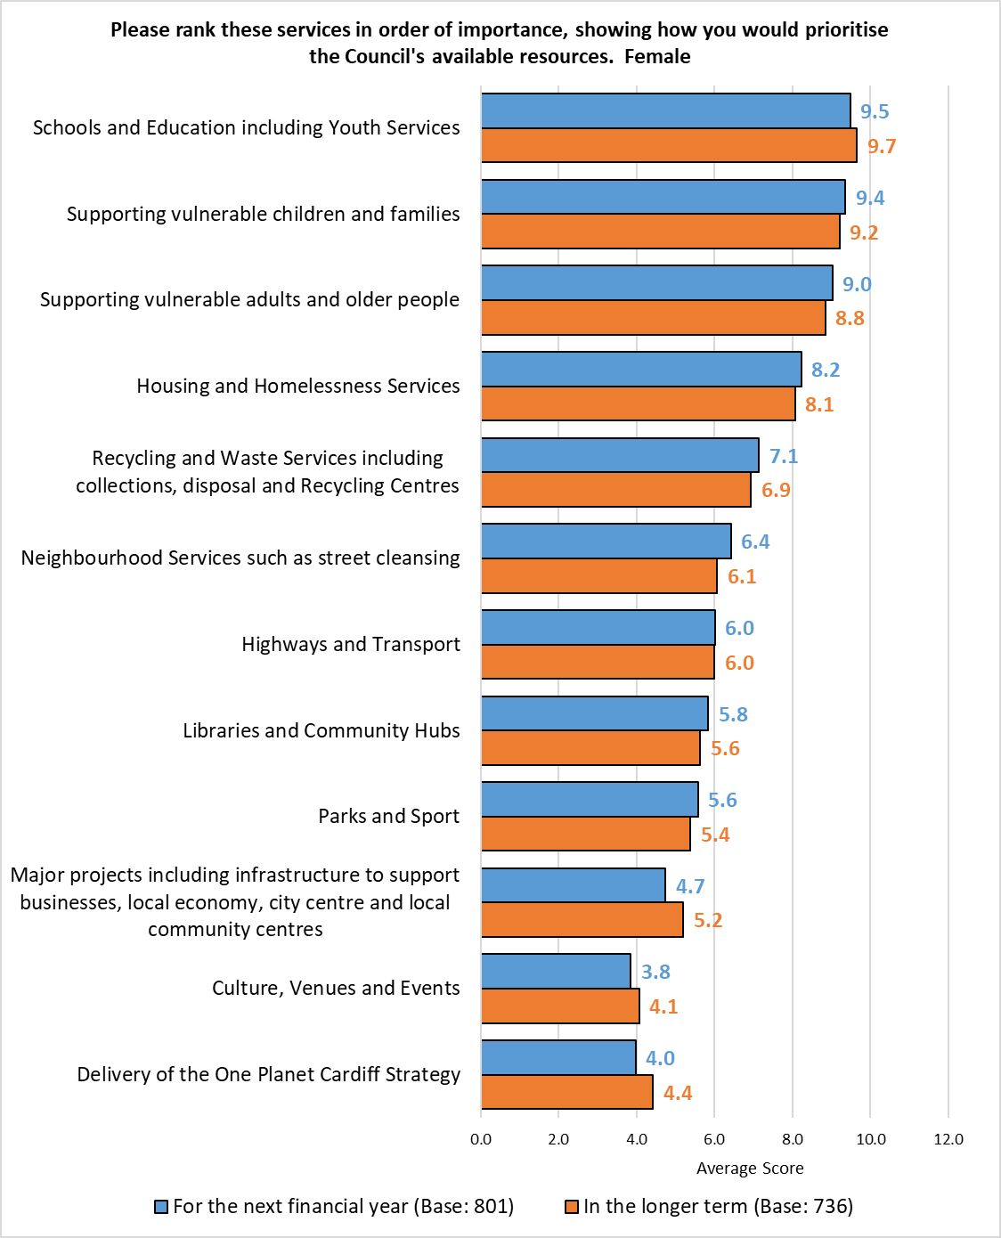

Male
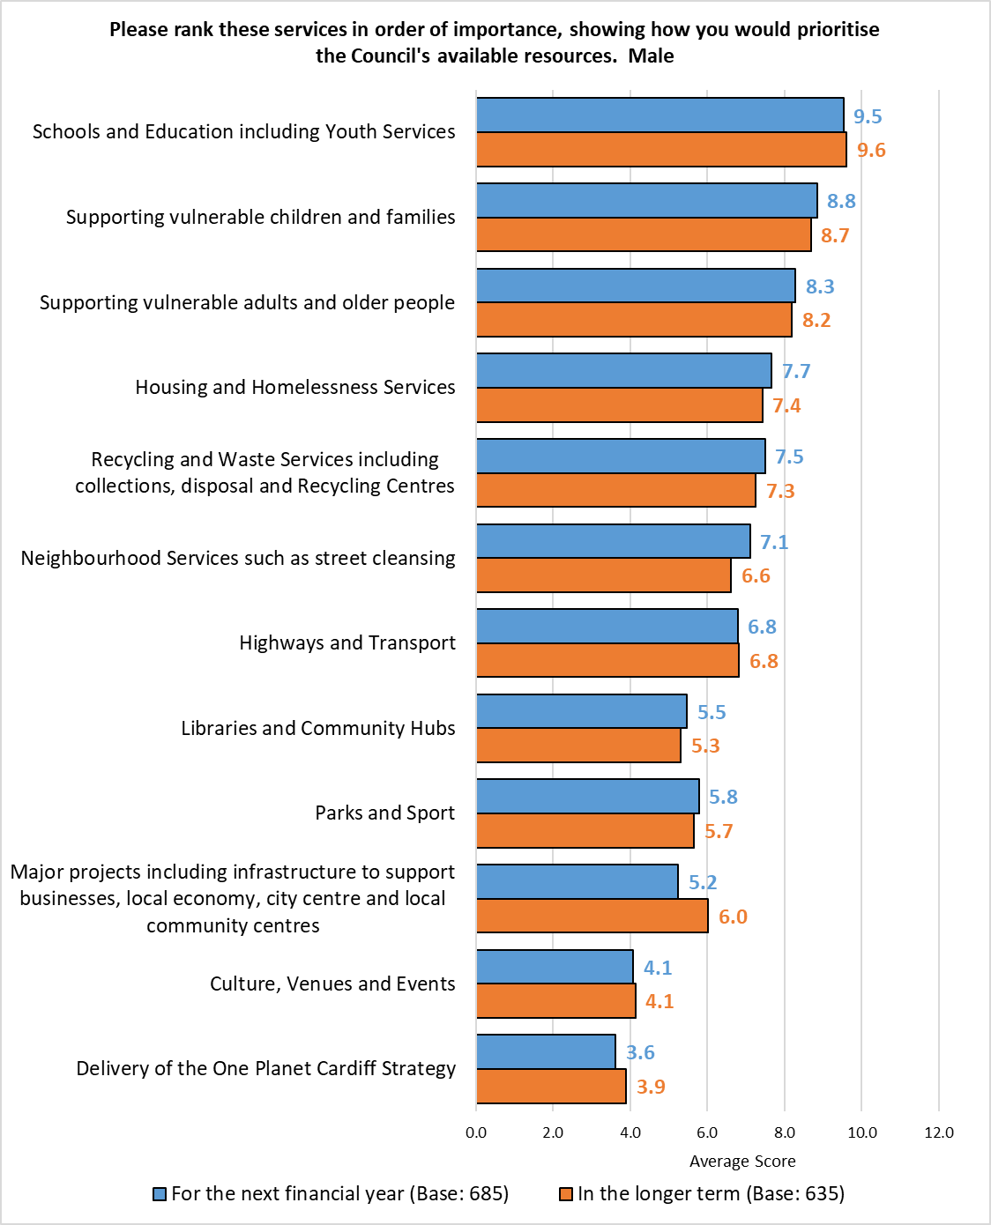

Ethnically Diverse
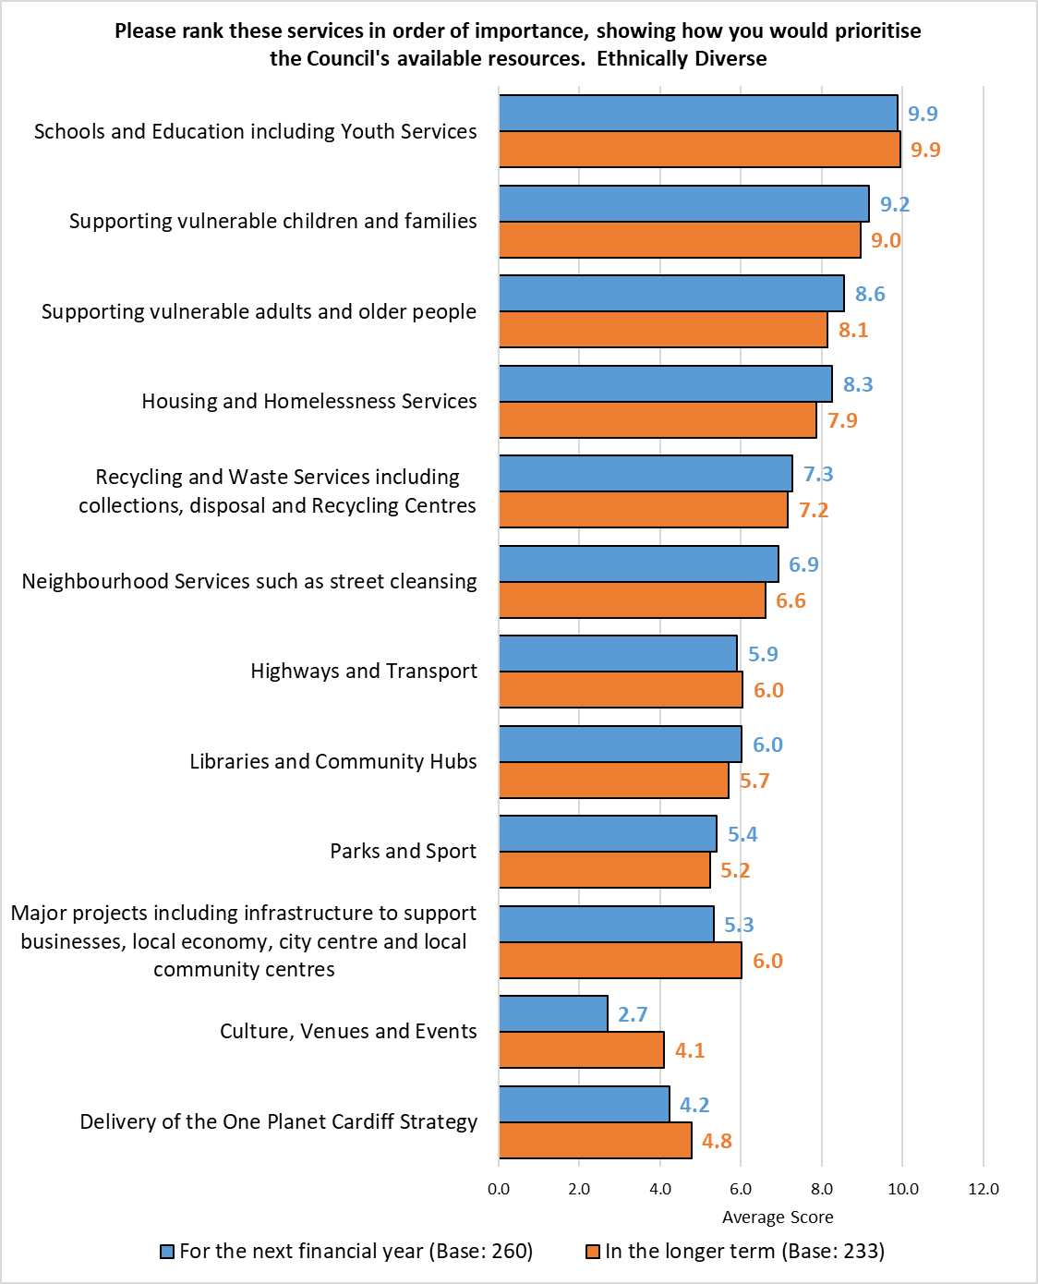
Identify as Disabled
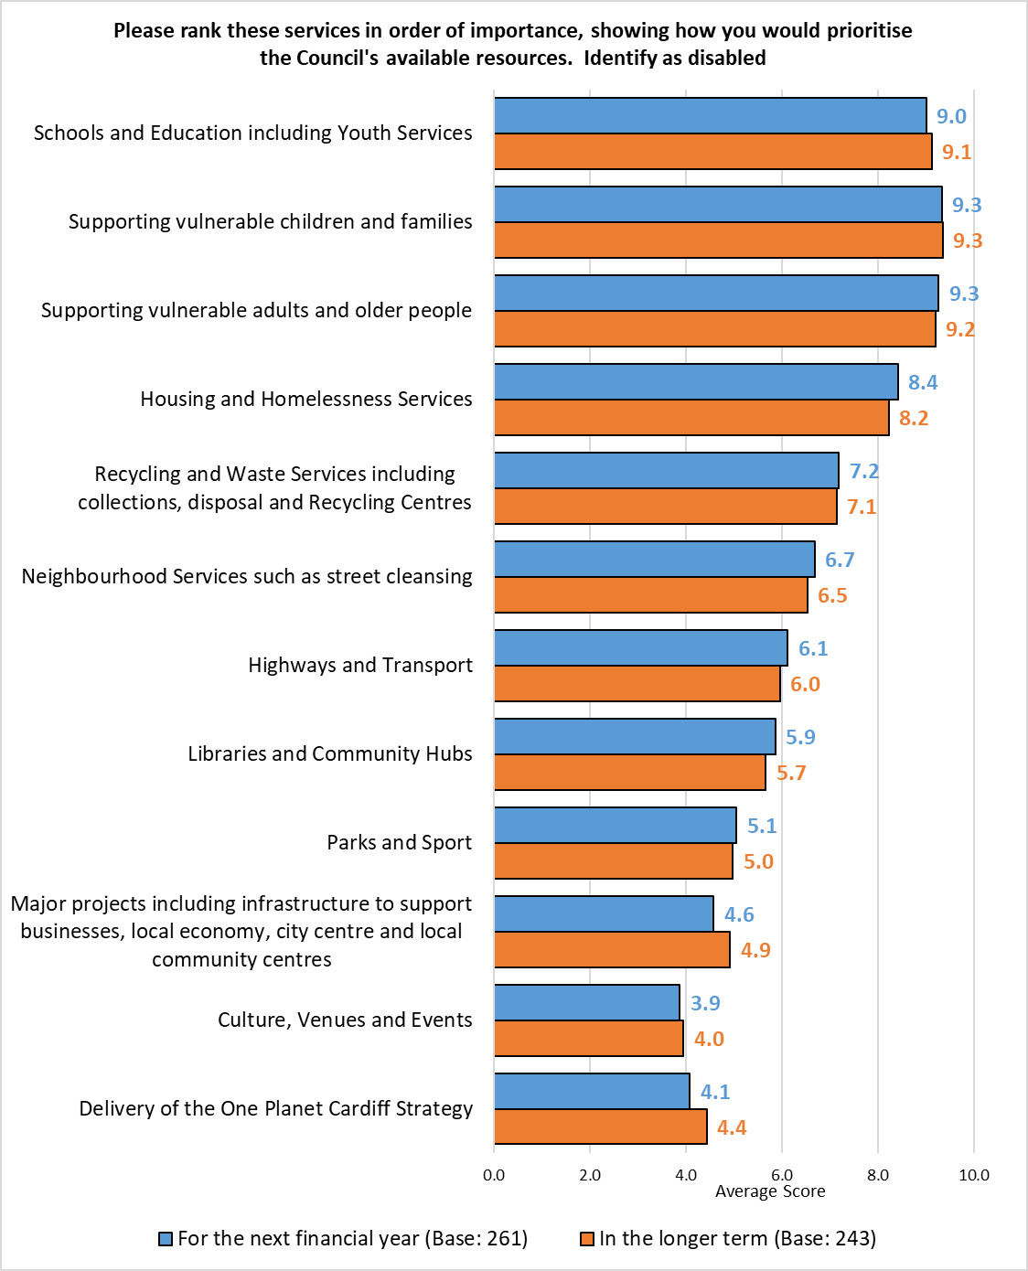

Welsh Speaker
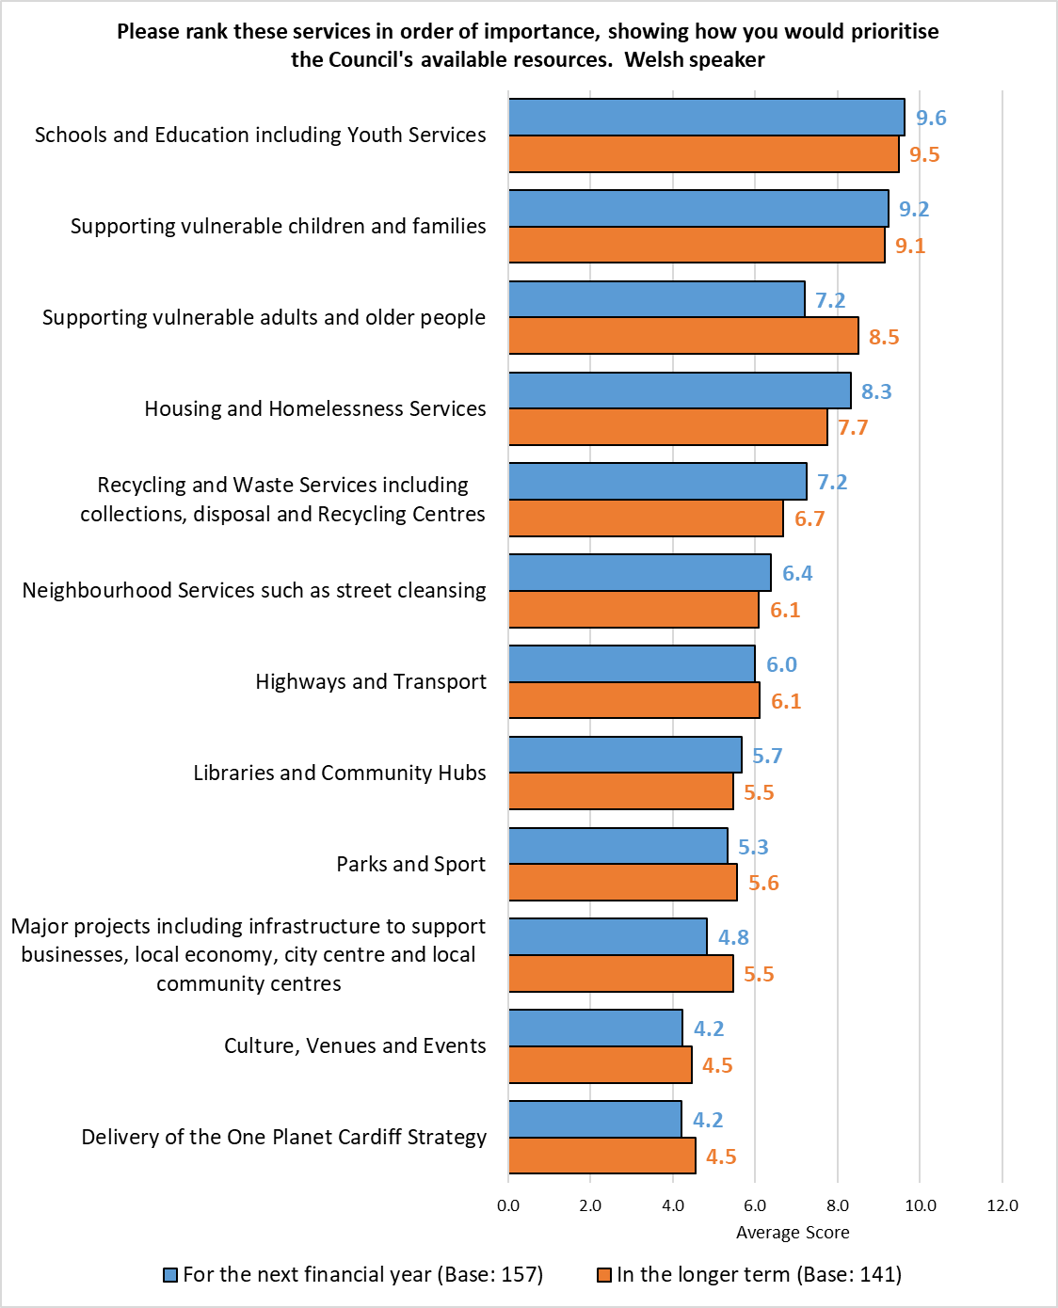

Southern Arc
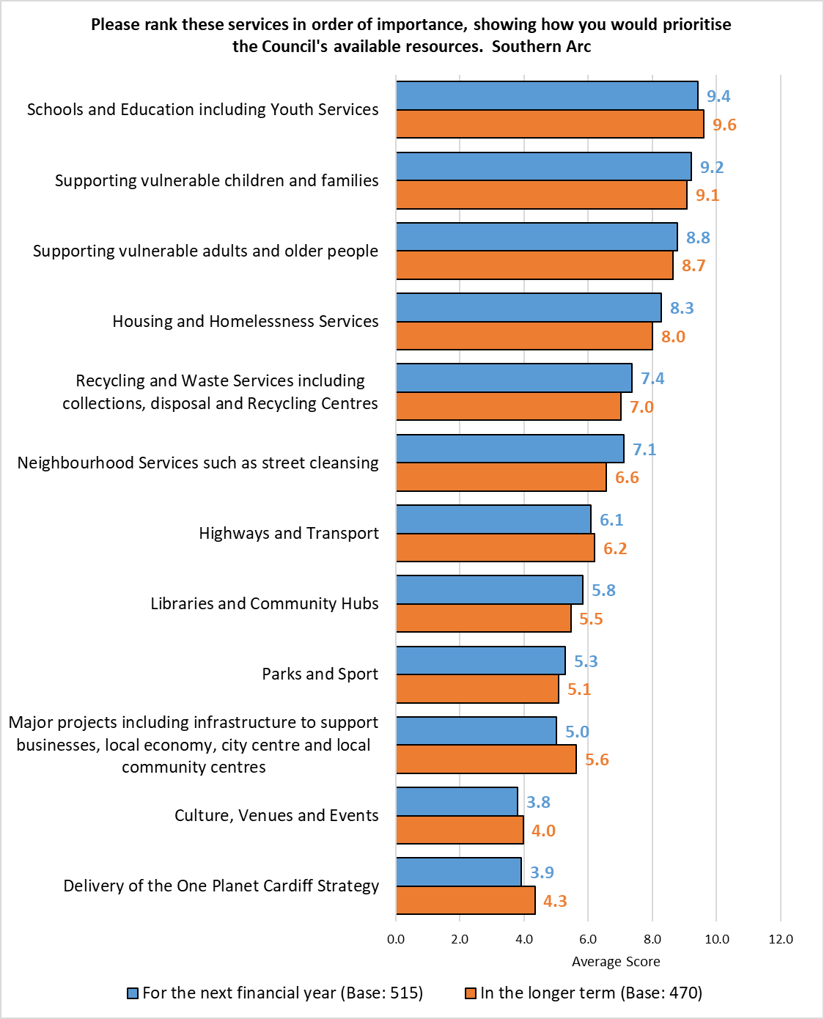

Children in the Household
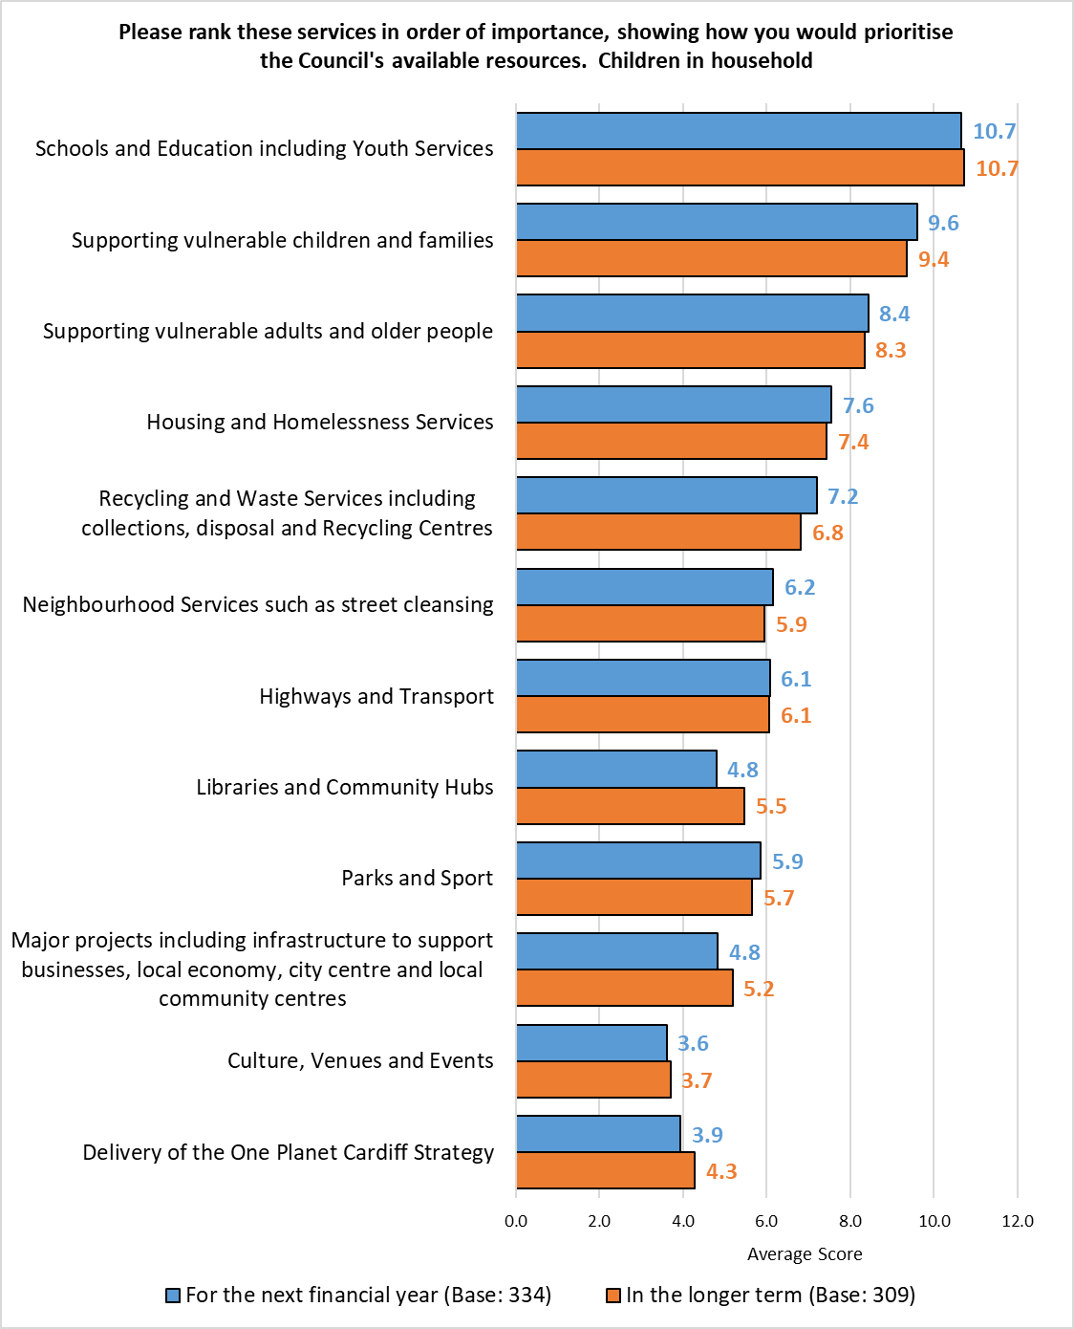

LGBTQ+
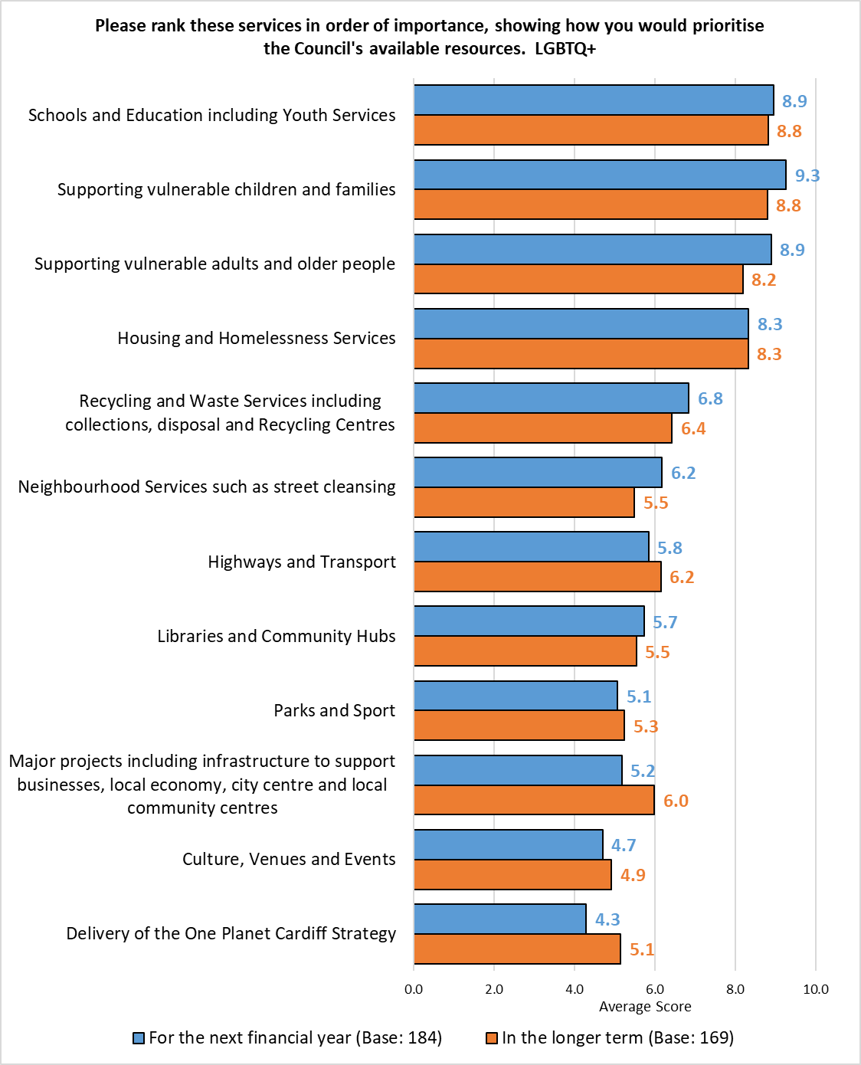

Most Deprived Fifth
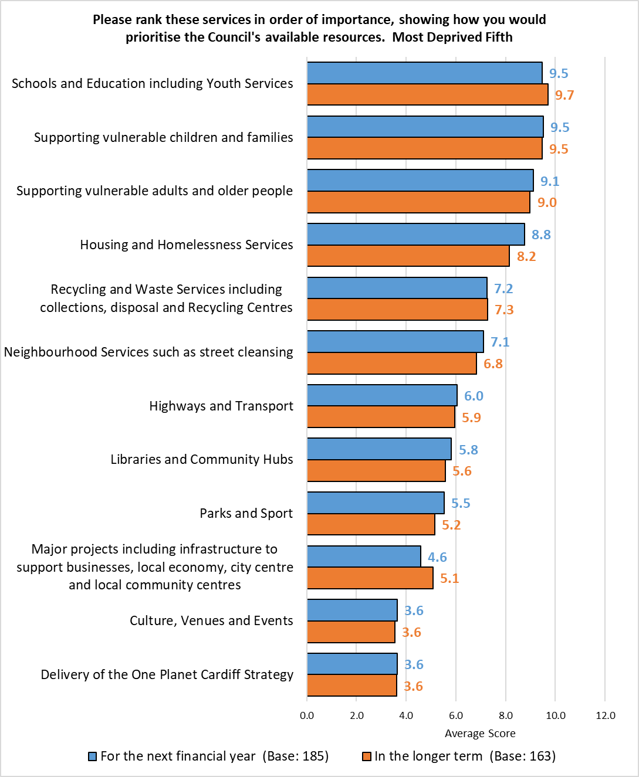

Next Most Deprived Fifth
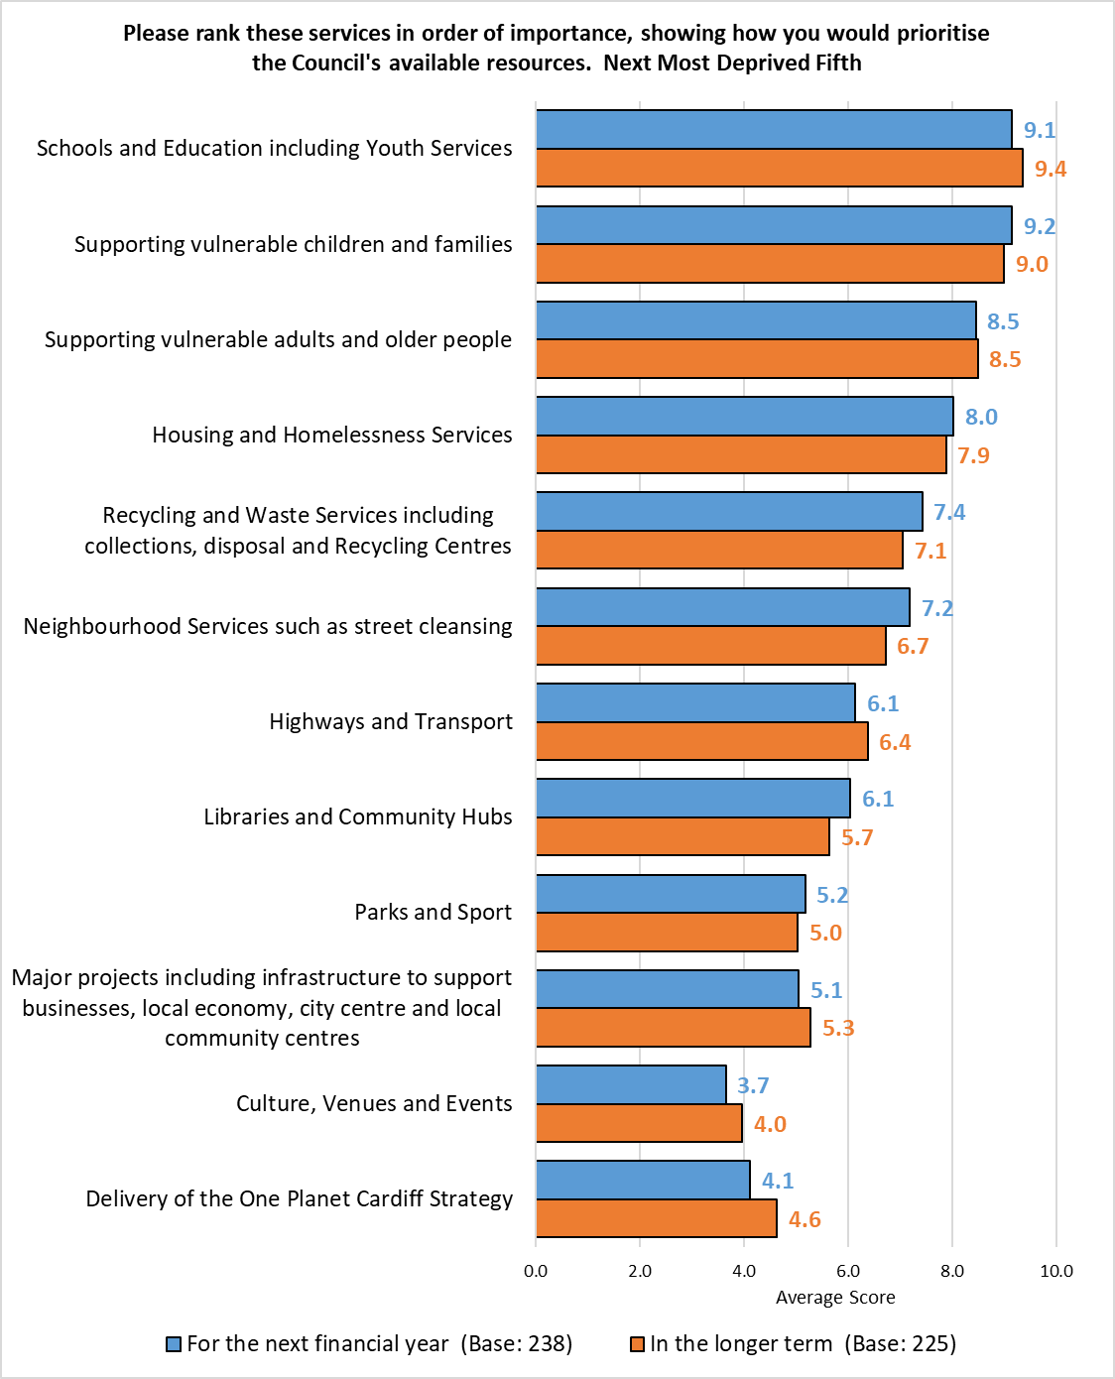

Middle Fifth
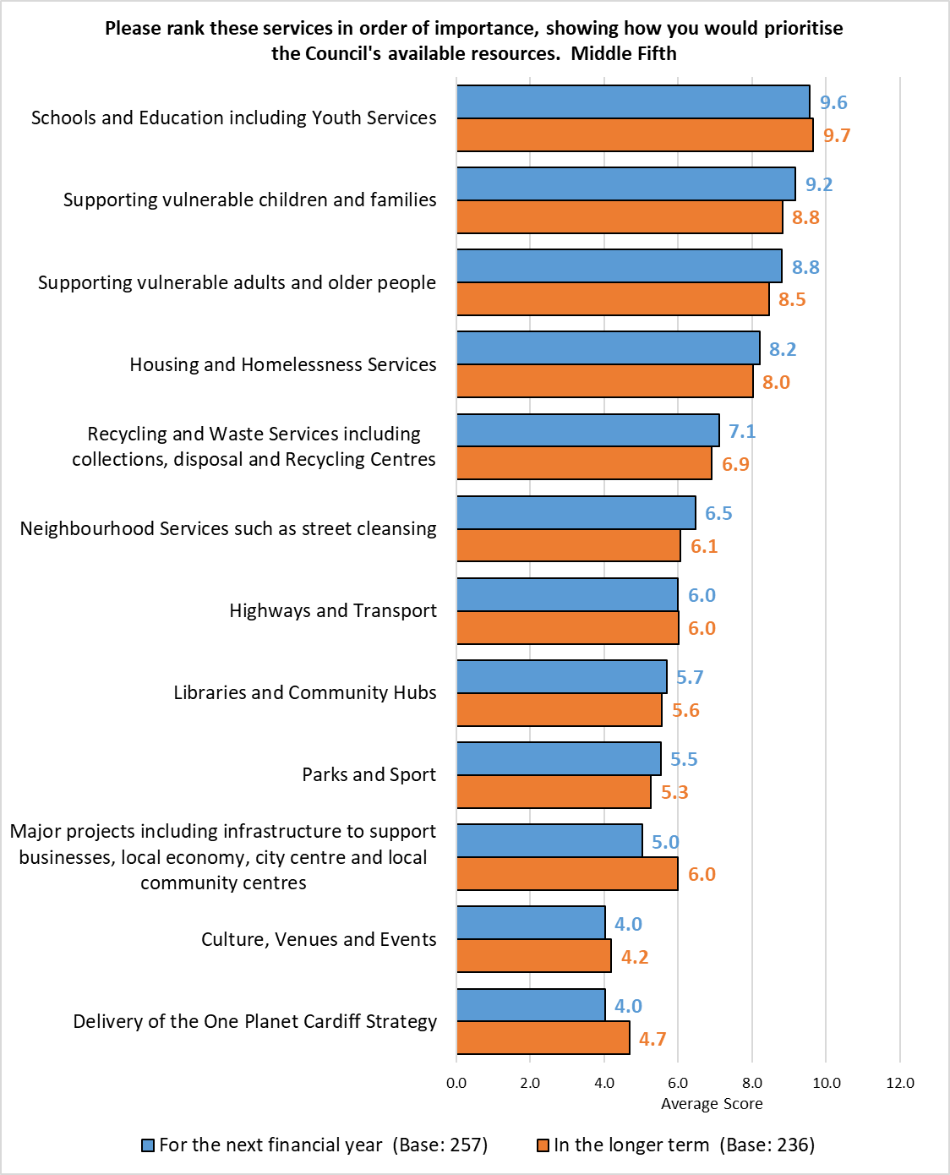

Next Least Deprived Fifth
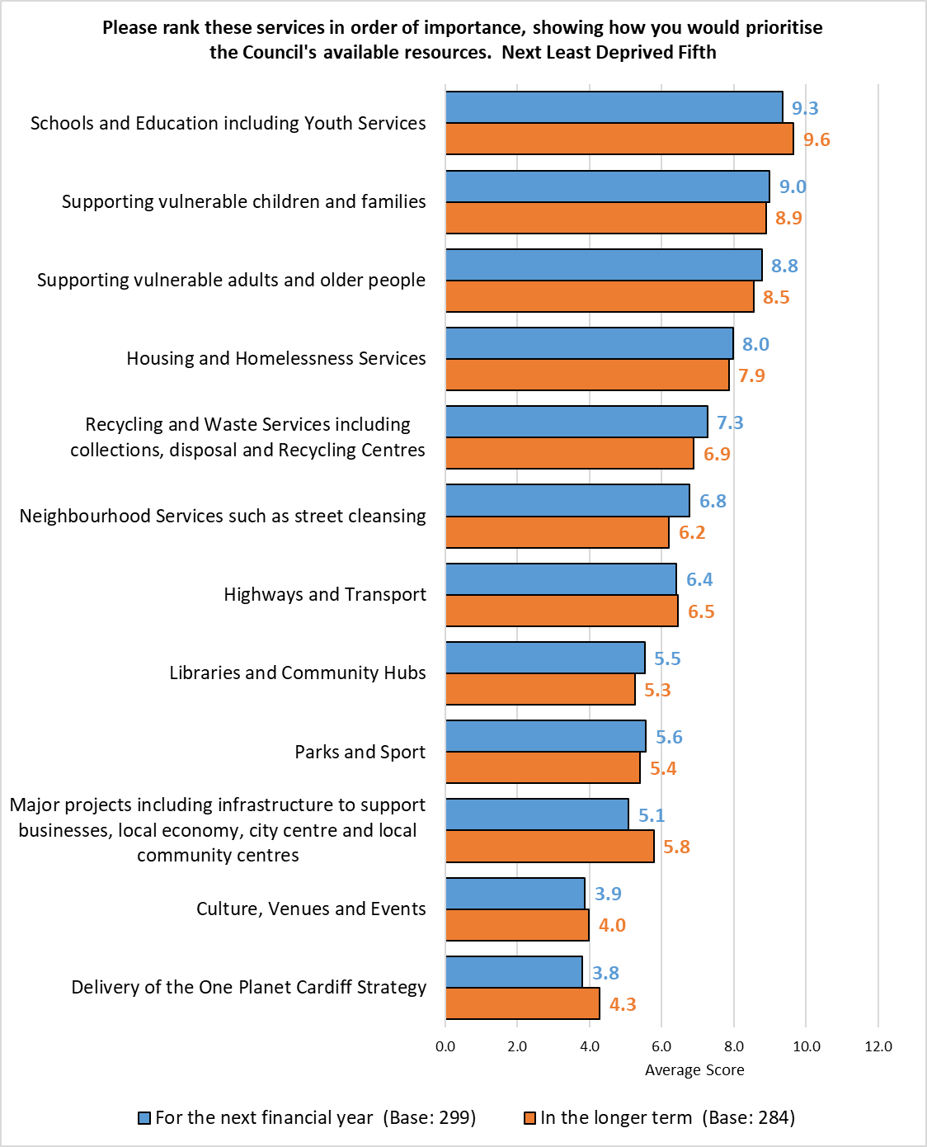

Least Deprived Fifth
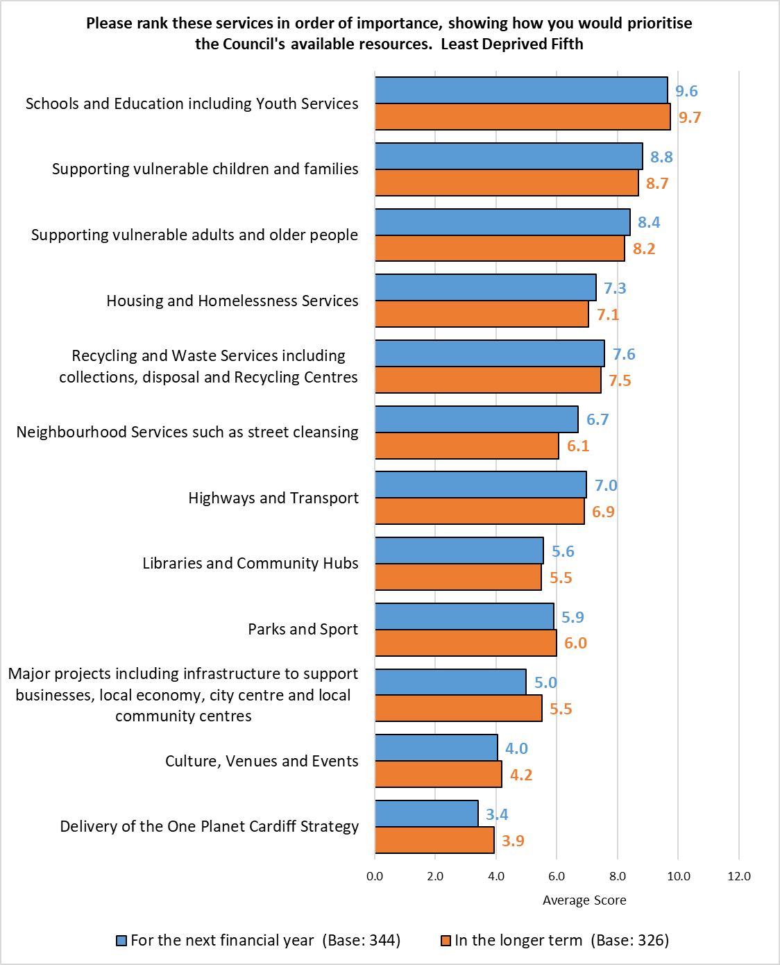

What Other Support Have You Accessed for Your Child?
Click here to return to the main report

Theme | No. | % | Example Comments
School | 8 | 22.9 | - Through the school  - Educational support  - He has a TA as a result of his IDP
Social services | 7 | 20.0 | - Social services  - Social worker
Specific services | 6 | 17.1 | - Respite  - Eating disorder  - Enfys
Family support | 4 | 11.4 | - Family first  - Family support
DLA | 3 | 8.6 | - DLA
Foster/Adoption | 3 | 8.6 | - post adoption support with cardiff and vale adoption service
St Davids | 2 | 5.7 | - One son accesses the ADHD team in st David's, the other son is on the waiting list there.
CAMHS | 2 | 5.7 | - Mental health advice
Parenting courses | 2 | 5.7 | - parenting courses
Health | 2 | 5.7 | - Health
Misc. | 8 | 22.9 | - Carers allowance and assessment  - Police  - I have tried to access support but have been declined.
Total Respondents | 35 | -
Respondents could comment on multiple themes so the total may exceed 100%.

Why Have You Not Accessed Support for Your Child?
Click here to return to the main report

Theme | No. | % | Example Comments
Unaware of what's available | 14 | 35.9 | - Not sure what is available. And not had positive experience from children's support services  - Don't know how. They don't want to go outside home  - Didn’t know about it
Cannot get support I need / Nothing available | 7 | 17.9 | - It's not available  - Nothing available for adhd
Awaiting assessment | 3 | 7.7 | - Child still going through assessment
Negative experiences | 3 | 7.7 | - Tried on several occasions and the council is too busy supporting immigrants
Sourced support elsewhere | 3 | 7.7 | - School managed dyslexia
Unsuitable times | 3 | 7.7 | - Not convenient times
Citizenship | 2 | 5.1 | - Visa does not allow it
Not offered any | 2 | 5.1 | - We were not offered
Unsure if I'd qualify for support | 2 | 5.1 | - Do not think I qualify
Misc. | 6 | 15.4 | - I do not have a social worker  - He's classed as an adult
Total Respondents | 39
Respondents could comment on multiple themes so the total may exceed 100%.

Do you have any other feedback for us?
Click here to return to the main report
Theme | No. | % | Example Comments
Recycling & Waste / Street Cleaning / Refuse Issues / Pollution | 197 | 26.3 | - I pay over £4000 council tax a year and I can’t even get a free bin!!!  - Find the design of the new red and blue bags for collection very bad  - Make city cleaner in appearance and inviting. Take more pride in public areas and parks/gardens  - clearing leaves up in the autumn needs to be addressed, leaves have been strewn around the pavements on my est for the last 6 weeks and its dangerous for the elderly  - The overhaul cleanliness of Cardiff has declined rapidly. Just in the last 4 years one area Canton has declined very sadly. It smells of garbage and the pavements are just dirty. It's really disappointing.  - Why are garden waste bins not collected for much of the year?  - Cleaning the streets roads in all areas to stop the roads flooding
Highways / Roads / Pavements / Walkways / Cycle lanes | 169 | 22.6 | - Fix the holes in the roads - until you can demonstrate competence in managing the highways I will trust you to do nothing else in a competent manner  - More attention to roads and repairs  - The general cleaning of roads and pavements throughout the city is awful. They haven't been cleaned for years and detritus formed from leaves and general dirt has solidified. Also, road signs throughout the city and surrounding motorways are covered in algae to such an extent that it's often difficult to read especially at night.  - There needs to be much stricter enforcement of speed limits. Cars regularly travel through my street at crazy speeds, dispite there being lots of families, older people, disabled people and even a school here! I've reported it but nothing ever seems to get done.  - BETTER BIKE LANES PLEASE  - I have rung the council regarding pavments in my street and they have not been resolved
Better Communication / Consultation / Transparency | 146 | 19.5 | - More involvement with residents regarding major decisions made by council  - Actually listen to the people of Cardiff - recent Roath Park enquiry proves failure to listen and arrogance of council views.  - Recent dealings with Cardiff Council have proved to be totally unacceptable. Communication has been appalling. A lot of my time has been needlessly wasted exacerbated by untrained staff working from home and clearly unsupervised.  - start coming door to door in communities/face to face  - Need to know who to contact  - c2c phone line is very frustrating
Don’t waste money | 118 | 15.8 | - Listen to people! Scrap vanity projects  - Stop wasting money on fancy projects. Stop thinking the Bay Area is the main and only part of the city. There are more parts of the city which need more support than the bay  - Stop wasting money on stupid things like Roath Rec  - Need to prioritise spending on those most in need  - Stop wasting money on promoting “political” opinions .. we don’t need murals telling us not to be racist it’s counter productive . You are prioriting the minority over the majority so it is not “ equality “  - Money not wasted on vanity prodjetts
Negative Council / Councillor Comments | 106 | 14.2 | - Get your act together.  - Cardiff council don't take any complaint seriously. You get passed around from department to department and never a clear answer. Tree issue at Rhydhelig Av typical. Reported no reply  - I have used your app to contact the council for various things in the past, broken glass, damage to trees, littering, blocked drains, antisocial behaviour and the response is mixed. A lot of the time things are ignored so I do wonder what's the point of having an app to contact and report anything.  - The council has no interest in listening to residents wishes. It has its own agendas and consultations like these are cherry picked to provide the answers the council officials wish to justify decisions and plans they have already decided on.  - I feel Cardiff Council is failing it's citizens on many levels.  - Cardiff is dull as dishwater and small 'c' conservative. It should be an exciting capital city. Please up your game.
Improve Public Transport | 89 | 11.9 | - The bus service desperately needs improving! Even with the new bus station, it is still a shambles. Buses are either late or don't turn up, with no warning or explanation - despite the technology available to do so! The council should be encouraging people to drive less and use public transport more, but the current state of Cardiff's public transport service is not encouraging at all!  - Please stop trying to prevent vehicles moving around the city safely. Public transport is not bad but not for those who work irregular hours.  - I am employed on a full time basis at UHW Heath, I live in Ely and the bus transport service is atrocious .  - Public transport in evenings is inadequate and until it's fixed the traffic problem will not be solved  - Bus service is appalling. No direct bus to Cardiff bay any more.
Protection of Green / Open Spaces / Tackle Climate Change | 70 | 9.4 | - Please prioritise the environment first. Everything else suffers if the environment is broken  - Cardiff is meant to be child friendly yet i have a 4 year old and the parks and green areas are not adequate for the amount of chidlren we have.  - The focus on climate change rather than environmental pollution is unbalanced - should be concentrating on cleaning up the environment rather than schemes to change the climate.  - Overall very satisfied with the many services the Council provides but stop wasting money on the "Climate Emergency" - UK emits 1.4% of annual global CO2 emissions and Cardiff's contribution to that is miniscule. Please stop gaslighting us and spend it on things that have an impact on people, make their lives better..  - stop paying lip service to green issues - pouring more concrete and tarmac is not the answer; stop disposing of public open space
Positive Comments | 64 | 8.6 | - on the whole I think the council does well and it can't be easy. Cardiff is good place to live and the council does a lot towards that. thankyou.  - I'm glad Cardiff is attracting big bands, it's brought a lot of dues to us lovely City.  - I believe that the services you provide such as advise for money, housing and work are very good but it is under utilised as the services are not as well known. They need to be pushed more so that the public is aware of the services.  - council hubs are fantastic and great for the community and i have more services should be available through the hubs  - Thanks for your work
Safer Streets / Greater Police Presence / Tackle ASB Issues | 62 | 8.3 | - We need safer, better lit streets, more car access to the city and more hope.  - the police are overstretched and therefore are unable to deal with antisocial behaviour which leads to people feeling unsafe. I dont feel the council listen, and either ignore negative feedback or deny there is a problem.  - cyclists not using the bicycle lanes nothing is enforced by this council they make rules but never enforce them  - The Spice, drugs and drunkenness crisis in the city has become unmanageable and needs addressing,. it is making the streets unsafe.  - Police presence is lacking - we need more of them on the street to discourage petty crime.
Housing / Tackle Homelessness Issues | 56 | 7.5 | - homelessness needs to be tackled in a better way, our capital city is dirty and does not offer a good impression on visitors to the city.  - Really need to see more affordable housing options in Cardiff  - You need to crack down on the false homelessness, begging and false claims on social services (e.g food banks). It might sound harsh but there’s a large amount of people that abuse these systems. I’ve been working in the city centre since 2014, so I’ve been seeing it firsthand. A lot of the people in the homeless shelter in Canton would go into the city centre to beg for money despite receiving benefits. Many would travel in by Car and train from other nearby locations to beg in the centre.  - Housing repairs could be more informative as to what is happening, I reported a damp issue in February and it wasn't tackled until September. If it had been looked at when reported it would have saved a lot of work.  - Need to address the homeless / displaced issue. Sort out the legitimate homeless from the people begging for money, address anti social issues.
Economy / Regeneration | 55 | 7.4 | - Cardiff holds many events in the city including concerts and rugby internationals. The provision of public transport for these events is diabolical. Additional bus services and late buses should be provided. Also more trains need to be laid and time of services extending. After many concerts I’ve seen queues of people outside the station waiting hours for trains in the pouring rain. What an advert for the city  - Cardiff has never recovered from the Covid period: schools, hospitals, street cleaning, cultural events - when will St David’s Hall reopen?  - improve investment in East Cardiff  - Your latest fixation with 20 mph zones and introducing cycle lanes is crippling Cardiff. The economy is suffering as a result. And you are efficiently at war with the people who fund your BS policies.  - The City Centre has become a dump with high cost shops and poor services
Planning concerns | 51 | 6.8 | - more involvement in planning for the community through the planning system  - Improve planning decisions. Better gender balance on Planning Committee  - There are 22 community campaigns running in the city to challenge the council on saving green space and cultrally important spaces. Decision makers are damaging our environment with over development, lack of scrutiny and are ignoring cardiff residents, damaging their health and wellbeing.  - Planning decisions need to be rethought. Cardiff desperately needs more places for middle income working people to live, not more high-rise student flats  - Cardiff council lacks class as it seems to just want to let big brands and developers do what they want and think that is developing the city.
Council budget | 51 | 6.8 | - The shortfall is very concerning. The general public will need to be reassured that cuts are not going to harm them and also that they will actually result in one day being in a surplus and able to invest into our city.  - People generally have a bad view of the council in its spending and priorities. This is normally due to misinformation. I would urge you to consider this deeply and provide transparent information through the post to residents.  - Councils are underfunded and don't perform well as a result. Work contracted out is poorly monitored and often does not provide value for money for the tax payer, the constant filling of pot holes is a prime example.  - Would be interested in the % of the budget utilised to further develop inclusiveness and the process followed in deciding how the budget is distributed.  - Greater access to council decison making. The public need to be reassured their money is being spent wisely, that financial choices have been properly costed to ensure the people of Cardiff get the best possible value for their hard-earned pounds.
Health / Well-being | 48 | 6.4 | - Waiting times for nhs  - I go to ty canna day services and my support worker is very good support for me. I also go to the activities they have there and they are very good too. Without the support I would not have any interaction with anyone. I am very happy with the support ty canna provide. I just wanted to say that they make a really big difference.  - Support the increase in availability of medical services, there is an extreme shortage  - Nature is a major emergency yet its just given lip service - its destruction affects my mental health
Greater Support / Services for the Elderly / disabled / vulnerable | 47 | 6.3 | - The council needs to provide better social care for the elderly and vulnerable  - Too many older people excluded from services because they don't use the internet  - I think the council needs to re think its response to persons with a disability faced with no fault evictions. They should not be treated in the same way as the ablebodied and should be given housing without all the need for being taken to court or put in temporary accomodation.  - There is absolutely no support/treatments available for those with neurodivergent conditions and the waiting list are ridiculously long for assessments & the availability of adhd medication is a problem aswell as shared care for those who are forced to go private as they are so desperate! It’s a disgrace!
More Needed for Young Adults / Children / Education | 43 | 5.7 | - If we don’t educate our children, everything else is irrelevant.  - Stop neglecting Butetown. Our kids have no library, high school or even school buses.  - The New ALN changes in school are diluting support for children with Additional needs. Schools and teachers are NOT trauma informed and treat behaviours rather than underlying needs.  - Providing good quality youth resources may help to tackle anti social behaviour.
Improve Infrastructure | 36 | 4.8 | - We’re a business in Cardiff, customers north of Newport simply do not come to Cardiff due to the traffic problems that have been created. The road structure into the City is simply disgraceful!  - the council must concentrate on the basic infrastructure and physical development of the city before trying to take over personal responsibilities of individuals to look after themselves and their families  - The lack of public toilets in the city centre is shameful
Parking | 31 | 4.1 | - Provide more free car parking.  - Pavement parking is a massive issue in Cardiff  - Parking fines are unfair when you can't park in your own street and have to double park. It's immoral
20 mph Speed limit | 30 | 4.0 | - Get rid of the 20mph on roads, but leave 20mph around schools and colleges, hospitals and care homes.  - Get rid of the 20mph speed limit and improve public transport  - Revert the 20mph speed limit in Cardiff
Council Tax | 27 | 3.6 | - It is becoming unaffordable for ordinary people to pay council tax. My council tax is one fifth of my pension. The council needs to reduce its costs drastically by cutting staff or amalgamating., by concentrating on basic public services like waste collection and street cleaning. We cannot afford Cardiff Council. X  - The council wastes a lot of money, my council tax is high for hardly any service, the state of the city is deteriorating and it is not in the condition a capital city should be  - Why is my council tax higher than Westminster?
More Localised Support / Community Activities / Groups | 18 | 2.4 | - The Council should expect citizens to do more. Many people agree. Public campaign to urge everyone to help, Fining people through filthy rubbish down.  - Give children something to do to get them off the street ….!!  - I would like to see an increase in more community gardens and allotments.
Welsh Government Concerns | 12 | 1.6 | - why do we need more MS? If i was voting for a welsh government again i would vote against it as don't see how we benefit. the money saved would be better distributed to the NHS. Schools. And Provision for the elderly  - There are too many councilors or just enough,we do not want more in the Syneth.This would save money more than by cutting services...  - The Council needs to strongly lobby both Welsh and National Govt for sustainable funding to deliver services. All LA should unite to refuse to implement cuts
Greater Support For The Arts / Hospitality Sector | 10 | 1.3 | - The arts support health, well being, the economy and education. Invest invest invest  - Must re-open St Davids Hall ASAP  - I have no clear sense of the cultural strategy of the council. It feels like everything is focussed on business and profit, wellbeing or aspirational thinking is too low on the agenda. The visual arts support is poor - esp when other cities are looked at.
Misc. | 40 | 5.3 | - I am trying to find a food bank in my area I can walk to.  - maybe there's an opportunity for more partnerships with charities  - NHS is disappointing  - Thanks for all the hard work - I know it’s not easy to deliver with budget cuts.
Total responses | 748 | -
Respondents could comment on multiple themes so the total may exceed 100%.

Organisations Approached to Support Promotion of the survey
Click here to return to the main report
- Hubs and libraries across the city
- Face-to-face engagement in Central Cardiff, Cardiff Bay, Adamsdown, Butetown, Canton, Riverside, surveys left in shops, cafes, restaurants, pubs and other local businesses

- ACE Cardiff, Butetown / Grangetown
- African Community Centre
- Amanah Cymru
- Army Careers
- Bangladesh Association Cardiff
- Bangladesh Welfare Association
- Bangladeshi Women’s Association Wales
- Barnardo’s
- BAWSO
- Beacon Centre
- Bengal Dragons Foundation
- Boss & Brew
- Butetown Medical Centre
- Butetown Community Centre
- Caerau Heritage Centre
- Cardiff Bangladeshi Society
- Cardiff Commitment
- Cardiff Met.
- Cardiff University
- Cardiff Women’s Aid
- CAVC
- Channel View Leisure Centre
- Diverse Cymru
- Dusty Forge
- EYST
- FAN groups
- Green squirrel
- Grangetown Pavillion
- Grangetown Youth Forum
- Hayaat Women Trust
- Hong Kong BNO / HongKongers CIC
- Kiran Cymru
- Lisvane Memorial Hall
- Llandaff North Community Centre
- Moorlands Community Centre
- Oasis
- Probation Service
- Race Council Cymru
- Race Equality First
- Safer Wales
- Settled
- Splott Community Volunteers
- The Mentor Ring
- Trinity Centre
- University of South Wales
- Wales Council for Voluntary Action
- Wates Construction
- Welsh Refugee Council
- Women Connect First

- Local councillors, particularly those in areas with historically low response
- Community Councils
- C3SC
- Public Health Wales
- Schools via Education & Lifelong Learning
- Youth Council
- PSB Members
- Tenants Website
- Partnership Team (to pass to Faith Groups, PCC, Disability groups including the Cardiff People First, Cardiff Institute for the Blind, Guide Dogs Cymru, RNIB and Diverse Cymru)
- Members
- Cardiff Council website (Home page and pop-ups on other pages receiving high traffic)
- Ask Cardiff Live Consultations Page
- Staff Intranet
- DigiGov
- Email to all staff from Staff Information
Social Media Presence
- Cardiff Council’s corporate accounts on Facebook, Twitter and Instagram
- Caerau (Cardiff) Residents
- Caerau and Ely MATTERS
- Residents of Canton & Riverside, Cardiff
- Victoria Park Matters
- Connect Cathays
- Keep Cathays Tidy
- Creigiau Hub
- Fairwater Community Group
- Gabalfa/Llandaff - Community Page
- Gwaelod y Garth villagers
- Heath & Birchgrove (Cardiff) Community Information Group
- Llandaff North & Whitchurch Daily Life Cardiff
- Llanishen and Thornhill Community Page
- Llanishen Residents' Group
- Llanishen & Rhiwbina Past And Present
- I love Llanishen and north Cardiff
- Llanishen Parks Group
- Llanrumney News
- Pentyrch Community Group
- Friends of Roath Brook. Protecting Penylan's parks
- Pengam Green residents
- Rhiwbina Community News
- Roath Living Streets Group
- Rumney Community
- Rumney and Cardiff East News
- Rumney News
- People of Splott
- Westfield Park Residents, St Fagans Cardiff
- St Mellons News And Info
- Trowbridge, Cardiff News and Events
- MyWhitchurch
- Friends of Whitchurch Library Park
- Tongwynlais Village

- Cardiff Dog Action Group
- Cardiff West Issues Group
- Developing Cardiff
- Gwaelod y Garth Villagers
- Creigiau Hub
- Pentyrch & Creigiau Hub
- Pentyrch Community Group
- Pentyrch Community Council FB Page

Map of the Southern Arc
Click here to return to the main report

