


Ask Cardiff 2025
Report

March 2026

Contents
Background 1
Response 2
City Life & Public Services 4
Your Neighbourhood 15
Accessing Services 29
Hubs & Libraries 38
Cost of Living 48
Housing 64
Jobs & The Economy 68
Health & Well-being 75
Community Safety 99
Environment 110
Budget Priorities 118
Family Services & Social Care 121
Any Other Comments 126
About You 129
Appendix 1 Volunteering 137
Appendix 2 How Would You Prefer to Access Information About Services, Events etc.? Breakdown by Demographic and Geography 139
Appendix 3 Why Do You Disagree That Contacting the Council is Simple? 142
Appendix 4 What Other Services Delivered in your Local Hub/Library Do You Find Most Helpful? 144
Appendix 5 What Services Delivered in your Local Hub/Library Do You Find Most Helpful? Breakdown by Demographic and Geography 146
Appendix 6 What Other Activities or Events Would You Like To See in Your Local Hub? 149
Appendix 7 What Activities or Events Would You Like To See in Your Local Hub? Breakdown by Demographic and Geography 150
Appendix 8 How Else Would You Like To Know About Events In Your Local Hub/Library? 153
Appendix 9 What other neurodivergent friendly activities would you like to access? 154
Appendix 10 What neurodivergent friendly activities would you like to access? 156
Appendix 11 In the last six months, have you or anyone else in your household done any of the following because you couldn't AFFORD food? Breakdown by Demographic and Geography 159
Appendix 12 In the last six months, have you or anyone else in your household had issues paying energy bills? Breakdown by Demographic and Geography 161
Appendix 13 Please tell us how you plan to cope with the increase in energy costs 163
Appendix 14 To what extent do you agree or disagree with this statement: Cardiff has a thriving and prosperous economy? Breakdown by Demographic and Geography 165
Appendix 15 Over the last 12 months, would you say your employment situation has…? Breakdown by Demographic and Geography 166
Appendix 16 Please Tell Us What Else Stopped You Taking Up The Invitation For Screening 167
Appendix 17 Please Tell Us What Else Stopped You Taking Up The Invitation For Vaccination 168
Appendix 18 How Safe or Unsafe Do You Feel In The Following Situations? Trend Data 169
Appendix 19 Why Do You Feel Unsafe in These Situations? 171
Appendix 20 What Could Be Done To Make You Feel Safer? 183
Appendix 21 Budget Priorities by Demographic and Geography 191
Appendix 22 Do you have any other feedback for us? 206
Appendix 23 Organisations Approached to Support Promotion of the survey 212
Appendix 24 Map of the Southern Arc 216

Background
Ask Cardiff is Cardiff Council’s annual resident’s survey. The 2025 survey ran from 2nd October to 30th November 2025; it was extended by a week from its planned closing date to boost the response rate, particularly amongst under-represented groups.
The survey was available in hard copy and online in English, Welsh, Arabic, Bengali and Somali, reflecting the more commonly spoken languages in the city, plus targeted engagement with under-represented groups.
Hard copies of the survey were made available in Hubs, Libraries and community buildings across the city, and were provided to local councillors to distribute within their communities. Posters with a QR code linking directly to the online survey were also used to promote the survey in community buildings including shops and faith spaces, e.g. churches mosques and temples.
Respondents to the survey were invited to enter a prize draw to win one of ten £50 FOR Cardiff vouchers.
The Cardiff Research & Engagement Centre worked closely with partnership organisations to ensure as representative a response as possible. In a bid to ensure the survey was promoted as widely as possible, the survey was promoted via:
a) Email

- Organisations known to work with less frequently heard groups (see Appendix 23)
- Cardiff’s Citizen’s Panel
- Faith spaces

b) Internet/intranet
The survey was hosted on the Council website, and promoted to Council employees via DigiGov, Intranet, Networks and Staff Information.

c) Social media

The survey was promoted via Facebook and Twitter throughout the consultation period. Social media ‘boosts’ were made to selected demographics with a focus on younger people and those in the south of the city.
d) Face-to-face
Engagement officers worked with typically under-represented communities to promote the survey and encourage response. Conversations were noted to understand areas of importance to residents, and capture lived experience.
The team engaged with 989 residents across the city.

Response
After data cleansing and validation, there were 2,760 responses to Ask Cardiff 2025.

 | Ask Cardiff 2021 | Ask Cardiff 2022 | Ask Cardiff 2023 | Ask Cardiff 2024 | Ask Cardiff 2025
Total responses | 2,704 | 3,856 | 3,187 | 2,620 | 2,760

Just over half of respondents (46.5%, or 1,283) shared their postcode information. The map below shows population representation at ward level for Cardiff residents.
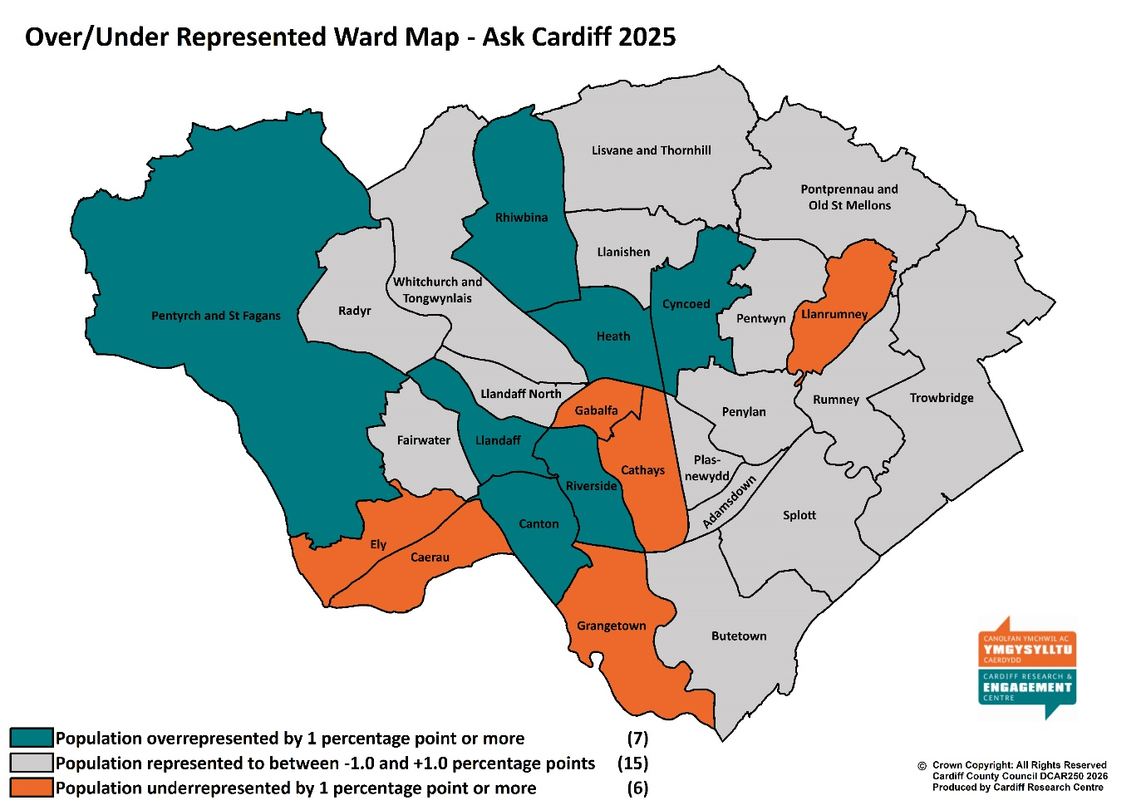
Those that did not provide a postcode are included in overall figures but are excluded from spatial analysis. Similarly, those that did not provide demographic information are included in the overall figures but excluded from subgroup analysis.
The response has been broken down by age, gender, ethnic background, Welsh Speakers, respondents with children in their household, those with a disability, those identifying as LGBTQ+, and those living in the least or most deprived areas of the city.
In addition, the analysis includes the response from those living in the ‘Southern Arc’ of Cardiff which comprises the following electoral wards: Adamsdown, Butetown, Caerau, Canton, Ely, Grangetown, Llanrumney, Riverside, Rumney, Splott, Trowbridge (see map at Appendix 24).
Open-response comments included in the report are verbatim; any errors in grammar or spelling have been ignored.

Welsh Index of Multiple Deprivation

To help gain a better understanding of the experiences and views of Cardiff residents an additional level of analysis has been introduced that looks at responses by deprivation fifth.
The Welsh Index of Multiple Deprivation (WIMD) is the official measure of small area deprivation in Wales and is designed to identify those small areas where there are the highest concentrations of several types of deprivation. Each Lower Super Output Area (LSOA) in Wales is ranked in terms of overall deprivation as well as for several separate domains, with a rank of 1 assigned to the most deprived area.
The 218 LSOAs in Cardiff are ranked from highest to lowest by their overall deprivation rank and then split into five equal bands, ranging from least deprived (i.e. least deprived 20% of LSOAs in Cardiff) to most deprived fifth (i.e. most deprived 20%). Respondents are then assigned to a deprivation fifth according to their postcode. As such, respondents from outside Cardiff or those with a missing/incomplete/incorrect postcode will be excluded from this analysis.

Weighted Data

Weighted Data refers to when the data collected from survey respondents are adjusted to represent the population from which the sample was drawn. The overall data for Ask Cardiff survey 2025 was weighted for some of the questions to ensure it was representative in terms of age and gender.
The weighting of the data was found to have no significant impact on the results, with the difference typically no more than one or two percentage points – something that could be explained by standard deviation and should not be cause for concern.
The strong similarity between the observed and the weighted data indicated a high level of robustness in the data collection. As a result, we have chosen to report on the ‘observed’ data i.e. the actual response received.

Section 1:

City Life & Public Services

- Overall, how satisfied or dissatisfied are you with Cardiff as a place to live?
Around seven out of ten respondents (70.3%) described themselves as satisfied with Cardiff as a place to live, on a par with results from the previous four years.

Satisfaction was highest amongst respondents identifying as LGBTQ+ (79.5%) and Welsh speakers (79.3%); it was lowest amongst respondents who identify as disabled (61.4%) and those living in the Southern Arc (71.3%).
Base sizes shown in brackets; excludes ‘Don’t Know’ responses.

There was little difference across the deprivation quintiles, although the least deprived areas showed slightly higher levels of satisfaction than the most deprived areas.
Base sizes shown in brackets; excludes ‘Don’t Know’ responses.

2. Overall, how satisfied are you with the following?
Satisfaction with the quality of public services in Cardiff was on a par with previous findings, with around half of those answering this question rating themselves as ‘satisfied’ with public services (48.0%).
When asked specifically about the services the Council provides, two-fifths of respondents (41.4%) declaring themselves to be satisfied.
Base sizes shown in brackets; excludes ‘Don’t Know’ responses.

There was a variation in levels of satisfaction across the different demographic groups analysed – respondents from ethnically diverse backgrounds were most satisfied with the quality of public services in Cardiff (55.7%), around 15 percentage points higher than those who identified as disabled (40.3%). This reflects findings of previous surveys.

Base sizes shown in brackets; excludes ‘Don’t Know’ responses.

There was a correlation between satisfaction with the quality of public services in Cardiff and deprivation quintile, with those living in the more deprived areas showing marginally higher levels of satisfaction.

Respondents from ethnically diverse backgrounds also showed the highest levels of satisfaction with the services the council provides (49.8%), again contrasting with those identifying as disabled (32.4%) – almost a quarter (23.4%) of this group described themselves as ‘very dissatisfied’, up from 20.1% in 2024.
Base sizes shown in brackets; excludes ‘Don’t Know’ responses

There was no correlation with level of deprivation and satisfaction with the services the Council provides.

3. How much do you agree that the Council gives residents good value for money?
Almost one in three respondents (31.4%) agreed that the Council gives residents good value for money, broadly consistent over the past three years.

Respondents from ethnically diverse backgrounds (43.1%) showed the highest level of agreement that the Council gives residents good value for money.
Those identifying as disabled were most likely to disagree (58.7%, up from 54.0% in 2024).
Base sizes shown in brackets; excludes ‘Don’t Know’ responses.

There was no correlation with level of deprivation.

The cost of Council Tax was raised during face-to-face engagement:
“If possible, can the council review the tax payments - it's very expensive”
(early 30s Ethnically Diverse couple).

4. Overall, how well informed do you think Cardiff council keeps residents about the services and benefits it provides?
Two in five (41.5%) felt the Council keeps residents informed about the services and benefits it provides ‘very’ or ‘fairly’ well, whilst 58.5% felt this was not done well. This is consistent with the 2024 results.

Respondents from ethnically diverse backgrounds were most likely to feel well informed by the Council (48.3%), contrasting with those identifying as disabled (35.2%) and respondents under the age of 35 (37.4%).

There was no correlation between how well-informed people felt and level of deprivation.
5. To what extent do you agree with the statement: Cardiff city centre feels welcoming and inclusive
Two in five respondents (42.4%) agreed that ‘Cardiff city centre feels welcoming and inclusive’, compared with 37.5% who disagreed. As in 2024, just 2.7% reported that they did not visit the city centre.
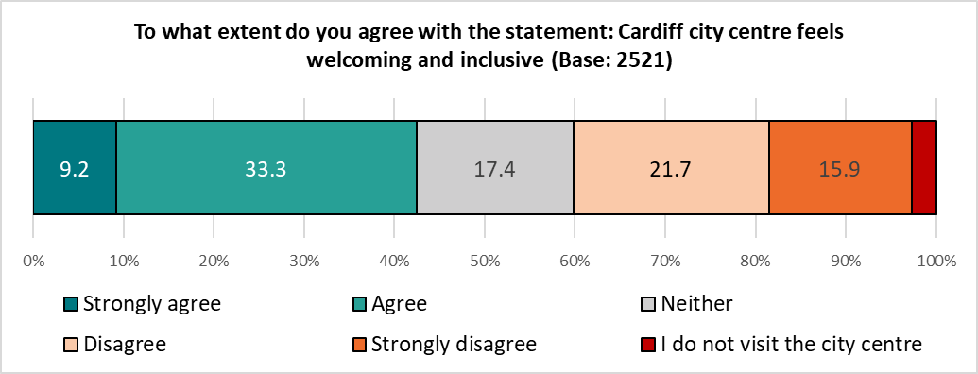

Over three in five respondents from ethnically diverse backgrounds (61.9%) or under the age of 35 (60.3%) were most likely to agree that Cardiff city centre feels welcoming and inclusive.
Agreement was lowest amongst those identifying as disabled (30.6%) aged 55 or over (37.4%). These groups were also most likely to report that they did not visit the city centre (4.2% and 3.1% respectively).
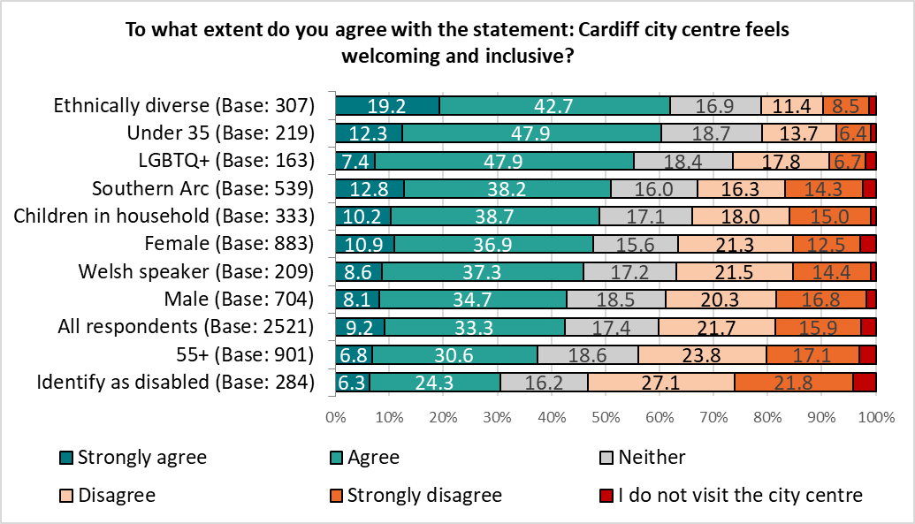

Respondents living in the more deprived areas of the city were a most likely to agree than those in living in the least deprived areas.
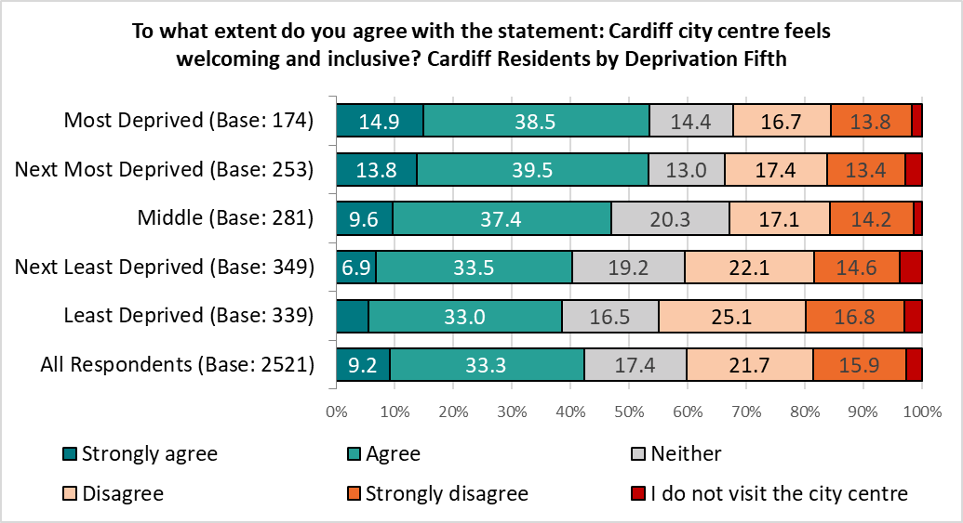

Section 2:

Your Neighbourhood

6. How satisfied or dissatisfied are you with your local community as a place to live?
Almost seven in ten respondents (68.4%) were satisfied with their local community as a place to live, reflecting the findings of previous Ask Cardiff surveys.

There was a clear correlation between level of deprivation and satisfaction with their local community as a place to live - respondents living in the least deprived areas of the city were notably more satisfied with their local community as a place to live than those in the most deprived areas, with satisfaction levels for the former over 33 percentage points higher than the latter (88.1% compared with 54.5% respectively), reflecting the results of previous surveys.
Less than one in ten respondents from the least deprived areas described themselves as ‘dissatisfied’ with their local community, four times less likely than those in the most deprived areas (8.1% compared with 34.8%), again reflecting previous findings.

Base sizes shown in brackets; excludes ‘Don’t Know’ responses.
The proportion of those living in the most deprived areas who were satisfied with their neighbourhood rose from 47.6% in 2024 to 54.5%, narrowing the gap between the most and least deprived areas from 37.0 percentage points in 2024 to 33.6, the smallest gap since the pandemic.
The proportion of residents from the most deprived areas of the city describing themselves as ‘very dissatisfied’ fell from 17.5% to 10.7%.
% Satisfaction with local community | Most deprived | Least deprived | Difference
2025 | 54.5 | 88.1 | 33.6
2024 | 47.6 | 84.6 | 37.0
2023 | 45.8 | 85.4 | 39.6
2022 | 50.0 | 85.2 | 35.2
2021 | 56.5 | 89.3 | 32.8

Reflecting these findings, those resident in the Southern Arc of the city showed the lowest level of satisfaction amongst the demographic and geographic groups analysed (61.7%, up slightly from the 57.3% recorded in 2024).
Base sizes shown in brackets; excludes ‘Don’t Know’ responses

7. To what extent do you agree or disagree with this statement: My neighbourhood is a place where people get on well together and help each other?
Three in five (59.0%) of those surveyed agreed that their “neighbourhood is a place where people get on well together and help each other”, broadly reflecting the findings of previous surveys.

As seen in 2024, Welsh speakers (69.8%) were most likely to agree with this statement, those living in the Southern Arc of the city were least likely to agree (51.2%).
Base sizes shown in brackets; excludes ‘Don’t Know’ responses.

There was a correlation with this statement and the level of deprivation, ranging from 46.5% amongst those living in the most deprived areas to 75.0% amongst those in the least deprived areas.

Base sizes shown in brackets; excludes ‘Don’t Know’ responses.

The gap between the most and least deprived areas remains broadly consistent post-pandemic.

8. To what extent do you agree that you are able to have a say on local issues or how Council services are run in your community?
Around a quarter of respondents (25.5%) agreed that they are able to have their say on local issues or how Council services are run in their community, reflecting the findings of previous surveys.

Respondents from ethnically diverse backgrounds were most likely to agree with this statement (35.3%).
Three in five respondents who identified as disabled (60.9%) disagreed, including 28.5% who ‘strongly’ disagreed.

There was no correlation with level of deprivation.

9. How satisfied or dissatisfied are you with the following in your neighbourhood?
Respondents were given a list of services and asked their level of satisfaction with each.
Satisfaction was highest for Libraries/Hubs (71.0%), parks and open spaces (70.9%) and street lighting (64.4%). Dissatisfaction was highest for pavement maintenance (63.6%), road maintenance (62.3%), and street cleansing (51.3%).
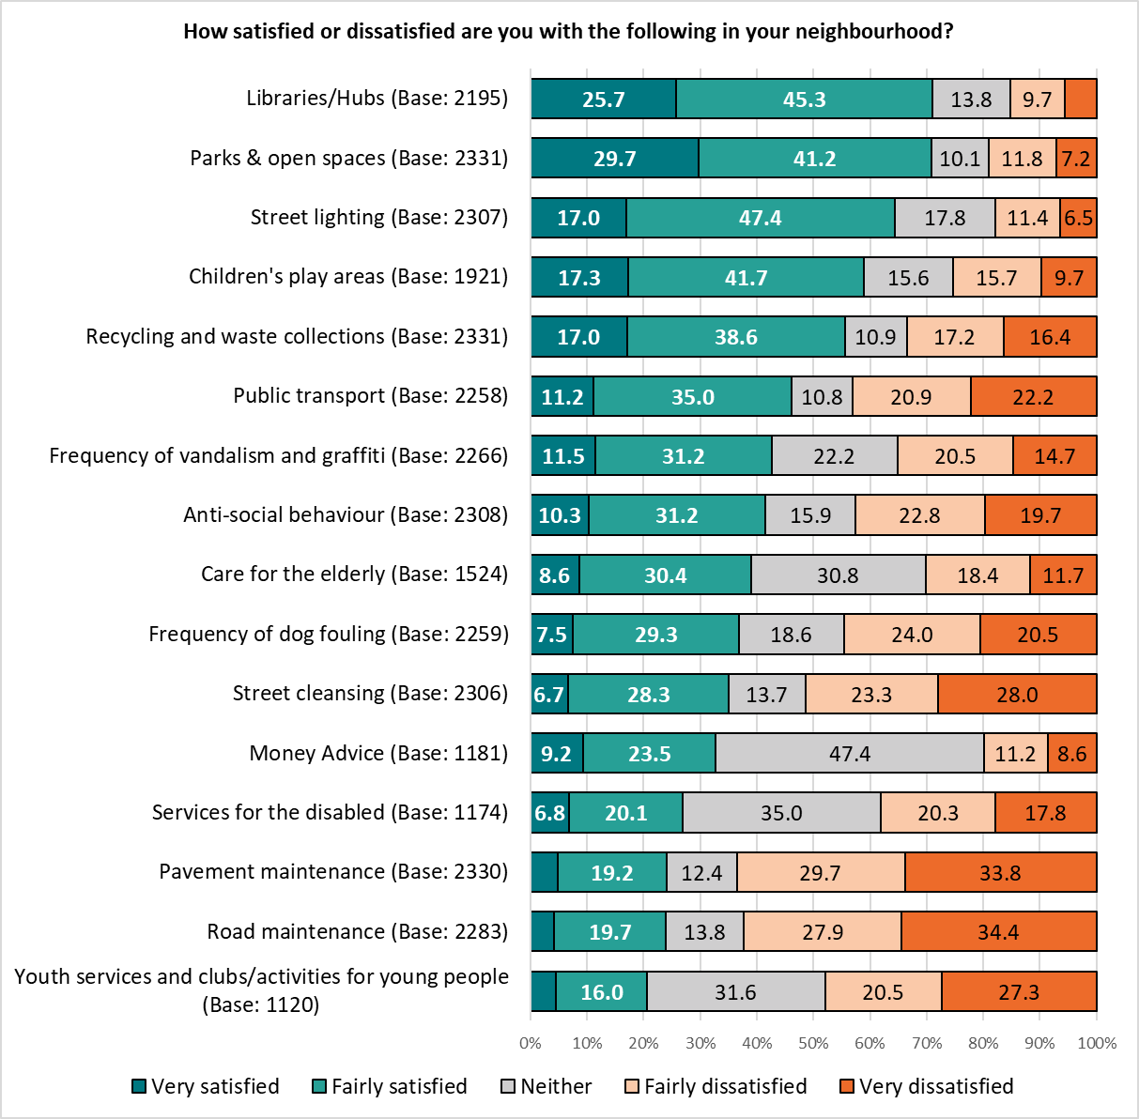
Base sizes shown in brackets; excludes ‘Don’t Know’ responses.

Where trend data is available, the top three services were unchanged from the previous year.
Compared with the previous year, there was an increase in satisfaction for Children’s Play Areas (rising to 59.0%), Recycling & Waste collections (rising to 55.6%) and Public Transport (rising to 46.1%).
There was a drop in satisfaction with Care for the Elderly (39.0%), Frequency of dog fouling (36.9%), Money Advice (32.8%), Services for the Disabled (26.9%) and Pavement Maintenance (24.1%)
 | 2025 | 2024 | 2023 | 2022 | 2021
Libraries/Hubs | 71.0 | 72.1 | 69.2 | 64.4 | 64.1
Parks and open spaces | 70.9 | 70.5 | 72.5 | 74.0 | 74.0
Street lighting | 64.4 | 66.0 | 67.9 | 66.2 | 66.8
Children's play areas | 59.0 | 56.0 | 52.7 | 57.5 | 52.9
Recycling and Waste Collections | 55.6 | 52.2 | 31.8 | 58.6 | -
Public transport | 46.1 | 42.6 | 32.0 | 48.0 | 43.6
Anti-social behaviour | 41.6 | 44.8 | 44.2 | 39.5 | 34.3
Frequency of vandalism and graffiti | 42.7 | 42.7 | 40.2 | 35.3 | 35.8
Care of the elderly | 39.0 | 41.9 | 37.4 | 30.9 | 32.4
Frequency of dog fouling | 36.9 | 39.3 | 35.5 | 30.4 | 35.0
Street cleansing | 35.0 | 36.8 | 33.9 | 37.3 | 39.3
Money Advice | 32.8 | 38.6 | 32.4 | - | -
Services for the disabled | 26.9 | 32.6 | 24.4 | 16.0 | 22.0
Pavement maintenance | 24.1 | 26.6 | 24.9 | 27.1 | 26.4
Road maintenance | 23.9 | 24.9 | 20.6 | 28.8 | 23.2
Youth services and clubs/activities for young people | 20.5 | 22.0 | 16.3 | 14.1 | 14.3
Orange indicates a drop of ±2% describing themselves as satisfied compared with the previous year, teal indicates an increase in satisfaction of ±2%.

Amongst respondents identifying as disabled, satisfaction with services for the disabled fell from 30.0% in 2024 to 21.5%; the level of dissatisfaction rose from 51.8% in 2024 to 57.9%. This group also showed the lowest level of satisfaction with children’s play areas (46.8%), libraries and Hubs (64.2%), parks & open spaces (67.4%), public transport (35.1%), street lighting (56.5%) and street cleansing (31.8%).
Respondents living in the Southern Arc showed the lowest levels of satisfaction with frequency of dog fouling (30.6%) and frequency of vandalism & graffiti (36.2%).
Respondents under the age of 35 were twice as likely to be satisfied with pavement maintenance as those aged 55 or over (40.0% compared with 20.1%), with a similar finding for road maintenance (39.9% compared with 20.1%).
Three of the services listed showed a correlation between satisfaction and level of deprivation, with the more affluent areas showing the highest levels of satisfaction:
% Satisfied | Most Deprived | Least Deprived | Difference
Anti-social behaviour | 26.2 | 62.6 | 36.4
Frequency of vandalism and graffiti | 30.5 | 59.9 | 29.4
Recycling & Waste collections | 50.0 | 65.1 | 15.1

Comments on local services from face-to-face engagement included:

“Children’s parks need more development. There’s nothing in them anymore, for the older children. There might be a slide or a swing…. there needs to be more for young people. Young people don’t go outside, they don’t trust the world.”
(Discussion with older teens in a Youth Group session)

“In Grangetown there’s no parking, so people have no choice. There’s too many people wanting too few spaces, it can get aggressive.”
(Female, 70s, Ethnically Diverse background)

“I am so dissatisfied about the recycling in my area [Cathays] as we have a back lane and there is accessibility for the recycling team to collect but none of them clean the chaos left there. This causes a lot of fly-tipping and it is a not hygienic area.”
(Female, 70s)

“You have to book a tip appointment in advance!”
(Female, 60s, Ethnically Diverse background)

A number of comments were made regarding the efficiency of waste and recycling collections:
“Whitchurch has the worst waste collection. I don’t fill my bag every week, so I put it out once in 3 or 4 weeks. They don’t collect it! So I have to phone, and someone has to come just to get mine! That doesn’t make sense.”
(Female, 70s)
“In Cyprus they have skips dotted around town, every few streets, so there’s no individual house collections. That must save a lot of money!”
(Male, Ethnically Diverse background)
“In Portugal there’s no house collection, there’s an underground bin for the road – you carry your rubbish and recycling there. That is much more efficient.”
(Female, 30s, Ethnically Diverse background)
10. Do you currently volunteer?
Overall, around three in ten respondents (29.3%) said they currently volunteer, on a par with previous findings – this rose to 45.1% amongst Welsh speakers and fell to 25.9% of under 35s.

Base sizes shown in brackets.

There was no correlation with level of deprivation.

Listed below are a number of ways that you could contribute to the wellbeing of your community. Please tell us if you are, or would like to be, involved in each of the following:
Respondents were most likely to already be involved ‘learning more about how to reduce your carbon footprint’ (21.5%) and Community Volunteering (16.4%), repeating the findings of previous surveys.
Of the volunteering opportunities listed, those generating the most interest for future volunteering opportunities were:
- Improving community safety as part of Neighbourhood Watch (20.7%)
- Community Volunteering (17.8%)

A total of 1,034 respondents expressed an interest in getting involved in contributing to the wellbeing of their community, of whom 511 provided contact details for further information to be sent to them. This has been passed to the relevant teams to take further action.
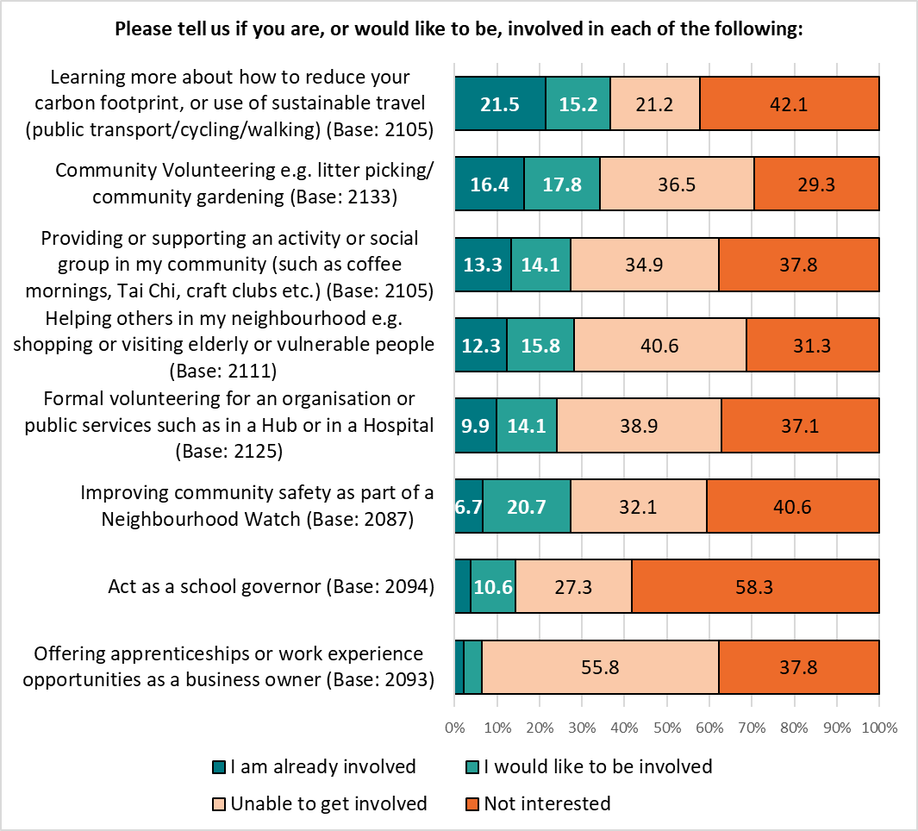Base sizes shown in brackets; excludes ‘Don’t Know’ responses.
Respondents were invited to give details of other volunteering opportunities they would be interested in getting involved with – 145 comments were received, and grouped into themes. The top three themes are shown below, with a full breakdown in Appendix 1.
Theme | No. | % | Example Comments
I can't volunteer now | 21 | 14.5 | - i would if i could but I am disabled  - I am 80 now. Have done most of these things in my life and saw great benefit from them.  - I just don't have time
Environmental | 19 | 13.1 | - Maintaining and improving green spaces.  - Cleaning leaves - i saw a resident sweeping them into marked bags. Also gardening front gardens for those unable to do so
I already volunteer | 18 | 12.4 | - Already volunteer for the City Hospice in Cardiff  - I volunteer with cadet service

Section 3:

Accessing Services

11. How do you prefer to access information about services, events, etc?
Respondents were presented with a range of methods, both digital and non-digital, of accessing information about services, events and so on, and asked which they preferred to use.
The top three preferred means of accessing information – websites (68.7%), email (54.4%) and social media (47.5%) – were (as in the past two years) all digital, with just 4.2% of respondents indicating they ‘don’t want to / can’t access information digitally’. [Note: most respondents completed the survey digitally.]
Two in five (41.5%) of those answering this question indicated a preference for ‘posters/flyers/leaflets in community buildings’ (again reflecting the findings of last year’s survey).
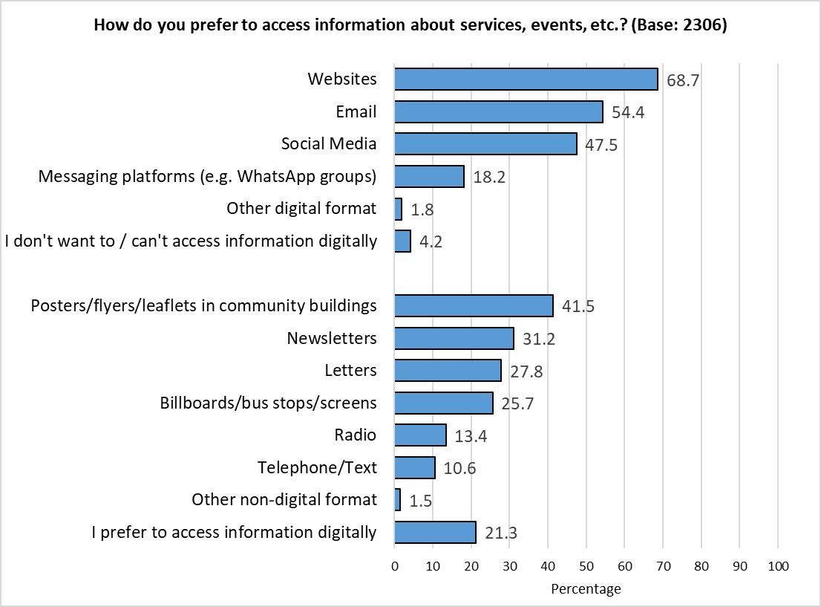
Digital
Non-Digital
Respondents could select multiple options so the total will exceed 100%.
Those answering ‘Other digital format’ were asked to specify how else they would like to access information; 21 responses were received, and grouped into themes:
- Council App (10 responses)
- Social media (6 responses)
- RSS (2 responses)
- Non-digital formats (3 responses)
- BSL (2 responses)
- Mobile phone (1 response)

Those answering ‘Other non-digital format’ were also asked to specify how else they would like to access information; 13 responses were received, and grouped into themes:
- In person (4 responses)
- Posters / newsletters / magazines (4 responses)
- Supermarkets (2 responses)
- Community organisations (1 response)
- Word of mouth (1 response)
- ‘Open to new digital platforms’ (1 response)
Results were generally consistent across the demographic groups analysed, although there were some notable differences:
- Younger respondents were most likely to express an interest in social media (62.7%) or messaging platforms (23.6%). They also reported the highest level of interest in billboards/bus stops/screens (41.4%). However, they were least likely to want to be updated via email (47.7%).
- Older respondents were most likely to want newsletters (35.6%), but showed the lowest levels of interest in letters (23.9%) or in social media (38.8%).
- Those identifying as disabled were most likely to indicate they “don’t want to/can’t access information digitally” (6.6%)
Looking across the deprivation quintiles, there were some correlations:
- Respondents living in the least deprived areas were more likely to express interest Websites (77.0% compared with 63.8% amongst those living in the most deprived areas)
- Those living in the most deprived areas showed the highest levels of interest in social media (55.2% compared with 42.2% amongst those in the least deprived areas), letters (36.2% compared with 20.9% respectively), and telephone / text (18.4% compared with 7.3%).

A full breakdown of results by demographic and level of deprivation is available in Appendix 2.

12. Do you have access to affordable broadband?
Nine out of ten respondents (90.9%) reported they had access to affordable broadband at home, with 8.9% accessing it elsewhere. One in seven (7.1%) reported having no access to affordable broadband. This reflects previous findings.
Respondents could select multiple options so the total will exceed 100%.

This pattern was broadly consistent across the demographic groups analysed. However, younger respondents and those with children in the household were most likely to have access elsewhere (14.9% and 12.3% respectively), whilst those from ethnically diverse backgrounds were twice as likely as average to have no access to broadband (15.4%).
Looking at results by level of deprivation showed just 2.6% of respondents living in the most affluent areas of the city had no access to affordable broadband (down from 5.0% in 2024), compared with 14.1% seen in the most deprived areas (unchanged from last year).
 | All Respondents | Least Deprived | Next Least Deprived | Middle | Next Most Deprived | Most Deprived
Base | 2,274 | 340 | 348 | 279 | 252 | 170
Yes, at home | 90.9 | 96.2 | 96.3 | 91.0 | 90.9 | 83.5
Yes, elsewhere | 8.9 | 9.4 | 8.3 | 7.5 | 10.3 | 6.3
No | 7.1 | 2.6 | 3.2 | 7.9 | 7.1 | 14.1

13. How do you currently access Council Services?
Reflecting the findings of the 2024 survey, most respondents (85.7%) currently accessed council services online. Three in ten (29.6%) accessed services by phone, and almost one in five (17.3%) in person.
Respondents could select multiple options so the total will exceed 100%.

The 44 respondents answering ‘Other’ were asked to give further details – 35 responses were received, and grouped into the following themes:
Theme | No. | % | Example Comments
Don't access services | 9 | 20.5 | - I dont access services as I am not very well informed  - I don't access the councils services. I'm unaware of what they provide that relates to me
Hub | 8 | 18.2 | - At library Hub  - Usually go to the Hub e.g. Digital Team
Letter | 8 | 18.2 | - Letters  - By post
App | 6 | 13.6 | - Cardiff Council App  - App
Email | 4 | 9.1 | - E-mail to book trips to the tip :)
Online | 3 | 6.8 | - Online is the only way !!! Phone goes round in circles.
In person | 2 | 4.5 | - Central library to try to access a person
Someone does it for me | 2 | 4.5 | - My daughter does for me
Misc. | 4 | 9.1 | - How do I? Dont get the info i need  - New to Wales, don't know how it works
Total Responses | 35 | -
Respondents could comment on multiple themes so the total may exceed 100%.
This pattern of response was broadly similar across the demographic and geographic groups analysed, with some notable variations. All groups were most likely to access services online, but:
- Respondents from ethnically diverse backgrounds were least likely to access services online (77.9%)
- Those identifying as disabled were most likely to access services by phone (35.2%), followed by respondents aged 55 or over (33.3%) and women (30.4%).
- Older respondents (15.6%) and men (15.7%) were least likely to access services in person.
% | Base | Online | By phone | In person | Other
All respondents | 2,272 | 85.7 | 29.6 | 17.3 | 2.6
Under 35 | 214 | 80.8 | 23.8 | 26.6 | 3.7
55+ | 902 | 87.5 | 33.3 | 15.6 | 2.4
Female | 882 | 84.0 | 30.4 | 20.2 | 2.8
Male | 690 | 91.7 | 25.9 | 15.7 | 1.3
Ethnically Diverse | 299 | 77.9 | 28.8 | 27.4 | 2.0
Identify as disabled | 281 | 83.6 | 35.2 | 20.6 | 3.2
Welsh speaker | 208 | 89.9 | 27.4 | 17.3 | 1.0
Southern Arc | 538 | 83.5 | 27.9 | 23.2 | 2.6
Children in household | 330 | 87.9 | 25.8 | 19.4 | 1.5
LGBTQ+ | 160 | 88.1 | 24.4 | 25.0 | 4.4
Respondents could select multiple options so the total will exceed 100%.

Respondents living in the more deprived areas were twice as likely as those in the most affluent areas to access services in person.
% | Base | Online | By phone | In person | Other
All Respondents | 2,272 | 85.7 | 29.6 | 17.3 | 2.6
Least Deprived | 341 | 91.2 | 30.8 | 12.6 | 1.5
Next Least Deprived | 346 | 93.1 | 22.0 | 13.3 | 2.3
Middle | 282 | 87.9 | 25.9 | 19.5 | 2.5
Next Most Deprived | 250 | 86.0 | 28.0 | 26.8 | 1.6
Most Deprived | 173 | 73.4 | 37.6 | 26.0 | 4.6

14. Please indicate the extent to which you agree or disagree with the below statements:
Three in five respondents (58.8%) agreed that “Council staff are approachable and friendly”; two in five agreed that “Contacting the Council is simple” and “Accessing up to date information about Council services is easy” (44.0% and 43.5% respectively). This reflects the findings from the 2024 survey.
Base sizes shown in brackets; excludes ‘Don’t Know’ responses.

Those who disagreed that ‘Contacting the Council is simple’ were asked to explain why they had said this; 456 comments were received, and grouped into themes. The top three are shown below, with a full list in Appendix 3.
Theme | No. | % | Example Comments
Telephone Wait Times / Calls Not Answered | 205 | 45.0 | - Wrong numbers listed, no one answering, services closed  - The length of time spent waiting for the correct person to talk to  - Don’t always answer the phone  - It’s fine if the answer is online - anything that requires a telephone call is a pain  - You are very much discouraged from using the phone service yet sometimes C2C is the best way to ask complicated queries. The wait time is terrible
Difficulty Reaching Correct Department / Being Passed Around | 103 | 22.6 | - Finding who to contact and navigating so many processes is a challenge  - Some departments are uncontactable, messages are not returned  - No one ever knows which department is responsible for what and you get transferred around the whole council and then nothing is done  - It’s not very often I need to contact the Council. When I do it’s impossible to speak to an officer who has knowledge and / or responsibility to deal with my query.
Website Difficult to Navigate / Hard to Find Information | 99 | 21.7 | - You have to go to to many pages to get to the right one  - Difficult to report too as website info changes and council reduce access to areas of concern by removing links to obviously reduce complaints  - Website non intuitive

Respondents identifying as disabled were least likely to agree that
- ‘Contacting the Council is simple’ (36.2%)
- ‘Accessing up to date information about Council services is easy’ (28.8%)
- ‘Council staff are approachable and friendly’ (54.4%).
Base sizes shown in brackets; excludes ‘Don’t Know’ responses.

When thinking about housing and access to services, a respondent told the Engagement Officers: “I am a single mother, in temporary accommodation for 16 years, my mother who is living with me has a mobility problem. I don't know what this system looks like.”
Base sizes shown in brackets; excludes ‘Don’t Know’ responses.

There was a general consistency of opinion across the deprivation quintiles for each of the three statements.

Section 4:

Hubs & Libraries

15. What services delivered within your local Hub/Library do you find most helpful to you?
Respondents were given a list of services delivered within their local Hub/library, and asked to indicate which they found most helpful.
Of the services listed, the two most helpful were unchanged from the previous year - ‘Book loan’, selected by 42.1% of respondents, followed by ‘community events’ (15.7%). ‘Adult learning’ was placed third, with 14.8%, all reflecting the findings of the 2024 survey.
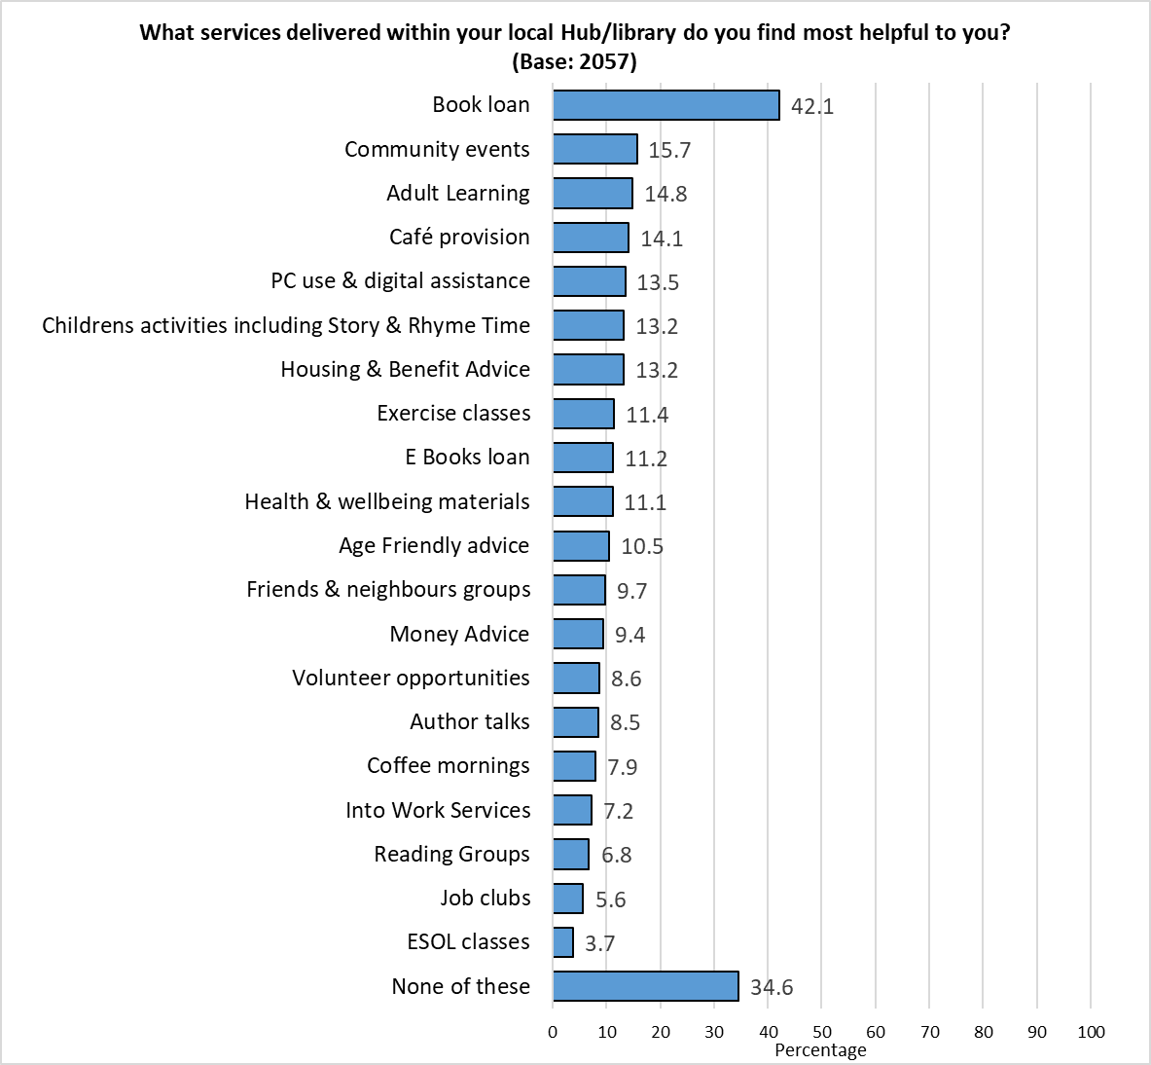 Respondents could select multiple options so the total will exceed 100%.

Respondents were invited to put forward for other services at their local Hubs/libraries they found to be helpful; 350 comments were received, and grouped into themes. The top three are shown below, with a full list in Appendix 4.
Theme | No. | % | Example Comments
There is no local Hub / Library / Access Issues | 66 | 18.9 | - We don't have a local hub  - No local hub or library nearby. But would like one in the community.  - Closest library (and easiest to travel to) is Cardiff centre - not exactly my local community!
Don't use | 50 | 14.3 | - Dont use it, work long hours  - I've never been to my library because it's very small and quiet. I was hoping for somewhere to work  - I dont use the hubs as they are too far away from where I live
Better Facilities - Seating - Café - Toilets - meeting / Quiet / Safe space | 22 | 6.3 | - Warm cafe for people who can't afford heating  - I think some could do with a better "chill zone" where young people can hang out.  - Safe space (domestic violence)

There were some differences by demographic and level of deprivation:
- Welsh speakers were most likely to find book loans (61.4%), community events (27.7%), café provision (22.8%), friends and neighbours’ groups (19.3%) and PC use and digital assistance (19.3%) helpful.
- Under 35s were most likely to find Into Work Services helpful (16.3%).
- Respondents with children in their household were most likely to cite children’s activities (33.7%).
- Those identifying as disabled were most likely to find housing and benefit advice (22.1%) helpful.
- Respondents from an ethnically diverse background were most likely to find adult learning (28.3%), exercise classes (18.0%), money advice (16.9%), coffee mornings (13.2%), job clubs (11.8%) and ESOL classes (9.2%) helpful. They were least likely to state that ‘none’ of the services listed were helpful (21.0%).
- Males were most likely to state they found ‘none’ of the services listed helpful (40.2%).

The following services correlated with level of deprivation, with those living in the most deprived areas finding them to be more helpful:
 | Most Deprived | Least Deprived
Base | 160 | 331
Housing & Benefit Advice | 24.4 | 4.8
PC use & digital assistance | 20.0 | 10.6
Café provision | 18.1 | 9.7
Money Advice | 16.3 | 4.2
Into Work Services | 13.1 | 2.4
Exercise classes | 15.6 | 9.7
ESOL classes | 10.0 | 1.5

A full breakdown is available in Appendix 5.

16. What activities and events would you like to see in your Hub/library?
Respondents were given a new list of services and asked to indicate which they would like to see in their local Hub or Library.
At least one in seven respondents expressed an interest in each of the services listed.
The most popular were fitness activities (e.g. walking groups) (26.9%) and Hobby & Interest groups (26.5%).
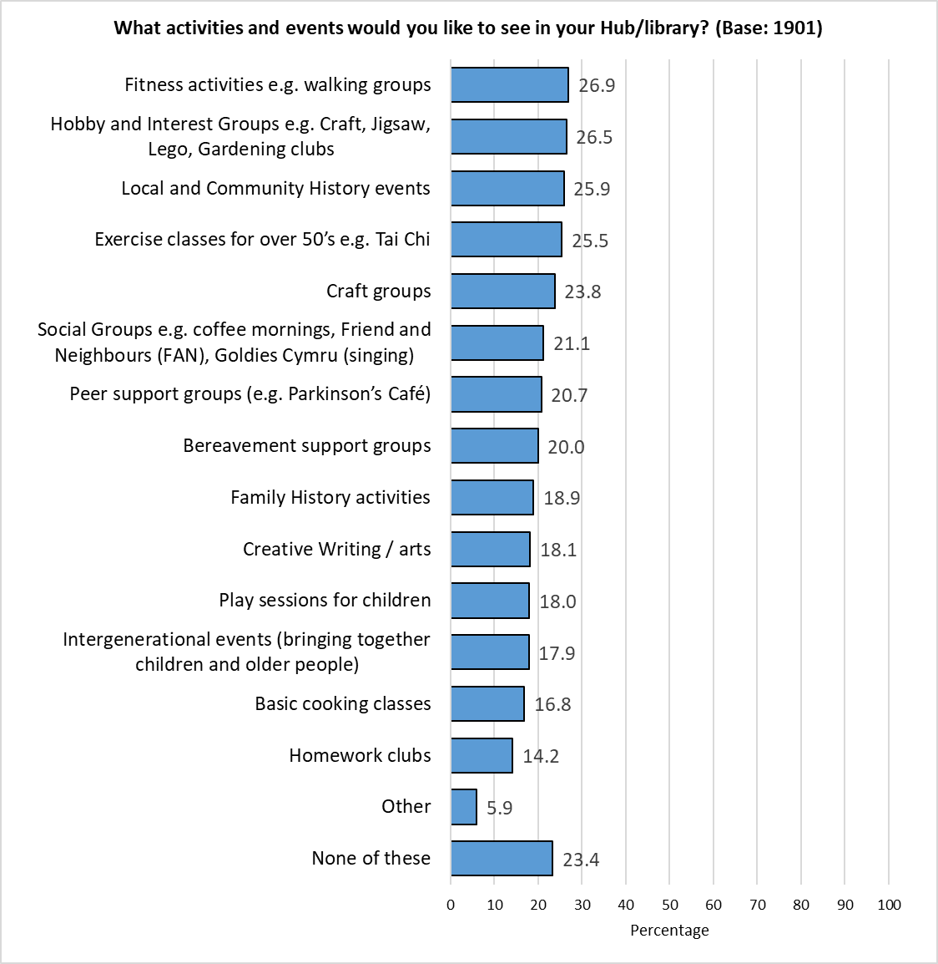
Respondents could select multiple options so the total will exceed 100%

Respondents were invited to put forward suggestions for other activities or events they would like to see in Hubs/libraries; 88 comments were received, and grouped into themes. The top three are shown below, with a full list in Appendix 6.
Theme | No. | % | Example Comments
Learning, Skills & Educational Opportunities | 28 | 31.8 | - Opportunity to learn about democrcy, active citizenship, sustainability  - Evening classes, evening exercise classes
Health, Wellbeing & Inclusion | 23 | 26.1 | - Local unpaid carers groups  - Mental Wellbeing Groups, Neurodiversity Support Network
Arts, Culture & Creative Activities | 22 | 25.0 | - Cake decorating classes  - Musical activities

There were some differences across the demographic and geographic groups analysed:
- Respondents under the age of 35 showed the highest levels of interest in hobby & interest groups (46.1%), craft groups (41.9%), creative writing / arts (37.7%), social groups such as coffee mornings (33.5%), basic cooking classes (31.4%), intergenerational events (30.4%), and homework clubs (27.7%).
- Those with children in the household were most interested in play sessions for children (36.4%).
- Welsh speakers were most likely to express interest in local and community history events (39.1%) and family history activities (24.0%).
- Men were most likely to indicate they were not interested in any of the services listed (31.7%)

Just one of the services listed showed a correlation with level of deprivation – those living in the most deprived areas were more than twice as likely to be interested in basic cooking classes than those in the least deprived areas (25.0% compared with 9.7% respectively).

A full breakdown of results by demographic and level of deprivation can be found in Appendix 7.

17. How would you like us to tell you about events that are happening in your Hub/ library? (e.g. technology events, book events)
Respondents were given a list of options, and asked how they would like to be told about events in their local Hub/library.
Almost two-thirds (62.9%) of respondents chose email, almost double the second most popular option, Facebook (38.7%), with just over a third (37.1%) wanting information via posters in Hubs/libraries. This reflects the findings of previous surveys.
Around one in ten respondents (9.6%) indicated that they didn’t want information from any of the sources listed.

Those answering ‘Other’ were asked how they would like to be told about events; 105 comments were received and grouped into themes. The top three are shown below, with a full list available in Appendix 8.
Theme | No. | % | Example Comments
Community Flyers / Leaflets / Posters / Newsletters | 40 | 38.1 | - Posters in local shops  - A weather-proof poster board could perhaps be erected outside the library announcing events.  - mail drop; or printed leaflet in books being borrowed
Council Website / App | 30 | 28.6 | - Council App or website  - website /app
Something in the post | 19 | 18.1 | - Leaflets through doors  - Maybe a news letter posted to home as I wouldnt see it anywhere else

Whilst there was generally a consensus of opinion, there were some notable differences between demographic groups:
- Younger respondents were most interested in hearing about events through Instagram (44.7%), through school or college (18.0%), YouTube (12.1%), X (formerly Twitter (11.2%) and Snapchat (4.4%)
- Welsh speakers were most likely to want to be informed by email (72.3%)
- Respondents with children in their household wanted to hear about events through Facebook (48.6%)
- Those from ethnically diverse backgrounds were most likely to choose to be updated via WhatsApp (22.5%)

There was a broad consensus of opinion across the deprivation quintiles.

18. Cardiff Council Hubs and Libraries are developing Neurodivergent friendly activities and groups. What neurodivergent friendly activities would you like to access?
Of the activities listed, the most popular were Arts & Crafts (20.2%), fitness classes15.8%) and women’s wellbeing (15.5%).
Respondents who identify as neurodivergent, or had a member of their household who did, showed higher levels of interest in each of the activities listed, although the pattern of interest in activities did not change. The proportion of this group stating they were not interested in any of the activities was less than half for the total sample (26.9% compared with 55.4%).

Those answering ‘Other’ were asked to say what other neurodivergent friendly activities they would like to see; 107 responses were received and grouped into themes. The top three themes are shown below, with a full breakdown in Appendix 9.
Theme | No. | % | Example Comments
Not neurodivergent | 35 | 85.4 | - I don't need these, but it is a good idea  - I don't know how useful any of these would be. I have no experience of neurodivergent people in Cardiff  - Don't understand neurodivergent
Views on Activities | 16 | 39.0 | - Not applicable to me, but they should be available  - I'm neurodiverse myself, but I honestly from experience have found things like the above to be incredibly condescending; I'm neurodiverse but I'm not a child and not incapable and hate the idea of being infantilised or considered as someone that needs "support" for everything. Show me something where the people are going to speak to me like a fully functioning adult with a fulltime job, a home that I run independently, a long term partner, hobbies and a job that wasn't thrown at me to meet a quota or get me off a list but who is just struggling with some elements of neurodiversity and I'd be curious. I know that the previous puts me in the minority as a neurodiverse adult, the stats prove this, but its just how I feel.
Social, Creative & Community Activities | 15 | 36.6 | - Play groups for young, sports, eg. Bocchia, for adults.  - Modelling

Looking at the results by demographic group showed interest in the activities listed was highest amongst under 35s (66.1%) and respondents from an ethnically diverse background (63.2%).
It was lowest amongst respondents aged 55 or over (33.6%) and men (33.8%).

Whilst there was not a direct correlation, respondents living in the more deprived areas of the city showed a higher level of interest in at least one of the activities listed (63.0% compared with 37.5% of those in the least deprived areas).

A full breakdown of results by demographic and level of deprivation can be found in Appendix 10.

Section 5:

Cost of Living

19. In the last 6 months, have you missed paying rent or mortgage payments?
Overall, 3.2% of respondents reported missing rent or mortgage payments over the past 6 months, down from the 5.7% recorded in the previous year.

The proportion of respondents living in the most deprived areas who reported missing rent or mortgage payments fell by 60%, from 10.8% in 2024 to 4.3% in 2025.
Missed Payments | 2025 | 2024 | 2023 | 2022
Most deprived | 4.3 | 10.8 | 9.3 | 5.3
Next most deprived | 5.1 | 6.4 | 4.3 | 3.4
Middle | 2.0 | 4.6 | 2.9 | 3.2
Next least deprived | 2.8 | 4.1 | 3.0 | 2.3
Least deprived | 0.9 | 0.7 | 1.1 | 0.5
All respondents | 3.2 | 5.7 | 3.7 | 3.1

There was consistency across the demographic groups analysed, with at least 93% of each group analysed reporting no missed payments.

20. In the last six months, have you or anyone else in your household done any of the following because you couldn't AFFORD food:
The proportion of respondents reporting having undertaken each of the actions listed below fell slightly compared with the previous year:
% | 2025 | 2024 | 2023 | 2022 | 2021
Had smaller meals than usual, or skipped meals | 13.7 | 15.9 | 16.2 | 15.6 | 9.6
Missed meals to afford to pay your bills | 5.9 | 8.6 | 7.5 | 5.9 | -
Been hungry but not eaten | 6.6 | 7.1 | 6.2 | 5.8 | 5.2
Not eaten for a whole day | 3.2 | 4.2 | 3.4 | 3.5 | 2.5
Received food from a food bank or charity | 3.6 | 4.4 | 2.5 | 2.6 | 1.8

Around three in ten respondents identifying as disabled (33.5%) or under the age of 35 (31.0%) had undertaken at least one of the actions listed because they could not afford food.
Welsh speakers (88.9%) and those aged 55 or over (87.6%) were most likely not to have taken any of the actions listed.
One in ten respondents under the age of 35 (11.1%) stated they had ‘not eaten for a whole day’. Respondents identifying as disabled were around twice as likely as average to receive food from a food bank (6.8% compared with 3.6% respectively.

There was a correlation with those unable to afford food and the level of deprivation, although the proportion of respondents living in the most deprived areas taking action because they were unable to afford food was at the lowest level for several years:
At least one of the actions listed | Most Deprived | Next Most Deprived | Middle | Next Least Deprived | Least Deprived | All Respondents
2025 | 29.6 | 22.7 | 18.4 | 13.3 | 9.0 | 18.7
2024 | 41.3 | 29.1 | 17.8 | 18.2 | 8.7 | 21.1
2023 | 36.8 | 21.8 | 18.1 | 15.3 | 9.0 | 20.1

 | 2025 |  | 2024
 | Most deprived | Least deprived | Most deprived | Least deprived
Had smaller meals than usual, or skipped meals | 16.6 | 7.2 | 29.3 | 6.6
Missed meals to afford to pay your bills | 12.4 | 3.3 | 20.0 | 2.6
Been hungry but not eaten | 9.5 | 3.0 | 12.9 | 2.9
Not eaten for a whole day | 5.3 | 0.9 | 9.8 | 0.3
Received food from a food bank or charity | 8.3 | 0.6 | 12.0 | 1.1

A full breakdown of these questions broken down by demographics is available in Appendix 11.

In the last 6 months, have you or anyone in your household…?
Almost two-thirds of those responding to this question (63.0%, up slightly from 58.6% in 2024) reported they had not taken any steps to deal with increasing energy costs. A third (33.5%) had ‘purposely not put the heating on because of the cost’, and around one in ten respondents (11.6%) had ‘struggled to pay gas and/or electric bills’.
 | No. | %
Purposely not put the heating on because of the cost | 707 | 33.5
Struggled to pay gas/electric bills | 244 | 11.6
Applied for support to pay for gas/electric | 47 | 2.2
Been cut off from the electricity/gas supply | 11 | 0.5
Received fuel vouchers from a charity | 10 | 0.5
None of these | 1330 | 63.0
Total Respondents | 1,330 | -
Respondents could select multiple options so the total will exceed 100%.

Around seven in ten men (71.7%), Welsh speakers (70.7%) and respondents aged 55 or over (69.7%) had not undertaken any of the actions listed regarding management of energy costs, reflecting the findings of previous surveys.
Amongst the demographic groups analysed, those most impacted by increasing energy costs were respondents identifying as disabled (45.4% having taken no action) and those under the age of 35 (50.5% having taken no action).

There was a clear correlation with level of deprivation, those living in the most deprived areas were least likely to state they had done none of the options listed, with those in the least deprived areas most likely to have taken no action, reflecting previous findings.

A full breakdown of these questions broken down by demographics is available in Appendix 12.

How will you/your household cope with the expected increase in energy costs this winter?
Respondents were given a list of options, and asked how they planned to cope with the expected increase in energy costs.
Two in five respondents (40.4%) reported they ‘can afford the increase in energy cost’, broadly reflecting the findings of the previous year.
 | No. | %
Significantly cut down on heating | 904 | 43.8
I can afford the increase in energy cost | 835 | 40.4
Not use the heating | 294 | 14.2
Cut out other essentials such as food | 182 | 8.8
Borrow money/pay on credit card | 92 | 4.5
Other | 138 | 6.7
Total Respondents | 2,065 | -
Respondents could select multiple options so the total will exceed 100%.

The proportion of respondents stating they would ‘significantly cut down on heating’ continued to fall:
Significantly cut down on heating | %
2025 | 43.8
2024 | 46.6
2023 | 54.5
2022 | 62.5

Those answering ‘Other’ were asked to say how they planned to cope with the increase in energy costs; 107 responses were received and grouped into themes. The top three themes are shown below, with a full breakdown in Appendix 13.
Theme | No. | % | Example Comments
Reducing Heating Use | 40 | 37.4 | - Reduce temperatures  - Turn on heating when it is very cold, eg. 12oC or below  - Turn the thermostat down (again)
Budgeting, Cutting Non-Essential Spending & Financial Sacrifice | 23 | 21.5 | - By saving up money and being on budget  - I save during the 'good times', to go over the bad times  - Change food buying - seek cheaper alternatives
Wearing More / Warmer Clothing | 20 | 18.7 | - put on extra clothes  - Put a thicker pullover on.  - Wear more layers / bed earlier
Respondents identifying as disabled were most likely to report they would ‘significantly cut down on heating’ (51.3%), and were least likely to feel they ‘can afford the increase in energy cost’ (26.5%), repeating previous findings.
Respondents aged 55 or over were notably more likely than those under the age of 35 to say they can ‘afford the increase in energy cost’ (49.3% compared with 31.6% respectively); the older group were less likely than their younger counterparts to ‘not use the heating (9.6% compared with 22.8% respectively), or ‘borrow money or pay on a credit card’ (1.6% compared with 13.6% respectively).
 | Base | Not use the heating | Significantly cut down on heating | Cut out other essentials such as food | Borrow money/ pay on credit card | I can afford the increase in energy cost
Identify as disabled | 279 | 21.5 | 51.3 | 14.0 | 9.0 | 26.5
Children in household | 320 | 14.1 | 47.5 | 9.4 | 7.5 | 34.1
Southern Arc | 521 | 15.2 | 46.3 | 8.6 | 6.9 | 37.2
LGBTQ+ | 159 | 16.4 | 45.9 | 8.8 | 11.3 | 36.5
Under 35 | 206 | 22.8 | 45.1 | 13.1 | 13.6 | 31.6
Female | 858 | 13.3 | 45.3 | 7.8 | 4.8 | 37.2
All respondents | 2065 | 14.2 | 43.8 | 8.8 | 4.5 | 40.4
Ethnically Diverse | 273 | 15.0 | 43.6 | 10.3 | 8.8 | 33.7
55+ | 888 | 9.6 | 39.1 | 5.3 | 1.6 | 49.3
Welsh speaker | 207 | 12.1 | 37.7 | 8.7 | 5.3 | 49.8
Male | 670 | 9.7 | 35.5 | 7.8 | 3.4 | 53.4

There were correlations between respondents stating they would take action to cope with the expected increase in energy costs and level of deprivation, with those living in the most deprived areas of the city most likely to not use or cut down use of the heating, or cut out other essentials; they were less likely to feel they could afford the increase:
 | Base | Not use the heating | Significantly cut down on heating | Cut out other essentials such as food | Borrow money/ pay on credit card | I can afford the increase in energy cost
All Respondents | 2065 | 14.2 | 43.8 | 8.8 | 4.5 | 40.4
Least Deprived | 337 | 5.3 | 38.9 | 4.7 | 1.5 | 54.0
Next Least Deprived | 342 | 8.8 | 37.7 | 6.7 | 4.7 | 48.5
Middle | 271 | 11.8 | 39.9 | 7.4 | 4.4 | 43.2
Next Most Deprived | 243 | 17.7 | 47.3 | 11.5 | 7.8 | 32.5
Most Deprived | 163 | 21.5 | 45.4 | 11.0 | 6.7 | 34.4

21. Are you aware that the Council offers help with benefits and income, help with debts, Into Work and housing advice?
Awareness of this service was broadly similar to that seen in 2024, with 59.0% of respondents aware of at least one of the options listed.
Awareness of support in Hubs/libraries was highest (52.5%), followed by the Cardiff Money Advice website (19.0%), and Adviceline (10.1%), reflecting the pattern seen in previous years.
Respondents could select multiple options so the total will exceed 100%.

Those answering ‘Other’ were asked to give further details – 35 comments were received:
- Not eligible (11 comments)
- Generally aware (8 responses)
- Aware advice is available but unsure how to access it (2 comments)
- Did not help me (2 comments)
- advice line (1 comment)
- Benefits system is traumatising, stressful and impossible to get off without being worse off. (1 comment)
- Family Help- i previously worked for them and currently still work for CCC (1 comment)
- Food Banks (1 comment)
- Get rid of all these services and reduce my council tax, I old then afford the bills (1 comment)
- I find out I can get support from youth services. (1 comment)
- ILS visits (1 comment)
- Into work team, housing options centre (1 comment)
- Other agencies and charities also offer support but people often not given choice (1 comment)
- The support is so timely, limited and it takes hours and some times weeks to access. (1 comment)

Awareness of this Advice Service was broadly consistent across the demographic groups analysed, with those living in the Southern Arc of the city showing the highest level of awareness:
 | Base | Yes, in Hubs / Libraries | Yes, at the website | Yes, the Adviceline | Welfare Liaison Team | Help with debts | Other | No
Southern Arc | 516 | 59.9 | 25.0 | 13.8 | 9.1 | 7.0 | 1.7 | 34.5
Female | 839 | 58.2 | 20.1 | 10.3 | 6.3 | 5.6 | 2.4 | 35.6
Children in Household | 317 | 56.2 | 18.3 | 9.1 | 6.0 | 6.0 | 2.2 | 38.5
Ethnically Diverse | 264 | 55.7 | 22.3 | 13.6 | 8.7 | 7.6 | 3.8 | 33.3
Identify as disabled | 270 | 55.6 | 17.4 | 10.4 | 5.2 | 5.2 | 4.1 | 38.1
LGBTQ+ | 160 | 54.4 | 20.6 | 8.8 | 4.4 | 4.4 | 3.8 | 40.0
55+ | 869 | 53.2 | 17.7 | 10.5 | 5.4 | 5.5 | 2.1 | 40.9
All respondents | 2048 | 52.5 | 19.0 | 10.1 | 5.7 | 5.9 | 2.5 | 41.0
Under 35 | 209 | 50.2 | 21.5 | 12.0 | 7.2 | 9.1 | 4.8 | 41.6
Welsh speaker | 205 | 49.8 | 16.6 | 8.3 | 2.4 | 2.4 | 3.4 | 43.4
Male | 676 | 49.0 | 18.8 | 11.5 | 6.7 | 6.8 | 2.8 | 44.1

Awareness of the advice service was higher amongst those living in deprived areas of the city:
 | Base | Yes, in Hubs / Libraries | Yes, at the website | Yes, the Adviceline | Welfare Liaison Team | Help with debts | Other | No
Most deprived | 165 | 66.7 | 29.1 | 15.8 | 11.5 | 5.5 | 1.8 | 29.1
Next most deprived | 241 | 61.0 | 25.3 | 13.3 | 10.4 | 10.8 | 2.5 | 32.0
Middle | 267 | 52.8 | 19.9 | 10.1 | 6.0 | 6.0 | 2.6 | 40.1
Next least deprived | 341 | 48.4 | 15.2 | 8.5 | 3.8 | 4.7 | 2.3 | 44.3
Least deprived | 331 | 50.5 | 18.1 | 10.3 | 5.1 | 5.1 | 2.1 | 44.1
All respondents | 2048 | 52.5 | 19.0 | 10.1 | 5.7 | 5.9 | 2.5 | 41.0

22. Which of the following statements regarding advice on money management, debt, benefits, Into Work or housing advice applies to you?
The proportion of respondents stating they have accessed advice in the past fell from 23.5% in 2024 to 17.9%.
Three in ten (30.3%) felt they may need advice in the future, down slightly from 36.7% in last year’s survey.
Base sizes shown in brackets.
Respondents identifying as disabled and those from an ethnically diverse background were most likely to have sought advice in the past (36.7% and 28.4% respectively). Along with under 35s, they were also most likely to expect to do so in the future:
 | Have sought advice in the past |  |  | May seek advice in the future
 | 2025 | 2024 | 2023 | 2025 | 2024 | 2023
Identify as disabled | 37.6 | 38.7 | 31.5 | 51.6 | 59.7 | 30.1
Ethnically Diverse | 28.4 | 35.6 | 24.9 | 50.0 | 57.1 | 33.5
LGBTQ+ | 24.7 | 31.5 | 26.8 | 47.2 | 43.8 | 28.4
Southern Arc | 23.8 | 31.8 | 21.4 | 38.1 | 48.9 | 22.4
Female | 21.1 | 26.3 | 19.4 | 36.0 | 39.2 | 19.7
Children in Household | 20.3 | 28.9 | 18.8 | 41.7 | 44.9 | 23.9
Under 35 | 18.6 | 29.4 | 22.7 | 51.2 | 54.3 | 28.0
All respondents | 17.9 | 23.5 | 17.0 | 30.3 | 36.7 | 18.1
55+ | 15.9 | 18.6 | 14.7 | 22.6 | 27.6 | 14.0
Male | 13.9 | 20.8 | 11.8 | 22.2 | 32.1 | 14.8
Welsh speaker | 12.7 | 22.0 | 14.9 | 28.7 | 31.0 | 12.8

Respondents living in the most deprived areas were almost four times more likely than those in the least deprived areas to have sought advice on money management, debt, benefits, Into Work or housing advice (35.2% compared with 10.4% respectively), and more than twice as likely to expect to seek advice in the future (48.9% compared with 19.0% respectively).
` | Have sought advice in the past |  |  | May seek advice in the future
 | 2025 | 2024 | 2023 | 2025 | 2024 | 2023
Most deprived | 35.2 | 39.8 | 32.5 | 48.9 | 59.1 | 31.3
Least deprived | 10.4 | 10.9 | 8.9 | 19.0 | 23.5 | 10.6
Difference | 24.8 | 28.9 | 23.6 | 30.0 | 35.6 | 20.7
Note – Rounding errors account for any apparent miscalculations

23. If you are State Pension age and over, do you currently claim Pension Credit?
Excluding responses from those indicating they were not of State Pension age, one in fourteen (7.6%) stated they currently claimed Pension Credit, reflecting previous findings.

Amongst respondents of State Pension age, those identifying as disabled were most likely to claim Pension Credit (14.8%), followed by those from an ethnically diverse background (10.1%).
Caution should be taken with small base sizes.

Whilst there was not a direct correlation with level of deprivation, residents in the most deprived areas of the city were around four times more likely to claim Pension credit than those in the most affluent areas (19.4% compared with 4.6% respectively).
Caution should be taken with small base sizes

Why don't you claim Pension Credit?
Those who did not currently claim Pension Credit were asked why they did not claim, selecting options from a provided list, or giving their own reasons.
Three in five (59.2%) did not think they were eligible, almost a quarter (23.9%) felt they didn’t need the extra financial help, and just under one in ten (9.1%) applied, but were not eligible.

Those answering ‘Other’ were asked to explain why, 27 responses were received:
- Income too high to qualify (12 comments)
- I know I’m not eligible (10 comments)
- Not the right age (3 comments)
- I didn't know that I could. I thought it is means texted. Can you do so if you get pension?? (1 comment)
- My business is private (1 comment)
- Studying the paperwork! (1 comment)

Selected demographic groups were analysed (those with small base sizes were excluded), with results broadly consistent across these groups.
Respondents identifying as disabled were notably less likely to state: “I don’t need the extra financial help” (11.3% compared with 23.9% of all respondents).
% | All respondents | 55+ | Female | Male | Identify as disabled | Southern Arc
Base | 682 | 474 | 232 | 259 | 80 | 105
I applied and was not eligible | 9.1 | 8.0 | 9.1 | 5.8 | 16.3 | 11.4
I don’t think I’m eligible | 59.2 | 63.1 | 60.8 | 64.5 | 61.3 | 64.8
I don’t need the extra financial help | 23.9 | 26.8 | 24.6 | 27.8 | 11.3 | 21.9
I don’t want to claim Pension Credit | 4.1 | 4.0 | 3.4 | 4.6 | 1.3 | 1.0
I don’t know how to apply | 2.8 | 2.5 | 2.6 | 2.3 | 7.5 | 5.7
I have not got around to it | 1.5 | 0.8 | 1.7 | 0.4 | 2.5 | 1.9
I do not know what Pension Credit is | 5.0 | 4.4 | 4.7 | 3.9 | 7.5 | 7.6
Other | 6.5 | 4.0 | 4.3 | 5.8 | 3.8 | 2.9

The proportion of respondents who had applied for Pension Credit but were not eligible to receive it correlated with level of deprivation, with those living in the more deprived areas notably more likely to give this answer than those in more affluent areas.
Those living in the most affluent quintile of the city were more likely to state that they didn’t need the extra financial help (30.8%).
% | All Respondents | Least Deprived | Next Least Deprived | Middle | Next Most Deprived | Most Deprived
Base | 682 | 159 | 117 | 74 | 46 | 20
I applied and was not eligible | 9.1 | 5.0 | 5.1 | 9.5 | 13.0 | 25.0
I don’t think I’m eligible | 59.2 | 64.8 | 68.4 | 64.9 | 56.5 | 55.0
I don’t need the extra financial help | 23.9 | 30.8 | 22.2 | 23.0 | 19.6 | 15.0
I don’t want to claim Pension Credit | 4.1 | 4.4 | 6.0 | 2.7 | 0.0 | 5.0
I don’t know how to apply | 2.8 | 2.5 | 0.9 | 2.7 | 8.7 | 0.0
I have not got around to it | 1.5 | 0.0 | 0.9 | 1.4 | 0.0 | 10.0
I do not know what Pension Credit is | 5.0 | 3.8 | 4.3 | 1.4 | 13.0 | 5.0
Other | 6.5 | 5.0 | 5.1 | 4.1 | 8.7 | 5.0
Caution should be taken with small base sizes
Pension Credit tops up weekly income to help with living costs, for people over State Pension age and on a low income. The average Pension Credit award is worth over £3,900 per year and opens doors to other support, including the Winter Fuel Payment, help with housings, council tax and heating bills.

Do you, or does anyone in your household, need support to claim Pension Credit?

Overall, one in 20 respondents (4.8%) stated they, or someone in their household, needed support to claim Pension Credit (down from 6.8% in 2024).
Those identifying as disabled were most likely to need support (10.7%).

Those living in the most deprived areas of the city were most likely to need support to claim Pension Credit (15.0%, compared with 5.1% of those in the least deprived areas.

Section 6:

Housing

24. To what extent do you agree that you have access to good quality housing?
Around three-quarters of respondents (74.0%) agreed they had access to good quality housing, up slightly from the 70.7% recorded in 2024.
Respondents aged 55 or over and Welsh speakers were most likely to agree (81.2% and 81.1% respectively, up from 77.1% and 76.9% respectively).
Respondents under the age of 35 were least likely to agree (61.4%).
Base sizes shown in brackets; excludes ‘Don’t Know’ responses.

Whilst those living in the least deprived areas of the city were most likely to agree with this statement, the proportion of those living in the most deprived areas agreeing rose from 50.8% in 2024 to 68.8%; the proportion disagreeing fell from 16.7% to 11.7%.

Base sizes shown in brackets; excludes ‘Don’t Know’ responses.
Over the last 12 months, has your housing situation:
The majority of respondents (86.0%) stated there had not been a change in their housing situation over the past year, reflecting previous surveys.
As in previous surveys, respondents under the age of 35 were most likely to report a change in their circumstance, with one in six (15.4%) stating it had improved, but almost one in ten (10.7%) that it had declined (down from 18.2% in 2024). Those aged 55 or over were least likely to report a change in their housing situation (91.2%).
Respondents identifying as disabled were most likely to report a decline in their housing situation (13.8%).
Base sizes shown in brackets; excludes ‘Don’t Know’ responses.

Respondents living in the two most deprived quintiles were most likely to report a change in their housing situation over the last 12 months.
Base sizes shown in brackets; excludes ‘Don’t Know’ responses.

Issues around the quality of housing repairs were raised during conversations with engagement officers:
“My children and I, we suffer from house damp, we always call the council team to get the damp fixed but only get promises.”

Section 7:

Jobs & The Economy

25. To what extent do you agree or disagree with this statement: Cardiff has a thriving and prosperous economy?

The proportion of respondents agreeing that Cardiff has a thriving and prosperous economy remained stable after a decline post-pandemic. Just over a third of respondents (34.4%) agreed with this statement, slightly less than the proportion who disagreed (39.3%).
Excludes ‘Don’t Know’ responses.

Responses were broadly consistent across the demographic and geographic groups analysed, apart from respondents identifying as disabled (25.3%).
A full breakdown of results is available in Appendix 14.

Concerns were raised about Cardiff’s economy during engagement sessions:
“In the city centre, Queen Street, now there are no businesses, it is all food places. City Road is all food places, Crwys Road is all food places.”
(Male, 70s)
26. Over the last 12 months would you say your employment situation has:
Respondents’ employment situation was broadly unchanged since 2021, following higher levels of decline reported during the pandemic, with around three-quarters (76.2%) reporting their circumstances had remained the same over the last 12 months.
Base sizes shown in brackets; excludes ‘Don’t Know’ responses.

As seen in previous surveys, respondents aged under 35 were most likely to report their employment situation had improved over the past year (15.0%), with the proportion of this group reporting a decline falling from 20.4% to 15.5%. Those aged 55 or older were more likely to report their employment situation was unchanged (80.1%).
Respondents identifying as disabled were most likely to report a decline in their employment situation (24.8%).

Base sizes shown in brackets; excludes ‘Don’t Know’ responses.
There was no correlation between level of deprivation and a change in employment situation.
A full breakdown of results can be found in Appendix 15.

How confident are you about your future job/career prospects in Cardiff?
The proportion of respondents stating they felt confident about future job/career prospects in Cardiff remained broadly unchanged at 47.0%. This is the lowest level of confidence since before the pandemic.
Base sizes shown in brackets; excludes ‘Don’t Know’ and ‘Not applicable’ responses

Welsh speakers (58.1%) showed the highest level of confidence in the future job/career prospects.
Four of the remaining demographic groups analysed felt marginally more confident than unconfident about their future job/career prospects – those with children in their household (50.9%), females (51.1%), those living in the Southern Arc (51.6%) and Under 35s (52.0%).
As in previous years, confidence in future job/career prospects was lowest amongst those identifying as disabled at 28.0% (down from 38.8% seen in 2024).
Base sizes shown in brackets; excludes ‘Don’t Know’ and ‘Not applicable’ responses

There was a notable increase in confidence amongst those resident in the most deprived areas of the city, increasing from 38.6% in 2024 to 52.3%, narrowing the gap between the most and least deprived areas from 19.5 to 5.2 percentage points.
% Feeling confident | Most deprived | Least deprived | Difference
2025 | 52.3 | 47.1 | 5.2
2024 | 38.6 | 58.1 | 19.5

27. Over the last 12 months would you say your personal financial situation has:
A third of respondents (34.1%) reported a decline in their personal financial situation, three times the proportion of those stating their situation had improved. Over half (55.1%) saw no change. This reflects the findings of the 2024 survey.
Base sizes shown in brackets; excludes ‘Don’t Know’ responses

All groups analysed were more likely to report a decline in their personal financial situation than an improvement.
Respondents identifying as disabled were again most likely to report a decline in their financial situation (49.3%, up slightly from 45.8% in the 2024 survey). This group was least likely to report an improvement in finances (8.9%).
Base sizes shown in brackets; excludes ‘Don’t Know’ responses.

Those living in the most deprived areas were almost twice as likely as those in the most affluent areas to report an improvement (18.7% compared with 9.7% respectively.
Base sizes shown in brackets; excludes ‘Don’t Know’ responses.

Section 8:

Health & Well-being

28. How would you describe your...?
Almost two-thirds of respondents (64.9%) described their physical health as ‘good’ or ‘very good’ on a par with the previous two years.
Base sizes shown in brackets; excludes ‘Don’t Know’ responses.

Analysis of the different demographic groups showed highest levels of physical health amongst Welsh speakers (77.6%), respondents under the age of 35 (75.9%) and those with children in their household (71.9%).
Those identifying as disabled gave the lowest ranking for physical health – just 24.3% of this group described their physical health as ‘good’ or ‘very good’; one in seven (14.6%) described their physical health as ‘very poor’.
Base sizes shown in brackets; excludes ‘Don’t Know’ responses.
As in previous years, respondents living in the most deprived areas were least likely to describe their physical health as ‘good’ or ‘very good’.
Base sizes shown in brackets; excludes ‘Don’t Know’ responses.

The proportion of respondents describing their mental health as ‘good’ or ‘very good’, remained broadly unchanged from the previous year, at 63.9%.
Base sizes shown in brackets; excludes ‘Don’t Know’ responses.

Perceptions of mental health showed much less consistency across the demographic groups:
Welsh speakers reported the highest levels of mental health, with 78.5% stating it was ‘good’ or ‘very good’.
Respondents identifying as disabled reported the lowest levels of mental health, repeating the findings of previous surveys, with just over a third (35.9%) describing their mental health as ‘good’ or ‘very good’.
Older respondents were notably more likely than their younger counterparts to describe their mental health as good (70.4% compared with 51.4% respectively).
Base sizes shown in brackets; excludes ‘Don’t Know’ responses.

Whilst there was not a correlation between mental health and level of deprivation, respondents living in the most deprived areas of the city reporting the lowest proportion of ‘good’ mental health (53.0%, compared with 71.7% amongst those living in the least deprived areas).
One in ten of this group (9.5%) felt their mental health was ‘very poor’, broadly consistent with previous years, however, the proportion reporting their mental health to be ‘very good’ rose from 13.0% in 2024 to 19.6% in 2025.

Base sizes shown in brackets; excludes ‘Don’t Know’ responses.

The difference in the proportion of respondents from the most and least deprived areas of the city with good mental health was 18.7 percentage points, the lowest gap seen since the pandemic in 2021.
 | Most Deprived | Least Deprived | Difference
2025 | 53.0 | 71.7 | 18.7
2024 | 46.3 | 72.6 | 26.3
2023 | 50.8 | 77.5 | 26.8
2022 | 54.0 | 75.3 | 21.2
2021 | 64.2 | 74.5 | 10.3

Engagement Officers heard about how mental health is not always obvious to other people:
“I am from Ukraine, I suffer from mental illness. It appears to people that I am beautiful, young, happy but I am not.”

Thinking about your health compared to a year ago, which of the following applies?
There was little change in respondents’ perception of their health compared with that of a year ago, with almost half (46.9%) reporting there had been no change. The proportion reporting a change in their health (positive or negative) year-on-year has been broadly consistent over the past four years.
Base sizes shown in brackets; excludes ‘Don’t Know’ responses.

Respondents under the age of 35 (31.4%) were most likely to report an improvement in physical health over the past year, reflecting the 2024 survey results.
More than half of those identifying as disabled reported a decline in their physical health compared with a year before (57.4%, reflecting previous findings); just one in seven (14.4%) reported an improvement in their health over that time.
Base sizes shown in brackets; excludes ‘Don’t Know’ responses.
Whilst results did not directly correlate with level of deprivation, respondents living in the most deprived areas of the city were most likely to report a change in their physical health over the last year, with almost three in ten (29.6%) reporting their physical health was better, but two in five (37.3%) stating it was worse.

Base sizes shown in brackets; excludes ‘Don’t Know’ responses.

Most respondents (57.8%) reported there had been ‘no change’ in their mental health compared to a year ago, continuing a year-on-year trend post-pandemic.
Base sizes shown in brackets; excludes ‘Don’t Know’ responses.

Under 35s were most likely to report a change in their mental health, with 27.5% saying their mental health was better, contrasting with 42.3% who reported a decline. Seven in ten respondents aged 55 or older (67.8%) felt there had been no change in their mental health over the past year. These reflect the pattern of responses in previous years.
Base sizes shown in brackets; excludes ‘Don’t Know’ responses.

There was a correlation between deprivation quintile and change in mental health, with those living in the most deprived areas most likely to report a change in their mental health (52.7% compared with 33.9% of respondents in the least deprived areas).
All quintiles were more likely to report a decline rather than an improvement.

Base sizes shown in brackets; excludes ‘Don’t Know’ responses.

29. How many portions of fruit and vegetables do you typically eat each day?
A quarter of respondents (25.9%) reported they typically ate at least five portions of fruit and vegetables each day; just under one in twenty (4.2%) said they didn’t eat any fruit or vegetables in a typical day. Both of these findings reflect the results of previous surveys.
The average respondent ate 3.1 portions of fruit and vegetables each day.

Welsh speakers (3.5 portions a day), those aged 55 or over (3.3 portions) and females (3.2 portions) reported the highest consumption of fruit and vegetables.
Respondents aged under 35, and those from ethnically diverse backgrounds ate the fewest, each averaging of 2.8 portions per day.
 | Base | 0 | 1 | 2 | 3 | 4 | 5 + | Average
Welsh speaker | 211 | 3.8 | 5.7 | 13.7 | 21.8 | 22.7 | 32.2 | 3.5
55+ | 908 | 3.6 | 11.0 | 17.6 | 20.6 | 15.9 | 31.3 | 3.3
Female | 896 | 3.2 | 11.3 | 19.2 | 21.7 | 15.2 | 29.5 | 3.2
LGBTQ+ | 162 | 2.5 | 16.0 | 19.8 | 25.3 | 8.0 | 28.4 | 3.1
All respondents | 2096 | 4.2 | 13.0 | 20.8 | 21.4 | 14.7 | 25.9 | 3.1
Identify as disabled | 282 | 9.9 | 16.0 | 21.3 | 18.4 | 9.9 | 24.5 | 3.1
Male | 696 | 5.6 | 14.2 | 20.4 | 20.7 | 13.9 | 25.1 | 3.0
Southern Arc | 544 | 5.7 | 15.6 | 21.7 | 21.1 | 11.0 | 24.8 | 2.9
Children in household | 333 | 4.5 | 12.9 | 24.6 | 25.8 | 12.3 | 19.8 | 2.9
Ethnically Diverse | 303 | 6.3 | 18.2 | 23.1 | 21.1 | 9.2 | 22.1 | 2.8
Under 35 | 211 | 5.9 | 14.9 | 24.4 | 20.8 | 14.0 | 19.9 | 2.8

As in previous years, there was a correlation between the amount of fruit and vegetables eaten each day and the level of deprivation, with those in the least deprived areas typically eating an extra 1.1 portions per day than those in the most deprived areas.
Residents in the most deprived areas were ten times as likely as those in the most affluent areas to state they didn’t eat any fruit or vegetables (11.6% compared with 1.2%, with this gap widening from 8.7% and 3.1% respectively in 2024).
 | Base | 0 | 1 | 2 | 3 | 4 | 5 + | Average
Most Deprived | 173 | 11.6 | 19.1 | 27.2 | 15.0 | 7.5 | 19.7 | 2.5
Next Most Deprived | 250 | 6.0 | 20.4 | 17.6 | 21.6 | 11.6 | 22.8 | 2.8
Middle | 283 | 2.8 | 13.1 | 21.9 | 21.9 | 13.8 | 26.5 | 3.1
Next Least Deprived | 352 | 3.7 | 10.5 | 20.5 | 19.9 | 15.1 | 30.4 | 3.2
Least Deprived | 346 | 1.2 | 7.5 | 15.3 | 22.0 | 19.1 | 35.0 | 3.6
All Respondents | 2096 | 4.2 | 13.0 | 20.8 | 21.4 | 14.7 | 25.9 | 3.1

And in a typical week, for how many​ minutes do you exercise or do physical activity (such as walking or gardening)?
A third of those (33.6%) surveyed reported undertaking at least 150 minutes of exercise or physical activity in a typical week. Just 4.3% said they didn’t do any exercise or physical activity, reflecting the findings of previous surveys.
The average respondent did a minimum of 87.5 minutes of exercise per week.

Welsh speakers and those aged 55 or older reported the highest levels of physical activity, with a minimum of 100.9 and 96.1 minutes per week respectively (both up slightly from 93.7 and 92.1). Those identifying as disabled had the lowest levels of activity, with an average of at least 67.4 minutes per week.
 | Base | 0 | 1-29 | 30-59 | 60-89 | 90-119 | 120-149 | 150 + | Average
Welsh speaker | 210 | 1.0 | 6.2 | 12.9 | 10.0 | 15.2 | 16.2 | 38.6 | 100.9
55+ | 901 | 3.6 | 9.3 | 11.1 | 12.1 | 10.7 | 13.7 | 39.6 | 96.1
Male | 697 | 4.6 | 9.3 | 12.1 | 11.0 | 10.8 | 12.8 | 39.5 | 94.5
LGBTQ+ | 164 | 3.7 | 7.9 | 15.9 | 11.0 | 16.5 | 10.4 | 34.8 | 90.8
All respondents | 2077 | 4.3 | 11.3 | 14.3 | 12.7 | 11.3 | 12.4 | 33.6 | 87.5
Female | 887 | 4.2 | 10.7 | 15.0 | 13.5 | 12.2 | 11.6 | 32.8 | 86.8
Southern Arc | 541 | 5.7 | 11.1 | 15.7 | 12.0 | 11.3 | 10.4 | 33.8 | 85.3
Under 35 | 221 | 4.5 | 9.5 | 17.2 | 11.3 | 16.7 | 10.9 | 29.9 | 84.9
Children in household | 332 | 5.4 | 12.7 | 17.5 | 13.6 | 10.8 | 10.5 | 29.5 | 80.2
Ethnically Diverse | 301 | 9.3 | 15.9 | 19.6 | 11.0 | 8.0 | 9.0 | 27.2 | 71.4
Identify as disabled | 281 | 12.1 | 17.1 | 14.6 | 13.2 | 11.0 | 10.0 | 22.1 | 67.4

Again, there was a correlation with level of deprivation, with those living in the most deprived areas doing almost 30 minutes less exercise per week than those in the least deprived areas (a minimum of 72.8 minutes compared with a minimum of 101.3 minutes, on average).
 | Base | 0 | 1-29 | 30-59 | 60-89 | 90-119 | 120-149 | 150 + | Average
Most Deprived | 171 | 9.9 | 12.3 | 21.1 | 10.5 | 11.1 | 8.8 | 26.3 | 72.8
Next Most Deprived | 248 | 3.6 | 16.5 | 13.7 | 11.7 | 10.9 | 7.3 | 36.3 | 84.2
Middle | 283 | 4.6 | 8.1 | 15.9 | 11.3 | 11.7 | 13.1 | 35.3 | 90.8
Next Least Deprived | 349 | 3.4 | 7.7 | 13.5 | 14.9 | 12.0 | 11.2 | 37.2 | 93.2
Least Deprived | 344 | 2.6 | 6.4 | 9.9 | 12.5 | 10.8 | 18.9 | 39.0 | 101.3
All Respondents | 2077 | 4.3 | 11.3 | 14.3 | 12.7 | 11.3 | 12.4 | 33.6 | 87.5

The NHS invites people for screening to identify those at higher risk of some diseases, such as bowel, breast or cervical cancers, and for vaccinations to protect against infectious diseases such as measles, flu, Covid-19 and meningitis.
30. Have you taken up invitations for screening?
Overall, 57.1% of those responding to this question had taken up invitations for screening, on a par with previous surveys.

Older respondents (74.6%) and women (61.7%) were most likely to take up their invitations, reflecting previous findings.
Respondents under the age of 35 (66.1%) were most likely to report they had not been invited for screening.
Respondents from an ethnically diverse background (12.0%), under 35s (11.5%) and those living in the Southern Arc (11.3%) were most likely to report they had declined invitations for screening.
Base sizes shown in brackets.
There was a correlation between take-up of screening invitations and level of deprivation, with those in the least deprived areas around 50% more likely to go for screening than those in the most deprived areas (65.6% compared with 43.5% respectively).
Base sizes shown in brackets.

Please tell us what stopped you taking up the invitation for screening.
Those stating they had not taken up the invitation for screening were asked what had stopped them from doing so. A total of 85 responses were received and grouped into themes; the top three themes are shown below with a full list in Appendix 16.
Theme | No. | % | Example Comments
Anxiety / Fear | 18 | 21.2 | - Anxiety/ embarrassment  - Scary  - social anxiety, fear of what they might discoer
Haven't been invited | 13 | 15.3 | - Don't think I've had a cervical invitation was unsure how to do bowel one as am dyslexic  - Haven't been invited
Issues / Availability with getting an appointment | 10 | 11.8 | - Having to spend hours on the phone trying to book one  - 3 times had appointment at breast clinic cancelled

And have you taken up invitations for vaccinations?
Three in five respondents (61.0%) reported they had accepted invitations for vaccinations in 2025, whilst one in 10 (10.6%) declined, and just over a quarter (28.3%) had not been invited, reflecting the 2024 findings.
Base sizes shown in brackets.

Whilst older respondents were most likely to accept an invitation for vaccination, the proportion doing so continued to decline
Three in ten of those under the age of 35 (60.7%) had not been invited for vaccination.
Base sizes shown in brackets.
55+ | 2025 | 2024 | 2023 | 2022
% Taking up invitation | 75.8 | 80.1 | 87.9 | 95.3

Take up of invitations for vaccination broadly correlated with level of deprivation, with the highest level was seen amongst those living in the most affluent areas of the city (74.0% compared with 48.5% in the most deprived areas:
Base sizes shown in brackets; excludes ‘Not Been Invited’ responses.

Please tell us what stopped you taking up the invitation for vaccination.
Those stating they had not taken up the invitation for vaccination were asked what had stopped them from doing so. A total of 144 responses were received and grouped into themes; the top three themes are shown below with a full list in Appendix 17.
Theme | No. | % | Example Comments
Not needed / Don't want it / My choice | 59 | 41.0 | - i do not want them  - I have not taken up flu or Covid vaccines - I do not feel I would benefit from them  - Personal choice
Previous negative experience / Heard Negative Stories / Don't trust the vaccine | 50 | 34.7 | - Don't trust the vaccines  - Last Covid jab affected me for a long time.  - I refuse flu vac because it always makes me ill.
Access issues | 8 | 5.6 | - Because it is IMPOSSIBLE to park…

31. How Do You Feel About Yourself?
Respondents were given four statements, and asked to indicate how they felt in relation to each, using a 0 to 10 scale:
- Overall, how satisfied are you with your life nowadays?
- Overall, how happy did you feel yesterday?
- Overall, how anxious did you feel yesterday?
- Overall, to what extent do you feel like the things you do in your life are worthwhile?
Mean scores were calculated for each of the questions posed.
The table below shows the scores, both overall, and for the different demographic groups analysed. Where scores are better than the overall mean by 0.2 (higher for satisfaction, happiness and feeling worthwhile, and lower for anxiety), cells are highlighted in teal; those worse by 0.2 are highlighted in orange. Those within +/- 0.2 of the overall mean are not highlighted.
Two of the demographic groups analysed were notably below average for all four of the measures:
- Those identifying as disabled (As in previous years, this group reported the lowest scores for satisfaction with their life, happiness and feeling the things they do are worthwhile.)
- Respondents identifying as LGBTQ+.
There was a correlation with level of deprivation and levels of satisfaction, happiness and feeling the things done in life are worthwhile, with those in the least deprived areas of the city showing the highest levels for these attributes, reflecting previous surveys.

Group | Satisfied | Happy | Anxious | Worthwhile
All respondents | 6.4 | 6.4 | 4.1 | 6.6
Under 35 | 6.1 | 6.0 | 5.2 | 6.5
55+ | 6.8 | 6.8 | 3.6 | 6.8
Female | 6.5 | 6.5 | 4.3 | 6.8
Male | 6.6 | 6.6 | 3.7 | 6.6
Ethnically Diverse | 6.0 | 6.0 | 4.6 | 6.3
Identify as disabled | 5.1 | 5.0 | 4.6 | 5.4
Welsh speaker | 7.3 | 7.2 | 4.1 | 7.6
Southern Arc | 6.2 | 6.2 | 4.3 | 6.4
Children in household | 6.4 | 6.4 | 4.6 | 6.8
LGBTQ+ | 6.1 | 6.0 | 4.9 | 6.2
Most Deprived | 5.9 | 6.0 | 4.4 | 6.3
Next Most Deprived | 6.1 | 6.1 | 4.5 | 6.4
Middle | 6.5 | 6.3 | 4.0 | 6.5
Next Least Deprived | 6.8 | 6.7 | 3.9 | 6.8
Least Deprived | 6.9 | 6.9 | 4.0 | 7.0
If an apparent difference of +/- 0.2 is not highlighted, this is due to figures being rounded up/down.

Overall, figures against each of the measures showed a similar sense of wellbeing than in previous years, lower than that of pre-pandemic levels.
 | Satisfied | Happy | Anxious | Worthwhile
All respondents 2025 | 6.4 | 6.4 | 4.1 | 6.6
All respondents 2024 | 6.3 | 6.2 | 4.0 | 6.5
All respondents 2023 | 6.4 | 6.3 | 4.0 | 6.6
All respondents 2022 | 6.6 | 6.5 | 4.1 | 6.6
All respondents 2021 | 6.7 | 6.6 | 4.0 | 6.7
All respondents 2020 | 6.7 | 6.5 | 4.2 | 6.8

32. Are your day-to-day activities limited because of a health problem or disability which has lasted, or is expected to last, at least 12 months? (This includes problems related to old age).
Overall, 14.3% of respondents reported their day-to-day activities were limited a lot because of a health problem or disability, with a further 28.0% saying their activities were limited a little, reflecting the proportions seen in previous surveys.
Perhaps unsurprisingly, those identifying as disabled were most likely to report a limit to their activities (91.6%).
Base sizes shown in brackets; excludes ‘Don’t Know’ responses.

There was a correlation with level of deprivation, with respondents in the most deprived areas most likely to report their activities were limited by a health problem. This was particularly apparent for those reporting their activities were ‘limited a lot’, with those in the most deprived areas almost three times as likely to report this (22.8%, compared with 8.2% amongst those in the least deprived areas.
Base sizes shown in brackets
33. Over the specified period, would you describe your sense of well-being as having:
Levels of wellbeing looking back over the past seven days were broadly consistent with those seen in previous years, with around four in five respondents stating it had remained the same for each of the last three years.
Base sizes shown in brackets; excludes ‘Don’t Know’ responses.

Respondents’ sense of well-being over the past seven days was broadly consistent across the demographic and geographic groups analysed, although around a quarter of respondents identifying as disabled reported a decline in their wellbeing over the last seven days (24.6%). Under 35s were most likely to report an improvement (11.7%)
Base sizes shown in brackets; excludes ‘Don’t Know’ responses.
There was no correlation with level of deprivation.
Respondents were around twice as likely to report a decline in their well-being over a 12-month period compared with over the last seven days, with 33.1% reporting a decline over this time, compared with 13.0% over the last week.
The sense of well-being was broadly unchanged compared with the findings of previous surveys.
Base sizes shown in brackets; excludes ‘Don’t Know’ responses.

More than half of those identifying as disabled (55.4%) reported a decline in their sense of well-being over the past 12 months.
Younger respondents were more than twice as likely as those aged 55 or over to report an improved sense of wellbeing over this period of time (25.1% compared with 10.8%).
Base sizes shown in brackets; excludes ‘Don’t Know’ responses.

A decline in well-being over the last 12 months did not directly correlate with level of deprivation, but respondents living in the most deprived areas were twice as likely to report an improvement as those in the least deprived areas (22.3% compared with 11.0% respectively).
Base sizes shown in brackets; excludes ‘Don’t Know’ responses.

34. In the last 12 months, have you been to any of the following in Cardiff?
As seen in previous surveys, respondents were most likely to have been to the cinema, with 56.0% having been at least once in the previous year:
Base sizes shown in brackets; excludes ‘Don’t Know’ responses.
The proportion of respondents attending at least one cultural activity over the last 12 months remained stable (83.3%), below pre-pandemic levels.
 | 2025 | 2024 | 2023 | 2022 | 2021 | 2020 | 2019
At least one activity | 83.3 | 82.9 | 84.7 | 81.9 | 64.4 | 68.8 | 92.1
Cinema | 56.0 | 56.9 | 57.6 | 53.9 | 37.7 | 59.7 | 74.0
Other cultural activity | 53.4 | 51.4 | 51.3 | 50.3 | 28.1 | 47.3 | 66.0
Live music or concert | 53.1 | 48.0 | 49.7 | 46.2 | 24.2 | 43.1 | 60.1
Theatre | 52.6 | 48.6 | 49.4 | 43.7 | 21.0 | 43.3 | 57.1
Museum | 50.8 | 48.8 | 50.0 | 42.6 | 25.0 | 50.9 | 64.0
Art Gallery | 26.9 | 28.5 | 25.5 | 22.7 | 12.0 | 25.9 | 36.3

As seen in previous surveys, respondents who identified as disabled and those living in the most deprived areas of the city were less likely to attend an event than the average respondent. The proportion of residents from the most deprived areas of the city rose by more than 10 percentage points, from 66.5% in 2024 to 76.7 in 2025%
Base sizes shown in brackets.

Base sizes shown in brackets.

Section 9:

Community Safety

35. To what extent would you agree or disagree that the police and other local public services are successfully dealing with anti-social behaviour and crime in your local area?
A quarter of respondents (25.2%) agreed that enough was being done to tackle anti-social behaviour and crime in their local area (down five percentage points from 30.0% in 2024; half (50.5%) disagreed, 24.8% disagreeing strongly.
Excludes ‘Don’t Know’ responses.

This halts a year-on-year increase in the proportion agreeing since 2021:

Respondents from ethnically diverse backgrounds were most likely to agree with this statement (33.2%, down from 40.9% in 2024); those living in the Southern Arc and respondents identifying as disabled were most likely to disagree (56.8% and 56.3% respectively).
Base sizes shown in brackets; excludes ‘Don’t Know’ responses.

As in previous years, there was a broad correlation between disagreement with this statement and level of deprivation, with those in the most deprived areas fifty percent as likely to disagree compared with those in the least deprived areas (61.0% and 41.7% respectively).
Base sizes shown in brackets; excludes ‘Don’t Know’ responses.
The gap in disagreement between the most and least deprived areas has fallen by ten percentage points since 2024:
% Disagree | Most Deprived | Least Deprived | Difference
2025 | 61.0 | 41.7 | 19.3
2024 | 60.8 | 31.8 | 29.0
2023 | 66.5 | 39.8 | 26.7
2022 | 67.9 | 39.8 | 28.1

36. How safe or unsafe do you feel in the following situations?
Overall, Cardiff residents felt most safe when:
- At home in the daylight (96.0%)
- Travelling by bus in daylight (92.0%)
- Walking in their neighbourhood in the daylight (91.0%)
They felt least safe when:
- Cycling in Cardiff after dark (27.4%)
- Walking in the city centre after dark (30.6%)
- Walking in their neighbourhood after dark (53.8%)
Base sizes shown in brackets; excludes ‘Don’t Know’ responses.

Compared with the previous year, respondents felt a little less safe when walking in their neighbourhood after dark, down 4.2 percentage points.
The proportion feeling safe fell marginally for most scenarios.
% Feeling Safe | 2025 | 2024 | Difference
At home in the daylight | 96.0 | 97.1 | -1.1
At home after dark | 87.1 | 86.9 | 0.2
Walking in your neighbourhood in daylight | 91.0 | 92.8 | -1.9
Walking in your neighbourhood after dark | 53.8 | 58.0 | -4.2
Walking in the city centre in daylight | 79.1 | 81.9 | -2.7
Walking in the city centre after dark | 30.6 | 33.2 | -2.6
Travelling by bus in daylight | 92.0 | 93.0 | -1.1
Travelling by bus after dark | 55.6 | 58.0 | -2.4
When cycling in Cardiff in the day | 63.8 | 65.8 | -2.1
When cycling in Cardiff after dark | 27.4 | 30.8 | -3.3

As seen in previous surveys, women felt less safe than men in all situations after dark, levels were broadly similar for each situation during daylight.
Younger respondents felt less safe than their older counterparts when walking in their local neighbourhood after dark; they felt safer when walking in the city centre and when cycling, both after dark.
% Feeling Safe | At home |  |  | Walking in your neighbourhood |  |  | Walking in the city centre |  |  | Travelling by bus |  |  | When cycling in Cardiff
 | Daylight | After Dark | Daylight |  | After Dark | Daylight |  | After Dark | Daylight |  | After Dark | Daylight |  | After Dark
Overall | 96.0 | 87.1 | 91.0 |  | 53.8 | 79.1 |  | 30.6 | 92.0 |  | 55.6 | 63.7 |  | 27.4
Under 35 | 95.8 | 86.0 | 90.2 |  | 48.6 | 83.3 |  | 38.6 | 90.6 |  | 59.0 | 68.1 |  | 31.3
55+ | 98.0 | 90.3 | 93.4 |  | 58.6 | 81.1 |  | 28.6 | 94.2 |  | 58.8 | 61.4 |  | 23.3
Female | 96.7 | 86.7 | 91.9 |  | 49.6 | 80.2 |  | 27.4 | 92.0 |  | 51.7 | 61.3 |  | 22.0
Male | 97.2 | 90.7 | 93.4 |  | 65.8 | 82.2 |  | 39.8 | 93.2 |  | 67.9 | 67.2 |  | 35.0
Ethnically Diverse | 94.9 | 85.0 | 91.8 |  | 59.4 | 89.3 |  | 48.5 | 91.1 |  | 66.1 | 72.3 |  | 33.3
Southern Arc | 94.1 | 83.2 | 86.8 |  | 48.2 | 80.8 |  | 38.2 | 89.7 |  | 55.9 | 66.4 |  | 31.7
Disability | 95.4 | 79.6 | 88.4 |  | 43.3 | 68.8 |  | 24.9 | 85.3 |  | 46.5 | 48.1 |  | 23.0
Welsh speaker | 95.8 | 89.9 | 92.0 |  | 55.6 | 76.3 |  | 30.8 | 93.4 |  | 56.5 | 61.7 |  | 28.0
Children in household | 96.3 | 83.8 | 90.5 |  | 57.6 | 75.3 |  | 31.8 | 89.7 |  | 54.0 | 67.1 |  | 26.5
LGBTQ+ | 95.2 | 85.3 | 90.7 |  | 52.2 | 77.8 |  | 34.6 | 90.1 |  | 62.3 | 65.9 |  | 32.1

Those living in the more deprived areas of the city felt less safe than those in the least deprived areas when:
- at home after dark
- walking in their neighbourhood, both during the day and particularly after dark
% Feeling Safe | At home |  | Walking in your neighbourhood |  | Walking in the city centre |  | Travelling by bus |  | When cycling in Cardiff
 | Daylight | After Dark | Daylight | After  Dark | Daylight | After Dark | Daylight | After Dark | Daylight | After Dark
Most Deprived | 91.8 | 77.1 | 83.7 | 44.3 | 80.4 | 40.3 | 86.4 | 61.8 | 71.3 | 36.8
Next Most Deprived | 94.8 | 85.8 | 88.0 | 44.1 | 79.3 | 34.3 | 91.2 | 56.1 | 60.4 | 30.4
Middle | 96.1 | 88.0 | 90.7 | 54.6 | 84.0 | 37.8 | 94.4 | 57.2 | 62.2 | 27.9
Next Least Deprived | 99.4 | 90.9 | 94.8 | 62.2 | 80.5 | 31.9 | 93.4 | 58.3 | 70.5 | 30.5
Least Deprived | 98.2 | 94.3 | 96.8 | 69.1 | 79.7 | 27.9 | 95.6 | 62.6 | 61.9 | 27.8
Overall | 96.0 | 87.1 | 91.0 | 53.8 | 79.1 | 30.6 | 92.0 | 55.6 | 63.8 | 27.4

As seen in previous years, there was a correlation between levels of deprivation and feeling safe, with residents in the least deprived areas feeling safer when:
- At home after dark
- When walking in their neighbourhood, both during the day and after dark

Trend data shows levels of safety in these situations are largely unchanged since 2020, although levels of feeling safe when walking in the city centre are notably lower than they were ten years ago.
Trend data by situation is available in Appendix 18.
Respondents who felt unsafe in these situations were asked to explain why they felt this way; responses for each situation were grouped into themes, with the top three reasons shown below, with full lists of themes provided in Appendix 19.
Walking in your neighbourhood |  |  | Walking in the city centre
Levels of criminal activity / Anti-Social Behaviour in the area | 52.0 |  |  | Levels of criminal activity / Anti-Social Behaviour / Drunks / Drug use / People in crisis - in the area | 58.1
Security Issues - Poor Lighting / No CCTV / lack of Police presence and response | 25.0 |  |  | Homeless / Beggers | 34.0
Motorbikes / Electric Bikes / Scooters | 22.3 |  |  | Cyclist / E-scooters | 14.2
Travelling by bus |  |  | Cycling
Feel intimidated / Anti-Social Behaviour | 31.2 |  |  | Too many cars / Dangerous driving or Speeding | 35.0
Intoxicated People Drunk / On Drugs | 19.1 |  |  | Safety concerns / Space | 30.5
At night | 15.3 |  |  | Not enough / Poor segregated cycle lanes / signage | 27.5

Respondents who reported feeling unsafe in any of the above situations were also asked what would make them feel safer. Again, responses were grouped into themes, with the top three for each scenario shown below, and a full breakdown for each available in Appendix 20.
When at Home
Theme | No. | % | Example Comments
Improved / More policing | 63 | 37.3 | - Increase police presence  - Visible police presence  - police do their job better and take seriously complaints
Tackle Crime / Better Enforcement / More prosecutions | 50 | 29.6 | - Send police and arrest people. Get those mentally ill somwhere where they can be under supervision so they are safe and watched.  - Police / enforce laws  - Enforce the law, police occasionally
Improve security - Lighting / CCTV / Railings | 30 | 17.8 | - Gated lanes, lighting in the lanes  - Security cameras and signs to act as a deterrent and low fencing separating the path from the lawn outside our windows.

When Walking in my Neighbourhood
Theme | No. | % | Example Comments
Improve security - Lighting / CCTV / Greater police presence | 433 | 61.6 | - Better policing, more visible police presence.  - I have never seen a PCSO or police officer - there are fairly obvious drug dealers around and I think some kind of patrols would discourage this  - Poor street lighting in most places  - Cameras  - Police!!!
Tackle Crime & Anti-Social Behaviour | 123 | 17.5 | - Drug dealing is problematic, I know it is taken seriously maybe more uniformed officers on the street  - Deal with the crime and anti-social behaviour and put in street lights that light the pavement  - Challenging men who make people feel uncomfortable; tackling speeding in residential streets; tackling antisocial behaviour  - stop them
Better deterrent / enforcement repercussions | 70 | 10.0 | - Proactive policing and strong enforcement  - Actual punishments for crime  - Police presence. Police stations where you can walk straight in. Punishment for criminals.

When Walking in the City Centre
Theme | No. | % | Example Comments
Improved security - Lighting / CCTV / More Police / PCSO / Community Wardens | 564 | 56.9 | - Zero tolerance policy by police and council  - City patrollers  - more lighting, more police patrols  - More police actually removing unsavoury characters rather than just talking to them  - Police presence. Clamp down on Anti social Behaviour.
Removal or Support for Homeless / Vulnerable / Youth | 180 | 18.2 | - Address homelessness  - Zero tolerance for all anti-social behaviour / rough sleeping  - Provide alternative spaces or support for these individuals to spend their time.  - More police and less vagrants
Tackle issues around anti-social behaviour | 158 | 15.9 | - stop anti-social behaviour  - Getting rid of Electric bike, gangs, children with masks on, drug users, lack of police  - Do something about significantly reducing antisocial behaviour  - Crack down on e bikes and be tougher on crime

When Travelling by Bus
Theme | No. | % | Example Comments
Security Measures - Police Patrols / CCTV / Improved Lighting | 113 | 25.3 | - Security on buses.  - Security needs to be provided in the City Centre at nights to stop problem passengers boarding services  - Better lighting & CCTV on or near bus stops  - a stronger sense of someone having your back, facial recognition maybe
Deal with ASB Issues / restrict passengers | 80 | 17.9 | - Less tolerance of antisocial behaviour  - No protection against anti social behaviour  - not allowing drunk or abusive people on
More Staff / Bus Conductor | 79 | 17.7 | - Bring back conductors  - Safety officers on the busses after dark  - Give the bus drivers better support to deal with the unruly behaviour of groups and individuals misusing alcohol.

When Cycling
Theme | No. | % | Example comments
Improved Cycling Infrastructure - Cycle Lanes / Paths / Tracks / Routes / Barriers / Lighting / Storage | 200 | 50.3 | - separate lit maintained bike lanes  - Adopt a common sense approach to cycleway layout  - Clearer signage for shared paths and cycle paths  - Segregated cycle lanes, improved lighting, better cycle storage from theft especially in city centre.  - Separate cycle lanes. Perhaps signage to advice pedestrians to stay out of cycle lanes
Enforcement / Policing - careless driving / E-bikes /Scooters | 113 | 28.4 | - Greater governance of e-bike riders  - Catch drivers on their phones whilst driving.  - Proper law enforcement  - Enforce compulsory use of cycle lan. Bells and lights on bikes
Improved Road Infrastructure | 63 | 15.8 | - Improved cycle ways and junctions that are not confusing  - Better road maintenance  - More cycle lanes on the roads with clear separation from motor traffic

In addition to these comments from the survey responses, a number of comments around feeling safe were raised in the conversations with Engagement Officers, particularly from younger people:
“I always walk places where I know there’ll be plenty of light”
(Female, white, late teens)
“It used to be very good, but like everywhere else………. There are more people. I don’t go out in the evenings after 5pm”
(Male, late 70s, Ethnically diverse background)
“Sometimes there are lots of people on bikes outside shops, and you have to go right round them, or sometimes they leave them on the pavement, and I’ve fallen over one. And they’re dressed all in black, so you can’t see them.”
(Male, early 20s, white, with disability)

E-bikes were a significant concern for youth participants:
“I bloody hate them!... You can’t hear them coming! I have to keep looking for them. “
(Male, early 20s)
“A man cycled into me, and told me to get out of his way. I told him it was a pavement, for walking!”
(Male, early 20s)
“They come out of side roads or jump straight into the middle of traffic, without looking – they don’t look after themselves.”
(Male, early 20s)
But were also seen as useful by some:
“The hire ones are useful. I keep looking for them, now they’re not there.”
(Female, late teens)

Safety around walking and driving was a common theme:

“Cutting back the hedges has helped with visibility at junctions”
(early 20s, BSL youth group)
“Roads are busier now, there’s more traffic, lorries.”
(Male, late 70s, Ethnically diverse background)
“[Other drivers] don’t pay attention to road markings / lanes, for example at Tyndal St and Cathedral Road, people don’t care less.”
(Male, late 70s, Ethnically diverse background)
“[The Council] should have put cameras everywhere. People in the 20mph go 20 30, 40, they don’t care.”
(Male, late 70s, Ethnically diverse background)

Section 10:

Environment

37. To what extent do you agree with the following statements?
Half of respondents rated air quality in Cardiff as good (48.3%), down slightly from the 2024 figure of 50.4%, but higher than other years since the pandemic.
Base sizes shown in brackets; excludes ‘Don’t Know’ responses.

Three in five respondents from an ethnically diverse background (59.5%) rated air quality as good, contrasting with those identifying as disabled (41.1%).
Base sizes shown in brackets; excludes ‘Don’t Know’ responses.
There was no clear correlation between rating of air quality in the city and the level of deprivation.
Three in ten respondents (30.3%) agreed that Cardiff has a clean environment, broadly unchanged over the past five years.
Base sizes shown in brackets; excludes ‘Don’t Know’ responses.

Respondents from an ethnically diverse background were most likely to agree that ‘Cardiff has a clean environment’ (43.5%). Those identifying as LGBTQ+ were least likely to agree (25.8%).
Base sizes shown in brackets; excludes ‘Don’t Know’ responses.

There was not a clear correlation with level of deprivation.
38. Over the last 12 months, would you say the cleanliness in your local area has:
Most of those responding (56.0%) felt levels of cleanliness in their area had not changed over the previous year, broadly reflecting the findings from previous years. Two in five (39.8%) felt cleanliness had declined, compared with one in twenty (4.3%) who felt it had improved.
Base sizes shown in brackets; excludes ‘Don’t Know’ responses.
Note: Waste operatives were involved in industrial action whilst the 2023 survey was live, potentially impacting these results.

More than half of each demographic group analysed reported no change in the cleanliness of their local area. However, a decline was reported by at least two fifths of those identifying as disabled (44.4%), those living in the Southern Arc (40.2%) and females (40.0%).
Base sizes shown in brackets; excludes ‘Don’t Know’ responses.
As seen in previous surveys, respondents living in the most deprived areas were most likely to report an improvement in cleanliness in their local area (10.1%, down slightly from 12.4% see in 2024). However, four times as many residents in this deprivation quintile (44.6%) reported a decline in cleanliness.
Those living in the more affluent areas were least likely to report a decline in cleanliness in their local area.
Base sizes shown in brackets; excludes ‘Don’t Know’ responses.

Respondents living in the most deprived areas were less likely to report a decline in cleanliness in their area, falling from 64.1% in 2023 to 47.3% in 2024 then down slightly to 44.6% in 2025.
 | 2025 |  | 2024 |  | 2023
 | Most deprived | Least deprived | Most deprived | Least deprived | Most deprived | Least deprived
Improved | 10.1 | 2.6 | 12.4 | 1.3 | 4.4 | 1.3
Remained the same | 45.2 | 64.4 | 40.3 | 64.8 | 31.5 | 61.8
Declined | 44.6 | 32.9 | 47.3 | 33.9 | 64.1 | 36.9

39. How concerned are you about Climate Emergency?
Seven in ten respondents (71.4%) expressed concern about Climate Emergency, reflecting the findings of previous surveys.
Levels of concern ranged from 85.7% amongst respondents under the age of 35 to 63.8% amongst men.
Base sizes shown in brackets; excludes ‘Don’t Know’ responses.

There was no correlation with level of deprivation.

Do you feel that the Council should continue to take action to respond to the challenge of Climate Emergency?
Looking at all responses, almost two-thirds (62.0%) felt the Council should continue to take action to respond to the challenge of the climate emergency, with a fifth (22.2%) feeling action is not needed; around one in seven (15.8%) were unsure.
When excluding those answering, ‘Don’t know’, around three-quarters (73.6%) supported continued action, compared with 26.4% who did not.
Base sizes shown in brackets.

At least two-thirds of each demographic group analysed felt the Council should continue to take action to respond to the challenge of the climate emergency, reflecting previous findings.
Base sizes shown in brackets; excludes ‘Don’t Know’ responses.
Whilst there was no correlation with level of deprivation, respondents living in the most deprived areas of the city were most likely to feel that the Council should continue to take action to respond to the challenge of the climate emergency.

Section 11:

Budget Priorities

40. The Council is currently forecasting a funding gap of £38 million next financial year (2026/27). This is because available funding is not expected to be able to keep up with rising costs and demand. Planning to bridge this gap and deliver a sustainable and affordable budget will require difficult decisions and careful prioritisation of resources.
Respondents were given a list of services provided by the Council, and asked to prioritise the Council’s available resources both for the next financial year, and in the longer term.
Scores were generated based on the number of votes for first place, second place and so on, giving each service a total score out of 12 – the higher the score, the more important the service.

Priorities for 2025/26
Schools and Education, including Youth Services, was seen as the most important service, with a score of 9.6 out of 12. Over two in five respondents (41.6%) ranked this as their most important priority, with two-thirds (65.8%) putting this in their top three priorities.
This was followed by supporting vulnerable children and families (scoring 8.8, with 12.2% placing this as their most important priority) and supporting vulnerable adults and older people (scoring 8.4, with 7.5% of first place votes).
These three services have consistently been identified as being the highest priorities since the 2021 Ask Cardiff survey.
‘Delivery of the One Planet Cardiff strategy’ was seen as the lowest priority overall, gaining a score of 3.8; it received 5.7% of first place votes.

Priorities for the Longer Term
The pattern of priorities for the longer term broadly matched those for the next financial year; two services were considered to be a higher priority for the longer term than for the next financial year:
- ‘Major projects including infrastructure to support businesses, local economy, city centre and local community centres’ (which scored 5.8 out of 12, and was ranked as the top priority by 11.8% of respondents)
- ‘Delivery of the One Planet Cardiff strategy’ (which scored 4.0 out of 12, and was ranked the top priority by 7.1% of respondents)

Priorities were broadly consistent across the different demographic and geographic groups analysed. A full breakdown is available in Appendix 21.

Section 12:

Family Services & Social Care

41. Would you be interested in fostering or would you like to receive more information?
Of the respondents answering this question, 6.2% indicated an interest in fostering, or in receiving more information on this.
Interest was highest for ‘becoming a short breaks foster carer’ (3.9%), followed by ‘becoming a supported lodging host’ (2.5%) and ‘becoming a long-term foster carer’ (2.4%).
Details of these respondents have been passed on to the project team.
Respondents could select multiple options so the total will exceed 100%.

42. Do any children live in your household?
Around a fifth of respondents (20.5%) had a child under the age of 18 in their household.
Total exceeds 100% as respondents could have children in multiple age categories

Does your child attend school in Cardiff?
Respondents with a child in their household were asked if their child attends a school in Cardiff; most reported their child attended a state (council-funded) school (87.0%), with around one in seven (13.4%) attending a faith school, 3.3% attending an Independent school, and 2.6% a special school.
Excludes respondents answering ‘Not applicable’

43. How satisfied are you with the school your child attends?
Six out of seven respondents (83.5%) reported they were satisfied with the school their child attends.
Results were not broken down by type of school due to small base sizes.

44. Has anyone in your household accessed social care from the Council over the last 12 months?
Amongst those responding to this question, 4.1% reported that someone in their household had accessed social care from the Council (down from 7.8% in 2024); 3.2% of these had accessed care for an adult, and 1.2% for a child.
Respondents could select multiple options so the total will exceed 100%.

How satisfied were they with the service they received?
Just over half (54.0%) of those who had accessed social care for an adult were satisfied with this service (down from 62.5% in 2024); just under half (41.1%) of those accessing this service for a child were satisfied, broadly unchanged from the previous year.
Base sizes shown in brackets; excludes ‘Don’t Know’ responses. Caution should be taken with low base sizes.

Section 13:

Any Other Comments

45. Do you have any other feedback for us? This could include comments about your experiences of Council services, what the Council does well, what we could do better, or what you’d like to see in the future.
Respondents were asked for any other comments they wished the Council to be made aware of; 850 comments were received, which have been grouped into themes. The top three themes are shown below, with a full breakdown in Appendix 22.
Theme | No. | % | Example Comments
Recycling & Waste / Street Cleaning / Refuse Issues / Pollution | 250 | 29.4 | - The collection of waste has declined they leave a mess on the road that they caused and dont pick it up. The road sweeper does not come around at all.  - Please improve on all rubbish and all recycling collections, every week  - Street cleaning is poor  - Rubbish collection has become extremely complicated + has therefore led to more fly tipping. Please address this  - I'm dissatisfied with littering around the city, also lots of strained rubbish during waste collection days in students populated areas.
Highways / Roads / Pavements / Walkways / Cycle lanes | 213 | 25.1 | - Fix the holes in the roads  - The footpaths have declined with no maintenance. Weeds growing everywhere. I personally look after and weed outside my home and the elderly around us. Get this sorted. Driving into cardiff should be maintained as its an eyesore for the many visitors we bring to Cardiff are embarrassing  - Streets in Pontcanna are full of leaves in autumn. It’s very dangerous to walk on  - Road and pavement surfaces are very poorly maintained and drainage is often ineffective, causing large puddles even in mild rain.  - Please fix the potholes!
Better Communication / Consultation / Transparency | 176 | 20.7 | - Nothing to add at the moment except poor communication of council services provided to the citizens of Cardiff  - More communication before doing work in my community Consulting people as a community and not just those immediately affected.  - Although I am able to give opinion/feedback, I don’t feel the Council actually listens and just does what it feels is best or easiest or cheapest  - Cardiff Council hides in the world of the emperor's new clothes, projects are implemented to a poor standard, feedback is not accepted, top down solutions as part of policy ticking when the council should be serving the city

Comments around parking were raised with Engagement officers:
“Parking is a problem. In town there’s nowhere to park (for free), it’s a minimum of £4.50 to £10. I want to go into town to buy things, but…”
(Male, 70s)
“Why can’t the Council have free parking for 1-2 hours to do some shopping?”
(Male, 70s, Ethnically diverse background).

Section 14:

About You

Please provide your full postcode below (e.g. CF10 4UW). This allows us to more accurately understand respondents’ views and needs by area, and to make sure we've heard from people in all parts of the city:-
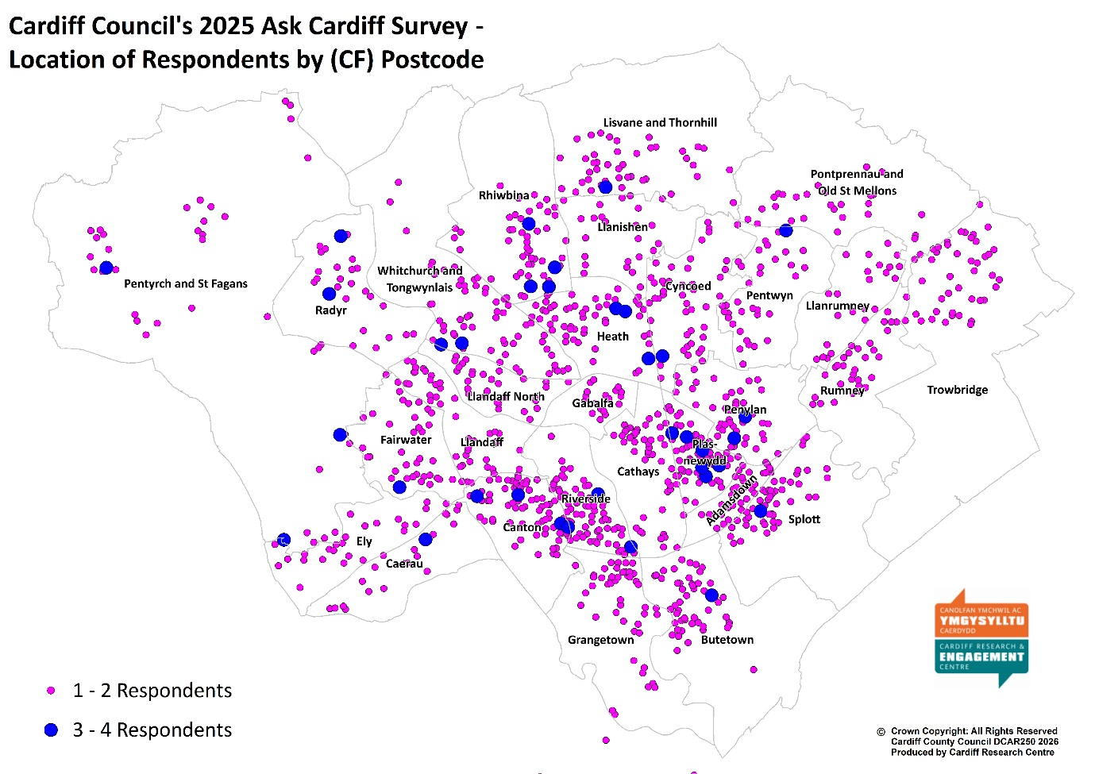

What was your age on your last birthday?
 | No. | %
Under 24 | 43 | 2.5
25-34 | 185 | 10.8
35-44 | 238 | 13.9
45-54 | 272 | 15.8
55-64 | 371 | 21.6
65-74 | 351 | 20.4
75+ | 199 | 11.6
Prefer not to say | 58 | 3.4
Total | 1,717 | 100.0

Are you…?
 | No. | %
Female | 915 | 53.3
Male | 708 | 41.2
Non-binary | 15 | 0.9
Other | 4 | 0.2
Prefer not to say | 75 | 4.4
Total | 1,717 | 100.0

Do you identify as Trans?
 | No. | %
Yes | 14 | 0.8
No | 1,565 | 93.2
Prefer to self-describe | 8 | 0.5
Prefer not to say | 92 | 5.5
Total | 1,679 | 100.0

How many children live in your household?
 | No. | %
No children | 1,341 | 79.5
Yes, under 5 years old (pre-school) | 79 | 4.7
Yes, aged 5 - 11 (primary school) | 145 | 8.6
Yes, aged 11 - 16 (secondary school) | 145 | 8.6
Yes, aged 16 - 18 in full-time education, or working | 92 | 5.5
Yes, aged 16 - 18 but not in full time education or working | 18 | 1.1
Total | 1,686 | -
NB. Percentages do not total 100% as respondent could have children in more than one age group

Are you pregnant, or have you given birth within the last 26 weeks?
 | No. | %
Yes, I’m pregnant | 10 | 0.6
Yes, I’ve given birth | 10 | 0.6
No | 1,581 | 94.6
Prefer not to say | 70 | 4.2
Total | 1,671 | 100.0

Do you care, unpaid, for a friend or family member due to illness, disability, a mental health problem or an addiction, cannot cope without your support?
 | No. | %
Yes | 287 | 17.2
No | 1,271 | 76.1
Prefer not to say | 113 | 6.8
Total | 1,671 | 100.0

Which of the following best describes what you are doing at present?
 | No. | %
Working full time (30+ hours per week) | 664 | 39.2
Working part time (less than 30 hours per week) | 211 | 12.5
In full time education | 33 | 2.0
On a government training scheme | 4 | 0.2
Unemployed - Registered Job Seeker | 25 | 1.5
Unemployed - Unregistered but seeking work | 33 | 2.0
On a zero hour contract | 27 | 1.6
Permanently sick or disabled person | 94 | 5.6
Wholly retired from work | 551 | 32.6
Looking after home | 77 | 4.6
Caring for a child or adult | 84 | 5.0
Other | 82 | 4.8
Total | 1,692 | -

Which best describes your housing tenure?
 | No. | %
Owned outright | 823 | 48.9
Owned with a mortgage | 456 | 27.1
Rented from the Local Authority | 73 | 4.3
Rented from a Housing Association | 69 | 4.1
Private rented | 190 | 11.3
Other | 71 | 4.2
Total | 1,682 | 100.0

Are you or a member of your household…?
 | You |  | A member of your household
 | No. | % | No. | %
Currently serving in the armed forces | 8 | 0.5 | 9 | 0.7
An armed forces service leaver (Veteran) | 39 | 2.6 | 23 | 1.9
Not applicable | 1,462 | 96.9 | 1,210 | 97.5
Total | 1,509 | 100.0 | 1,241 | -

Do you identify as a disabled person?
 | No. | %
Yes | 294 | 17.7
No | 1,265 | 76.0
Prefer not to say | 105 | 6.3
Total | 1,664 | 100.0

Please tick any of the following that apply to you:
 | No. | %
Deaf/ Deafened/ Hard of hearing | 207 | 14.0
Mental health difficulties | 210 | 14.2
Learning impairment/ difficulties | 36 | 2.4
Visual impairment | 75 | 5.1
Wheelchair user | 8 | 0.5
Mobility impairment | 200 | 13.6
Long-standing illness or health condition (e.g. cancer, diabetes, or asthma) | 358 | 24.3
Prefer not to say | 87 | 5.9
Other | 33 | 2.2
None of these | 702 | 47.6
Total Respondents | 1,474 | -
NB. Percentages do not total 100% as respondent could answer more than one option

Do you or a member of your family identify as neurodivergent (e.g. Attention Deficit Disorders, Autism, Dyslexia, Dyspraxia, Dyscalculia and Dysgraphia)?
 | You |  | A member of your household
 | No. | % | No. | %
Yes | 183 | 12.6 | 211 | 15.5
No | 1,275 | 87.4 | 1,150 | 84.5
Total | 1,458 | 100.0 | 1,361 | 100.0

Do you regard yourself as belonging to a particular religion?
 | No. | %
No, no religion | 714 | 42.3
Buddhist | 10 | 0.6
Christian (Including Church in Wales, Catholic, Protestant and all other Christian denominations) | 698 | 41.4
Hindu | 20 | 1.2
Jewish | 10 | 0.6
Muslim | 75 | 4.4
Sikh | 4 | 0.2
Other | 28 | 1.7
Prefer not to answer | 128 | 7.6
Total | 1,687 | 100.0

How would you describe your sexual orientation?
 | No. | %
Bisexual | 77 | 4.6
Gay Woman/Lesbian | 29 | 1.7
Gay Man | 45 | 2.7
Heterosexual/Straight | 1,298 | 78.1
Other | 24 | 1.4
Prefer not to answer | 188 | 11.3
Total | 1,661 | 100.0

Are you…?
 | No. | %
Single | 402 | 24.2
In a Civil Partnership | 31 | 1.9
Married | 780 | 46.9
Living together/Co-habiting | 219 | 13.2
Separated/divorced or legally separated if formerly in a Civil Partnership | 91 | 5.5
Widowed | 102 | 6.1
Other | 38 | 2.3
Total | 1,663 | 100.0

Do you consider yourself to be Welsh?
 | No. | %
Yes | 1,090 | 66.0
No | 561 | 34.0
Total | 1,651 | 100.0

How would you describe your Welsh language skills?
 | No. | %
Fluent | 116 | 6.9
Moderate | 97 | 5.8
Basic | 323 | 19.3
Learner | 284 | 17.0
None | 853 | 51.0
Total | 1,673 | 100.0

What is your ethnic group?
 | No. | %
White - Welsh/English/Scottish/Northern Irish/British | 1,269 | 75.6
White – Irish | 22 | 1.3
White - Gypsy or Irish Traveller | 3 | 0.2
White - Any other white background | 97 | 5.8
Mixed/Multiple Ethnic Groups - White & Asian Welsh / British / Other | 16 | 1.0
Mixed/Multiple Ethnic Groups - White and Black Caribbean Welsh / British / Other | 13 | 0.8
Mixed/Multiple Ethnic Groups - White and Black African Welsh / British / Other | 5 | 0.3
Mixed/Multiple Ethnic Groups - Any other | 9 | 0.5
Asian/Asian Welsh/British – Bangladeshi | 18 | 1.1
Asian/Asian Welsh/British – Chinese | 12 | 0.7
Asian/Asian Welsh/British – Indian | 27 | 1.6
Asian/Asian Welsh/British – Pakistani | 12 | 0.7
Asian/Asian Welsh/British - Any other | 2 | 0.1
Black/African/Caribbean/Black Welsh/British – African | 17 | 1.0
Black/African/Caribbean/Black Welsh/British - Caribbean | 5 | 0.3
Black/African/Caribbean/Black Welsh/British - Any other | 5 | 0.3
Arab | 18 | 1.1
Any other ethnic group | 38 | 2.3
Prefer not to say | 90 | 5.4
Total | 1,678 | 100.0

How did you hear about this survey?
 | No. | %
Cardiff Council social media account (X/Facebook/Instagram) | 359 | 21.5
Other social media account | 75 | 4.5
From a local councillor | 81 | 4.8
I'm a member of the Citizens Panel | 570 | 34.1
A paper copy in my local library/Hub | 165 | 9.9
Staff email where I work | 156 | 9.3
Other | 218 | 13.0
Don't know | 47 | 2.8
Total | 1,671 | 100.0

Volunteering
Click here to return to the main report

Theme | No. | % | Example Comments
I can't volunteer now | 21 | 14.5 | - i would if i could but I am disabled  - I am 80 now. Have done most of these things in my life and saw great benefit from them.  - I just don't have time
Environmental | 19 | 13.1 | - Maintaining and improving green spaces.  - Cleaning leaves - i saw a resident sweeping them into marked bags. Also gardening front gardens for those unable to do so
I already volunteer | 18 | 12.4 | - Already volunteer for the City Hospice in Cardiff  - I volunteer with cadet service
Transport | 12 | 8.3 | - Community bicycle maintenance as a trainer/qualified mechanic  - Help with community transport
With (or for) children/ young people | 12 | 8.3 | - Community or educational activities for young people and adults with a learning disability or autism.  - Would love to volunteer in a Primary school to help children with reading but I understand these opportunities no longer exist.
Community | 12 | 8.3 | - Being involved with helping neighbours  - I want to be proactive regarding crime in this area.
With (or for) adults | 11 | 7.6 | - Supporting the homeless in Cardiff  - Get together with elderly clients for walking, knitting, art& crafts, Fancy dress entertainment to raise funds for elderly care, Etc.
Other volunteering | 11 | 7.6 | - Visiting hospital patients  - Remote and short term volunteering opportunities - I am not available to volunteer regularly
Council decision-making | 10 | 6.9 | - I would like to represent the public within Cardiff Council. To be a resident representative within the council structure. I do not believe such a role exits, however, I believe these types of volunteer roles should exit. We would be the councils " conscience "
It is difficult to become a volunteer | 9 | 6.2 | - I have volunteered in numerous roles through my lfe from scouts to school governor. Volunteering now is made harder than applying for a job. The system puts people off
These should be paid roles | 9 | 6.2 | - You should be doing these jobs not getting volunteers involved
Events-based | 3 | 2.1 | - Major events run by the Council
Street cleaning / Waste | 3 | 2.1 | - Helping to get council tips open to stop fly tipping
IT | 2 | 1.4 | - I own a software development company and can help with technical consultations or more
Misc comments, not related to volunteering | 25 | 17.2 | - Parking is an issue for me  - Contacting Councillors in my area regarding various issues is a nightmare because they don't reply and keep you waiting weeks  - Wait times. Some departments operate on answer phone eg Council Tax
Total Respondents | 145 | -
Respondents could comment on multiple themes so the total may exceed 100%.

How Would You Prefer to Access Information About Services, Events etc.? Breakdown by Demographic and Geography
Click here to return to the main report

% | All respondents | Under 35 | 55+ | Female | Male | Ethnically Diverse
Base | 2306 | 220 | 913 | 896 | 702 | 306
Digitally:
Websites | 68.7 | 65.9 | 70.5 | 66.3 | 76.1 | 62.4
Social Media | 47.5 | 62.7 | 38.8 | 51.7 | 41.2 | 47.4
Email | 54.4 | 47.7 | 58.8 | 51.9 | 59.7 | 51.3
Messaging platforms (e.g. WhatsApp groups) | 18.2 | 23.6 | 16.5 | 19.1 | 16.4 | 22.5
Other digital format | 1.8 | 3.6 | 1.2 | 1.1 | 2.6 | 2.0
I don't want to / can't access information digitally | 4.2 | 1.8 | 5.1 | 4.2 | 3.0 | 4.2
Non-Digital:
Posters/flyers/leaflets in community buildings | 41.5 | 47.3 | 39.6 | 49.6 | 33.5 | 37.6
Newsletters | 31.2 | 27.3 | 35.6 | 32.6 | 30.6 | 30.1
Radio | 13.4 | 19.1 | 12.6 | 14.3 | 11.7 | 11.1
Billboards/bus stops/screens | 25.7 | 41.4 | 22.1 | 31.7 | 21.8 | 24.8
Letters | 27.8 | 33.6 | 23.9 | 29.7 | 24.9 | 34.6
Telephone/Text | 10.6 | 15.9 | 8.9 | 10.8 | 9.8 | 12.7
Other non-digital format | 1.5 | 2.3 | 1.3 | 1.9 | 0.7 | 2.0
I prefer to access information digitally | 21.3 | 19.1 | 23.5 | 18.2 | 26.4 | 19.0
Respondents could select multiple options so the total will exceed 100%.

% | All respondents | Identify as disabled | Welsh speaker | Southern Arc | Children in household | LGBTQ+
Base | 2306 | 289 | 210 | 543 | 334 | 162
Digitally:
Websites | 68.7 | 65.1 | 72.4 | 70.5 | 68.6 | 74.1
Social Media | 47.5 | 48.1 | 49.5 | 52.1 | 58.4 | 52.5
Email | 54.4 | 56.1 | 57.1 | 53.8 | 53.3 | 56.8
Messaging platforms (e.g. WhatsApp groups) | 18.2 | 19.0 | 18.6 | 19.2 | 19.2 | 14.8
Other digital format | 1.8 | 2.1 | 3.3 | 2.2 | 2.4 | 2.5
I don't want to / can't access information digitally | 4.2 | 6.6 | 4.3 | 3.3 | 2.4 | 3.7
Non-Digital:
Posters/flyers/leaflets in community buildings | 41.5 | 37.7 | 45.7 | 41.6 | 43.7 | 51.9
Newsletters | 31.2 | 31.8 | 31.9 | 32.0 | 26.9 | 24.1
Radio | 13.4 | 13.8 | 17.6 | 12.2 | 12.3 | 16.7
Billboards/bus stops/screens | 25.7 | 27.0 | 34.8 | 29.1 | 29.0 | 35.2
Letters | 27.8 | 37.0 | 25.2 | 31.5 | 33.2 | 29.6
Telephone/Text | 10.6 | 15.2 | 9.0 | 11.6 | 11.1 | 9.9
Other non-digital format | 1.5 | 3.1 | 1.4 | 1.7 | 1.8 | 2.5
I prefer to access information digitally | 21.3 | 20.4 | 17.6 | 21.7 | 19.8 | 20.4
Respondents could select multiple options so the total will exceed 100%.

% | All Respondents | Least Deprived | Next Least Deprived | Middle | Next Most Deprived | Most Deprived
Base | 2306 | 344 | 352 | 284 | 254 | 174
Digital
Websites | 68.7 | 77.0 | 72.7 | 71.8 | 67.3 | 63.8
Social Media | 47.5 | 42.2 | 47.4 | 46.5 | 46.9 | 55.2
Email | 54.4 | 59.3 | 59.1 | 50.7 | 51.6 | 54.6
Messaging platforms (e.g. WhatsApp groups) | 18.2 | 14.8 | 15.1 | 17.3 | 16.5 | 27.6
Other digital format | 1.8 | 0.6 | 1.4 | 1.8 | 2.4 | 2.9
I don't want to / can't access information digitally | 4.2 | 2.9 | 2.3 | 3.5 | 2.4 | 6.9
Non-Digital:
Posters/flyers/leaflets in community buildings | 41.5 | 44.2 | 39.5 | 45.1 | 42.1 | 39.7
Newsletters | 31.2 | 31.7 | 30.4 | 29.9 | 31.5 | 32.8
Radio | 13.4 | 12.5 | 11.6 | 13.0 | 12.6 | 12.1
Billboards/bus stops/screens | 25.7 | 25.6 | 28.1 | 27.8 | 28.3 | 29.3
Letters | 27.8 | 20.9 | 24.1 | 28.2 | 33.9 | 36.2
Telephone/Text | 10.6 | 7.3 | 8.2 | 9.5 | 11.0 | 18.4
Other non-digital format | 1.5 | 1.2 | 2.0 | 1.4 | 1.2 | 1.1
I prefer to access information digitally | 21.3 | 24.1 | 25.6 | 21.5 | 21.7 | 18.4
Respondents could select multiple options so the total will exceed 100%.

Why Do You Disagree That Contacting the Council is Simple?
Click here to return to the main report

Theme | No. | % | Example Comments
Telephone Wait Times / Calls Not Answered | 205 | 45.0 | - Wrong numbers listed, no one answering, services closed  - The length of time spent waiting for the correct person to talk to  - Don’t always answer the phone  - It’s fine if the answer is online - anything that requires a telephone call is a pain  - You are very much discouraged from using the phone service yet sometimes C2C is the best way to ask complicated queries. The wait time is terrible
Difficulty Reaching Correct Department / Being Passed Around | 103 | 22.6 | - Finding who to contact and navigating so many processes is a challenge  - Some departments are uncontactable, messages are not returned  - No one ever knows which department is responsible for what and you get transferred around the whole council and then nothing is done  - It’s not very often I need to contact the Council. When I do it’s impossible to speak to an officer who has knowledge and / or responsibility to deal with my query.
Website Difficult to Navigate / Hard to Find Information | 99 | 21.7 | - You have to go to to many pages to get to the right one  - Difficult to report too as website info changes and council reduce access to areas of concern by removing links to obviously reduce complaints  - Website non intuitive
Complex Phone Menus / Automated Systems | 81 | 17.8 | - Too many clicks difficult to find info  - You have to go thought so many different options  - Press this line goes dead
No Response or Slow Response (Email / Webforms / Follow-up) | 73 | 16.0 | - It’s simple to contact, impossible to get a follow up or speak to a human  - Takes forever and then they do not follow through with actions  - Never had a response to emails ive sent
Online Forms Limited or Not Suitable | 35 | 7.7 | - I've filled in contact forms that have gone unanswered  - If the problem doesn't fit in a tick box it is impossible
App Issues (Errors, Limited Options, No Feedback) | 35 | 7.7 | - Paying your council tax via the app is difficult and very time consuming as its so slow and not fit for purpose.  - Its very hard to talk to a person. No feedback from issues raised via the app.
Rude, Dismissive, or Unhelpful Staff | 27 | 5.9 | - Very rude and obnoxious staff members on advice hub  - because there are very rarely any helpful people to talk to.
No Direct Contact Details | 26 | 5.7 | - Cannot contact council tax, very annoying, have to walk to hub and they cannot contact them either  - Contact info feels buried
Poor Staff Knowledge / Inconsistent Information | 21 | 4.6 | - C2C is a very poor service ,always busy, long wait times, and poorly trained staff.  - Staff aren’t always knowledgeable enough in the area they work.
Digital Exclusion | 19 | 4.2 | - Digital over-dependence.  - I like to speak with a person when I need to ask a question or tell you when something is wrong
Accessibility Barriers | 16 | 3.5 | - No access or Deaf awareness. Phone only not suitable for me because I'm Deaf.  - No info on parking zones . Terrible system . System no good for elderly with visiting family, carers. System discriminates against elderly
Misc. | 12 | 2.6 | - i havent seen a local councilor to talk with in years. its as if they don't want to be here  - How do I do it  - I didn't contact the Council as my husband is dealing with everything
Total Respondents | 456 | -
Respondents could comment on multiple themes so the total may exceed 100%.

What Other Services Delivered in your Local Hub/Library Do You Find Most Helpful?
Click here to return to the main report

Theme | No. | % | Example Comments
There is no local Hub / Library / Access Issues | 66 | 18.9 | - We don't have a local hub  - No local hub or library nearby. But would like one in the community.  - Closest library (and easiest to travel to ) is Cardiff centre - not exactly my local community!
Don't use | 50 | 14.3 | - Dont use it, work long hours  - I've never been to my library because it's very small and quiet. I was hoping for somewhere to work  - I dont use the hubs as they are too far away from where I live
Better Facilities - Seating - Café - Toilets - meeting / Quiet / Safe space | 22 | 6.3 | - Warm cafe for people who can't afford heating  - I think some could do with a better "chill zone" where young people can hang out.  - Safe space (domestic violence)
Languages | 19 | 5.4 | - Welsh language activities - I am a learner  - Books in community languages like Urdu, Gujarati, Hindi, Bengali
Better Advertising of what's available | 19 | 5.4 | - I rarely hear whats going on unless i go out of my way to go in and ask  - I don’t know anything about the services Hub offered. These needs to be advertised more.
Increase Opening Times | 16 | 4.6 | - Poor opening times for people who work  - It is very good but not open when I want them.
More Books / Printed media | 15 | 4.3 | - Not enough actual books in the library  - Not enough books are available. Local library service has become almost non-existent
Positive Comments | 14 | 4.0 | - The hub is perfect  - Good service! Adequate staffing.
Recycling & Waste | 14 | 4.0 | - waste recycling bags  - Rubbish sacks
Exercise / Fitness / Sport Classes | 14 | 4.0 | - More Tai chi classes  - Excercise classes for over 60's
Personal Development | 14 | 4.0 | - more youth activities - for example life skills, like budgeting, taxes, CVs, after school clubs  - Home maintenance classes e.g. electrician, plumbing, DIY, tools etc.
Digital - Computer / Phone related | 13 | 3.7 | - Independent use of a public computer for those with a disability eg Dragon Section 20.4 EA  - more digital help
Information / Advice- Blue Badges / Council Tax / Pension Credit | 13 | 3.7 | - Council Tax and Blue Badge enquiries  - More consistent help with benefits - people have been turned away - 'we don't do that here'.
Age specific activities | 12 | 3.4 | - Things for teenagers and autistic teenagers  - Social gatherings for adults
Arts & Crafts | 9 | 2.6 | - More crafting classes
Author Talks / Book Clubs | 6 | 1.7 | - I'm not aware that author talks are available.
Negative Comments | 5 | 1.4 | - Hubs are a waste of public money and should be closed
All / Many of those listed | 5 | 1.4 | - There are lots of things on this list I would like to do but they are not available in my local-hubs
Community group areas / Rooms to hire | 5 | 1.4 | - Space for community groups
Health & Well being | 5 | 1.4 | - I think a mental wellbeing group once a week for all diffrent ages should be added.
Environmental | 4 | 1.1 | - More opportunities to recycle material not collected at the roadside.
Councillor Surgeries | 3 | 0.9 | - Tried to meet up with my local councilor as per the timetable but no show!
Qualified / More Staff | 2 | 0.6 | - Well trained staff who are knowledgeable about Council Services
Misc. | 32 | 9.1 | - Police  - I get a number of CDs from my hub, which you do not mention...  - banking facilities
Total Respondents | 350 | -
Respondents could comment on multiple themes so the total may exceed 100%.

What Services Delivered in your Local Hub/Library Do You Find Most Helpful? Breakdown by Demographic and Geography
Click here to return to the main report

% | All respondents | Under 35 | 55+ | Female | Male | Ethnically Diverse
Base | 2057 | 196 | 855 | 833 | 641 | 272
Adult Learning | 14.8 | 19.9 | 12.3 | 15.8 | 12.2 | 28.3
Age Friendly advice, including help in your home, wellbeing services | 10.5 | 14.8 | 11.0 | 12.7 | 8.0 | 14.0
Author talks | 8.5 | 11.7 | 8.5 | 10.0 | 6.7 | 7.0
Book loan | 42.1 | 49.5 | 44.2 | 49.8 | 38.5 | 43.4
Café provision | 14.1 | 16.8 | 12.2 | 15.8 | 11.9 | 15.1
Childrens activities including Story & Rhyme Time | 13.2 | 16.3 | 9.2 | 16.7 | 8.9 | 18.4
Coffee mornings | 7.9 | 10.7 | 6.3 | 8.8 | 6.1 | 13.2
Community events | 15.7 | 21.4 | 13.6 | 19.4 | 12.5 | 20.6
E Books loan | 11.2 | 15.8 | 10.3 | 13.1 | 8.9 | 13.6
ESOL classes | 3.7 | 6.6 | 1.4 | 4.4 | 2.7 | 9.2
Exercise classes | 11.4 | 15.8 | 11.9 | 16.3 | 7.3 | 18.0
Friends & neighbours groups | 9.7 | 13.8 | 9.9 | 12.0 | 8.0 | 17.3
Health & wellbeing materials (including books on Prescription/ information leaflets) | 11.1 | 12.8 | 11.3 | 13.6 | 9.0 | 14.0
Housing & Benefit Advice | 13.2 | 17.3 | 10.4 | 14.0 | 11.7 | 22.1
Into Work Services | 7.2 | 16.3 | 3.6 | 8.3 | 6.2 | 14.7
Job clubs | 5.6 | 11.7 | 3.2 | 6.1 | 4.7 | 11.8
Money Advice | 9.4 | 13.3 | 6.4 | 10.2 | 7.8 | 16.9
PC use & digital assistance | 13.5 | 16.8 | 13.8 | 13.8 | 13.3 | 16.5
Reading Groups | 6.8 | 13.3 | 6.2 | 8.4 | 4.2 | 7.0
Volunteer opportunities | 8.6 | 11.2 | 7.6 | 9.6 | 7.3 | 12.5
None of these | 34.6 | 24.0 | 36.4 | 27.6 | 40.2 | 21.0
Respondents could select multiple options so the total will exceed 100%.

% | All respondents | Identify as disabled | Welsh speaker | Southern Arc | Children in household | LGBTQ+
Base | 2057 | 271 | 202 | 498 | 306 | 156
Adult Learning | 14.8 | 15.1 | 21.8 | 16.1 | 15.7 | 22.4
Age Friendly advice, including help in your home, wellbeing services | 10.5 | 11.4 | 17.3 | 11.0 | 10.5 | 10.3
Author talks | 8.5 | 6.3 | 17.8 | 6.2 | 8.2 | 16.7
Book loan | 42.1 | 39.1 | 61.4 | 43.0 | 49.3 | 57.1
Café provision | 14.1 | 14.4 | 22.8 | 15.7 | 17.3 | 17.9
Childrens activities including Story & Rhyme Time | 13.2 | 11.1 | 24.8 | 13.5 | 33.7 | 10.9
Coffee mornings | 7.9 | 8.1 | 12.4 | 8.6 | 8.2 | 11.5
Community events | 15.7 | 19.6 | 27.7 | 17.5 | 22.2 | 23.1
E Books loan | 11.2 | 11.1 | 18.8 | 13.7 | 9.8 | 22.4
ESOL classes | 3.7 | 2.2 | 7.9 | 5.8 | 6.9 | 5.1
Exercise classes | 11.4 | 12.9 | 17.8 | 14.7 | 11.1 | 17.3
Friends & neighbours groups | 9.7 | 12.9 | 19.3 | 12.2 | 10.1 | 10.9
Health & wellbeing materials (including books on Prescription/ information leaflets) | 11.1 | 12.2 | 18.3 | 12.9 | 8.8 | 18.6
Housing & Benefit Advice | 13.2 | 22.1 | 13.9 | 17.1 | 16.3 | 14.7
Into Work Services | 7.2 | 8.9 | 10.9 | 9.4 | 8.5 | 12.2
Job clubs | 5.6 | 4.8 | 10.9 | 6.8 | 6.2 | 7.1
Money Advice | 9.4 | 14.0 | 13.9 | 11.0 | 10.5 | 14.1
PC use & digital assistance | 13.5 | 12.9 | 19.3 | 15.5 | 9.8 | 17.3
Reading Groups | 6.8 | 6.3 | 16.3 | 6.2 | 7.2 | 13.5
Volunteer opportunities | 8.6 | 10.7 | 16.8 | 10.8 | 8.8 | 12.2
None of these | 34.6 | 36.2 | 21.8 | 32.5 | 27.1 | 23.7
Respondents could select multiple options so the total will exceed 100%.

% | All Respondents | Least Deprived | Next Least Deprived | Middle | Next Most Deprived | Most Deprived
Base | 2057 | 331 | 327 | 257 | 237 | 160
Adult Learning | 14.8 | 13.0 | 10.1 | 12.1 | 17.3 | 20.0
Age Friendly advice, including help in your home, wellbeing services | 10.5 | 9.1 | 9.2 | 9.3 | 12.7 | 13.1
Author talks | 8.5 | 13.3 | 6.7 | 8.2 | 6.8 | 3.1
Book loan | 42.1 | 51.7 | 42.5 | 45.9 | 44.7 | 37.5
Café provision | 14.1 | 9.7 | 12.5 | 16.0 | 15.6 | 18.1
Childrens activities including Story & Rhyme Time | 13.2 | 14.2 | 13.1 | 11.3 | 13.1 | 16.9
Coffee mornings | 7.9 | 6.3 | 5.2 | 5.4 | 11.4 | 10.0
Community events | 15.7 | 15.7 | 15.3 | 13.6 | 18.1 | 18.1
E Books loan | 11.2 | 10.3 | 11.6 | 10.1 | 16.5 | 10.0
ESOL classes | 3.7 | 1.5 | 1.5 | 2.3 | 5.9 | 10.0
Exercise classes | 11.4 | 9.7 | 9.8 | 12.1 | 14.3 | 15.6
Friends & neighbours groups | 9.7 | 11.5 | 9.2 | 7.4 | 11.8 | 11.9
Health & wellbeing materials (including books on Prescription/ information leaflets) | 11.1 | 11.2 | 9.2 | 9.7 | 14.8 | 15.6
Housing & Benefit Advice | 13.2 | 4.8 | 9.8 | 13.2 | 21.5 | 24.4
Into Work Services | 7.2 | 2.4 | 7.3 | 4.7 | 11.4 | 13.1
Job clubs | 5.6 | 2.1 | 4.3 | 4.7 | 9.3 | 8.8
Money Advice | 9.4 | 4.2 | 6.7 | 7.8 | 13.5 | 16.3
PC use & digital assistance | 13.5 | 10.6 | 10.7 | 11.3 | 18.1 | 20.0
Reading Groups | 6.8 | 7.9 | 5.8 | 5.1 | 10.5 | 4.4
Volunteer opportunities | 8.6 | 6.9 | 8.0 | 5.8 | 10.1 | 15.0
None of these | 34.6 | 30.5 | 39.4 | 34.6 | 32.1 | 29.4
Respondents could select multiple options so the total will exceed 100%.

What Other Activities or Events Would You Like To See in Your Local Hub?
Click here to return to the main report

Theme | No. | % | Example Comments
Learning, Skills & Educational Opportunities | 28 | 31.8 | - Opportunity to learn about democrcy, active citizenship, sustainability  - Evening classes, evening exercise classes
Health, Wellbeing & Inclusion | 23 | 26.1 | - Local unpaid carers groups  - Mental Wellbeing Groups, Neurodiversity Support Network
Arts, Culture & Creative Activities | 22 | 25.0 | - Cake decorating classes  - Musical activities
Social & Community Activities | 20 | 22.7 | - Sewing and knitting. Social club for older people.  - Groups for parents, groups for older care experienced people
Digital Skills & Technology Support | 10 | 11.4 | - Computer skills  - Internet training
Children & Young People's Activities | 10 | 11.4 | - More children and teenager activities  - Neurodiversity play groups
Physical Activities & Sport | 7 | 8.0 | - running clubs  - Yoga/pilates
Misc. | 18 | 20.5 | - All of the above and more. Different things suit different people at different times  - I don’t know what’s going on in the hub  - I'd like a hub for a start...
Total Respondents | 88 | -
Respondents could comment on multiple themes so the total may exceed 100%.

What Activities or Events Would You Like To See in Your Local Hub? Breakdown by Demographic and Geography
Click here to return to the main report

 | All respondents | Under 35 | 55+ | Female | Male | Ethnically Diverse
Base | 1901 | 191 | 775 | 777 | 581 | 252
Basic cooking classes | 16.8 | 31.4 | 11.2 | 19.4 | 11.9 | 26.6
Bereavement support groups | 20.0 | 26.2 | 18.2 | 22.9 | 14.8 | 23.0
Craft groups | 23.8 | 41.9 | 18.6 | 32.8 | 13.3 | 34.1
Creative Writing / arts | 18.1 | 37.7 | 12.6 | 21.1 | 15.3 | 32.9
Exercise classes for over 50’s e.g. Tai Chi | 25.5 | 11.5 | 33.2 | 31.8 | 18.4 | 30.2
Family History activities | 18.9 | 19.4 | 19.9 | 19.6 | 17.0 | 18.7
Fitness activities e.g. walking groups | 26.9 | 34.6 | 26.8 | 34.5 | 20.5 | 38.1
Hobby and Interest Groups e.g. Craft, Jigsaw, Lego, Gardening clubs | 26.5 | 46.1 | 22.2 | 33.7 | 19.1 | 33.3
Homework clubs | 14.2 | 27.7 | 8.6 | 18.0 | 10.2 | 21.0
Intergenerational events (bringing together children and older people) | 17.9 | 30.4 | 14.8 | 22.3 | 13.6 | 25.0
Local and Community History events | 25.9 | 20.9 | 29.5 | 26.8 | 26.2 | 25.8
Peer support groups (bringing people together who have been through similar experiences) e.g. Parkinson’s Café | 20.7 | 28.8 | 18.2 | 25.9 | 15.8 | 26.2
Play sessions for children | 18.0 | 34.6 | 12.1 | 21.6 | 14.3 | 28.6
Social Groups e.g. coffee mornings, Friend and Neighbours (FAN), Goldies Cymru (singing) | 21.1 | 33.5 | 19.1 | 25.7 | 16.5 | 28.2
Other | 5.9 | 5.2 | 6.6 | 7.1 | 4.5 | 8.3
None of these | 23.4 | 9.9 | 25.4 | 16.0 | 31.7 | 13.9
Respondents could select multiple options so the total will exceed 100%.

 | All respondents | Identify as disabled | Welsh speaker | Southern Arc | Children in household | LGBTQ+
Base | 1901 | 255 | 192 | 466 | 294 | 148
Basic cooking classes | 16.8 | 16.5 | 14.1 | 19.1 | 20.4 | 22.3
Bereavement support groups | 20.0 | 22.4 | 23.4 | 22.7 | 17.7 | 27.7
Craft groups | 23.8 | 25.9 | 31.8 | 28.3 | 26.5 | 34.5
Creative Writing / arts | 18.1 | 24.3 | 24.0 | 24.2 | 20.4 | 35.1
Exercise classes for over 50’s e.g. Tai Chi | 25.5 | 23.1 | 32.8 | 26.2 | 16.7 | 16.2
Family History activities | 18.9 | 20.0 | 24.0 | 19.1 | 17.0 | 15.5
Fitness activities e.g. walking groups | 26.9 | 24.7 | 34.4 | 30.7 | 26.2 | 27.7
Hobby and Interest Groups e.g. Craft, Jigsaw, Lego, Gardening clubs | 26.5 | 31.8 | 29.2 | 29.2 | 28.9 | 40.5
Homework clubs | 14.2 | 12.2 | 19.8 | 17.8 | 25.5 | 16.9
Intergenerational events (bringing together children and older people) | 17.9 | 22.4 | 22.4 | 22.3 | 21.4 | 18.2
Local and Community History events | 25.9 | 27.1 | 39.1 | 27.3 | 18.4 | 23.6
Peer support groups (bringing people together who have been through similar experiences) e.g. Parkinson’s Café | 20.7 | 29.8 | 21.9 | 24.2 | 21.4 | 27.7
Play sessions for children | 18.0 | 19.2 | 21.4 | 20.8 | 36.4 | 14.9
Social Groups e.g. coffee mornings, Friend and Neighbours (FAN), Goldies Cymru (singing) | 21.1 | 24.3 | 26.0 | 21.7 | 20.7 | 27.0
Other | 5.9 | 8.6 | 6.3 | 7.9 | 6.5 | 7.4
None of these | 23.4 | 18.0 | 17.7 | 19.5 | 18.0 | 18.9
Respondents could select multiple options so the total will exceed 100%.

% | All Respondents | Least Deprived | Next Least Deprived | Middle | Next Most Deprived | Most Deprived
Base | 1901 | 289 | 308 | 240 | 213 | 148
Basic cooking classes | 16.8 | 9.7 | 12.3 | 12.9 | 22.5 | 25.0
Bereavement support groups | 20.0 | 18.0 | 18.2 | 16.3 | 20.7 | 27.7
Craft groups | 23.8 | 19.7 | 23.7 | 23.3 | 30.0 | 29.1
Creative Writing / arts | 18.1 | 16.3 | 16.2 | 20.4 | 24.4 | 23.6
Exercise classes for over 50’s e.g. Tai Chi | 25.5 | 27.7 | 24.0 | 22.5 | 22.5 | 24.3
Family History activities | 18.9 | 19.0 | 15.3 | 18.3 | 19.7 | 23.6
Fitness activities e.g. walking groups | 26.9 | 25.3 | 25.0 | 21.7 | 31.5 | 37.8
Hobby and Interest Groups e.g. Craft, Jigsaw, Lego, Gardening clubs | 26.5 | 25.3 | 28.9 | 29.2 | 30.0 | 29.1
Homework clubs | 14.2 | 10.4 | 10.7 | 14.2 | 21.6 | 17.6
Intergenerational events (bringing together children and older people) | 17.9 | 15.6 | 20.8 | 17.9 | 22.5 | 19.6
Local and Community History events | 25.9 | 30.4 | 23.1 | 26.7 | 25.8 | 25.0
Peer support groups (bringing people together who have been through similar experiences) e.g. Parkinson’s Café | 20.7 | 21.1 | 21.8 | 16.3 | 25.8 | 25.0
Play sessions for children | 18.0 | 13.8 | 18.8 | 17.1 | 20.7 | 24.3
Social Groups e.g. coffee mornings, Friend and Neighbours (FAN), Goldies Cymru (singing) | 21.1 | 20.4 | 19.5 | 22.1 | 21.6 | 24.3
Other | 5.9 | 5.5 | 6.5 | 3.8 | 5.6 | 8.1
None of these | 23.4 | 22.8 | 26.3 | 23.3 | 21.6 | 16.2
Respondents could select multiple options so the total will exceed 100%.

How Else Would You Like To Know About Events In Your Local Hub/Library?
Click here to return to the main report

Theme | No. | % | Example Comments
Community Flyers / Leaflets / Posters / Newsletters | 40 | 38.1 | - Posters in local shops  - A weather-proof poster board could perhaps be erected outside the library announcing events.  - mail drop; or printed leaflet in books being borrowed
Council Website / App | 30 | 28.6 | - Council App or website  - website /app
Something in the post | 19 | 18.1 | - Leaflets through doors  - Maybe a news letter posted to home as I wouldnt see it anywhere else
Social Media | 11 | 10.5 | - Bluesky  - TikTok - Instagram
Community Initiatives | 5 | 4.8 | - Community groups, PCSOs
Email | 3 | 2.9 | - Email. You have most residents address, why not send it directly.
Local Press / Radio | 3 | 2.9 | - Echo
Misc. | 8 | 7.6 | - Dont have hub/library  - Word of mouth
Total Respondents | 105 | -
Respondents could comment on multiple themes so the total may exceed 100%.

What other neurodivergent friendly activities would you like to access?
Click here to return to the main report

Theme | No. | % | Example Comments
Not neurodivergent | 35 | 85.4 | - I don't need these, but it is a good idea  - I don't know how useful any of these would be. I have no experience of neurodivergent people in Cardiff  - Don't understand neurodivergent
Views on Activities | 16 | 39.0 | - Not applicable to me, but they should be available  - I'm neurodiverse myself, but I honestly from experience have found things like the above to be incredibly condescending; I'm neurodiverse but I'm not a child and not incapable and hate the idea of being infantilised or considered as someone that needs "support" for everything. Show me something where the people are going to speak to me like a fully functioning adult with a fulltime job, a home that I run independently, a long term partner, hobbies and a job that wasn't thrown at me to meet a quota or get me off a list but who is just struggling with some elements of neurodiversity and I'd be curious. I know that the previous puts me in the minority as a neurodiverse adult, the stats prove this, but its just how I feel.
Social, Creative & Community Activities | 15 | 36.6 | - Play groups for young, sports, eg. Bocchia, for adults.  - Modelling
Learning & Skills Development | 11 | 26.8 | - Social understanding classes  - A class to teach people about credit debit interest rates, loans etc.
Accessibility & Inclusion | 4 | 9.8 | - I’m disabled so not really able to access activities  - Sign language _BSL
Group Delivery & Operational Considerations | 4 | 9.8 | - Depends on how these groups operate, many people do not want a group activity, many people would not like to be labelled by attending a group such as this in a space where so many other people may be accessing at the same time  - Neurodivergent specific groups as multiple types means there is no one size fits all
Misc. | 20 | 48.8
Total Respondents | 107 | -

What neurodivergent friendly activities would you like to access?
Click here to return to the main report

 | All respondents | Under 35 | 55+ | Female | Male | Ethnically Diverse
Base | 1836 | 183 | 769 | 740 | 591 | 231
Arts and crafts | 20.2 | 45.9 | 12.6 | 25.7 | 13.2 | 34.6
Reading groups | 11.6 | 26.2 | 7.5 | 13.5 | 7.6 | 17.7
Adults lego groups | 8.9 | 23.0 | 3.5 | 10.0 | 5.9 | 13.9
Children’s lego groups | 8.7 | 17.5 | 4.6 | 10.4 | 4.9 | 11.3
Board games | 13.4 | 33.3 | 7.2 | 16.2 | 9.0 | 22.9
Computer skills | 15.0 | 20.8 | 12.4 | 13.4 | 15.2 | 24.2
Cookery | 11.5 | 22.4 | 7.3 | 13.0 | 8.1 | 19.0
Dance classes | 11.5 | 21.3 | 6.6 | 15.1 | 6.1 | 26.4
Family activities | 10.1 | 15.8 | 5.7 | 12.2 | 5.9 | 17.3
Fitness classes | 15.8 | 24.6 | 11.3 | 18.6 | 12.2 | 26.8
Language classes | 13.7 | 28.4 | 8.2 | 14.2 | 12.2 | 26.0
Literacy classes | 7.3 | 14.2 | 4.8 | 8.2 | 6.3 | 12.1
Music groups | 11.2 | 23.0 | 7.2 | 12.7 | 8.3 | 19.9
Photography | 11.2 | 20.8 | 6.1 | 11.9 | 10.0 | 21.6
Sensory rhyme/story time | 7.7 | 16.9 | 4.7 | 9.3 | 5.1 | 11.7
Support groups | 13.5 | 24.0 | 8.5 | 14.9 | 9.0 | 18.2
Women’s wellbeing | 15.5 | 27.9 | 9.4 | 23.0 | 4.4 | 28.1
Other | 2.9 | 1.6 | 3.3 | 3.0 | 2.2 | 4.3
None of these | 55.4 | 33.9 | 66.4 | 51.2 | 66.2 | 36.8
Respondents could select multiple options so the total will exceed 100%.

 | All respondents | Identify as disabled | Welsh speaker | Southern Arc | Children in household | LGBTQ+
Base | 1901 | 253 | 182 | 445 | 278 | 142
Arts and crafts | 20.2 | 25.3 | 23.1 | 24.0 | 27.3 | 36.6
Reading groups | 11.6 | 13.8 | 19.2 | 12.4 | 14.4 | 19.7
Adults lego groups | 8.9 | 9.9 | 9.9 | 10.1 | 12.6 | 15.5
Children’s lego groups | 8.7 | 7.9 | 17.0 | 8.1 | 18.7 | 9.2
Board games | 13.4 | 14.2 | 19.8 | 16.4 | 18.0 | 23.9
Computer skills | 15.0 | 18.6 | 18.7 | 16.0 | 16.5 | 14.8
Cookery | 11.5 | 14.6 | 12.6 | 14.6 | 14.7 | 19.7
Dance classes | 11.5 | 12.3 | 13.2 | 12.4 | 15.8 | 17.6
Family activities | 10.1 | 8.7 | 12.6 | 10.1 | 21.2 | 11.3
Fitness classes | 15.8 | 17.8 | 17.6 | 18.7 | 19.1 | 17.6
Language classes | 13.7 | 19.0 | 17.0 | 14.4 | 14.4 | 21.8
Literacy classes | 7.3 | 6.3 | 13.2 | 9.2 | 9.4 | 10.6
Music groups | 11.2 | 12.3 | 13.2 | 10.8 | 16.5 | 15.5
Photography | 11.2 | 14.2 | 13.2 | 11.7 | 16.9 | 19.7
Sensory rhyme/story time | 7.7 | 8.3 | 11.0 | 7.4 | 14.4 | 12.7
Support groups | 13.5 | 20.2 | 17.0 | 11.7 | 17.3 | 21.1
Women’s wellbeing | 15.5 | 20.2 | 17.0 | 19.1 | 21.2 | 22.5
Other | 2.9 | 5.9 | 3.3 | 4.3 | 3.2 | 2.1
None of these | 55.4 | 47.0 | 48.9 | 50.3 | 45.3 | 43.0
Respondents could select multiple options so the total will exceed 100%.

% | All Respondents | Least Deprived | Next Least Deprived | Middle | Next Most Deprived | Most Deprived
Base | 1901 | 293 | 299 | 238 | 212 | 138
Arts and crafts | 20.2 | 18.1 | 15.1 | 21.0 | 22.2 | 29.7
Reading groups | 11.6 | 11.3 | 8.7 | 12.6 | 10.4 | 16.7
Adults lego groups | 8.9 | 5.5 | 7.4 | 6.7 | 9.4 | 14.5
Children’s lego groups | 8.7 | 5.8 | 7.7 | 7.6 | 8.5 | 10.9
Board games | 13.4 | 10.9 | 9.0 | 14.3 | 15.6 | 21.0
Computer skills | 15.0 | 11.9 | 7.7 | 12.6 | 15.6 | 25.4
Cookery | 11.5 | 7.8 | 9.0 | 8.8 | 13.7 | 19.6
Dance classes | 11.5 | 9.2 | 7.4 | 10.9 | 14.6 | 16.7
Family activities | 10.1 | 7.5 | 6.7 | 9.2 | 9.0 | 13.0
Fitness classes | 15.8 | 12.3 | 8.7 | 13.9 | 19.8 | 23.9
Language classes | 13.7 | 11.6 | 10.4 | 12.6 | 12.3 | 20.3
Literacy classes | 7.3 | 6.5 | 3.3 | 8.4 | 9.9 | 10.9
Music groups | 11.2 | 9.9 | 8.0 | 8.4 | 10.4 | 18.1
Photography | 11.2 | 11.6 | 7.4 | 9.7 | 11.3 | 16.7
Sensory rhyme/story time | 7.7 | 5.5 | 6.0 | 7.1 | 9.0 | 11.6
Support groups | 13.5 | 10.6 | 9.7 | 10.5 | 16.0 | 16.7
Women’s wellbeing | 15.5 | 11.6 | 11.4 | 13.4 | 19.3 | 26.1
Other | 2.9 | 2.0 | 2.0 | 2.9 | 4.7 | 3.6
None of these | 55.4 | 62.5 | 69.6 | 55.0 | 50.5 | 37.0
Respondents could select multiple options so the total will exceed 100%.

In the last six months, have you or anyone else in your household done any of the following because you couldn't AFFORD food? Breakdown by Demographic and Geography
Click here to return to the main report

% | All respondents | Under 35 | 55+ | Female | Male | Ethnically Diverse
Base | 2119 | 216 | 893 | 875 | 690 | 295
Had smaller meals than usual, or skipped meals | 13.7 | 26.4 | 8.3 | 13.9 | 9.0 | 15.6
Been hungry but not eaten | 6.6 | 15.3 | 3.1 | 5.1 | 6.7 | 7.1
Not eaten for a whole day | 3.2 | 11.1 | 1.1 | 2.7 | 3.3 | 5.1
Missed meals to afford to pay your bills | 5.9 | 9.7 | 3.2 | 4.8 | 5.9 | 7.5
Received food from a food bank or charity | 3.6 | 4.6 | 2.2 | 3.8 | 2.6 | 6.8
None of these | 81.3 | 69.0 | 87.6 | 81.6 | 85.8 | 75.3
Respondents could select multiple options so the total will exceed 100%.

% | All respondents | Identify as disabled | Welsh speaker | Southern Arc | Children in household | LGBTQ+
Base | 2119 | 281 | 207 | 534 | 327 | 159
Had smaller meals than usual, or skipped meals | 13.7 | 26.0 | 9.2 | 15.2 | 15.0 | 24.5
Been hungry but not eaten | 6.6 | 13.9 | 4.3 | 6.9 | 7.6 | 14.5
Not eaten for a whole day | 3.2 | 7.1 | 2.9 | 4.5 | 3.7 | 8.8
Missed meals to afford to pay your bills | 5.9 | 11.4 | 3.9 | 7.5 | 7.6 | 10.1
Received food from a food bank or charity | 3.6 | 5.0 | 1.0 | 5.1 | 3.7 | 3.8
None of these | 81.3 | 66.5 | 88.9 | 78.1 | 78.9 | 72.3
Respondents could select multiple options so the total will exceed 100%.

% | All Respondents | Least Deprived | Next Least Deprived | Middle | Next Most Deprived | Most Deprived
Base | 2119 | 335 | 347 | 277 | 251 | 169
Had smaller meals than usual, or skipped meals | 13.7 | 7.2 | 11.5 | 14.4 | 15.9 | 16.6
Been hungry but not eaten | 6.6 | 3.0 | 3.7 | 5.8 | 10.0 | 9.5
Not eaten for a whole day | 3.2 | 0.9 | 1.7 | 2.5 | 5.6 | 5.3
Missed meals to afford to pay your bills | 5.9 | 3.3 | 3.5 | 3.6 | 8.4 | 12.4
Received food from a food bank or charity | 3.6 | 0.6 | 0.6 | 3.2 | 6.0 | 8.3
None of these | 81.3 | 91.0 | 86.7 | 81.6 | 77.3 | 70.4
Respondents could select multiple options so the total will exceed 100%.

In the last six months, have you or anyone else in your household had issues paying energy bills? Breakdown by Demographic and Geography
Click here to return to the main report

 | All respondents | Under 35 | 55+ | Female | Male | Ethnically Diverse
Base | 2111
Struggled to pay gas/electric bills | 11.6 | 21.5 | 7.0 | 11.1 | 9.3 | 12.9
Purposely not put the heating on because of the cost | 33.5 | 43.9 | 27.8 | 35.3 | 24.7 | 32.1
Been cut off from the electricity/gas supply | 0.5 | 2.3 | 0.0 | 0.3 | 0.7 | 0.7
Received fuel vouchers from a charity | 0.5 | 1.4 | 0.2 | 0.6 | 0.4 | 0.7
Applied for support to pay for gas/electric | 2.2 | 3.3 | 1.1 | 2.1 | 1.9 | 3.1
None of these | 63.0 | 50.5 | 69.7 | 61.5 | 71.7 | 62.7
Respondents could select multiple options so the total will exceed 100%.

 | All respondents | Identify as disabled | Welsh speaker | Southern Arc | Children in household | LGBTQ+
Base | 2111
Struggled to pay gas/electric bills | 11.6 | 22.0 | 7.7 | 12.2 | 16.0 | 19.1
Purposely not put the heating on because of the cost | 33.5 | 48.9 | 26.4 | 35.5 | 35.2 | 39.5
Been cut off from the electricity/gas supply | 0.5 | 0.7 | 1.0 | 0.8 | 1.2 | 1.2
Received fuel vouchers from a charity | 0.5 | 1.8 | 0.5 | 0.8 | 1.2 | 0.6
Applied for support to pay for gas/electric | 2.2 | 6.7 | 1.4 | 2.8 | 2.8 | 3.1
None of these | 63.0 | 45.4 | 70.7 | 60.5 | 59.9 | 54.3
Respondents could select multiple options so the total will exceed 100%.

% | All Respondents | Least Deprived | Next Least Deprived | Middle | Next Most Deprived | Most Deprived
Base | 2111 | 332 | 347 | 276 | 250 | 170
Struggled to pay gas/electric bills | 11.6 | 6.6 | 9.2 | 9.8 | 15.2 | 17.6
Purposely not put the heating on because of the cost | 33.5 | 25.0 | 30.0 | 33.0 | 38.0 | 40.6
Been cut off from the electricity/gas supply | 0.5 | 0.0 | 0.0 | 0.7 | 0.8 | 1.2
Received fuel vouchers from a charity | 0.5 | 0.0 | 0.0 | 0.4 | 1.2 | 1.2
Applied for support to pay for gas/electric | 2.2 | 0.6 | 1.7 | 1.4 | 3.6 | 5.3
None of these | 63.0 | 72.3 | 68.6 | 64.1 | 58.0 | 51.2
Respondents could select multiple options so the total will exceed 100%.

Please tell us how you plan to cope with the increase in energy costs
Click here to return to the main report

Theme | No. | % | Example Comments
Reducing Heating Use | 40 | 37.4 | - Reduce temperatures  - Turn on heating when it is very cold, eg. 12oC or below  - Turn the thermostat down (again)
Budgeting, Cutting Non-Essential Spending & Financial Sacrifice | 23 | 21.5 | - By saving up money and being on budget  - I save during the 'good times', to go over the bad times  - Change food buying - seek cheaper alternatives
Wearing More / Warmer Clothing | 20 | 18.7 | - put on extra clothes  - Put a thicker pullover on.  - Wear more layers / bed earlier
Fixed Tariffs / Not Affected | 9 | 8.4 | - I’ve a fixed deal so it doesn’t affect me at the moment  - We're on a fixed rate
Struggling / Unable to Cope / Having No Options | 9 | 8.4 | - It's really difficult due to high prices  - We won't be able to cope
Not Applicable / Dismissive of Question | 9 | 8.4 | - We don't have a problem paying  - This question is ridiculous. The average bill is rising £3 a year according to Ofgem, the council should stop peddling that energy is rising significantly.
Using Alternative Heat Sources | 7 | 6.5 | - Install solar panels  - Use alternative heat source - Woodburner
Increasing Income / Borrowing Money | 7 | 6.5 | - Plan my budget and do some part time work  - Borrow from parents
Behavioural Adjustments to Stay Warm / Reduce Bills | 5 | 4.7 | - Get out more, keep moving & save on heating. Cook from scratch not buy ready meals. Live within my budget  - Use a low constant and wear extra clothes and bed sheets, keep an eye on smart meter during this period. In short change habits to fit the seasons
Insulation and Home Improvements | 4 | 3.7 | - Wear more clothes. Add curtain layers. Use dehumidifier instead of opening windows for bathroom & kitchen.  - renovated house and we have PV+solar panels
Other Administrative Comments | 2 | 1.9 | - I have Section 95
Misc. | 5 | 4.7 | - Use my pension!  - Increased my monthly payment in the summer to cover winter bills
Total Respondents | 107 | -
Respondents could comment on multiple themes so the total may exceed 100%.

To what extent do you agree or disagree with this statement: Cardiff has a thriving and prosperous economy? Breakdown by Demographic and Geography
Click here to return to the main report

Base sizes shown in brackets; excludes ‘Don’t Know’ responses.

Base sizes shown in brackets; excludes ‘Don’t Know’ responses.

Over the last 12 months, would you say your employment situation has…? Breakdown by Demographic and Geography
Click here to return to the main report

Base sizes shown in brackets; excludes ‘Don’t Know’ responses.

Base sizes shown in brackets; excludes ‘Don’t Know’ responses.

Please Tell Us What Else Stopped You Taking Up The Invitation For Screening
Click here to return to the main report

Theme | No. | % | Example Comments
Anxiety / Fear | 18 | 21.2 | - Anxiety/ embarrassment  - Scary  - social anxiety, fear of what they might discoer
Haven't been invited | 13 | 15.3 | - Don't think I've had a cervical invitation was unsure how to do bowel one as am dyslexic  - Haven't been invited
Issues / Availability with getting an appointment | 10 | 11.8 | - Having to spend hours on the phone trying to book one  - 3 times had appointment at breast clinic cancelled
Not Interested | 9 | 10.6 | - It’s not necessary
No time / Work Commitments | 6 | 7.1 | - 24/7 carer so cannot go anywhere alone whether screening or treatment
Age | 5 | 5.9 | - My age
Forgot / Haven't got around to it | 5 | 5.9 | - Haven't got around to it yet
Negative previous experience | 4 | 4.7 | - Discomfort
Personal Circumstances | 4 | 4.7 | - I didn't feel the screening was relevant for me.
Wasn't aware of it | 3 | 3.5 | - Don’t know about screening
Issues getting to appointment | 2 | 2.4 | - Unable to get there
Misc | 9 | 10.6 | - No comment  - Breast screening for women shouldn't stop at the age of 70, it should carry on. There should be free eye screening for over 60.
Total Respondents | 85
Respondents could comment on multiple themes so the total may exceed 100%.

Please Tell Us What Else Stopped You Taking Up The Invitation For Vaccination
Click here to return to the main report

Theme | No. | % | Example Comments
Not needed / Don't want it / My choice | 59 | 41.0 | - i do not want them  - I have not taken up flu or Covid vaccines - I do not feel I would benefit from them  - Personal choice
Previous negative experience / Heard Negative Stories / Don't trust the vaccine | 50 | 34.7 | - Don't trust the vaccines  - Last Covid jab affected me for a long time.  - I refuse flu vac because it always makes me ill.
Access issues | 8 | 5.6 | - Because it is IMPOSSIBLE to park…
Health Reasons | 7 | 4.9 | - my mental health means I don't leave my house if I can help it, sometimes for weeks on ends
Commitments / No Time | 7 | 4.9 | - Time & work commitments
Haven't received invitation | 5 | 3.5 | - Have not received an invitation for vaccination
Anxiety / Fear | 4 | 2.8 | - Fear of needles
Forgot / Haven't got around to it | 3 | 2.1 | - I forgot my appointment
Misc | 11 | 7.6 | - Because I am not in the category to get them and I cannot afford to pay for them.  - What's this question got to do with Cardiff Council services ? You are not in charge of health. Unless this is a join survey with the Health Board. It seems like an invasive question. I'm going to stop answering most of this section because I don't understand the purpose of these questions.
Total Respondents | 144 | -
Respondents could comment on multiple themes so the total may exceed 100%.

How Safe or Unsafe Do You Feel In The Following Situations? Trend Data
Click here to return to the main report

Why Do You Feel Unsafe in These Situations?
Click here to return to the main report

At Home
Theme | No. | % | Example Comments
Levels of criminal activity / Anti-Social Behaviour in the area | 112 | 60.9 | - Drug dealers, dodgy neighbour watching me coming and going, people smoking weed, seriously mentally sick neighbours.  - Children coming on to my property to harass and cause damage  - Because of racism and crime and drugs in my area
Past experiences | 63 | 34.2 | - My car was burgled this week, things stolen and my credit card used or attempted multiple times. My car was parked outside of my house  - My bike was stolen from my enclosed garden. Nothing was done by authorities or my landlord  - I have been burgled before so still nervous
Generally feel unsafe in area | 44 | 23.9 | - unsafe area of cardiff  - Bad neighbourhood  - I live in an area which has high incidence if anti-social behaviour
Security Concerns / Lack of Police presence and response | 40 | 21.7 | - Burglarly on rise, no police action or visibility  - Drug dealing lack of police  - When I’ve reported issues to 101 they have not been interested
Different kinds of/unsavoury people / groups | 31 | 16.8 | - We have alot of homeless people walking our street and also drug users getting there drugs off people on the corner  - I live on a housing association ground floor flat with my bedroom window open to the street and pavement of a busy road. We regularly get strangers wandering around the premises and at night drunk and unsocial noise and bad behaviour.
Anxious / Live in fear of potential crime | 15 | 8.2 | - They get in & kill you  - Worry of break ins
Disability / Health Condition | 12 | 6.5 | - It's more because of my mental health situation than the safety of the places; I find it hard to feel safe anywhere.  - Because of my age and dissabilities, and aggravation at times by unruly youths
Issues with Neighbours | 12 | 6.5 | - My neighbour often gets angry and throws things out of his window , smashes windows and scares me and my child  - My neighbours are drug dealers and bring crime and trouble to the street all the time.
Specific Wards mentioned | 7 | 3.8 | - Masked people on e bikes driving around Whitchurch  - Neighbourhood I live. Woman living alone in Splott.
After Dark | 6 | 3.3 | - I lock my front door and windows as soon as it gets dark and don’t answer the door
Living alone | 6 | 3.3 | - Because I live alone
My age | 4 | 2.2 | - Just being older feel more vunerable
Misc | 30 | 16.3 | - Due to having an animal that needs access to garden - back door left open when home  - House is near trees with TPO. Im constantly worried in winds  - Financially broken
Total Respondents | 184
Respondents could comment on multiple themes so the total may exceed 100%.

Walking in your Neighbourhood
Theme | No. | % | Example Comments
Levels of criminal activity / Anti-Social Behaviour in the area | 385 | 52.0 | - News of attacks  - It is a particularly rough area within Cardiff and there can be gangs and fighting happening regularly  - Antisocial behaviour in neighbouring communities  - Drug dealers on electric bikes nearly running you over or fighting!!!  - More crime is happening
Security Issues - Poor Lighting / No CCTV / lack of Police presence and response | 185 | 25.0 | - Street lights are poor  - The absence of onfoot police .  - No police presence. Groups of rowdy youths.  - Seeing drug dealing taking place openly and when 101 are called being told they can’t do anything about that.
Motorbikes / Electric Bikes / Scooters | 165 | 22.3 | - Speeding on electric bikes  - Afraid of getting hit by a bike  - The amount of bikes on the pavement and dogs not on the leads  - Loads of deliveroo riders using the pavements
Gangs / Groups of youths / unsavoury people | 159 | 21.5 | - People  - Feral kids and NO police  - Too many strangers  - Bad people
At night / After dark | 120 | 16.2 | - only in the dark  - During the dark - worried about being attacked or having dog stolen etc  - Darkness changes other people’s attitudes and actions  - At night. You don't know who is around
Due to age / Health condition / Gender / Ethnicity | 69 | 9.3 | - I’m elderly and worried about being attacked. I can’t run either away.  - As a female, unease around poorly lit areas, run down areas, lack of police presence, unerved by some people out in public - drink/drug issues, groups etc  - reduced mobility so feel more vulnerable especially when alone in the dark
Issues with Homelessness / Begging | 66 | 8.9 | - the huggard centre and salvation army have alot of undesirable people and they are always floating around in Butetown  - Lots of people begging/asking for money  - rough sleepers, beggars on street drug dealing, on street drug and alcohol usage
Poor Maintenance - Unsteady Pavements / Hedges Overgrown | 44 | 5.9 | - poor street lighting, uneven pavements  - I feel most unsafe at night time. The area is enclosed there is a ring road that runs around. When walking on the pathways which are internal the lighting is not very good and the pavements very uneven and a big trip hazard, they are not saft to walk on quickly which I do if I am on my own in the evening. I have raised a complaint about the state of the pavements three times and nothing has been done about it.  - Pavements are poor, and lighting is compromised because of overhanging trees
Fear of Abuse / Sexual Harassment / Assault / Racism | 39 | 5.3 | - Fear of mugging, assault. Antisocial behaviour and drugs  - Threat of Knife crime and young people on bikes and scooters  - The rise of right wing groups in the UK without challenge makes me feel unsafe now and for my future life in the UK as a gay man, to the extent that my partner and I are making contingency plans to flee the country to seek safety if we have to.
Cars - Speeding Cars / Parking concerns / inconsiderate drivers | 29 | 3.9 | - speeding motor vehicles who ignore zebra crossings  - Lots of speeding, dangerous driving and drug dealing
Specific Wards mentioned | 23 | 3.1 | - local area (in Roath) now full of drug addicts and weed smell from houses. needs proper police crack down  - St Mellons - says it all really
Lonely / Isolated | 21 | 2.8 | - Too lonely, not enough people around should an event take place  - I have a walk of over half a mile to my nearest bus stop and it’s quite a lonely walk
Asylum seekers / Foreign Nationals | 21 | 2.8 | - People living around me, obviously immigrants urinating against houses, muslim kids hanging around street corners making threats  - No english and welsh live here anymore
Past Experiences | 12 | 1.6 | - Sometimes people following me. That's why not safe  - I have heard hateful comments by teenagers passing by with racism
Misc. | 32 | 4.3 | - Due to my exes family- this is currently in the process of being reviewed for housing transfer  - I moved to this suburb recently and I have yet to know the area.  - balaclavas
Total Respondents | 740 | -
Respondents could comment on multiple themes so the total may exceed 100%.

Walking in the City Centre
Theme | No. | % | Example Comments
Levels of criminal activity / Anti-Social Behaviour / Drunks / Drug use / People in crisis - in the area | 632 | 58.1 | - Anti social behaviour  - Too much alcohol and drug fuelled people  - Too many drunks out of control.  - full of drunks and undesirables.  - Anti social behaviour from others
Homeless / Beggers | 370 | 34.0 | - Homeless people often approach me  - There are lots of homeless people and drug abusers walking around  - Lots of people begging/asking for money  - Lots of homeless people gathered in groups asking for money etc  - Homeless people and beggers
Cyclist / E-scooters | 154 | 14.2 | - E-bikes and bikes on roads and pavements having total disregard for pedestrians  - Cyclists riding through the streets.  - Delivery cyclists NOT WALKING their bikes thru the pedestrian areas ... seen 3 people knocked over, and the cyclists didnt stop  - The speed of electric bikes makes me concerned that I may be involved in a collision.
Gangs / Large Crowds | 143 | 13.1 | - I am a young woman and drunk men (especially large groups from the pubs/clubs) are dangerous  - Too many unsavoury people around  - Lots of people around and in the day  - The groups of people that sometimes hang about.
Feels unsafe at night time | 111 | 10.2 | - After dark the city centre sometimes feels lawless with gangs of young people spilling out of pubs and clubs  - Certain areas where drug users hang around, west gate street always has a uneasy vibe after dark  - after dark just a little more wary espically later in evening when pubs clubs are closing  - walking to and from a car park in the centre of town after 9pm is not a pleasant experience at the weekend.
Generally feel ill at ease / not a safe place | 110 | 10.1 | - It doesn't feel secure  - One needs to be cautious these days as one never knows what or who is around the corner  - General feeling  - I just feel vulnerable
Security Issues - Poor Lighting / Lack of police resource & presence | 90 | 8.3 | - Total lack of Police presence  - All the beggars and drunks about and no police in sight  - Not enough police presence or visibility.
Area has deteriorated/ feels rundown | 49 | 4.5 | - It’s become a awful place full of illegals boarded up shops  - It’s not a pleasant place to be, compared to years ago  - Having been previously employed in and around Cardiff city centre all my full working life, I never felt unsafe, but unfortunately times have changed, and now that I am older, I would feel anxious nowadays
Disruptive / Intimidating Youths | 44 | 4.0 | - Homeless groups of young men hanging around  - Groups of drunk noisy youths can be intimidating.  - Having to walk past groups of loud young people can feel intimidating
Fear of Racial Abuse / Sexual Harassment / Physical Assault | 43 | 4.0 | - Always hear of people getting attacked  - Due to current political situation and racial attacks etc especially the sanctions are so lenient  - Crime is so high, I'm scared of knife attacks, sexual predators drug users and drug dealers. Untrustworthy individuals, it feels like no one can be trusted any more
Foreign Nationals | 35 | 3.2 | - Too many illegal immigrants  - It no longer feels British - I feel alienated.
Poorly Maintained area / Unsteady Pavements | 32 | 2.9 | - Uneven pedestrianised areas, trip hazzards so afraid of falling.  - Poor pavements trip hazard
General Public | 30 | 2.8 | - Loud and boisterous groups of people.  - Too many people
More vulnerable as a female | 28 | 2.6 | - Just the fact of being a woman and you don’t know who has taken drugs  - ASB is higher at night for women
Past experiences | 27 | 2.5 | - I've been sexually assaulted in the city centre several times  - I have been mugged and never feel totally safe in busy public spaces
Age / Heath Reasons | 27 | 2.5 | - Always fearful of being mugged. Wheelchair user and constantly feel quite vulnerable.  - I am frightened of bikes and e bikes and scooters in pedestrian areas. I have poor eyesight and walk with a stick.
Rarely / Don't visit city centre | 20 | 1.8 | - I rarely go into the it’s centre as the public transport doesn’t go where iI want to go and the distance between bus rouses is too far for me to walk i.e. Greyfriars road to Wood street. I can’t walk the distance any more.  - i try to avoid city centre. Too many delivery bilkes wizzing around pedestrian areas. Def avoid international days
Issues with Public Transport | 12 | 1.1 | - Gangs of young people. Too much theft and attacks on streets. Scared just waiting for a bus after dark  - Badly lit areas and poor walking areas. not knowing when or where buses leave from - a bus timetable that seems to constantly change and a bus terminal that doesn't hold or the buses in one place to make it easier and safer for people to find and use public transport.
Misc | 60 | 5.5 | - A lot quieter than before covid  - Listening to news  - If you have to ask that then you are deluded
Total Respondents | 1088 | -
Respondents could comment on multiple themes so the total may exceed 100%.

When Travelling by Bus
Theme | No. | % | Example Comments
Feel intimidated / Anti-Social Behaviour | 155 | 31.2 | - trapped in a limited space with people who are rude and selfish and ignore the norms of decent behaviour, either through illness or mendacity  - Captive space if someone unwell or aggressive boards the bus.  - Anti social behaviour  - Too many chavs  - People and levels of rudeness and antisocial behaviour
Intoxicated passengers / Drink / Drugs | 95 | 19.1 | - Journeys at night are often problematic due to drunkenness and passengers "under the influence!". The bus drivers cannot do anything on their own.  - Drinks and drug use on buses  - Drunken behaviour  - Drinks on bus in the night, acting aggressively. The buses smell strongly of Canabis.
At night | 76 | 15.3 | - Wary at night  - At night I feel unsafe on the because of unruly behaviour of groups and individuals misusing alcohol.  - I have always been told to be careful at night  - Only at night, bus drivers or passengers wont speak up if anyone is abusive
Safety / Security Reasons | 71 | 14.3 | - some areas are safer to travel to than others.  - No security  - The driver should be accompanied by uniformed guard.  - Waiting at the bus stops is nerve wracking
Unsavoury characters / People | 67 | 13.5 | - Loud ignorant uncouth people  - buses are full of undesirables  - The buses are full of mentalists
Poor Bus Service - Unreliable / Lack of Services / Overcrowding / Dirty / Communication | 52 | 10.5 | - no good links and frequency of buses. bus stops are miles away  - services inconsistent  - Hygiene of buses.
Concerns waiting at bus stop / travelling to bus stops /Lighting | 42 | 8.5 | - Buses regularly have not turned up. Hanging about dark bus stops is not safe especially if female.  - At night because my bus stop in poorly lit area
Driver comments | 36 | 7.2 | - The drivers treat stop start as a game, maximum acceleration and breaking  - Bring back conductors. Driver is busy
More vulnerable as a female | 25 | 5.0 | - I’m a woman  - As a woman, public transport at night is inherently unsafe
Youth concerns | 23 | 4.6 | - Very unsavoury youths  - rowdy teenagers coming home
Harassment / Sexual Harassment / Assault / Racial | 21 | 4.2 | - Fear of harassment  - I'm foreign and worry about being singled out if I speak with my accent
Feel isolated / trapped | 20 | 4.0 | - With only a driver there is no sense of safety. Bus stops poorly lit  - Lonely
Heath Reasons | 15 | 3.0 | - I am vulnerable as a disabled person, with an invisible disability  - Being physically disabled I do not feel safe regardless of any actual threats. As such I avoid bus travel after dark
Avoid / Don't travel by bus | 14 | 2.8 | - I just feel uneasy so I don't use the bus in the night time  - social anxiety means I can't face bus travel at all
Crime | 10 | 2.0 | - Due to the rise in knife crimes and stabbings on public services  - I was robbed on a bus
Lack of Passengers / Travelling Alone | 9 | 1.8 | - Lack of customers  - Not many people use the bus
Misc. | 49 | 9.9 | - Depends on route  - Depends on who is on the bus
Total Respondents | 497
Respondents could comment on multiple themes so the total may exceed 100%.

When Cycling
Theme | No. | % | Example Comments
Dangerous driving or Speeding cars | 149 | 35.0 | - I would not cycle in town, it’s too dangerous  - Cardiff is a dangerous place for cyclists. The bike lanes are not fit for purpose and deliveroo and uber drivers are too reckless.  - Car drivers (and I am one) are not respectful of other road users  - drivers don't drive properly anymore
Safety concerns / Space | 130 | 30.5 | - Lack of cycle paths and narrow roads  - Taff trail is unlit remote and feels risky  - Some motorists do not give the necessary space.  - Because cycling is an unsafe activity - the council have done good work to improve the cycling situation but it is still a dangerous thing to do particuarly around motorists
Not enough / Poor segregated cycle lanes / signage | 117 | 27.5 | - Too few cycle lanes, too many short cycle lanes that 'disappear' after a few meters. Cycle lanes on the wrong side of the road.  - Lack of cycling infrastructure and smooth roads in my area.  - I feel unsafe on the parts of routes where there is no separate designated cycle path  - Cycling in East cardiff, there is no separate cycling infrastructure, so I don't cycle because I prefer not to be run over. I do appreciate the efforts of introducing separate infrastructure in the city centre, though.
Dark / Poor lighting / visibility | 72 | 16.9 | - Cycling at night is dangerous, especially through parks.  - Danger of cars in the dark  - I wouldn’t cycle at night!
Anti-Social Behaviour / anti-cyclist | 61 | 14.3 | - I’ve literally been pushed off my bike on the taff trail. And I’ve seen youth stealing bikes in the city in broad daylight. It is unsafe  - Some drivers very aggressive, passing distances not regarded, electric bikes not obeying road rules  - It's better now that there are more separated cycle paths, but there is a very strong anti-cyclist view in Cardiff these days which makes me uneasy.
Other cyclist / scooter users / e-bikes / delivery bikes | 57 | 13.4 | - Some cyclists not following the traffic light and it was my right to cross the road then 8 cyclists just cut me off  - too many delivery scooters and cycles which have total disregard for highway safety and other cyclists / pedestrians / cars  - Anti social behaviour and bullying by more proficient cyclists
Potholes / Road Surface | 54 | 12.7 | - A lot of holes on the road  - The roads are i n a discusting state of repairs i spend more time looking at the road and avoiding damage rather than where i am going  - The cycle paths are great! But there is no maintenance. The leaves are not being cleared away making the paths slippery and dangerous to use.
Traffic / other road users | 47 | 11.0 | - Traffic  - Maniac drivers / road users
Bike theft / Muggings / Crime | 30 | 7.0 | - I was challenged by some men who wanted to take my bike off me  - The level of mugging and robbery - I personally know of several people who have had their bikes robbed
Previous accident / incident | 23 | 5.4 | - I've been knocked off my bike  - Having been wolf whistled, approached, shouted at inappropriately on the taff trail.
Pedestrians / Dog owners | 17 | 4.0 | - I don't trust that pedestrians won't walk in front of my bicycle  - On shared trails like the Taf trail that I cycle very frequently, some dog owners are a serious problem. Their dogs are off the lead and they are not train to follow voice commands. Invariably they blame the cyclist for going too fast, even when I’ve stopped before hitting their out of control dog. Asking them to put their dog on a lead usually results in foul abuse even though this is what the Highway Code requires. An owner even blamed me when their dog ran into the side of my bike. Other owners routinely throw a ball down the trail for their dog to retrieve. I know two cyclist who have been knock off and injured by dogs and the use of telescopic leads that in the dark are invisible, these are real menace.
Inconsiderate parking | 13 | 3.1 | - cycle paths have cars parked on them, also city road has lots of illegal parking, double parked, parking on junctions  - Cycle lanes are often full of parked cars.
20 MPH limit | 10 | 2.3 | - cars being driven more erratically since the 20 mph restrictions came into force. Waving about more.  - The 20mph limit is not enforced. Cars travel too quickly and view cyclists as an obstacle
I don't / can't cycle | 5 | 1.2 | - I no longer cycle in Cardiff as cars just ignore bikes-it’s too dangerous  - Afraid of being assaulted and falling on leaves anyway too old now
Harassment as a woman | 3 | 0.7 | - Just some incidents of women being attacked or harrased
Misc. | 17 | 4.0 | - Just do  - Cycling is mental  - If alone, but if with a friend or family member would feel fairly safe
Total Respondents | 426
Respondents could comment on multiple themes so the total may exceed 100%.

What Could Be Done To Make You Feel Safer?
Click here to return to the main report

At Home
Theme | No. | % | Example Comments
Improved / More policing | 63 | 37.3 | - Increase police presence  - Visible police presence  - police do their job better and take seriously complaints
Tackle Crime / Better Enforcement / More prosecutions | 50 | 29.6 | - Send police and arrest people. Get those mentally ill somwhere where they can be under supervision so they are safe and watched.  - Police / enforce laws  - Enforce the law, police occasionally
Improve security - Lighting / CCTV / Railings | 30 | 17.8 | - Gated lanes, lighting in the lanes  - Security cameras and signs to act as a deterrent and low fencing separating the path from the lawn outside our windows.
Don't know | 13 | 7.7 | - I don’t know  - Not sure
A home / To be moved | 12 | 7.1 | - To be offered a council housing transfer  - Moving somewhere safer
Taken preventative action | 8 | 4.7 | - I already have CCTV, security lights, a dog.  - I know lock my front door at all times
Misc | 33 | 19.5 | - Council to force woodland owner to manage tree safety  - Landlord repairing her obligations  - limit shared communal door.
Total Respondents | 169 | -
Respondents could comment on multiple themes so the total may exceed 100%.

Walking in your Neighbourhood
Theme | No. | % | Example Comments
Improve security - Lighting / CCTV / Greater police presence | 433 | 61.6 | - Better policing, more visible police presence.  - I have never seen a PCSO or police officer - there are fairly obvious drug dealers around and I think some kind of patrols would discourage this  - Poor street lighting in most places  - Cameras  - Police!!!
Tackle Crime & Anti Social Behaviour | 123 | 17.5 | - Drug dealing is problematic, I know it is taken seriously maybe more uniformed officers on the street  - Deal with the crime and anti-social behaviour and put in street lights that light the pavement  - Challenging men who make people feel uncomfortable; tackling speeding in residential streets; tackling antisocial behaviour  - stop them
Better deterrent / enforcement repercussions | 70 | 10.0 | - Proactive policing and strong enforcement  - Actual punishments for crime  - Police presence. Police stations where you can walk straight in. Punishment for criminals.
Cyclists / E bikes / scooters | 66 | 9.4 | - Ban the bikes from pedestrianised areas and pavements  - No tolerance of illegal electric bikes.  - Take these bikes off the road
Better Maintenance - Pavements / Verges / Hedges / Litter | 48 | 6.8 | - Proper pathways maintenance, fix loose floor slabs, fill pot holes, fix fences etc  - repair the pavements
Better education / opportunities for youth / vulnerable | 47 | 6.7 | - anti-rape education for boys in school  - Give the kids somewhere dedicated where they can show off instead of on the roads. I could say confiscate and crush their bikes, etc., but that would only make them more defiant. They'd sell more drugs to buy new ones and ride more furiously.  - Parents could start disciplining their kids properly.
Sort out issues with Homelessness / Beggars | 29 | 4.1 | - Deal with homeless anti social behaviour - put rules in place for temporary accommodation, more police presence  - Address housing and poverty, homelessness, drug use, education to social life since early years
Don't know | 25 | 3.6 | - I don't know  - do not have any ideas
Nothing | 19 | 2.7 | - Nothing I can think of  - Not much
Traffic calming measures | 17 | 2.4 | - Install a zebra crossing at the roundabout to inform car drivers that it is a crossing and they should stop. Also have a speed bump or other calming device on the bend to slow them down  - Speed bumps, stop it being a cut through for e bikes
Remove / Less foreign nationals | 14 | 2.0 | - Keeping it British - nothing to do with race, everything to do with culture.  - remove all illegal immigrants and hotels housing the same from Cardiff
Sorting parking issues | 7 | 1.0 | - being able to walk on the pavement and not dodge cars vans parked on the pavement  - mend the pavements, stop people parking on pavements
Misc | 40 | 5.7 | - please don’t make me laugh  - Less men / the men being less intimidafing  - improved mobility
Total Respondents | 703 | -
Respondents could comment on multiple themes so the total may exceed 100%.

Walking in the City Centre
Theme | No. | % | Example Comments
Improved security - Lighting / CCTV / More Police / PCSO / Community Wardens | 564 | 56.9 | - Zero tolerance policy by police and council  - City patrollers  - more lighting, more police patrols  - More police actually removing unsavoury characters rather than just talking to them  - Police presence. Clamp down on Anti social Behaviour.
Removal or Support for Homeless / Vulnerable / Youth | 180 | 18.2 | - Address homelessness  - Zero tolerance for all anti-social behaviour / rough sleeping  - Provide alternative spaces or support for these individuals to spend their time.  - More police and less vagrants
Tackle issues around anti-social behaviour | 158 | 15.9 | - stop anti-social behaviour  - Getting rid of Electric bike, gangs, children with masks on, drug users, lack of police  - Do something about significantly reducing antisocial behaviour  - Crack down on e bikes and be tougher on crime
Stop / Limit - Cyclists / Scooters - Enforce rules / greater restrictions | 112 | 11.3 | - Ban cyclists totally from pedestrian areas in the city centre.  - Ban the bicycle riders from riding their bikes on pavements/paved shopping streets  - Ban all eScooters and scrap them, they are illegal so why are they allowed ?  - Enforcement of cycling rules.
Disperse Gangs / Intoxicated People | 76 | 7.7 | - Tell the bad people to stay at home  - Get rid of all the hooded men hanging about on street corners.  - Deal with the unruly behaviour of groups misusing alcohol.
Improve Surroundings | 57 | 5.8 | - Repairing uneven pavements.  - too many empty shops.
Healthier Socialising Culture | 45 | 4.5 | - better alcohol licensing  - happy drunks not fighty drunks
I don't know | 56 | 5.7 | - I dont know  - Not sure if this can be remieded
Remove Foreign Nationals | 21 | 2.1 | - Send ILLEGAL immigrants home  - Get rid of foreign men that hang around
Nothing | 15 | 1.5 | - Nothing.  - Not a lot
I don't / rarely visit city centre | 15 | 1.5 | - I rarely go into the city centre now, and in the day it's ok, but don't go in the evening or at night.  - God knows, thankfully I can’t afford to shop their much, so rarely need to go
Improved Public Transport Infrastructure | 7 | 0.7 | - Not have such gaps between bus routes. More linking routes - all buses start in the same place. I have no reason to go to the city centre now, no shops worth visiting. My mobility is limited, I can’t walk like I used to.  - More regular bus service, waiting for transport can make me feel vulnerable.
Better Education | 5 | 0.5 | - Address housing and poverty, homelessness, drug use, education to social life in early years  - Support systems for the growing rise of extremist views in our youth due to lack of proper education and facilities to give these kids / teens a broad perspective of self worth, empathy and ambition.
Misc | 52 | 5.2 | - Improving the cost of living  - Anything will require financial resources. I would prefer those resources to go on adult social care  - Turn the clock back to the 80,s
Total Respondents | 991 | -
Respondents could comment on multiple themes so the total may exceed 100%.

When Travelling by Bus
Theme | No. | % | Example Comments
Security Measures - Police Patrols / CCTV / Improved Lighting | 113 | 25.3 | - Security on buses.  - Security needs to be provided in the City Centre at nights to stop problem passengers boarding services  - Better lighting & CCTV on or near bus stops  - a stronger sense of someone having your back, facial recognition maybe
Deal with ASB Issues / restrict passengers | 80 | 17.9 | - Less tolerance of antisocial behaviour  - No protection against anti social behaviour  - not allowing drunk or abusive people on
More Staff / Bus Conductor | 79 | 17.7 | - Bring back conductors  - Safety officers on the busses after dark  - Give the bus drivers better support to deal with the unruly behaviour of groups and individuals misusing alcohol.
Don’t Know / Not Sure | 76 | 17.0 | - I don’t know  - Not sure as more of a societal issue
Improved Bus Service | 55 | 12.3 | - Better and more timely bus service  - Proper bus station  - buses turn up when the app says they will!
Bus Driver Comments | 28 | 6.3 | - The drivers being more aware of troublemakers  - A driver that appears more confident or is more hands on/present
Nothing | 26 | 5.8 | - Nothing  - At night, nothing
Avoid / Don't use Bus | 14 | 3.1 | - I avoid travelling by bus through fear.  - Avoid buses altogether if possible
Health & Safety Measures | 11 | 2.5 | - I am deaf. More visual announcements ie on screens, and if emergency say on screen. Not just verbal announcements.  - Install non-slip floors
Misc. | 58 | 13.0 | - Ban phones  - House the homeless and police the station area  - don’t put advertisements on the bus windows
Total Respondents | 446 | -
Respondents could comment on multiple themes so the total may exceed 100%.

When Cycling
Theme | No. | % | Example Comments
Improved Cycling Infrastructure - Cycle Lanes / Paths / Tracks / Routes / Barriers / Lighting / Storage | 200 | 50.3 | - separate lit maintained bike lanes  - Adopt a common sense approach to cycleway layout  - Clearer signage for shared paths and cycle paths  - Segregated cycle lanes, improved lighting, better cycle storage from theft especially in city centre.  - Separate cycle lanes. Perhaps signage to advice pedestrians to stay out of cycle lanes
Enforcement / Policing - careless driving / E-bikes /Scooters | 113 | 28.4 | - Greater governance of e-bike riders  - Catch drivers on their phones whilst driving.  - Proper law enforcement  - Enforce compulsory use of cycle lan. Bells and lights on bikes
Improved Road Infrastructure | 63 | 15.8 | - Improved cycle ways and junctions that are not confusing  - Better road maintenance  - More cycle lanes on the roads with clear separation from motor traffic
Education / Guidance | 50 | 12.6 | - Increase driver awareness  - Better awareness from drivers  - Better standard of driving
Don't know | 21 | 5.3 | - I dont know  - Not sure
Speed Limits | 15 | 3.8 | - Enforce the 20mph limit  - restore the 30 mph limit so cars can pass quicker and the drivers not be frustrated
Nothing | 13 | 3.3 | - Nothing, its more changing society attitudes  - Nothing you're talking Cardiff council lol
Less Traffic on Roads | 13 | 3.3 | - Less cars. I still can’t believe it’s possible to drive though the city centre. Way too easy to choose to drive.  - Less cars by having a much better public transport system which is available for much more extended times
Reduce Crime | 11 | 2.8 | - For people to stop being angry drivers and the eradication of criminal behaviour!  - Stopping bike thiefs
Don't Currently Cycle / at night | 6 | 1.5 | - i dont cycle in the dark  - Nothing, I only cycle on well lit routes
Remove Cycle Lanes / Ban Bikes / Money Should be Spent Elsewhere | 4 | 1.0 | - Request training, give insurance, insist on face being visible that is for identification  - Reduce cycle lanes
Ensure faces are visible | 2 | 0.5 | - insist on face being visible that is for identification
Misc. | 17 | 4.3 | - Less cars by having a much better public transport system which is available for much more extended times  - Better community of bikers!  - Drive!
Total Respondents | 398
Respondents could comment on multiple themes so the total may exceed 100%.

Budget Priorities by Demographic and Geography
Click here to return to the main report
All charts are shown in the order of the overall response, to highlight differences.

Under 35

55+

Female

Male

Ethnically Diverse

Identify as Disabled

Welsh Speaker

Southern Arc

Children in the Household

LGBTQ+

Most Deprived Fifth

Next Most Deprived Fifth

Middle Fifth

Next Least Deprived Fifth

Least Deprived Fifth

Do you have any other feedback for us?
Click here to return to the main report

Theme | No. | % | Example Comments
Recycling & Waste / Street Cleaning / Refuse Issues / Pollution | 250 | 29.4 | - The collection of waste has declined they leave a mess on the road that they caused and dont pick it up. The road sweeper does not come around at all.  - Please improve on all rubbish and all recycling collections, every week  - Street cleaning is poor  - Rubbish collection has become extremely complicated + has therefore led to more fly tipping. Please address this  - I'm dissatisfied with littering around the city, also lots of strained rubbish during waste collection days in students populated areas.
Highways / Roads / Pavements / Walkways / Cycle lanes | 213 | 25.1 | - Fix the holes in the roads  - The footpaths have declined with no maintenance. Weeds growing everywhere. I personally look after and weed outside my home and the elderly around us. Get this sorted. Driving into cardiff should be maintained as its an eyesore for the many visitors we bring to Cardiff are embarrassing  - Streets in Pontcanna are full of leaves in autumn. It’s very dangerous to walk on  - Road and pavement surfaces are very poorly maintained and drainage is often ineffective, causing large puddles even in mild rain.  - Please fix the potholes!
Better Communication / Consultation / Transparency | 176 | 20.7 | - Nothing to add at the moment except poor communication of council services provided to the citizens of Cardiff  - More communication before doing work in my community Consulting people as a community and not just those immediately affected.  - Although I am able to give opinion/feedback, I don’t feel the Council actually listens and just does what it feels is best or easiest or cheapest  - Cardiff Council hides in the world of the emperor's new clothes, projects are implemented to a poor standard, feedback is not accepted, top down solutions as part of policy ticking when the council should be serving the city
Get back to basics / Don’t waste money | 141 | 16.6 | - Get the basics right before spending money on vanity schemes  - Stop wasting money  - I believe too much money is wasted on unimportant things  - Cardiff city Council do nothing, except squander our money. Fact
Negative Council / Councillor / Management Comments | 131 | 15.4 | - Council does well - financial mis-management and incompetence . What the Council could do better and see in the future - Proper financial management and competence.  - Better sensible management is needed rather than spending thousands on consultations for projects that don't materialise  - Cardiff Council waste funds on stupid projects that benefit nobody. Reduce the number of managers and increase the workers.  - Please answer the phone calls to the council. More services available over the phones. Less wait time on the line
Safer Streets / Greater Police Presence / Tackle ASB Issues / Traffic | 127 | 14.9 | - Homelessness and drugs need to be eradicated from the streets. Council and Police need to work in tandem regarding drug abuse  - Antisocial behaviour and the perceived entitlement of a proportion of residents is ruining our city you need to have real consequences for offenders be they tenants, property owners or drivers  - The local police desperately need autism training  - Adamsdown & Clifton st in particular is a dump. Illegal shops and money laundering businesses should be shut down
Improve Public Transport | 121 | 14.2 | - Sort out the buses.  - It is not safe for my daughter to cycle to school, the buses are too expensive and it’s too far for her to walk. What’s the solution???  - improvements in public transport such as more Metro improvement work, to help reduce traffic and improve air quality  - Restructuring the public transport network is important for the city development. Introducing mini buses and a more interconnected public transport network. It is also important to make public transport affordable so that people can visit more frequently the commercial areas and the city centre.
Planning concerns / Developments / Events | 103 | 12.1 | - Giving planning permission to ugly buildings and allowing the city’s heritage to be dismantled is terrible. City has become littered with bland tall buildings. Some of the developments lack creativity and innovation. The design around the old brewery behind the train stations has been an opportunity wasted. Incredibly sad. City planners lack ambition and seem to settle for mediocrity.  - Your traffic policies and planning are misguided, counterproductive, disingenuous, unprofessional and aimed at making money for the council. It increases pollution. Your city centre planning is fragmented, visionless, counterproductive, and ruining the city and increasing pollution. Your surveys are only there as a token. No one believes you take any notice.  - There are no questions around planning. Cardiff is becoming a city of high rises and nothing else. All the character is going. There’s nothing different about the centre, you could be any city.
Positive Comments | 96 | 11.3 | - I think the council is doing a good job in difficult circumstances  - I appreciate the regularity and good work of the street cleaners.  - I really appreciate the cycling infrastructure. I consider it a luxury and we're lucky to have it.
Economy / Regeneration - City Centre - City events | 93 | 10.9 | - Cardiff is a thriving city with lots of high profile events which should be utilised to provide good services.  - The city's planning policies with regards to the city centre are a disgrace. Stop tearing down older buildings and our heritage. Stop building rabbit hutch accommodation in high rise buildings. Run the city for us not the developers  - The city centre looks dreadful - it's not a welcoming capital city any longer
Protection of Green / Open Spaces - Park comments Tackle Climate Change | 93 | 10.9 | - One planet policy is important - practical decisions should reflect the policy as well as other Welsh Gov policy for example reducing cars and making places more active.  - Restore Dredge Roath Park Lake so that the islands are actually islands and continually maintaing the lake Maintain the Rose gardens and the flower gardens the park has suffered years of neglect  - You need to stop the obsession with recycling and net zero
Greater Support / Services for the Elderly / disabled / vulnerable | 89 | 10.5 | - Please give disabled people that need it their blue badge  - Neurodiverse support is dire, particularly in schools  - Easier to access personal care. Let people know more about services available.
Parking - enforcement / costs / concerns / permits | 82 | 9.6 | - I’d like to see more enforcement of things transport wise like double yellow lines around junctions to stop drivers parking there. Also, pavements should be for pedestrians not cars.  - Improve enforcement against those parking in residents parking spaces when they have no right to do so.  - Parking permits for residents keeps going up. Not as much this year as previous few years but you are adding to my costs just to park where I live.
Health / Well-being | 79 | 9.3 | - Mental health service provision for children in Cardiff is extremely poor. Waiting lists too long, not enough special needs clubs, activities or inclusion in council events  - excellent health care  - NHS health and testing hub in city centre.
Council is anti-car / No alternative option to drive | 78 | 9.2 | - I am not happy that the road restrictions like cycle lanes, traffic calmers, changes to traffic light sequencing actually cause congestion - to get people not using cars but the public transport system is not good enough.  - The bus service is a joke! You expect residents to stop using their cars but do not provide bus sevices to enable them to do so.  - There needs to be much better support for people who have no option but to drive, picking grandchildren up from school etc
Housing / Tackle Homelessness Issues | 72 | 8.5 | - Homelessness is the biggest issue in the City. Amd indeed in the UK. No one should be sleeping in doorways or in tents in local parks in the 21st century.  - Could do better on repair times and prioritising Families who are already overcrowded  - I am sleeping rough, I was living with friend but they kicked me out as he got his girlfriend recently.
Improve Infra-structure | 72 | 8.5 | - There is no doubt that the current travel infrastructure is in need of a radical overhaul. Traffic issues causing gridlock & pollution can easily be addressed with some common sense approach. This more than anything needs addressing otherwise Cardiff will become a giant car park !!  - We need a public transport system that continues into the early hours of the morning. We need train stations at more locations  - I would like green spaces to be protected. If new houses need to be built, there should be a corresponding increase in local services (school places, GP surgeries etc) to support the increase in population.
Council budget | 68 | 8.0 | - Not enough scrutinising of budget and how they are spent on foolish items...  - You waste so much money then ask for us to rank what is important, you would not survive in business start by putting your framework right first.  - I feel for the Council as these difficult decisions need to be taken
More Needed for Young Adults / Children / Education | 66 | 7.8 | - Not enough mental health support for schools. Poor SEN provision  - Council are doing a good job but think there is not much out there for kids of an older age  - My one current concern is lack of support for Kids. I’m a private tutor and all the kids I teach between 10 - 18 all lack passion / drive! It’s a really struggle to get them to be enthusiastic about music education & practice.
Council Tax | 55 | 6.5 | - Our council tax is far too expensive. I live in a flat and am paying more than people I know who live in big houses. We have tried to appeal but they still didn’t change anything. It’s a ridiculous amount of money. And then I don’t feel as though I benefit from anything the council do.  - Cardiff Council seriously needs to make drastic cuts and efficiencies and to cut its cloth accordingly, instead of expecting residents to pay for ever increasing council tax. Enough is enough of council tax rises.
Community Spaces / Activities | 54 | 6.4 | - Llandaff North and Gabalfa Hub is a lifesaver. the staff there who give advice on Housing are outstanding. The Hub initiative is in my opinion once of the most important and worthwhile services the Council offers.  - please keep libraries going thank you
Greater Support For The Arts / Hospitality Sector | 26 | 3.1 | - I think Cardiff has huge potential but it needs to be cleaner and safer - most of all, it needs investment in culture and events. We can be like cities like Nantes or Rennes. Cardiff can be more  - Please ensure St David’s Hall is reopened as soon as possible and that it continues to offer a wide and varied classical music programme, as well as many opportunities for local and community events to use it.
20 mph Speed limit | 16 | 1.9 | - Please reinstate the speed limits on more roads back to 30mph  - Spend money wisely, not by digging up roads to remove the 20 off them
Welsh Government Concerns | 5 | 0.6 | - Why has Cardiff not been given the adequate budget to meet its needs? It would be helpful to have this explained, council tax rises and rises every year but services decline. Is it due to the Welsh Government not funding the councils properly? Is the council being asked to house more people than they should?
Misc. | 86 | 10.1 | - Can't think of anything specific  - Please get rid of Community Councils - especially Radyr and Morganstown. They are an unelected, untouchable local mafia taking residents' money and providing no discernable service in return. The place is an absolute state.  - all council staff should stop working from home and return to County Hall as it helps the economy
Total responses | 850 | -
Respondents could comment on multiple themes so the total may exceed 100%.

Organisations Approached to Support Promotion of the survey
Click here to return to the main report
- Hubs and libraries across the city
- Face-to-face engagement in Central Cardiff, Cardiff Bay, Adamsdown, Butetown, Canton, Riverside, surveys left in shops, cafes, restaurants, pubs and other local businesses

- ACE Ely (Dusty Forge)
- ACE Butetown / Grangetown
- ACT training
- ADFERIAD
- African Community Centre
- Age Connects Cardiff & Vale
- Amanah Cymru
- AP Cymru
- Army Careers
- ASC Cymru
- Bangladesh Association Cardiff
- Bangladesh Welfare Association
- Bangladeshi Women’s Association Wales
- Barnardo’s (YEWS)
- BAWSO
- Bengal Dragons Foundation
- Boss & Brew
- Brawd
- Butetown Medical Centre
- Butetown Community Centre
- Caerau Heritage Centre
- Cardiff Bangladeshi Society
- Cardiff Buddhist Centre
- Cardiff Community Food Collective
- Cardiff Foxes
- Cardiff Metropolitan University.
- Cardiff University
- Cardiff Women’s Aid
- Cardiff Yemeni Community Association (CYCA)
- Cathays Community Centre
- CAVC
- CCHA (Trowbridge Community Centre)
- Chapter Arts Centre
- Chinese in Wales Association

- Channel View Leisure Centre
- Citizens Wales
- Diverse Cymru
- EDACDF
- EYST
- FAN groups
- FFLAG South Wales
- Glitter Cymru
- Golden Oldies
- Grangetown Pavillion
- Grangetown Youth Forum
- Gypsies & Travellers Wales
- Hayaat Women Trust
- Hindu Council for Wales
- Hindu Cultural Association of Wales
- Hong Kong BNO / HongKongers CIC
- HORN Development Association
- Kiran Cymru
- Lisvane Memorial Hall
- Llamau
- Men’s Sheds Cymru
- Mirus
- National Museum of Wales
- Oasis
- Police
- Pride Cymru
- Probation Service
- Race Alliance Wales
- Race Council Cymru
- Race Equality First
- Radyr & Morganstown Association
- Radyr Chain
- Royal Welsh College of Music and Drama
- Safer Wales
- Salvation Army
- Settled
- Splott Community Volunteers
- Sunday Sign School
- The Hive, (aka Beacon, Hope St Mellons)
- The Mentor Ring
- The Wallich
- There and Back Again
- Travelling Ahead
- Trinity Centre
- Ukrainian Hub Cymru
- University of South Wales
- Wales Council for Voluntary Action
- Welsh Refugee Council
- Welsh Womens Aid
- Women Connect First
- YMCA

- Local councillors, particularly those in areas with historically low response
- Community Councils
- C3SC
- Public Health Wales
- Schools via Education & Lifelong Learning
- Youth Council
- PSB Members
- Tenants Website
- Partnership Team (to pass to Faith Groups, PCC, Disability groups including the Cardiff People First, Cardiff Institute for the Blind, Guide Dogs Cymru, RNIB and Diverse Cymru)
- Members
- Cardiff Council website (Home page and pop-ups on other pages receiving high traffic)
- Cardiff Council Access Equality Forum
- Ask Cardiff Live Consultations Page
- Staff Intranet
- DigiGov
- Email to all staff from Staff Information
Social Media Presence
- Cardiff Council’s corporate accounts on Facebook, Twitter and Instagram
- Caerau (Cardiff) Residents
- Caerau and Ely MATTERS
- Residents of Canton & Riverside, Cardiff
- Victoria Park Matters
- Connect Cathays
- Keep Cathays Tidy
- Creigiau Hub
- Fairwater Community Group
- Gabalfa/Llandaff - Community Page
- Gwaelod y Garth villagers
- Heath & Birchgrove (Cardiff) Community Information Group
- Llandaff North & Whitchurch Daily Life Cardiff
- Llanishen and Thornhill Community Page
- Llanishen Residents' Group
- Llanishen & Rhiwbina Past And Present
- I love Llanishen and north Cardiff
- Llanishen Parks Group
- Llanrumney News
- Pentyrch Community Group
- Friends of Roath Brook. Protecting Penylan's parks
- Pengam Green residents
- Rhiwbina Community News
- Roath Living Streets Group
- Rumney Community
- Rumney and Cardiff East News
- Rumney News
- People of Splott
- Westfield Park Residents, St Fagans Cardiff
- St Mellons News And Info
- Trowbridge, Cardiff News and Events
- MyWhitchurch
- Friends of Whitchurch Library Park
- Tongwynlais Village

- Cardiff Dog Action Group
- Cardiff West Issues Group
- Developing Cardiff
- Gwaelod y Garth Villagers
- Creigiau Hub
- Pentyrch & Creigiau Hub
- Pentyrch Community Group
- Pentyrch Community Council FB Page

Map of the Southern Arc
Click here to return to the main report

